VicRoads Conditions for Use of Community Event Signs on Event Posts
VicRoads would have no objections to the event signs being erected on the existing approved event posts provided the following conditions are met:
- The sign design must be submitted to Council for approval prior to installation;
- The sign must be no larger than 1.5 m2 (1.5 m [w] x 1.0 m [h]) and professionally made of solid non-reflective materials and have the corners of the sign suitably rounded;
- Information permitted on sign: Event name, date, location
- The sign must have a maximum of four lines of information, with 18 letters maximum per line. Only one community group logo is permitted per sign;
- The sign may be placed two weeks prior to the event and, must be removed within two days of completion of the event;
- The sign must be fastened securely to cover the top of the posts, and if clamps are used; split clamps are recommended. Self-tapping screws (tech screws) must not be used to fix the sign directly to the posts. No brackets or fastening material is to remain on the posts following the signs’ removal;
- The sign must be covered by a public risk liability insurance to a minimum of $10 million indemnifying VicRoads and Council from any liabilities should the signs presence or dislocation cause accident or injury;
- Only one sign is permitted to be erected on each of the approaches to a town;
- Community groups are permitted to promote one event per year (any additional events within the same calendar year must be by special agreement with Council);
- Only community groups located within Macedon Ranges Shire are permitted to promote their events on these posts.
- Groups that do not comply with the above conditions will have their signs removed by Council.
Note: Other community groups may wish to promote their event at a site. If there is a sign erected at a site, no additional signs are permitted to be installed on those posts. Please move on to the next set of approved posts and erect your sign there.
Example of Community Event post installation:
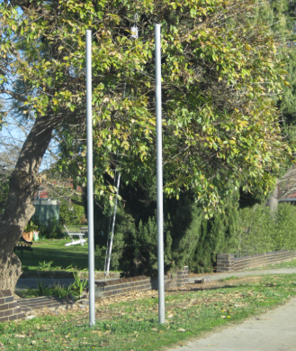

Sign Requirements:

- Sign size requirements i.e. no larger than 1.5 m2.
- Four lines max of information per sign.
- 18 letters max per line
- Information permitted on sign: Event name, date, location
- Use a font that is easily read (e.g. Arial), no script, old English or narrow fonts permitted.
- Only one community group logo is permitted per sign. Sponsors logos may appear on the back of the sign.
- Signs to be covered by a public liability insurance policy.
- Signs may be placed two weeks prior to the event and removed within two days of completion of the event.
- Clamps to be used to fix sign to posts, no tech screws.
- Sign to be installed to cover the top of the posts
- Only one sign on the posts, per site.
- One event per community group, per year

Example of good sign design:


Flower Show
10, 11 March 2016
Kyneton
Racecourse
1000 mm

1500 mm

Example of bad sign design
Sign Design – Non Compliant | Comments
 | Sign cluttered with information. Keep signs simple.  Road users only have 2 seconds max to absorb the information. This sign is a potential traffic hazard.
Sign Design – Compliant


8 – 9 June 2013
Bendigo Central
Lyttleton Tce

Chrysler Car Show


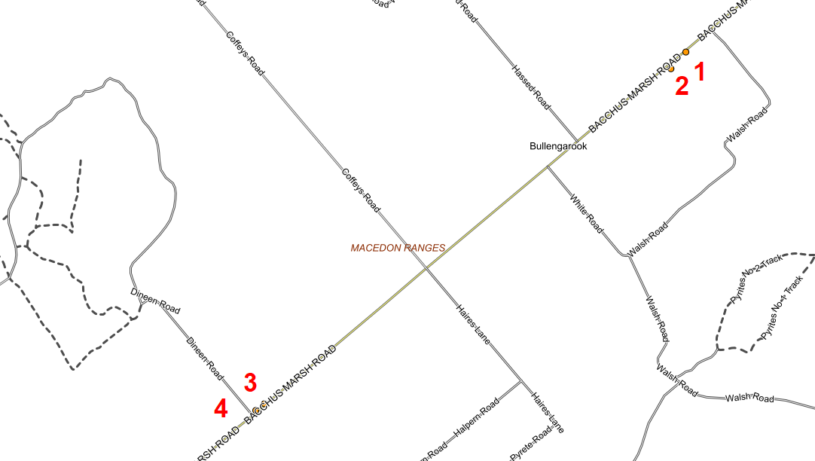
BULLENGAROOK
Sign Number | Road | Location Description
1 | Bacchus Marsh Gisborne Road | 145m west of Walsh Road, west bound carriageway
2 | Bacchus Marsh Gisborne Road | 250m west of Walsh Road, west bound carriageway
3 | Bacchus Marsh Gisborne Road | 30m east of Dineen Road, east bound carriageway
4 | Bacchus Marsh Gisborne Road | 90m east of Dineen Road, east bound carriageway
GISBORNE
Sign Number | Road | Location Description
5 | Robertson Street | 110m north of Hamilton Street, north bound carriageway
6 | Robertson Street | 190m west of Neal Street roundabout, east bound
7 | Hamilton Street | 20m east of Stephen Street, eastbound carriageway
8 | Aitken Street | 30m north of Fisher Street, north bound carriageway
9 | Gisborne Melbourne Road | 120m east of Howey Street, westbound carriageway
10 | Gisborne Melbourne Road | 290m east of Howey Street, west bound carriageway
11 | Gisborne Melbourne Road | 460m east of Howey Street, west bound carriageway
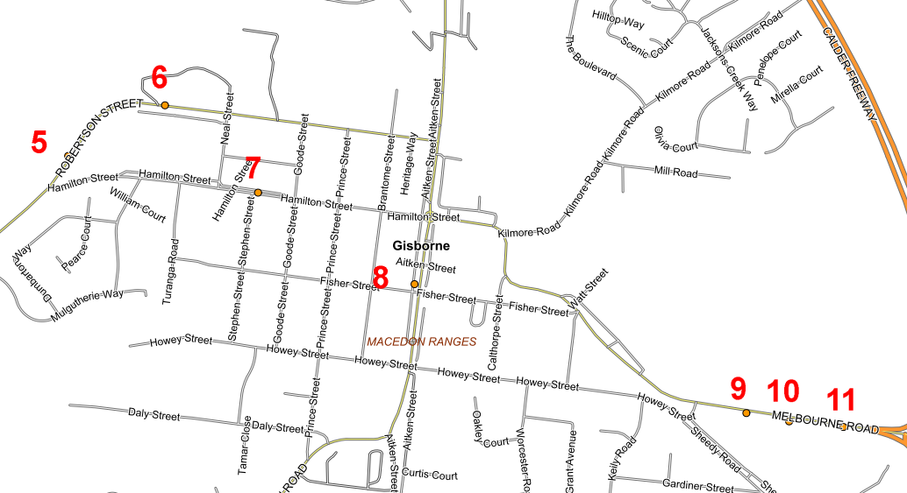
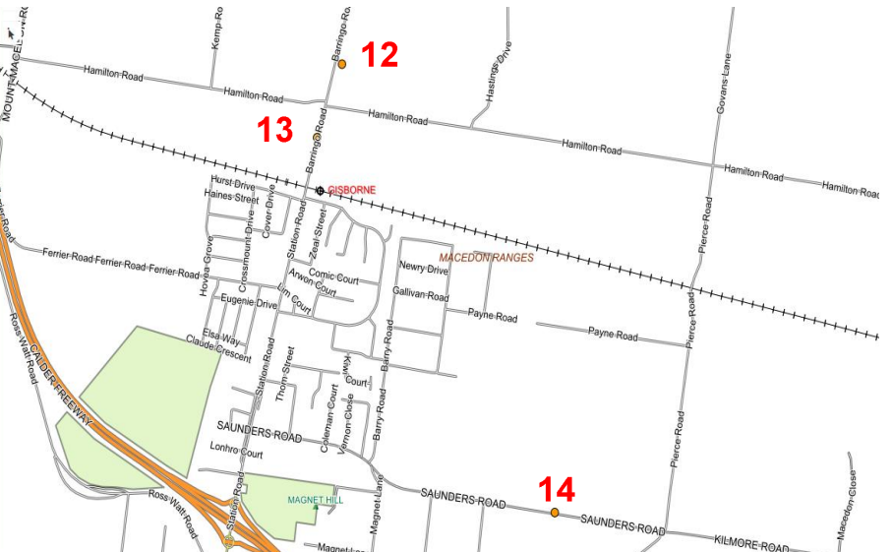
NEW GISBORNE
Sign Number | Road | Location Description
12 | Barringo Road | 225m north of Hamilton Road, south bound carriageway
13 | Barringo Road | 303m north of Hurst Drive, north bound carriageway
14 | Saunders Road | 584m east of Pierce Road, west bound carriageway
RIDDELLS CREEK
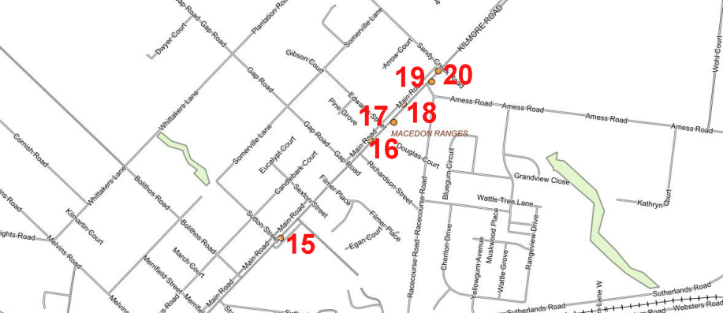
Sign Number | Road | Location Description
15 | Main Road | 30m north of Sutton St, north bound carriageway
16 | Main Road | 150m north of Gap Road, north bound carriageway
17 | Main Road | 215m south of Amess Road, south bound carriageway
18 | Main Road | 130m north of Edwards Road, north bound carriageway
19 | Main Road | 30m north of Amess Road, South bound carriageway
20 | Main Road | 80m north of Amess Road, south bound carriageway

ROMSEY
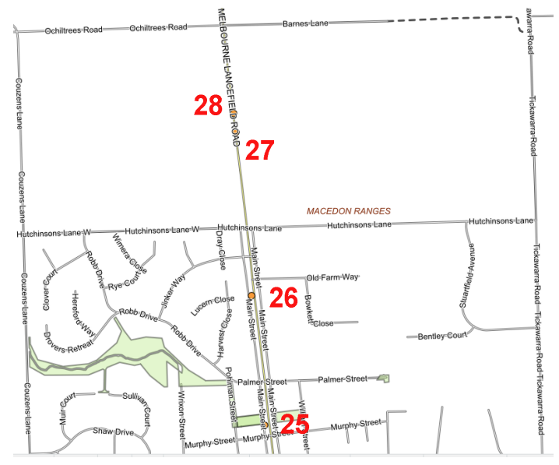
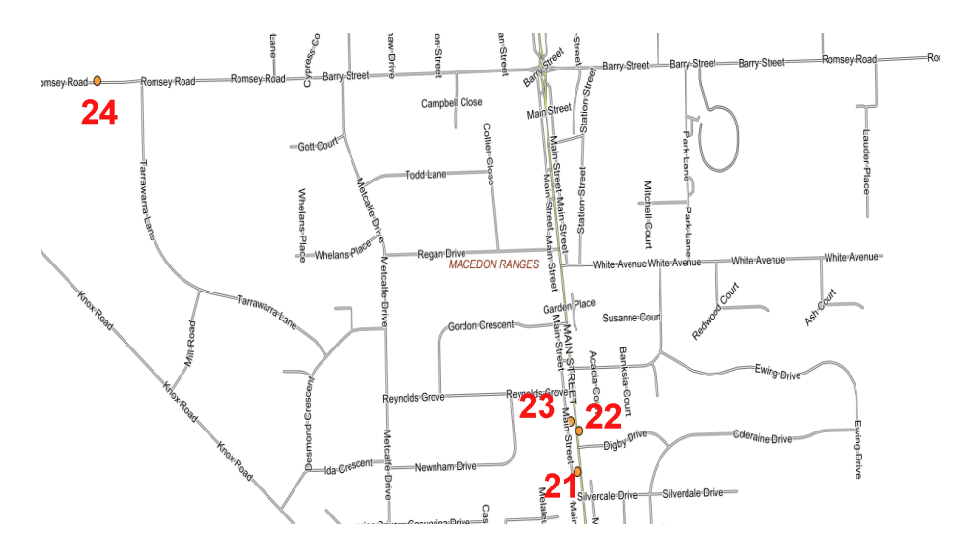
Sign Number | Road | Location Description
21 | Main Street | 70m south of Digby Drive, north bound carriageway
22 | Main Street | 45m north of Digby Drive, south bound carriageway
23 | Main Street | 80m south of Reynolds Grove, north bound carriageway
24 | Romsey Road | 170m west of Tarrawarra Lane, east bound carriageway
25 | Main Street | 50m north of Murphy Street, north bound carriageway
26 | Main Street | 65m south of Old Farm Road, north bound carriageway
27 | Main Street | 440m south of Barnes Lane, south bound carriageway
28 | Main Street | 360m south of Barnes Lane, south bound carriageway

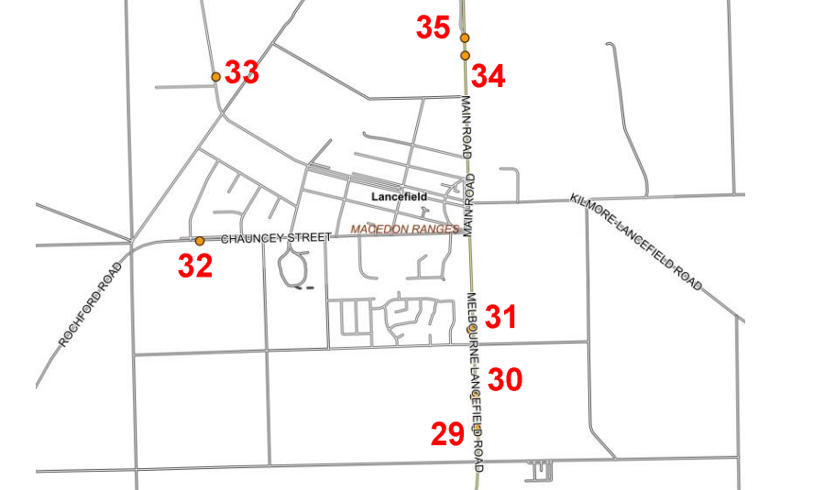
Sign Number | Road | Location Description
29 | Melbourne Lancefield Road | 500m south of Beckermans Lane, north bound c/way
30 | Melbourne Lancefield Road | 310m south of Beckermans Lane, north bound c/way
31 | Main Road | 90m north of Beckermans Lane, north bound c/way
32 | Chauncey Street | 55m east of Rose Blvd, west bound carriageway
33 | Three Chain Road | 220m north of cnr High Str & McMasters Ln, south bound
34 | Melbourne Lancefield Road | 245m north of Showlers Lane, south bound c/way
35 | Melbourne Lancefield Road | 350m north of Showlers Lane, south bound c/way

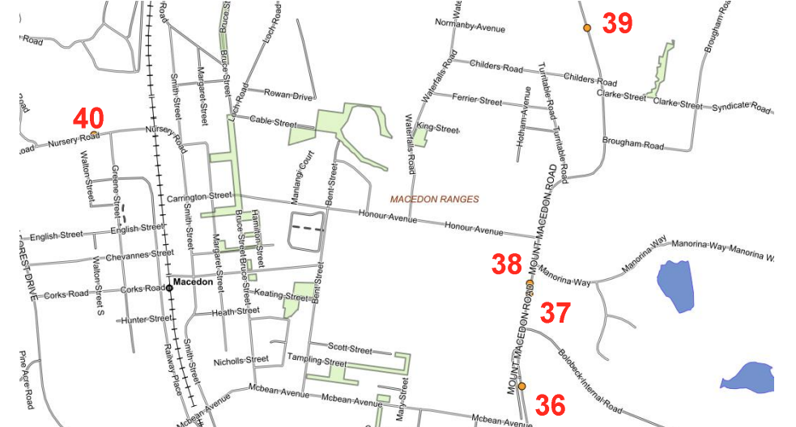
Sign Number | Road | Location Description
36 | Mount Macedon Road | 200m north of McBean Avenue, north bound carriageway
37 | Mount Macedon Road | 650m north of McBean Avenue, north bound carriageway
38 | Mount Macedon Road | 280m north of Childers Road, south bound carriageway
39 | Mount Macedon Road | 90m south of Mandrina Way, south bound carriageway
40 | Nursery Road | 77m west of Greene Street, east bound carriageway
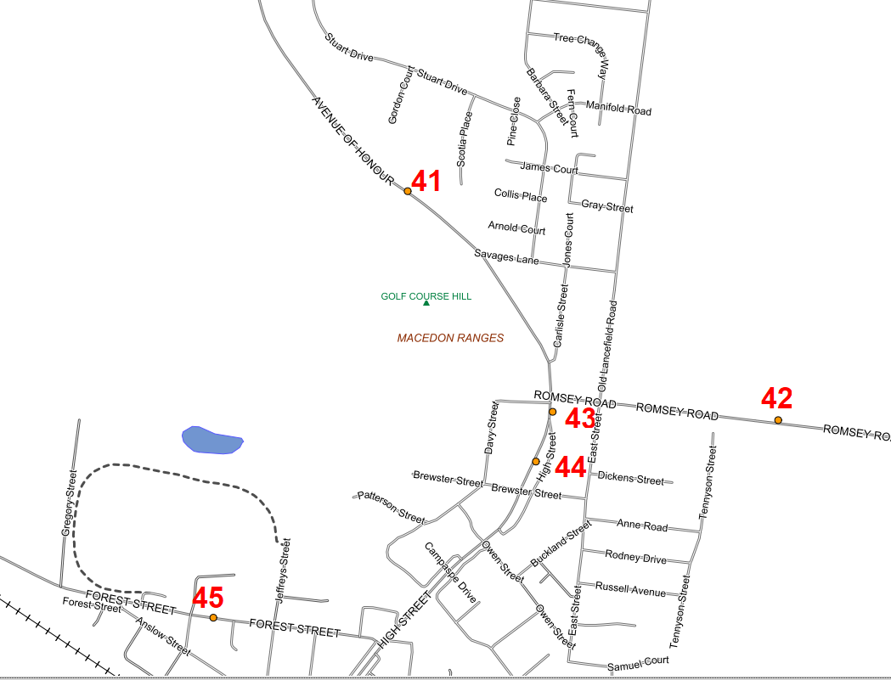
WOODEND
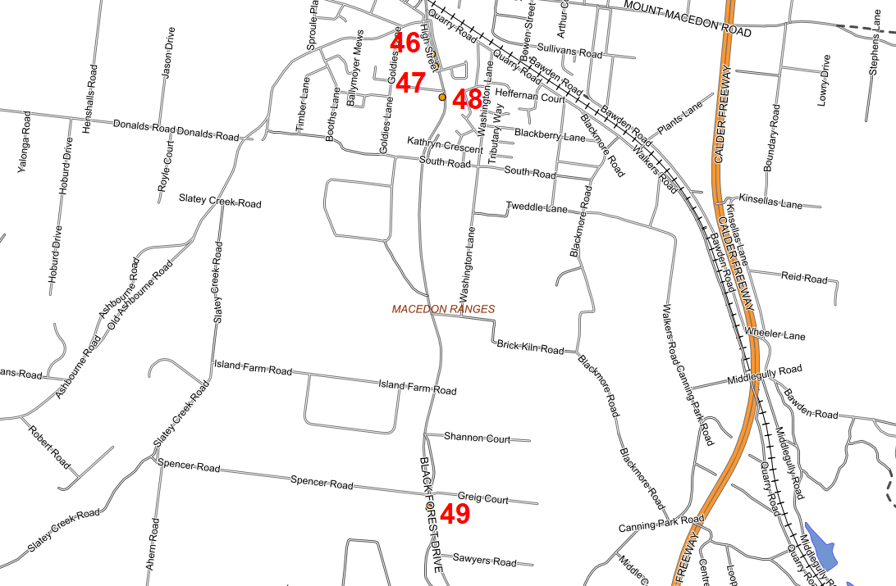
Sign Number | Road | Location Description
41 | Avenue of Honor | 320m north of Savages Lane, south bound carriageway
42 | Romsey Road | 546m east of Old Lancefield Road, east bound carriageway
43 | High Street | 50m south of Romsey Road (C324), south bound c/way
44 | High Street | Opposite 155 High Street Woodend, south bound c/way
45 | Forest Street | 520m west of High St Woodend (C792), east bound c/way
46 | High Street | 200m south of Ashbourne Road, north bound carriageway
47 | High Street | 40m south of 39 High St (service road), north bound c/way
48 | High Street | 80m south of Coach House Blv, south bound carriageway
49 | Black Forest Drive | 82.5m south of Spencer Road, north bound carriageway
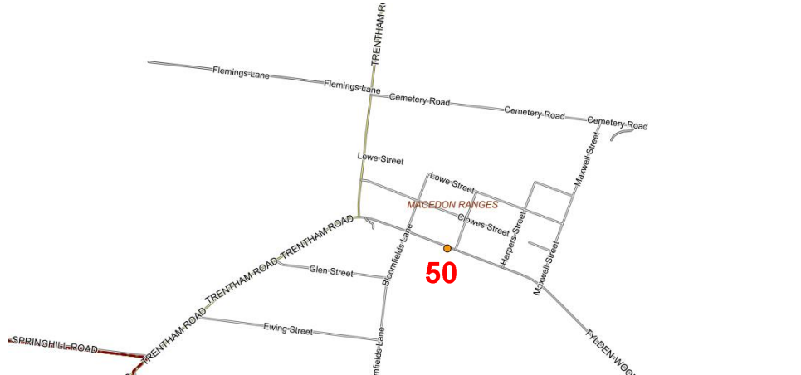
TYLDEN
Sign Number | Road | Location Description
50 | Tylden Woodend Road | 35m west of Macbain Street, west bound carriageway
KYNETON


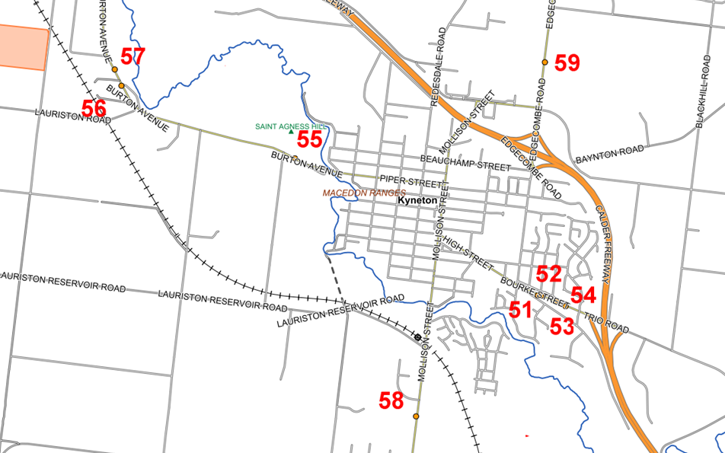
Sign Number | Road | Location Description
51 | Bourke Street | 130m east of High Street, west bound carriageway
52 | Bourke Street | 160m east of High Street, east bound carriageway
53 | Bourke Street | 241m west of Caroline Chisholm Drive, east bound c/way
54 | Bourke Street | 140m west of Wills Street, west bound carriageway
55 | Burton Avenue | 120m east of Flynns Lane, west bound carriageway
56 | Burton Avenue | 120m north of Hoadleys Lane, south bound carriageway
57 | Burton Avenue | 60m south of Hoadleys Lane, north bound carriageway
58 | Trentham Road | 180m south of Hill Drive, north bound carriageway
59 | Edgecombe Road | 450m north of Saleyards Road, south bound carriageway

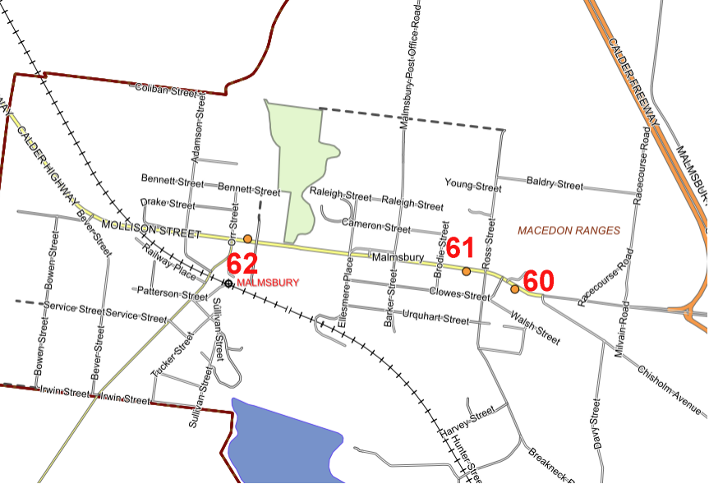
MALMSBURY
Sign Number | Road | Location Description
60 | Malmsbury-Elphinstone Road (C794) | 175m east of Ross Street, west bound carriageway
61 | Malmsbury-Elphinstone Road (C794) | 95m west of Ross Street, west bound carriageway
62 | Malmsbury-Elphinstone Road (C794) | 80m east of Daylesford-Malmsbury Road (C316), east bound carriageway. (Install 1m west of tree)

