Frogs of the Macedon Ranges

Frogs are essential for the health of our local ecosystems. Frogs consume large numbers of invertebrates and are an important food source for many wetland birds and reptiles.

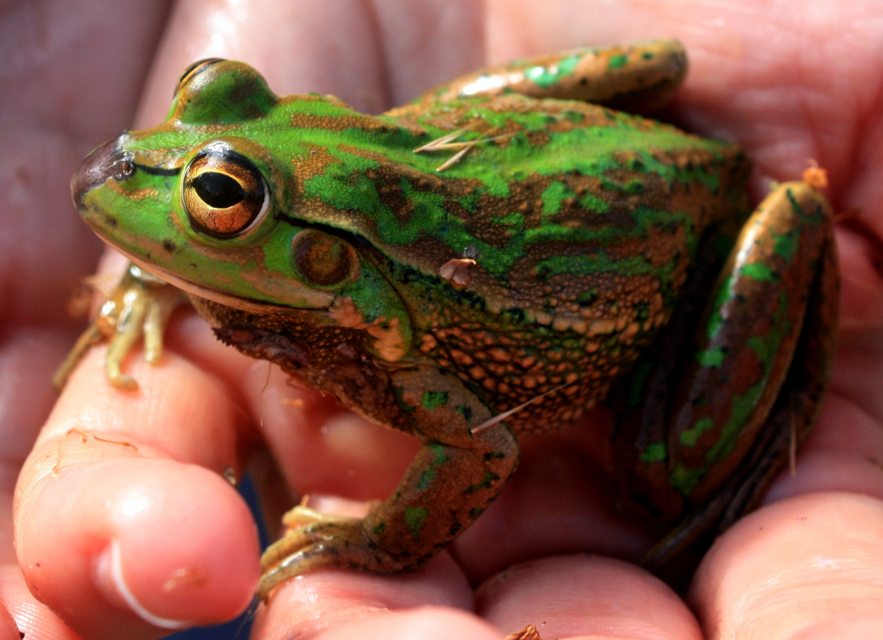
Growling Grass Frog (Litoria raniformis)
Status: Endangered Size: 100mm
Call: Grrruh-uh-uh-urk. Grrruh-uh-uh-urk. Grrruuuurk
A large frog that varies in colour from bright lime green to dark moss green. This species is in serious population decline in Victoria. Despite being from the tree frog family, it dwells on the ground and often preys upon smaller frogs. Its large body size, bright green colour and warty back make it easy to identify.

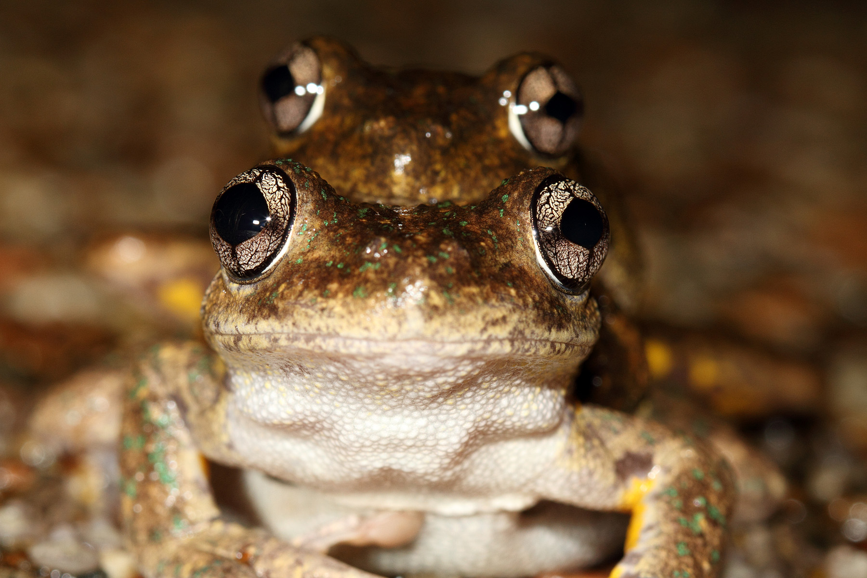
Peron’s Tree Frog (Litoria peroni)
Status: Secure Size: 65mm
Call: Chattering, descending cackle.
Grah-a-a-a-ah-ah-ah-ah-aah-aah-aah-aaaah-aaaah
The Peron’s Tree Frog has the ability to change its colour from grey and browns to an almost white. Its armpits, groin and thighs are coloured a yellow and black marbled pattern. This species is easily identified by its cross shaped pupils. This frog is very quick and a fast climber.

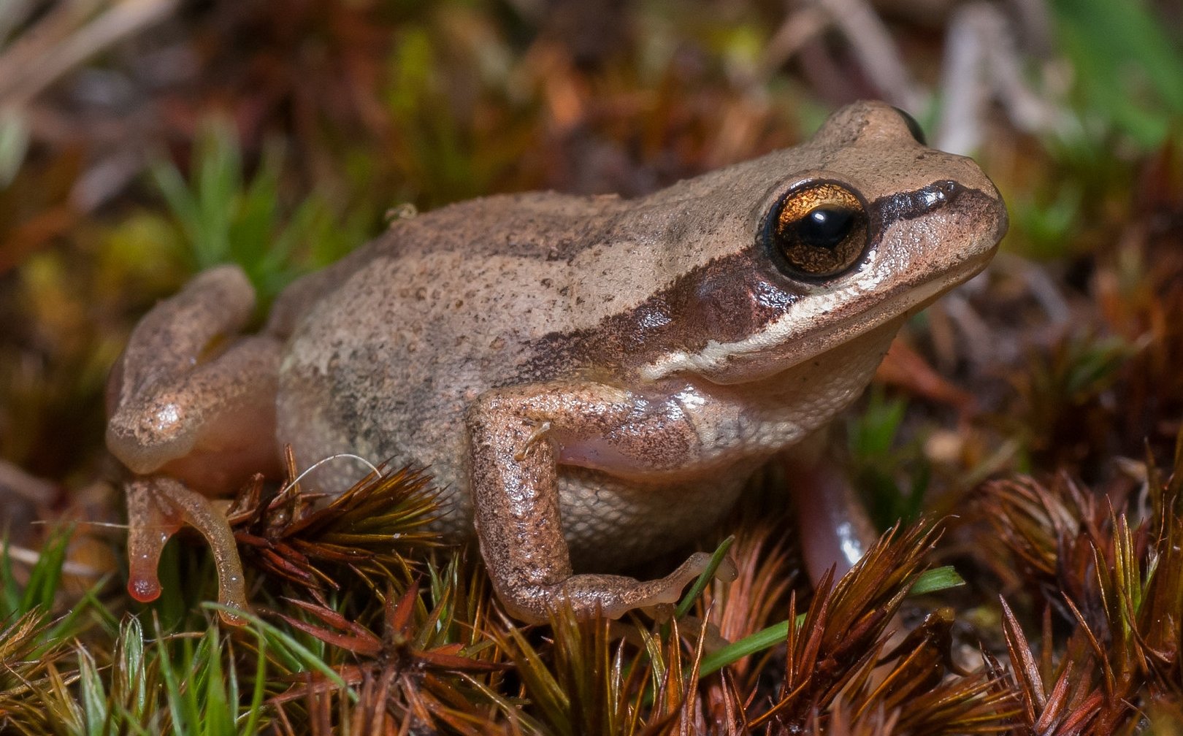
Southern Brown Tree Frog (Litora ewingi)

Status: Secure Size: 45mm
Call: Low-pitched, gravelly repeated whistling.
Cree-cree-cree-cree-cree-cree-cree
One of the more common frog species, the Southern Brown Tree Frog is an excellent climber and jumper. This small frog is usually either a dark or light shade of brown and sometimes green. There’s a black line on its face from the nostril, through the eye to the shoulder. Tree frogs such as the Southern Brown Tree Frog have large sticky toe pads for climbing. They are often seen after rain.

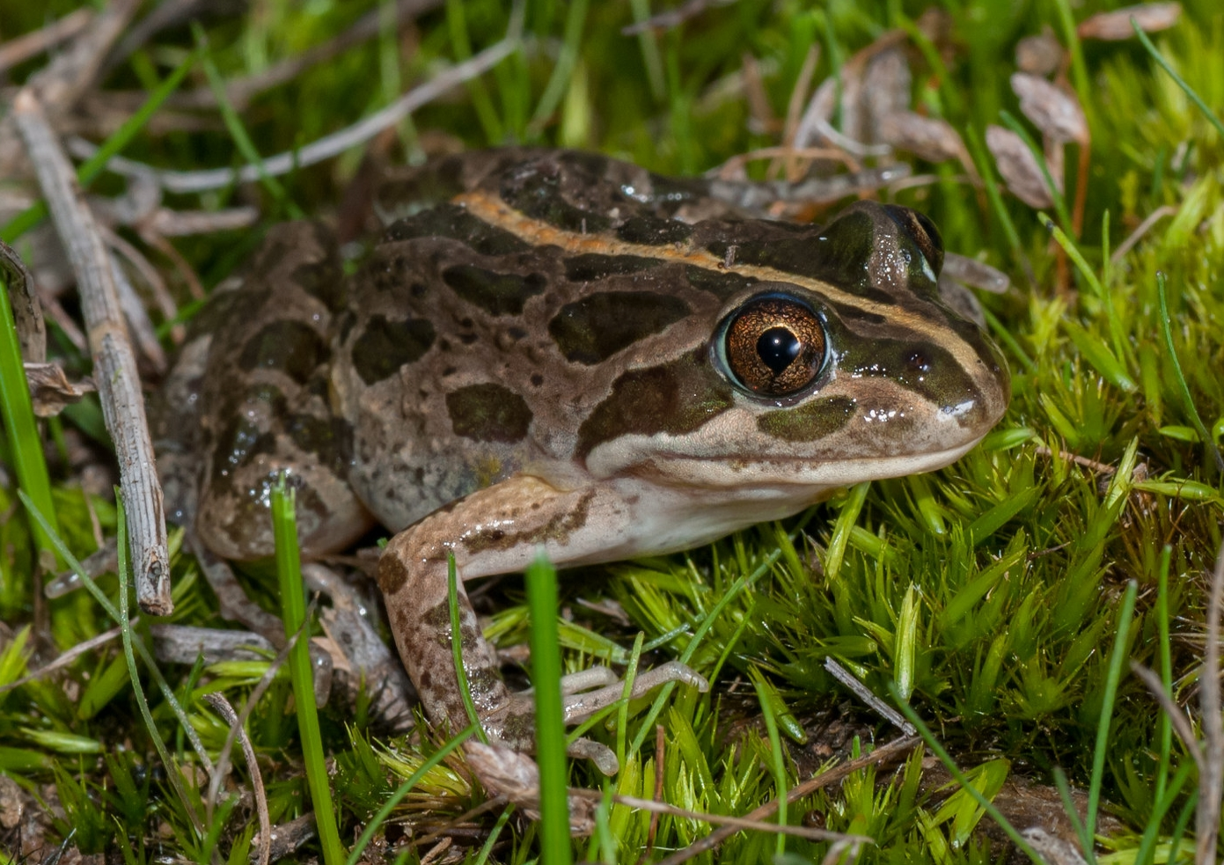

Spotted Marsh Frog (Limnodynastes tasmaniensis)
Status: Secure Size: 45mm
Call: Single note click like two stones being hit together.
This frog shelters during the day under loose timber and rocks. It can be found in grassland, bushland and around houses. It’s distinctly recognised with its irregular spots and blotches and with its golden eye colour. The Spotted Marsh Frog often has a pale stripe down its back.
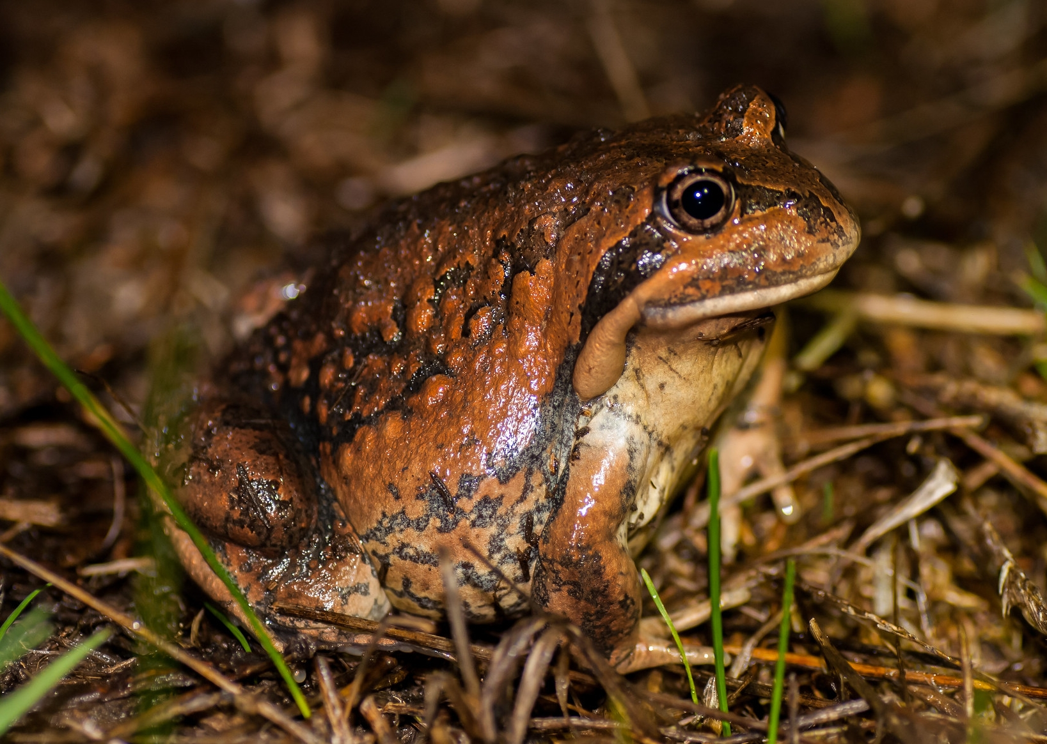

Eastern Banjo Frog (Limnodynastes dumerilii)
Status: Secure Size: 70mm
Call: Distinctive single-note ‘bonk’.
The Eastern Banjo Frog has an oval-shaped gland on the top of its hind legs and white or mottled belly. The colour of this frog varies from light greys to greens, browns or black. Its unique call sounds like a slack string of a banjo. This species buries itself and can often be found while digging in the garden.
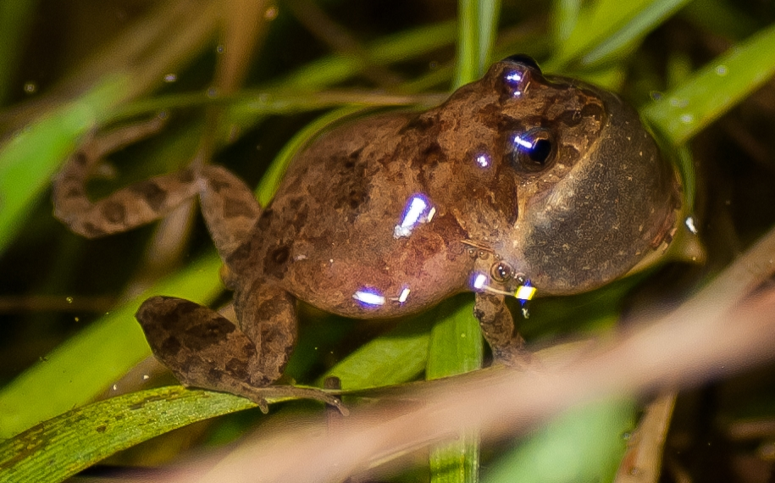
Common Eastern Froglet (Crinia signifera)
Status: Secure Size: 65mm
Call: Ratchet-like ‘crick-crick-crick’
This frogs is the common species in the shire. It often occurs around farm dams and other stagnant ponds. The appearance varies greatly but often consists of a grey or brown back, with darker coloured lines or blotches. They have a very pointy looking head.
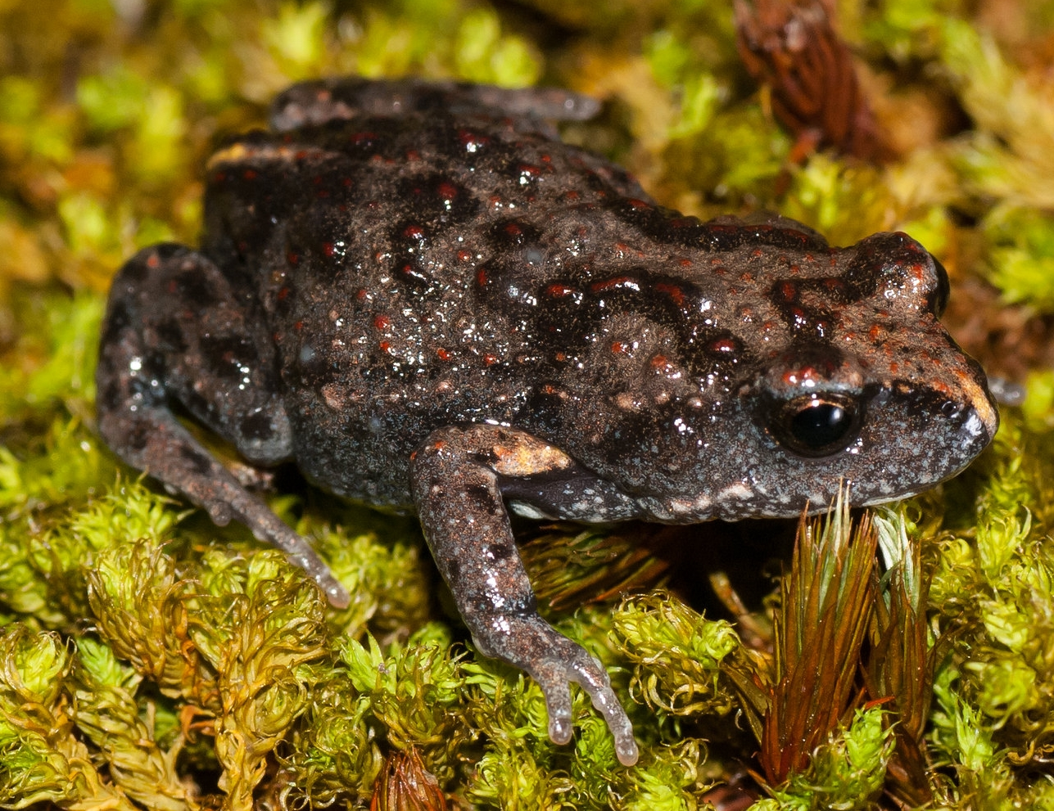
Brown Toadlet (Pseudophryne bibronii)
Status: Endangered Size: 30mm
Call: Grating 'ark' a bit like two marbled rubbing together
Unlike the other species listed, the Brown Toadlet lacks the ability to jump. Instead, its short arms allow it to climb around in the ground litter of open forests, woodlands and grasslands. They have a dark brown warty back. On the belly of this species is a unique marbling of black and white. Extensive habitat loss and degradation of waterways are said to be contributing to the serious decline of the Brown Toadlet in Victoria.

Photo credits in order of images:
Callie Nickolai, Jim Mclean, William Terry

