Community and Business Directory
User guide

Create an account
- Open this webpage www.mrsc.vic.gov.au/mycontent/Log-in?mode=register
- Follow the steps on this page to create an account
- When you have completed this process, follow the directions below to create a listing.

Submit your listing
- Once logged into your account
- Visit your dashboard www.mrsc.vic.gov.au/mycontent/dashboard. Click on the Manage your listings button.
- Enter your organisations details into the required fields. The details you enter will be what you see on our website once your listing has been published.
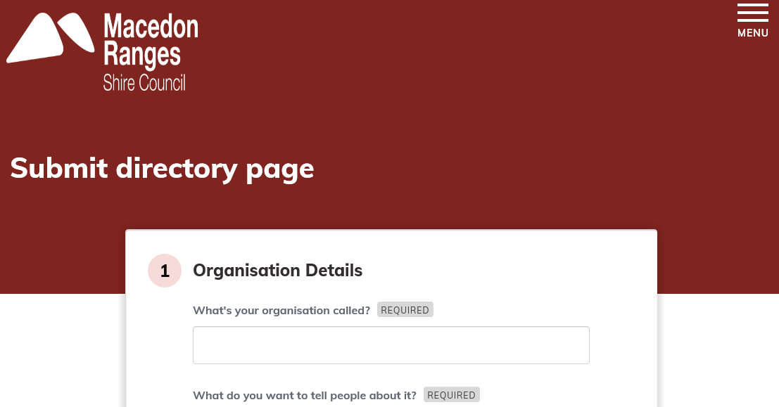

- Once you have completed filling in the form, click the submit button.
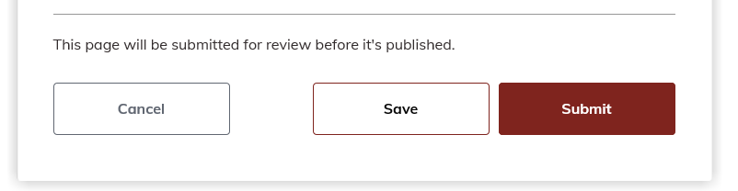

- Once submitted Council will review the details of your listing to make sure it meet our terms and conditions.
- You will receive an email once your listing has been approved and your listing will be published on Council’s website.
Maintaining your listing/s
- Once logged into your account
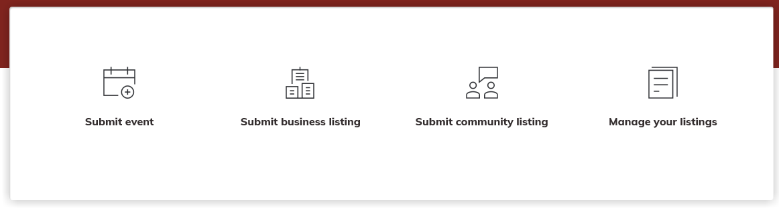
- Click on the Manage your listings button found at the right of your screen
- Your listing/s will appear on this page. Click on the button to the right of your page under Manage to delete, archive or edit your page.
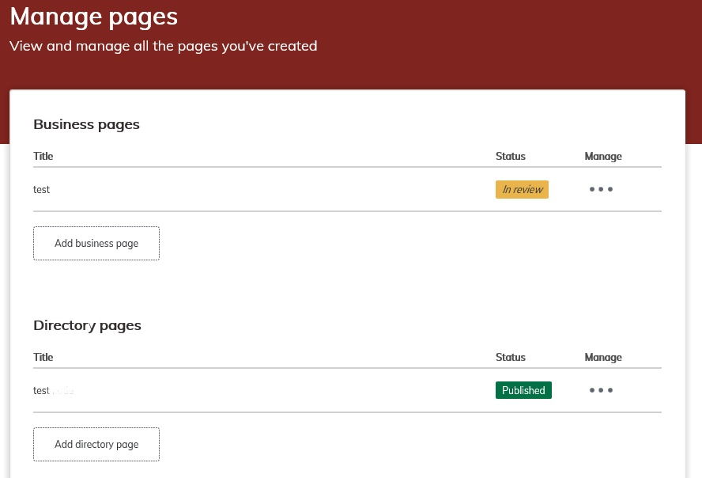

Manage your account
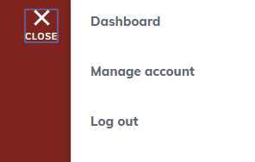
- Select ‘Manage Account’ from the menu up the top right hand side of your screen

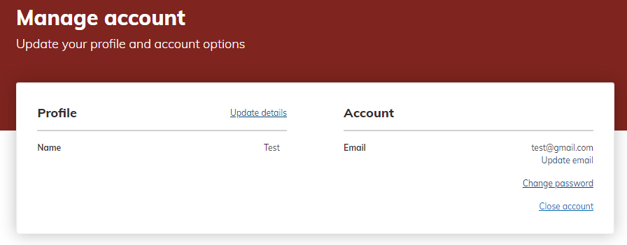
- In this section you can change the name of your account, update your email, change your password or close your account.

Tip: we recommend that your group/organisation uses a generic email e.g. <groupname>@gmail.com. This is important so that when committee members/key people change, the email address and account login stays current.

Reviewing your listing/s
- Council will send a review notification to your email address every 6 months for each of your listings.
- Once you receive this notification log into your account and check to make sure all of your listing details are up to date.

Contact Council if you need help
For business-related enquiries, contact our Economic Development team on 03 5421 9616 or email ecodevadmin@mrsc.vic.gov.au

For enquiries about community groups and organisations, contact our Communications team on 03 5422 0310 or email comms@mrsc.vic.gov.au

