Date: 20 November 2020

Amendment C126macr to the
Macedon Ranges Planning Scheme

Errors, Anomalies and Minor Changes

Council submission – Part B

Table of Contents
1. Introduction 3
1.1 Introduction and Summary 3
2. Rezoning of 51 Aitken Street, Gisborne from PUZ to C1Z (change 4). 3
2.1 What are the issues? 3
2.2 Council response 4
3. Proposed amendment to the Riddells Creek Strategic Framework Map insert within Clause 21.13-5 of the Macedon Ranges Planning Scheme (change 31). 7
3.1 What are the issues? 7
3.2 Council response 8
4. Proposed changes to Heritage Overlay Schedule 89 (HO89) along High Street, Kyneton (change 27). 9
4.1 What are the issues? 9
4.2 Council response 9
5. Rezoning of the Malmsbury Common and any possible road closure (change 16). 12
5.1 What are the issues? 12
5.2 Council response 12
6. Rezoning of the Hobbs Road Bushland Reserve (PUZ to PCRZ) and the rezoning of the Bald Hill Bushland Reserve (PPRZ to PCRZ) (changes 13 and 15) and how these address the contamination risk of these sites. 12
6.1 What are the issues? 13
6.2 Council response 13
7. CONCLUSION 15

Introduction

Introduction and Summary
- This submission is made on behalf of Macedon Ranges Shire Council (Council). Council is the Planning Authority for Amendment C126macr to the Macedon Ranges Planning Scheme (Scheme).
- On 16 November 2020 Council provided its 'Part A' Submission. Council's ‘Part A’ Submission is adopted for the purposes of this Panel Hearing and is taken as read and forming part of these submissions.
- In summary, there are ten unresolved submissions that raise concern with five key matters:
  - The justification and reasoning behind the rezoning of 51 Aitken Street, Gisborne from PUZ6 to C1Z (change 4).
  - The justification for the proposed amendment to the Riddells Creek Strategic Framework Map insert within Clause 21.13-5 of the Macedon Ranges Planning Scheme (change 31).
  - The justification and response regarding the proposed changing to HO89 polygon mapping along High Street, Kyneton (change 27).
  - A response regarding the rezoning of the Malmsbury Common and any road closure (change 16).
  - A response regarding the rezoning of the Hobbs Road Bushland Reserve (PUZ to PCRZ) and the rezoning of the Bald Hill Bushland Reserve (PPRZ to PCRZ) (changes 13 and 15) and how to address the contamination risk of these sites.
- Council’s Part B submission will address these five key matters and provide Council’s response to the issues raised.

Rezoning of 51 Aitken Street, Gisborne from PUZ to C1Z (change 4).

What are the issues?

- Council summarised the main issues in Part A of its submission. The main issues are:

  - The method and process of the land sale; and the rezoning occurring after the sale of the land.
  - The new owner of the land can do other commercial developments on this site once the rezoning occurs.
  - That the proposed Commercial 1 Zone (C1Z) is an inappropriate compared to the Public Use Zone Schedule 6 (PUZ6) for the site. Further, the zoning is not an anomaly.
  - Concern about the exhibition process which ‘perpetuates the myth that objectors can have any impact on the rezoning process’ and the outcome is a foregone conclusion.
  - Concern with increased traffic flow and noise that will accompany the development with the preference the land remains in the public domain.
  - The rezoning of the land would make it impossible to create walking tracks along the Bunjil Creek.

Council response

- The process and agreement for the sale of the 51 Aitken Street, Gisborne land occurred between 2015 and 2016 and has subsequently been finalised.

- A main condition of the sale was that the developer was to construct a public car park on the land and that a Section 173 Agreement would be entered into requiring that the developer would:

  - Construct a car park on the Land at its costs and make the car park available for free but time limited parking by the general public.
  - In the event of failure to construct the car park, at Council’s option, retransfer the Land to Council.
  - Maintain the car park on the Land at its cost.
  - Construct a store and associated car park on the land at 45, 47 and 49 Aitken Street, Gisborne.

- As stated above, a condition of the sale agreement was that a supermarket and public carpark were established.

- Council issued planning permit PLN/2016/241 for the development of a supermarket, development and use of a public car park, display of advertising signage, use of land for a licenced premises and alteration of access to Road Zone Category 1 on 30 May 2017.

- There was no appeal at the Victorian Civil and Administrative Tribunal regarding the issue of this permit.

- The subject land has been subsequently sold and consolidated into the adjoining 45, 47 and 49 Aitken Street and development has since commenced on the subject land (see figure 2 in Part A submission for plan of consolidation).

- Part of the sale agreement was that Council would take reasonable steps to rezone the land to reflect the change in land ownership.

- The rezoning is seeking to reflect that Council does now not own the land and that the land has since been consolidated into 45 Aitken Street, Gisborne.

- The rezoning would not affect the Section 173 Agreement applying to the land and its requirements.

- The rezoning of the land is to reflect the land ownership arrangement and apply a consistent zoning over the site.

- There is no requirement that a public carpark must be zoned PUZ6.

- The use and development of the public carpark is locked in via a Section 173 Agreement.

- The Panel has little ability to address the historic process of the sale of the land or the issue of the planning permit issued on 30 May 2017.
- Any change to the permit and Section 173 Agreement arrangement would require the consent of Council through a planning application. This would be subject to notice and review under the Planning and Environment Act 1987.
- The land could be transferred back to Council if the construction of the carpark does not occur. The construction has already commenced on the site.
- The Commercial 1 Zone would not subsequently stop Council from being able to use the land as a public carpark regardless if it were to transfer back to Council.
- A Practitioners Guide to Victorian Planning Schemes outlines that “A zone boundary should align with title boundaries or other clearly defined feature such as a road centreline or watercourse unless there is a deliberate reason not to” (pg. 16).
- The zoning for the site should therefore run along the title boundaries in this instance and not reflect old title boundaries.
- Council is not advocating the PUZ6 zoning is an anomaly within the Macedon Ranges Planning Scheme but a minor change to reflect new land ownership and to keep a consistent single zoning on the site.
- The C1Z is considered appropriate as it reflects the zoning of the land at 45 Aitken Street.
- Council does not agree with the concern about the exhibition process which ‘perpetuates the myth that objectors can have any impact on the rezoning process’ and the outcome is a foregone conclusion (submission 3), as the whole point of exhibiting the amendment is to receive feedback on an amendment.
- An independent planning panel can review the amendment and make recommendations on the amendment to determine if the proposed changes are in line with best planning practice.
- The Council must consider the recommendations of the panel.
- The use and development of the land has been determined via an issued planning permit and a section 173 agreement. This outcome also has a process in which a Council decision may have been reviewed at the Victorian Civil and Administrative Tribunal.
- The rezoning of the land under planning scheme amendment C126macr would ultimately not affect the outcomes on the use and developments under permit PLN/2016/241.
- The detrimental impact of traffic flow and noise from a development approved under a planning permit was considered as part of the assessment of the planning permit application and is not a matter that can be resolved through this amendment.
- The amendment is reviewing whether the proposed zoning C1Z is appropriate.
- The commercial supermarket land use is occurring within existing C1Z land.
- The 51 Aitken Street land will remain available for public use as a public carpark.
- The rezoning of the land would not affect the ability to create walking tracks along Bunjil Creek.
- Bunjil Creek runs along the reserve at 14A Fisher Street, Gisborne to the east of the subject site (see figure 1).
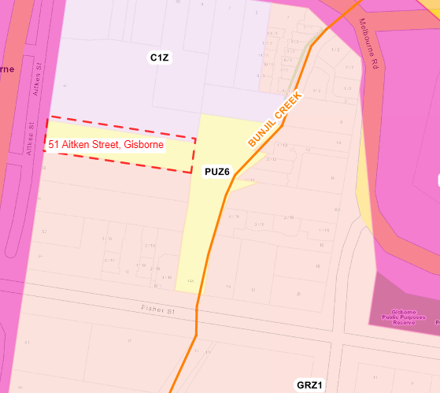
Figure 1: Location of Bunjil Creek and 51 Aitken Street land (Vicnames)
- The rezoning of the site would not affect the ability to create a walking track along 14A Fisher Street, Gisborne.
- The approved carpark approved under PLN/2016/241 has pedestrian steps into the 14A Fisher Street reserve. This allows for pedestrian access into the reserve and allow for any possible future connection to walking trails.

Proposed amendment to the Riddells Creek Strategic Framework Map insert within Clause 21.13-5 of the Macedon Ranges Planning Scheme (change 31).

What are the issues?
- Council summarised the main issues in Part A of its submission. The main issues are:
  - The area south of the rail line in Riddells Creek changed from a ‘priority development area’ to a ‘future investigations area’ when the Minister for Planning gazetted Amendment C100macr. Further, this change does not reflect the adopted Riddells Creek Strategic Framework Plan adopted by Council and which received support from panel.
  - The outcome means that any precinct structure will fail to holistically address bushfire risk, development standards, staging of key infrastructure and additional costs to rezone the ‘future investigations area’ at a later date.
  - The amendment of the Riddells Creek Strategic Framework Map insert to reflect the overall Strategic Framework Map within Clause 21.13.-5 of the Macedon Ranges Planning Scheme implicates Council in any bushfire risk and subsequent negligence from the changes adopted under Amendment C100macr.
  - The area being a ‘future investigations area’ within a township boundary is inconsistent with other townships framework plans within the Municipal Strategic Statement.

Council response
- The major changes to Amendment C100macr by the Minster for Planning cannot being undone through an errors, anomalies and minor changes amendment.
- Change 31 is in part to ensure the Strategic Framework Map Insert within Clause 21.13-5 displays the same information as the Strategic Framework Map inserted by the Minister for Planning in the approval of amendment C100macr.
- The merits of including the area south of the rail line within Riddells Creek was determined by the Minister of Planning under C100macr and gazetted on 15 June 2017.
- Any attempt to try to reverse the Minister for Planning’s decision through an errors, anomalies and minor changes amendment would be futile as the outcome does not constitute an error, anomaly or minor change.
- The Strategic Framework Map Insert being updated to reflect the revised Strategic Framework Map approved by the Minster for Planning does constitute an error correction and should be corrected to ensure consistency within the Macedon Ranges Planning Scheme as an insert must match the overall map.
- Any future precinct structure plan under the existing Urban Growth Zone would need to address the relevant bushfire risk mitigation, staging of infrastructure and acceptable development standards.
- The ‘future investigations area’ is within the protected settlement boundary of Riddells Creek under the Macedon Ranges Statement of Planning Policy Framework.
- Having a ‘future investigations area’ within a protected settlement boundary is not an error even if it has not been replicated elsewhere under clause 21.13.
- Any urban growth in Riddells Creek will be within the settlement boundary. It is therefore appropriate the ‘future investigations area’ is within the settlement boundary.

Proposed changes to Heritage Overlay Schedule 89 (HO89) along High Street, Kyneton (change 27).

What are the issues?
- Council summarised the main issues in Part A of its submission. The main issues are:
- No recent study or reasoning to justify the extension of HO89 over 39 High Street, Kyneton.
- No pre-exhibition consultation was undertaken No physical inspection was undertaken on the site. Proposed mapping is inaccurate.
- The proposed change would result in:
  - Reduced aggregated land value
  - Restrictions on the proposed development which benefit the visitor economy.
  - Increased costs associated with consultant reports.
  - Additional applicant costs in relation to development.
  - Additional and onerous obligations in facilitating development applications.
- Increased negative sentiment on the part of potential buyers given Council’s reputation for being difficult and problematic in relation to development matters.
- The amendment conflicts with Planning Practice Note – 01 (PPN-01) and is not in accordance with it.

Council response
- There has been no new heritage study to support or justify the extension of HO89 over the properties where it already applies along High Street, Kyneton.
- The original HO89 was applied as a result of the Shire of Kyneton Conservation Heritage Study 1990.
- Council is seeking to ensure that HO89 applies along property boundaries that already have the HO89 applied.
- Council maintains as per its Part A submission that the proposal is in accordance with (PPN-01).
- Pg. 5 of the PPN-01 outlines how the curtilages and Heritage Overlay polygons should be applied.
- It states: “In many cases, particularly in urban areas and townships, the extent of the curtilage will be the whole of the property (for example, a suburban dwelling and its allotment)”.
- It further gives reasons along pg 5 and 6 of areas where a HO applying to the whole site are not appropriate such as a large farm with only the house and outbuildings being important, a single tree on an otherwise unimportant property, an important item on a road reserve etc…
- Where it outlines steps for establishing curtilage and polygon it includes of particular note point 1,2 and 3 – provided below:
“Suggested steps in establishing a curtilage and polygon include:
1. Review the heritage study documentation and ask the question ‘What is significant?’. The polygon should capture those elements of the place that are significant. If there are multiple elements that are widely dispersed on the property, one option may be to have multiple polygons which share the same Heritage Overlay number.
2. In addition to capturing the elements that are significant, it is almost always necessary to include a curtilage (see definition above) to: • retain the setting or context of the significant building, structure, tree or feature • regulate development (including subdivision) in proximity to the significant building, tree or feature.
3. Where possible, uncomplicated and easily recognised boundaries (such as a fence line) leave little room for potential dispute in terms of the land affected by any future Overlay”.
- It is further noted the practice note outlines that “Councils are encouraged to review their planning schemes to ensure that all heritage places are correctly mapped and that there are no discrepancies between how places are identified in the Heritage Overlay schedule and Heritage Overlay maps”.
- In review of the above, Council maintains that the proposed amendment aligns with PPN – 01 and falls within the scope of an errors, anomalies and minor changes amendment.
- The proposed change ensures the mapping polygon for the High Street Precinct follows the property boundaries of these properties that front High Street and already have the HO89 applied.
- The concern raised that the revised HO89 mapping is inaccurate can be further worked on if required. However, as outlined in Part A – the polygon follows the Vicplan cadastral mapping layer shape for these impacted properties. The 39 High Street, Kyneton title plan (See Part A: figure 1) shows the shape of the property to reflect existing title boundaries shown on Vicplan’s cadastral map see figure 2 below.
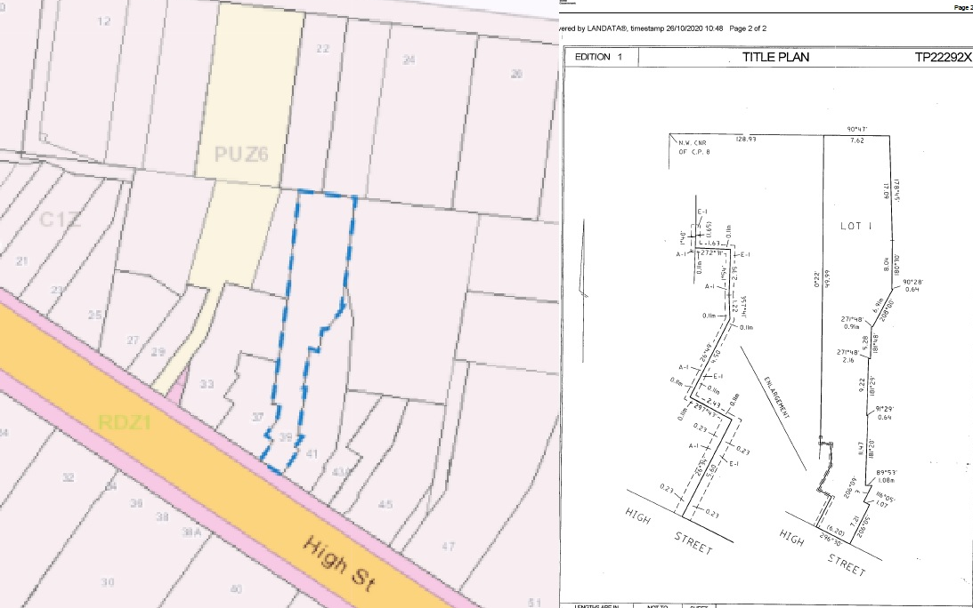
Figure 2: 39 High Street, Kyneton title plan and Vic map boundaries comparison
- No pre-exhibition consultation was undertaken for amendment C126macr with private landholders. Feedback was sought through the formal statutory exhibition phase of the amendment. This is not abnormal and sets out a clear process and timeframes regarding submissions in accordance with the Planning and Environment Act 1987.
- It is noted no other submissions were received regarding the changes to the HO89 along High Street.
- A physical site inspection can be arranged now that Covid-19 restrictions are easing if required. Broadly speaking a physical site inspection, particularly the rear of sites is not always possible. Panel also has an opportunity to view the site if needed.
- Council maintains there are not onerous application requirements in response to the increase of the HO89 on 39 High Street, Kyneton.
- 39 High Street, Kyneton is zoned C1Z which triggers a permit for most types of development applications.
- The site already has the HO89 applied over the front half of the property.
- Any development application would need to have regard to areas of heritage sensitivity under the Planning Policy Framework (PPF) and Local Planning Policy Framework (LPPF).
- Any future new development proposed to the rear of a site and not visible from High Street is likely not to have any onerous requirements or require particular expert advice.
- Any development visible from High Street should have regard to the heritage values of this area.
- This is why it is important to include the HO89 to apply to the whole property and ensure a holistic consideration of the High Street heritage values.

Rezoning of the Malmsbury Common and any possible road closure (change 16).

What are the issues?
- Council summarised the main issues in its Part A submission. The main issues are:
- The road closure associated with the rezoning of the Malmsbury Common would adversely impact on adjoining property owners access and bushfire survival plan.
- The road closure of the unnamed road reserve has not followed proper procedure or been explicitly mentioned in the explanatory report or other documents associated with amendment C126macr.

Council response
- There is no proposed road closure associated with the rezoning of the Malmsbury Common Reserve from PPRZ to PCRZ.
- The explanatory report and other documents produced by Council related to amendment C126macr did not refer to any road closure as there is none proposed.
- There will be no changes to access private property along the unmade road reserve as a result of amendment C126macr.
- The submissions were likely brought about from operational works to the Malmsbury Common and these submissions were after the exhibition period had ended. This hindered Council’s ability to resolve them prior to requesting a Panel.
- However, Council officers have discussed with the submitters regarding the matter and confirmed access to private land would not be impacted by virtue of the proposed rezoning contained within this amendment.

Rezoning of the Hobbs Road Bushland Reserve (PUZ to PCRZ) and the rezoning of the Bald Hill Bushland Reserve (PPRZ to PCRZ) (changes 13 and 15) and how these address the contamination risk of these sites.

- Council summarised the main issues in Part A of its submission. The main issues are:

What are the issues?
- Concern changes 13 and 15 do not address site contamination risk from previous or current land uses adequately.
- The existing Environmental Audit Overlay does not adequately address contamination risk by itself.
- Request additional controls to both sites to have an assessment of landfill gas (Hobbs Road) or contamination risks being undertaken prior to the use or development of any intrusive structures or public open space.

Council response
- As outlined in its Part A submission, Council has sought to address the Ministerial Directions regarding the contamination of land.
- Council had sought to amend the zoning of these sites to reflect the bushland reserve status and the current and ongoing management of these sites.
- The rezoning is not occurring in response to any management change or new use of these sites.
- Use and development of these sites are subject to Council approval as Council is the public land manager for these sites.
- The Hobbs Road Bushland Reserve (former landfill) is monitored by Council and continually audited under Section 53V of the Environment Protection Act 1970.
- It is acknowledged that an existing Environmental Audit Overlay also covers both sites.
- The Environmental Audit Overlay will not address contamination risk for anything other than defined sensitive uses.
- The EPA has expressed concern that there is limited control regarding the assessment of contamination risk to public open space uses.
- Public open space uses are currently undertaken on these sites, which include activities such as bushwalking and bike riding. The Environmental Management Plans also in part review the existing uses of the reserve.
- A shooting range continues to operate at the Bald Hill Reserve.
- Council has not been able to find a copy of the audit undertaken in the 1990’s regarding the Bald Hill Reserve shooting range. Only the reference within the Bald Hill Environmental Management Plan and the recommendations listed within.
- The proposed zoning change would not significantly alter what could be approved on either of these sites subject to the use conditions under Clause 36.03-1 of the PCRZ. The existing zones permit a wide range of uses if they are conducted by or on behalf of a public land manager.
- It is Council’s view that any risk from land contamination would not alter as a result of the proposed rezoning.
- Council agrees that there would be no specific contamination risk control applying to the reserves if any new use was proposed under the new zoning that does not fall under the sensitive use category.
- A new control would need to be created as per the EPA requirements raised in its submission for this additional consideration outside of the PPF, LPPF and EAO.
- The PCRZ allows for an incorporated plan to dictate uses within the Public Conservation and Resource Zone.
- However, the incorporate plan does not override the allowances under the first dot point of the table of uses (see figure 2).
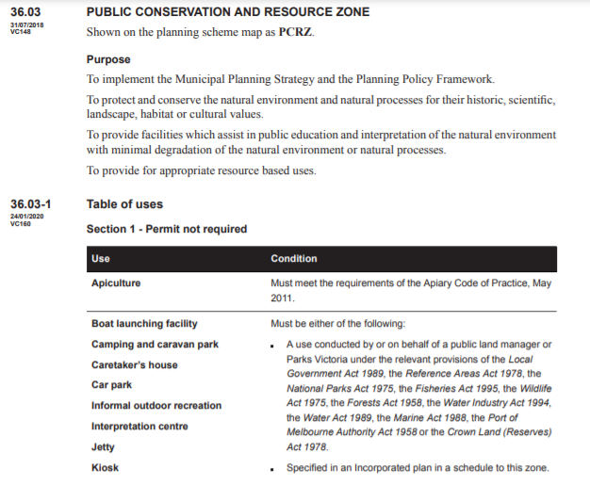
Figure 3: 36.03 Public Conservation and Resource Zone
- Council is not aware of the incorporated plan being used to address contamination risk in other planning schemes and notes it is only one of two viable conditions for permitting a use under Section 1 of the PCRZ.
- Council acknowledges the EPA expertise on these matters and accepts that the management of risks associated with new uses and contaminated land as a high priority.
- The rezoning of these sites was an exercise to apply the public use zoning that best reflects the nature of the bushland reserves due to their environmental and habitat values.
- The way forward may be some other type of control outside of the existing planning provisions or outside the planning system.
- Any new controls created would likely remove the two proposed changes as falling within an errors, anomalies and minor changes amendment due to the additional work and costs associated with this work.
- Council is seeking recommendations on the direction from panels regarding this matter.

CONCLUSION
- This completes the submissions for the Council.
- Council reserves its right to respond to any new matters raised through submissions in its reply.

