

Community Awards
Nomination Guide

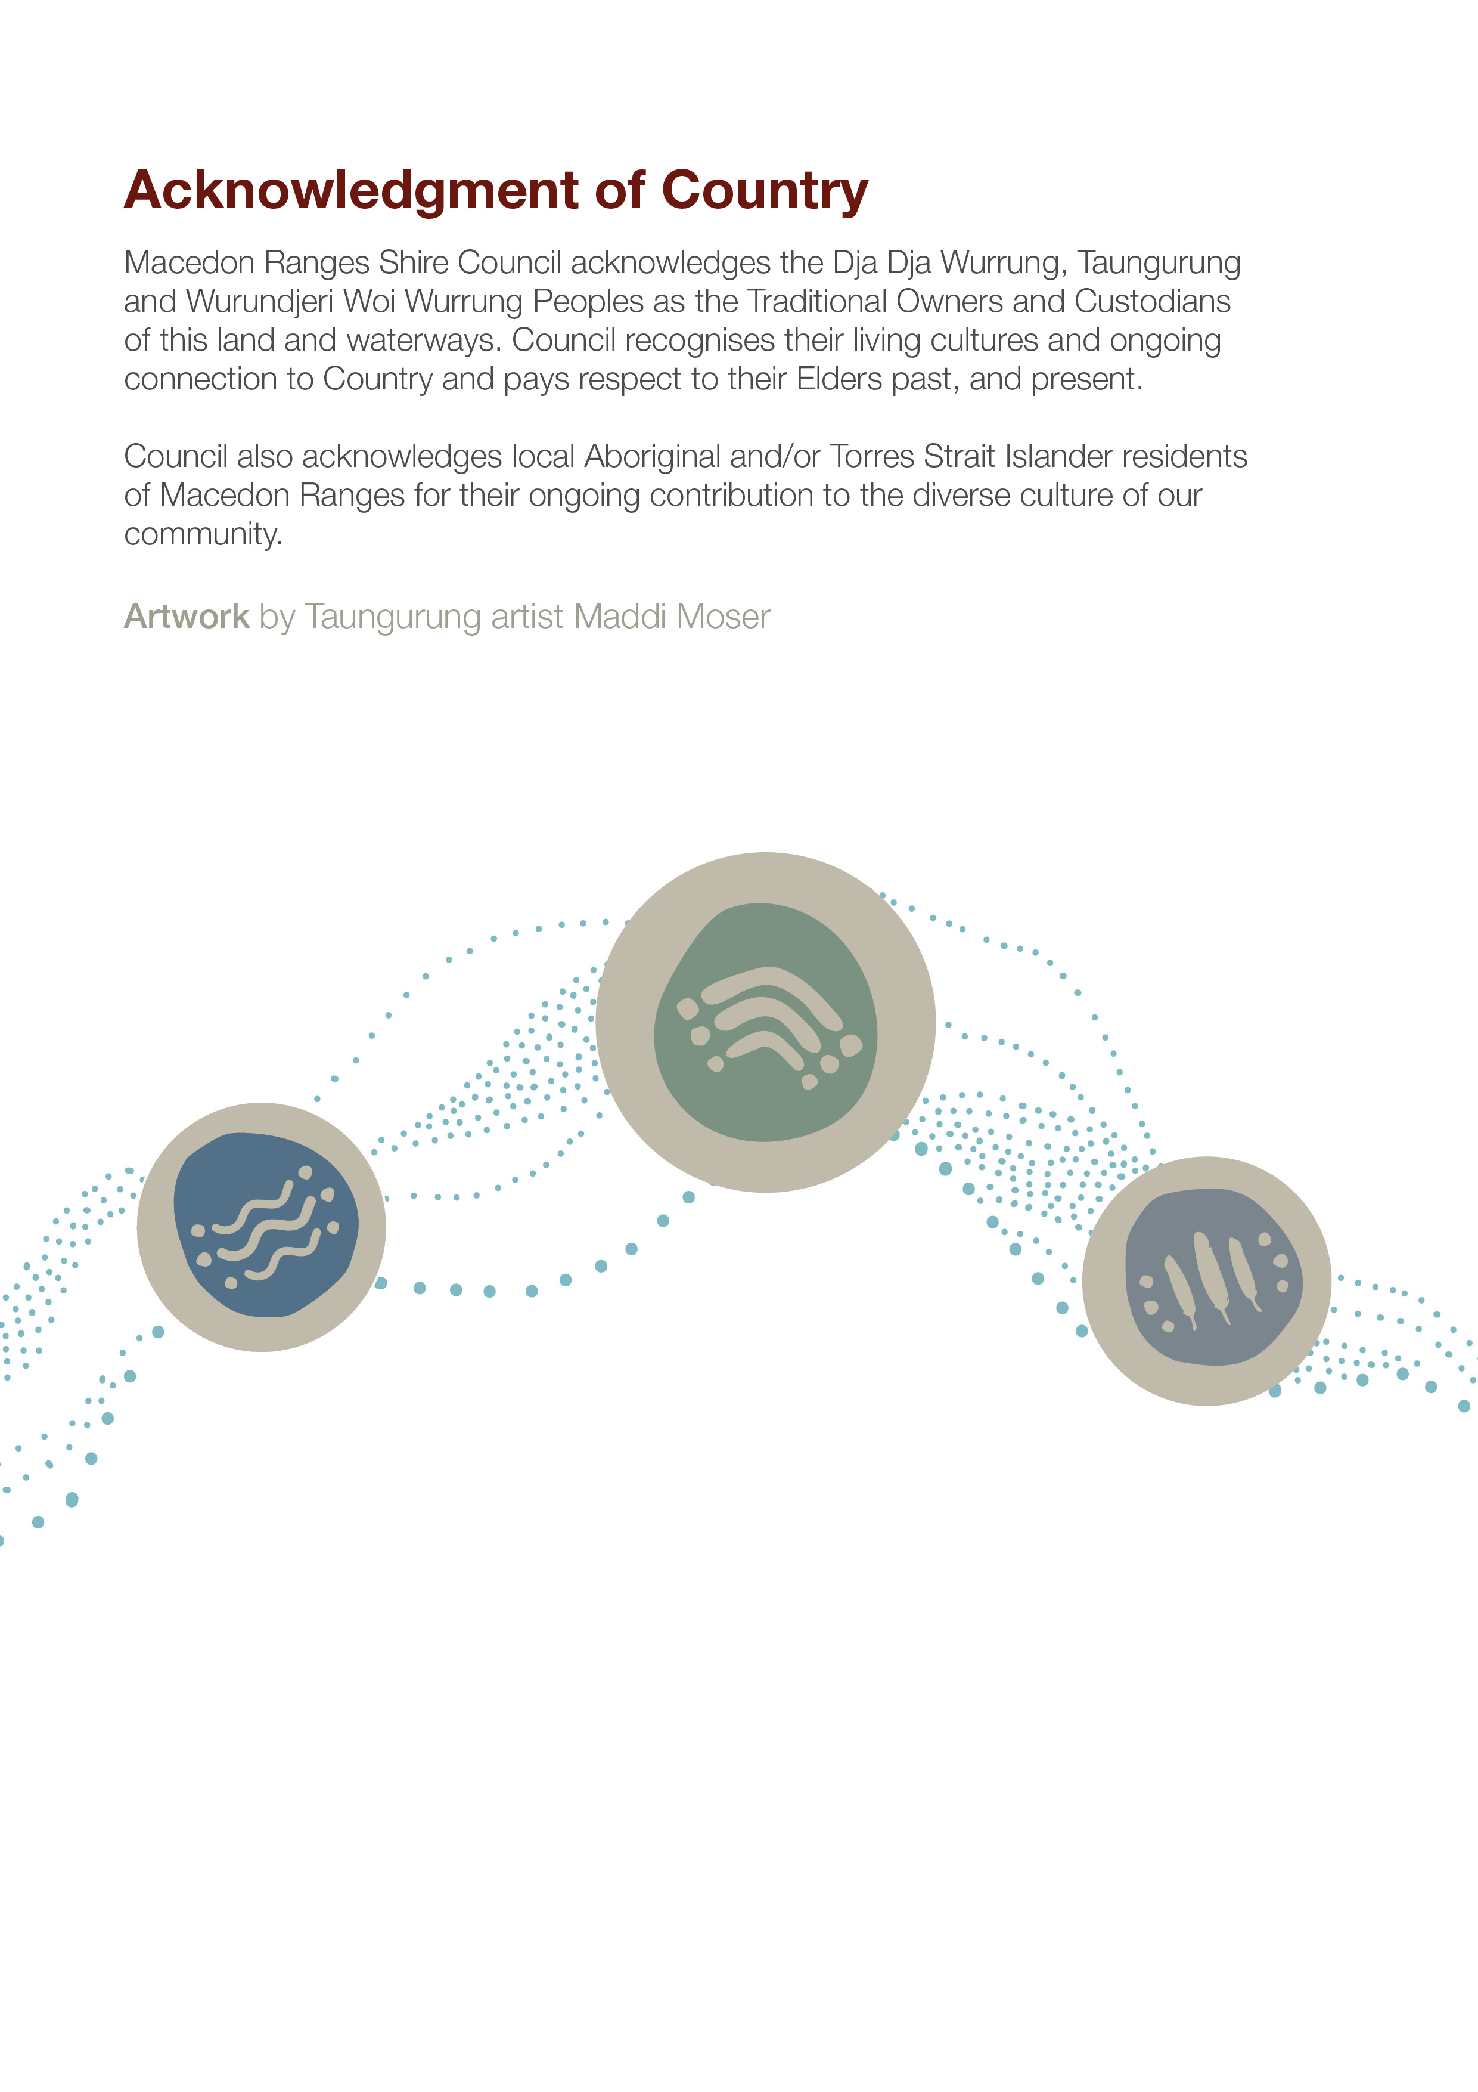
Contents
Overview 3
Eligibility 3
Award Categories 4
Citizen of the Year 4
Young Citizen of the Year 4
Inclusive Communities 4
Contribution to the Environment 4
Contribution to Community Arts 4
Contribution to Sports and Wellbeing 4
Youth Leadership 5
Community Event of the Year 5
Conditions of nomination 5
Nominee details – what you will be asked to provide 5
Assessment 5
Table 1: Scoring criteria 5
Contact information 6

Overview
Council recognises and celebrates community members and organisations that make significant contributions to our community every year through the Community Awards program. The Award Ceremony is held annually during National Volunteer Week and includes acknowledgement and celebration of all nominees across eight (8) categories:
Citizen of the Year
Young Citizen of the Year
Inclusive Communities
Contribution to the Environment
Contribution to Community Arts
Contribution to Sports and Wellbeing
Youth Leadership
Community Event of the Year
Please note: Council also holds an annual Business Awards program, run by Council’s Economic Development Team.

Eligibility
Individuals and community groups can be nominated for a Community Award.
To be eligible:
- individuals must live, work or study in the Macedon Ranges Shire at the time of nomination
- community groups must be incorporated
- individuals can be nominated in all categories, however community groups cannot be nominated for Citizen and Young Citizen of the Year.
- youth award nominees must be between 12-25 of age. All other award categories are open to ages 18 and over.
- nominees cannot be previous recipients of Community Awards (formerly known as the Australia Day Awards)

Award Categories
There are eight (8) categories as part of the Community Awards program.

Citizen of the Year
Awarded to an individual aged 18 or over who has made an extraordinary contribution to the Macedon Ranges community and has demonstrated community service over many years.

Young Citizen of the Year
Awarded to a young person aged 12 - 25 who has made a significant contribution to their community and demonstrates community service in the Macedon Ranges Shire. This could be through advocating and raising awareness of important local issues, involvement in promoting and advancing participation in health and wellbeing activities, fundraising, volunteering, business, sports, arts, the environment, or other contributions that help the community grow and thrive.

Inclusive Communities
Awarded to an individual or group whose work promotes harmony and understanding of others and has made a significant contribution to helping to build a more inclusive community in the Macedon Ranges. This could include building social connectedness and equity among diverse and underrepresented groups or improving participation for isolated and vulnerable community members.

Contribution to the Environment
Awarded to an individual or group who has made a significant contribution in the areas of protection of the natural environment, such as biodiversity, climate change and waste reduction. This could include contributions related to climate emergency, building disaster preparedness, sustainability, reducing impact on the environment, improving biodiversity.

Contribution to Community Arts
Awarded to an individual or group who has made a significant contribution to community in the areas of arts and culture. This individual or group may have encouraged artistic expression in community members who would not usually participate in the arts or inspired community members with a performance or art installation.

Contribution to Sports and Wellbeing
Awarded to an individual or club who has made a significant contribution to community in the areas of sports and wellbeing. This individual or club may have encouraged participation in sport by community members who would not usually participate in active recreation or inspired club members to do their personal best.

Youth Leadership
Awarded to an individual aged 12 – 25 years or group that has shown exemplary leadership, innovation, advocacy or service to Youth in the Macedon Ranges. This might include demonstrated leadership and teamwork skills within a community or school setting, raising awareness on a particular topic or issue, advocating for change, inspiring other young people, mentoring fellow students or community members.

Community Event of the Year
Awarded to an individual or group for the most outstanding community event of the year that involved significant community organisation, participation and attendance, resulting in a substantial impact across the shire.

Conditions of nomination
- Nominators must have the permission of the person they are nominating, prior to submitting an application.

Nominee details – what you will be asked to provide
- Identify the areas in which the nominee has excelled
- Describe your reasons for nominating this person or group
- List past and present memberships of community groups
- List past and present achievements of the group or nominee
- Provide any relevant background details on the nominee
- Upload any additional information to support your nomination e.g. letters of support from other groups, news articles or reviews
- Details of at least one referee who may be contacted to provide further information about your nominee.

Assessment
All nominations will be reviewed by an assessment panel made up of Council officers whose roles align with the award category areas.
All nominations will be assessed against a scoring matrix to address the nomination criteria listed in Table 1 below.

Table 1: Scoring Criteria
Weighting | Criteria | What we will consider
60% | Impact in the community | - Community support for nominee/nominated group  - Outcomes delivered for community (relevant to award category)  - Involvement in community groups or partnerships with other groups and organisations  - Sustained achievements of the group or individual with measurable benefit to the broader community
20% | Alignment to Council goals | - Contributions made towards Council goals/strategic plans e.g. business and tourism, health and wellbeing, environment
20% | Equity of recognition | - Does the nominee represent a new/emerging group?  - Does the nominee represent a diverse group?  - Has the nominee or group received recognition for the same contributions previously or through other awards?

Contact information
For further information or to discuss your event ideas please visit Council’s website or contact the Community Development team on:
Ph: (03) 5422 0333 Email: comdevadmin@mrsc.gov.au

