|  |  |
| --- | --- |
| **Excursion Risk Assessment and Management** | |
| **Service name** | **<Insert kindergarten name> Kindergarten Ph: xxxx xxxx Mobile: xxxx xxx xxx**  **<Insert kindergarten address>** |
| Excursion details | Within 5 kilometre radius of <insert kindergarten name> Kindergarten |
| **Date(s) of excursion**  If it is a regular outing, include a description of when children are to be taken on regular outings | Spontaneous from period: February to December 2023 in accordance with the circumstances outlined in the permission form. |
| **Proposed activities.**  List all activities that will take place during the excursion | * A variety of places within the local community- some examples, but not exclusive to: * Sessions and transitions with teachers and children at local primary schools * Kindergarten carpark- fire/evacuation drills (including visits with CFA, police, ambulance etc). * Local shops to purchase items * Book shop for reading activities * Exploring local community and learning about road safety * Posting letters at the post office * Exploring the local park to learn about flora and fauna * <add any additional items if required> |
| **Any water hazards during the excursion, including any risks associated with water-based activities?**  If yes, detail in the risk assessment table below | Yes No  Comment: |
| **Pick up location and destination(s)**  List each location travelled to and from as part of the excursion  E.g. the museum, park for lunch and service | Walking - to destinations within the community.  Destination will depend on program focus,  May include: park, CFA, police station, ambulance, local shops including supermarket and book shop, post office, local park, local school. |
| **Estimated departure and arrival times and duration of the excursion**  E.g. from the service to each destination and returning to the service | Excursions will be for minimum of 30 minutes to a maximum of 2 hours and will only occur between the hours of 9.30am – 2.30pm of session time. Families to be notified on a case-by-case basis of specific excursions via Storypark or email. |
| **Proposed route**  You can include an image of the route sourced online | The excursion will be within a 5km radius of the kindergarten and will go no further than <insert landmarks representing radius> |

|  |  |
| --- | --- |
| **Means of transport**  E.g. public bus, private bus, coach, private car, taxi, tram | Walking only <update if required> |
| **Describe the procedures for embarking and disembarking the vehicle (include how each child is accounted for in embarking and disembarking):** | Not applicable for this excursion |
| **Requirements for seatbelts or safety restraints in Victoria have been met:**  [Seat belts & child restraints](https://www.vicroads.vic.gov.au/safety-and-road-rules/road-rules/a-to-z-of-road-rules/seat-belts-and-child-restraints#:~:text=Children%20aged%204%20years%20to,in%20an%20adult%20seat%20belt) | Not applicable for this excursion Yes  Comment: |

|  |  |  |
| --- | --- | --- |
| **Number and full names of each adult involved in the excursion**  E.g. service staff, family members, volunteers | Permanent educators: <insert names of educators attending> | |
| **The number of educators / responsible adults, appropriate to provide supervision, and whether any adults with specialised skills are required**  E.g. for children’s individual needs | Minimum 1 educator to 4 children and a maximum of 3 educators to 30 children. An extra support educator (KIS) when needed to support child with additional needs <update or delete if not applicable>. Additional parent volunteers may assist with some excursions. | |
| **The number of children involved in the excursion** | Up to 30 | |
| **Educator to child ratio, including whether this excursion warrants a higher ratio**  Provide details in the risk assessment table below | □1:4 to maximum of 3:30  Higher adult/child ratio will be required with specific cohorts that require more support, eg. walk to school and moving around the school ground, child in group with <insert special need> requires higher ratio (1:1 support) <update or delete if not applicable> | |
| **Describe the process for entering and exiting the service premises and the pick-up location or destinations (as required); (include how each child is accounted for):**  Children are to be lined up in pairs and head check done before leaving the premises. Staff to be allocated jobs i.e. Someone to carry the excursion bag with medication, action plans and emergency numbers. Another to be responsible for emergency phone and iPad (attendance details etc on it – SISO/ZOHO).  Head checks done regularly – before leaving, when arriving at location, before leaving excursion location and upon returning to kinder. Regular head checks carried out during the experience as well. | | |
| **Excursion checklist – items to be readily available during the excursion (please tick)** | | |
| □First aid kit (portable kit) | | □List of adults involved in the excursion |
| □List of children involved in the excursion | | □Contact information for each adult |
| □Contact information for each child | | □Mobile phone / other means of communicating with the service and emergency services |
| □Medication, health plans and risk assessments for individual children (medication buddy bags) | | □Cellular iPad |
| □Other items, please list | | |

Use the table below to identify and assess risks to the safety, health or wellbeing of children attending the excursion, and specify how these risks will be managed and minimised (regulation 101(1)). This must include any risks associated with water-based activities.

|  |  |  |  |  |  |
| --- | --- | --- | --- | --- | --- |
| **Risk assessment** | | | | | |
| **Activity** | **Hazard identified** | **Risk assessment  (use matrix)** | **Elimination/control measures** | **Who** | **When** |
| Walking to the venue | Traffic | High | Discussion with children on road safety (in lead up to excursion) adhering to adult/child ratios. Diligence by educators. | All educators | Prior to excursion and continually throughout the experience. |
| Crossing Roads | Traffic | High | Educator will stand on the road and ensure all children cross safely.  Children and educators will wear high vis vests to be easily seen  Routes will include crossings where possible. | All educators | All times |
| Child(ren) may wander away from the group | Child(ren) becoming lost | Med/high | All children will stay with the group, be supervised at all times. Regular head counts will be conducted | All adults | All times |
| Sports activities | Tripping/falling | High | Prior discussion on behaviours when at venue. Ensure no tripping hazards. Diligence of educators and teachers. | All educators | During scheduled visit. First Aid applied as soon as needed. |
|  | Children’s behaviours/special needs | Med | Parents of children who are not confident or are anxious are asked to attend. Adult/child ratios in place. | Excursion coordinator to make arrangements with such parents prior to excursion. | During visit and when walking |
|  | First Aid or illness | Low | Procedures:  Take first Aid Kit  Take Ventolin/Epipen. Spare clothes, sick bag.  <update if child/ren with additional needs> | All staff are trained in first aid. Medications and action plans of children that require them. | At all times when away from kinder |
|  | Toileting | Med | All children will be asked to go to the toilet before leaving. If toileting required, a staff member will assist. | All educators | All children will be asked to go to the toilet before leaving kinder. Toilets are available and if required, an educator will assist. |
|  | Volunteers- WWC cards | Low | Check volunteers and ensure WWC card | Excursion coordinator | All volunteers will have a WWC card and will have read and signed the volunteer form that acknowledges MRSC’s Child Safe policies, have an understanding of the Child Safe Standards and will have agreed to Council’s volunteer protocols. |
| Animal allergies | Asthma/allergic reactions | Low | Check children’s files for allergies and develop risk management plan. Consult with families. | Excursion coordinator | Prior to excursion |
| Viewing animals | Animal bites/dogs off lead | High | Prior discussions on behaviours. No touching of animals. Educate children in line with “responsible pet program”. Diligence of educators. | All educators | Prior and during excursion |
| Weather | Inclement weather | Low | Excursion will be cancelled /postponed if inclement weather is expected. Parents/carers asked to provide appropriate clothing for weather conditions. | All educators | Coats/hats…appropriate clothing will be asked to be supplied by families. |
| Parent helpers | Supervision of siblings | Medium/low | Parents will be directed to ensure siblings are cared for whilst they are a helper to ensure appropriate supervision. | Excursion coordinator | Prior to excursion |

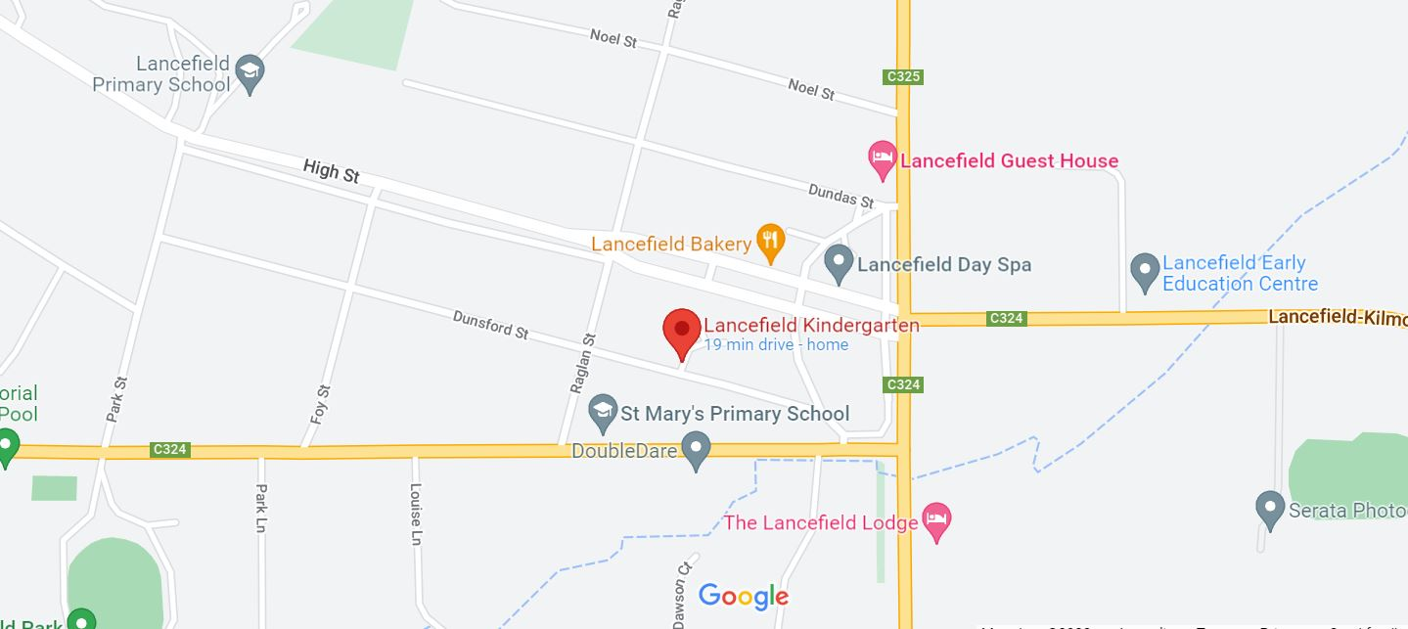**Insert map of area that encompasses area of regular outing:**

**Please list how the team will plan for and address the below child safe standards**

|  |
| --- |
| **Culturally Safe Environments for Aboriginal Children:** *Establish a culturally safe environment in which the diverse and unique identities and Experiences of Aboriginal children are respected and valued*   * Build and maintain a strong service culture that supports inclusion * Provide a welcoming environment for all Aboriginal children, and ensure that any venues we plan to visit do the same * Be aware of and call out practices that are racist and/or discriminatory |
| **Child and Student Empowerment:**  *Children are empowered about their rights, participate in decisions affecting them and are taken seriously*   * Volunteers will be required to have a WWC Card and this will be recorded at the service * Volunteers never to be left alone with children other than their own * Adults at excursion venue (where applicable) will have a WWC Card and this will be sighted and recorded beforehand |



|  |  |  |
| --- | --- | --- |
| **Plan and review** | | |
| Plan prepared by: | Full name: <insert name>  Role/position: Nominated Supervisor | Date: insert date |
| Date sent to Regional Team Leader:  (minimum two (2) weeks prior to excursion) | Insert date use drop down | |
| Prepared in consultation with: | Full name: <insert name>  Role/position: <insert role> | |
| Communicated to all relevant staff: | Yes No  Comment if needed: | |
| Vehicle safety information reviewed and attached: | Yes No  Not applicable  Comment if needed: | |
| Regional Team Leader approved: | Yes No  Comment if needed: List permanent staff | |
| Risk assessment to be evaluated and reviewed on:  The nominated supervisor must ensure a risk assessment is undertaken prior to an excursion being undertaken (and before seeking authorisation for that excursion to be undertaken - see regulation 102). If the excursion is a 'regular outing'*, a risk assessment must be undertaken at least annually. | Date: insert date | |