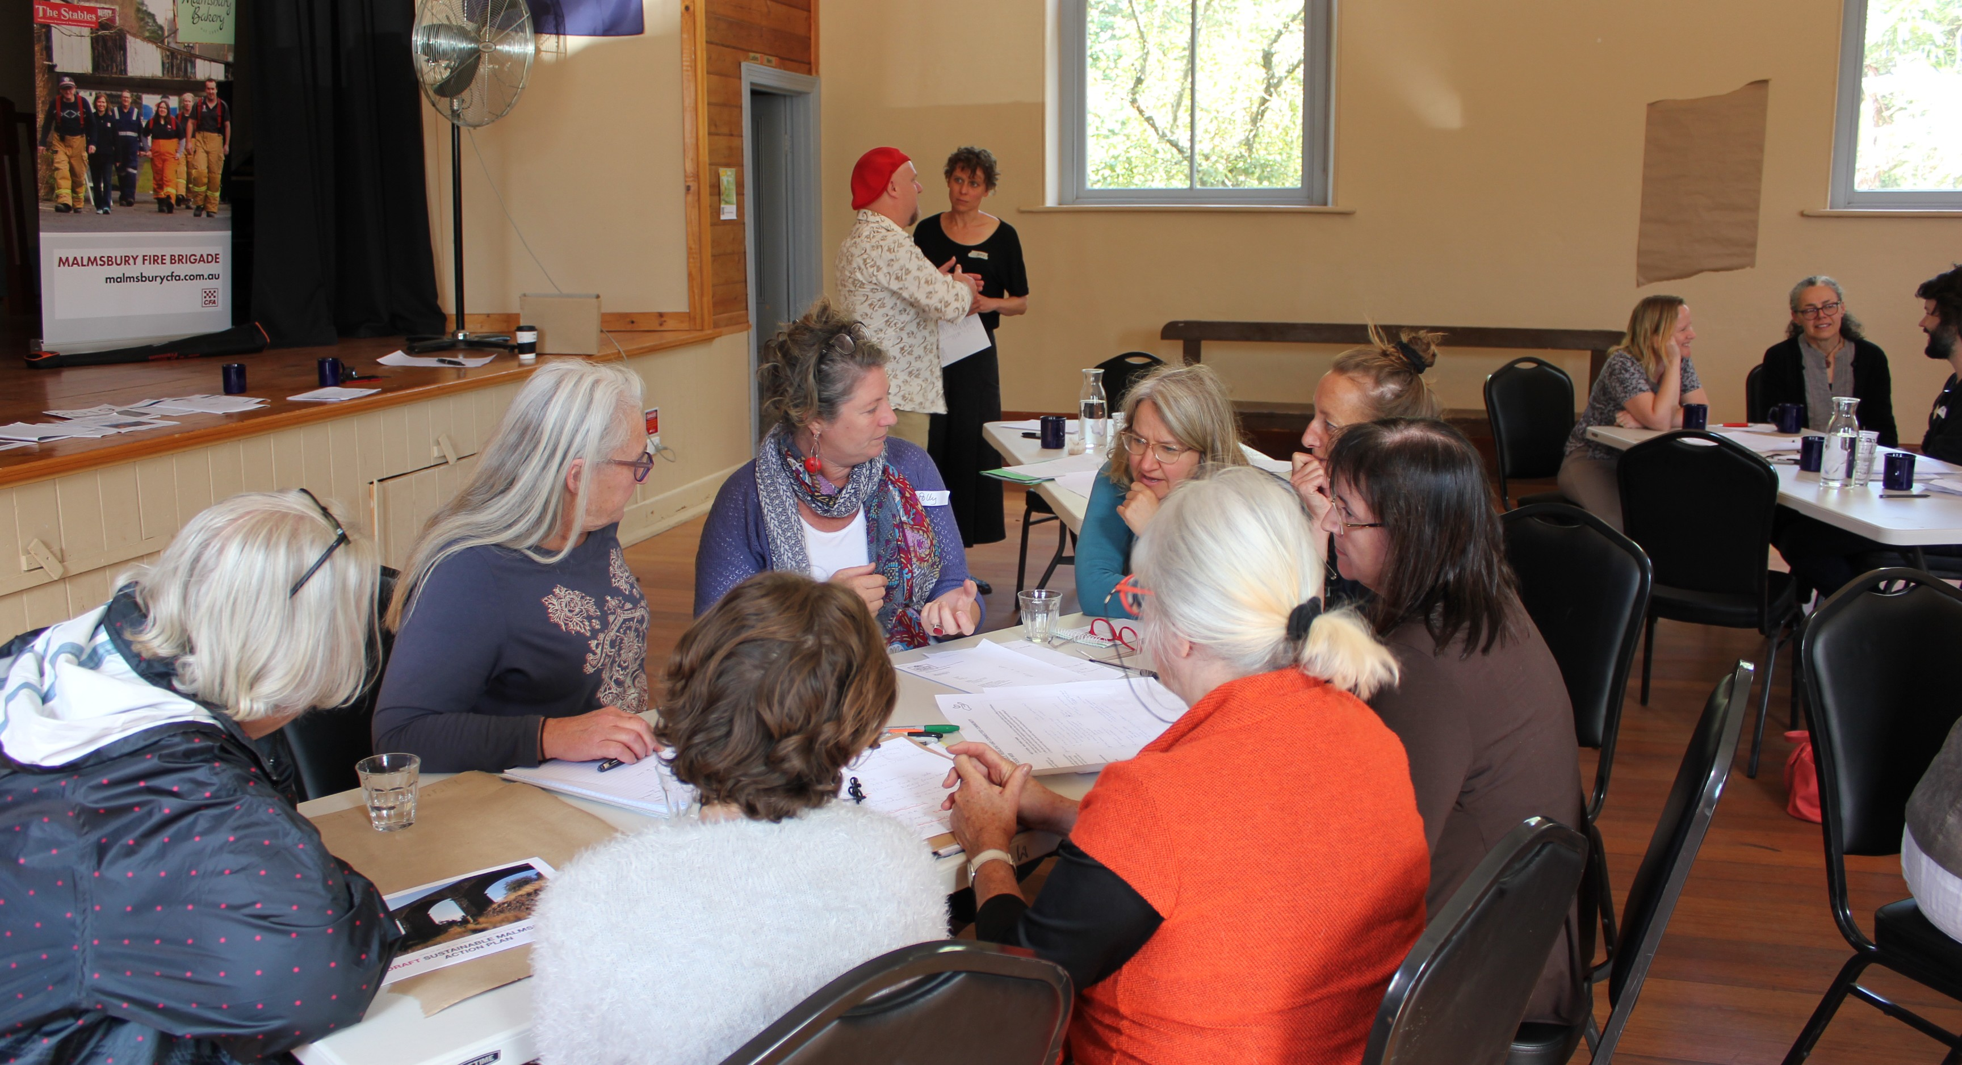

CREATED FOR AND BY THE LOCAL COMMUNITY: EVERYONE IS INVITED TO PARTICIPATE

**SUSTAINABLE MALMSBURY ACTION PLAN**

WORKING TOGETHER 3

GOAL: ZERO NET EMISSIONS 4

PERSONAL ACTIONS 4

COMMUNITY ACTION: ENERGY EFFICIENCY INITIATIVE 5

COMMUNITY ACTION: ZERO NET EMISSIONS: COMMUNITY SOLAR ON LOCAL BUSINESSES 5

GOAL: RESOURCE WISE 6

PERSONAL ACTIONS 6

COMMUNITY ACTION: GREEN WASTE CHIPPING SERVICE 7

COMMUNITY ACTION: SHARING AND REUSE OF HARD RESOURCES 7

GOAL: GROW A SUSTAINABLE, RESILIENT AND CONNECTED COMMUNITY 8

PERSONAL ACTIONS 8

COMMUNITY ACTION: MALMSBURY FOOD WEB 9

GETTING IT DONE! 10

RESOURCING OUR ACTIONS 10

HOW WE CREATED THIS PLAN 11

THANK YOU! 12

APPENDIX: ACTIONS: COMPLETE BRAINSTORM 13

APPENDIX: GOALS: COMPLETE BRAINSTORM 14

APPENDIX: RESOURCES AND READINGS SUGGESTED BY PARTICIPANTS 15

THIS PLAN WAS FUNDED BY MACEDON RANGES SHIRE COUNCIL AND SUPPORTED BY HIP V. HYPE SUSTAINABILITY

# This Plan was created by and for the Malmsbury community.

**Finalised in February 2019, it outlines the sustainability goals of the Malmsbury community along with a set of personal and community actions that can help bring these goals to life.**

**Everyone is invited to participate! Take the personal actions in your home or workplace. Check out the community action sections in the following pages to find out how to get involved or keep an eye out around town and in the Malmsbury Mail for updates.**

**If you’re looking for inspiration for more actions, the appendix includes the entire brainstorm of action ideas that emerged in the workshops.**

This plan was created through a series of workshops (see page 11 for more details). In the first workshop we created agreements of how we will work together:

_ Listening without interruption

_ ‘Stepping up’ and ‘stepping back’

_ Freedom to express

_ Respect and allow vulnerability and emotion

_ Let the process build trust

_ Create space for the ‘introverts’

_ Acknowledge conflict through respectful process

_ Embrace diversity of opinion

_ Use this process to build a positive social network

_ Right to ‘be silent’ and make a contribution in your own way

_ Encourage contributions and connections to other social networks

_ Operate flexibly to allow responsiveness

These agreements really demonstrate the culture and strength of the Malmsbury community. There is willingness to collaborate, listen to different opinions and bring people along. This culture creates

a great foundation from which this Plan can be take from idea into reality.

Everyone in Malmbury should be proud of our community and all we have achieved to date.

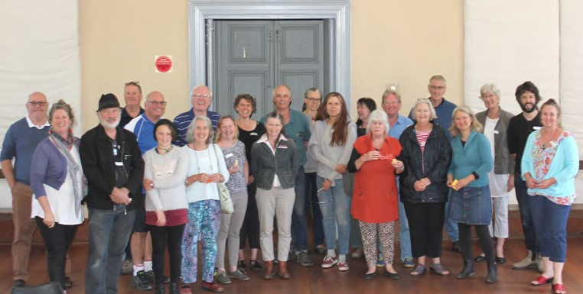

PARTICIPANTS FROM WORKSHOP NUMBER 3, FEBRUARY 2019.

# Malmsbury will make a contribution to climate change

**mitigation. We are joining the global community of business, governments, groups, towns, cities and local councils also working toward zero net emissions.**

**The breadth of this goal means that as actions are completed, we can develop new, relevant actions for an ongoing journey toward zero net emissions.**

**By aiming for ‘Zero Net’ (rather than ‘zero’) we acknowledge that we all create emissions in the natural course of life. However, over time, we have the potential to significantly reduce emissions and counteract any remaining emissions through local carbon sequestration or offset projects.**

**You can help Malmsbury reach zero net emission by taking personal action or participating in a shared community action.**

## PERSONAL ACTIONS

If you’re not sure where to start, here are some suggestions:

_ Wash your clothes in cold water.

_ Minimise the area to be heated or cooled by closing doors to areas of your home you’re not using – ‘zoning’ your home. Set your thermostat between 18°C and 20°C for living areas – every degree higher can increase your bill by up to 10 percent.

_ Switch to [GreenPower](https://www.greenpower.gov.au/) through your electricity retailer.

_ Install a solar system on your home or business. If you need support, [MASH](http://mash.org.au/what-is-mash/) (run by Central Victorian Greenhouse Alliance) runs solar bulk buy programs in the Macedon region.

_ Advanced: Switch your household to all-electric with solar.

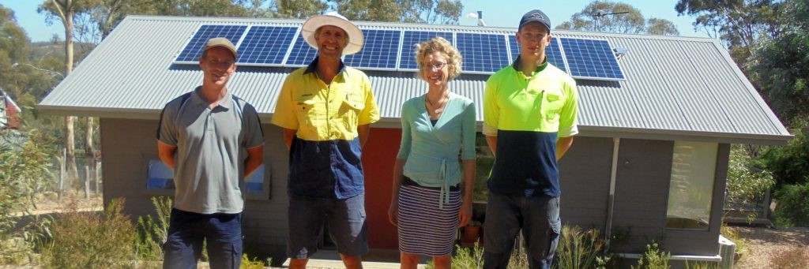

MASH RUN LOCAL SOLAR BULK BUY PROGRAMS TO MAKE IT EASIER TO BUY SOLAR, KNOWING YOU’LL GET THE INFORMATION AND SUPPORT YOU NEED.

**TABLE 5.14** ELECTRICITY BENCHMARKS - VICTORIA CLIMATE ZONE SEVEN AND EIGHT

|  |  |  |
| --- | --- | --- |
| **Autumn** | **Summer** | **Winter Spring** |
| **kWh/ season** | **kWh/ season** | **kWh/ season kWh/ season** |
| **Without underfloor heating** | | |

## COMMUNITY ACTION: ENERGY EFFICIENCY INITIATIVE

A local energy efficiency auditing scheme for local households and businesses.

## Why

This action will help locals reduce energy use while maintaining a

## COMMUNITY ACTION: ZERO NET EMISSIONS: COMMUNITY SOLAR ON LOCAL BUSINESSES

Work with Macedon Ranges Sustainability Group to identify local businesses for a community donation or investment model solar project.

## Why

comfortable home or business and reducing energy bill costs. This

|  |  |  |  |  |
| --- | --- | --- | --- | --- |
| 1 Person Household | 863 | 819 | 1176 | 880 |
| 2 Person Household | 1270 | 1167 | 1637 | 1316 |
| 3 Person Household | 1525 | 1463 | 1974 | 1564 |
| 4 Person Household* | 1525 | 1463 | 1974 | 1564 |
| 5+ Person Household | 2069 | 1811 | 2611 | 2054 |
| **With underfloor heating** | | | | |

action can deliver climate change mitigation while supporting more healthy, affordable living.

Can reduce fossil fuel use in the local area, focusing on high energy users first to maximise the impact.

1 Person Household 1946 1267 3571 2295

|  |  |  |  |  |  |
| --- | --- | --- | --- | --- | --- |
| 2 Person Household | 2353 | 1615 | 4031 | 2732 | **How we’ll do it** |
| 3 Person Household | 2608 | 1911 | 4369 | 2980 | _ Obtain Malmsbury data to see how much energy we are using. |
| 4 Person Household* | 2608 | 1911 | 4369 | 2980 | Malmsbury doesn’t have town gas. Access Powercor suburb |

5+ Person Household 3152 2259 5006 3470

* As illustrated in Table 4.3, the number of four person households in climate zone six for was too small to produce reliable benchmarks. These benchmarks are therefore only distinguished by one, two, three and four, and five or more person households.

*SOURCE: ACIL ALLEN CONSULTING*

**TABLE 6.5** GAS BENCHMARKS – VICTORIA

|  |  |  |
| --- | --- | --- |
| **Autumn Summer** | **Winter** | **Spring** |
| **MJ/ season MJ/ season**  **Without gas heater** | **MJ/ season** | **MJ/ season** |

|  |  |  |  |  |
| --- | --- | --- | --- | --- |
| 1 Person Household | 4890 | 2490 | 8909 | 5662 |
| 2 Person Household | 5406 | 3396 | 11317 | 7283 |
| 3 Person Household | 6104 | 3511 | 12436 | 7779 |
| 4 Person Household | 8229 | 3977 | 16951 | 9865 |
| 5+ Person Household | 9547 | 5277 | 19442 | 11027 |
|  | **With gas heater** |  |  |  |
| 1 Person Household | 7232 | 3188 | 18590 | 10147 |
| 2 Person Household | 12034 | 4564 | 29720 | 16210 |
| 3 Person Household | 12418 | 5225 | 31332 | 17170 |
| 4 Person Household | 14543 | 5691 | 35847 | 19256 |
| 5+ Person Household | 15861 | 6991 | 38338 | 20417 |
| *SOURCE: ACIL ALLEN CONSULTING* |  |  |  |  |

MALMSBURY IS IN CLIMATE ZONE 7. SOURCE: AER.GOV.AU, REPORT TO AUSTRALIAN ENERGY REGULATOR 13 OCTOBER 2017 ENERGY CONSUMPTION BENCHMARKS ELECTRICITY AND GAS FOR RESIDENTIAL CUSTOMERS. ACIL ALLEN CONSULTING

data online. Consider ways to obtain data on transport energy use. Publish this in the Malmsbury Mail along with publicising this energy efficiency initiative.

_ Gauge interest and get sign-ups. Use community connections, Malmsbury Mail and local media channels to attract households and businesses to the project.

_ Draw on existing local experts to train others in the community.

_ Build simple audit methodology linked to specific retrofit actions and changes in behaviour.

_ Consider the use of the Victorian Residential Efficiency Scorecard or develop own checklist (e.g draughts, insulation, lighting, heating/cooling, appliances, hot water, solar PV, transport behaviours)

_ Consider how existing local institutions and community groups could get involved and support recruitment and behaviour change.

_ Provide information on existing schemes and consider the need for a grant to support households to implement actions.

_ Continue to publish Malmsbury energy use in every edition of the Malmsbury mail and a tip for householders and businesses to reduce their energy use.

## Get involved

David Perry and Kathryn Allen are collaborating on this action. If you are interested in supporting the delivery of this action or if you would like to improve efficiency in your house or business, please keep an eye on the Malmsbury Mail for more information.

## How we’ll do it

_ Contact potential project partners (e.g. Macedon Ranges Sustainability Group).

_ Liaise with local solar experts to consider which organisations/ businesses/community infrastructure would benefit from solar.

_ Confirm delivery model.

_ Develop a 1-2 page pitch to give to potential business/ organisations who may be keen to install solar.

_ Individually contact local businesses/organisations to see if they would like to be involved.

_ Use local media (Malmsbury Mail, Midland Express, Kyneton Connect, Facebook, Kyneton Co-op etc) to gain broader community support and invite people to invest.

## Get involved

The following people are collaborating this action: Nea Gyorffy, Manny Pasqualini, Deborah Pach, Lyn McMurdie, David Perry. If you would like to get involved or support this action please email [Deborah Pach, deborahpach@yahoo.co.uk.](mailto:deborahpach@yahoo.co.uk)

If you own a business in the Malmsbury region and are interested in being involved, this group is keen to hear from you.



# We are shifting the conversation from ‘waste’ to ‘resource use’.

**Through avoidance, sharing, reusing, repurposing, and recycling, we can stop putting things into landfill. Instead we will respect that everything has value and embodied energy and can be used rather than wasted.**

**Through this goal we are contributing to climate change mitigation and creating opportunities to build resilience through sharing and reusing locally.**

**You can help Malmsbury to be a community that uses its resources wisely by taking personal action or participating in a shared community action.**

## PERSONAL ACTIONS

If you’re not sure where to start, here are some suggestions:

_ Before you buy something new, ask yourself “Do I really need this or is it something I can borrow or do without?”.

_ Prevent food waste. Plan your meals and only buy the food you need each week. If you’ve got excess, invite someone to dinner!

_ Convert organise waste into resources by composting, worm farming or getting a goat to process organic waste.

_ Before you throw it away, try and give it away. Consider posting your item on social media (e.g. [Sunbury, Macedon Ranges and](https://www.facebook.com/groups/SunburyBSS/?ref=group_header) [Surrounds Buy, Sell, Swap Anything](https://www.facebook.com/groups/SunburyBSS/?ref=group_header) or [Kyneton Buy, Swap and](https://www.facebook.com/groups/123414681051780/?ref=group_header) [Sell](https://www.facebook.com/groups/123414681051780/?ref=group_header)).

_ Advanced: Challenge yourself to buy nothing new for a month.



BUY NOTHING NEW MONTH IS A NATIONAL EVENT HELD IN OCTOBER EACH YEAR (BUYNOTHINGNEW.COM.AU). WHY WAIT? YOU CAN START BUYING NOTHING NEW RIGHT NOW.



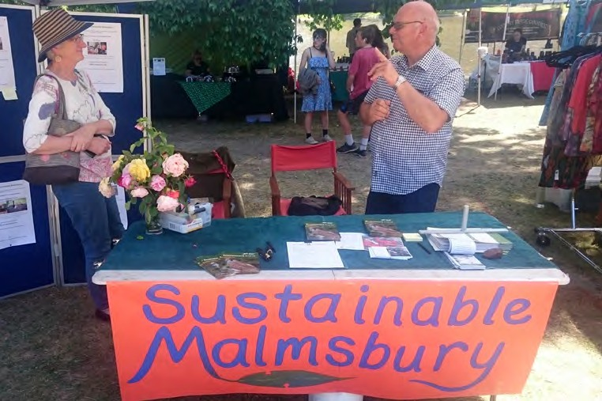WE TALKED TO LOTS OF LOCALS AT THE 2018 MALMSBURY FAYRE.

## COMMUNITY ACTION: GREEN WASTE CHIPPING SERVICE

During peak periods, a mobile chipper would travel around chipping green waste. Chipped waste would be deposited in a central location for the community to collect and use as free mulch.

This action may start with a trial to test the needs of the community and prove the case before it is expanded.

## Why

The Malmsbury community creates a lot of green waste. There is currently no green bin service. However, a green bin service is not necessarily a good fit for the region as the volume of green waste is too large for green bins to satisfy.

This action can stop green waste from being burnt or transported to other areas. Instead, green waste can be chipped and reused locally to reduce emissions and provide a valuable resource back to the community.

## How we’ll do it

There are multiple ways in which the project could be successfully delivered:

_ A pilot with a local chipping contractor.

_ A community chipper, potentially in collaboration with the CFA and serviced by volunteers, provides low cost chipping for locals.

_ A roster where people with trailers collect green waste from others who are unable to transport it.

Consideration will need to be given to avoiding contamination to ensure a high-quality end product.

As this project intersects with Council services (e.g. the amount of green waste going to the tip and waste collection services) continued communication with Council will be important. A business case may be prepared to seek funding from Council to

support the pilot. Future opportunities for biochar may be explored.

## Get involved

The following people are collaborating this action: Peter Lane, Bill Impey, David Gormley-OBrien, Alan Sharpe. If you would like to get involved or support this action please contact Bill on impey10@ bigpond.net.au

## COMMUNITY ACTION: SHARING AND REUSE OF HARD RESOURCES

Encourage Council to expand the Kyneton Tip Shop and then seek opportunities for local swapping of hard resources (e.g. tables, building supplies etc)

## Why

Supports reuse instead of things being sent to recycling and landfill. This reduces emissions and provide opportunities for the community to access low cost, yet valuable resources.

## How we’ll do it

_ Lobby Council to expand the Kyneton Tip Shop

_ Investigate and pilot potential local sharing initiatives such as:

+ Local swap at the flea market.

+ CFA fund raiser where local donate second hand goods for resale.

+ Neighbourly groups or volunteers support those less able to manage their own hard waste (e.g. those without an appropriate vehicle, the elderly etc).

## Get involved

The following people are collaborating to deliver this action: Alan Sharpe, Sue Walter and Peter Lane. If you would like to get involved or support this action please email Alan Sharp, alan.sharp2@ optusnet.com.au.

# Having strong social connections and practiced

**capacity to collaborate is a key factor in helping communities manage shocks and stressors (heat waves, floods, drought etc). Communities that can self-organise are better able to respond and support each other in times of crises.**

**Connected communities also have a huge positive impact on the health and wellbeing of individuals within that community.**

**You can start building Malmsbury’s resilience today by taking personal action or participating in a shared community action.**

## PERSONAL ACTIONS

If you’re not sure where to start, here are some suggestions:

_ If you don’t already know them, visit your immediate and surrounding neighbours and introduce yourself.

_ Ask and offer often. If you could do with a hand, ask for it. People are generally happy to help, and you’ll pass it forward in other ways. If you’re more comfortable with a structured exchange [The](https://www.casseroleclub.com/) [Casserole Club](https://www.casseroleclub.com/) matches cooks with people in need of a meal and company in the Macedon region.

_ Give away or swap excess food production. Deliver to your friends and neighbours, offer produce through social media or pop it on the verge with an invitation for people to help themselves.

_ Join a local group. There are many to choose from, for example [Landcare](http://www.mrsc.vic.gov.au/Live-Work/Environment/Environment-Groups-Events/Landcare-Friends-and-Sustainability-Groups#section-1), [Macedon Ranges Sustainability Group](https://mrsg.org.au/), [Kyneton](https://kynetontransitionhub.com/) [Transition Hub](https://kynetontransitionhub.com/), [Malmsbury CFA](http://www.malmsburycfa.com.au/).

_ Advanced: Plan a working bee or social event to nurture a culture of connection and sharing with your neighbours.

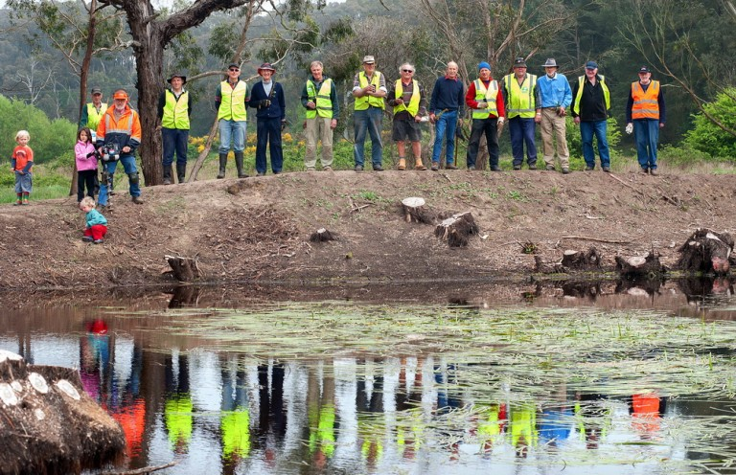

LANDCARE HAS CREATED SOME GREAT LOCAL CONNECTIONS AND LAND REGENERATION. THIS ACTION AIMS TO FIND ADDITIONAL WAYS FOR LOCALS TO CONNECT, LEARN, LEND A HAND, IMPROVE LOCAL RESILIENCE, SHARE AND GROW FOOD. IMAGE THANKS TO UPPERCAMPASPELANDCARE.ORG.AU

## COMMUNITY ACTION: MALMSBURY FOOD WEB

Through things like working bees, talks, garden visits, food/seeds/ plant swaps, progressive dinners we can increase local knowledge and connections.

## Why

Throughout the development of this Plan, food kept coming up as a key issue for local residents. Everyone is involved in the food system (producer, consumer, gardener, home cook, service or

hospitality industry, etc). This creates an opportunity to connect and share around a common interest.

This project can create many different pathways for involvement, ensuring everyone in the community can get involved in a way that works for them.

By increasing our ability to produce food locally we can improve our resilience and reduce carbon emissions from food transport.

## How we’ll do it

_ Consult with existing groups/organisations already working on food related projects or who might like to collaborate. Build on the work that’s already being done.

_ Co-ordinate the network, including the set-up of a [Next Door ap](https://au.nextdoor.com/)p that facilitates people in the same neighbourhood to communicate easily with each other.

_ Promote the network through existing groups and local media.

## Get involved

The following people are collaborating on this action: Sue Love, Sue Everett, Polly, Deborah. If you would like to get involved or support [this action please email Sue Love, fourleaf@netspace.net.au.](mailto:fourleaf@netspace.net.au)

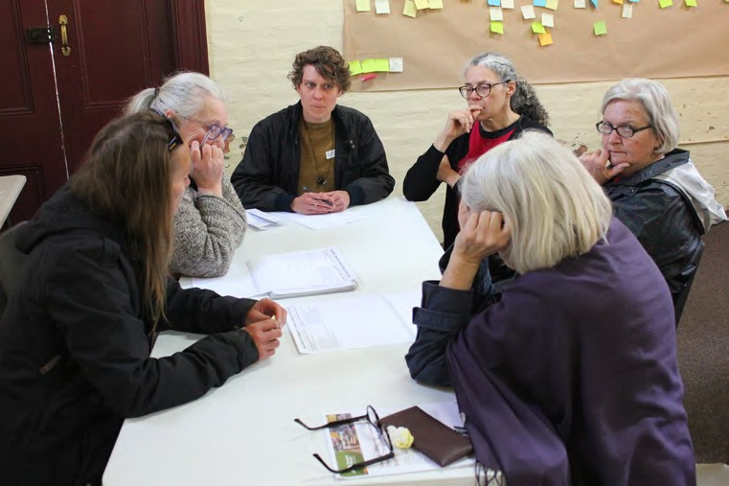

PARTICIPATIONS FROM OUR FIRST WORKSHOP IN OCTOBER 2018.

# The desire to keep the administration of this Plan light

**came out strongly during the community workshops. As such, there we be no centralised community coordination of the overall plan. Instead, those people interested in each action will work collaboratively to progress that particular action.**

**It was acknowledged that there are existing community networks that could be used to share information, including the Malmsbury Mail and the quarterly community meeting.**

## RESOURCING OUR ACTIONS

Given the desire to keep administration light, first consider whether a grant is required or whether there is enough collaboration and skills-share to enable to provide to proceed without external funding.

Applying for grants can provide much needed resources, but remember it also requires time is put into applying, managing and reporting on the project. If you decide external funding is required, you might like to consider the sources below:

**Macedon Ranges Shire Council:** provides a range of grants each year. [Visit their grants page](http://www.mrsc.vic.gov.au/About-Council/Find-A-Grant) to find the right grant for your project.

**Victorian Government:** Available grants change regularly. Stronger Regional Communities grants are currently open and may be relevant for some projects. [Visit the Grants Victoria website](https://www.vic.gov.au/grants.html) to search for more grant opportunities.

**Federal Government:** Available grants change regularly. [Visit the](https://www.grants.gov.au/?event=public.home) [Grants Connect website](https://www.grants.gov.au/?event=public.home) to search the current and future grants.

**Philanthropy:** The [Australian Environmental Grantmakers Network](https://aegn.org.au/for-grantseekers-old/funder-listing/) lists a range of philanthropic organisations that supply project funding.

Financial institutions: [Bendigo Bank](https://www.bendigobank.com.au/community/community-funding) and [Bank Australia](https://bankaust.com.au/about-us/news/people/2018-customer-grants/) both offer community grants.

## MACEDON RANGES SHIRE COUNCIL

Council funded the development of this Plan. Council’s project manager, Silvana Predebon, can be contact for implementation [advice. Please email SPredebon@mrsc.vic.gov.au.](mailto:SPredebon@mrsc.vic.gov.au)

Council will host a check in meeting during 2019. The meeting will be an opportunity for the community to reflect on implementation progress, and help Council understand how the planning process could be adapted to spark climate change action in other regions.

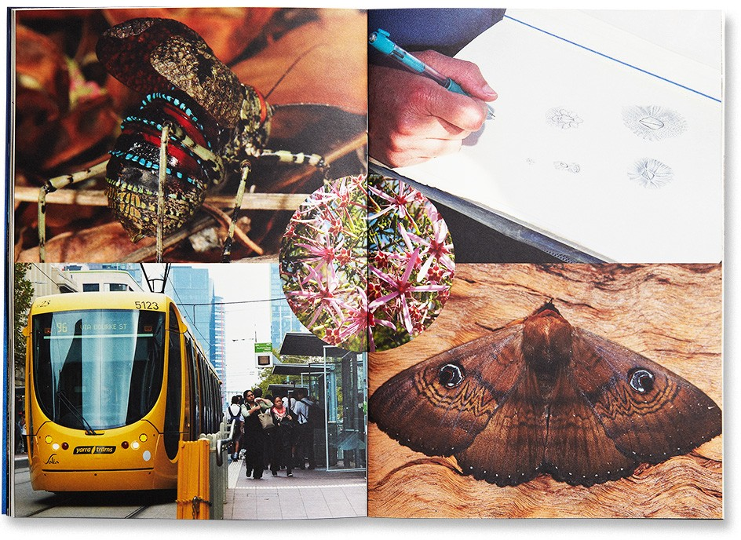THE AUSTRALIAN ENVIRONMENTAL GRANTMAKERS NETWORK (AEGN) ENCOURAGES PHILANTHROPISTS TO CONTRIBUTE TO A POSITIVE ENVIRONMENTAL LEGACY FOR FUTURE GENERATIONS. THEY HAVE A GOOD LIST OF PHILANTHROTIC ORGANISATIONS THAT COULD SUPPORT YOUR PROJECT. IMAGE: AEGN’S GANTMAKERS HANDBOOK, PHOTO COURTESY OF GOZER.COM.AU

# This Action Plan was created over spring/summer of 2018/19 through a series of community events and workshops attended by local residents.

## Info session (14 October 2018):

We came together to discuss the project, seek initial feedback and let people know about the proposed process.

## Workshop 1 (28 October 2018):

We created principles for working together, created a community skills list, considered Malmsbury’s strengths and weaknesses in relation to climate change and brainstormed potential actions.

## Workshop 2 (11 November 2018):

We defined what the structure and governance for the Plan, discussed and selected headline community goals, created a criteria for ranking potential actions, selected draft goals and actions to test with the broader community.

## Workshop 3 (10 February 2019):

We formed action groups and scoped each action that you see in this plan. From here, group will get together to move from planning into delivery. It’s not too late to get involved - most actions have a contact email listed and you can simply get in touch with them.

The workshops were funded by Macedon Ranges Shire Council as a prototype for how to empower communities to organise a local climate response. The insights from this process will support Council to deliver services to other communities. HIP V. HYPE Sustainability facilitated the workshops and provided advice.

The hardest work was done by the workshop participants who thought deeply about what’s needed in Malmsbury and how it could be done.

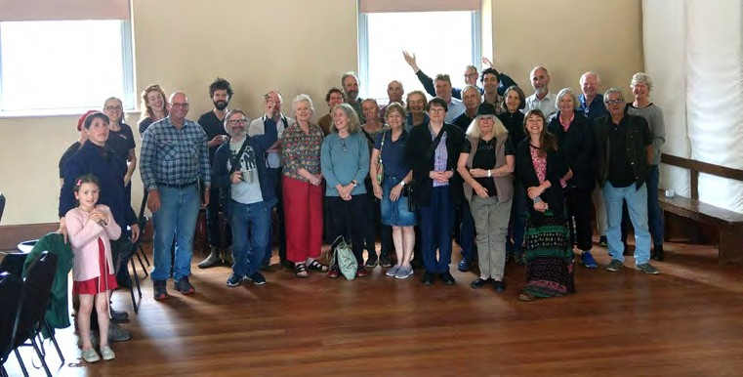

WE HELD A COMMUNITY INFO SESSION ON THE 14 OCTOBER 2018.

# This Plan was created through the interest, ideas, and generous contributions of the Malmsbury community, including participants from the info session, workshop and Fayre listed on this page.

Alan Sharp Alicia Illingworth Andy Rigby Anne Savvinos

Anthony Stephens Bernice Snowden Bill Impey

Carol Westrup Chris Bromley Chris O’Higgins

David Gormley- O’Brien

David Perry Dean Farago Deb Cox

Deborah Hambleton Deborah Pach Diana Brady

Ed Neve Elise Zoluck

Fiona Halloran Gabriel Martin George Lianos Graham McNicol

Grazyna Van Egmond

Heather Venn

Helen Anderson Helen Chilianis Hugh Kelly Jack Forrest

Jane jervis-Read John Chilianis Julia Impey

Julie Goldsworthy Karl Fitzgerald Kathryn Allen

Lee Ferguson Len McDonnell Lyn McMurdie Madeleine Zarb Manny Pasqualini Marg Gray

Michael Stambrey Mike Aston Mirella Gavidia Moya Aston

Nea Gyorffy Nicole McBain Pam Cornthwaite Patrick Walsh Peter Lane

Phil Melgaard

Phil Treacey Polly Christie Ray Brindle Rayna Fitzgerald Robert Newton Ross Wilkinson

Ruby Ferguson- Gamble

Siobhan O’Shaugnessy

Stephen West Sue Everett Sue Love Susan Walter Sylvie

Taash McIntyre Tony Fryer

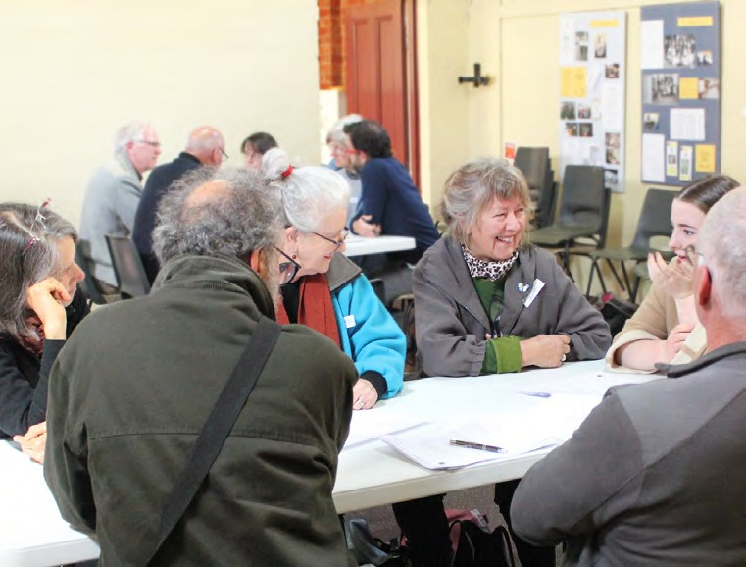

PARTICIPANTS FROM OUR FIRST WORKSHOP IN OCTOBER 2018.

## ACTIONS: COMPLETE BRAINSTORM

Below is the full list of actions and ideas that were derived throughout the process of creating this Plan. Once the current actions have been completed, we can look to these and to new ideas, for the next things we want to achieve. In the meantime, if you want to bring one of these actions to life, go for it!

## Sustainable building

_ Develop a multi-dwelling sustainable building project to attract people to the area (e.g. Castlemaine example) “Good system of living”

_ Move toward 100% renewable with all electric appliances. Electrify heaters and cooking. Displace gas (inc. bottled) and wood stoves.

## Transport

_ Try to increase train frequency

_ Improve paths for walking

_ Improve railway station – better community use

_ Commuting EV fleet for local trip. Electric recharging stations

## Education

_ Integrate sustainability into learning activities (Malmsbury Primary School)

## Reducing food waste

_ Make biochar (Biochar is commonly made from waste material ranging from peanut shells to rice straw to wood scraps. During the slow baking of biomass in the near or total absence of oxygen, gas and oil separate from carbon-rich solids. The output is twofold: fuels that can be used for energy and biochar that can be used to enrich soil).

## Waste and resources

_ More info/input in supermarket policies re good packages (refer to War on Waste TV program). Liaison between Malmsbury and Woolworth to better lower their carbon footprint

_ Community recycling hub

_ Advocacy for reduction in waste/plastic usage – use of media

_ Community goats to reduce green waste (existing project in 1 area of Malmsbury)

_ Recycling education and community-based waste and recycling

_ Implement green waste bins and annual hard rubbish collection

_ Improve materiality of takeaway containers use by shops in town so they are easily recyclable (Trashless Takeaway)

_ Program to reduce recycling contamination

_ Recycling strategy for the town

## Agriculture, food and ecology

_ Getting farmers engaged and onside

_ Network for accessing local food. Food swap, help for low income families, e.g. Glen Lyon market use local suppliers – once a month help create community contacts

_ Better planning to replace willows and weeds immediately with native planning on rivers so weeds don’t grow back and so the net result is not demanding of the landscape and heating of the water, killing local fish.

_ Vegetation planning that considers carbon, fire, flood, food, beauty

_ Community garden

_ Cooperative group to help manage surplus food through distribution, making preserves etc

_ Community info on roundup and similar garden products that are detrimental to the environment

_ Encouraging a plant rich diet. E.g meat free Mondays

_ Encourage silvopasture (the intentional combination of trees, forage plants and livestock together as an integrated,

intensively-managed system. Silvopasture can provide profitable opportunities for softwood or hardwood timber growers, forest landowners, and livestock producers)

_ Practice regenerative agriculture (no tillage), diverse cover crops, in-farm fertility (no external nutrients), no pesticides or synthetic fertilizers, and multiple crop rotations. Together, these practices increase carbon-rich soil organic matter and conservation agriculture

_ Practice afforestation (creating new forests where there were none before). Work on this is already happening e.g. tree planting and grassland on the Common and in the cemetery

_ Increase the number of properties running on permaculture principles

_ Seek opportunities to strength the local sale and swap of local produce

_ Set up local systems for carbon sequestration in the landscape (see [Darren Doherty’s work in Bendigo](https://vimeo.com/154090332))

## GOALS: COMPLETE BRAINSTORM

**Energy**

_ Tour communities elsewhere that have renewable energy projects

_ Partner with Youth Justice Centre to get solar on their (new) building (it’s likely that they are the largest single energy user in town)

_ Develop an assistance program to help people cope with increasingly high energy costs

_ Helping people reduce energy use at home with personal heating options (heat blankets and cushions as alternative to heating whole rooms)

_ Retrofitting homes to assist with heat loss (e.g. pelmets, correct window coverings, insulation)

_ Malmsbury microgrid – solar, peer-to-peer, enable islanding during storm / fire outages

_ Use bicycles in the gym to generate power

_ Community wind farm on Post Office Road (there was some agreement and disagreement noted on this comment)

_ Community solar schemes – shared purpose, group PV generation etc with individual and community batteries

_ Solar farm

_ Macedon Ranges Community Energy Park – existing Macedon Ranges Sustainability Group project that aims to generate enough clean electricity to match the local consumption of the entire Macedon Ranges.

_ Solar schools project - existing Macedon Ranges Sustainability Group project

_ Funding Renewables in the Macedon Ranges - existing Macedon Ranges Sustainability Group project that sets up a revolving fund through low interest, fixed term loans

_ MASH (More Australian Solar Homes) an existing non-for-profit solar panel bulk buy and installation program by Central Victorian Greenhouse Alliance

## Resilience and community building

_ Community bartering program or co-op for skills and services

_ Encourage local industries to engage with and employ local community members

_ Develop an active community hub

_ Expand the role of the existing fireguard groups toward a focus on community resilience

_ Create eco teams who learn to do sustainable things together

_ Create a [Good Karma Network](http://www.goodkarmaeffect.com/networks/) social network for the region using Facebook or another social media platform

_ Start a local [Casserole Club](https://www.casseroleclub.com.au/) using the existing free online program

## Other

_ Ban petrol leaf blowers for council cleaning

Below is the full list of goals that were derived throughout the process of creating this Plan.

_ Zero Net Emissions

_ 80% rooftops with solar PV (including heritage)

_ Reduce travel-related carbon emissions by 5% per annum

_ Dwellings are future-proofed to deal with severe climate change (water, fire, food, power…)

_ Every household is doing something by 2025

_ Sustainable growth

_ Reduce burning of greenwaste by 100%

_ Wise resource use

_ Reduce contamination of recycling stream by 100%

_ Reduce waste by 80% in 5 years

_ A plastic free town

## RESOURCES AND READINGS SUGGESTED BY PARTICIPANTS

**Books**

Drawdown edited by Paul Hawken

The Natural Step for Communities by Sarah James and Torbjorn Lahti

Fostering Sustainable Behaviour, Doug McKenzie-Mohr

Changeology, how to enable groups, communities and societies to do thing they’ve never done before, Les Robinson

Inside the Nudge Unit, David Halpern

## Websites

Transition Network: [transitionnetwork.org](http://transitionnetwork.org/)

Beyond Zero Net Emissions: [bze.org.au](http://bze.org.au/)

Macedon Ranges Sustainability Group: [mrsg.org.au](http://mrsg.org.au/)

Renew: [renew.org.au](http://renew.org.au/)

Moreland Energy Foundation: [mefl.com.au](http://mefl.com.au/)

MASH Community Solar Bulk-Buy: [mash.org.au](http://mash.org.au/)

Totally Renewable Yackandah: [totallyrenewableyack.org.au](http://totallyrenewableyack.org.au/)

Adapting to Climate Change Impacts: climatechange.vic.gov.au/ adapting-to-climate-change-impacts

Love food hate waste: [lovefoodhatewaste.vic.gov.au/](https://www.lovefoodhatewaste.vic.gov.au/)

## Regeneration

Local resident Dean Farago is passionate about Regeration as an approach and has supplied the following information for those interested in exploring the concept.

Regrarian describes those who are actively undertaking the serious and timely process of regenerating, restoring, rehabilitating, rekindling and rebooting production landscapes, be they urban or rural, across the world.

Suggested resources:

_ Dr Samual Alexander interview with Nicole Foss:

[simplicitycollective.com/my-interview-with-nicole-foss](http://simplicitycollective.com/my-interview-with-nicole-foss)

_ [regrarians.org](http://regrarians.org/)