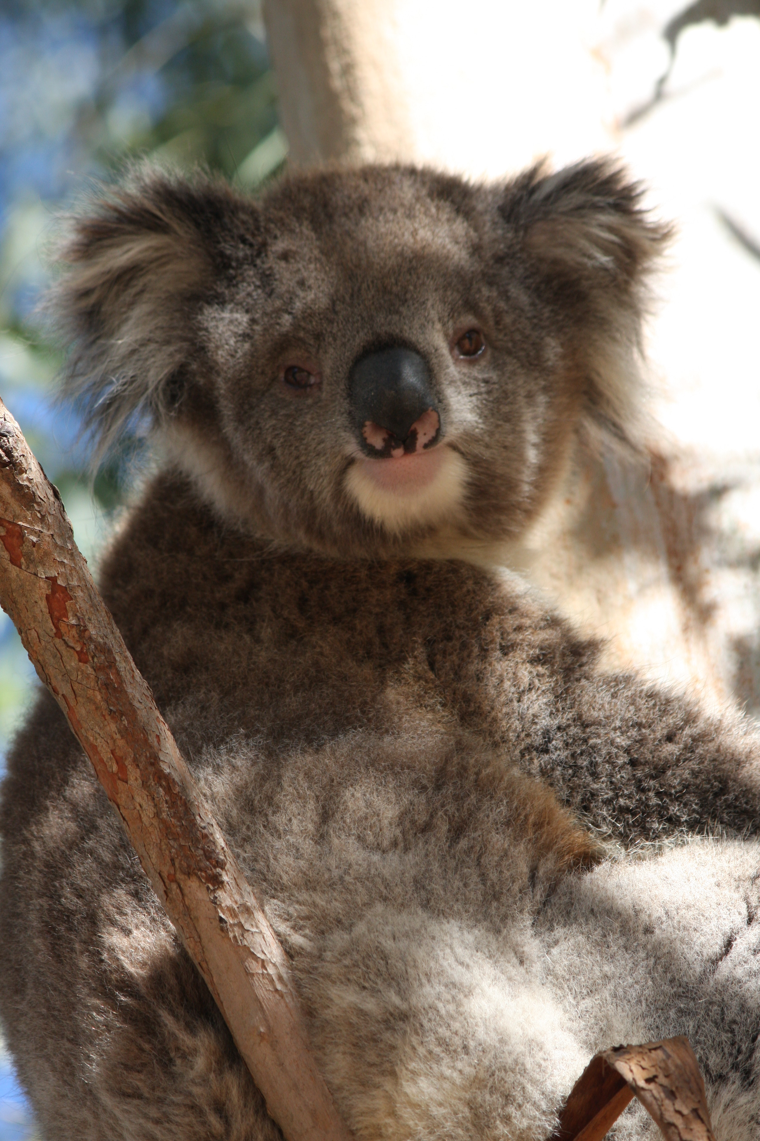

Australia Day Grants

Guidelines 2024

# 

Contents

Overview 4

Program objectives 4

How much is available? 4

Key dates/timelines 5

Eligibility 5

Who can apply? 5

Who will not be funded? 5

What will be funded? 6

Event conditions 6

What will not be funded? 6

Legal requirements 7

Incorporation status 7

Child Safe Standards 7

Public liability insurance 8

Groups without public liability insurance 8

How to apply 8

Assessment 8

What we are looking for 8

Table 1: Assessment criteria 9

Budget 9

Permits, insurance and authorisations 10

Notification of outcome 10

Funding agreements and payment 10

Event registration 10

Grant acquittal 11

Incomplete activities/events and unspent funds 11

Contact information 11

## Overview

The Australia Day Grants program provides grant funding to support community groups to mark 26 January through events/acknowledgement ceremonies in a way that is respectful of all community members. These events can be hosted on any day one week before or after 26 January 2024.

Council recognises that Australia Day/January 26 is not a day of celebration for all, especially for First Nations Australians. Any activities funded through this program should align to Council’s vision:

*“With our unique regional identity, Macedon Ranges Shire embodies a caring, resilient approach to community through our robust local economy, protection of the natural environment and a collaborative commitment to inclusivity for all.”*

### Program objectives

The intention of the Australia Day Grants program is to support local groups to organise an event/acknowledgment ceremony that achieves some or all of the following objectives:

* Recognise and acknowledge days of significance to the local community
* Encourage community participation and contribute to health and wellbeing
* Deliver an event that is welcoming, accessible and inclusive
* Deliver a successful, safe and compliant event with consideration to environment impacts and sustainability
* Showcase community identity by engaging local talent or including artistic and/or cultural education
* Build new social connections and partnerships within the community or reinforce those that already exist
* Build understanding and respect for diversity and/or enable community members to learn about a local issue or need
* Support reconciliation and/or celebration of Aboriginal and Torres Strait Islander peoples.

### How much is available?

The Australia Day Grants budget for 2024 is $5,000 and provides grants of up to $1,000 per group/event. Each group may only receive funding for one application per year.

### Key dates/timelines

**Applications open:** Monday 2 October 2023, 9am

**Applications close:** Monday 30 October 2023, 5pm

**Applications assessed by panel:** 1 November 2023

**Recommendations to Executive:** 20 November 2023

**Outcomes announced:** 21 November 2023

**Funding agreements and payment:** 21 November 2023

**Event takes place:** 19 January – 2 February 2024

**Grants Acquitted:** 15 March - 29 March 2024

## Eligibility

### Who can apply?

Incorporated, community-based not-for-profit groups operating or being established in the Macedon Ranges can submit one application per year. Government schools and churches can apply if they can demonstrate a need and a broad community benefit beyond the school community or congregation respectively.

### Who will not be funded?

The following individuals are ineligible to apply to the Australia Day Grants program.

* Individuals
* Political organisations
* For profit/commercial organisations
* Groups that are in debt to Council
* Groups that have not completed their reporting requirements of previous Council grants
* Groups that do not have the appropriate insurance to deliver the event
* Groups that have not demonstrated compliance with Child Safe Standards.

### What will be funded?

Assistance with the costs associated with planning and delivering an event/acknowledgment ceremony. This may include:

* Venue costs
* Staging/equipment costs
* Marketing/promotional costs
* Catering costs
* Performer/artist fees
* Welcome to Country/Cultural education fees.

### Event conditions

* Priority will be given to events attracting a large number of participants.
* The event must be free and open to all members of the public.
* The event must be held within the shire.
* Macedon Ranges Shire Council must be acknowledged as a sponsor.
* The event must be held between 19 January and 2 February 2024.

### What will not be funded?

The following list provides advice on what will not be funded through the program:

* Events that are not submitted by the application closure date
* Applications that are incomplete or fail to meet criteria
* Events that are not held between 19 January – 2 February 2024
* Events held outside the Macedon Ranges Shire
* Events that have already commenced, have been completed, or have received funding from another Council funding scheme for the same event/acknowledgment ceremony
* Are commercial, religious, political, discriminatory, sexist, racist or disrespectful
* Groups that receive direct income from electronic gambling machines/promote or involve gambling-related activities
* Events that do not support responsible serving of alcohol
* Fundraising activities
* Private events that are not broadly accessible to the community
* Events on private land that have not determined potential restrictions and permit requirements with Council’s statutory requirements
* Do not have broad support amongst the community.

## Legal requirements

### Incorporation status

Applicants must be registered as an incorporated body to apply for grant funds.

Where an application is made by a group that is not an Incorporated Association, the applicants will need to nominate another incorporated association which is willing to manage the grant funds (auspice the grant) on their behalf. A letter will be required from your auspice organisation confirming their willingness to accept the auspice role. For more information on auspice arrangements visit the [Not-for-profit Law Information Hub.](https://www.nfplaw.org.au/free-resources/working-with-others/what-is-auspicing)

Please note: Council does not auspice applicants.

### Child Safe Standards

Macedon Ranges Shire Council is committed to a zero tolerance approach to child abuse, through actively promoting child safety and ensuring compliance with the Victorian Child Safe Standards. Victorian organisations that provide services to children are required, under the Child Safety and Wellbeing Act 2005, to ensure that they implement compulsory child safe standards to protect children from harm.

As a Child Safe organisation, Council requires that all grant applicants demonstrate their compliance with the Victorian Child Safe Standards and read/understand Council’s [Child Safety and Wellbeing Policy and Code of Conduct](https://www.mrsc.vic.gov.au/About-Council/Our-Council/Policies/Child-Safety-and-Wellbeing-Policy-Code-of-Conduct). Within the application form, applicants will be required to identify whether their event involves direct or incidental contact with children and young people, and complete either a Child Safe Statement of Commitment or submit their Child Safe Policy and Child Safe Direct Contact Checklist. These questions are contained within the eligibility section of the application form and must be completed by all applicants.

Please note: If your organisation is being auspiced for the purpose of this grant, the auspicing organisation will also need to meet the Child Safe Standards.

More details on the Child Safe Standards can be found on the [Commission for Children and Young People website](https://ccyp.vic.gov.au/child-safe-standards/the-11-child-safe-standards/).

### Public liability insurance

Public liability insurance covers incidents that occur during an activity being conducted by a group. All groups must be covered by public liability insurance and be able to provide a valid certificate of currency if they are involved in any events or activities in public open space, using Council facilities or sporting grounds. Other activities may also require public liability insurance.

It is the responsibility of the applicant or recipient to arrange appropriate insurance. Applicants are encouraged to discuss their insurance requirements with their insurance company or a professional advisor.

### Groups without public liability insurance

Groups who do not currently hold public liability insurance can contact [localcommunityinsurance.com.au](http://www.localcommunityinsurance.com.au) which offers an affordable public liability scheme for not-for-profit community groups. Alternatively, groups could seek an auspice with public liability insurance for the purpose of this grant.

## How to apply

Applicants are advised to read the guidelines thoroughly before submitting their application. All applications must be submitted online, via Council’s online grants management system, SmartyGrants. All applicants will receive an email acknowledgement via SmartyGrants once their application has been successfully submitted.

### Assessment

Eligible applications are assessed by a panel of staff across the organisation, based on responses provided in the application form. Eligibility does not guarantee funding. All applications are scored based on the weighted assessment criteria in Table 1 (below). An application that scores 50 out of 100 and below will not be recommended for funding and will not be forwarded to Council or Council’s delegate for approval.

Council reserves the right to exercise judgement on the appropriateness of funding eligibility criteria in respect to contentious, topical or contemporary issues where the event may be perceived to be in conflict with Council’s objectives, plans or the wider wellbeing of its residents.

### What we are looking for

The table below outlines the scoring for each criteria. Referring to this and the details contained in the scoring matrix at the end of these guidelines will help you to develop a strong application.

#### Table 1: Assessment criteria

|  |  |  |
| --- | --- | --- |
| Weighting | Criteria | What we are looking for |
| 30% | Community engagement/benefit | * Number of people participating * Number of people benefiting from the event * Impact of the community benefit (anticipated community outcomes) * Community/stakeholder participation and/or involvement * Supports local sourcing of goods and services where applicable |
| 30% | Alignment to Council priorities | * Consideration and planning to minimise environmental impact and promote sustainability * Demonstrate measures to make event safe, welcoming, accessible and inclusive e.g. consideration of gender equity and accessibility for diverse community groups |
| 40% | Ability to deliver the event | * Demonstrate sound budget * Demonstrate clear event plan * Demonstrate risk management plan * Includes site plan * Appropriate permits, permissions and insurances in place * Demonstrate sound marketing/promotion plan |

#### Budget

The budget needs to include all expenditure related to the event/acknowledgment ceremony for which you are requesting funding.

*Please note: if expenditure exceeds the grant, the difference will be covered by the applicant.*

See a sample budget below:

**Expenditure**

|  |  |
| --- | --- |
| Venue hire | $100 (in kind) |
| Guest Speaker/musician | $200 |
| Welcome to Country and Smoking Ceremony | $1,000 |
| Marketing and Promotion | $100 (in kind) |
| Printing | $100 |
| Catering | $200 |
| Total expenditure (please calculate) | $1,700 |

For groups who are registered for GST, GST will be added to the amount requested (as such, your budget should be exclusive of GST). Grants to recipients not registered for GST will be made exclusive of GST. For information about GST and ABNs contact the Australian Taxation Office.

#### Permits, insurance and authorisations

The applicant is responsible for any regulatory and statutory requirements associated with the event, such as permits, permissions and public liability insurance.

### Notification of outcome

All applicants will be notified of the outcome of their application in writing on 21 November 2023.

#### Funding agreements and payment

Successful applicants will be sent a funding agreement and recipient created tax invoice form to complete. All applicants are required to complete these forms and to sign and abide by the terms and conditions of a funding agreement. The event/acknowledgment ceremony must be completed by the date set in the funding agreement. Funds must be spent on the activities/events described in the application budget and event plan.

#### Conditions

In some cases, conditions such as additional approvals/permits maybe required to carry out the proposed event. Applicants should discuss their event with the responsible body e.g. Council or a Victorian Government department, prior to submitting their application. Your offer of funding may be made conditional to you obtaining further regulatory approvals.

#### Event registration

Once notified, successful applicants will need to submit an [event notification form](https://www.mrsc.vic.gov.au/See-Do/Events/Register-Your-Event). Once approved these events will be listed on Council’s website.

#### Grant acquittal

Successful applicants are required to submit a report (acquittal) on grant monies spent upon completion of their event/acknowledgment ceremony by the date set out in the funding agreement. This process is important as it enables Council to continuously evaluate and improve on this grant program. It also provides applicants an opportunity to reflect on the successes and learnings gained from their event.

Groups who do not submit an acquittal will not be eligible to apply for further funding from Council until the event has been acquitted.

#### Incomplete activities/events and unspent funds

If an event can no longer be completed, please contact Council. Any unspent funds are to be returned to Council.

## Contact information

For further information or to discuss your event ideas please visit Council’s [website](https://www.mrsc.vic.gov.au/About-Council/News/News/2023-Australia-Day-awards-and-celebration-grants-now-open) or contact the Community Development team on:

**Ph:** (03) 5422 0333 **Email:** [grants@mrsc.vic.gov.au](mailto:grants@mrsc.vic.gov.au)