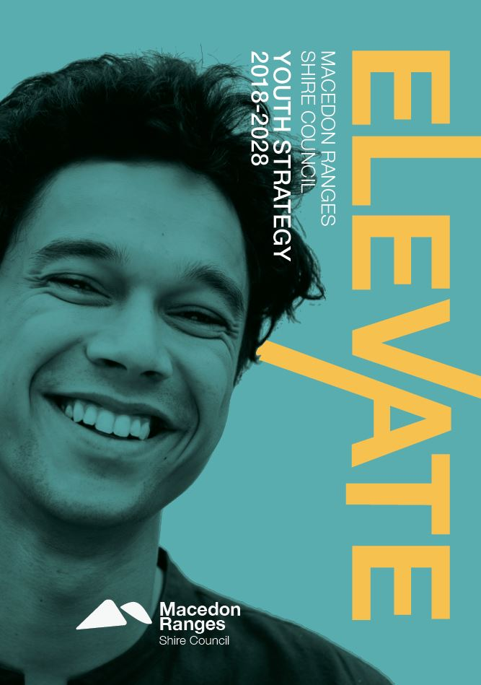

Acknowledgement

We acknowledge that Macedon Ranges Shire is located on Dja Dja Wurrung, Taungurung and Wurundjeri Country whose ancestors and their descendants are the traditional owners of this Country.

We acknowledge that they have been custodians for many centuries and continue to perform age old ceremonies of celebration, initiation and renewal.

We acknowledge their living culture and their unique role in the life of this region.

Contents

Acknowledgement 2
“Not your usual Council strategy,” an introduction from our young Co-designers 4
“A fantastic opportunity,” Co-designers on being Co-designers 5
The Story of Elevate 6
Elevate, what we did 7
Elevate, why we did it 7
Young people & the State Government 11
Young people & the Federal Government 12
Elevate, how we did it 12
Elevate, what we found 16
Elevate, what we found cont’d… 20
Elevate, action 30
Priority Area 1: Young people feel healthy and well 34
Priority Area 2: Young people feel safe 39
Priority Area 3: Young people feel connected to each other, and those around them 42
Priority Area 5: Young people feel embraced and heard 51
Priority Area 6: Young people feel supported 55
Priority Area 7: Young people feel inspired 59
Priority Area 8: Young people feel informed 62
How we will implement Elevate 65
How we will evaluate Elevate 65
Appendix A. Survey results 68
Appendix B. Qualitative interviews 74
Appendix C. Qualitative findings 75
Appendix D. MRSC Youth Development work 2016/17 79
Appendix E - Young people & local services 82
Appendix F. Youth summits 83

“Not your usual Council strategy,” an introduction from our young
Co-designers

Elevate – the Macedon Ranges Shire Council Youth Strategy – is a game plan for what Council will do for young people in the Macedon Ranges over the next ten years. This document outlines how Council will work with young people, parents, schools, workplaces, service providers and other levels of government to raise up young people. It is not your usual Council strategy; it was co-directed, co-developed and co-written by young people with assistance from Council’s Youth Development Unit. The Strategy is a product of months of meetings, interviews, surveys, tours, consultations, mind-maps, brainstorms, thinking, and informal discussions, problem-solving and writing.

As the authors of this Strategy, we understand what it is like to be young in the Macedon Ranges, because we are young people living, working and studying in the Macedon Ranges ourselves. In putting Elevate together, we’ve drawn on our own experiences and those of our friends, as well as stories we gathered from hundreds of other young people. You told us the best things about growing up in this area, as well as some things that you would like improved. You shared your thoughts on everything from the best spot to put a new skate park to plans to open a cinema in every town. You suggested ways to make healthcare more accessible for young people who can’t yet drive and have to be in school until 3.30pm each weekday. You recommended that Council do these things, not because you feel entitled, rather because you deserve to be supported and elevated.

Elevate, the name and theme of this Strategy, spoke to us in many ways:

Firstly, we know the best way to elevate young people is with the backing of the community. At the heart of elevation is collaboration.

Secondly, this Strategy actively elevates the voices and desires of young people. We prioritise their stories and recommendations. Rather than employing an external consultant, or writing it themselves, Council engaged us – twelve young people from the Macedon Ranges – to take control of every aspect of this Strategy. As a result, it is grounded in real, lived experiences.

Elevate means to raise something higher. Broadly speaking, most young people in the Macedon Ranges already enjoy a relatively good quality of life. However most is not all. Our Strategy recognises this and will – through practical actions – maintain and improve the quality of life for all young people in the Macedon Ranges.

Elevate will drive improvement in the delivery of services by Council and other agencies in the area. We found that these service providers are already doing great things and are eager to do more. Here, we provide practical ways that these service providers can elevate their offerings, making them more relevant, efficient and accessible for young people.

“A fantastic opportunity,” Co-designers on being Co-designers

“Being a Co-designer of Elevate has been a fantastic opportunity. The tasks we completed pushed us far outside our comfort zones and honed our skills. Working alongside young people, Council members and a range of other stakeholders has provided us with training and experiences that no ordinary job can offer. Knowing that the strategy we have designed will support young people in the Macedon Ranges today and into the future is rewarding and fulfilling.”

Our Elevate Co-designers live across the breadth of the Shire and range in age from 16-21.

Sebastian Antoine

Kieran Atkins

Rebecca Barker

Gabriella Candia

Kyle Hayes

Bridie Johnstone

Tara Kankindji

Dean Karopoulos

Lachlan McKenzie

Rhys Morton

Meghan Walker

Ren Wilson

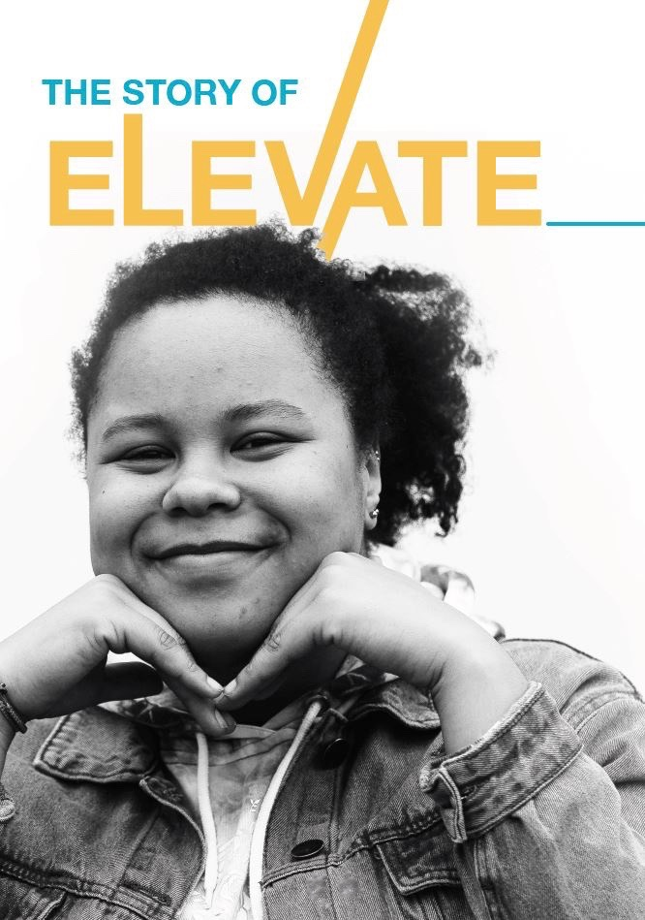

The Story of Elevate

Elevate, what we did

We developed Elevate, a ten year Youth Strategy 2018-2028, through a unique partnership between young people and Council. From over 50 applicants, 12 young people aged 16-21 were formally engaged by Council to co-design Elevate. Working as casual Council employees, these individuals led the development of the Strategy from its inception to delivery.

The consultation process for the Youth Strategy was one of the largest undertaken in the Macedon Ranges, and the first to be led by passionate members of the community themselves. More than 1,000 people shared their experiences through surveys, group discussions, key informant interviews, youth summits and a presentation session all of which were facilitated by young people.

Elevate, why we did it

Young voices and young lives – the great shape of things to come – here and now!

First and foremost we believe that by raising young people up, by elevating, supporting and celebrating them we ensure that they are in great shape mentally, physically and socially, now and into the future. This in turn positively impacts the Macedon Ranges community, now and into the future.

This Strategy will guide the work of the Youth Development Unit (YDU) for the next ten years. It holds critical data and analysis that provide a solid foundation as to what we will do and why. It highlights ways in which the Macedon Ranges Shire Council can support individuals living, working and studying in the Macedon Ranges aged 12-25 from 2018-2028. While much of this work centres on Council’s Youth Development Unit, there are actions that touch on many different areas of Council’s work. Equally, we recognise that much of the work that has been identified in this Strategy must be led by others in the community, including the State Government, schools, service providers, community organisations. We will seek to embrace all partners as we meet the needs of young people in our community, and continue to elevate the next generation of leaders, thinkers, workers and families.

This Strategy helps Council understand more comprehensively how the varying Council departments work together. Many Council areas have a connection with the work of the Youth Development Unit. This cross department connection is also evident in the following Council plans and strategies:

- The Macedon Ranges Shire Council Plan 2017-2027
- Arts and Culture Strategy 2018-2028
- Sport and Active Recreation Strategy 2018-2028
- Economic Development Strategy 2009-2019
- Environment Strategy
- Climate Change Action Plan
- Municipal Emergency Management Plan
- Organisational Gender Equality Action Plan 2017-18
- Goldfields Library Corporation Library Plan 2017-21

Our work in the development of this Strategy has also been guided by the five priority areas outlined in Council Plan (2017-2027)

Priority Area | Youth context
Promote health and wellbeing | - Mental health and wellbeing has been identified as a core challenge for young people  - Mental illness is the biggest burden of disease in adolescents  - Connecting young people to each other, and to those around them is essential to promoting social cohesion and social capital  - Healthy lifestyle choices are established and normalised when people are between the ages 12-25  - Attitudes that underpin healthy and respectful relationships are significantly shaped during adolescence  - 75 % of people who suffer from mental illness experience a first episode in adolescence
Promote the natural environment | - Young people are often the champions of environmental protection  - Young people will inherit custodianship of the natural environment  - Young people are an untapped volunteer resource to support the protection and promotion of our natural resources
Improve the built environment | - Young people comprise 15% of our community. All decisions concerning the built environment from footpaths, roads, open spaces and buildings affect young people, but they are rarely comprehensively consulted regarding these types of decisions
Enhance the social and economic environment | - Young people comprise around 16% of our workforce  - Young people also struggle with rising costs of living, particularly a lack of affordable housing in the Macedon Ranges  - Accessing services, schools, jobs and social activities can be extremely difficult without a licence or a car.  - Young people in our community can be left behind if they are unable to access the needed services and opportunities
Deliver strong and reliable government | - This strategy has been developed in partnership with young people. We have led a transparent, consultative and rigorous process to ensure that Council can deliver an effective program that meets the needs of young people in our community.

The current situation

Young people account for 7,272 people or 15.77% of the total Macedon Ranges population (Census 2016). In the 10-24 age bracket 72 young people in the Shire are Aboriginal (Census 2016). Of the overall Macedon Ranges Shire 13.4 % of the population was born overseas. By 2028 the total number of young people in the Macedon Ranges Shire is expected to grow to 8,777 (forecast.id).

Depending on the source used, there are different growth levels predicted over the next 10 years and beyond. However, irrespective of the source, the total population of the Shire is expected to increase over the next 20 years (i.e. to 2038) and requires consideration in this strategy.

Our population is dispersed across nine townships, with secondary schools in Kyneton, Macedon, Woodend, Gisborne and Bullengarook. Services for young people are largely based in Gisborne and Kyneton, with limited services growing in Romsey. Expected population growth in Riddells Creek, Gisborne and Romsey will pose challenges for service delivery over the next decade.

While the focus of Elevate is on people aged 12-25, we understand that this category is just one label and just one experience that shapes the lives of the individuals in this group. Age, like gender, sexuality, race, class, and other attributes, affects different people in different ways at different times. We recognise that inequalities are never the result of any single or distinct factor. Rather, ‘they are the outcome of different social locations, power relations and experiences’. We have tried to understand the diversity of young people in the Macedon Ranges in all their forms; considering all of the different factors that can disadvantage or marginalise individuals.

The Macedon Ranges Shire Council has a Youth Development Unit (YDU) to lead its support for young people aged 12-25. With a Coordinator and five part time employees, the YDU runs a series of youth related programs and activities. In the 2016/17 financial year period the YDU ran a total of 195 events/sessions for a total of 3340 participants. (Appendix E).

Council continues to recognise the need and value of engaging young people as partners in our community. This is evidenced through cross departmental engagement of young people within Council with services and programs being delivered through Sports and Recreation, Economic Development, Cultural Development, and Tourism and Environment.

In 2016, Council formally recognised its commitment to young people through the Macedon Ranges Shire Council Youth Charter, in the form of eight guiding principles to help foster stronger engagement with young people:

- We are reaching out: Council actively reaches out to young people in order to engage them more fully with a variety of Council departments, events and processes.
- We are inviting in: Council reviews how it presents itself to young people in order to remove obstacles and barriers to connecting with Council.

- We are partners: Council sees young people as valued and necessary partners in the development and success of the community.

- We are equals: Council sees young people, in all their diversity, as equals. As equals, they’re respected, listened to and included in the making of decisions that affect community.

- We are talking: Council keeps an ongoing dialogue with young people. We don’t assume to know what they think, want and need, we ask them.

- We are working together: Council actively supports, empowers and skills young people by working with them. Likewise, Council develops skills, is supported and empowered by working with young people.

- We are adventurous: Council is agile and responsive to fresh ideas and new and unexpected ways of being, doing and engaging with young people.

- We are community: Council recognises that young people are uniquely situated to be a representative force / voice for the whole community.

Young people & the State Government

The Victorian State Government has committed to an inclusive society where all young people are empowered to voice their ideas and concerns, as part of its 2016 Youth Policy. This is being supported by a state-wide youth summit, youth congress, annual youth surveys and social policy design labs.

From 2017-2019, the State Government has also committed to supporting partners in designing and delivering programs to improve the health and wellbeing of diverse groups of young Victorians with a focus on:

- Preventing alcohol-related harm among young people
- Preventing the uptake of smoking among young people
- Promoting young people’s mental wellbeing by building physical activity, resilience and social connection.
Regional Development Victoria (RDV) is the Victorian Government's lead agency in developing rural and regional Victoria. RDV is a division of the Department of Economic Development, Jobs, Transport and Resources and provides crucial investment to support youth engagement, employment and connection.

The Department of Health and Human Services empowers young people through its Engage! and FReeZA funding, supporting youth participation, skills development and youth events. Stated priorities for the State Government include:
- Getting young people involved
- Services that meet the needs of young people
- Create new ideas and partnerships
The Department of Education and Training also supports 31 Local Learning and Employment Networks (LLENs) across Victoria – including the Central Ranges LLEN which includes the Macedon Ranges – and a School Focused Youth Service (SFYS) which is based at Cobaw Community Health and covers the local government areas of Central Goldfields, Mount Alexander and Macedon Ranges.

Youth Affairs Council of Victoria (YACVic) is the state peak body representing and advocating for young Victorians and the youth sector. Macedon Ranges Shire Council is an active member.

Young people & the Federal Government

We recognise the Australian Government has responsibility for managing the Federal Budget, and setting strategic policy direction in areas such as healthcare, education and social support structures such as Centrelink.

No Minister for Youth exists in the current portfolios. The national peak body for young people, Australian Youth Affairs Coalition (AYAC) was dissolved in 2017.

The Government has committed to prioritising access to quality higher education, to support economic productivity and social wellbeing for young people. The Government has recognised that the learning and education journey is different for every person, particularly people from disadvantaged backgrounds and vulnerable communities.

In 2016, the Government invested $840 million in a Youth Employment Package to increase the employability of vulnerable young people. And, the Youth Jobs PaTH program assists young Australians in finding employment, by providing them with practical pre-employment training, and with real work experience through internships.

The Federal Government has also identified youth-homelessness as a key public policy initiative. The Reconnect program uses early intervention services to assist young people aged 12 to 18 years who are homeless, or at risk of homelessness, and their families.

Elevate, how we did it

The development and consultation process which led to Elevate was one of the largest ever undertaken in the Macedon Ranges, and the first to be led by passionate young members of the community. Consultations were conducted across the Macedon Ranges, with feedback provided from 14 townships. More than 1,000 people shared their experiences through a range of activities, all of which were facilitated by young people. These activities included; online and face to face surveys, focus groups, pop up consultations, youth summits, one on one stakeholder interviews and attendance at a regional assembly – 49 consultations and 718 online and face to face surveys in total. Of the overall number of individual community members engaged in our consultations, 61% were young people.

Once Elevate was drafted review consultations were held to check back in with the community on what we’d found.

Here’s a breakdown of the process that led to Elevate, how we went about it and what we found.

Numbers:

Surveys and consults (949 individuals engaged)
Public Comment and Elevate draft review consults (83 individuals engaged)
Grand Total (1032 individuals engaged)

Elevate used an Integrated Design, Evaluation and Engagement with Purpose (InDEEP) approach; where research and the formation of ideas are undertaken concurrently. Underpinning this model was an ongoing evaluation of the process, where lessons were considered and approaches refined across time as we developed the Strategy.

From January-February 2018, we conducted a ‘horizon scan’ literature review to identify common issues, trends, policy frameworks and best practice programs. This included a review of government reports, policy statements, issues papers, comparative youth strategies alongside published best practice reviews.

A full list of consultations is included at Appendix B. All sessions prioritised opportunities for women, girls, people with disabilities, young people who identify as Lesbian, Gay, Bisexual, Transgender, Intersex, Questioning (LGBTIQ+), Aboriginal and Torres Strait Islander peoples and other marginalised voices. This included participation quotas and engagement approaches. Discussions in all consultation sessions were guided by the Lewis Method of Deep Democracy, where diverse voices are encouraged to be heard. Co-designers also undertook a one-day training in consultation approaches, facilitated by Pru Gell.

The largest engagement with young people came through two Youth Summits (Appendix F), one with participants over 18, and the other with those aged 12-17. Each Summit was facilitated by young people. Group discussions were guided around key issues identified by the Macedon Ranges Youth Ambassadors. Written feedback, voting forms and video insights were also collected at the Youth Summit.

In order to hear from socially or economically marginalised youth voices, we worked closely with partners such as the Victorian Police, to capture insights and experiences.

We analysed the combined data during two workshops held in March and April. Council and the young Co-designers collectively reviewed the information through a theory of change lens. Issue mind-maps were developed for each key challenge to uncover its direct and indirect impacts. Key objectives were then identified within this context, and corresponding activities prioritised. In small groups, we prototyped long-term, or complex ideas, to test activities and establish specific project solutions.

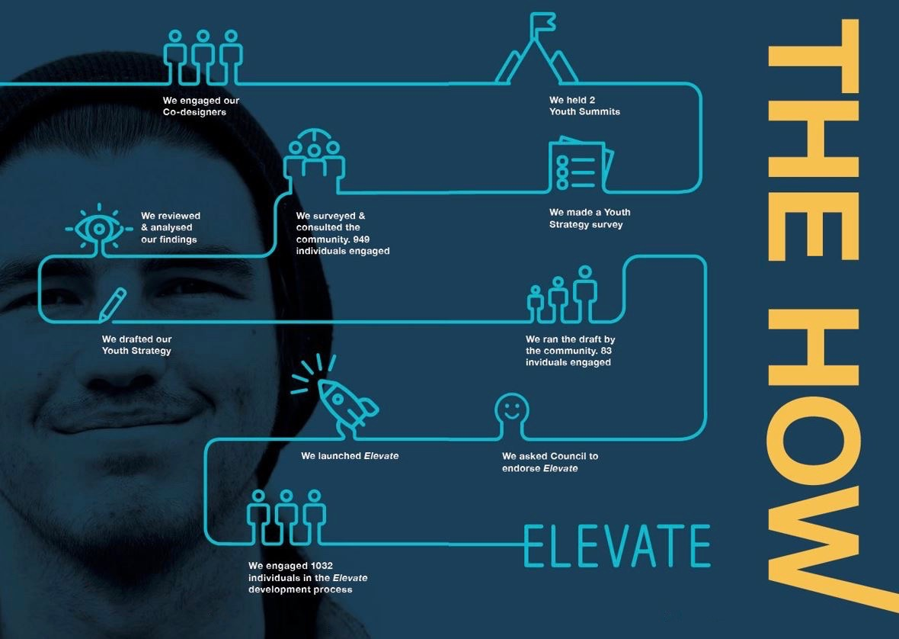

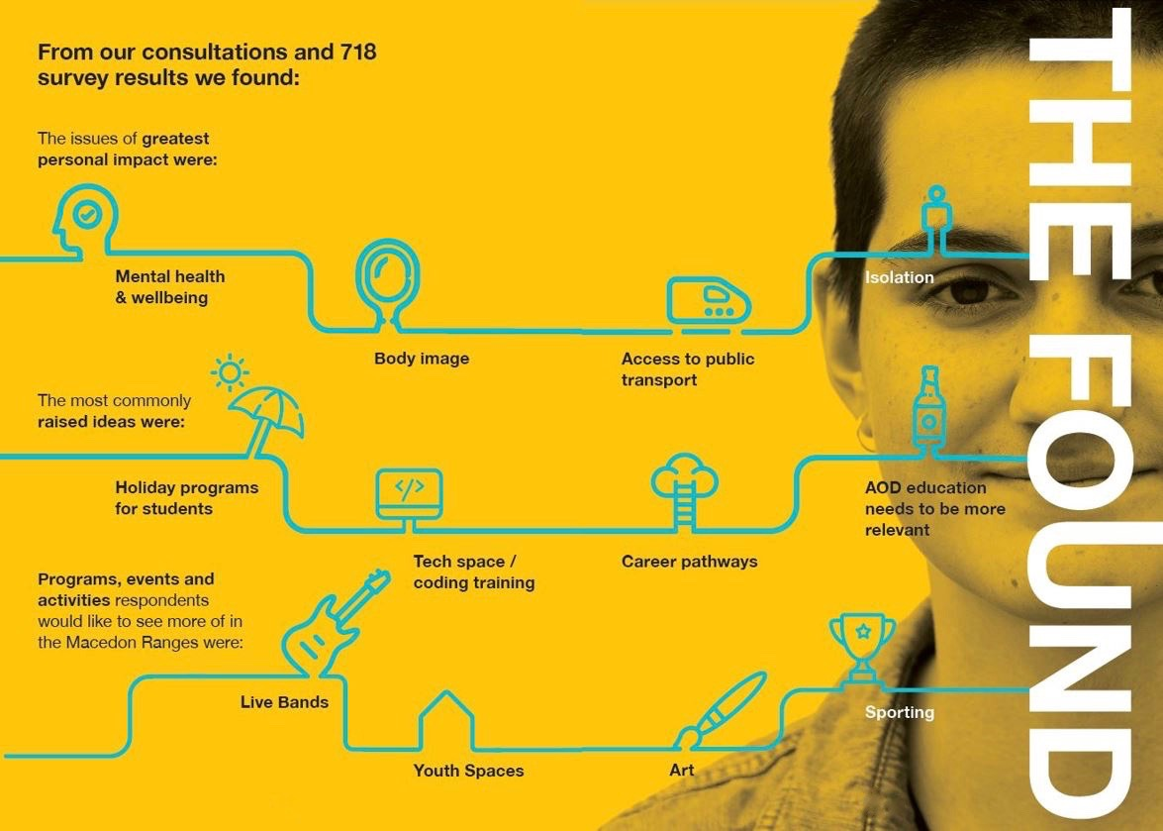

Elevate, what we found

From our surveys; the top issues affecting young people are highlighted in Charts 1 and 2. The most commonly raised ideas by young people and the most popular activities for young people are highlighted in Charts 3 and 4.

Chart 1. Total number represents cumulative ranking of respondents’ top three issues.

Chart 2.

Chart 3.

Chart 4.

Elevate, what we found cont’d…

From our meetings and group consultations, twenty eight ‘observation’ themes were identified, and ideas were grouped as one of fifty three different themes. A full list of these is included at Appendix C. When combined with our research, the key findings highlighted below were identified.

We found that mental health will almost certainly remain the most pressing challenge for young people

Mental health was considered the most important issue for young people in the Macedon Ranges in surveys. It had the greatest personal impact on survey respondents and was the most discussed issue at the Youth Summits. Forty percent of survey respondents’ listed mental health and wellbeing as one of the three most pressing issues they faced, including nearly 20% ranking it as their top issue – substantially higher than any other concern. Macedon Ranges Health reported that nearly all students who accessed school wellbeing did so with a mental health concern. While Resilient Youth Australia’s school resilience survey found that 41% of students (Years 7-11) felt constantly under strain, nearly 50% of students in Year 11 lost sleep through worry, and nearly one in every three students felt unhappy or depressed.

“A lot of my friends are constantly coping with unhealthy amounts of stress”

Nationally, almost one in four young people aged 15-19 showed symptoms of probable mental illness, according to Mission Australia. Around one in five respondents in national surveys were either extremely concerned or very concerned about depression.

Mental illness has been identified as the biggest burden of disease for young people and 75% of people with a mental illness experienced their first episode in adolescence according to the Australian Institute of Health and Welfare.

Globally, the World Health Organisation (WHO) announced that depression is now the leading cause of ill health and disability, having risen by more than 18% worldwide since 2005. Young women have been found to be twice as likely to suffer from anxiety and depression, with recent evidence in the UK indicating 21% of young women reported symptoms of these conditions to their GP.

Young people interviewed highlighted stress, dealing with expectations, toxic relationships, bullying and trauma (such as family violence, or sexual assault) as drivers of these mental health issues. Indeed, over four in ten respondents indicated that they were either extremely concerned or very concerned about coping with stress.

Suicide rates for young Australians are at their highest level in 10 years. It is the leading cause of death for young people. A third of all deaths for young men are due to suicide. Self-harm related hospitalisations for young females are 2.5 times higher than for young men. And suicide rates for women have doubled since 2005. The biggest concern raised by young people aged 5-25 calling Kids Help Line is mental health, according to the North Western Primary Health Network.

Body image issues are also having a greater impact than most people realise. Body image ranked second only to mental health as having the biggest personal impact on survey respondents in the Macedon Ranges, despite not being regarded as a top five issue in other quantitative or qualitative measures. Body image also ranked as the third highest concern for Mission Australia; an issue which has been rising in significance over time.

Council’s Live4Life program continues to make inroads in raising awareness of mental health issues and how to provide practical support to those in need. But education about mental health needs to start earlier and be more relevant to students. Three quarters of survey respondents aged 25 or under favoured starting mental health education in, or before Grade 6; including nearly a third (32%) who supported commencing before Grade 5. We also acknowledge that the results of the consultation may require Council to focus some work on 10 and 11 year olds, which has been typically out of the ‘young people’ scope.

“Learning about mental health early is really important. Myself and a few other friends all dealt with mental health problems as early as year 8… If I had have been informed earlier about said resources then I may not have had to struggle for as long as I did and would have reached for help earlier.”

Physical activity is also having an important protective effect on the mental health of young people in the Macedon Ranges. Resilient Youth Australia’s school resilience survey found 72% of students in Years 7-11 are keeping physically fit. While Mission Australia found, sport (as both a participant and spectator) were the top two activities for young people nationally.

We found that safety is an ongoing issue – with multiple dimensions – for young people

Many young people in the Macedon Ranges are not able to access the help they need, when they need it. No single organisation or individual is solely dedicated to engaging young people who may be struggling with a family or mental health challenge. Victoria Police’s Youth Engagement Officer – the nearest equivalent to a generalist youth support worker in the region – is inundated with requests for flexible, and responsive care for young people in need. In 2017 alone, the Youth Development Unit supported a number of young people who had considered, or attempted suicide; a role above and beyond allocated hours, and designated position descriptions. Young people will continue to lack the support they need without the addition of a generalist youth worker to support existing services in the area.

“getting access to mental health services can be tricky, and also financially taxing”

Most young people are not accessing the help they need because of stigma, access issues and a lack of awareness of what services are available. Fewer than 7% of young people surveyed indicated they would speak to a doctor or counsellor in the first instance if they had a personal problem. National studies, including Beyond Blue, have also found that young people seek help reluctantly. Services that are not flexible, mobile, known or trusted are simply not used. The peak advocacy body for young people in Victoria, YACVic, has echoed these findings.

Relationships can be a source of both strength and angst for young people. Most young people spoke favourably about their peer support networks, with nearly one in three preferring to confide in a friend rather than parents, siblings or other support people when needed. However, bullying, both in person and online, was rated as the third highest issue for young people in the Macedon Ranges, and had the fifth highest rating in personal impact. According to Resilient Youth Australia’s school resilience survey, 38% of students claimed to have been bullied at least once in the past 12 months, with 16% of students reporting being bullied at least three times a week. Boredom, isolation, stress and poor support networks were seen as key drivers for bullies. Several young people spoke of the effects of ‘toxic relationships’, where they simply were not aware what appropriate behaviour they should expect.

Nationally, women in Australia aged 18 to 24 are more likely to experience physical or sexual violence than women in any other age group (Australian Bureau of Statistics (ABS, 2013). 13% of women aged 18-24 have experienced sexual or physical violence in the past 12 months, while eight out of ten women aged 18-24 were harassed on the street in the past year, according to Our Watch. Young women in the Macedon Ranges identified ‘feeling unsafe’ as a significant personal issue. A 2014 report by VicHealth also found that young men showed a lower level understanding of violence against women and gender equality and a higher level of attitudinal support for violence against women.

Problematic alcohol and other drugs (AOD) usage was considered the second highest issue for young people, and was the most discussed challenge in conversations. Binge drinking was considered reasonably common in the Macedon Ranges, given the prevalence of private parties, a lack of entertainment options and cultural norms around drinking. Victoria Police reported that most youth crime in the Macedon Ranges is associated with possession or dealing cannabis. Nationally, around 16% of 12-17 year olds have tried cannabis, though usage rates are possibly higher in the Macedon Ranges according to anecdotal evidence. Many young people highlighted boredom, stress and isolation as the drivers of problematic AOD issues. Problematic AOD often increases risk taking behaviour, while harming individuals’ capacity to maintain relationships, study and work. It can also be used to mask a growing mental health problem.

“People think that excessive alcohol use is a norm and a ‘rite of passage’”

More needs to be done to provide affordable and emergency housing for young people in the Macedon Ranges. Insecure housing for young people – couch surfing, or remaining in unsuitable accommodation arrangements – was raised during Youth Summits as an important issue. Nationally, 46% of people who are homeless in Australia are younger than 25.

We found that isolation can be both a problem and a symptom of a problem

Many young people identified isolation as driver of mental health issues, problematic AOD usage and an inability to access work and support services. Equally, according to Beyond Blue, withdrawal from social connection can often be a sign of a young person struggling. Isolation was identified as the fourth most significant issue affecting young people, and was also the fourth most discussed issue in consultations.

“When I needed services, I couldn’t find them.”

Social media has a mixed role in connecting young people. Research has found that while social media can increase positive social connections for young people, cyberbullying is an amplified issue for young people living regionally, who are more reliant on social media platforms for social connection. Compared to their Metropolitan counterparts, regional people (this includes young people) are more likely to witness or experience harassment or bullying through social media.

Youth spaces were the most discussed idea raised during consultations, highlighting a need for more opportunities for young people to come together outside of school to learn, connect and play. According to the school resilience survey, 78% of students are part of a social or sporting club. This shows young people want to feel more connected to those around them. Our ongoing youth spaces at Council’s Youth Development Unit also show there is a young cohort looking to gather, socialise and engage in activities that fall outside of mainstream or sport based recreational pursuits. Research has consistently found that connectedness may decrease the risk of suicide, boost mental health, and increase productivity.

Public transport is a key barrier to social connection in rural communities such as the Macedon Ranges. Young people rely on parents and limited public transport to commute to school, sport, services and other recreational activities. Young people who live beyond walking distance from train stations in Kyneton, Gisborne or Woodend often depend on connecting buses or family/friends for transportation – limiting their ability to independently access people, places and support.

Young parents are feeling particularly isolated. Around 5% of new parents in the Macedon Ranges are aged 15-19 (North Western Melbourne Primary Health Network). Research has found that young parents, particularly young mothers, face several major adjustments to their identity and they are particularly vulnerable to experiencing postpartum depression, and stress. Young parents in the Macedon Ranges noted they felt particularly disconnected; many were too intimidated to join parents groups, or were unable to access existing services. Our findings echo and are supported by findings in Council’s past Young Parent Connection Project.

Many young people must also commute long distances to access certain services. With a dispersed population placed between Bendigo and Melbourne, young people in the Macedon Ranges are often serviced by organisations based outside of the Shire. Even within the Shire, accessibility from township to township can be difficult for young people. Flexible engagement is critical to ensure services can meet the unique demands and circumstances for young people.

We found that identity matters…a lot

The achievements of young people should be recognised. Young people indicated that promoting their achievements challenges community expectations, builds confidence and promotes the unique identities and experiences of the diversity of young people in the Macedon Ranges.

Young people want to be accepted as they are. Discrimination is as big an issue as problematic drug use. Young people reported the same levels of personal impact for discrimination as they did for problematic drug usage. Young people identified as having being judged by age, gender, sexual orientation, ability or socio-economic status. Discrimination, particularly of individuals identifying as Lesbian, Gay, Bisexual, Transgender, Intersex or Questioning (LGBTIQ+), was the most common issue raised during YACVic’s 2017 youth forum for the Loddon Campaspe region.

LGBTIQ+ young people felt particularly judged and excluded. Nationally, lesbian, gay, bisexual, transgender and intersex Australians are twice as likely to have a high/very high level of psychological distress as their heterosexual peers. Young LGBTIQ+ individuals are most affected. 55% of LGBTIQ+ individuals identifying as women aged between16-24 reported experiencing a mental health problem.

Same-sex attracted young Australians have 6 times higher rates of suicide attempts than their heterosexual peers. As Beyond Blue notes, the elevated risk of mental ill-health and suicidality among LGBTIQ+ people is not due to sexuality, sex or gender identity in and of themselves but rather due to the impacts of discrimination – isolation/exclusion, as key determinants of health.

Similarly, 15% of Australian adolescents and young adults (aged 15–29) with disabilities have poor psychological health. The experiences of young people with a disability in rural communities, such as the Macedon Ranges are also complicated by a lack of support services, a lack of public transport and poor accessibility.

We found that young people can drive change in their communities, but to do so they need to be embraced as partners by the community

Involving young people in an organisation or in the community benefits everyone. Research shows improvements in skills, opportunities, knowledge, health and well-being for younger and older people. Research also indicates that services, particularly local government services are more effective when it involves young people in design and decision-making processes.
Giving young people a voice creates a shared sense of belonging. During our Youth Summits in 2017, one of the most common recommendations was for Council to host more summits, forums and workshops with young people. Young people felt valued, recognised and connected.
Young people have been found to develop increased self-esteem, negotiation techniques and communication skills through participation in decision-making. Research indicates that providing supported opportunities to contribute to decision-making increases a range of soft-skills essential in academic, social and employment settings.
Youth participation can stimulate a more inclusive and cohesive community. Involving young people can transform entrenched biases, more effectively address needs, and create a collective purpose across generations.
There is a need for community organisations and groups to create more meaningful ways and opportunities to involve/engage diverse groups of young people. Few, if any, local organisations provide pathways for youth engagement to address the underrepresentation of young people in decision-making roles.

We found that helping young people to feel more supported requires a community-wide approach

Communities need to do more to combat rising levels of youth unemployment. Youth employment is around 12% - around double national unemployment rates. Here in the Macedon Ranges, youth unemployment is likely to be between 15-25%. Unemployment – particularly long-term unemployment – can have devastating effects on young people’s financial and emotional wellbeing. Roy Morgan Research found that as the youth unemployment rate rose, mental health issues among young people simultaneously rise.

The closure of the satellite VCAL program in 2017 has left a gap for students needing tailored educational support. It remains to be seen how the upgrade of Kyneton Secondary College, including the development of a Training and Innovation Hub, will address this need.

Career pathways was one of the most discussed issues during consultations. Young people identified a lack of suitable work opportunities, a lack of affordable transportation and competition with older workers as key barriers to meaningful work in the Macedon Ranges. Young people identified additional work experience opportunities, volunteering and mentoring as key initiatives that could support their transition into the jobs they desire.

“there should be more ways for people like me to get jobs”

Intergenerational links were highlighted as crucial connections for many young people today. Mentoring can have a range of positive outcomes for young people, particularly those disengaged from study or work. The Realising Their Potential report, survey found that 78% of respondents said they were less likely to use drugs or alcohol as a result of being in a mentoring program, 81% said they went to school more often, and 90% said they had a more positive view of their futures. While 70% of students indicated they have support from adults other than parents; camps, activities and programs can, and should, be used to further foster connections across generations.

Many young people need early intervention support to overcome entrenched disadvantage. Around four to six per cent of the community experiences chronic or persistent poverty or deprivation. Socio-economic disadvantage, family violence and mental illness are all key contributors that can cause young people to endure long-term disadvantage. While young people aged 10–17 under youth justice supervision during 2014–15 were 15 times as likely as the general population to be involved with the child protection system in the same year.

Transitioning from school can be difficult. Both early-leavers and school graduates (around 85% of young people in the Macedon Ranges finish Year 12 according to the school resilience survey) reported finding the post-school period to be more challenging than they expected. While 65% of current students in the Macedon Ranges reported feeling optimistic about the future, many school-leavers indicated they felt underprepared for post-school work or study. Many young people also leave the Macedon Ranges to pursue opportunities, meaning they are embarking on these new challenges often without the support of family and friends. During consultations, YACVic also identified a strong desire for life skills training in school, including topics such as consent, relationships, self-defence, finances, tax, and voting.

“jumping from high school in the Ranges to uni and work in the city, it’s been quite a shock to the system….there’s a lot of pressure to succeed/get up to their ‘standard”

We found there needs to be more spaces and events to excite young people

Young people need inspiring spaces and opportunities in the Macedon Ranges to learn, play and connect. Youth spaces were the second most popular initiative young people wanted to see more of in surveys. It was also the most commonly raised idea during consultations. Current Council-led youth spaces in the Macedon Ranges are servicing a broad range of young people each week, but should continue to grow and evolve to meet the need identified by young people. Consistent with best-practice, such spaces should, where possible, be youth-run (with support from a youth worker), be multipurpose, facilitate skills development, and foster belonging in a safe environment.

Existing spaces that young people frequent, such as libraries, need to be more engaging and more inspiring. Young people surveyed visited libraries, on average, less than once a month. Libraries were seen as catering to children and older people, with few programs, spaces or initiatives targeting young people. As a study space, WIFI is an important drawcard, but few young people felt genuinely welcomed in libraries. Opening hours were viewed as a common hindrance to after school or weekend study. Libraries can be youth hubs for young people. Examples in Bendigo and Castlemaine provide space for groups or individuals to gather, study and socialise. Programs, such as coding training or band rehearsal space after hours, could draw young people inside. And simple investments such as charging stations, basic tech labs, and hang-out spaces have been found to transform youth engagement with libraries.

Young people need creative outlets. According to VicHealth, engaging with creative activities has been found to contribute to better academic outcomes, improved levels of self-esteem and a reduction in drug and alcohol consumption for young people. In the Macedon Ranges, around 45% of students are already involved creatively in art or music, though most do so within school structures.

Young people surveyed overwhelmingly indicated their desire for more youth-friendly events, such as live music, outdoor cinemas and art exhibitions. Boredom was one of the most common issues raised during consultations. Social events can stimulate and inspire young people and foster peer-to-peer connection.

Parks, gardens and the natural environment were the second most frequented spaces (outside of homes and schools) listed by young people surveyed. Young people in the Macedon Ranges are using our natural environment, and many wanted to do more to help protect and promote these spaces for their peers, and for future generations to enjoy.

Service providers need to find ways to better promote their work

Many young people are not aware of the programs, events and opportunities available to them. That service providers need to promote more effectively the opportunities available to young people was the third most discussed need in consultations. Young people commonly called for programs and activities that are already available in the Macedon Ranges, such as youth spaces, stand-up performances, live music and services such as free medical consultations, LGBTIQ+ spaces, transitional housing support and counselling. Many young people are simply not aware of the opportunities they may desire or need. While more work needs to be done to make services and activities more accessible and appealing (as discussed above), service providers must also focus on more effectively promoting their work to foster greater engagement with young people. During consultation, service providers themselves acknowledged they must do more to promote their programs.

There needs to be more collaboration and cross-promotion between service providers. Young people consistently reported they felt confused about what service providers do, and where they should go if they need support. Some service providers reported vulnerable young people can ‘give up’ if they face barriers in getting the help they need. Many young people suggested that service providers need to be more interconnected to help young people find the right support.

“There needs to be a stronger connection between those who can help and those who need help”

Service providers must constantly refresh their engagement approach, to ensure they are reaching young people. How young people access information continues to rapidly evolve. Over the past 12 months for example, Facebook usage in Australia has slightly declined, while Instagram rose from 31% to 46%, Twitter from 19% to 32%, and Snapchat has risen from 22% to 40%. In the US, Snapchat has already outpaced Facebook as the platform of choice for young people. Over the next 10 years, new platforms will inevitably emerge. Given the pace of change, Council and service providers must work quickly and flexibly to ensure they are effectively reaching young people through relevant social media.

Schools are an essential channel of information for students and parents. They are critical gatekeepers ensuring students are not inundated with information ‘noise’, but also must work collaboratively with service providers to ensure the right information is reaching those that need it most.

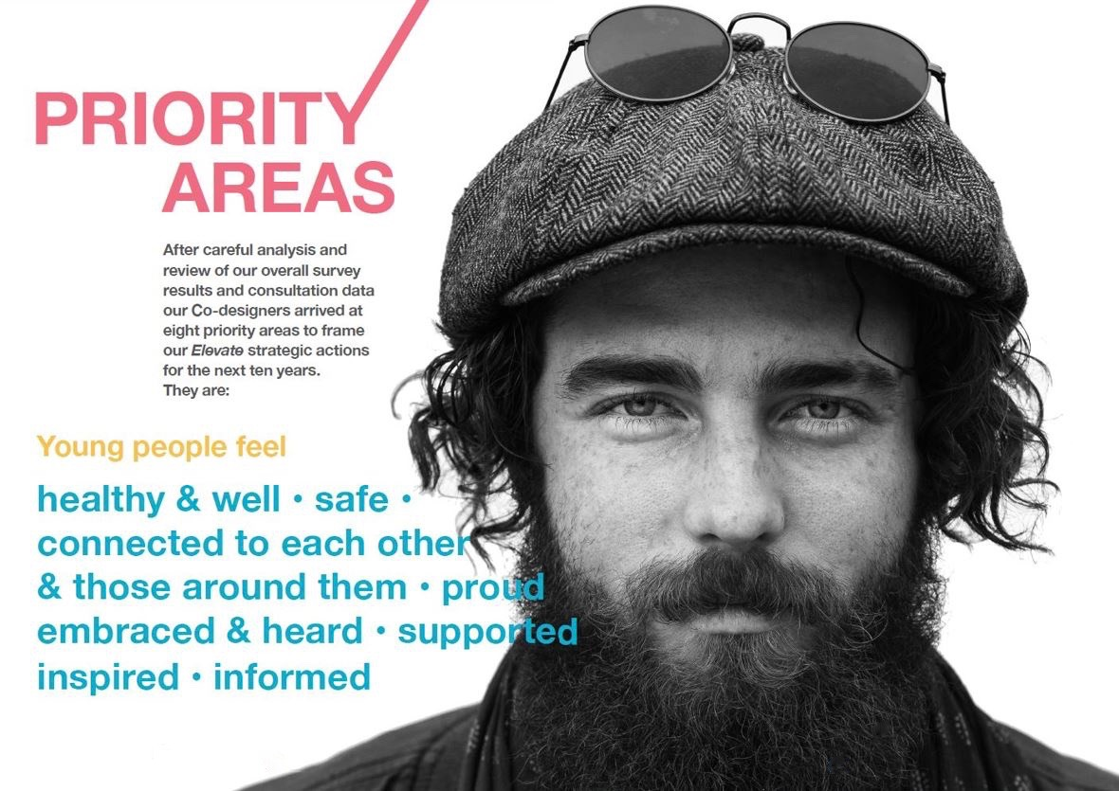
Elevate, action

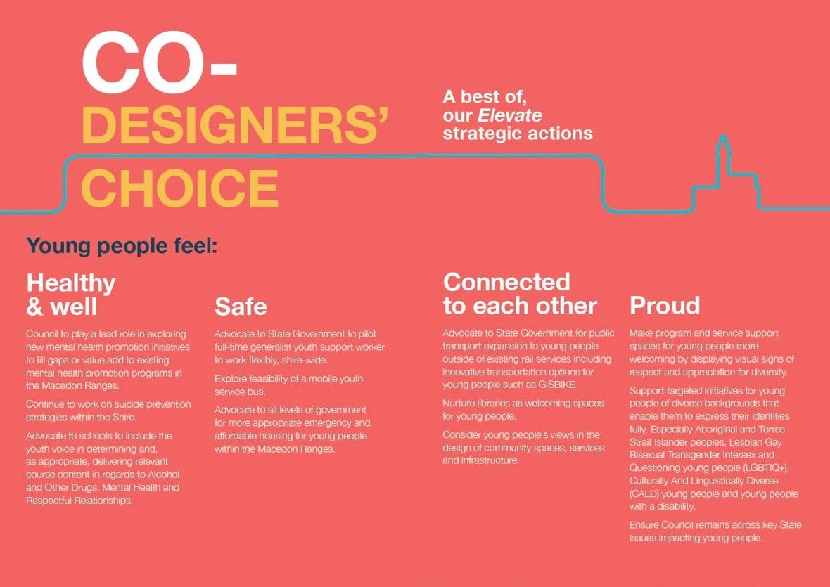

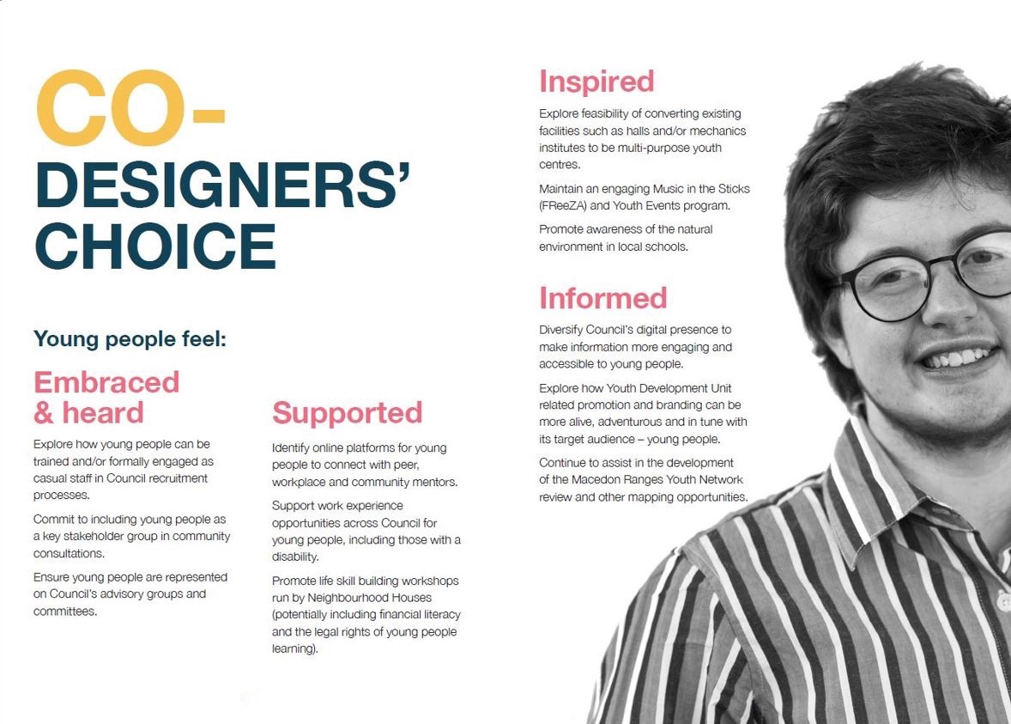

Action Table Legend:

Timeframe
2018-2020 2021-2024 2025+
Indicates action will occur over all three time periods | 2018-2020  Indicates action will occur only in this specific period | 2021-2024  Indicates action will not occur during this time period

Resources

Action is funded or currently sits within budget | Funding source identified but yet to be secured/locked down | Currently unfunded/funding sources not yet identified

Where there is no allocated resources for the actions below, the Youth Development Unit will submit business cases for Council consideration through the annual budget process. The Youth Development Unit will also seek State and Federal funding and collaborative partnership opportunities to assist in realising this strategy.

Priority Area 1: Young people feel healthy and well

Council Action  2018-2020 2021-2024 2025+ | Target | Outcomes | Lead / partners | Timeframe | Resources
Continue to prioritise and promote meaningful programs that support youth Mental Health
Maintain an evidence based Live4Life program | - Live4Life program delivered to all Year 8 students each year with the support of the Live4Life Crew  - All Year 11 students complete Teen Mental Health training  - At least five Youth Mental First Aid courses delivered each year  - Conduct an evaluation of Live4Life with support from Youth Live4Life Inc.  - Participate with Youth Live4Life at least twice a year and other partner communities to share learnings  - At least two young people engaged and trained to assist in the delivery of Live4Life each year | - Our community better supports and understands young people  - Decrease in mental health stigma  - Increase in help offering and help seeking  - Increase accessibility of support services for young people  - Strong relationship with Youth Live4Life Inc. | - Youth Development Unit  - Schools  - Community service partners | 2018-2020 2021-2024 2025+ | Within existing resources  $100,000 allocated for financial year 17/18
Develop and implement a Live4Life mental health sessions for Grades 5 & 6 students including teachers and parents | - Identify best practice model and associate costs of pilot program  - Conduct 2 year pilot program in two schools by 2020  - Conduct an evaluation of pilot program within 12 months of completion  - Implement program in all primary schools (engaging teachers and parents) in the Macedon Ranges based on recommendations of evaluation by 2023 | - Our community better supports and understands young people  - Decrease in mental health stigma  - Increase in help offering and help seeking  - Increase accessibility of support services for young people  - Mental health concerns identified for students at an earlier age | - Youth Development Unit  - Schools  - Community service partners | 2018-2020 2021-2024 2025+ | Approximately $100,000 to implement and evaluate pilot in two school sites. New initiative consideration required, and additional resources sought externally
 |  |  |  |  | Annual implementation of full primary school Live4Life costings to be determined by pilot evaluation
Explore implementation of a Live4Life online platform that delivers key information on mental health services and supports for young people and their families | - By 2019, engage Live4Life Partnership Group and Live4Life Crew in the assessment and determination of next steps | - Greater accessibility to mental health information, awareness and promotion resources for young people in the Macedon ranges | - Youth Development Unit  - Schools  - Community service partners | 2018-2020 2021-2024 2025+ | Within existing resources (Live4Life Coordinator)
Council to play a lead role in exploring new mental health promotion initiatives to fill gaps or value add to existing mental health promotion programs in the Macedon Ranges. | - Establish a working group to map mental health promotion gaps and identify appropriate new mental health promotion initiatives that could be successfully employed in the Macedon Ranges | - Greater range of mental health promotion options for young people in the Macedon ranges | - Youth Development Unit  - Schools  - Community service partners | 2018-2020 2021-2024 2025+ | Initiatives from this work may require external budget support. Will respond to funding opportunities as they are identified
Connect student mental health advocates with community events | - At least two student mental health advocates from each secondary school represented each year in the Colour Run, International Day Against Homophobia, Biphobia, Intersexism and Transphobia, Macedon Ranges Suicide Prevention Action Group Walk and Daffodil Festival | - Increased community awareness and ownership of mental health as an issue impacting the Macedon Ranges | - Youth Development Unit  - Schools  - Community service partners | 2018-2020 2021-2024 2025+ | Within existing resources
Continue to work on suicide prevention strategies within the Shire | - Support the work of the Macedon Ranges Suicide Prevention Action Group | - Reduced suicides in the Shire  - Systemic changes within the current mental health systems allowing greater flexibility and support to young people when and where it is needed | - Bendigo health  - North Western Melbourne Primary Health Network  - Council  - Support services  - Brooke St Medical | 2018-2020 2021-2024 2025+ | Within existing resources
Advocate to the North Western Melbourne Primary Health Network to strengthen outcomes for the Macedon Ranges community through the Suicide Prevention trial. | - North Western Melbourne Primary Health Network Suicide Prevention trial achieves stated objectives | - Systemic changes within the current mental health systems allowing greater flexibility and support to young people when and where it is needed | - Bendigo health  - North Western Melbourne Primary Health Network  - Council  - Support services  - Brooke St Medical | 2018-2020 2021-2024 2025+ | Within existing resources
Improve students’ engagement with content delivered on mental health, alcohol and other drugs and respectful relationships

Advocate to schools to include the youth voice in determining and, as appropriate, delivering relevant course content in regards to Alcohol and Other Drugs, Mental Health and Respectful Relationships. | - Schools include young people on working groups to consider content delivered on mental health, alcohol and other drugs and respectful relationships  - Schools to trial engaging former students to assist in the delivery of content on Mental Health, Alcohol and Other Drugs and Respectful Relationships | - Students actively engaged in development and evaluation of Mental Health, Alcohol and Other Drugs & Respectful Relationships course content  - Improved student engagement with Mental Health, Alcohol and Other Drugs and Respectful Relationships content  - Improved student understanding of and engagement with issues and activity relating to gender equality. | - Youth Development Unit  - Schools | 2018-2020 2021-2024 2025+ | Within existing resources
Provide spaces and opportunities for young people to have fun, exercise and maintain physical health
Support implementation of Macedon Ranges Shire Council Leisure Strategy | - Leisure Strategy actions relating to young people are fully implemented | - Healthy, fit and active young people in our community | - Youth Development Unit  - Recreation and Sport Dep’t | 2018-2020 2021-2024 2025+ | To be determined as need arises
Promote active living among young people | - Youth Development Unit events include at least three each year that promote physical activity | - Increased engagement of young people in physical activity | - Youth Development Unit  - Recreation and Sport Dep’t | 2018-2020 2021-2024 2025+ | Within existing resources
Council contributes to the successful roll-out of Regional Development Victoria’s Loddon Campaspe Healthy Hearts Program for young people | - Identify opportunities to support implementation of Healthy Hearts program by 2019 | - Increased mental health awareness and decreased obesity (and related health impacts) in the Macedon Ranges | - Youth Development Unit | 2018-2020 2021-2024 2025+ | $5m State Government funded by Regional Development Victoria

Priority Area 2: Young people feel safe

Council Action | Target | Outcomes | Lead / partners | Timeframe | Resources
Improve access to mental and emotional health support services

Advocate to State Government to pilot full-time generalist youth support worker to work flexibly, shire-wide | - At least one generalist youth support worker engaged for a period of at least 24 months  - Conduct impact evaluation to determine ongoing need/effectiveness | - Increased access to specialised youth support for young people, including beyond normal work hours  - More timely and appropriate referrals for young people in need | - Youth Development Unit  - Schools  - Victoria Police  - Community service partners | 2018-2020 2021-2024 2025+ | Approximately $250,000 required over 2.5 year period. External support; Federal, State and philanthropic opportunities to be sought
Understand and promote best practice technology use to improve access, support and information | - Service providers and school wellbeing coordinators investigate feasibility of running Skype consultations for young people  - Develop and promote a factsheet to highlight support available online for young people and their families | - Improved access to professional support and information services for young people  - Deeper understanding of how online platforms can assist young people | - Youth Development Unit  - Schools  - Community service partners | 2018-2020 2021-2024 2025+ | Within existing resources
Explore feasibility of mobile youth service bus | - Community service providers consulted on feasibility of jointly operated mobile youth-hub service  - Potential funding streams identified and applied for if feasibility study supports it. | - Increased access to professional youth supports and services across all the entire Shire | - Youth Development Unit  - Schools  - Community service partners | 2018-2020 2021-2024 2025+ | New initiative consideration required for feasibility and model development approximately $5,000.
Council works as a champion of youth mental health
Council publishes a position statement on youth mental health | - Position statement drafted and endorsed by Council by June 2019 | - Increased understanding by young people of Council’s commitment to their ongoing mental health and wellbeing  - Clear targets to address gaps in current information and service provision | - Youth Development Unit | 2018-2020 2021-2024 2025+ | Within existing resources
Ensure public spaces are safe for young people

Advocate to V-line for improved lighting in and around train stations and to Council for same at skate parks | - Support community consultation on lighting needs at train stations and skate parks in the Macedon Ranges | - Increased safety for young people in the Macedon Ranges | - Community Development  - V-line  - Local Safety Committee | 2018-2020 2021-2024 2025+ | To be determined
Increase availability of appropriate housing options for young people that need it most
Advocate to State Government and the peak housing support body for a needs assessment of housing stress, insecurity and homelessness for young people in the Macedon Ranges | - Needs assessment completed  - Development of partnership advocacy project in line with needs assessment outcomes. | - Decreased incidences of homelessness for young people  - Increased housing support for young people at risk of homelessness. | - Youth Development Unit  - Cobaw Community Health  - Community service partners  - Strategic Planning Dep’t  - Local Safety Committee | 2018-2020 2021-2024 2025+ | Within existing resources
Advocate to all levels of government for more appropriate emergency and affordable housing for young people within the Macedon Ranges | - Creative housing solutions identified (such as Kyneton Hospital or aged care facilities in exchange for voluntary work) and costed | - Young people off streets/couches and housed in appropriate emergency and/or affordable housing | - Youth Development Unit  - Community service partners  - Strategic Planning Dep’t  - Local Safety Committee | 2018-2020 2021-2024 2025+ | Within existing resources

Priority Area 3: Young people feel connected to each other, and those around them

Council Action | Target | Outcomes | Lead / partners | Timeframe | Resources
Support an increase of transportation options that meet the unique needs of young people

Advocate to state Government for public transport expansion to young people outside of existing rail services including innovative transportation options for young people such as GISBIKE | - Implement transport needs assessment of young people in the Macedon Ranges  - Development of partnership advocacy project in line with needs assessment outcomes. | - Increased social connection – Mobility and movement between townships – for young people | - Youth Development Unit  - Public Transport Victoria  - GISBIKE | 2018-2020 2021-2024 2025+ | Within existing resources
Advocate to State Government to fund a feasibility study of expanding bus services connecting satellite townships | - Conduct bus service needs assessment for young people in the Macedon Ranges  - Host community workshop on Flexiride in Woodend  - Development of partnership advocacy project in line with needs assessment outcomes. | - Increased social connection – mobility and movement between townships – for young people | - Youth Development Unit  - Council Co-designers  - Public Transport Victoria | 2018-2020 2021-2024 2025+ | Within existing resources
Increase opportunities for young people to connect remotely

Explore opportunities to extend the reach of free WiFi in community spaces - | - Identify funding to establish WiFi hubs in Kyneton, Gisborne, Romsey and Woodend | - Increased social connection and access to online entertainment, and services for young people – across townships | - Youth Development Unit  - Goldfields Library Corporation  - Regional Development Victoria | 2018-2020 2021-2024 2025+ | Within existing resources
Deliver engaging and dynamic school holiday programs

Identify ways to sustainably grow Council’s school holiday programs including events that specifically target particular age groups | - Cross organisational working group established, including Cultural Development Unit and Recreation and Sport Department.  - Organisational commitment to implementing cross-organisational programs  - Conduct at least eight school holiday events each year | - Increased social connections for young people especially during periods of increased vulnerability for isolated young people  - Increased, ongoing and varied opportunities for social connection for young people | - Youth Development Unit  - Cultural Development Unit  - Recreation & Sport Dep’t  - Goldfields Library Corporation | 2018-2020 2021-2024 2025+ | Contingent upon recurring State Government funding (Financial Year 17/18 allocated $24,000) and community grants (Financial Year 17/18 $6,800)
Foster youth friendly places and spaces

Continue to deliver Council-run youth spaces, as per demand across the Shire. | - Youth spaces operate once -weekly during school terms in at least two townships | - Increased social connection for young people  - Increased safe and youth friendly social spaces for young people | - Youth Development Unit | 2018-2020 2021-2024 2025+ | Contingent upon recurring State Government  funding (Financial Year 17/18 allocated $24,000)
Nurture libraries as welcoming spaces for young people | - Conduct at least one youth engagement training session with librarians from the Goldfields Library Corporation  - Support Goldfields Library Corporation to consult with young people about their spaces and programs | - Increased youth friendly spaces  - Increased access to and use of community learning/entertainment resources by young people | - Youth Development Unit  - Goldfields Library Corporation | 2018-2020 2021-2024 2025+ | Within existing resources
Consider young people’s needs and include young people’s views in the design of community spaces, services and infrastructure | - Young people are consulted in the design and development of all new community developments | - Increased user friendliness of community spaces, particularly for young people | - All Council Departments  - Goldfields Library Corporation  - Vic Roads  - Vic Track | 2018-2020 2021-2024 2025+ | Within existing resources
Advocate to State Government to replace the current steel Kyneton Skate Park at the end of its useful life | - Relevant stakeholders engaged in the design and funding necessary to replace the skate park.  - Kyneton Skate Park replaced at the end of its useful life | - Safe recreational facilities for young people | - Recreation and Sport Dep’t | 2018-2020 2021-2024 2025+ | $400,000 ($100,000 from Sports and Recreation Victoria)
Advocate to State Government for the redevelopment of Woodend Skate Park as a youth-friendly hub | - Relevant stakeholders engaged in the design and funding necessary to redevelop the Woodend Skate Park as a youth-friendly hub | - Increased youth friendly spaces and places for young people | - Recreation and Sport Dep’t  - Youth Development Unit | 2018-2020 2021-2024 2025+ | $300,000
Foster connections between young parents

Advocate to State government for the re-establishment of a Young Parent Connection Project support group | - Funding and governance model to enable the group to be re-established developed with stakeholders  - Young parents support group runs at least five activities each year for young parents | - Increased social connection and peer support for young parents | - Youth Development Unit  - Maternal Child Health Unit  - Community service partners  - Goldfields Library Corporation | 2018-2020 2021-2024 2025+ | Approx. $45,000 annually, contingent upon on State Government or Council funding
Foster connections between young people with a disability

Connect young people with disabilities through programs and referrals | - Autism Spectrum Disorder youth group held once a week during school terms  - Support the development of opportunities for people with varied disabilities to connect socially (as per the Autism Spectrum Disorder youth group) | - Increased social connection and peer support for young people with a disability | - Youth Development Unit  - Windarring  - Sunbury Macedon Ranges Specialist School  - Macedon Ranges secondary schools | 2018-2020 2021-2024 2025+ | Contingent upon State Government Funding (Financial Year 17/18 allocated $24,000)
Increase connections across generations

Identify and develop/ support community-based connections | - Relevant stakeholders engaged to develop cross generational initiatives and seek appropriate support and funding.  - Cross generational initiatives successfully developed | - Increased mentoring opportunities for young people  - Increased inter-generational connection for and with young people | - Neighbourhood Houses  - Goldfields Library Corporation  - Men’s Shed  - Victoria Police (Youth Resource Officer) | 2018-2020 2021-2024 2025+ | To be determined

Priority Area 4: Young people feel proud
Council Action | Target | Outcomes | Lead / partners | Timeframe | Resources
Strengthen respect, appreciate and consider young people’s different needs, wants and aspirations

Make program and service support spaces for young people more welcoming by displaying visual signs of respect and appreciation for diversity | - Youth Co-designers assist in the development of youth friendly space sign/symbol  - Signs/collateral of inclusiveness and respect identified and displayed where appropriate, particularly in Council youth spaces | - Identified welcomed spaces for young people  - Increased sense of welcome for all young people in Council spaces. | - All Council departments  - Youth co designers  - Economic Development Unit  - Small business | 2018-2020 2021-2024 2025+ | Within existing resources
Support targeted initiatives for young people of diverse backgrounds that enable them to express their identities fully. Especially Aboriginal and Torres Strait Islander peoples, Lesbian Gay Bisexual Transgender Intersex and Questioning young people (LGBTIQ+), Culturally And Linguistically Diverse (CALD) young people and young people with a disability | - Minimum of two targeted initiatives supported per year | - Increased inclusion and specific support for diverse groups of young people | - Youth Services  - Community and Culture Dep’t | 2018-2020 2021-2024 2025+ | Approx. $3000, contingent upon Community/  banking grants
Ensure all paper and electronic forms allow people to categorise themselves in a way that affirms their identity | - All Council forms (external and internal) to include ‘non-binary’ and ‘prefer not to say’ as gender identifying options | - Increased recognition of young people’s chosen identities.  - Young people’s chosen identities are acknowledged and affirmed at/by Council | - Communications Unit  - Human Resources Dep’t | 2018-2020 2021-2024 2025+ | Within existing resources
Continue to support young people to participate in national events that support diversity in the Macedon Ranges, such as:  - National Aborigines and Islanders Day Observance Committee (NAIDOC) Week  - Cultural Diversity Week  - International Day for People With Disability (IDPWD)  - International Day Against Homophobia, Biphobia, Intersexism and Transphobia (IDAHOBIT) | - Rainbow flag raised and celebrated each year for IDAHOBIT Day  - Young people recognised and involved in NAIDOC Week celebrations  - Young people recognised and involved in IDPWD Week celebrations | - Increased awareness of the various forms of discrimination faced by young people  - Increased public support for diverse young people | - Community service partners  - Youth Development Unit  - Community and Culture Dep’t | 2018-2020 2021-2024 2025+ | Within existing resources
Spaces are created for young LGBTIQ+ to gather, affirm and support one another
Continue to run Lesbian Gay Bisexual Transgender Intersex and Questioning (LGBTIQ+) space for young people while a need exists | - LGBTIQ+ space open at least once a week during school terms | - Ongoing social and peer support activity for LGBTIQ+ young people | - Youth Development Unit  - Community service partners | 2018-2020 2021-2024 2025+ | Contingent upon State Government funding (Financial Year 17/18 allocated $24,000)
Ensure programs and activities are inclusive of young people with a disability

Support implementation of updated Macedon Ranges Shire Council Disability Action Plan | - Community Access and Inclusion Plan actions relating to young people are fully implemented | - Young people with a disability have equal opportunities to access goods, services and facilities  - Tangible changes in attitudes and practices which discriminate against persons with a disability. | - Youth Development Unit  - Community service partners  - Goldfields Library Corporation | 2018-2020 2021-2024 2025+ | To be determined as need arises
Continue to run an Autism Spectrum Disorder space for young people while a need exists | - Autism Spectrum Disorder space open at least once a week during school terms | - Ongoing social and peer support activity for young people with autism | - Youth Development Unit  - Community service partners | 2018-2020 2021-2024 2025+ | Contingent upon State Government funding (Financial Year 17/18 allocated $24,000)
Celebrate the efforts and achievements of young people
Continue to host annual Youth Awards | - Youth Awards held at least once every year; run by young people | - Ongoing public celebration of young people’s achievements  - Ongoing recognition of young people’s contributions to their community | - Youth Development Unit | 2018-2020 2021-2024 2025+ | Approx. $5,000 for Financial Year 17/18.  Within existing resources.
Identify and promote the achievements of young people | - Ensure young people are appropriately recognised during Australia Day awards, Business Awards and other relevant events | - Broader recognition of young people’s achievements in the community | - Youth Development Unit  - Economic Development Unit  - Recreation & Sport Dep’t | 2018-2020 2021-2024 2025+ | Within existing resources
Ensure Council remains across key State issues impacting young people | - Remain members of Youth Affairs Council of Victoria  - Participate on the state-wide Youth Affairs Council of Victoria rural working group | - Macedon Ranges Shire Council involved in shaping the rural issues on a State level | - Youth Development Unit | 2018-2020 2021-2024 2025+ | Within existing resources

Priority Area 5: Young people feel embraced and heard

Council Action | Target | Outcomes | Lead / partners | Timeframe | Resources
Strengthen opportunities for young people to contribute to the work of local government

Explore how young people can be trained and/or formally engaged as casual staff in Council recruitment processes. | - More young people trained and/or formally engaged in Local Government recruitment processes  - More Council interview panels include young people | - Increased employment  opportunities for young people with Council  - Deeper understanding of Council recruitment and interview processes results in bigger uptake in Council employment opportunities by young people  - Young people learn and apply human resource management experience  - Departments have trained young people to flexibly draw on for panels  - Young people have an opportunity to contribute to local government | - All Council Departments | 2018-2020 2021-2024 2025+ | Approx. $2,500 annually – may draw on funding allocations for youth Co-designers TBC (2019-2020)
Explore engaging Co-designers to input into and provide feedback on the effectiveness of various Council departments’ communications with young people. | - All Council projects that affect young people have been designed in consultation with young people | - Increased employment opportunities for young people with Council  - Increased engagement with the voices of young people within Council | - All Council Departments | 2018-2020 2021-2024 2025+ | New initiative consideration required to cover intern. Approx. $3,800
Actively consult, engage and consider young people in Council’s decision-making

Review effectiveness of Youth Ambassador Program | - Review of Youth Ambassador Program undertaken in 2019  - Incorporate learnings into revised Youth Ambassador program from 2020. | - Council’s youth related programs remain relevant to young people | - Youth Development Unit | 2018-2020 2021-2024 2025+ | Within existing resources
Evaluate cohort of young Co-designers as casual employees to conduct consultations on behalf of Council | - At least 10 young people are engaged by Council to undertake consultations and co-design activities in 2019-20  - 2019-20 initiative evaluated and recommendations made to Council on future co-design initiatives. | - Increased employment of young people at Council  - Increased consultation by and with young people at Council | - Youth Development Unit | 2018-2020 2021-2024 2025+ | Contingent upon new initiative proposed for 2018/19
Commit to including young people as a key stakeholder group in community consultations | - Young people specifically listed as a Stakeholder in Council’s Engagement Strategy  - All Council-led consultations consider young people | - Increased ongoing consultation by and with young people at Council. | - Youth Development Unit | 2018-2020 2021-2024 2025+ | Within existing resources
Host regular youth summits, that meaningfully inform Council’s work | - One youth summit is held at least every two years  - Key outcomes and recommendations are presented to Council by at least two youth summit participants | - Increased opportunities for young people to influence Council’s work  - Increased peer led and peer run consultations at Council | - Youth Development Unit  - Macedon Ranges Youth Network | 2018-2020 2021-2024 2025+ | Approx. $7,500  Within existing resources, supplemented by relevant community funding streams
Ensure young people are represented on Council’s advisory groups and committees | - At least one young person is included on all Council-led advisory groups and committees | - Stronger youth voice in Council decision making. | - Youth Development Unit | 2018-2020 2021-2024 2025+ | Within existing resources
Promote the views of young people across the community

Advocate for the inclusion of young people on local boards, committees and action groups | - Develop and distribute guidance material (info pack/video) to local partners on the value of youth participation on boards, committees and action groups | - Stronger youth voice in broader community decision making | - Youth Development Unit  - Economic Development Unit  - Community service partners | 2018-2020 2021-2024 2025+ | Within existing resources
Increase connection between young people and opportunities they are passionate about

Explore opportunities with secondary schools to establish and share a volunteer register for students who are eager to explore interests such as leadership, community development, emergency management, environmental sustainability etc. | - Student volunteer register established and updated annually | - Increased opportunities for young people to explore their interests through volunteering | - Youth Development Unit  - Schools  - Community service partners | 2018-2020 2021-2024 2025+ | Within existing resources
Explore the development of a youth projects funding program  to support young people applying to Council community funding scheme (program to include a grant-writing 101 workshop for young applicants) | - Youth Funding project delivers 1-2 grant-writing 101 sessions to young people a year  - Simplified and easily understood application processes established for young people seeking project support from Council | - Increase in number projects by young people supported by Council  - Young people have the resources to pursue the programs and events that they are passionate about and contribute to the community | - Community and Culture | 2018-2020 2021-2024 2025+ | Within existing resources

Priority Area 6: Young people feel supported

Council Action | Target | Outcomes | Lead / partners | Timeframe | Resources
Increase opportunities for mentoring programs

Identify online platforms for young people to connect with peer, workplace and community mentors | - Review online mentoring platforms and approaches  - Develop and seek to implement recommendations for increased mentoring opportunities engaging young people | - Young people successfully connected with mentors and mentoring opportunities | - Youth Development Unit | 2018-2020 2021-2024 2025+ | Within existing resources
Explore opportunities to increase workplace mentoring programs in business and private workplaces | - Identify best-practice workplace mentoring practices  - At least two workplaces to trial mentoring program to support young people | - Workplace skills, confidence and opportunities for young people developed through mentoring | - Economic Development Unit  - Youth Development Unit | 2018-2020 2021-2024 2025+ | Within existing resources
Advocate to Vic Roads for the re-establishment of L2P learner driver mentor program | - Tabled current situation at the Local Safety Committee  - Re-establish discussions with Road Safe Victoria.  - New partnership identified with key stakeholders and appropriate funding model developed to support instatement of program.L2P program funded for at least a 12 month trial period and then evaluated. | - Funding shortfall of previous L2P addressed.  - Local Safety Committee endorsed  - Young people have the opportunity to learn and practice their driving skills. | - Youth Development Unit  - Local Safety Committee  - Road Safe Victoria  - Secondary schools  - Other stakeholders as identified. | 2018-2020 2021-2024 2025+ | To be determined
Provide and promote meaningful work experience and skill building opportunities for young people

Encourage employment service providers to operate job-ready and work placement programs | - Local Learning and Employment Network programs are promoted by Council to both schools and local businesses | - Increased career pathways for young people | - Youth Development Unit  - Schools  - Central ranges Local Learning and Employment Network | 2018-2020 2021-2024 2025+ | Within existing resources
Develop opportunities for Council to provide work experience for Victorian Certificate of Applied Learning (VCAL) students | - VCAL student opportunities within Council departments identified  - Relevant team leaders are trained to host placements  - At least three placements occur each year | - Increased VCAL accredited/work ready young people in the Macedon Ranges | - Youth Development Unit  - Human Resources Dep’t  - Other Council departments as identified.  - Central Ranges Local Learning and Employment Network | 2018-2020 2021-2024 2025+ | Within existing resources
Support work experience opportunities across Council for young people, including those with a disability | - Design a local government ‘taster’ work experience week, giving students a taste of the varying aspects of local government work.  - A minimum of one work-experience opportunity offered to a person with a disability per year | - Increased work experience opportunities for a diverse range of young people at Council | - Youth Development Unit  - Human Resources Dep’t  - All Council Departments  - Council Place-making group | 2018-2020 2021-2024 2025+ | Within existing resources
Provide work pathways through the Youth Development Unit | - Train and engage at least five young people as generalist casual employees across the next 10 years | - Increased employment opportunities for young people at Council | - Youth Development Unit  - Human Resources Dep’t | 2018-2020 2021-2024 2025+ | Within existing resources
Promote emergency management opportunities | - Annual training opportunity for young people with State Emergency Service/Country Fire Association  - Where appropriate provide opportunities for interested young people to walk alongside/assist Council emergency management team | - Increased access to and engagement with alternative employment pathways for young people | - Youth Development Unit  - Council Emergency Management Team  - Country Fire Association  - State Emergency Service | 2018-2020 2021-2024 2025+ | Within existing resources and identified relevant funding for external training
Connect young people to job opportunities

Explore opportunities with Central Ranges Local Learning and Employment network and secondary schools to host a careers expo/roadshow for young people in the Macedon Ranges | - Careers expo for young people held in the Macedon Ranges in the next three years | - Increased access to employment pathways and opportunities, for young people | - Youth Development Unit  - Employment service providers  - Schools  - Economic Development Unit  - Central Ranges Local Learning and Employment Network (CRLLEN) | 2018-2020 2021-2024 2025+ | To be determined
Help young people with the transition to an independent lifestyle

Promote life skill building workshops run by Neighbourhood Houses (potentially including financial literacy and the legal rights of young people learning) | - At least two life skills sessions for young people are run by Neighbourhood Houses each year | - Independent and skilled up young people | - Youth Development Unit  - Neighbourhood Houses | 2018-2020 2021-2024 2025+ | Within Existing resources

Priority Area 7: Young people feel inspired

Council Action | Target | Outcomes | Lead / partners | Timeframe | Resources
Establish creative, multipurpose spaces for young people to learn in, rehearse in and play in

Support the Macedon Ranges libraries to become tech learning hubs for young people | - At least one library in the Macedon Ranges is upgraded to include coding software, high-speed processors and 3D printer  - At least two coding workshops are run each year  - At least two gaming events are hosted by libraries each year | - Tech savvy and tech resourced young people | - Goldfields Library Corporation  - Community and Culture Dep’t  - Youth Development Unit  - Information Technology Dep’t | 2018-2020 2021-2024 2025+ | To be determined
Explore feasibility of converting existing facilities such as halls and/or mechanics institutes to be multi-purpose youth centres | - Implement youth space needs assessment of young people in the Macedon Ranges  - At least one new youth space is established, that includes resources for creative design, art, band rehearsals, recreational games and hang-out spaces | - Increased social connection for young people  - Increased creative learning spaces for young people | - Youth Development Unit | 2018-2020 2021-2024 2025+ | To be determined
Explore creative opportunities for hospitality training for young people within the Macedon Ranges | - Explore feasibility of partnership between Youth Development Unit and Cultural Development Unit to create training space that utilises Kyneton Town Hall  - Encourage local cafes to open after school hours and provide barista training to students | - Increased number of young people completing hospitality training  - Increased number of youth friendly businesses | - Youth Development Unit  - Economic Development Unit  - Cultural Development Unit  - Kyneton Community and Learning Centre | 2018-2020 2021-2024 2025+ | Within existing resources
Maintain innovative programs for youth-friendly events, gigs and parties

Maintain an engaging Music In The Sticks (MITS) FReeZA and Youth Events program. | - Battle of the Bands held once every year, including hosting a regional final once every five years.  - Five youth friendly events, including at least once skate/scooter, to be held across the Shire each year  School Holiday programs to be run in collaboration with the Youth Engage Program (YEP!) | - Ongoing public music based events for social connection. | - Youth Development Unit  - Cultural Development Unit | 2018-2020 2021-2024 2025+ | Contingent upon State Government funding (Financial Year 17/18 $85,300 which includes $63,500 of Council contribution)  School holiday program reliant on community grants (Financial Year 17/18 $6,800)
Support implementation of Macedon Ranges Shire Council Arts and Culture Strategy | - Arts and Culture Strategy actions relating to young people are fully implemented | - More opportunities for young people in our community to express their creativity | - Youth Development Unit  - Cultural Development Unit | 2018-2020 2021-2024 2025+ | To be determined as need arises
Protect Macedon Ranges’ natural environment as a place for young people to explore

Support implementation of Macedon Ranges Shire Council Environment Strategy | - Environment Strategy actions relating to young people are fully implemented | - Improved environment sustainability in the Macedon Ranges | - Youth Development Unit  - Strategic Planning & Environment Department | 2018-2020 2021-2024 2025+ | To be determined as need arises
Promote awareness of the natural environment in local schools | - Council collaborates with Landcare or other local environmental groups to deliver at least three environment sessions in local secondary schools each year | - Increased awareness of opportunities in and importance of the local natural environment | - Youth Development Unit  - Strategic Planning & Environment Department | 2018-2020 2021-2024 2025+ | Within existing resources

Priority Area 8: Young people feel informed

Council Action | Target | Outcomes | Lead / partners | Timeframe | Resources
Improve communication between Council and young people
Diversify Council’s digital presence to make information more engaging and accessible to young people | - Establish Macedon Ranges youth online presence beyond Facebook and explore potential ‘re-skin” of youth page on Council website | - Increased real time engagement with young people through ‘relevant’ social media platforms  - Easier online access to all Council youth related activity/opportunities | - Youth Development Unit  - Communications Unit | 2018-2020 2021-2024 2025+ | Within existing resources
Explore how Youth Development Unit related promotion and branding can be more alive, adventurous and in tune with its target audience – young people | - Council stakeholders engaged in reviewing and evaluating the effectiveness and reach of current Youth Development Unit promotion and branding with young people (using a co-design approach to develop recommendations to Council)  - Council and young people agreed promotion and branding options implemented (and promoted to young people) | - Increased Youth Development Unit recognition and engagement by/with young people. | - Youth Development Unit  - Communications Unit | 2018-2020 2021-2024 2025+ | New initiative will be required. Approx. $10,000
Improve coordination and information flow between Council and the service sector
Continue to assist in the development of the Macedon Ranges Youth Network review and other mapping opportunities | - Council is represented on the re-established Macedon Ranges Youth Network  - Council actively supports the work of the Macedon Ranges Youth Network  - Council supports the Central Victoria Primary Care Partnership’s role | - Relevant and responsive services available to young people | - Community service partners  - Youth Development Unit  - Central Victoria Primary Care Partnership | 2018-2020 2021-2024 2025+ | Funding provided by Central Victoria Primary Care Partnership
Council continue to cross-promote services, events and opportunities relevant to young people | - Council maximises partnerships to reach young people in the community | - Young people are informed and aware of the services, events and opportunities available to them. | - Goldfields Library Corporation  - Community Service Partners | 2018-2020 2021-2024 2025+ | Within existing resources

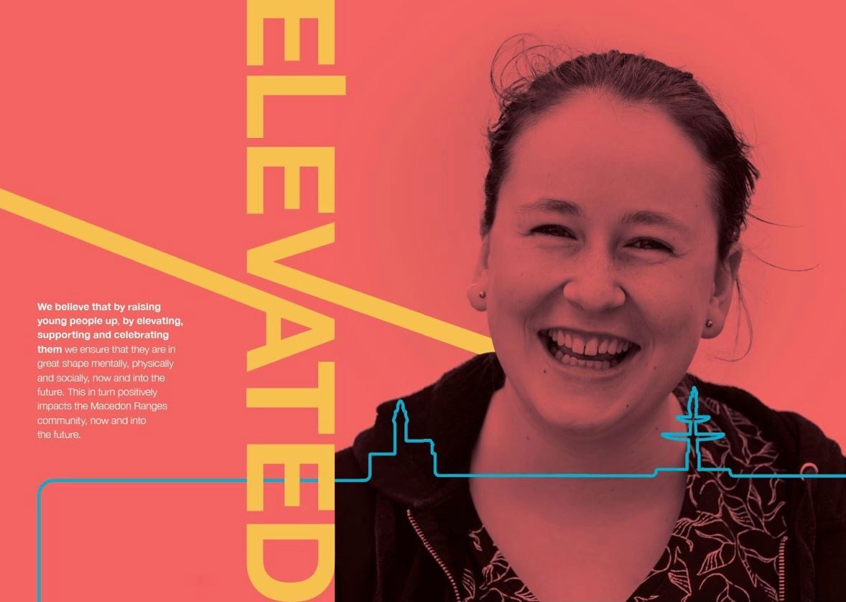

How we will implement Elevate

We will develop annual action plans that detail how we will work towards achieving our goals and objectives. These action plans will be prepared in line with Council’s budget cycle and will allow us to respond to emerging opportunities such as new streams of government funding or community-led initiatives. We will use this annual planning cycle to review and refresh the strategy as required.

We have identified high level actions, outcomes and performance indicators against each objective to guide how we promote, support and invest in youth development in the Shire over the next ten years.

How we will evaluate Elevate

Youth Summits will be held once every two years to review our work, and re-prioritise our Elevate actions. A mid-term review will be conducted internally to formally evaluate our progress and identify any emerging gaps that need to be addressed. This will likely use ‘most significant change’ evaluation methodology to highlight evidence how effectively programs are achieving the objectives set out in this Strategy.

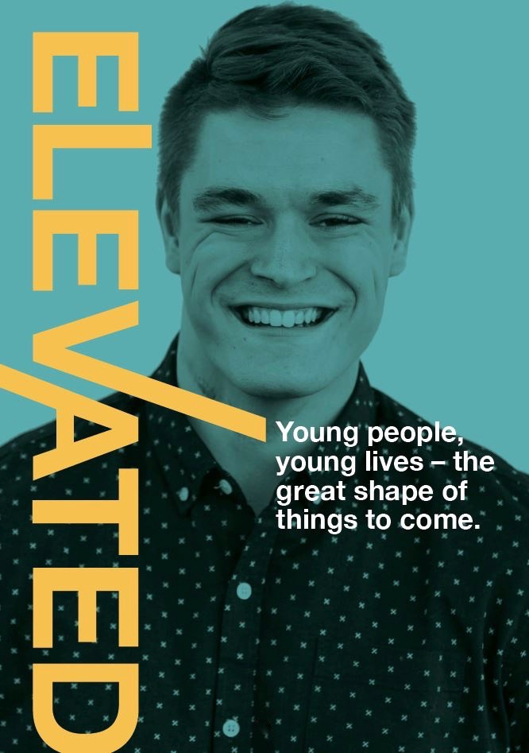

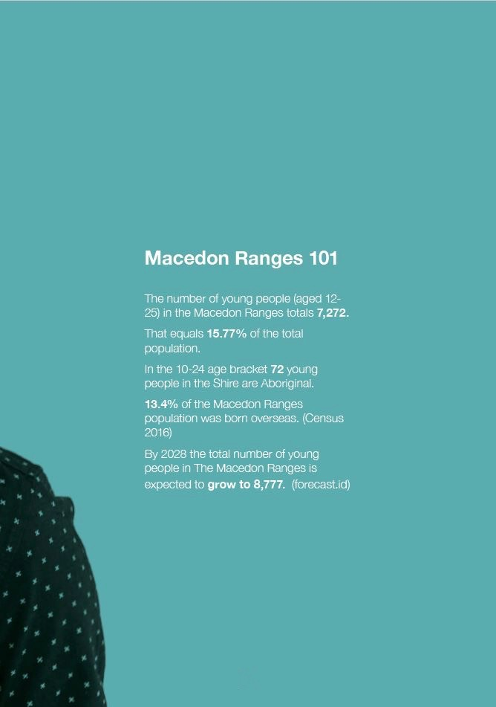

Appendix A. Survey results
An online survey was open to the public from February-April. Different question were asked to those under 25 to those over that aged over 25. The survey was promoted at events, festivals and markets by Co-designers, who assisted respondents complete the survey and, where possible, engaged in follow-up discussions.
General Information

- Age
More than 70% of respondents were aged 25 or under. The average age of those of completed the survey was 17.6 years old. n=718

Answer option | % response
12 | 4.2%
13 | 5%
14 | 3.9%
15 | 6.3%
16 | 5.6%
17 | 6%
18 | 9.4%
19 | 10.9%
20 | 7.4%
21 | 7.5%
22 | 2.1%
23 | 1%
24 | 1.4%
25 | 1.1%
25+ | 28.5%

Respondents aged 25 or under (n=512) completed the questions below. Results for those aged over 25 begin at question 14.

- What best describes you?
Two-thirds of respondents to this question aged 25 or under identified as females (n=339).

Answer option | % response
Female | 66.3%
Male | 31.5%
Non binary | 1.2%
Prefer not to say | 1%

- Do you identify as Aboriginal or Torres Strait Islander?
Five respondents identified as Aboriginal or Torres Strait Islander.

Answer option | % response
Yes | 1%
No | 99%

- What is your nearest town?
Respondents aged 25 or under were recorded for all major townships in the Macedon Ranges, with the highest number of surveys completed by individuals from Gisborne (n=134), Kyneton (n=110) and Woodend (n=94). Based on population estimates, Lancefield, Mount Macedon and Romsey were under-represented as a proportion of survey responses.

Answer option | % response
Gisborne | 26.2%
Kyneton | 21.5%
Woodend | 18.4%
Riddells Creek | 7.6%
Romsey | 6.3%
Lancefield | 5.5%
Macedon | 4.9%
Malmsbury | 2.5%
Tylden | 2.3%
Ashbourne | 1.2%
Bullengarook | 1.2%
Mount Macedon | 1%
Newham | 0.8%
Carlsruhe | 0.6%

- A range of issues have been identified as potentially impacting young people in the Macedon Ranges. Which of the following do you feel is the top issue facing young people in this area?
Over one-quarter of respondents aged 25 or under overwhelmingly perceived mental health & well-being to be the most important issue facing young people (n=133), followed by alcohol and drugs (n=74) and access to public transport (n=62). Of the list of issues provided, unwanted sexting/nudes was considered to be the least important issue. This list was compiled through qualitative findings from the youth summit and discussions with the Co-designers.

Answer option | % response
Mental health and well being | 26.1%
Alcohol and drugs | 14.5%
Access to public transport | 12.2%
Bullying | 9.8%
Pressure to succeed/stress | 6.7%
Body image | 5.3%
Suicide | 5.3%
Access to housing | 3.5%
Isolation | 3.5%
Unemployment | 3.3%
Work pathways | 3.1%
Access to health services | 2.2%
Family violence | 2.2%
Discrimination | 1.2%
Gender | 0.8%
Unwanted sexting/nudes | 0.2%

- So the biggest issue you think is [insert response to question 5 here]. What do you think is the second biggest issue?
Removing answers to what respondents regarded as the biggest issue, mental health and well-being (n=101) also rated highest as the second biggest issue, followed by alcohol and drugs (n=77) and bullying (51).

Answer option | % response
Mental health and well being | 20%
Alcohol and drugs | 15%
Bullying | 10%
Pressure to succeed/stress | 8%
Access to public transport | 7%
Suicide | 7%
Body image | 6%
Work pathways | 6%
Unemployment | 4%
Discrimination | 4%
Family violence | 4%
Isolation | 3%
Access to health services | 3%
Access to housing | 2%
Gender | 1%
Unwanted sexting/nudes | 1%

- So the biggest issue you think is [insert response to question 5 here] and the second biggest issue is [insert answer to question 6 here]. What do you think is the third biggest issue?
Answer option | % response
Alcohol and drugs | 13%
Mental health and well being | 12%
Pressure to succeed/stress | 9%
Bullying | 9%
Work pathways | 9%
Suicide | 8%
Body image | 7%
Isolation | 6%
Discrimination | 5%
Access to public transport | 5%
Unemployment | 5%
Family violence | 4%
Access to health services | 3%
Unwanted sexting/nudes | 3%
Access to housing | 2%
Gender | 1%

- In the past 12 months, how negatively affected have you been by the following issues? 1 = not affected at all. 3 = somewhat affected. 5 = very affected.
Mental health and wellbeing was also the issue respondents aged 25 or under were most affected by, however body image, access to public transportation and isolation all registered significant responses. Unlike the perceived most important issues (above) the issues individual respondents were most affected by provides a more accurate reflection of challenges.

Answer option | Average response
Mental health and well being | 2.87
Body image | 2.27
Access to public transport | 2.13
Isolation | 2.13
Bullying | 1.97
Feeling unsafe | 1.92
Access to health services | 1.87
Unemployment | 1.87
Suicide | 1.84
Gender inequality | 1.83
Alcohol and drugs | 1.78
Discrimination | 1.78
Self-harm | 1.61
Access to housing | 1.54
Sexting or nudes | 1.47
Domestic violence | 1.43

- What type of programs/events/activities would you like to see more of in the Macedon Ranges? (n=502)
Over half of all respondents aged 25 or under wanted to see more live music in the Macedon Ranges (n=279), while more youth spaces, art and sporting events all ranked highly.

Answer option | Total # responses
Live bands | 279
Youth spaces | 183
Art | 181
Sporting | 180
Comedy | 173
Theatre | 167
Sustainability/environment | 166
Laser tag | 148
Excursions/camps | 146
Cooking | 136
Culturally diverse | 135
Dance | 135
LGTQI+ | 135
Leadership | 125
Youth Summits | 112
Gaming | 106
Indigenous | 105
Parkour | 84
Spoken-word | 67
Skate park | 65
Equine | 49

- How often do you use the following facilities? 1 = never. 3 = once a month. 5 = once a week or more
Of public spaces, respondents aged 25 or under were most likely to access cafes (3.44) and parks and gardens (3.13) – averaging between once a month and once a week. The low level of usage for most other spaces probably indicates both a lack of youth-friendly spaces and young people’s access to certain spaces (transport, opening times). Anecdotally, many young people noted they travel outside of the Shire for recreation activities (Sunbury/Bendigo/Melbourne).

Answer option | Average response
Cafes | 3.44
Parks, gardens | 3.13
Sports centres | 2.58
Pubs | 2.49
Pool | 2.30
Netball/football clubs | 2.07
Theatres | 1.87
Library (outside of school) | 1.81
Kyneton or Gisborne youth spaces | 1.56
Gallery/museums | 1.50
Skate parks | 1.44

- If you needed support for a personal problem, who would you go to first?
Respondents aged 25 or under were most likely to seek support from their immediate networks, parents [n=205], friends [n=148] or siblings [n=37]. Confidentiality and accessibility were likely key factors in the least likely support people being a teacher [n=3] or school welling coordinator [n=9].

Answer option | % response
Parent | 42%
Friends | 30%
Sibling | 8%
Other (partner) | 6%
Don’t know | 4%
Other family member | 3%
Counsellor | 2%
Doctor | 2%
School wellbeing coordinator | 2%
Teacher | 1%

- What education or skills based supports would help you to achieve your work goals?
Most respondents aged 25 or under favoured on-site learning (work experience and volunteering) and mentoring as key skill development opportunities.

Answer option | Response #
Work experience/placement | 249
Volunteering | 147
Mentoring | 127
Barista training | 117
Careers expo | 104
Don’t know | 90
RSA training | 88
School careers counsellor | 83
TAFE | 79
Small business help | 63
Apprenticeships | 60
Other | 15

- At what age do you think young people should start learning about mental health?
Three quarters of respondents aged 25 or under favoured starting mental health education in, or before Grade 6; including nearly a third [n=156] who supported commencing before Grade 5.

Answer option | % response
Before grade 5 | 32%
Grade 6 | 22%
Grade 5 | 21%
Year 7 | 18%
Year 8 | 3%
Don’t know | 2%
Year 10 | 0%
Year 11 | 0%
Year 12 | 0%

The following questions were completed by those aged over 25 [n=202].
- What best describes you?
Three quarters of respondents to this question aged over 25 identified as females (n=154).

Answer option | % response
Female | 66.3%
Male | 22%
Prefer not to say | 2%
Non binary | 0%

- Do you identify as Aboriginal or Torres Strait Islander?
Answer option | % response
Yes | 0%
No | 100%

- What is your nearest town?
Respondents aged over 25 were most likely to have been from Gisborne (n=65), Woodend (n=41) or Kyneton (n=29).

Answer option | % response
Gisborne | 32%
Woodend | 20%
Kyneton | 14%
Lancefield | 8%
Romsey | 7%
Riddells Creek | 5%
Macedon | 4%
Malmsbury | 3%
Bullengarook | 1%
Carlsruhe | 1%
Tylden | 1%
Newham | 1%
Mount Macedon | 0%
Ashbourne | 0%

- A range of issues have been identified as potentially impacting young people in the Macedon Ranges. Which of the following do you feel is the top issue facing young people in this area?
Respondents aged over 25 considered mental health and wellbeing [n=49], alcohol and drugs [33] and access to public transport [n=24] as the top three issues; the same as respondents aged under 25.

Answer option | % response
Mental health and well being | 25%
Alcohol and drugs | 17%
Access to public transport | 12%
Bullying | 10%
Isolation | 7%
Suicide | 7%
Unemployment | 5%
Work pathways | 5%
Pressure to succeed/stress | 4%
Access to health services | 4%
Body image | 2%
Housing | 2%
Discrimination | 1%
Family violence | 1%
Sexting | 1%
Gender | 0%

- So the biggest issue you think is [insert response to question 17 here]. What do you think is the second biggest issue?
Answer option | % response
Mental health and wellbeing | 20%
Alcohol and drugs | 15%
Access to public transport | 11%
Bullying | 10%
Access to health services | 7%
Unemployment | 7%
Work pathways | 7%
Isolation | 6%
Pressure to succeed/stress | 6%
Suicide | 4%
Family violence | 4%
Housing | 1%
Sexting | 1%
Gender | 1%
Discrimination | 1%

- So the biggest issue you think is [insert response to question 17 here] and the second biggest issue is [insert answer to question 18 here]. What do you think is the third biggest issue?
Answer option | % response
Alcohol and drugs | 13%
Bullying | 11%
Isolation | 10%
Access to public transport | 10%
Mental health and well being | 9%
Pressure to succeed/stress | 9%
Unemployment | 9%
Work pathways | 8%
Body image | 6%
Housing | 5%
Suicide | 4%
Access to health services | 3%
Family violence | 1%
Discrimination | 1%
Gender | 1%
Sexting | 1%

- What type of programs/events/activities would you like to see more of in the Macedon Ranges? [n=197]
Most respondents over 25 (54%) indicated a desire for more live music, with sporting (46%) the second highest.

Answer option | Total # responses
Live bands | 104
Sporting | 91
Youth spaces | 90
Excursions/camps | 64
Leadership | 60
Art | 59
Dance | 59
Theatre | 58
Comedy | 54
Sustainability/environment | 49
Youth summits | 49
Equine | 48
LGBTIQ+ | 45
Skate park | 45
Cooking | 43
Culturally diverse | 36
Indigenous | 34
Laser tag | 25
Gaming | 22
Parkour | 20
Spoken work | 20

- What education or skills based supports would help you to achieve your work goals?
Respondents aged over 25 provided similar responses to those aged 25 or under, although perception of apprentices [57% versus 12%] school counsellors [40% versus 17%] ranked significantly higher for the older age cohort.

Answer option | Response #
Work experience/placement | 140
Mentoring | 129
Apprenticeships | 113
TAFE | 112
Volunteering | 98
School careers counsellor | 79
Careers expo | 72
Small business help | 64
Barista training | 55
RSA training | 48

- At what age do you think young people should start learning about mental health?
Like those aged 25 or under, most respondents aged 25 considered mental health should be taught in or before grade 6, including 48% who felt it should be first taught be grade 5 (compared with only 32% of respondents aged 25 or under).

Answer option | % response
Before grade 5 | 48%
Grade 7 | 17%
Grade 5 | 16%
Year 6 | 10%
Year 9 | 3%
Don’t know | 3%
Year 10 | 2%
Year 8 | 2%
Year 12 | 1%
Year 11 | 0%

Appendix B. Qualitative interviews

Qualitative engagement involved a total of 49 meetings/facilitated discussions led by our Co-designers, including;
16 key informant interviews
13 pop up consultations
10 focus groups
7 meetings
2 youth summits
1 regional assembly presentation session

A summary of interviews is included in the Table below.

Interview list | Org Type | Meeting type
YDU | Local Govt. | Focus group discussion
City of Bendigo | Local Govt. | Key informant interview
YACVIC | Peak body | Key informant interview
Library at the Docks | Service | Key informant interview
Go Coffee | Social enterprise | Key informant interview
Artful Dodgers | Service | Key informant interview
Victorian Emergency Mgmt. Institute | State Govt. | Key informant interview
Mary Anne Thomas | Politician | Key informant interview
MRSC Exec | Local Govt. | Meeting
MRSC Council | Local Govt. | Meeting
Business Representatives | Business | Key informant interview
Local Safety Committee | Advisory group | Focus group discussion
Vic Pol | Police | Key informant interview
Place Making group | Local Govt. | Meeting
Kyneton MRSC Staff | Local Govt. | Focus group discussion
Gisborne MRSC staff | Local Govt. | Focus group discussion
Landcare Representatives | Issue based | Focus group discussion
L4L Partners | Issue based | Focus group discussion
Service providers | Service | Focus group discussion
Windarring | Service | Key informant interview
Woodend Skate Park | Issue based | Meeting
Neighbourhood Houses | Community | Focus group discussion
LLEN | Service | Key informant interview
Youth Summit > 18 | Youth | Summit
Youth Summit < 18 | Youth | Summit
Youth Ambassadors | Youth | Focus group discussion
Bendigo Library | Service | Key informant interview
Goldfields Library Corporation (w Macedon Ranges Libraries) | Service | Meeting
Bendigo Drug and Alcohol Service? | Service | Key informant interview
Headspace Bendigo | Service | Key informant interview
School Wellbeing Coordinators | School | Focus group discussion
MRSC Disability Support | Local Govt. | Key informant interview
MRSC young parents support | Local Govt. | Key informant interview
Health and Wellbeing Committee | Local Govt. | Meeting
Youth Space | Youth | Focus group discussion
Friday youth space | Youth | Focus group discussion
Cobaw Community Health | Service | Key informant interview

Appendix C. Qualitative findings

Notes from the 70 consultation sessions were collated and coded as ‘observations’ or ‘ideas’. 28 ‘observation’ themes were identified, while ‘ideas’ were grouped as one of 53 different themes.

The full list of key issues were identified below, with bullying, mental health and alcohol and other drugs the most discussed challenges.

Issues | #
Bullying / discrimination | 17
Mental health and wellbeing | 15
Alcohol and other drugs | 14
Isolation | 9
Stress/pressure to succeed | 9
Transport | 9
Not connecting services to those most in need / access to services | 9
Toxic/dangerous relationships/fitting in/making friends | 9
Suicide | 5
Body Image | 5
Boredom | 4
LGBTIQ+/Homophobia | 4
Lack of housing/Cost of living | 4
Mental health support | 3
Work pathways | 3
Family breakdown/violence | 3
Post schooling transition/shock | 3
Lack of resilience | 2
Lack of job opportunities | 2
Programs/services catering to binary gender norms | 2
Affordable / emergency housing | 2
Insufficient sporting / rec facilities | 2
Poor eating habits | 2
Lack of services in Gisborne | 2
Lack of environmental awareness | 1
Social media bullying | 1
Lack of youth participation in decision making | 1
Lack skills to engage youth | 1
Young parents disconnected | 1
Peer pressure | 1
Lack of opportunities | 1
Sexual assault | 1
Obesity | 1
Chronic illness | 1
Lack of sleep | 1

The full list of ideas identified in consultations is included below.

Observations/Ideas | #
More youth spaces / Multi-purpose youth spaces (possible mobile, KYN primary or Mechanics Institutes/Town Halls) | 19
Cinema (outdoor?) | 17
Connecting young people to services / programs (being more aware of where/how) + safe spaces to share problems | 12
Improved public transport. Extend Flexiride in Woodend + beyond | 12
Youth gym / more courts / athletics track (Romsey and Gisborne) | 11
More youth friendly (opening hours for cafes and pools / WiFi) places. Barista training after café closes? | 10
AOD education needs to be more relevant | 8
More career pathways | 7
Tech space / Coding training for young people (possibly in libraries) | 6
Holiday program for students / more to do! | 6
Mentoring programs (including within sporting clubs, businesses and between uni students and young leaders) | 6
more equestrian facilities | 6
Redevelop Woodend Skate Park as youth hub | 5
Support youth leadership / participation | 5
LGBTIQ+ hangout/support | 5
Technology in public spaces (WiFi/charging stations) | 4
Transform libraries to youth friendly spaces | 4
Invest in youth social enterprises (training and funds) | 4
Generalist youth worker for the MR | 4
Supporting young parents / young parents playgroup | 4
Youth curated art spaces | 4
Increase accessibility of pools | 3
Parkour/paintball park | 3
Dance/music studio / theatre (for young people) | 3
Mental health education must start earlier | 3
Yoga/music in the park | 2
Engage young people in Council (HR / Communications) | 2
Council should support the re-establishment of L2P | 2
Better collaboration between service providers | 2
Start AOD education earlier | 2
Youth Hub hosted by Cobaw | 2
More Youth based events | 2
Life skills focus in schools/holiday program to assist transitions | 2
Sex education in schools needs to be reformed | 2
Anti-bullying campaign (and education for teachers) | 2
Info campaign - how to recognise a toxic relationship | 2
Train teachers - MHFA for teachers | 2
Community gardens in schools | 1
Connecting young people to volunteer orgs | 1
Youth Environmental Leadership Program | 1
Cross-promote events / calendar | 1
Redevelop Kyneton Skate park | 1
E-waste bin in libraries | 1
I-pad dispenser in libraries | 1
Support where young people need it (home visits) | 1
Affordable housing at nursing homes for young people | 1
Ongoing skills development for youth workers | 1
Maintain L4L | 1
Explore more opportunities for young people to be involved in emergency management | 1
Better collaboration across departments - mainstreaming 'youth engagement' | 1
Partner with Vic Pol on camps | 1
Explore ways to support 'middle years' development (i.e. 9-12) | 1
Sleep bus for emergency accommodation | 1
old hospital in Kyneton -> boarding house | 1
Greater access to recreation activities | 1
Opportunities for young indigenous leaders | 1
Disability inclusive recreational and sporting | 1
More support for youth-friendly live music | 1
Mountain Bike Facilities | 1
Self-defence classes | 1
Connecting young people to clubs (not sporting) | 1
Thrift store / social enterprise | 1
Public rock climbing walls | 1
Skype consults for doctors / counsellors | 1
Youth employment in the Macedon Ranges roadshow | 1
Develop a communication strategy to encourage businesses to give opportunities to young people | 1
Adopt a 10% youth dividend across Council's work | 1
Work with/consult younger people about types of jobs, skills and opportunities for the future | 1
More Council consultation with young people | 1
More career education in schools | 1
More effective communication pathway between Council and schools | 1
A more prominent culture and arts centre in Gisborne | 1
Improve advertising from Council | 1
Stronger partnerships between stakeholders, service providers, community members | 1
Save a mate' campaign | 1
Need more support services @ school | 1
Domestic violence awareness casual clothes day at school (DVACCDAS) | 1
stop and help' day - brainstorm solutions for anyone with a mental health problem | 1
More regular youth forums | 1
Family violence/bullied/issue Day where anyone can talk to people | 1

Appendix D. MRSC Youth Development work 2016/17

Live4Life

- Life4Live. A school and community partnership promoting mental health awareness. All Year 8 students in the Macedon Ranges secondary schools participate in Live4Life modules co-facilitated by a Life4Life crew made up of students from Years 9 and 10. All Year 11 students also complete Teen Mental Health First Aid training, while Youth Mental Health First Aid courses are run for service providers, teachers, parents and the broader community.
- Youth Life4Life Inc. Is an expansion of the Macedon Ranges’ Live4Life program, with sites in Benalla and Glenelg Shire’s. The Macedon Ranges Live4Life continues to be fully funded and led by the Macedon Ranges Shire Council along with the school and community partnership groups.
N.B. as part of our Mental Health work through our Live4Live (and Live4Life schools sessions) young people begin to learn about healthy and respectful relationship building, gender diversity, bullying as in issue and its impacts and issues that relate to body image and healthy eating.

Live4Life (2016/17 financial year stats)
Number of Live4Life crew members: 45
Number of Live4Life year 8 sessions: 47
Number of Live4Life sessions, year 8 participants: 1,157
Number of Live4Life year 11 sessions: 10
Number of Live4Life sessions year 11 participants: 597
Number of Youth Mental Health first Aid (YMHFA) sessions: 10
Number of YMHFA teachers and parents participants: 122
Number of Live4life year 8 Launch participants: (557)
Number of Live4Life year 8 Celebration participants: (600)

Events/sessions (incl. Launch and Celebration) total = 69
Participants (incl. crew) total = 1,799

Youth Engage! Program (YEP)

- Youth Spaces. Youth spaces are run in Kyneton and Woodend each week for young people aged 12-18 to socialise in a safe space with activities varying week to week. An LGBTIQ+ group also runs once a week in Kyneton, connecting and affirming, sexually and gender diverse young people.

- Youth events. Through Engage! funding and community support, the YDU has run gaming in the sticks, skate park events, outdoor cinema, pool parties and parkour demonstrations during school holidays.
YEP! Youth Engage Program (2016/17 financial year stats)
Number of Youth Space sessions: 99
Number of Youth Space participants: 564
Number of LGBTIQ youth space sessions: 19
Number of LGBTIQ Youth Space participants: 107
Number of Holiday and ancillary events: 1
Number of Holiday and ancillary events participants: 6

Events/sessions (incl. HOA and Holiday sessions) total = 119
Participants total = 677

Youth Ambassadors

- Youth Ambassadors. A youth leadership program for young people aged 17-21. The program involves a leadership camp, skills development, community project and running the annual Macedon Ranges Youth Awards.
Youth Ambassadors (2016/17 financial year stats)
Number of Youth Ambassador Program meetings: 12
Number of Youth Ambassador Program events: 2
Number of youth ambassadors: 24
Number of Participants at Youth Ambassador Events: 372

Events/sessions total = 14
Participants (incl. youth ambassadors) total = 507

Music in the Sticks.
- A skills development program funded through the FReeZA program, for event management, Battle of the Bands and skills training.

Music In The Sticks (2016/17 financial year stats)
Number of MITS crew members: 20
Number of MITS events: 4
Number of participants at MITS events: 413

Events/sessions total = 10
Participants (incl. crew) = 433

Leadership Camp
- A skills development and social bonding experience for our annual intake of Youth Ambassadors, MITS and Live4Life crew members.
Leadership Camp (2016/17 financial year stats)

Events/sessions total = 1
Number of Youth Leadership Camp Participants: 34

Appendix E - Young people & local services
Young people in the Macedon Ranges are supported by a range of services, covering health, wellbeing, employment and education, including those outlined in the table below.

Service | Location/s | Youth focus
Cobaw Community Health | Kyneton, Woodend and Romsey | Youth outreach, housing, WayOut.
Central Ranges Local Learning and Employment Network | Remote support based in Wallan | Mentoring, skills development, job placements
Macedon Ranges Health | Gisborne | Healthcare, counselling, youth clinic in schools and Gisborne
Brooke Street Medical | Woodend | Healthcare, counselling
Neighbourhood Houses | Kyneton (KCLC) & Gisborne (MRFEC)  Woodend, Romsey, Lancefield and Riddells Creek | Skills training, outreach, community connection, and accredited training support, for young people disengaged from mainstream education
Windarring | Kyneton | Disability support, employment and participation
Fieldtrip | Riddells Creek | Youth leadership and participation
Goldfields Library Corporation | Kyneton, Romsey, Woodend and Gisborne | Library services and community spaces
Victoria Police ( youth Resource Officer) | Macedon Ranges Shire | Youth outreach officer, camps for disengaged young people
Kidz Flip | Gisborne | Mentoring, training
Bendigo Health | Kyneton District Health | Child and Adolescent Mental Health Services
Social Foundry | Kyneton | Social enterprise, training, mentoring and life skills learning for at risk people

Appendix F. Youth summits
Two youth summits were held 2017 to support the development of this Strategy. A Summit with young people aged 18-25 was held in May, with a second Summit for those aged 12-17 held in November. 86 young people participated across the two summits. Each Summit was facilitated by young people, with group discussions focussed on key issues identified by the Macedon Ranges Youth Ambassadors. Key insights are included below.

Mental health
- Anxiety was flagged as a significant issue for young people, particularly those in schools.
- Body image issues span a range of challenges – femininity to masculinity. Social media is creating unrealistic expectations and pressures for young people.
- Parental pressures can be difficult to manage.
- Young people need easier access to supports.
- More needs to be done to remove the taboo around mental health issues
- Young people need more safe spaces to help support maintenance of positive mental health.
- Many young people are unaware how to help someone with a mental health issue
- Stigma around mental health issues remain – and can be perpetuated by teachers.
- Seeking help can be expensive

Alcohol and other drugs
- Experimentation is prevalent and occurring at a younger age, for some starting around 12-14.
- Binge drinking is also prevalent. A house party culture is an enabling environment.
- Young people often are not modelled sensible drinking behaviours
- Adults frame drinking as “don’t do it” so young people rebel; zero tolerance doesn’t work.
- AOD education should replace punishment. There needs to be a focus on creating a safe environment and how to support someone who is in trouble.
- AOD education should be relevant and taught by young people, not teachers
- Need to create an environment where young people feel confident talking to parents / guardians / teachers / friends about people in trouble. Young people can be scared of talking about the issue in case they get in trouble.

Life skills and preparation for adulthood
- Young people from the Macedon Ranges are often sheltered. Transitioning to study or work can be difficult, but more-so when having to move to a larger city as part of this transition.
- Schools should look to spend more time developing practical life skills; paying bills, tax, registering to vote, applying for rental properties, applying for jobs, etc.
- Big challenge – young people too protected. Transition is difficult.

Challenging relationships
- Family breakdowns can have significant effects on young people, particularly in remote locations.
- Young women are often victims in emotionally or physically abusive relationships.
- There is a poor understanding of what toxic relationships look like (including intimate partners and friends)
- Sex education requires review – more relevant information is needed, delivered by more relatable facilitators and address the heteronormative focus.
- Young people need to know where they can turn if they need help during or after a toxic relationship

Pressure to succeed
- There is constant pressure for young people to aim higher / always do something more
- Too much pressure results in low motivation, stress, anxiety and chronic illness
- There is a stigma around VCAL
- Schools need to build awareness that there are other options (pathways other than university)
- Competitive sporting teams often punish mistakes and failure

Social exclusion
- Young people often feel excluded from the community. Most spaces and most activities are geared towards people over 25.
- Young people are often excluded because of their identity – gender, race or sexual orientation.

Bullying
- Most young people experience bullying at some stage in school
- Teachers need to be better trained to identify people being bullied and then helping them (and not just as a once off)

Olena Hankivisky. 2014. Intersectionality 101.
VicHealth. 2017. Young people, health and wellbeing.
Department of Education and Training. 2017. Corporate Plan 2017-2018.
Resilient Youth Australia. 2017. Resilience Survey, Macedon Ranges Region, Year 7,8,9,10,11,12
Survey comment from young person
Mission Australia. 2017. Youth Survey Report 2017.
Australian Institute of health & Welfare. 2011. Australian Burden if Disease Study: Impact and causes of Illness and Death in Australia
World Health Organization. 2017. Depression. Let’s Talk.
National Health Service. 2014. Adult Psychiatric Morbidity Survey: Mental Health and Wellbeing, England, 2014.
Headspace. 2016. New ABS Figures: Youth suicide.
Orygen. 2016. Looking The Other Way; Young People and self-harm.
Orygen. 2016. Raising the bar for youth suicide prevention.
Mission Australia. 2017. Youth Survey Report 2017.
Live4Life. 2016. Live4Life Macedon Ranges Evaluation 2016
Survey comment from young person
Resilient Youth Australia. 2017. Resilience Survey, Macedon Ranges Region, Year 7,8,9,10,11,12
Mission Australia. 2017. Youth Survey Report 2017.
Survey comment from young person
Beyond Blue & the Black Dog Institute. 2016. Youth Mental Health Report 2012-2016.
Resilient Youth Australia. 2017. Resilience Survey, Macedon Ranges Region, Year 7,8,9,10,11,12
Our Watch. 2017. Facts and Figures.
Vic Health. 2014. Young Australians attitudes towards violence against women.
Australian Institute of Health and Welfare. 2016. ‘Illicit Drug Use’. Australia’s Health 2016.
Survey comment from young person
Australian Human Rights Commission. 2009. Human Rights and Children and Young People.
Beyond Blue. 2015. Understanding Anxiety and Depression.
Comment from a young person during community forum
Sensis. 2017. Sensis Social Media Report.
Department of Health & Human Services. 2013. Evaluating mental wellbeing and social connectedness.
Mental Health Foundation. 2012. Young Mums Together: Promoting young mother’s wellbeing.
YACVic. 2016. Turning Ideas Into Actions – Summary Report.
Gabi Rosenstreich. 2013. LGBTI People. Mental health and suicide. Revised 2nd edition. National LGBTI Health Alliance. Sydney.
Ibid.
VicHealth. 2012. Disability and health inequalities in Australia. Research summary.
YERP. 2013. The Benefit of Involving Young People.
Rys Farthing. 2012. ‘Why Youth Participation? Some Justifications and Critiques of Youth Participation Using New Labour’s Youth Policies as Case Study’. Youth & Policy. Sep 2012. 109.
Brotherhood of St Laurence. 2018. An Unfair Australia? Mapping youth unemployment hotspots.
Mental Health Association of NSW. 2016. The Impacts of Unemployment on Youth Mental Health.
Survey comment from young person
YACVic. 2016. Youth Mentoring Hub.
Committee for Economic Development Australia. 2015. Addressing Entrenched Disadvantage in Australia.
Australian Institute of Health and Welfare. 2017. Australia’s Welfare 2017.
Resilient Youth Australia. 2017. Resilience Survey, Macedon Ranges Region, Year 7,8,9,10,11,12
Survey comment from young person
Department of Health and Human Services. 2017. Youth Space Latrobe. The co-design journey.
When asked how frequently you visit a library, with 0 = never, 3 = once a month and 5 = once a week, survey respondents averaged 1.81 / 5.
See Library at the Docks
VicHealth. 2010. Opportunities for Social Connection. A determinant of mental health and wellbeing. Summary of learnings and implications
Cafes were the most frequented space young people listed.
Survey comment from a young person
Sensis. 2017. Social Media Report. Australians and social media.
Statista. 2017. Reach of leading social media and networking sites used by teenagers and young adults in the United States as of February 2017.
End notes
See AITEC. 2016. Adelaide Hills Youth Services Bus and Other Models and City of Casey. 2017. 360 Youth Service Bus
Nursing homes in Europe have trialled offering free accommodation to young people in exchange for work. See Johanna Harris. 2016. ‘Here’s why some Dutch university students are living in nursing homes.’ The Conversation.
See City of Melbourne. 2017. Library at the Docks and NMC. 2017. ‘Trends Accelerating Technology Adoption in Academic and Research Libraries’ in NMC 2017 Library Edition.

