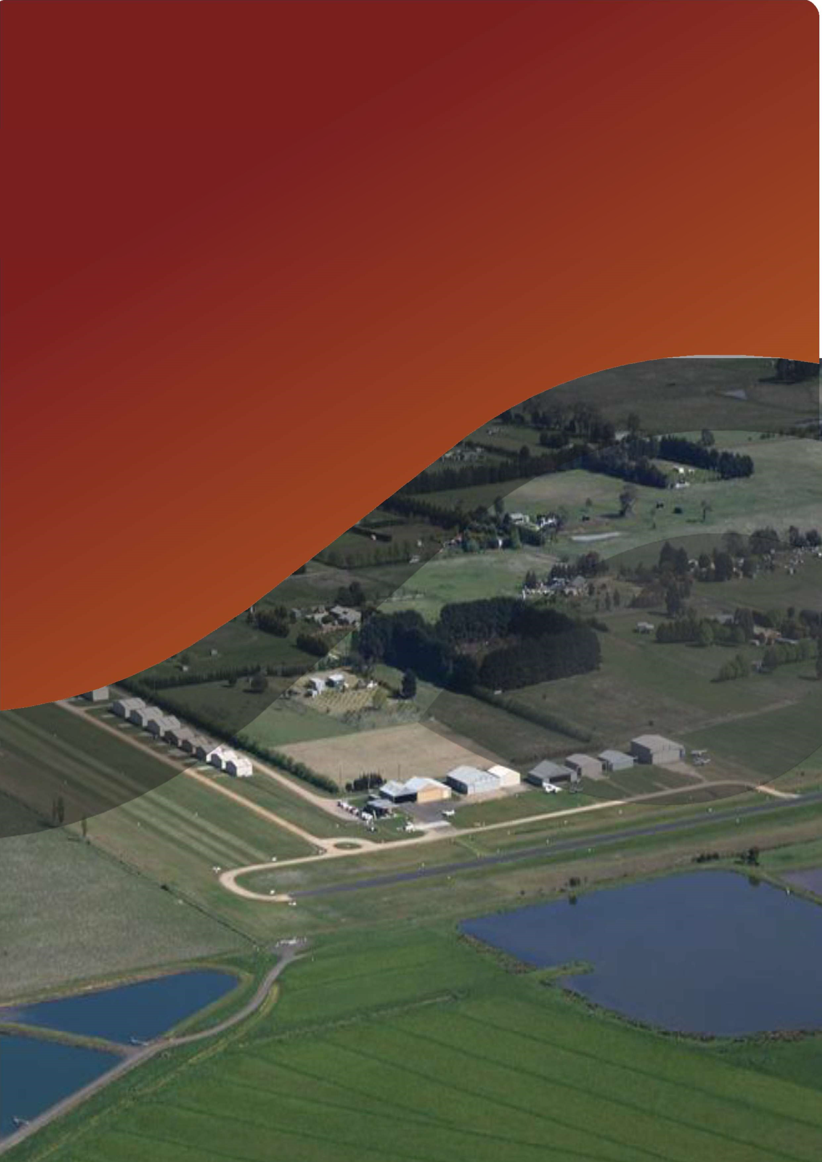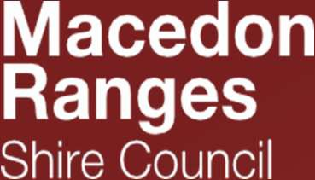P

Kyneton Airfield Master Plan 2019

Adopted by Council at their Ordinary Council Meeting of 22 July 2020

Contents

Introduction 1
Overview of Airfield 1
Purpose of the Master Plan 1
Conditions Precedent 2
Methodology and Consultation 2
Master Plan Structure 3
Background Information 4
Master Plan Context 4
Regional Context 4
Economic Context 4
Regulatory and Policy Context 4
Previous Master Plans 5
Key Stakeholders 5
Current Situation 5
Ownership and Management 5
Airfield Site Description 6
Surrounding Land 7
Existing Activities 7
Existing Facilities 8
Ground Access 8
Utility Services 9
Environmental Values 9
Heritage Values 9
Planning and Policy Context. 10
Macedon Ranges Planning Scheme and Land Use Precinct Guidelines 10
Municipal Strategic Statement 10
Local Planning Policies 10
Zones 11
Overlays 11
Council Plan 16
Kyneton Structure Plan 17
Economic Development 17
Kyneton Airfield Economic Opportunities Analysis 17
Airport Planning Parameters 17
Aircraft Operations Activity Forecast 17
Selected Design Aircraft 18
Navigation Systems 18
Aerodrome Reference Code 19
Determining Applicable MOS 139 Standards 19
Determining Runway Length and Width 20
SWOT Analysis 21
Airfield Master Plan 23
Strategic Vision and Objectives 23
Vision 23
Objectives 23
Facilities Development Plan 23
Movement Area Facilities 23
Aviation Support Facilities 25
Other Supplementary Facilities 27
Non-aviation / commercial development 27
Airport Safeguarding Plan 27
Implementation Plan 31
Planning Scheme Amendment 31
Municipal Strategic Statement 31
Design and Development Overlay Schedule 2 31
Airport Environs Overlay 31
Environmental Significance Overlay Schedule 7 (Wastewater Treatment Facilities) 31
Operations Manual. 32
Indicative Implementation Plan 32
Appendices 33

Prepared with data from:

To70 Aviation (Australia) Airport Surveys Pty Ltd
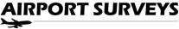

Introduction

Overview of Airfield

Kyneton Airfield is located approximately 2km north of the Kyneton Township. It is owned by the Macedon Ranges Shire Council (MRSC) and currently operated by the Kyneton Aero Club (KAC). The airfield is used for General Aviation (GA) including recreational flying, flight training provided by the KAC’s flight school, as well as occasional charter, aerial ambulance, and aerial firefighting activities undertaken by contractors on behalf of the Country Fire Authority (CFA) and Emergency Management Victoria.

In September 2014, to continue the use of the site for the purposes of an airfield on a permanent basis, Council resolved to review the governance and operations arrangements for the site and to prepare a Master Plan for the Airfield. An initial draft was released for public consultation in 2016 where significant feedback was obtained.

The review of the draft Kyneton Airfield Master Plan 2016 (Draft 2016 Plan) and subsequent development of the Kyneton Airfield Master Plan 2019 (2019 Plan) has been prepared in response to feedback provided and Council’s commitment to better planning for the future operation of the site and its surrounds. The 2019 Plan has been developed in line with the Australian Airports Association – Regional Airport Master Planning Guidelines.

Purpose of the Master Plan

The purpose of the 2019 Plan is to:

Review the existing on-ground facilities that comprise the airfield site.

Review the current level of aircraft activity occurring on the site.

Provide an assessment of potential future demand for the use of the site by various aircraft.

Examine the potential opportunities and constraints to further airfield related development on the site.

Consider surrounding land uses and address potential impacts that may result from development of the site.

Outline a vision for future airfield related development and land use on the site.

Provide implementation actions to be undertaken through amendments to the Macedon Ranges Planning Scheme and via other measures to facilitate the Master Plan vision for the site.

Conditions Precedent

There are four items that are conditions precedent prior to the full implementation of the 2019 Plan. These items are:

Resolution of planning permit anomalies pertaining the installation of the aircraft hangars.

Resolution of proposed planning scheme amendments.

Risk review of operations and operating model, noting a requirement to look beyond the airfield boundaries.

Confirmation and resolution of any technical matters arising from the three points above.

Items 1 and 2 refer to correction of planning anomalies discovered during the creation of the 2019 Plan. These need to be addressed prior to the implementation of any other action items presented under the section titled Airfield Master Plan [page 23].

Item 3 extends the current operational risk assessment and mitigation from within the boundary of the airfield to review risk impacts beyond the airfield boundary.

Item 4 is a hold point to enable resolution of any issues identified as a result of completing items 1, 2 and 3.

Methodology and Consultation

Feedback from consultation with a number of groups helped inform the development of the Draft Kyneton Airfield Master Plan 2016. As the primary user group and current managers of the site, the Kyneton Aero Club was initially consulted to understand the operating arrangements on site and gauge the Aero Club’s expectations over the potential future development of the site.

From the public exhibition of the Draft 2016 Plan, Council received subject matter expert recommendations from the Environmental Protection Agency (EPA), VicRoads, Coliban Water, Department of Jobs, Precincts and Regions (formerly Department of Economic Development, Jobs, Transport and Resources), Department of Environment, Water, Land and Planning (DEWLP), the Country Fire Authority (CFA) and Kyneton Airfield Advisory Committee. This feedback has been considered in the development of the 2019 Plan.

As a result of the community consultation, 179 submissions were received from public and airfield stakeholders. These have formed the basis of this revised 2019 Plan.

Master Plan Structure

The 2019 Plan has been developed in line with the Regional Airport Master Planning Guidelines set by the Australian Airports Association (AAA); and therefore reflects the structure recommended by the AAA.

The 2019 Plan comprises two parts, being; background information pertaining to the airfield, its uses and the surrounding area and town. The second part details the planning and policy context which is applied to the airfield. An assessment of the relevant Planning Policy Context and Aircraft Assessment Criteria is then presented, which informed the SWOT analysis for the site.

The 2019 Plan defines the Strategic Vision and Objectives for the site, including the Master Plan diagram. The plan for the future development of the airfields physical facilities and infrastructure is discussed and subsequent changes to the airspaces protection surfaces and noise contours.

Background Information

Master Plan Context

Regional Context

Situated on the banks of the Campaspe River, the township of Kyneton is located 89 kilometres north-west from Melbourne CBD and is part of the Macedon Ranges Shire. The town centre is of historic significance with granite and cobble stone pavements.

The 2016 Australian Bureau of Statistics (ABS) Census results had the Kyneton District population at 6,951 (Usual Residence Population). The 2019 population forecast for the Kyneton District is 9,322, and is forecast to grow to 11,431 by 2036 which is a 22.63% increase between the two periods. (Data prepared by forecast.id using the Estimated Resident Population from the ABS)

Macedon Ranges Shire has a long history of urban and rural development, and this coupled with changes to the transport network has created some diversity in the role and function of areas within the Shire.

Economic Context

Kyneton is largely reliant on the mix of service, industry, retail and tourist-related activities that co-exist within the town.

Regulatory and Policy Context

Considerations have been given to the below regulations and policies in preparation of the 2029 Plan. Due to the characteristics of Kyneton Airfield; not all publications are binding but best practice is enforced where reasonably practicable.

Civil Aviation Safety Regulations 1998 (CASRs).

Civil Aviation Advisory Publication No 92-1(1) Guidelines for aeroplane landing areas.

National Airports Safeguarding Framework.

Environment Protection and Biodiversity Conservation Act.

Department of Environment, Land, Water and Planning – Planning Policy Framework.

Macedon Ranges Shire Council Planning Controls.

Macedon Ranges Settlement Strategy 2011: Recognises the community’s desire to see Kyneton expand, the growing significance of tourism, and the need to maximise the use of existing infrastructure.

Macedon Ranges Shire Council Climate Change Action Plan 2017

Previous Master Plans

The Draft 2016 Plan was met with varying degrees of objections, but a consistent theme presented was that this draft had no substance, proposals were too unclear and economic opportunities and developments were based on assumptions. This 2019 Plan revisits the proposals in the Draft 2016 Plan and investigates sensible development while representing the community as a whole.

In 2014 Macedon Ranges Shire Council undertook an Economic Opportunities Analysis for the Kyneton Airfield. This project stemmed from a Council resolution from June 2012 that recommended Council apply for funds from the Department of Business and Innovation for a study into available infrastructure and expansion opportunities within the Kyneton Airfield and surrounding region for the longer term.

The Economic Opportunities Analysis examined the function and role of the airfield and explored opportunities for and constraints to future development of the airfield site for both Council and community benefit. This process culminated in Council’s resolution mentioned above. It is intended that the review of the governance matters relating to the site will follow the adoption of this 2019 Plan.

Key Stakeholders

Aside from the community being the primary stakeholder and who will contribute the most valuable feedback, the aforementioned Methodology and Consultation section identified numerous key stakeholders which will influence the future direction of Kyneton Airfield. Detailed outcomes from the Draft 2016 Plan realised the following as key stakeholders: Environment Protection Authority (EPA), Regional Roads Victoria (formerly VicRoads), Coliban Water, Department Jobs Precincts and Regions (DJPR), Department of Environment Land Water and Planning (DEWLP), Country Fire Authority (CFA) and the Kyneton Aero Club.

Current Situation

Ownership and Management

The Airfield is owned by Macedon Ranges Shire Council and is operated under a service agreement with the Kyneton Aero Club, who have managed the site since 1966. As the airfield is uncertified, it is considered a low upkeep facility in aviation standards. This results as a cost neutral asset for Council as it is self-sustaining and requires little oversite by Council due to the work conducted by the Aero Club under the service agreement provisions.

Council generates revenue from Kyneton Airfield through site leases and Council rates. The lease component is then returned to the Kyneton Aero Club on an annual basis for maintenance and upkeep of the site. This is considered the most beneficial arrangement as the cost of maintaining the airfield by council would exceed the returned lease amount. The costs associated with running the Aero Club is raised through membership fees.

Airfield Site Description

The Kyneton Airfield has been in operation since 1962 and was constructed by the former Shire of Kyneton.

It is an unregistered aerodrome located at 1503 Kyneton Metcalfe Road, Kyneton. The site is not registered with the Civil Aviation Safety Authority (CASA) and is uncertified in terms of its ability to comply with Manual of Standards Part 139 regulations.

The site has an approximate area of 197,000 square metres and is irregular in shape, with its two runways defining the north-south and east-west axis of the site (see Figure 1 below). The airfield currently comprises two lots, being the original airfield site, which is accessed directly from Kyneton-Metcalfe Road, and an adjoining piece of land at 8 Rawson Place. 8 Rawson Place was acquired by Council during subsequent subdivision of the land to the north west of the site for rural residential development.

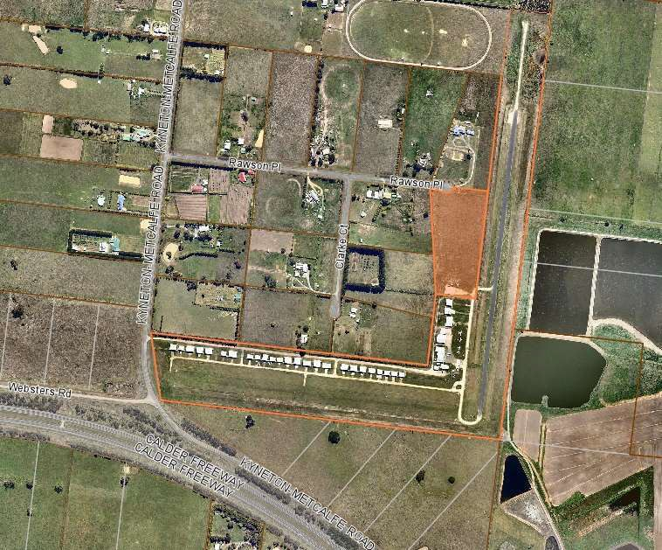
Figure 1: Kyneton Airfield site and surrounds with 8 Rawson Place shaded

The Airfield has two runways:

Runway 18/36 - a 700m sealed north-south runway with an additional unsealed overrun of 150m towards the north boundary of the site; and

Runway 09/27 - a 650m unsealed grassed east-west runway

The site currently accommodates 25 hangars on privately rented sites adjoining the entry way to the site and Runway 09/27. A club house and training room for the Kyneton Aero Club and several larger hangars and sheds are situated opposite Runway 18/36. The northern most hangar is situated on the adjoining council owned lot at 8 Rawson Place. In total there are 34 buildings on the airfield site.

Surrounding Land

The site is surrounded mainly by private properties which until the mid-1980s were used exclusively as farming land. The western boundary of the site abuts several of these properties which are all approximately 26,000sqm in area. These lots are within the Farming Zone and some are used for rural residential purposes while others are vacant or used for grazing.

The northern end of the airfield’s western boundary abuts another larger lot which is also in the Farming Zone and accommodates a dwelling, outbuildings and a horse training racecourse. Immediately to the north of this lot is a larger property, also in the Farming Zone, which accommodates a dwelling and farm related outbuildings and a large paddock used for horse training.

The eastern boundary of the site abuts a sewerage treatment plant operated by Coliban Water, which is zoned Public Use Zone Schedule 1 (PUZ1 – Service & Utility).

A large piece of Farming Zone land comprising five separate lots adjoins the airfield site to the south. This property is approximately 43,419sqm and is triangular shaped with a gradual slope towards its south western perimeter, which abuts Kyneton-Metcalfe Road.

Kyneton-Metcalfe Road, which provides access to the site accommodates a very low number of vehicles with a Council traffic count conducted in early 2016 indicating no more than 500 vehicles travelling past the airfield site in each direction every 24 hours.

Existing Activities

The main activities that occur at Kyneton Airfield are associated with the Aero Club and they focus principally on recreational flying. Some flight training occurring and occasional aviation-related events (e.g. Kyneton Air show, World’s Biggest Morning Tea) occur from time to time.

There are commercial scenic flights and non-commercial aircraft maintenance activities occurring at the Airfield, however these operators are not based at the Kyneton Airfield.

Existing Facilities

Kyneton Airfield is located approximately 2km north of Kyneton. It has two runways, RWY18- 36 of 700m (bitumen) with approximately 150 metres of gravel overrun to the north and RWY09-27 of 650 metres (grass). Aviation Gasoline (AVGAS) is available via a fixed self- service fuel bowser and airfield lighting is provided via a Pilot Activated Lighting (PAL) system on both runways and taxiways.

The airfield includes 34 hangars which typically house around 60 aircraft. The hangars are all privately owned but constructed on Council land. A waiting list of parties wishing to lease sites from Council to construct additional hangars is maintained by the Aero Club. Designated itinerant aircraft parking areas are located on the grass to the north of the fuel bowser or on the grass south of the aero club building.

The Kyneton Airfield currently serves small aircraft used for recreational flying and pilot training. It also accommodates occasional charter operations with tourists and business visitors, and helicopters including air ambulance and aerial firefighting aircraft, in an informal capacity without any dedicated infrastructure. Helicopters using AVGAS can refuel at the fixed bowser. Water, electricity and on site wastewater treatment are provided.

Aerial firefighting aircraft that have operated from Kyneton Airfield have used water from the Kyneton Wastewater Treatment Plant immediately to the east of the airfield. These aircraft are refuelled using portable tankers supplied by the operators, as they rely on AVTUR jet fuel, which is not available on site. Firefighting personnel also benefit from the club house and amenities provided on site.

Ground Access

A gravel road provides site access from Kyneton-Metcalfe Road which runs parallel to RWY 09/27 and extends to the Aero Club building. Some adjacent properties have access gates from the gravel road.

The following traffic flow data was collected during a 2016 study:

- Vehicles travelling north on Metcalfe Rd per day or vpd figure (past the site) 3159 vehicles over 7 days; 447 vehicles per day

AM Peak 1145 - 1245 (34) AM PHF = 0.90

PM Peak 1615 - 1715 (50) PM PHF = 0.88

- Vehicles travelling south on Metcalfe Rd per day of vpd figure (past the site) 3365 vehicles over 7 days; 477 vehicles per day

AM Peak 0800 - 0900 (49) AM PHF=0.77

PM Peak 1600 - 1700 (35) PM PHF=0.83

Utility Services

Powercor provide power and electrical assets to the airfield via Clarke Court. There are three high voltage poles with 22kV overhead power lines which then feed the flight training building and the club house. From the club house low voltage overhead mains line feed several of the larger north-south hangars. No other hangars currently have mains power connected.

The airfield site is currently not connected to a reticulated sewerage service. This would need to be addressed prior to any development or a permit must be sought in accordance with the ESO4 overlay.

A full utility services capability survey must be conducted and included in any future development plan.

Environmental Values

Initial assessment of both 8 Rawson Place and the southern farming land occurred early April 2019 to see if any native grass of environmental value could be identified. This assessment was inconclusive and a further assessment will be carried out.

Heritage Values

Kyneton Airfield – The airfield site has no heritage overlays applied.

Kyneton Cemetery, located 817 metres to the west of the airfield is affected by a heritage overlay under the Macedon Ranges Planning Scheme. From a planning perspective, any planning scheme amendments or developments would need to have regard to the heritage value of the Cemetery.

Planning and Policy Context

Macedon Ranges Planning Scheme and Land Use Precinct Guidelines

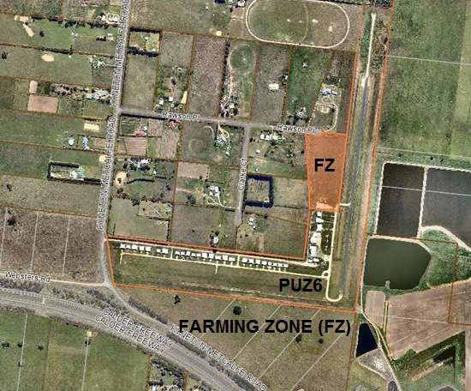
Figure 2: Current land use precincts

Municipal Strategic Statement

Council’s current Municipal Strategic Statement provides no specific policy direction regarding the Kyneton Airfield or aviation activity occurring in the Shire.

Local Planning Policies

Council’s current Local Planning Policies provide no specific policy direction regarding the Kyneton Airfield or aviation activity occurring in the Shire.

Zones

Public Use Zone Schedule 6 (PUZ6)

Most of the Airfield site is currently zoned Public Use Zone Schedule 6 (PUZ6 - Local Government). As described under Clause 36.01 of the scheme the purposes of the Public Use Zone are:

To implement the State Planning Policy Framework and the Local Planning Policy Framework, including the Municipal Strategic Statement and local planning policies.

To recognise public land use for public utility and community services and facilities.

To provide for associated uses that are consistent with the intent of the public land reservation or purpose.

Under the provisions of this zone a planning permit is not required for works or development on the site provided it is carried out by or on behalf of the public land manager. Use and development that does not meet this condition would require a planning permit. A permit is also required to subdivide land.

Farming Zone (FZ)

The Council owned lot at 8 Rawson Place is within the Farming Zone. It is proposed that this parcel of land be amended to Public Use Zone Schedule 6 to allow the development outlined in the Master Plan concept.

As described under Clause 35.07 of the scheme the purposes of the Farming Zone are:

To implement the State Planning Policy Framework and the Local Planning Policy Framework, including the Municipal Strategic Statement and local planning policies.

To provide for the use of land for agriculture. To encourage the retention of productive agricultural land.

To ensure that non-agricultural uses, including dwellings, do not adversely affect the use of land for agriculture.

To encourage the retention of employment and population to support rural communities.

To encourage use and development of land based on comprehensive and sustainable land management practices and infrastructure provision.

Clause 75.13 of the planning scheme includes an airport within the broader definition of ‘transport terminal’. The use and development of land within the Farming Zone for the purposes of a transport terminal requires a permit.

Overlays

The Airfield site is currently subject to Design and Development Overlay Schedule 2 (DDO2 – Kyneton Airfield), and the Environmental Significance Overlay Schedule 4 (ESO4 – Eppalock Proclaimed Catchment). The far south eastern corner of the site is also subject to the Land Subject to Inundation Overlay (LSIO).

Design and Development Overlay Schedule 2 (Kyneton Airfield) (DDO2)

The purpose of the DDO Schedule 2 is to ensure that development satisfied the following design objectives:

To maintain the efficiency and safety of the Kyneton airfield.

To prevent development that is incompatible with airfield operations.

To ensure that development is appropriately sited with respect to the operation of the Kyneton airfield.

To ensure that all building and works are sited to take account of and minimise any off site effects of the Kyneton airfield.

To recognise any adopted Obstacle Limitation Surface Plan (OLS).

This schedule states that a permit is not required to construct a building or carry out works provided that the building or works will not create a structure that exceeds the OLS plan requirements or impacts on the landing and take-off approaches from each end of the relevant runway.

An application for a permit subject to DDO2 is required to provide a site plan showing the location of the relevant Obstacle Limitation Surface, the height of the OLS above the site and the heights of all buildings proposed.

Before deciding on an application to use or develop land subject to the provisions of this schedule, the responsible authority must consider:

The need to prevent buildings or structures from being built which would interfere with or cause a safety hazard in aircraft operations in the immediate vicinity of the airfield.

The existing and likely future operation and development of the airfield.

An approved Obstacle Limitation Surface plan for the airfield.

The intended use and purpose of the proposed building.

The feasibility of alternative sites on the same allotment which is,

located outside any Australian Noise Exposure Forecast contour zone.

located outside any Obstacle Limitation Surface plan.

located outside the 1% approach gradient.

The proximity of the site to the boundary of any Noise Exposure Contour.

Existing and likely future flight paths and volumes of flights to and from the airfield and over the subject site.

The need for Section 173 agreements to prevent the future development of land, for uses incompatible with the operation of the Kyneton airfield.

Airport Environs Overlay Schedule 2 (AEO2)

The purpose of the AEO is:

To implement the State Planning Policy Framework and the Local Planning Policy Framework, including the Municipal Strategic Statement and local planning policies.

To identify areas which are or will be subject to high levels of aircraft noise, including areas where the use of land for uses sensitive to aircraft noise will need to be restricted.

To ensure that land use and development are compatible with the operation of airports in accordance with the appropriate airport strategy or Master Plan and with safe air navigation for aircraft approaching and departing the airfield.

To assist in shielding people from the impact of aircraft noise by requiring appropriate noise attenuation measures in new dwellings and other noise sensitive buildings.

To limit the number of people residing in the area or likely to be subject to significant levels of aircraft noise.

A permit is not required for buildings and works under this Overlay, but where a permit for construction of a building is triggered the following requirement applies:

Any new building must be constructed so as to comply with any noise attenuation measures required by Section 3 of Australian Standard AS 2021- 2015, Acoustics - Aircraft Noise Intrusion - Building Siting and Construction, issued by Standards Australia Limited.

As well as the provisions of the State and Local Planning Policy Frameworks, a responsible authority must consider:

Whether the proposal will result in an increase in the number of dwellings and people affected by aircraft noise.

Whether the proposal is compatible with the present and future operation of the airport in accordance with the appropriate airport strategy or Master Plan.

Whether the design of the building incorporates appropriate noise attenuation measures.

The views of the airport owner.

Schedule 2 to the AEO requires that an application to use land for a number of uses, including accommodation, office or place of assembly, must be referred to the airport owner for comment.

Environmental Significance Overlay Schedule 4 (ESO4) (Eppalock Catchment)
The purpose and environmental objective of ESO4 is to ensure the protection and maintenance of water quality and water yield within the Eppalock Water Supply Catchment Area as listed under Section 5 of the Catchment and Land Protection Act 1994.

Under the provisions of this overlay a permit is required for buildings and works for the purposes of Accommodation (including a Dwelling) if it is not connected to reticulated sewerage.

Proposed Environmental Significance Overlay Schedule 7 (ESO7) (Wastewater Treatment Facilities)

Council is currently considering applying a new schedule to the Shire’s ESO to address development within proximity to wastewater treatment facilities under Planning Scheme Amendments.

The Statement of Environmental Significance under the draft ESO7 provisions states:

Wastewater treatment facilities within the Shire treat domestic sewage and commercial and industrial trade waste under an Environment Protection Authority scheduled premises licence that allows for discharge to local waterways or irrigation re-use.

The ongoing operation of these facilities is critical for maintaining public health, the protection of the environment, and protection of valuable community assets.

Land within this overlay should not be developed for any purpose that might compromise the continued operation or expansion of wastewater treatment facilities to service the future growth of the Shire.

The proposed environmental objectives to be achieved by ESO7 are:

To protect wastewater treatment facilities from encroachment by sensitive uses.

To make landowners aware of the buffer area to wastewater treatment facilities and of its likely expansion or intensification of use over time.

To ensure that applications for development which may impact on the ongoing operation of a wastewater treatment facility are referred to the relevant agency.

Under the draft provisions of this overlay schedule a planning permit will be required for works on the airfield site, in accordance with the proposed overlay extent indicated in red on the map at Appendix 3 to this report.

Referral to Coliban Water will be required for any permit triggered under this Overlay, with consent of the authority required for a permit to be granted.

Land Subject to Inundation Overlay (LSIO)

The purpose of the LSIO is:

To implement the State Planning Policy Framework and the Local Planning Policy Framework, including the Municipal Strategic Statement and local planning policies.

To identify land in a flood storage or flood fringe area affected by the 1 in 100 year flood or any other area determined by the floodplain management authority.

To ensure that development maintains the free passage and temporary storage of floodwaters, minimises flood damage, is compatible with the flood hazard and local drainage conditions and will not cause any significant rise in flood level or flow velocity.

To reflect any declaration under Division 4 of Part 10 of the Water Act, 1989 where a declaration has been made.

To protect water quality in accordance with the provisions of relevant State Environment Protection Policies, particularly in accordance with Clauses 33 and 35 of the State Environment Protection Policy (Waters of Victoria).

To ensure that development maintains or improves river and wetland health, waterway protection and flood plain health.

A permit is generally required under this overlay to construct a building or to construct or carry out works and a permit is also required to subdivide land. An application must be referred to the relevant floodplain management authority.
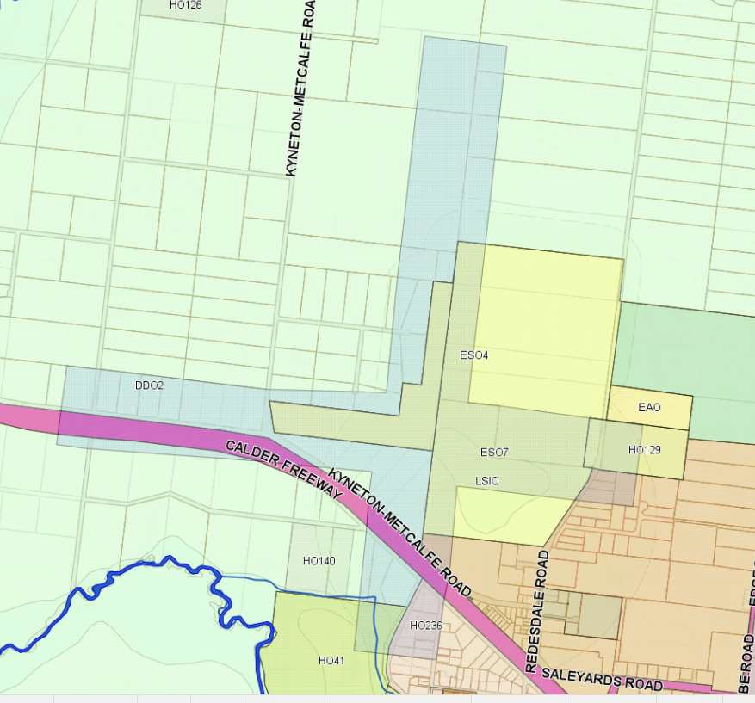
Figure 3: Planning Overlays applicable to the airfield and surrounds

Council Plan

The Council Plan 2017 – 2027 outlines the key priorities for the next four to ten years, and sets out how Council will invest in the services and facilities such as the Airfield.

Priorities | Objectives
Promote health and wellbeing | We will contribute to positive health and wellbeing in our community by proactively supporting mental health, the prevention of violence against women, healthy lifestyles for all ages and abilities, social connection/ inclusion, volunteers, community safety, and  arts and culture
Protect the natural environment | We will protect our natural environment through proactive environmental planning, advocacy and policy to address climate change, support biodiversity, enhance water catchment quality, and manage waste as a resource.
Improve the built environment | We will maintain our built environment— including roads, paths, buildings, open space and other assets—in a fiscally, environmentally and socially sustainable way. This includes effective land use planning, which has a direct impact on the liveability of our shire.
Enhance the social economic environment | We will foster economic vitality in a way that promotes positive individual and community health outcomes, including business diversity; housing, transport and employment options. Investment attracted to the shire will be  consistent with Council’s vision.
Deliver strong and reliable government | We will demonstrate the qualities of good governance including a clear vision and culture, transparency, respect, consistency, accountability and responsiveness.

The Council Plan aims to manage infrastructure in a sustainable and efficient way that support the delivery of services to the residents and visitors. In this regard this 2019 Plan must consider the demand for further hangar sites and potential increase in the use of the airfield site for recreational pilots and emergency services.

The Airfield is also a unique facility that attracts specific activities such as pilot training and aircraft maintenance. As such, the airfield site presents an opportunity for Council to support the development of diverse industry sectors, skilled labour and increased investment within the Shire.

Kyneton Structure Plan

The Kyneton Structure Plan was adopted by Council in June 2013 to guide the future growth and development of the town through to 2036. The Airfield site is located outside the Structure Plan Area boundary but is within the broader Study Area.

Economic Development

Kyneton Airfield Economic Opportunities Analysis

Council’s 2014 Economic Opportunities Analysis provided a number of potential outcomes for the airfield site. The development of an economic opportunities analysis report for the Kyneton Airfield stems from a Council resolution from 2012.

The development of the report involved detailed consultation including workshops, focus groups and one on one sessions with residents and other key stakeholders, and exhibition of the draft report in May 2014.

The report included an analysis of the economic and social values of the Airfield, the opportunities and constraints for the future use, land use planning issues and future governance and management structures. The report outlines economic and recreation opportunities including but not limited to extending the runway to 1,000m, additional hangars and the potential to develop the adjoining private land to the south for aviation related businesses, short term accommodation for pilots and a museum.

In line with the Economic Analysis and public consultation, Council resolved in September 2014 to ‘Develop a Master Plan for the Kyneton Airfield and surrounds including all relevant overlays and zoning requirements.’

Airport Planning Parameters

Council has committed to assessing the airfield’s potential for future development, including a technical assessment of a future expansion of facilities for increased aircraft activity. Australian aerodrome standards are addressed in the Civil Aviation Safety Regulations 1998 (CASR 1998) - Manual of Standards Part 139 – Aerodromes (MOS). These standards are based on International Civil Aviation Organization (ICAO) Annex 14, which is a recognised and commonly used international standard. Although these standards apply to registered and certified aerodromes (Kyneton Airfield is unregistered and uncertified), planning authorities can choose to use Civil Aviation Safety Authority (CASA) standards as best practice guidelines.

Aircraft Operations Activity Forecast

A detailed aircraft movement analysis has been conducted and currently, there are on average 5,110 annual aircraft movements. One movement is defined as a single take- off, single landing or a go-around/missed approach at the airfield.

Consultation with the aero club indicates that there would be sufficient future demand for up to 10,000 annual movements; if supporting infrastructure is available to aircraft operators. The 2019 Plan’s assessment of 30,000 annual movements was only a demand forecast which was used for the ANEF assessment and does not represent the realistic activity levels with sensible development.

Selected Design Aircraft

From the Draft 2016 Plan, it was identified that Council should investigate the site’s capacity for future fixed-wing and helicopter aerial firefighting operations from Kyneton Airfield. In particular, exploring the feasibility of operating the Air Tractor AT-802F at the airfield as needed. This aircraft has a higher payload than the water bombing helicopters that have previously operated from the airfield, and can be used for different missions to the helicopters.

Consultation with the CFA revealed, that ‘while expansion is not objected to, the runway extension would still not be utilised by fixed wing aviation assets as Bendigo, Avalon, Bacchus Marsh and Ballarat airfields are better suited. There would be no additional safety benefits to the Kyneton Community if the AT-802F was based at the airfield’. Further to this statement from the CFA; Tim Gill from T070 aviation consulting advised in their report that Emergency Management Victoria have no desire to operate out of Kyneton.

It is recommended that any extension to the 18/36 should be devoid of the increased firefighting capability justification.

Navigation Systems

Kyneton Airfield does not contain any navigation aids and the inclusion of any has not been identified in this report.

Aerodrome Reference Code

Determining Applicable MOS 139 Standards

The standards applicable to an aerodrome are dependent on the aircraft that the aerodrome is intended to accommodate. The aerodrome reference code is a two- element, alpha-numeric notation derived from the critical design aeroplane for that aerodrome facility.

Code element 1 |  | Code element 2
Code number | Aeroplane reference field length | Code letter | Wing span | Outer main gear wheel span
1 | Less than 800m | A | Up to but not including 15m | Up to but not including 4.5m
2 | 800m up to but not including 1200 m | B | 15m up to but not including 24m | 4.5m up to but not including 6 m
3 | 1200m up to but not including 1800 m | C | 24m up to but not including 36m | 6m up to but not including 9m
4 | 1800m and over | D | 36m up to but not including 52m | 9m up to but not including 14m
Table 1 – MOS 139 (page 2-4): Aerodrome reference code
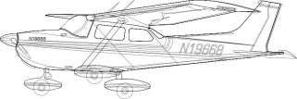
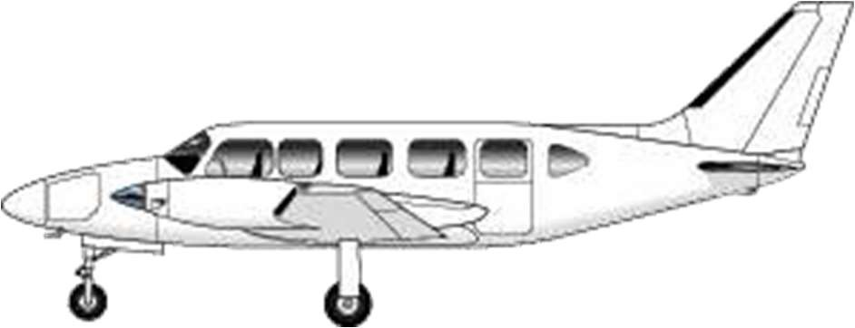
Cessna C172M PA-31-350 Navajo Chieftain

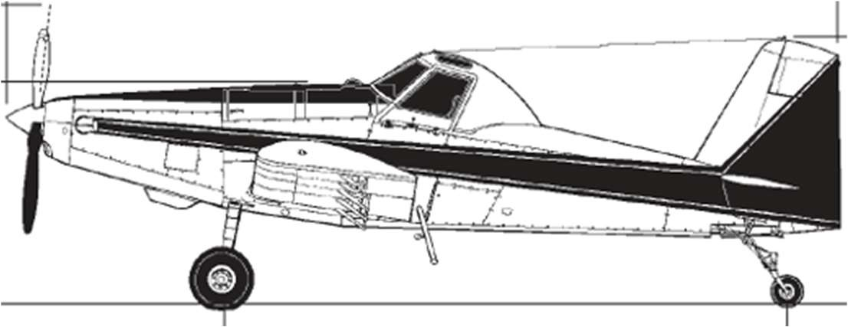

AT-802 Air Tractor

Determining Runway Length and Width

Aircraft | Aeroplane reference field length | Wing span | Outer main gear wheel span | Aerodrome reference code
CAC CA-25  Winjeel | Less than 800m | 11.8m | 3.1m | 1A
Piper PA-30 Twin Comanche | Less than 800m | 11.0m | 2.2m | 1A
Piper PA-31- 350 Navajo  Chieftain | Less than 800m | 12.4m | 4.3m | 1A
Air Tractor AT-802F | Less than 800m | 18.0m | 3.1m | 1B
Table 2 – Aerodrome reference code for critical aircraft at Kyneton Airfield

The Twin Comanche and visiting Winjeel operate safely at the Kyneton Airfield with the current north-south length. The current 700m runway is not of sufficient length to meet the aeroplane reference field length of the Piper PA-31-350 Navajo, which could be used if the north-south runway were extended by a further 65m.

Other CASA Criteria

CASA’s Manual of Standards prescribes other operational criteria for aerodromes including pavement strength and the radius of taxiway turning points that may be relevant to the operation of the airfield. A further assessment of the relevance of these criteria will be undertaken if upgrading works are proposed in the future.

SWOT Analysis

A SWOT analysis is a tool for documenting internal strengths (S) and weaknesses (W), as well as external opportunities (O) and threats (T). The following section outlines the SWOT analysis for the Kyneton Airfield.

Strengths
- The site is located in a rural area adjacent to road and water services infrastructure.
- Most of the existing airfield is located in Public Use Zone.
- Buildings on the site already accommodate aviation related uses and existing infrastructure on site is of a good standard for current aircraft operations.
- The Farming Zone restricts further residential development in the surrounding area.
- The site has access to water and power infrastructure.
- The site is provided with good access from the Calder freeway via Kyneton- Metcalfe Road.
- Kyneton-Metcalfe Road carries relatively low levels of vehicle traffic but is increasing.
- The adjoining property to the south is undeveloped and offers a good buffer for the required public safety area.
- Airfield maintenance and management is managed by Kyneton Aero Club through a service agreement which realises a cost neutral solution to Council.
Weaknesses
- Operation of the site provides Council with positive revenue from rates but not sufficient to support minor facilities upgrades or building improvements.
- Existing north south runway 18/36 is not long enough to appropriately accommodate larger water bombing aircraft or to meet CASA’s MOS 139 criteria.
- Some sensitive uses including house and accommodation exist near the airfield site.
- The Airfield is not supervised on day to day basis and air traffic cannot be managed.
- Aircraft noise and the inability to enforce local procedures to visiting aircraft has been problematic and a concern with local community.

Opportunities
- The Council owned land at 8 Rawson Place provides opportunity to accommodate further hangar development and business precinct.
- Extending the north-south runway provides an additional opportunity to improve amenity for surrounding land uses by locating aircraft landings and departures further to the north.
- Upgrade existing infrastructure so that the existing facilities become more attractive as a dual use facility.
- Opportunity to formalise a helicopter landing pad and commercial helicopter operations which would also benefit Aerial Ambulance as they currently operate on the runway.
- Opportunity to provide local employment opportunities on the site via aircraft related uses and tourism development.
Threats
- Aircraft clearance from obstacles, including trees, electricity lines, vehicle traffic on the Calder Freeway and existing buildings and structures on site, need to be ensured.
- Additional development around the airfield may result in amenity conflicts.

Table 3 – SWOT Analysis

Airfield Master Plan

Strategic Vision and Objectives

Vision

This 2019 Plan’s vision for the Kyneton Airfield is:

To develop the Kyneton Airfield site in line with all applicable standards to ensure that the site remains a unique recreational and emergency services asset for the Shire providing for recreational aircraft, associated commercial activity and broader community benefits.

Objectives

To guide the fulfilment of the above stated vision, the following objectives are proposed:

To continue to facilitate recreational aircraft use on site via additional hangars and associated infrastructure that is appropriately scaled and sited with regard to setbacks from site boundaries, runway strips and existing structures and within specified OLS derived height restrictions.

To increase the amenity value of the site by upgrading existing community accessible infrastructure and develop further working accommodation for emergency service personnel during airfield use.

Sensibly develop the Council owned 8 Rawson Place to deliver additional hangar spaces for the purpose of aviation maintenance. The land offers opportunity for supplementary apron areas for aircraft parking of visiting aircraft.

Facilities Development Plan

This facilities development charter has been prepared to provide strategic direction for any future proposed development of the Kyneton Airfield and Council owned 8 Rawson Place. The following information sets the framework for the improvement of Kyneton Airfield but any proposed development, even within the scope of the framework, must be accompanied by a formal development plan.

Movement Area Facilities

» Runways

The Draft 2016 Plan proposed to provide for an extension of the site’s main north-south runway (Runway 18/36) towards the site’s southern boundary by approximately 300m. Consultation with Coliban Water revealed that a runway extension to the south would cross two significant Coliban Water assets, being; sewer rising from Malmsbury to the water reclamation plant and the discharge to the Campaspe River. Buildings and structures are not to be built within or over five metres of a sewer rising. Additionally; there are concerns about the distance between the newly proposed RWY threshold and the Calder Freeway in accordance with the National Airports Safeguarding Framework and the State Government Planning Scheme Amendment VC 128 Clause 18.04.2 – Planning for Airports.

It is no longer proposed to extend the 18/36 runway to the south. As stated in the Selected Design Aircraft section; extending the runway to address the requirements for accommodating water bombing fixed wing aircraft is invalid.

The 150 metre gravel section of RWY 36 is to be sealed to increase the Landing Distance Available (LDA) and also to provide an increased Take-off Runway Available (TORA) for RWY 18 and to get aircraft to a higher altitude when departing to the south.
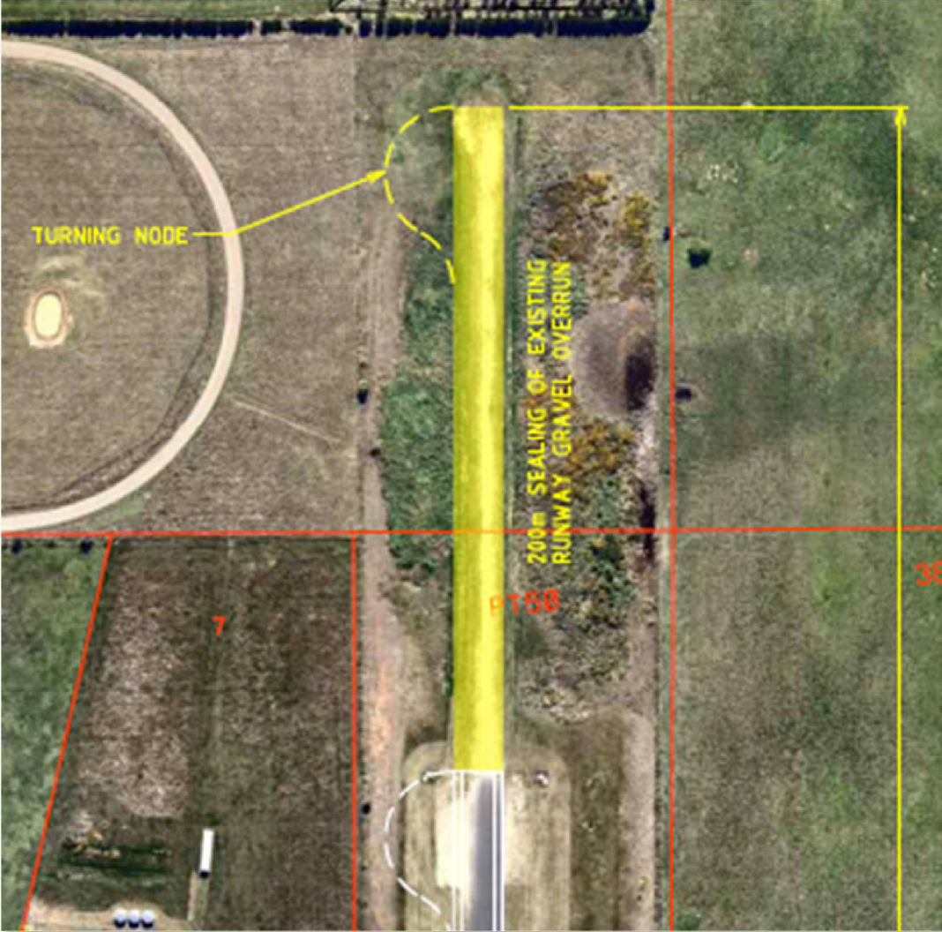
Figure 4: Runway 18/36 Northern overrun seal

» Taxiways

The taxiway is to be extended up to the 8 Rawson Place boundary

» Aprons, aircraft parking areas

Additional short term parking areas to be established along 8 Rawson Place with tie down points. The existing apron areas outside the north-south hangar precinct are heavily degraded and require resealing and should be considered in development upgrades

» Lighting

Lighting upgrades to the current PAL LIRL will not be necessary for the northern runway extension as the displaced threshold will begin from the current runway end, but additional investment will need to be consumed to add lighting to the extended taxiway.

Aviation Support Facilities

» Fuel facilities

Fuel facilities are acceptable at Kyneton Airfield and no further investment is proposed. An eye wash station and emergency shower will need to be installed close to the aviation fuel bowser.

» Aircraft hangars

The re-zoning of 8 Rawson Place allows for approximately three aviation business hangars that could support maintenance, avionics, restoration and charter businesses.

Current Kyneton Aero Club membership sits at over 170 members over 34 hangars, housing approximately 60 aircraft. Consultation with Kyneton Aero Club suggest there are close to 20 members on the waiting list for a hangar permit.

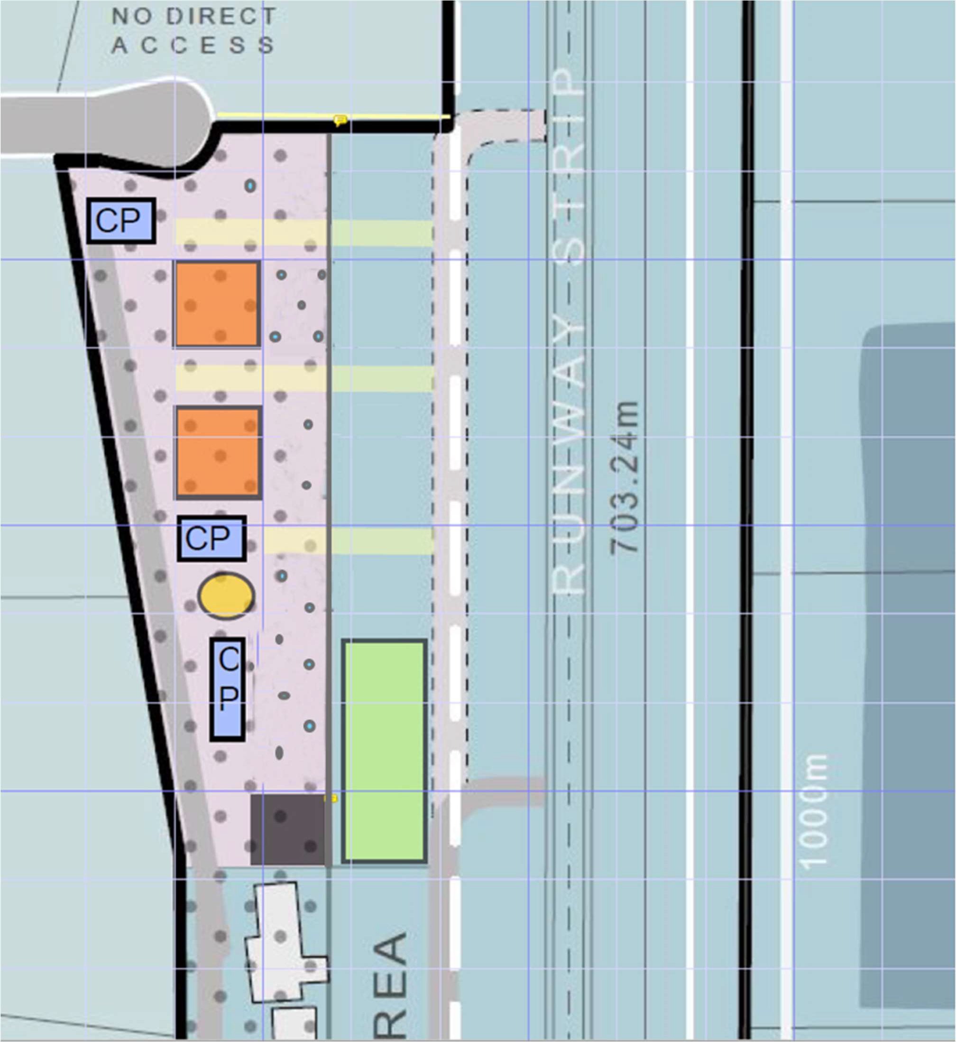
Figure 5: 8 Rawson Place Master Plan
28M x 28M hangar up to 9M high. Powered site.
Commercial maintenance, avionics, painting and restoration businesses.
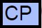
Sealed car parking.

Publically accessible toilets and wash facilities

Existing facility/hangar.

Grass apron area for short term and long term aircraft parking.

Other Supplementary Facilities

» Access roads

An additional internal vehicle access road may need to be provided along the western boundary of 8 Rawson Place to provide access to hangars. The existing access road from Kyneton-Metcalf Road should be sealed and an asset management renewal lifecycle placed on the road of 7 – 15 years.

» Car parks

Additional car parking may be established on the western boundary of 8 Rawson Place.

Non-aviation / commercial development

» Utility services

Consultation with Coliban Water has concluded that they would not consent to any development over the sewer rising and discharge to the Campaspe that runs along the southern border of the airfield. Any future development plans for the southern precinct must include the re-location of both assets to the far southern boundary parallel to Kyneton-Metcalfe Road.

A full utility services capability survey which addresses the shortfalls in reticulated sewerage and power requirements must be conducted and included in any future development plan in line with the Master Plan. In accordance with the Climate Change Action Plan 2017; opportunities to make all aspects of the airfield as energy efficient as possible should be investigated.

» Drainage

Any development plan must include the requirements for drainage surveys. The requirements to draw water away from the airside boundary must be considered to alleviate the grassed runway closures during the wetter months

Airport Safeguarding Plan

National Airports Safeguarding Framework

“The National Airports Safeguarding Framework provides guidance on planning requirements for development that affects aviation operations. This includes building activity around airports that might penetrate operational airspace and/or affect navigational procedures for aircraft.”

Not all of the National Airports Safeguarding Framework (NASF) guidelines are applicable to Kyneton Airfield, but the following have been considered:

» Guideline A: Managing Noise - Aircraft Noise Contours and Alternative Noise Metrics

Traditionally Australian Noise Exposure Forecast (ANEF) assessments have been undertaken to delineate where and what type of development can occur around airports, but experience has shown that a range of problems with relying solely on the ANEF as a noise information tool has its limitations.

N Contours indicate potential noise exposure where the noise level from a single aircraft exceeds 60dB(A), 65dB(A) or 70dB(A) per day, as opposed to the annual average approach that informs the application of ANEF Contours. Where N contours exist, they should be examined when considering strategic planning proposals near airports. This is additional to the ANEF contours, which remain the metric applied in Victoria for statutory planning purposes through the Airport Environs Overlay and Melbourne Airport Environs Overlay.

» Guideline F: Obstacle Limitations Surface (OLS)

A Survey of OLS Approach, Take Off and Transitional Surfaces at the Kyneton Airfield was carried out on the 23 February 2016. The survey was conducted in accordance with the specifications defined in the CASA Manual of Standards (MOS) Part 139 for a Code 1 Runway used for night operations, which is equivalent to the standard for a Code 2 Runway.

There are obstacles noted in this survey that infringe the OLS Approach or Transitional Surfaces (see Table 5 below). In accordance with MOS 139 Section 7.1.4.1, obstacles should not be located in these areas and where they infringe the Approach surfaces of the OLS it may be necessary to displace the runway threshold if the obstacles cannot be removed.

There has been a number of potential obstacles that require further consideration with regard to the identified OLS areas for both runways:

At the northern boundary of the airport along the runway centreline OLS height= is less than 7m above the elevation of the edge of runway strip. The trees planted= on the adjoining site to the north are currently around 9m tall and therefore= currently penetrate the OLS.

The existing southern hangar precinct is situated around 25 m from the runway= strip of the east west runway. At this distance, the OLS is 5m above the elevation= of the nearest point on the centreline of the runway. The OLS at the westernmost= hangar in this precinct is even lower as the hangar is beyond the runway end.= Hangars along this axis of the site are generally 5 metres in height.

The existing midfield hangar precinct is situated around 45m from the runway= strip. At this distance, the OLS is 9m above the runway surface’s Reference= Elevation Datum. These buildings are generally within a height range of 5 – 7= metres.

A map of the Obstacle Limitation Surface (OLS) for the site’s two runways has been provided in Appendix 1 of this report.

The OLS contours prescribe height limits across the site and adjoining land. The OLS area projects from the existing runway strips at a gradient of 20 per cent to form the transitional surface of the OLS. As such, to ensure safe operation of aircraft on site the OLS requires that maximum height limits for any future development underneath them are to be setback at a ratio of five metres for every metre in height from the boundary of the runway strip.

» Guideline I: Managing the risk to public safety areas at the ends of runways

A Public Safety Area (PSA) is a designated area of land at the end of an airport runway within which development may be restricted in order to control the number of people on the ground at risk of injury or death in the event of an aircraft accident on take-off or landing.

Kyneton Airfield’s PSA has been determined as a 1 in 100,000 risk level per year which extends the distance to the Calder Freeway (450 m) This identifies the area (or risk contour) within which, any person living or working for a period of a year, has approximately a 1 in 100,000 chance per year of being killed as a result of an aircraft incident

General planning guidance for new/proposed developments in this area is such that the National Airports Safeguarding Framework – Guideline I – Table 1 should be consulted for incompatible uses.

Upgrades to existing infrastructure

Publically accessible toilets to be upgraded to comply with Disability Discrimination Act, adding two shower rooms and hot water.

The provision of general purpose meeting facilities / community hub through the redevelopment of the existing Aero Club building presents an opportunity to attract more user groups to the airfield, while providing rental income to the operator of the facility. This concept – which would leverage from its unique setting – might include meeting rooms, recreational area, kitchen etc. Such a facility would principally be used by the operator, but facilities could be hired out to businesses, Council, community groups, schools etc. similar to other Council owned recreation infrastructure.

Rawson Place Hangar Precinct

The Council-owned lot at 8 Rawson Place is currently within the Farming Zone. It is proposed that 8 Rawson Place is rezoned to PUZ Schedule 6.

An additional internal vehicle access road may need to be provided along the western boundary of this site to provide access to hangars and an extension of the existing north south taxiway will also need to be provided along the site’s eastern boundary. The 2019 Plan indicates that there will be no new vehicle access provided to or from the site connecting Rawson Place.

The Public Use Zoning of 8 Rawson Place will ensure that the following can be catered for in any proposed development, but also be in line with the height requirements of the Airport Environs Overlay (AEO):

Aviation maintenance.

Aircraft Storage.

Development Guidelines

To safeguard the operation of the airfield, building height limits and setbacks need to be applied to any future development within the site’s landside areas. These height limits need to be based on OLS transitional surface gradients of 1:5 gradient ratio which project from the edge of each runway strip up to a height of 548 metres AHD above the runway strip’s origin height of approximately 503.42 AHD.

Within the 2019 Plan this has translated into a 25 metre setback from the runway strip for 5 metre high recreational hangars, such as those on the north side of Runway 09/27 and a 35 metre setback for the 7 metre high commercial hangars located to the north of the existing Aero Club facilities. These areas have been prescribed a 5 metre height limit and 7 metre height limit, respectively.

Across the site greater building heights could be accommodated up to a maximum height of 9 metres, which is the maximum height recommended under Council’s adopted Design Guidelines for Industrial and Commercial Developments clause 22.06, which is an Incorporated Document under the Planning Scheme. In the instance that a 9 metre high building or structure was proposed this would require a 45 metre setback from the boundary of the runway strip to remain below the 20 per cent or 1:5 ratio gradient of the OLS’s lateral transitional slope.

Implementation Plan

Planning Scheme Amendment

Municipal Strategic Statement

Council will provide updated policy support for the vision of the adopted 2019 Plan, which will relate to the development of the site and adjoining land to support the proposed airfield related development opportunities.

Design and Development Overlay Schedule 2

Council will revise the existing DDO2 provisions which apply to the site and surrounding land to reinforce the findings of the OLS survey conducted for the purpose of this project and to require that development occurring within proximity to the airfield is in accordance with the directions of this Master Plan.

Airport Environs Overlay

Council will revise the existing Airport Environs Overlay Schedule 2 and remap the extent of this overlay in accordance with a revised Australian Noise Exposure Forecast (ANEF) assessment to ensure that areas within the projected noise exposure contours of the airfield are included within the overlay and appropriate design requirements are applied to these areas.

A secondary noise metric analysis for the aircraft circuit paths will also be undertaken and the AEO2 schedule area remapped.

Environmental Significance Overlay Schedule 7 (Wastewater Treatment Facilities)

Council is currently considering applying a new Schedule to the Shire’s Environmental Significance Overlay to address development within proximity to wastewater treatment facilities under Planning Scheme Amendments.

The Statement of Environmental Significance under the draft ESO7 provisions states:

Wastewater treatment facilities within the Shire treat domestic sewage and commercial and industrial trade waste under an Environment Protection Authority scheduled premises licence that allows for discharge to local waterways or irrigation re-use.

The ongoing operation of these facilities is critical for maintaining public health, the protection of the environment, and protection of valuable community assets.

Land within this overlay should not be developed for any purpose that might compromise the continued operation or expansion of wastewater treatment facilities to service the future growth of the Shire.

The proposed environmental objectives to be achieved by ESO7 are:

To protect wastewater treatment facilities from encroachment by sensitive uses.

To make landowners aware of the buffer area to wastewater treatment facilities and of its likely expansion or intensification of use over time.

To ensure that applications for development which may impact on the ongoing operation of a wastewater treatment facility are referred to the relevant agency.

Under the draft provisions of this overlay schedule a planning permit will be required for works on the airfield site, in accordance with the proposed overlay extent indicated in red on the map at Appendix 3 to this report.

Referral to Coliban Water will be required for any permit triggered under this Overlay, with consent of the authority required for a permit to be granted.

Operations Manual

In line with Council’s resolution of September 2014, Council has published an Operations Manual for the Kyneton Airfield. The Operations Manual addresses issues that fall outside of the scope of the Master Plan project. The document outlines local procedures and guidelines to be followed when operating at the airfield and includes the following:

Airfield safety and emergency management.

Airside access control and public safety.

Disabled aircraft removal.

Reporting aviation accidents and incidents.

Airfield local operating procedures.

Remotely piloted aircraft systems operation.

The Operations Manual can be found on the Macedon Ranges Shire Council Website and also the Kyneton Aero Club Website.

Indicative Implementation Plan
1
- Adopt final Kyneton Airfield Masterplan 2019 in May 2020.
2
- Undertake a supplementary aircraft noise metric analysis for the AEO overlay review.
3
- Conduct and update the Kyneton Airfield Obstacle Limitation Surfaces (OLS) survey.

- Investigate and prepare PUZ zoning application for 8 Rawson Place
4 Kyneton.
5
- Investigate any required changes to the DDO/AEO Schedules.

Appendices
Appendix 1 – Obstacle Limitation Surfaces Plan

266000 267000 268000 269000 270000 271000 272000 273000 274000 275000 276000 277000 278000 279000 280000 281000
4

KYNETON AERODROME
5882000
OBSTACLE LIMITATION SURFACE DIMENSIONS CO-ORDINATES ARE MGA94 ZONE 55
LEVELS ARE TO THE AUSTRALIAN HEIGHT DATUM

AERODROME REF. POINT E.273560.096 N.5876953.330 RL.503.0
8
A
5881000

UNNAMED

A E
M D
M
10
5
7
5882000

RUNWAY 09 - 27 E
0
F
5881000
0
CODE 2 NON INSTRUMENT RUNWAY
AR

09 THRESHOLD E.272868.666 N.5877042.571 RL.502.260
E

27 THRESHOLD E.273509.519 N.5876965.798 RL.503.410
6

CENTRELINE BEARING 276° 49' 53" TAKE OFF GRADE 4%
4
LENGTH OF TAKE OFF AREA 2500 metres INNER EDGE WIDTH 80 metres
5880000
4
DIVERGENGE ANGLE 10%
UN

APPROACH GRADE 4%
LENGTH OF APPROACH AREA 2500 metres INNER EDGE WIDTH 80 metres
A
N

DIVERGENGE ANGLE 10%

90

5
0
0
20
EA
O METCALFE R
5 0
0
5

NAM D
N E
0
4
5880000

4
43

0
0
RUNWAY 18 - 36
49
5879000
5879000
CODE 2 NON INSTRUMENT RUNWAY

18 THRESHOLD RL.500.099

36 THRESHOLD RL.503.423

E.273642.621 N.5877651.503

E.273524.881 N.5876655.404
7
5
4
0
3

CENTRELINE BEARING 186° 44' 28"

M

TAKE OFF GRADE 4%
A

LENGTH OF TAKE OFF AREA 2500 metres
5878000

INNER HORIZONTAL SURFACE RL 548.0 metres
5878000

INNER EDGE WIDTH 80 metres

DIVERGENGE ANGLE 10%

INNER HORIZONTAL SURFACE RL 548.0 metres

APPROACH GRADE 4%
D
8

M
6
LENGTH OF APPROACH AREA 2500 metres
E
52

INNER EDGE WIDTH 80 metres

DIVERGENGE ANGLE 10%
0

TRANSITIONAL SLOPE 20% INNER HOR. SURFACE HT 45 metres
5877000
INNER HOR. SURFACE RAD 2500 metres CONICAL SURFACE SLOPE 5% CONICAL SURFACE WIDTH 1100 metres
N
D
N E

ARP

D
3
54
MED
BURTO AVEN
54
5877000

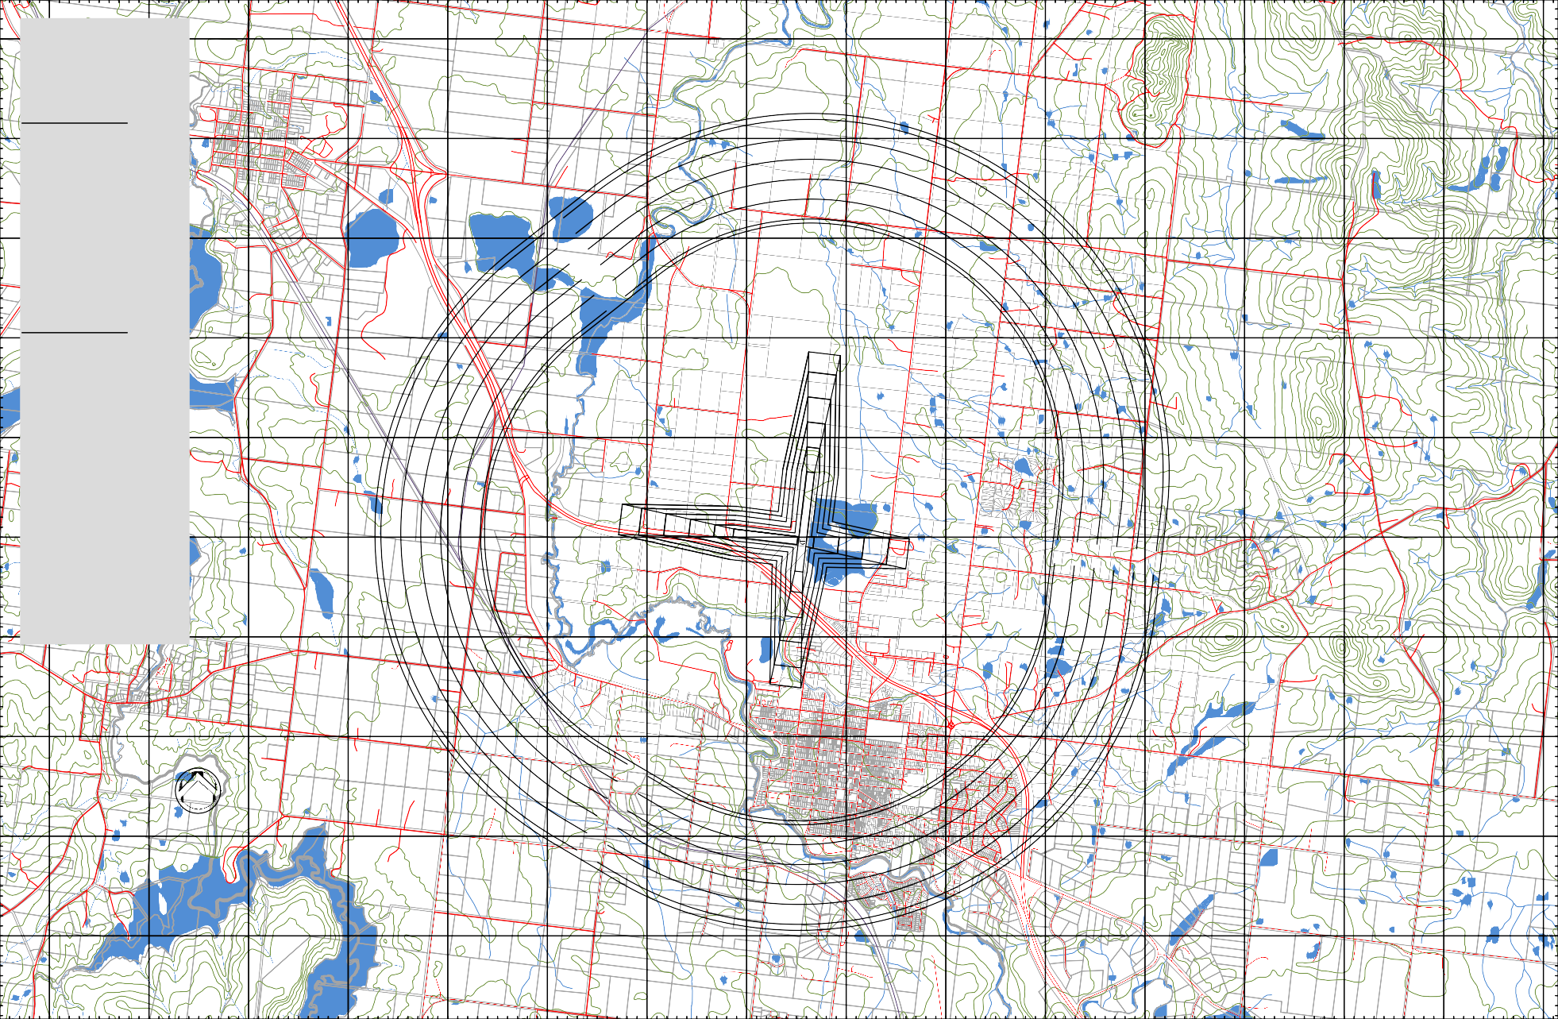
U A D

A
5
6
N
8
5876000
ED
D
5876000

U
4
LA
LANE
0
A
NNAMED
0

INNER HORIZONTAL SURFACE RL 548.0 metres A
T
NNAMED
N
5875000
H
5875000

ST
R VE
T

T

T

D
4
5874000
4
N
5874000

RV I
O O
E
U
L

E

E

M
NNAMED

CLOS
A

5
0
E
Y
5873000
5
E
5873000

2
0

266000 267000 268000 269000 270000 271000 272000 273000 274000 275000 276000 277000 278000 279000 280000 281000

DRAWN | P.FITZGERALD | NOTE:  - THE CONTOURS ON THIS PLAN DEPICT THE OBSTACLE LIMITATION SURFACES FOR KYNETON AERODROME  - LEVELS ARE TO AUSTRALIAN HEIGHT DATUM (AHD)  - CO-ORDINATES ARE MGA94 ZONE 55  - DUE TO THE VARIABLE NATURE OF THE TRANSITIONAL SURFACE, OBJECTS LOCATED WITHIN IT SHOULD BE CHECKED BY GROUND SURVEY FOR CLEARANCE | KYNETON AERODROME |  | OBSTACLE LIMITATION SURFACES PLAN (300m EXTENSION TO SOUTH) | Meters  250 0 250 500  1:20000 | AMENDMENTS
DATE | 06.03.2016 |  |  |  |  |  | DATE | AMENDMENT | SIGNED
SURVEYED | B.FITZGERALD
DATE | 22.02.2016
ARCHIVED
DRAWING No. | KTN/001  Sheet 2 of 2 Sheets

