Event Management Plan
Event name:
Event date:
Location:
Plan date:
Version number:
Prepared by:

The following information can be included in your event management plan. Use the headings as a guide and include information relevant to your event.

Keep in mind that some of the items on this list won’t be relevant to your event but this gives you a guide for what should be included in an event management plan.

Ensure you check information with the appropriate authorities when preparing your plan.

Contents
- Event details 3
Event name: 3
Event place and time: 3
Expected attendance 3
Program/Schedule of activities 5
Personnel 8
Contact 8
- Venue details 10
- Insurance 13
- Traffic and pedestrians 14
- Risk Management Plan (Appendix 1) 15
- Emergency Management Plan (Appendix 2) 16
- Public Health 17
- Event Communications 26
- Appendices 28
Appendix 1: Risk Management Plan (template available from Council) 28
Appendix 2: Emergency Management and Evacuation Plan (template available from Council) 28
Appendix 3: COVIDSafe Plan 28
Appendix 4: Marketing Plan (template available from Council) 28
Appendix 5: Traffic Management Plan (if required) 28
Appendix 6: Budget 28
Appendix 7: Insurance Certificates 28
Appendix 8: Victorian Guidelines for Planning Safe Public Events 28
- Site Inspection 29
(sample only – adjust to suit your event) 29

Event details

Event Overview

Event name:
[insert] Provide overview of event.

Event place and time:
Location: [insert]
Date: [insert]
Bump in: [insert]
Event start: [insert]
Event finish: [insert]
Bump out: [insert]

Expected attendance
Participants: [insert]
Spectators: [insert]
Others: [insert]

Program/Schedule of activities

[Insert overview of what is included in the event]

Contacts

RESPONSIBLE ENTITY
[Your event] is notionally owned by the [incorporated entity]. The latter is an incorporated body with a formal constitution and bank accounts. As such it takes financial responsibility for the festival and pays for the event’s public liability insurance.
[Your event] is organised and delivered by the locals comprising an executive committee, complemented by [insert number of] section coordinators and [insert number of] volunteers. The Event Management Plan contact person details are as follows:
Name:
Address:
Phone:
Email:

Key event contacts (pre-event)
Position | Name | Mobile | Email
Event Coordinator
Talent Manager
Vendor Coordinator
Volunteer Coordinator

Emergency and event contacts (on the day)
Position | Number
EVENT TEAM
Event Coordinator – [Insert Name]
Stage Manager - [Insert Name]
Vendor Coordinator [Insert Name]
Parade Coordinator - [Insert Name]
EMERGENCY CONTACT
Police, Victorian Fire Service, Ambulance | 000
Local CFA
SES
Local Police
Poisons Information
Water Authority
Relevant Government Depts
EVENT SPECIFIC CONTACTS
Electrician
Venue owner/manager
Suppliers/contractors
Water/toilets
Event running sheet
Insert event run sheet – sample provided
Date | Time | Activity | Personnel | Contact
Bump in
Sat 26 Jan | 6:30am | Example: Staff arrive on site.  Site induction/Toolbox talk  Mark site: Toilets, drinking fountain, marquees  Inspect site for hazards. | Colin Coordinator  Astrid Assistant  Sally Safe | 0400 000 000  0411 111 111  0422 222 222
Sat 26 | 7:15am – 9:30am | Marquee supplier arrives and commence set up.  Site manager sign-off when complete | Supplier A – Eileen Engineer  Colin Coordinator | 0433 333 333
Sat 26 | 7:45am – 8:45am | Toilets arrive – installation | Supplier B – Wally Waste | 0444 444 444
 | 9:15am | Warden’s briefings | Chief and Deputy Wardens
 | 9:00am | Vendors arrive – site induction | Colin Coordinator
 | 10:00am | Pre-opening safety inspection  Complete pre-event checklist
Event Time
Sat 26 | 12 noon | Event gates open. | Colin Coordinator
 | 12 – 4pm | On-going site inspections (refer checklist) | Astrid Assistant
 | 2pm | Rubbish collected and bin liners replaced | Sally Safe
Bump out
Sat 26 | 5.00pm | Waste collectors arrive -

Venue details
Site plan

Location: [insert]
Area: [insert]*Council can assist with this calculation
Usable area (minus buildings and other infrastructure): [insert]
Maximum people permitted on site: [insert]
Access and inclusion: Infrastructure and other factors that make your event accessible.
Under Australia’s Disability Discrimination Act, it is unlawful to discriminate against people with a disability. If your event, venue or service is not as accessible as possible, patrons may lodge complaints with the Anti-Discrimination Commission, which could lead to legal action if their concerns are not addressed.
Legalities aside, making your event inclusive for all patrons, including seniors, parents with prams, and people with impairments and disabilities, means you are making it possible for more attendees to come to your event –a win-win!
Here is a checklist that will help you make your event accessible.

Site Map:

Insert - Site plan and/or route map. Council may be able to provide an image of your site that can be used for this plan.

A site plan is a detailed birds-eye-view drawing with the location of all facilities marked. It must include the following items when present:

- Accessible paths, car parks and toilets
- Drinking water locations
- Emergency vehicle entry points and access routes
- Emergency assembly points
- Entrances and exits
- Event control centre
- Fire extinguishers
- First aid posts
- Food/vendors/stalls sites (number these so you can allocate to vendors)
- Generators or power boxes
- Information point
- Lost children point
- Lost property collection
- Key areas for activities
- Marquees
- Rubbish bins (general waste, recycling, FOGO, glass)

Example site map:
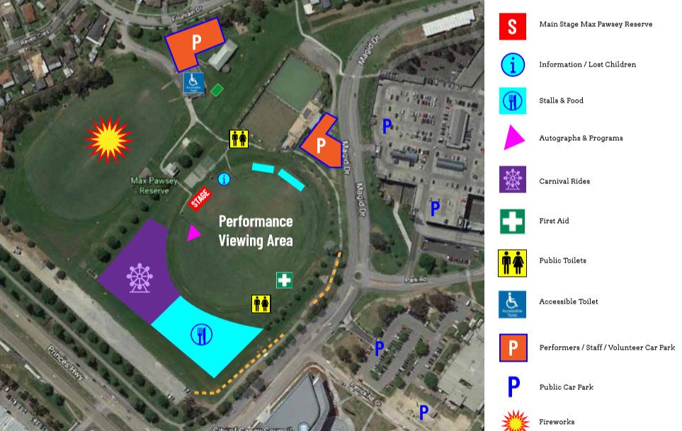

Insurance

Type of Insurance | Provider or Company | Coverage Amount | Policy Number | Expiry Date
Public liability
Personal accident (volunteers)
Other insurances
Supplier Insurance
List supplier insurances e.g.
Food vendors
Traffic management company
Marquee/audio/lighting hire

Attach insurances to this plan.

Traffic and pedestrians

Responsible committee person: [insert] Phone: [insert] Email: [insert]

Depending on the location of your event a Traffic and Transport Management Plan (TTMP) may be required. Ask Council for advice.

Activities occurring on roads, road reserves, or activities that will affect the normal flow of traffic such as races or parades will require a permit from one or all of the following authorities: Council, VicRoads, Victoria Police.

Parking Plan
Vehicles | No. of spaces | Location | Set up time / Required Signage | Responsibility
General parking
Stallholders
Entertainers
Committee members
Patrons with a disability
Buses
Emergency vehicles
Marshals/traffic controllers
Other

Risk Management Plan (Appendix 1)

Council template available

Emergency Management Plan (Appendix 2)

Council template available

Public Health
COVIDSafe plan – Appendix 3
It is mandatory to have a COVIDSafe plan in place.

Your COVIDSafe Plan must set out:
- Your actions to help prevent the introduction of COVID-19 into your event
- The level of face mask or personal protective equipment (PPE) required by your workforce
- How you will prepare for, and respond to, a suspected or confirmed case of COVID-19 in your event

This plan must demonstrate how you will meet all the requirements set out by the Victorian Government.

Organisations must review and update their COVIDSafe Plans routinely, especially when restrictions or public health advice changes. Organisations with multiple worksites must complete a COVIDSafe Plan for each worksite.

For more information as well as COVIDSafe Plan toolkits please visit: www.coronavirus.vic.gov.au/public-events

Food and Beverage

Responsible person: [insert] Phone: [insert] Email: [insert]
The following food and beverage will be provided, sold, given away at the event:
Vendor | Contact person | Mobile | Email | ABN | Food / beverage | Streatrader registered | SOT | Product &Public Liability Insurance

There will be approximately x# market stalls at this year’s event.
Stallholders will be able to arrive and set up on [date/s and times]. Access will be through the main entrance.
All vehicles are required to be offsite by [e.g. 8am] at the latest.
The market stalls will be located as powered and unpowered sites. See Site Map.

Key contacts
Council’s Public Health Services: 03 5422 0333
Web link: www.mrsc.vic.gov.au/Live-Work/Business-Economy/Permits-Licences-Laws/Food-Premises-Safety
Streatrader: https://streatrader.health.vic.gov.au

Alcohol
If you intend selling or supplying alcohol at the event, a liquor licence must be obtained from the Victorian Commission for Gambling and Liquor Regulation (VCGLR), and approval will also be required from Council at least two months prior to the event.

Event organisers will be required to provide adequately segregated areas for the sale and consumption of alcohol if it is an all-ages event. These should be clearly marked on your site plan.

Toilets
Responsible person: [insert] Phone: [insert] Email: [insert]
Scheduled cleaning intervals: [insert]
Expected crowd numbers: [insert] Event duration: [insert]

Number/type of toilets and handwashing facilities:
For the advice on the provision of toilets at events visit: www.health.act.gov.au/sites/default/files/2018-09/Provision%20of%20toilets%20at%20public%20events.pdf

 | Male |  |  | Female |  | Unisex |  | Accessible
 | WC | Urinals | Hand Basins | WC | Hand Basins | WC | Hand Basins | WC
Existing
Portable

Water
Events must have sufficient supply of freely available water with clear directional signage to water. Outdoor events that expose patrons to the elements must take due care for their health and comfort. A wash basin does not constitute a drinking fountain or tap.
Western Water and Coliban Water have water trailers available for hire.
https://coliban.com.au/community/supporting-community-events
www.westernwater.com.au/Community-Education/Community/Drinking-water-for-events
Responsible person: [insert] Phone: [insert] Email: [insert]
The following free drinking water will be provided: [insert]
Water source: [insert] Location: [insert]
Supplier: [insert]

Shelter
Shelter and shaded areas should be available wherever patrons or staff and volunteers (including First Aiders) may be located for an extended period of time, and where weather conditions dictate that it is required.

Shelter location (staff): [insert]
Shelter location (First Aid): [insert]
Shelter location (patrons): [insert]

Clean up and Waste Management
What arrangements have been made for extra bins for the event?
What arrangements have been made for rubbish to be appropriately removed?
What arrangements have been made to reduce waste at the event?
See Zero Waste guide for events: www.reduce-recycle.com.au/news/zero-waste-event-guide-available-now
Macedon Ranges Sustainability Group Wash Against Waste: waste@mrsg.org.au
Macedon Ranges Shire Council Event Bins: www.mrsc.vic.gov.au/See-Do/Events/Running-An-Event/Bins-Toilets

Responsible person: [insert] Phone: [insert] Email: [insert]

Contractor:

Types and quantities of waste generated: [insert]

Plan to ensure site remains litter free/monitoring during the event: [insert]

Number of rubbish recycling stations, skips etc: [insert]

Location of recycling stations, skips etc: [insert]

Supplier of bins and other waste receptacles: [insert]

Delivery dates/times: [insert] Collection dates/times: [insert]

Training program to ensure all involved are aware of procedures: [insert]

Noise
Events can create noise levels much higher than normal. Music amplifiers, refrigerators, generators, and crowds are all contributing factors. It is important to monitor the level of noise produced by the event to minimise disruption to nearby residents and businesses.
Events are required to comply with the provisions of the Environmental Protection (Noise) Regulations 1997 and may require local government approval.

Event contact: [insert] Phone: [insert] Email: [insert]

Type of noise: [insert] Location: [insert] Times: [insert]

Impacts: [insert]

Plan to address and manage noise (including complaints): [insert]

Electricity
Electricity supply will be provided by [e.g. five hired generators], which will supply the power to [e.g. the stages, cooking demonstrations and powered food stalls]. Distribution boxes will be connected to the generators providing 3 phase power to the stages and 240v to the food stalls. A qualified electrician will connect and set up all electrical connection on the day and will remain onsite throughout the event to ensure power continuity and safety.

Fire Safety
Fire extinguishers and fire blankets will be located onsite at [insert locations]. All volunteers will be inducted in procedures for notifying emergency services as required. Dial 000.

First Aid
A first aid tent will be set up next to the Information Tent and will be staffed by [e.g. St Johns Ambulance]. The location of the First Aid Tent is included in the site map.

Responsible Person: [insert] Phone: [insert] Email: [insert]

Security
Responsible Person: [insert] Phone: [insert] Email: [insert]
Security plan (types of security required): [insert]
Security personnel: [insert]
Arrangements to secure site before, during and after hours: [insert]
Security staff briefing and de-briefing information: [insert]

It is recommended that you read the Victorian Guidelines for Planning Safe Public Events and add into this section anything else relevant to your event, such as, but not limited to:
- Amusement rides
- Fireworks
- Animal welfare
- Temporary structures
- Motorsports
- Alcohol and drug related issues
- LPG gas

Permits
Situation | Application to be Completed /  Permit Needed | Apply/provide to
Will your event change the usual use of a road or footpath? | MRSC – General Purpose and Amenity Local Laws Permit | e.g. Council or Main Roads
Will alcohol be served? | A temporary limited license is often required by unlicensed organisations who want to sell or supply liquor on a one-off occasion. | Victorian Commission for Gambling and Liquor Regulation
Will food be served? | Documentation required: Food License | Take from vendors and keep in file
Will you have stallholders of any type? | Documentation required:  Public Liability Certificate of Currency
Will the event be amplifying sounds or creating noise? (e.g. announcements or music) | Event Permit for Music Noise – Environment Protection Agency | EPA  Council
Will there be temporary structures such as marquees, grandstands and stages? | Prescribed temporary structures have additional requirements under the Building Act. Any prescribed temporary structure must have a separate occupancy permit issued by the Building Commission. Siting of the temporary structure must be organised before the event with the Municipal Building Surveyor at your local Council. Information about occupational health and safety obligations can be found in Guideline 14: Occupational Health and Safety or at www.worksafe.vic.gov.au | Victorian Building Authority  Council
Will you be using gas or extension cords? | All power leads and appliances to be tested and tagged within date.  Learn about gas bottle safety | Energy Safe Victoria
Will there be rides? | Certificate of Registrable Plant for each ride from ride owner  Safe Work Method Statements, Log Books, operator training evidence  Registration | Council  Workplace Health and Safety
Will you have fireworks? | Fireworks Discharge Notification | Worksafe Victoria
Will you advertise on road sides with corflute signs? | If installed on road verges managed by Transport & Main Roads, a permit is required. | For signage on state roads, contact your state Department of Main Roads, and for signage on local roads, contact Council.
Is the event to be held on Council-owned land or road or in a Council-owned facility? | Booking venue  Road Authority | Council  Regional Roads Victoria/Council
Will there be temporary camping at your event? | Check with Council if this is a permitted use on land | Council
Is the on private land? | Does the venue have a planning permit in place that allows the activity (if not in place allow 6-12 months to know outcome of a permit)  Place of Public Entertainment | Council  Council

Event Communications

Marketing and Communications Plan – Appendix 4
Event promotion and marketing is one of the most important aspects of planning your event. Your marketing plan will include methods and dates of communication to your target audience to achieve strong attendance.

The Marketing and Communications Plan should also consider how to relay key information to attendees such as COVIDSafe messaging, such as ‘Stay home if you are unwell’; public transport options; alcohol-free event; or if the need arises, event cancellation.

Notification plan
Notifying impacted residents and stakeholders of your event is important, it provides an opportunity to mitigate any concerns raised and helps to ensure ongoing support.
Stakeholders | Method of communication  letter drop/email/door knock/phone call | Event contact provided | Name of individual notified (if known) | Date contacted
Police
Road authority
CFA
SES
Ambulance Victoria
Public Transport Victoria
Residents (may want to list individually)
Businesses (may want to list individually)

Ticketing
Insert ticketing information if relevant.

Event Signage
Clear event signage is essential. You will need to liaise with Council about when and where signage can be placed. Examples of signage required include:
- Entrances and exits
- Parking
- Toilets
- First aid
- Security
- Information/communication/incident control centre
- COVIDSafe messaging

Insert planned event signage.

Appendices

Appendix 1: Risk Management Plan (template available from Council)

Appendix 2: Emergency Management and Evacuation Plan (template available from Council)

Appendix 3: COVIDSafe Plan

Appendix 4: Marketing Plan (template available from Council)

Appendix 5: Traffic Management Plan (if required)

Appendix 6: Budget

Appendix 7: Insurance Certificates

Appendix 8: Victorian Guidelines for Planning Safe Public Events

Site Inspection

(sample only – adjust to suit your event)
Site Inspection date:
Site Inspection performed by:

Description | OK | NOT OK | Not  Applicable | Details/Actions
COVID check in QR codes installed
Hand sanitiser points installed
COVIDSafe messaging installed
Barriers in place
Emergency access clear
Extension leads and plugs
Fire extinguishers in position
Gas bottles secured
Hot surfaces out of public reach
Housekeeping & recycling
Incident /Injury Reporting Forms
Licensed areas
PA systems
Pedestrian access
Two-way radio functions
Safety fences in place
Sharp or protruding objects
Stage edges and steps marked
Steps and handrails (condition)
Switchboxes / generators
Tents / marquees secured
Toilets functioning
Tree & branches
Tripping hazards / pegs ropes etc.
Umbrellas secured
Warning signage
Weather and wind conditions
Other

