Tree protection in the
Macedon Ranges Shire

Trees are a vital part of our natural environment and play an integral role in the aesthetic appeal of our shire and way of life. We have a responsibility to retain and protect our natural landscapes, to enhance biodiversity and to retain the semi-rural small-town character of our townships. Throughout the shire, a diversity of tree species occur of varying ages including ancient eucalypts and early settler plantings, all of which contribute to the shire’s natural and cultural values.

Trees are sensitive to change and require minimal disturbance to retain optimum health. Trees need to be protected at all stages of a development to ensure they survive. It is rarely possible to repair stressed and injured trees.

This document provides guidelines aimed at ensuring trees are retained and protected as a part of new development and buildings and works.

Tree protection requirements

Native vegetation (including trees and patches of forest) is protected under the Victorian Planning Provisions. These provisions require applicants to avoid and minimise native vegetation loss as a first priority. Development works can also impact trees through soil compaction from the construction of roads and driveways close to trees. These impacts should also be avoided where possible.

Clause 52.17 of all Planning Schemes in Victoria requires all native vegetation proposed for removal to be quantified and offset. This applies to all native trees whether alive or dead, as well as maintenance works where more than 1/3 of the canopy is proposed for removal. Vegetation loss can be calculated via https://nvim.delwp.vic.gov.au/

Non-native trees may also be protected under local planning provisions in some areas of the shire e.g. in Vegetation Protection Overlays (VPO), Environment Significant Overlays (ESO), and Heritage Overlays (HO).

When to consider trees

Tree protection is most effective when considered at the earliest stages of development planning. If trees occur on your property, a comprehensive site analysis is recommended to determine how tree removal or detrimental impacts to trees can be avoided.

Always contact Council prior to undertaking any tree works or prior to developing site plans to discuss what approvals are required and how negative impacts can be avoided.

Components of a tree

The root system of a tree generally extends well beyond its canopy or dripline. These roots can be impacted by compaction from vehicles as well as the construction of driveways and foundations.

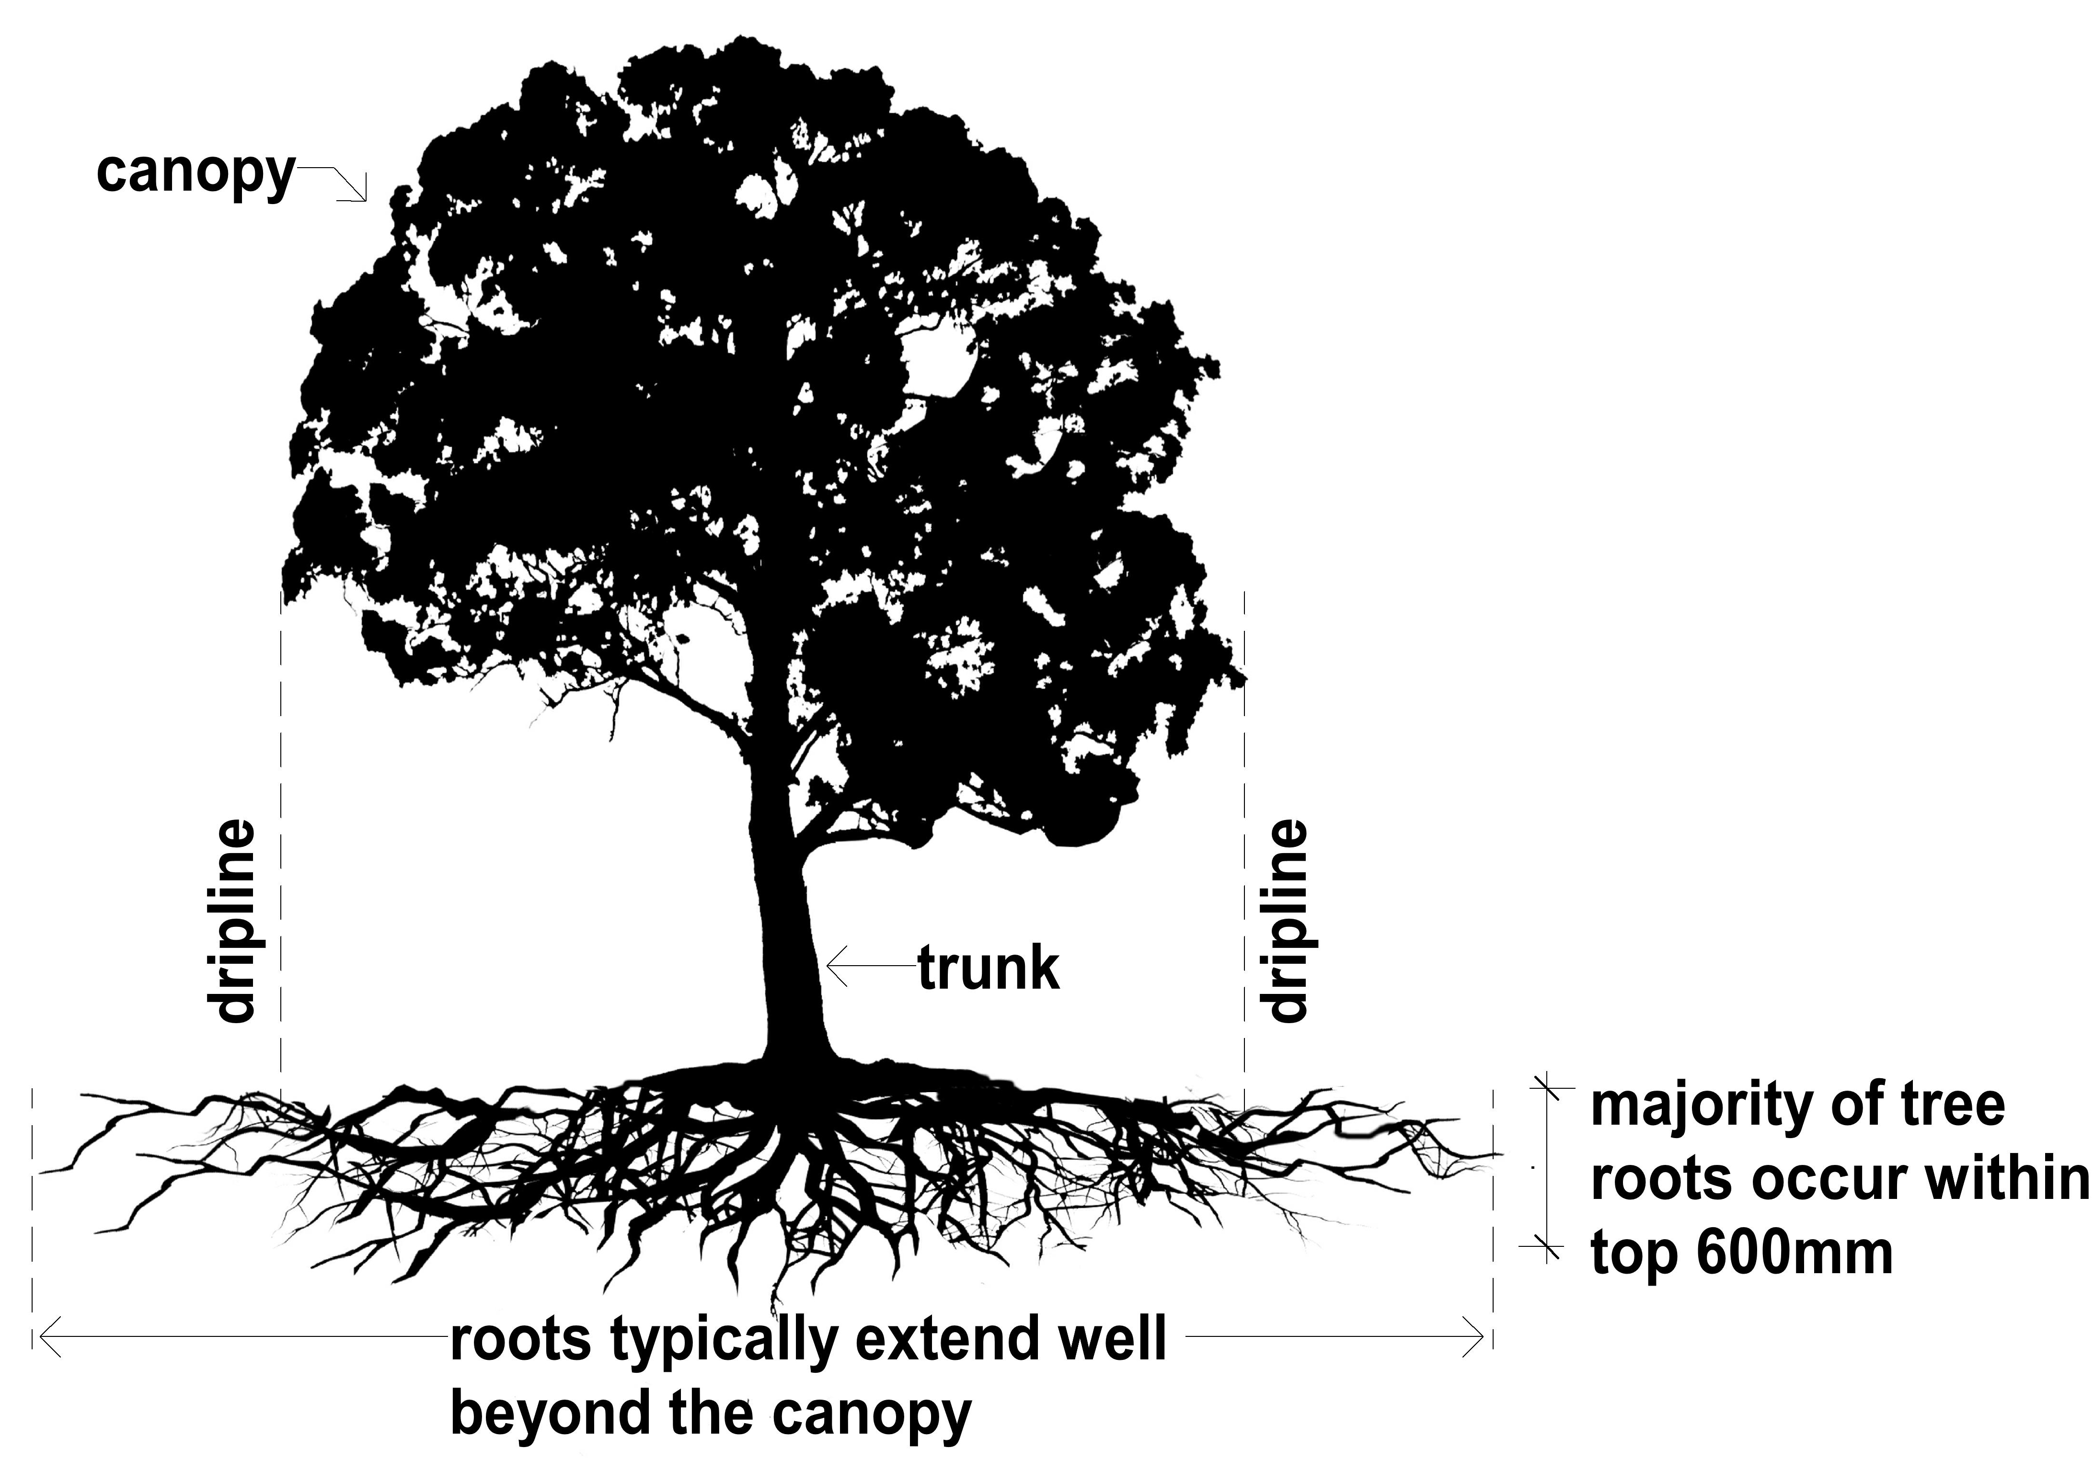

Figure 1. Components of a tree

Tree Protection Zone (TPZ)
The Tree Protection Zone (TPZ) is the calculated area above and below ground at a given distance from the trunk to provide for the protection of the tree’s roots and canopy during construction works.
The Tree Protection Zone (TPZ) is determined by the diameter of the tree at breast height (DBH). “Breast height” is always 1.4m above ground level.
The Australian Standard, Protection of Trees on Development Sites (AS4970 2009) defines a Tree Protection Zone as follows:

The TPZ is a combination of the root area and crown area requiring protection. It is an area isolated from construction disturbance, so that the tree remains viable.
The TPZ incorporates the structural root zone (SRZ). The radius of the TPZ is calculated for each tree by multiplying its DBH × 12.
TPZ = DBH × 12 where DBH = trunk diameter measured at 1.4 m above ground.

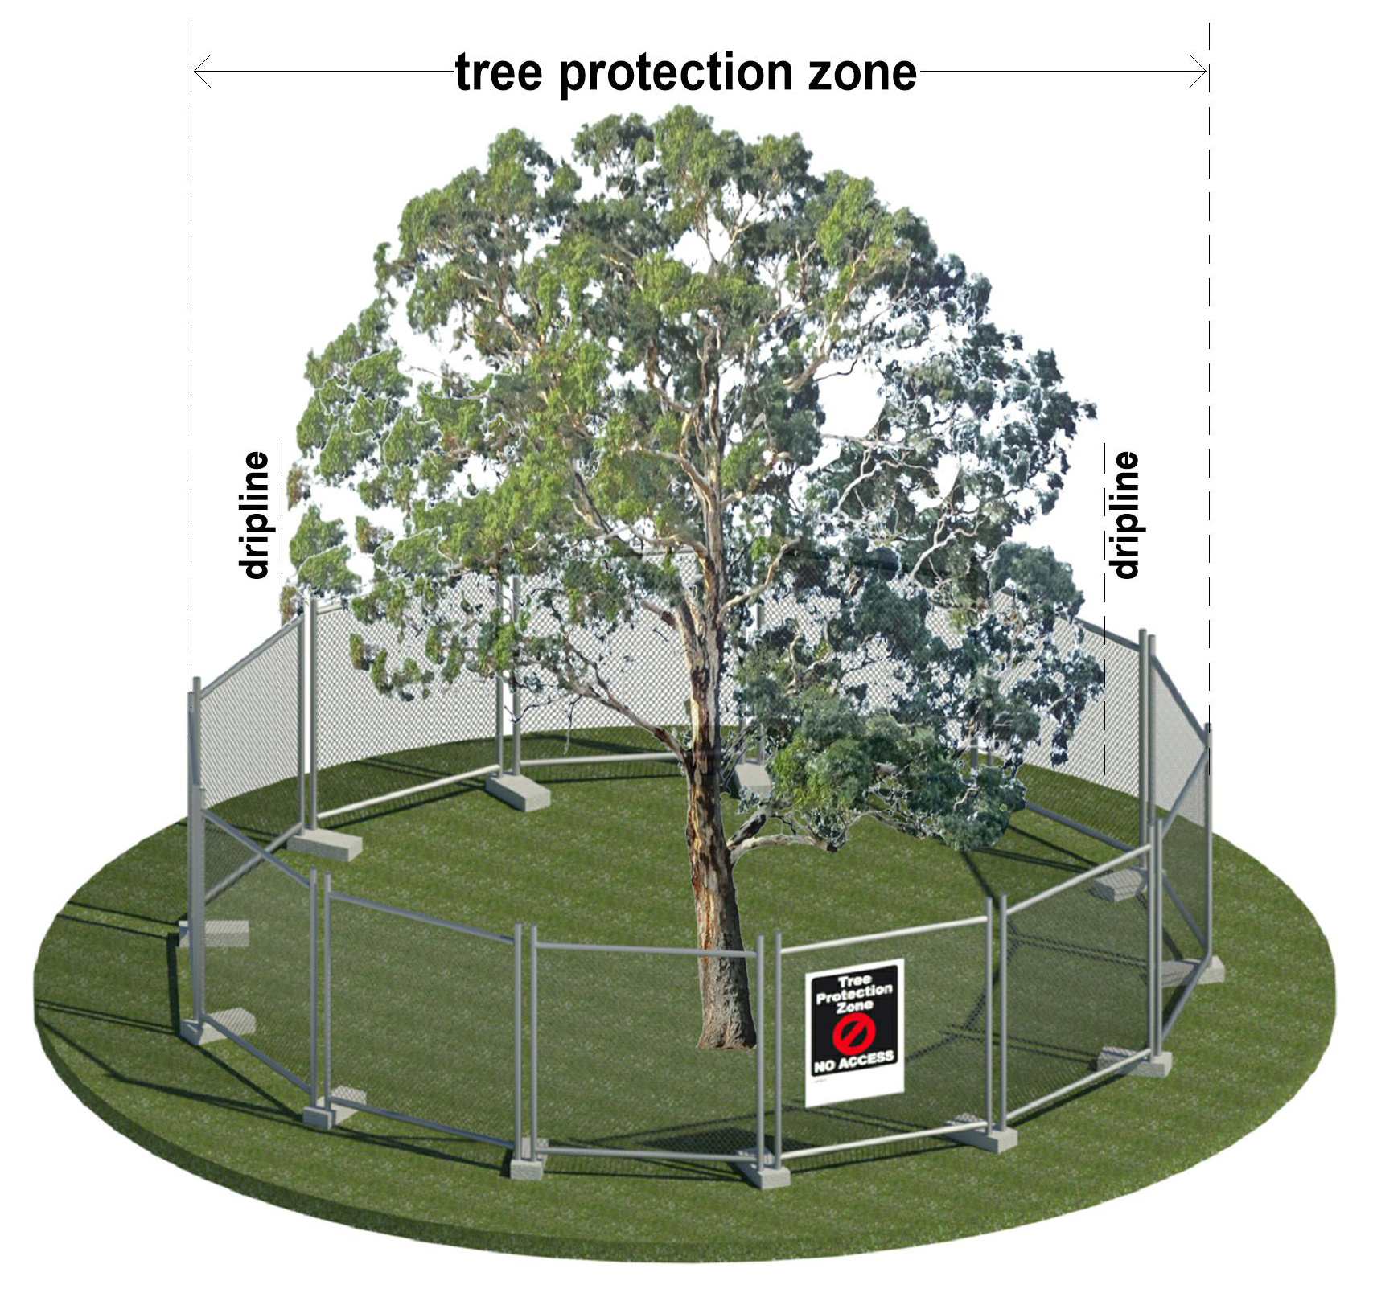

Figure 2. Tree Protection Zone and example of required fencing

Arboricultural assessments and reports
If any significant site trees, neighbouring trees, or Council owned street trees are likely to be adversely impacted by construction works, an Arborist report will be required. The report needs to be prepared by a suitably qualified (AQF Level 5 or above) and experienced Arborist who will conduct a site visit and assess each tree in accordance with Australian Standard AS4970: 2009 ‐ Protection of Trees on Development Sites.

Up to four arborist reports are required for development proposals as follows:

Preliminary Tree Assessment Report
The purpose of a Preliminary Tree Assessment Report is to evaluate all site trees to determine their significance in the landscape, suitability for retention and to guide the layout of the proposed development. It will provide tree protection measures for all trees to be retained and should include any trees within 5 metres of the site boundary. The tree protection zone of neighbouring trees may also require assessment.

All assessed trees are typically numbered in the report along with the following information:

- Correct botanical identification and common name
- Health and structure
- Dimensions: height, crown spread, and trunk diameter
- Age class and useful life expectancy
- Other matters relevant to the site, e.g. existing site features, heritage, ecology
- Retention value
- Tree Protection Zone
Biodiversity Assessment Report

If native vegetation is proposed to be removed, a Biodiversity Assessment Report is required. This applies to all native trees, shrubs and understory, all dead trees and any trees where more than 1/3 of the canopy is proposed to be removed.

A Biodiversity Assessment Report can be obtained from the State Government’s Native Vegetation Information Management (NVIM) system at https://nvim.delwp.vic.gov.au. All losses will need to be offset in accordance with State Government native vegetation regulations.

Aboricultural Impact Assessment Report
This report is prepared once the final site plan is complete. The report will identify trees to be removed, retained and transplanted, and determine the extent of any possible impacts on trees that are to be retained. It will also recommend measures necessary to protect the trees throughout all demolition and construction stages. Architectural and Landscape plans must be available for the arborist to review

Tree Management Protection Plan
A Tree Protection Management Plan (TPMP) is often a requirement of a planning permit and sets out the tree protection measures to be followed through all phases of demolition and construction. It will include details of construction staging, a project arborist inspection timeframe and a compliance check list.

Protective Fencing
All protective measures must follow the recommendations of the Arborist Report, and be in accordance with the Australian Standard for the protection of trees on development sites (AS 4970-2009).

Fencing around tree(s) should be installed in accordance with the Tree Protection Zone prior to site establishment and should remain until the completion of works. An Arborist report will provide all of the measurements. Protective fencing should be erected before any machinery or materials are brought on site and before the commencement of works including demolition. The fencing should be approved by the project arborist in compliance with a permit condition.

If tree protection fencing is to be constructed for a home project that does not require a planning permit, a suitable area to fence around a tree can be determined using the Tree Protection Zone calculation in this fact sheet. That is:

A radius of 12 times the diameter of the tree trunk at a height of 1.4 metres to a maximum of 15 metres but no less than 2 metres from the base of the trunk of the tree.

Tree protection fencing should comply with the following requirements:

- Fence post supports (e.g. star pickets) should have a diameter greater than 20 mm and should not impact surface tree roots
- Fencing height minimum of 1.8 m
- Shade cloth, paraweb, wire mesh panels or similar should be attached to the fencing posts
- Signage should be installed stating “Vegetation Protection Zone - No Entry”
- The tree protection fencing must remain in place until construction is completed
- No vehicular or pedestrian access, trenching or soil excavation is to occur within the Tree Protection Zone
- No storage or dumping of tools, equipment or waste is to occur within the Tree Protection Zone

See Figure 2 for an example of what fencing is required.
Approved Tree Protection Techniques

If a Tree Protection Zone is to be impacted by construction works or the installation of underground services, the following techniques are highly desirable to maximise tree health. Consultation with an arborist is required to ensure the following techniques can be incorporated on a site plan, to minimise the impact of encroachment.

Tree Sensitive Construction Measures

To protect trees throughout construction, tree sensitive measures such as pier and beam, suspended slabs, cantilevered building sections, screw piles and contiguous piling can minimize the impact of encroachment.

Boring

Boring is the recommended method for all underground services within a Tree Protection Zone. The entry and exit pits should also be excluded from a Tree Protection Zone and native vegetation.

Contact us:
- For more information, contact Council’s Environment Department on 5422 0333 or at environment@mrsc.vic.gov.au.

Resources:
- Native Vegetation Information Management system, https://nvim.delwp.vic.gov.au/
- Native Vegetation Regulations, https://www.environment.vic.gov.au/native-vegetation/native-vegetation

