Flora and Fauna Fact Sheet
Bald Hill Reserve, Kyneton
Bald Hill Reserve is valued by the community as an ecologically, geologically and culturally significant location. Bald Hill Reserve provides low impact, passive tourism opportunities for bird watching, photographers, naturalists and education.
Widespread land clearing practices during early European settlement has resulted in very little remnant vegetation remaining in the Kyneton region. The Bald Hill Reserve has a mix of remnant and regenerating forests. It provides essential habitat for a range of native animals and plants, many of which are at threat of extinction.
This fact sheet aims to provide an overview of some of the unique species that inhabit Bald Hill Reserve and the importance of conserving this special place for the community.

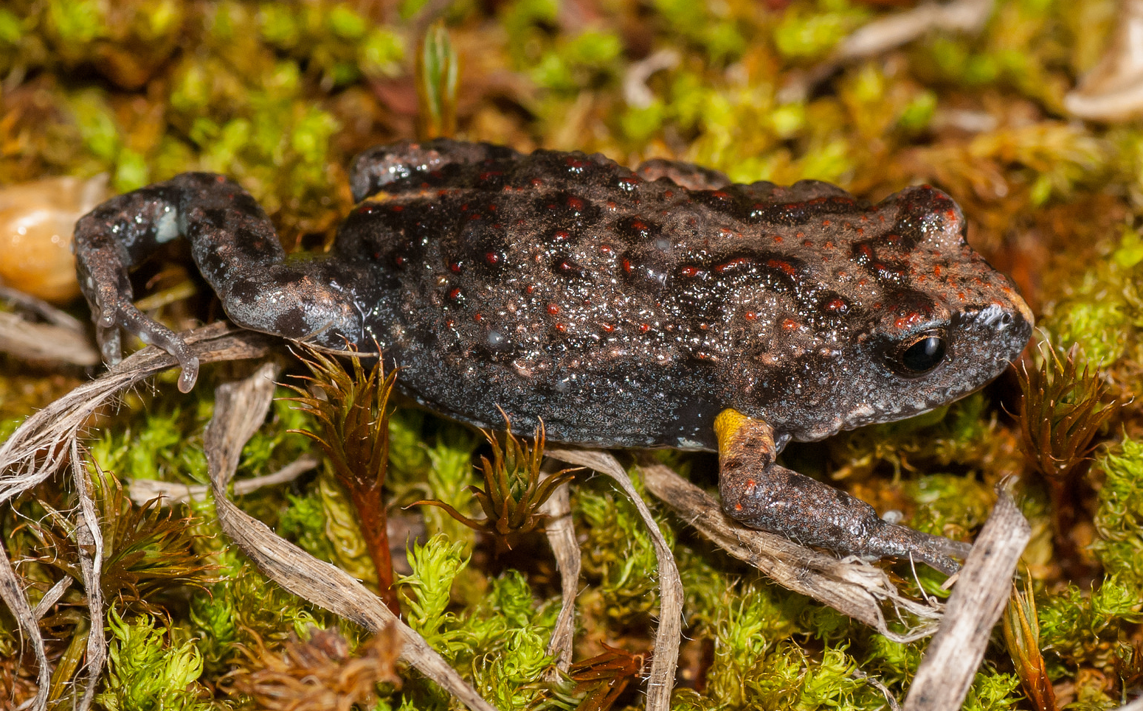
The threatened species
Brown Toadlet, Pseudophryne bibroni
Regular surveys for the Brown Toadlet have identified a large number at this site. Research suggests that this may be Victoria’s largest extant population. The species lives in small burrows in the soil or under leaf litter on the ground. This close relative to the well-known Corroboree Frog breeds during autumn rain. The species is threatened in Victoria with an annual estimated population decline of 3%.

Powerful Owl, Ninox strenua
A pair of Powerful Owls are known to frequent the reserve. This raptor is the largest species of Owl in Australia. They feed on possums and birds. Breeding usually commences during winter and a very large hollow is required for nesting. Fortunately, there are many large hollows which could be used by Powerful Owls in Bald Hill Reserve. Powerful Owls are threatened by extinction due to habitat loss. During autumn, they begin calling with a deep hooo hoooo as they begin to defend their territory and initiate breeding.

Brush-tailed Phascogale, Phascogale tapoatafa
This marsupial carnivore is well known to the reserve and has been encountered several times by Council officers. The species feeds primarily on invertebrates such as beetles and spiders. It also requires as many as 12 natural tree hollows per individual. The Brush-tailed Phascogale is generally found in woodlands and dry forests throughout central Victoria. This threatened species has been impacted by loss of habitat and introduced predators.
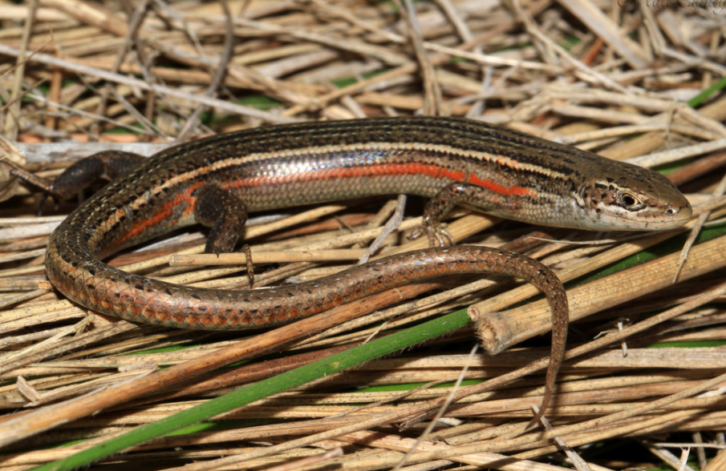
Tussock Skink, Pseudemoia pagenstecheri
This reptile was recently found in the open grassy areas of the reserve. The individual found at Bald Hill is the first record of this species in the Kyneton district. This skink relies on rocks and cracks in the soil to protect itself from potential predators. Widespread land clearing has reduced the habitat for this species. It can be identified by the conspicuous orange stripe down each side of the body.
Photo by Matt Clancy
Clover Glycine, Glycine latrobeana
This beautiful purple flower is nationally threatened due to clearing of native grasslands. At Bald Hill Reserve the species is known to be widespread in several grassy sections. Clover Glycine is an annual wildflower that flowers in spring. Weeds and erosion are potential threats for this delicate species.

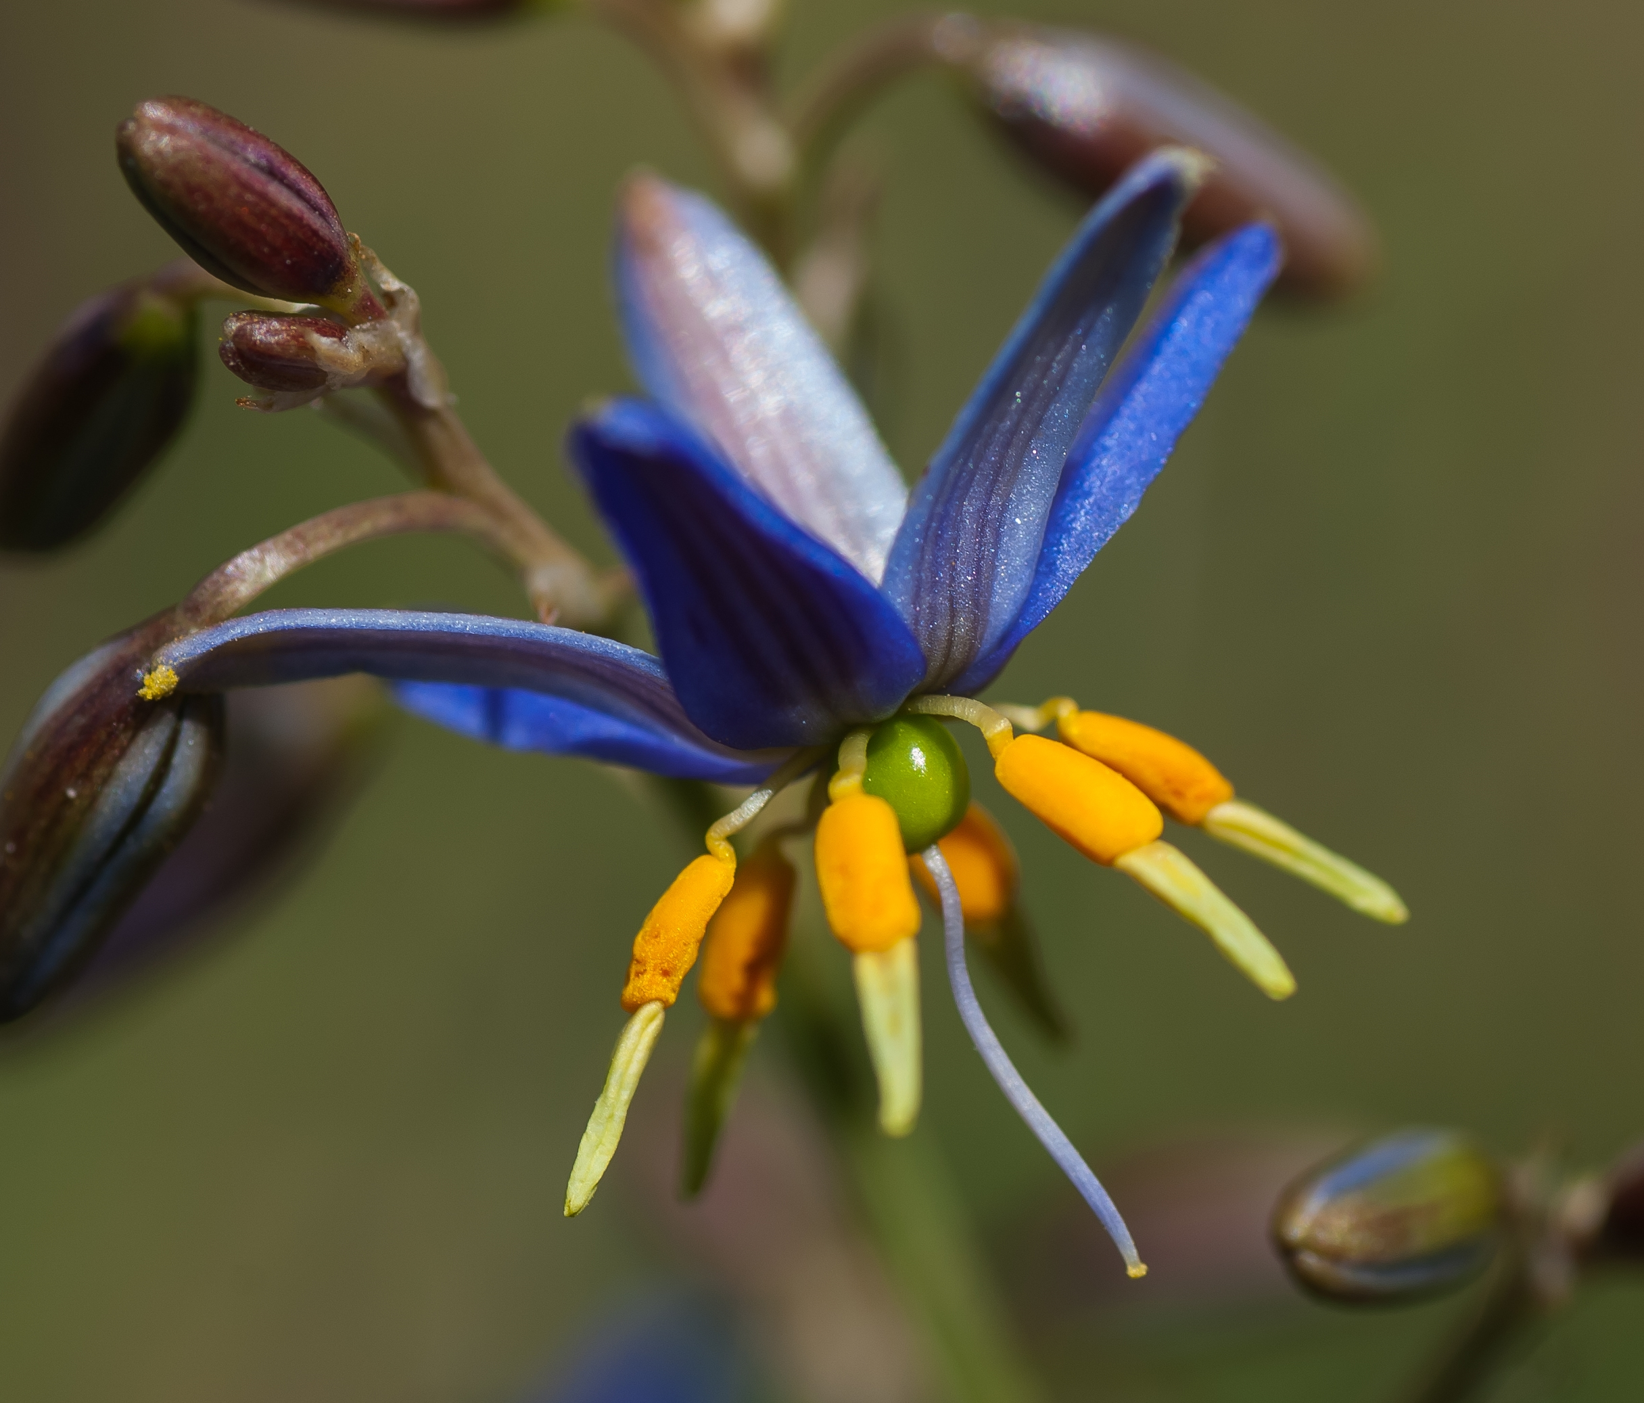
Matted-flax Lily, Dianella amoena
In Victoria, this nationally threatened lily is known to occur in as few as 120 locations. Only 50 of these known locations are believed to be producing seed. The Matted-flax Lily can be distinguished from other Flax-lily species by the pale white anthers. The species generally occurs in grasslands or in open woodlands.

For more information about Bald Hill Reserve or the threatened species listed here, contact the Council environment team at environment@mrsc.vic.gov.au

