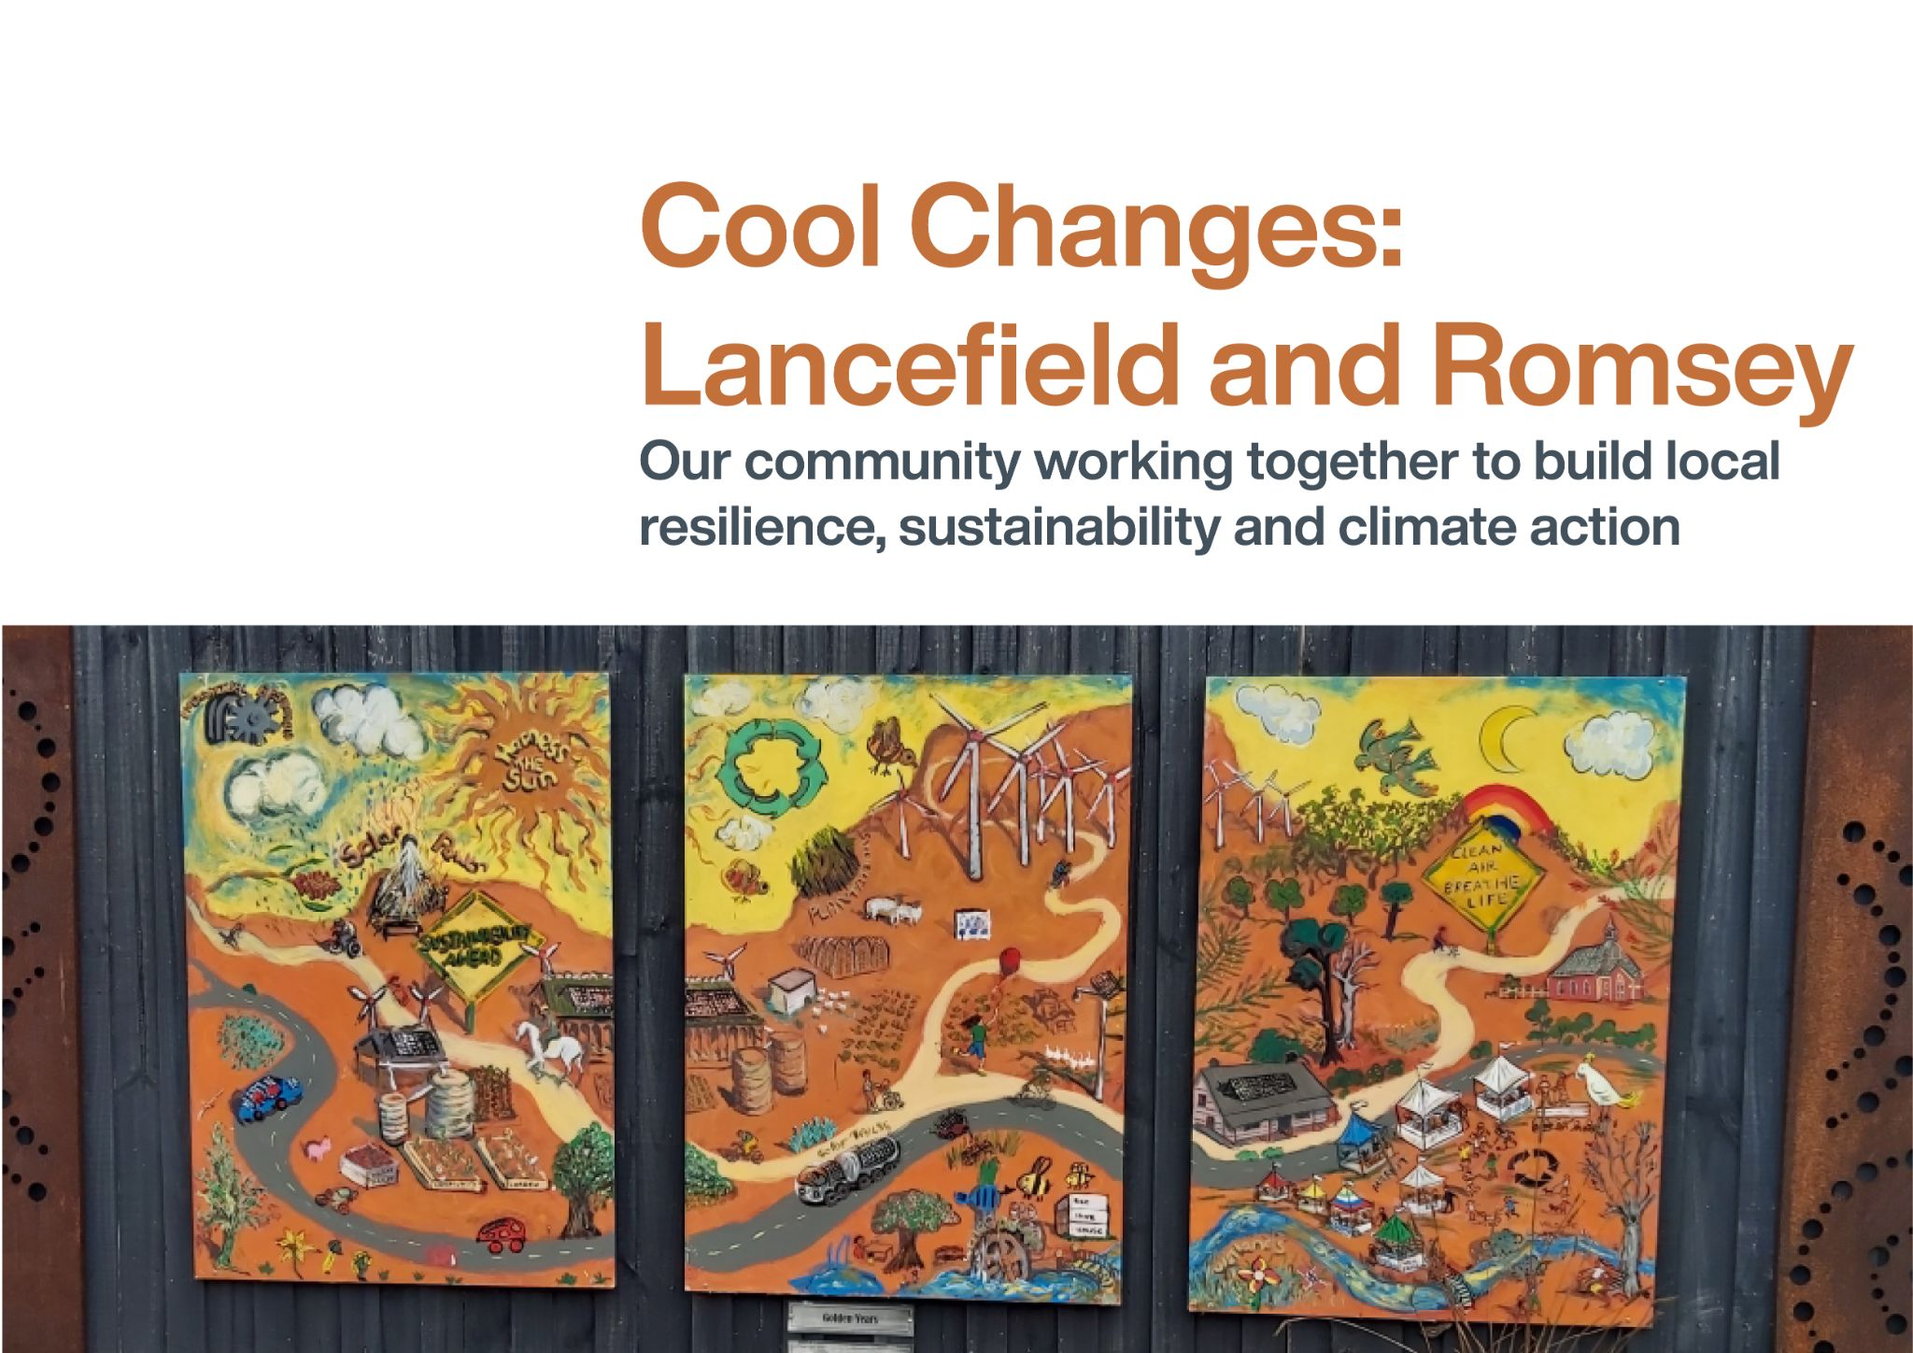

TRADITIONAL CUSTODIANS
We acknowledge that the Romsey and Lancefield region is located on Wurundjeri Woi Wurrung country. We pay respects to their Elders past, present and emerging and any Aboriginal and/or Torres Strait Islander People who live in the region today.

WORKING TOGETHER FOR OUR COMMUNITY
The Romsey and Lancefield communities have a history of working locally to improve the land and the lives of people who live in the region.
This document showcases the huge range of community projects that together build local resilience, strengthen local social connections, address climate change, and help us live more locally and more sustainably. It includes projects that are happening now, new and emerging projects, and some ideas for the future.

AN INVITATION
Everyone is invited to participate in their own time and their own way. If we all work on the things we’re passionate about, collectively we will have a big impact in delivering change.
In the following pages you’ll find a range of organisations and projects from across the Romsey and Lancefield Region. If you see something that sparks your interest, we invite you to get in touch via the contact details supplied with the listing.
You’ll notice that some ideas are currently just that, an idea. If any one of these ideas gets you excited, you’re welcome to take a lead on helping the project happen locally. Reach out to friends and local organisations to let them know what you’re doing. You might be surprised at what you can achieve, and what you might be able to get funding for.
And lastly, perhaps you have a great idea that isn’t listed in the document. Don’t let that stop you. Great projects, start from great ideas.

Our themes
We have identified six areas that we can work on together for the betterment of our whole community in the face of climate change:
- Caring for country
- Food, health and wellbeing
- Sustainable energy
- Sustainable transport
- Better homes and buildings
- Waste minimisation, recycling and the circular economy
Each theme is explored in the following pages, including:
- Current community projects
- Ideas for potential future activity
- Community needs and insights
- Funding and resources for your ideas
- Spotlight on some of our key organisations and projects

KEY ORGANISATIONS AND GROUPS
A variety of organisations and groups play an important role in building community connections, providing support services, and facilitating local sustainability in Romsey and Lancefield. Some key organisations and groups are listed below, noting that others (like sports clubs) are also working in the community, or in the process of being established.
- Country Women’s Association - Romsey
- Country Women’s Association - Lancefield
- Deep Creek Landcare Group
- Friends of Deep Creek
- Lancefield Agricultural Society / Show
- Lancefield Fire Brigade
- Lancefield Neighbourhood House
- Macedon Ranges Sustainability Group
- Men’s Shed, Romsey
- Men’s Shed, Lancefield
- Romsey Ecotherapy Park
- Romsey Fire Brigade
- Romsey Golf Club
- Romsey Neighbourhood House
- Romsey Toy Library
- Sunbury Cobaw Community Health
- The Romsey Region Business and Tourism Association
Most community activity runs on the power of volunteers, whose amazing work provides many benefits to many people - THANK YOU! If you would like to volunteer a bit of your time or skills to any of your local community organisations, please follow the links above to connect into your area of interest.

CARING FOR COUNTRY
The natural environment is a critical, complex and interconnected system that helps sustain us all. It is deeply valued by our local community. We work to take care of it, and live in harmony with it.
The natural environment around Romsey and Lancefield supports biodiversity, purifies the air, helps regulate temperature, supports pollination of flowers and food crops, and creates space for recreation and relaxation.
It is also culturally significant, with many of us having a strong connection to the land and water. In particular, the Wurundjeri Woi Wurrung Traditional Custodians have a longstanding, ongoing connection and deep knowledge of the local natural world.
Sadly, our way of life can have a negative impact on the natural environment. Native vegetation has been extensively cleared for housing and farmland, threatening many plant species and communities, and the wildlife that depends on them. Water quality has deteriorated and soil fertility has depleted. In a changing climate, hazards such as decreased rainfall, increased temperatures and more severe weather impacts will also negatively impact our natural environment.
Thankfully the Romsey and Lancefield region has passionate individuals and groups working to enhance our natural environment and ensure there is synergy between the natural and agricultural environments. Such action not only makes our region more beautiful, it also helps to mitigate climate change by sequestering carbon in trees, improving the ecosystem and increasing the security of our food systems through improved soil quality.
Caring for Country also means we have a connection to place, thereby enhancing our overall wellbeing.

CURRENT COMMUNITY PROJECTS

Gardens for Wildlife: Every garden is a place where wild plants and animals shelter, visit, or make their homes. We can all garden in a way that supports the unique and special plants and animals native to our area – what we call gardening for wildlife. Find out more at the Gardens for Wildlife website or connect with other interested locals.
Contact: Victoria Morris, vwmorfield@gmail.com
Macedon Ranges Regenerative Farming Group (in formation): Regenerative agriculture is a system of farming principles and practices that seeks to rehabilitate and enhance the entire ecosystem of the farm. It is a method of farming that improves the health of soils and pastures and waterways to ultimately benefit biodiversity and improve productivity. Regenerative farming is also helping to fight climate change by locking more carbon into the soil. There is increasing local interest in and practice of regenerative farming in our region, with lots of opportunities to learn together. Community action in this area could compliment Council’s existing Healthy Landscapes: Practical Regenerative Agricultural Communities Program
Contact: Jan Rovnholt, info@summerleigh.farm, or Amber Bruce, amber-lf@hotmail.com
Deep Creek Landcare Revegetation Projects: Across Forbes Crossing, Doggett’s Bridge, Sheehan's Crossing Stream Side Reserve and Gallaghers Crossing, our local Landcare group helps to ensure the ongoing health of our waterways and natural environment. Everyone is invited to join.
Contact: deepcreeklandcare@gmail.com

Romsey Ecotherapy Park: See page 6 for information.

Regeneration of the Romsey Golf Club: Since the 2009 millennium drought broke, our club has carried out strategic, mostly indigenous plantings. We have planted over 1,700 trees, shrubs and bushes with an excellent strike rate of ~80% of our plants surviving. We have also installed 55 nesting boxes to further support local wildlife. We work with Council and Western Water to improve water efficiency and use recycled water across the golf course and planting sites.
Contact: mail@romseygolfclub.net
Friends of Deep Creek Facebook Group: With around 1,400 followers in the Shire, this group also extends statewide with a Victorian Rivers and Creeks Page, allowing people to see waterways “beyond the farm gate”. It celebrates the beauty of our waterways, and the importance of protecting them through sustainable land and water management.
Contact: Ern Greene at erngreene@gmail.com or join them on Facebook
The Lancefield Agricultural Show: This important annual event happens on the third Sunday of each October (the 2021 show is scheduled for Sunday 17 October). There are opportunities to include even more sustainability components at the 2021 Show and in future years:
- Wash Against Waste, to avoid disposable crockery and cutlery
- Bus transport to and from the show to reduce parking impacts and transport emissions
- A “talks tent” which will host presentations and demonstrations about local ideas, produce and initiatives. Locals are encouraged to present and share what matters to them.
Contact: lancefieldshow@live.com.au or 0400 045 808

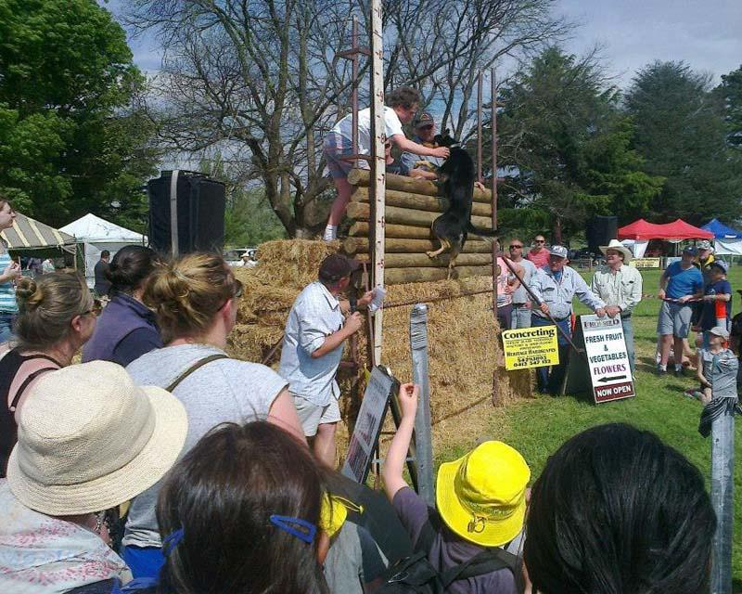

SPOTLIGHT ON: DEEP CREEK LANDCARE GROUP
The Deep Creek Landcare group was formed in 1985 and covers the Lancefield and Romsey districts. We meet at the Lancefield Mechanics Hall Annexe on the 2nd Monday of each month at 8pm.
Landcare is multidisciplinary. It embraces and integrates not just tree planting but also soil conservation; creation of wildlife habitats; weed and pest animal control; salinity amelioration; stream bank and roadside management and restoration; protection of remnant vegetation; and community education.
Benefits to becoming a Landcare member include:
- Networking with locals who have experience in land management
- Access to monthly newsletter, information and events to assist you with good land management covering topics such as weeds, revegetation, agroforestry, and grazing management
- Access to funding opportunities for land management
- Access to low cost indigenous plants
- Access to courses such as Whole Farm Management
Contact: deepcreeklandcare@gmail.com
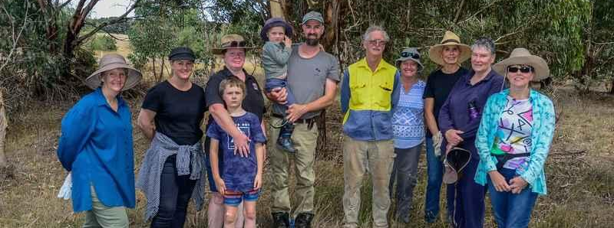

SPOTLIGHT ON: ROMSEY ECOTHERAPY PARK
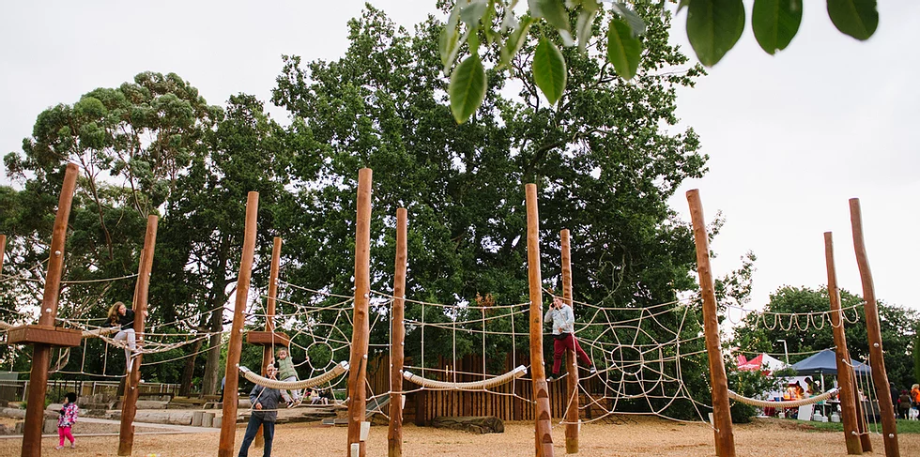
The Romsey Ecotherapy Park is being created to enhance health and wellness through connection with nature for all ages and all abilities. There are 4 key spaces for your enjoyment and relaxation:
- Active Nature Space is an enticing nature play space with balancing logs, a 40 metre flying fox, basket swing, timber fort, a climbing forest, plus a storytelling chair coming in 2021/22
- The Sensory Therapeutic Space (construction begins this year, 2021) will feature sensory gardens, permanent art installations, ephemeral billabong, sand play and a water feature
- The Arts Culture Space (construction begins this year, 2021) will feature an outdoor event space and picnic facilities that can host a vast range of events to help locals connect, address social isolation and attract visitors to our region!
- Woodland Ramble: coming in 2021/22 at the southern end of the park, it will provide a natural space for freeform interactions
The Park is located at 140 Main St Romsey and will be 100% complete in June 2022. Donations to help enhance and maintain the Park are always welcome.

IDEAS FOR POTENTIAL FUTURE ACTIVITY
- Rehabilitate the Deep Creek Nature Walk
- Continue to collaborate with Council to implement the Romsey Five Mile Creek Masterplan.
- Upgrade Lions Reserve with new plantings and watering system
- Create a local botanic garden
- Plant more flowering ground cover and trees to support lizards, bees and other insects, in public and private places
- Advocate to and work with Council to ensure housing estate developers create significant (at least 100m wide) conservation corridor buffers around new developments and ensure stormwater runoff is used to nurture the landscape
- The Deep Creek Landcare Group could reactivate the River Detectives program with local schools and the Junior Landcare Facilitator
- The Men’s Shed could create wildlife boxes for the Gardens for Wildlife program

Contact romseyecotherapypark@gmail.com

COMMUNITY NEED AND INSIGHTS
- We need more opportunities for all locals to connect with nature
- People are increasingly moving to the region to farm or to enjoy weekends away from the city. These newcomers need support and guidance to understand the local landscape and community. In particular, they need guidance to understand the interplay between agricultural and natural environments
- Revegetation and other land management work needs to be done in collaboration with neighbours, particularly in agricultural areas. What we do on one property has an impact on our neighbours
- We have issues with natural landscapes and farm lands being taken over by housing developments. We need developments to be more appropriate to the natural environment and contained, to avoid the spread of towns
- Reduced lawn mowing / leaving grass a bit higher by residents and council through spring and summer will allow flowers and grasses to better support insects, bees, lizards, spiders, birds etc, and also help store carbon
Note: Other thoughts posted to the online platform or raised in discussions related to this theme are included in the appendix.

FUNDING AND RESOURCES FOR YOUR IDEAS
- Landcare (available annually)
- Melbourne Water (available annually)
- The Macedon Ranges Sustainability Group (MRSG) hosts a Sustainable Development Action Group that educates and empowers locals to engage with state and local government planning processes to entrench sustainable development practices at a foundational level
FOOD, HEALTH AND WELLBEING
Food, health and wellbeing are intimately connected to our natural environment. Access to fresh, locally grown produce supports our physical and mental health. Food can also provide nourishing opportunities for sharing, swapping and building the community connections that are essential for long term wellbeing and resilience.
Extreme weather events such as heatwaves, droughts and floods have a significant impact on our physical and mental health, as well as food systems. These impacts restrict agricultural production and disrupt supply chains, the fragility of which we have seen with COVID-19 (impacting labour and distribution). Climate change means these weather events will become more frequent and severe.
In Romsey and Lancefeild, we are already starting to share resources and set up systems to help everyone access healthy food and build stronger local connections. We know that buying locally produced food, and from local traders, helps strengthen our resilience, reduces the reliance on international and national supply chains and the emissions that contribute to climate change, and importantly supports our farmers and small businesses.
We also know that the supportive social connections made amongst residents through the various activities hosted by the neighborhood houses, the library, and other community groups contribute to the wellbeing of individuals and the community, locally and beyond.

CURRENT COMMUNITY PROJECTS
Lancefield Community Garden: Located at 28 High St Lancefield, and open on Tuesdays at 10am and as advertised or just drop in. The garden provides an opportunity to learn from each other about what and when to plant, composting, and healthy, productive soil. To keep updated about garden activities, contact the Neighbourhood House.
Romsey Primary School: Our local school endeavours to promote energy efficiency, reduce water wastage, increase biodiversity and encourage community practice in sustainability. Students are encouraged to develop an awareness of a more effective management of resources, including through the school worm farm.
Country Women’s Association (Romsey and Lancefield branches): The CWA focus is on gardening and food security. We conduct masterclasses in crafting, preserving and cooking, and host regular meetings and craft meetups in Romsey and Lancefield. We coordinate an annual community Christmas hamper program to support local families in need. Donations in the lead up to Christmas are always welcome.
Contact Romsey branch: Visit the Facebook page or email strawbridgejoan@gmail.com
Contact Lancefield branch: Visit the Facebook page or email lancefieldcwa@gmail.com
Feed it Forward: The Feed it Forward program takes donated locally grown produce from gardeners, farmers and businesses and turns it into a delicious community feast. The Romsey and Lancefield Neighbourhood Houses are currently working to extend the program to establish a local food share pantry in each town. Anyone with produce to donate is encouraged to contact Romsey Neighbourhood House on 5429 6724 or Lancefield Neighbourhood House on 5429 1214 or via email to admin@lancefieldhouse.org.au
Lancefield and District Farmers Market: Held on the 4th Saturday of each month (3rd Saturday in December) at the Central Plantation of Lancefield, High St from 9am - 1pm. The Market provides an opportunity for locals to buy beautiful, healthy produce from our region, and support the viability of local small businesses. Join their Facebook page to stay up to date on all the Market activity and opportunities.
Contact: lancefieldfarmersmarket@hotmail.com
Get to Know Your Grower: The Macedon Ranges Veg Action Group and Sunbury Cobaw Community Health are working together to develop a local grower's directory and also promote a campaign to introduce growers and their produce to consumers. Growers can complete the survey to register for the directory. They are also planning for an awards program to recognise and promote the many benefits of “plant positive” meals and menus at local food outlets.
Contact: veg@mrsg.org.au

Romsey and Lancefield Fire Brigades: See page 10 for information.

Romsey and Lancefield Neighbourhood Houses: See pages 10-12 for information.

Romsey Library: See page 12 for information.

SPOTLIGHT ON: ROMSEY AND LANCEFIELD FIRE BRIGADES
Fire is a real and tangible concern for all rural areas. Climate change is already and will continue to extend the fire season and increase the severity of the fires.
Under these conditions, it is more important than ever that communities prepare for fires and work in partnership with local emergency services and fire brigades.
Both Romsey and Lancefield are lucky to have local Fire Brigades staffed by dedicated volunteers who serve our local communities.
If you are looking to make your home or business more fire-safe, please visit the Romsey Fire Brigade website and review the guides and advice that can be downloaded for free. You can also find information on the Romsey and Lancefield Facebook pages.
For all emergencies call 000

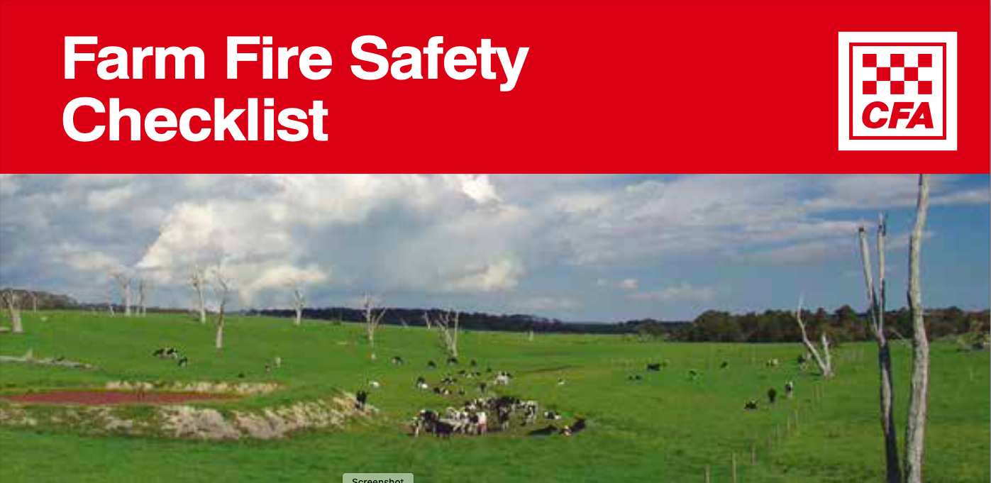

SPOTLIGHT ON: OUR NEIGHBOURHOOD HOUSES
Created for our community, by our community. The Lancefield and Romsey neighbourhood houses are truly the heart of our community.
The breadth of services – programmed and as-needed – are nearly impossible to summarise. In short, if you’re new to our region and seeking connections, visit your neighbourhood house. If you’re in need of support or services, if you’re looking to meet new people, if you want to learn something new or give back to your community, the neighbourhood house can help, or point you in the right direction.
Each neighbourhood house runs its own program but there are also some shared services:
Community Driven is a volunteer program helping people without transport access medical appointments (see page 18 for more information). The new Shareride car offers low cost transport for social, educational, shopping and appointment needs. Call your neighbourhood house or email lrcommunitytransport@gmail.com to book or volunteer.
The Feed it Forward monthly community lunch offers a low cost, nutritious and social meal. The lunch is an opportunity to reduce social isolation, bringing many, and diverse, members of the community together. The lunches often feed around 90 people, everyone from school groups, families and singles. Absolutely everyone is welcome. Call your local neighborhood house for dates, venues and bookings.
If you’re a local business or producer, you are invited to donate food to the Feed it Forward program (and attend the lunch!). See page 9 for more information.
Lancefield Neighbourhood House
78 High St, Lancefield
Contact: 5429 1214 or admin@lancefieldhouse.org.au
You might be surprised to learn that the Neighbourhood House runs:
- Lancefield District Farmers Market
- Opportunity Knocks Op Shop (34 High St)
- The Townhouse (38 High St) As a community resource centre, The Townhouse includes a food pantry; community nursery; seed library; photocopying, fax, laminating and print service; massage chair; internet access; sale of local products and handcrafts; and community and visitor information
- Men’s Shed (76 High St) supports the mental health of local men, providing a venue to gather, talk, work together and access machinery and tools. The Shed also offers a ‘tools in schools’ program and a repair and building service for community members and organisations
- Recycling Centre where you can recycle those hard-to-recycle items like batteries, coffee pods, writing instruments, contact lenses, cleaning product bottles, and oral care products
- Community Driven, Feed it Forward and Community Support project in partnership with Romsey Neighbourhood House
The Neighborhood House offers a massive range of everchanging workshops and events such as first aid training, exercise programs, dance workshops, driver education, crafternoons, art classes, meditation, help with filing in forms, yoga and bike riding.
It also hosts special interest groups including a local choir, succulent interest group, family history research group, boomerang bag group, and a reading circle.
Everyone is welcome. Check out the program on our website.
Romsey Neighbourhood House
96-100 Main St Romsey
Contact: 5429 6724 or admin@romseynh.org.au
We work to create an accessible space to run events, services and activities for and with our community, about the things that matter most to people in Romsey:
- Crisis support: We have a community crisis trailer that can generate power in times of emergency. A list of vulnerable residents is maintained, so we can check on people who might need support during emergencies and challenging times. We do weekly meal deliveries to people in need and we continue to work with our community to understand what support they need.
- Community food share initiative: We are working on a community swap, sell or take program for fresh and non-perishable food. Everyone can participate in the swap and those in need of free food can register to receive this support and are welcome to pay the community back through volunteering.
- Romsey Community Co-Op: As a social enterprise, the volunteer-run shopfront offers opportunities to buy and sell a huge range of beautiful local products and services. Alongside craft and giftware, you can get a haircut (the hairdresser has discount days for people on low incomes) and soon, you’ll be able to enjoy the coffee house run by young people getting experience in the workplace.
- Commercial kitchen (in development as at July 2021): Once up and running it will provide opportunities for local cooks, bakers and makers to produce food in a safe and regulated kitchen ensuring they are fit for sale and swapping.
- Community garden (in development as at July 2021): The garden will include affordable plant sales, gardening related workshops and activities.
- Workshops and events: The program is regularly updated with events for kids and adults, covering a range of topics like cooking for one class, chainsawing, welding for women, fire safety, yoga, meditation, art and craft, and literary events.
- Op shop: Open each Saturday, we offer people in need access to free clothes through our voucher program. So far, we have given away around $15,000 worth of clothes to help people feel good and keep warm. We have also been able to donate clothing to other charities to share the benefits.
- Mind-health hub: We provide a quiet, comfortable location for local residents to access mental health support. This service is for people experiencing mental illness and those caring for others.
A new website is coming soon. In the meantime, join our Facebook page or pick up a term brochure from the House.
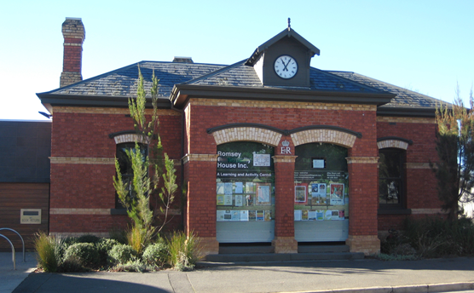

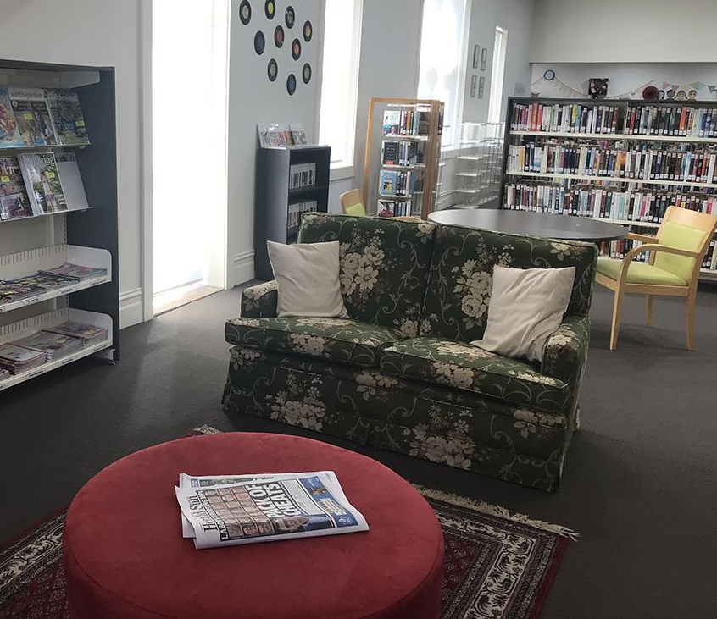
SPOTLIGHT ON: ROMSEY LIBRARY
Open 6 days a week (closed Sun) at 98 Main St, Romsey.
Our library is full of surprises for people of all ages, abilities and interests. Of course we have an amazing array of books but we offer so much more (and most of it is free!):
- Workshop, talks and online events for adults and children
- Warm, comfortable spaces in winter and cool spaces in summer for recreation, socialising, study and work
- Free wifi and 5 public computers
- Colour copying and printing (fees apply)
- Scooter charging point
- Community meeting room
We have just launched a new, monthly event, A Curious Circle: Come and create wondrous things for fun and connection in a friendly, inclusive setting. A different activity will be taught each month, led by our creative library staff. No skills required and refreshments provided.
Regular events continue, including Mums and Bubs and Toddler Time.
Locals are welcome to work with the Library to organise workshops and talks on topics that matter most to them.
Our Library is truly for everyone. Come in, connect, enjoy.
Contact: 5429 3086 or romsey@ncgrl.vic.gov.au
COMMUNITY NEED AND INSIGHTS

IDEAS FOR POTENTIAL FUTURE ACTIVITY
- Develop refuge centres that serve the community during a crisis. The Library and Hub in Romsey, and the Neighbourhood House in Lancefield already deliver services during emergency events but their efforts are limited when mains power goes out. These locations could be retrofitted with solar and batteries so they have energy independence and can act as a response coordination centre and refuge during times of crisis
- Work together to promote local growing and buying:
  - Local food outlets showcasing local products
  - Promote cost effectiveness of farmers market produce
  - Work with Council on their buy local campaign
- Develop a regular community stall at the Lancefield Market so anyone running a local project can promote their initiative
- Rehabilitate the Deep Creek Nature Walk (also links to Caring for Country)
- Reinstate annual events (community picnics on public holidays)
- Create a local Human Library (ongoing or periodic)
- Provide more opportunities to learn about permaculture, companion planting, smart water use in the garden, composting, worm farms, bee keeping, animal care, preserving and cooking
- Refurbish the skate park in Romsey
- Develop more senior citizens homes
- Find a venue for the Lions Club to hold meetings and functions

- We need to work together and advocate to protect existing farmland in the region. It is essential that our farmland is not built over with new residential developments or it will decrease our local resilience and self sufficiency
- The price of firewood means some people are not heating their homes adequately. We need better heating solutions
- Romsey-Lancefield RSL needs better facilities for their ongoing work in caring for veterans and their dependants
Note: Other thoughts posted to the online platform or raised in discussions related to this theme are included in the appendix.

FUNDING AND RESOURCES FOR YOUR IDEAS
- Macedon Ranges Shire Council has an annual community grants programs that support a whole range or initiatives
- VIC Health has regular funding rounds that could support future projects
- Wood4Good is one opportunity to access sustainable firewood

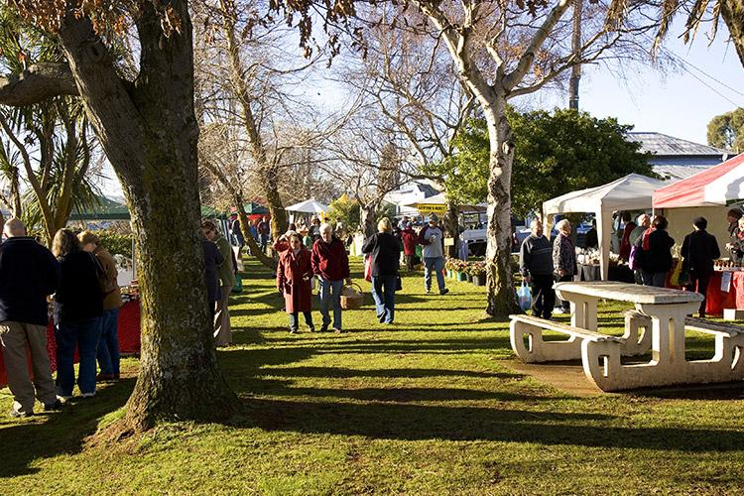

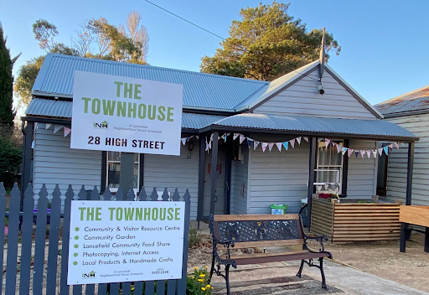

SUSTAINABLE ENERGY
Reducing the amount of energy we use and switching to renewable energy reduces the emissions that cause climate change. Renewable energy can also help prevent overspending on electricity, gas and petrol.
The most common form of renewable energy in Australia is solar. We are also seeing more large-scale wind farms being developed in regional areas.
As with our food supply, our traditional energy network has relied on centralised generation and a vast grid of infrastructure to supply us with fossil-fuel-based energy. Transitioning to local, renewable energy is not only better for the planet, but it can also improve resilience, while often reducing prices. Increasingly, we can also store the renewable energy in local batteries and share the energy we generate through sharing platforms and microgrids.
While not yet widespread in Australia, in the near future we will have access to electric vehicles and charge them with solar power so we no longer have to pay for petrol.
There are local solar success stories from the Macedon Ranges. The Social Foundry in Kyneton saves an estimated $5,000 each year due to its 20kW rooftop solar system.
Of course, not everyone owns their own home and can afford to install solar. Government incentives, community bulk buys and Green Power can help more people access renewable energy.

CURRENT COMMUNITY PROJECTS
Renewable Energy Action Group: Convened by MSRG, the goal of the Renewable Energy Action Group is to make the Macedon Ranges carbon neutral by 2030, by leading, supporting and investing in local energy efficiency, generation and offset projects in partnership with community, government and industry. The Group is working on a range of projects, including a community wind farm.
Contact: renewenergy@mrsg.org.au
Solar on community buildings: The Romsey Hub has already installed a solar system. The Lancefield Neighbourhood House is in the process of securing roof top solar through the MASH program.
MASH: See page 16 for more information.

SPOTLIGHT ON: MASH

IDEAS FOR POTENTIAL FUTURE ACTIVITY
- A township micro-grid (solar powered) for Lancefield and Romsey, or a community solar co-op with battery power storage to help more people access renewable energy
- Education for local trades in emerging technologies and industries
- A support program for households with low income to access solar so they can better afford to heat and cool their homes
- Adding solar to the existing senior citizens homes

MASH bulk-buy offers quality solar power systems and battery storage, backed by solid warranties and installed according to best practice industry standards. It also provides great value, with competitive prices negotiated as part of the bulk-buy.
There’s also a ‘give back’ in the form of free solar for community groups, kindergartens or schools in the region. One percent of bulk-buy revenues is donated as free solar.
MASH is coordinated through the Central Victorian Greenhouse Alliance based in Castlemaine. Since 2014 MASH has installed over 1,500 new rooftop solar systems (around 20,000 panels), cut household electricity bills cut by $1M each year, reduced carbon emissions by more than 9,000 tonnes each year (equivalent to getting around 1800 cars off the road) and installed seventeen community solar systems for schools and community groups.
Approximate prices for solar systems and batteries can be found on the MASH website. You can also request a quote for your property.
Anyone in Romsey or Lancefield thinking about going solar is encouraged to get a quote from MASH.
Contact: info@cvga.org.au or 1300 466 274

COMMUNITY NEED AND INSIGHTS
- More community education about the benefits of solar, including the most reputable companies
- Government support for cheaper battery storage
Note: Other thoughts posted to the online platform or raised in discussions related to this theme are included in the appendix.

FUNDING AND RESOURCES FOR YOUR IDEAS
- Agriculture Victoria free on-farm energy assessments and on-farm energy grants as part of the Agriculture Energy Investment Plan (closing 15/12/21. Vic Gov likely to offer a different range of grants following closure of this round)
- The Victorian Government has a range of solar rebates including:
  - Up to $3,500 for small businesses for up to half the cost of the system
  - Up to $1,850 plus the option of an interest-free loan for landlords/renters
  - Solar and battery rebates for homeowners
- The Victorian Government also offers rebates for:
  - Efficient heating and cooling upgrades
  - Efficient hot water upgrades
SUSTAINABLE TRANSPORT
Transport is Australia’s third largest source of carbon emissions (17%), with cars responsible for approximately half of these emissions.
We can reduce transport emissions and their contribution to climate change by sharing cars, using public transport, walking, cycling, skateboarding and driving electric vehicles.
When travelling short distances, leaving the car at home can also have financial and health benefits. Riding your bike, walking or skating for short trips provides physical exercise and mental wellbeing, and costs nothing.
Unfortunately Romsey and Lancefield are not supported by a train line but public transport is available. Three bus routes connect Lancefield to Kyneton and Sunbury. These services were upgraded in 2019 to a simpler timetable with more frequent services. For route maps and timetables are available from the Public Transport Victoria website links below:
- Sunbury/Clarkefield to Lancefield
- Gisborne to Lancefield
- Lancefield to Kyneton

SPOTLIGHT ON: COMMUNITY DRIVEN
Community Driven is a volunteer run program helping people in our community access predominantly medical appointments. This project is a joint initiative of the Lancefield and Romsey Neighbourhood Houses.
Flexible transport options have been a major challenge for people needing to access health care. In 2018 Community Driven was launched in response to this need. It has since completed over 300 trips, helping people get to appointments in Melbourne, Bendigo, Sunbury and of course between Lancefield and Romsey.
Do you need help?: Are you missing medical appointments because of a lack of transport solutions? Contact us to register as a passenger for this service. Once registered we can take bookings and help you get to where you need to be. Our volunteer drivers appreciate advance notice and we request a minimum of 48 hours notice for bookings.
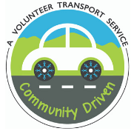
Volunteer: Become a volunteer driver for our program. Our pool of drivers gives you flexibility to volunteer when it suits you, and we can reimburse your expenses. Our community car is also available to volunteers to use.
Sponsors: We are grateful to Bendigo Bank, Macedon Ranges Shire Council and Department of Transport for their support.
To book or volunteer email lrcommunitytransport@gmail.com or call your local neighbourhood house:
Lancefield: 5429 1214
Romsey: 5429 6724

IDEAS FOR POTENTIAL FUTURE ACTIVITY
- Community advocacy for better local public transport, including reinstating the bus connection to the train line
- Work together to install electric vehicle charging points in our towns
- In partnership with Council, improve walking and cycling path connections to help people walk/ride to schools and shops

COMMUNITY NEEDS AND INSIGHTS
- Clear, accessible information about existing public transport services
- More affordable, efficient public transport, including a train line connecting the towns back to Clarkefield or Riddells Creek stations
- Better walking and cycling paths
Note: Other thoughts posted to the online platform or raised in discussions related to this theme are included in the appendix.

FUNDING AND RESOURCES FOR YOUR IDEAS
- The Victorian Government is offering rebates on electric vehicles
- High quality, second hand electric vehicles can be purchased through the Good Car Co.
- The Public Transport Users Association Victoria is the recognised consumer organisation representing passengers of all forms of public transport. A non-profit, voluntary organisation, they lobby governments and public transport authorities in the interest of all users of public transport
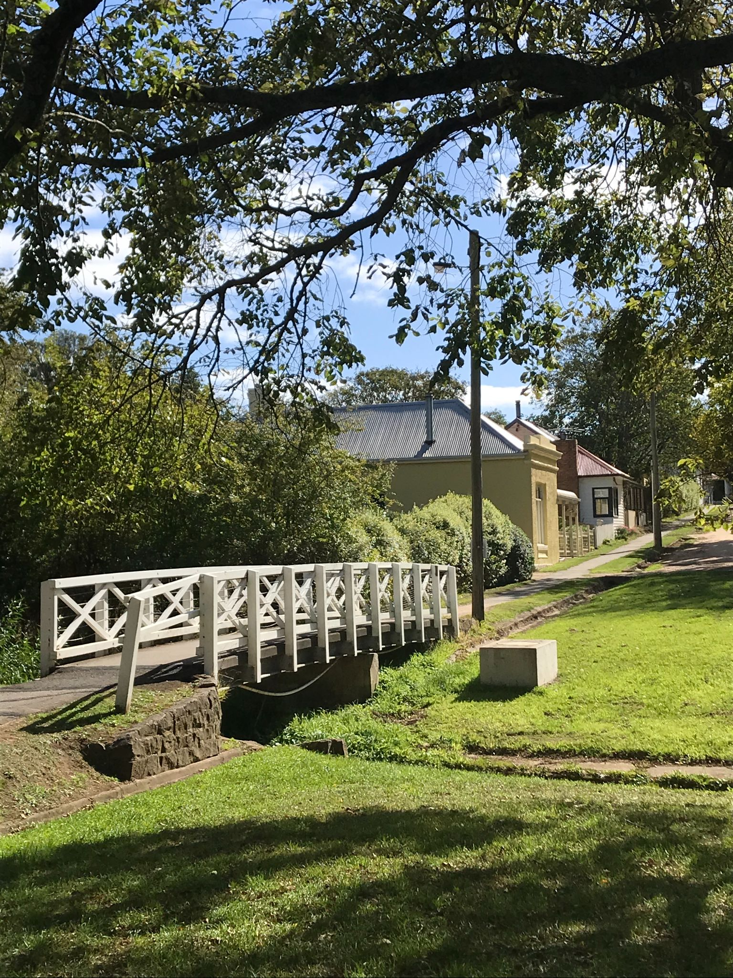

BETTER HOMES AND BUILDINGS
As the impacts of climate change become more prevalent, increasing temperatures and other extreme weather events will mean that the quality of our homes becomes even more important.
Poor quality homes are hot in summer and cold in winter. They usually cost more to operate, and are owned by people who can least afford expensive energy bills.
On the other hand, a well designed house with a high star rating is more comfortable to live in and costs less to heat, cool and maintain. These homes also generate less carbon emissions so they are better for our environment. A well designed, energy efficient house will usually be well insulated, have quality double glazed windows, appropriate external shading, natural cross-ventilation, appropriate tree canopy cover, all-electric appliances (including induction cooktops) and powered by solar or another form or renewable energy.
In addition to the environmental and financial benefits associated with good building design, it provides health and wellbeing benefits for building users and occupants.
While gas has been promoted by the federal government as a pathway towards cleaner energy, a recent report by the Climate Council has identified the health risks of using gas in the home. Cooking with gas is estimated to be responsible for up to 12% of childhood asthma in Australia.
A home can be well designed and constructed from day one but most existing homes will need to be renovated to make them more comfortable and efficient. In Romsey and Lancefield there is a mix of old and new housing stock, with high potential for improvement.
SPOTLIGHT ON: SUSTAINABLE HOMES GROUP
Convened by MRSG, our Sustainable Homes Group provides practical, local support to help people to make their homes more environmentally friendly, cheaper to run and comfortable to live in.
Our group’s flagship event is Renew’s Sustainable House Day, in September each year. Sustainable House Day provides the opportunity to explore some of Australia’s most unique and inspiring homes, and learn from the people who designed them, built them, and live in them. And, if you own a high efficiency home, you can elect to showcase your home to support locals to learn from your experience.
Our definition of a Sustainable Home is one that:
- Is geographically as close as possible to the things we need so we can get most places with no, or low, carbon impact
- Is just big enough to suit our needs, and adaptable to suit us as our needs change in the short- and longer term. We use all parts of our homes every day
- Is built to suit the climate in Macedon Ranges (Climate Zone 7). Minimal additional energy is needed to keep our homes comfortable (especially in winter!) because they are well-designed, well-built and well-maintained
- Runs efficiently, powered by renewable energy, whether generated on-site or elsewhere
New group members are always welcome. Contact: susthomes@mrsg.org.au

IDEAS FOR POTENTIAL FUTURE ACTIVITY
- Develop a local home retrofit program to help people who are elderly, have a low income or require support to improve the thermal comfort and efficiency of their homes. Climate Safe Rooms run by Geelong Sustainability Group is one program example.
- Host community workshops to educate everyone about how to better manage our energy and water to reduce our bills and live more sustainably
- Host community workshops about retrofitting homes to improve their thermal comfort and efficiency
- Work with EPA to install an air quality meter so we can understand the impact of wood heaters in the local area
- Form partnerships and seek grants to have solar panels installed on roofs of sports clubrooms and other community use buildings

COMMUNITY NEEDS AND INSIGHTS
- There is a lack of quality residential development in our region
- Education pro[grams are needed to help local designers and builders work with clients about the financial, comfort and health benefits of sustainable design
- Move away from wood fired heating which creates pollution, reduces air quality and impacts our health
- State and Federal government building regulations need to improve to make houses more energy efficient
- Promote the value of good design, like having case study homes open on Sustainable House Day
Note: Other thoughts posted to the online platform or raised in discussions related to this theme are included in the appendix.

FUNDING AND RESOURCES FOR YOUR IDEAS
- See Sustainable Energy section on page 15 for rebates on home solar PV, batteries, efficient hot water systems and heating and cooling upgrades
- The Victorian Government has rebates available for households and businesses for a huge range of energy saving products including insulation, weather sealing, switching to double glazed windows, pool pumps, fridges and freezers and lots more
- Some banks offer lower interest green loans to build or upgrade homes to be more sustainable
- MSRG hosts a Sustainable Development Action Group that educates and empowers locals to engage with state and local government planning processes to entrench sustainable development practices at a foundational level

WASTE MINIMISATION, RECYCLING AND THE CIRCULAR ECONOMY
Through reuse, recycling, sharing and re-purposing we can reduce carbon emissions, stop precious resources being sent to landfill, and strengthen community connections.
What we consume every day has a profound impact on our planet. We are lucky to live in an abundant society, but the reality is that the resources we depend on are limited. Every time we buy, then throw away a product, the energy and resources that have gone into its production are wasted.
Our traditional consumption model of ‘take, make, use and dispose’ needs to shift towards a circular economy. A circular economy aims to keep resources in circulation forever. It aims to design waste out of the system and use outputs from one process as inputs in another.
Some people are already participating in the circular economy without even realising it. If you compost your food waste, then use that compost on your garden to grow more food, you’re in the circular economy!
It’s important we start to reduce what we buy, prioritise borrowing, and reuse wherever we can, and then recycle where necessary (your purple, yellow and green bins). The very last option is sending an unused item to landfill (your red bin). You can find out more about waste and recycling options in our region here at the Macedon Ranges Shire Council website.

CURRENT COMMUNITY PROJECTS
Local Op Shops: Donate unwanted items and buy what you need second hand. Reduce waste and save money!
- St Pauls Anglican Op-Shop is located at 77 Main St, Romsey, and is open Friday 12.30-4.30pm and Saturday 10am-1pm (closed during January)
- Opportunity Knocks is located at 34 High Street, Lancefield, and is open 10am–4pm Monday to Friday, and 10am–1 pm Saturdays
Lancefield Boomerang Bags: Boomerang Bags is a global, grassroots movement that is connecting and empowering local communities to tackle plastic pollution at its source. Sewers use recycled fabric to create reusable bags that are distributed through the community so these bags are used in place of plastic bags. The Lancefield Boomerang Bags Group sews and distributes bags locally. New sewers are always welcome.
Contact: admin@lancefieldhouse.org.au
Lancefield Recycling Hub: See page 23 for more information.
Romsey Toy Library: See page 23 for more information.

SPOTLIGHT ON: LANCEFIELD RECYCLING HUB
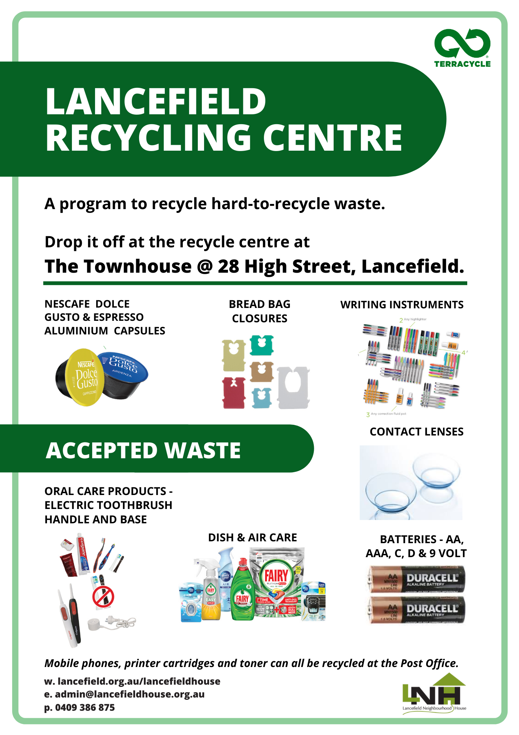

SPOTLIGHT ON: ROMSEY TOY LIBRARY
Romsey Toy Library is a toy lending service which allows parents, grandparents and carers to borrow toys for a low-cost annual membership of $25-35. A huge range of toys and equipment are on offer, including specialist toys for children with disabilities that might typically be out of reach for many families or carers.
This important local, volunteer run service not only helps kids access toys that support play and learning, it also saves families and carers money, and reduces the volume of toys going to waste as kids outgrow them.
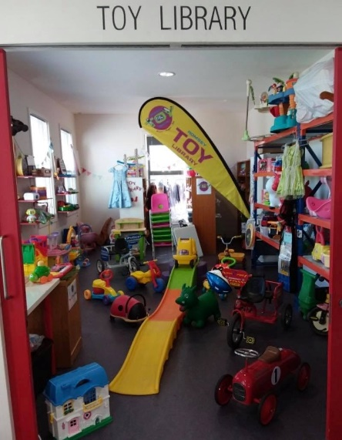
Open 2nd and 4th Tuesday of every month 11:30-12:30 and Saturdays 10:30-11:30pm at 96-100 Main St, Romsey.

The Toy Library is always in need of more volunteers. If you would like to get involved please email Rachel on romseytoylibrary@gmail.com

IDEAS FOR POTENTIAL FUTURE ACTIVITY
- Continue working to make the Romsey and Lancefield region plastic free. The Plastic Free campaign can help with advice
- Encourage the use of reusable coffee cups. People can bring their own cups or we could develop a model like a café in Yackandandah who operates have a mug library
- Extend the Men’s Shed to host a tool library. For example, the Brunswick Tool Library has developed a model that could be adapted locally
- Develop a Romsey/Lancefield Recycling Centre that sells recovered items that can be re-used rather than go into landfill
- Establish a local repair cafe
- Work with Council to identify the best locations for the Victorian Government’s Container Deposit Scheme which is due to commence in 2023. There are opportunities for clubs, groups, and not-for-profits to earn an income from the Scheme, through the cash rewards for the return of drink cans, cartons, bottles
- Investigate local circular economy solutions where “waste” products from one business are used as an input into another business. Work with Council’s Economic Development team to identify local partnerships.
- Advocate for a four-bin system at all sports grounds and public places, consistent with kerbside collection service in the shire
- Connect to and expand on waste reduction programs like Resource Smart Schools

COMMUNITY NEEDS AND INSIGHTS
- Local or shire-wide solution for hard-to-recycle products such as polystyrene, silage wrapping and other agricultural plastics, compostable cups
- Improved public place infrastructure so that rubbish, recycling and organic waste can be put into the right bins
- Information for traders so they understand viable alternatives to plastic bags and packaging
- Local soft plastic recycling drop off point
- Regular recycling education through local media outlets
- Support for families to access reusable nappies (collect and wash service)
- A tip shop at the Romsey Transfer Station
Note: Other thoughts posted to the online platform or raised in discussions related to this theme are included in the appendix.

FUNDING AND RESOURCES FOR YOUR IDEAS
- Sustainability Victoria regularly has grants to support waste and circular economy programs, research and pilots
- Find out about the State Governments Container Deposit Scheme, including fundraising opportunities for local community groups
- Find out more about waste and recycling options in our region here at the Macedon Ranges Shire Council website
- Ellen MacArthur Foundation has a range of free resources about the circular economy, including resources for schools
- MRSG hosts a Waste and Recycling Action Group who works for a cleaner, less wasteful world. Contact waste@mrsg.org.au

NEXT STEPS
When you reflect on all the activities listed above, it’s clear we have great community foundations in Romsey and Lancefield and can continue to create a more sustainable place to live and work.
And when you can, consider volunteering or joining one of our local groups according to your area(s) if interest.
The MRSG has offered to support the formation of a Romsey and Lancefield Action Group under its broader banner. This would provide an opportunity to connect with and learn from over 500 members from 12 specialist sustainability groups across the Macedon Ranges Shire. It would also assist with obtaining grants and funding.
The structure of the new local action group can be designed to work best for anyone involved. We can decide how often to meet, what we want to achieve and how we can coordinate with existing local groups.
If you are interested in forming and being part of a new local action group, please register your interest on https://mrsg.org.au/lancefield-romsey , or contact spredebon@mrsc.vic.gov.au.

HOW THIS PLAN WAS DEVELOPED
This Plan was developed through contributions from local groups and individuals across the Romsey and Lancefield region, through a facilitated process outlined below:

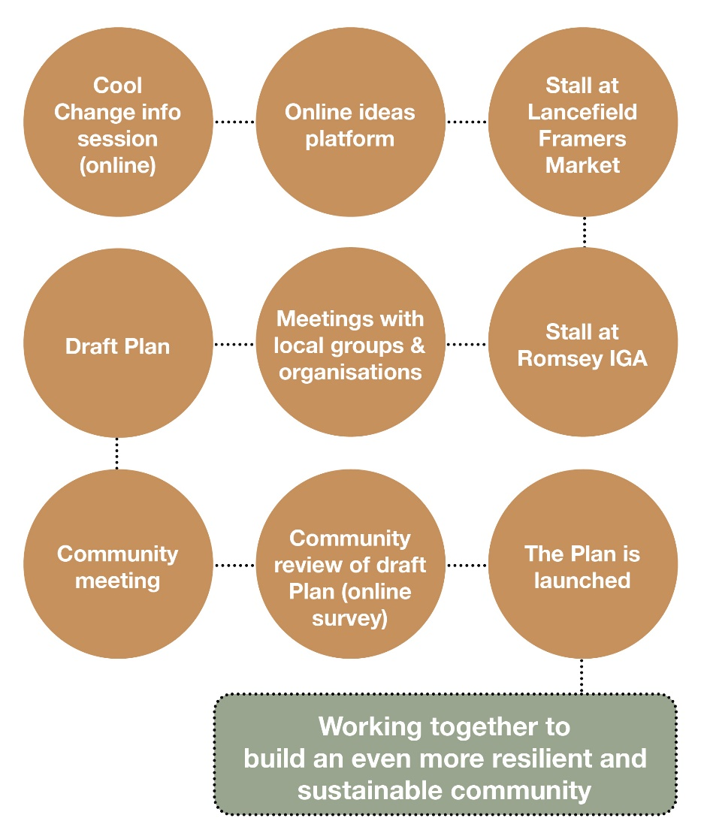

ABOUT COOL CHANGES
Cool Changes is an ongoing program funded by Macedon Ranges Shire Council (MSRC) to support local communities across the Shire to develop climate change action plans that are created by and for local communities.
Two Cool Changes plans have been developed so far:
- The Sustainable Malmsbury Action Plan (2019)
- Cool Changes Woodend Climate Action Plan (2020)
The Plans have helped locals connect around the issues that matter most to them and have also made it easier to attract community grant funding into the towns.

THANK YOU
A big thank you to everyone that helped create this Plan, and more importantly, to all of you who give your time to your local community to help create a better and more sustainable future.
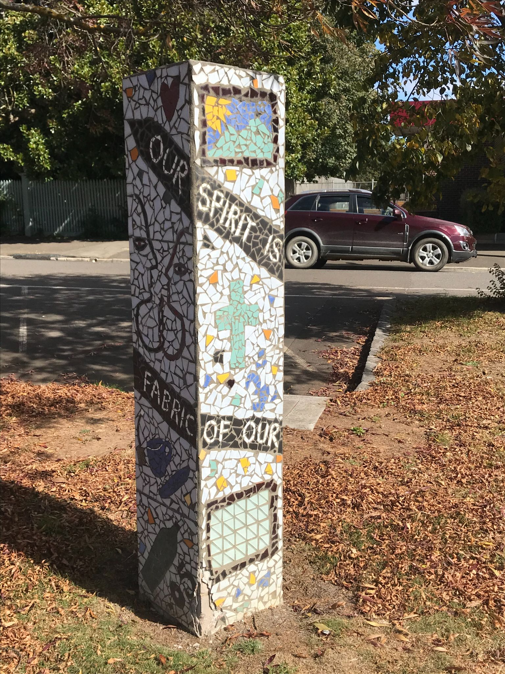

APPENDIX
Below are some additional notes from the community brainstorm process. These have been included to ensure all contributions are documented and available for future reference.
Caring for Country
- Concerns around appropriate land use, including the operation of an airfield just outside the growing township of Romsey
- Concerns around mineral exploration by mining companies destroying local habitat and polluting the environment
- Advocating for speed limits that respect wildlife and community safety
Food health and wellbeing
- No additional notes
Sustainable Energy
- Hydrogen (as a fuel alternative) for cars, power for houses and/or a substitute for refrigerants
- Make it easy for people to reduce their energy consumption
Sustainable transport
- Install community bikes that people can rent out to ride around
- New dump point for either Lancefield or Romsey
- New rest stop at Lancefield
- Access roads to housing estates from the surrounding farming zone should have a legal speed limit of 40km/hr
- Advocate to have MYKI cards valid for community bus trips

Better homes and buildings
- No additional notes

Waste minimisation, recycling and the circular economy
- No additional notes

