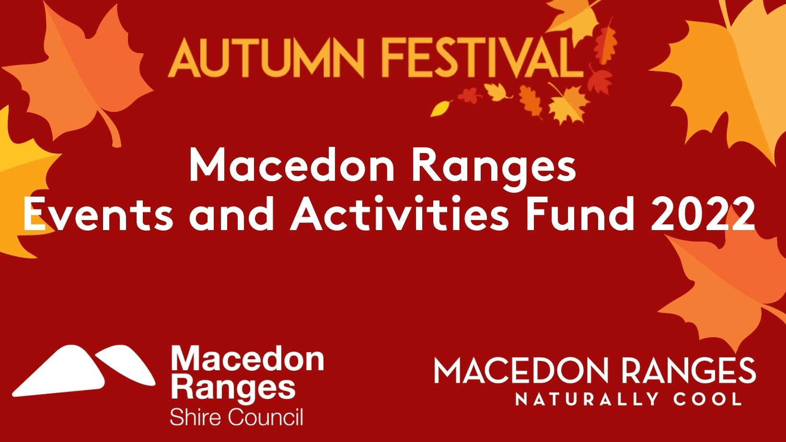
Macedon Ranges Autumn Festival 2022

Events and Activities Fund
Application

Nine Villages, One Festival
Unearth autumn in the Macedon Ranges. A month-long exploration of events, nature experiences, autumn produce and creativity across nine unique and colourful villages.
.

1. Introduction
Macedon Ranges Shire Council is providing funding support to enable businesses and community to host events and activities, and be a part of the Macedon Ranges Autumn Festival 2022.
To be successful to the fund, applicants must demonstrate how their event will:
- Support local business and connect communities.
- Align with the festival call to action:
Nine Villages, One Festival
Unearth autumn in the Macedon Ranges. A month-long exploration of events, nature experiences, autumn produce and creativity across nine unique and colourful villages.
- Showcase one or more of shire’s brand strengths which celebrate the uniqueness of the Macedon Ranges:
  - Arts, culture and makers;
  - Nature and the outdoors;
  - Historic villages and rural landscapes;
  - Food, wine and ferments.
- Deliver a COVIDSafe event.

2. Funding
Two levels of support are available:
- Small-scale events and activities - Up-to $1,000 for events or activities held in a single location.

Example: artist talk at a restaurant, live music at a cellar door, or workshop series.

- Medium-scale events and activities - Up-to $5,000 for events or activities that encourage participants to explore the shire, events held across multiple venues, or events that support multiple businesses.

Example: bespoke twilight market, multiday street performer event, progressive degustation tour, or trails featuring produce from the Macedon Ranges.

Events or activities applying to the fund must be delivered between 26 March – 25 April 2022, and have registered their event or activity concept via Council’s website to ensure eligibility to be on the festival program.
Please return the completed application to Nicole Pietruschka tourismadmin@mrsc.vic.gov.au.

3. Event or Activity Details
EVENT NAME

VENUE/LOCATION

EVENT/ACTIVITY START DATE * Event must be delivered between 26 March and 25 April 2022.

EVENT/ACTIVITY END DATE

EVENT/ACTIVITY DESCRIPTION

Word Count: Must be between 50 and 200 words.
ORGANISATION NAME

ABN

PRIMARY ADDRESS

WEBSITE

4. Key Contact
TITLE

FIRST NAME

LAST NAME

POSITION

PHONE NUMBER

EMAIL ADDRESS

Do you or anyone within your organisation have any signiﬁcant ﬁnancial or other interests of which you are aware, which could reasonably raise an expectation of a conﬂict of interest?
◯ Yes ◯ No
If yes, please provide details:

5. Proposal

- Is the event or activity being held in Macedon Ranges Shire Council?
☐ Yes ☐ No

- Briefly outline how your event or activity will support business recovery and the local economy.

Word Count: Must be between 50 and 250 words.
- Briefly outline how your event or activity will engage and connect the community.

Word Count: Must be between 50 and 250 words.
- How will your event or activity align with the festival call to action and the brand strengths of the Macedon Ranges?

Word Count: Must be between 150 and 400 words.

- Participation: Please list your expected event or activity participation ﬁgures:
TOTAL ATTENDANCE | Local | From outside the shire
0 | 0 | 0

- Funding steam and amount requested:
☐ Small-scale event or activity (up-to $1,000) $______________________ OR
☐ Medium-scale event or activity (up-to $5,000) $______________________

- Funding Purpose - Provide detail of how the requested funding will be used. Quotes must be provided.

Word Count: Must be between 50 and 250 words.
- If you are unsuccessful in securing funding would your event be able to proceed?
☐ Yes ☐ No

- What measures will you be putting in place to ensure that your event or activity is COVIDSafe?

- If you have any documentation that you feel will support your application please attach, such as:
- Planning documentation
- COVIDSafe plan
- Registration with the Public Events Framework
- Budget

6. Next Steps
Thank you for taking the time to fill in the Expression of Interest Form.
Applications to the program close on 1 November 2021.
Your application will be assessed by the Visitor Economy Team and you will be informed of the outcome by 15 November 2021.
Successful applications will be offered a funding agreement.

