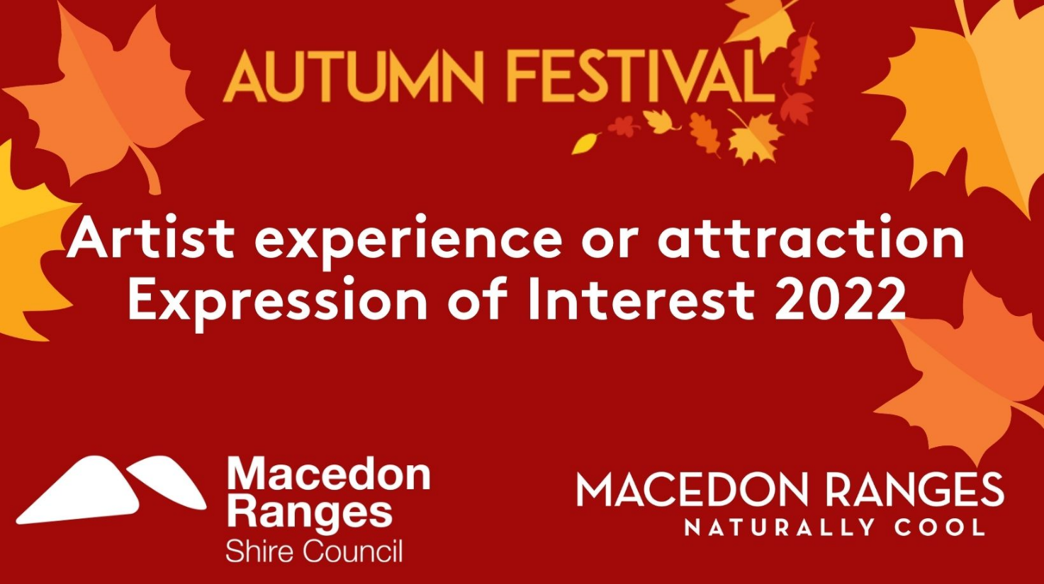

Macedon Ranges Autumn Festival 2022

Artistic Experience or Attraction
Expression of Interest

Nine Villages, One Festival
Unearth autumn in the Macedon Ranges. A month-long exploration of events, nature experiences, autumn produce and creativity across nine unique and colourful villages.
Macedon Ranges Shire Council is calling for expressions of interest from suitably accomplished artists to deliver an experience or attraction for the Macedon Ranges Autumn Festival.
1. Introduction
1.1 Project
Macedon Ranges Shire Council invites Expressions of Interest (EOI) from suitably accomplished artists to undertake development and delivery of an artistic experience or attraction for the 2022 Macedon Ranges Autumn Festival. The successful experience or attraction will be a showcase feature, to be accessible for the duration of the festival.
A total funding pool of $20,000 is available to the successful applicant.
Examples of the types of experiences we are seeking include, but are not restricted to:
• Sculpture or mural trails
• Sound, light or multimedia trails
• Shire wide scavenger hunt
• Town and village activations
The artwork or activity should aim to inspire locals and visitors to explore the Macedon Ranges beyond already popular tourist attractions in the shire. Successful expressions of interest will reflect the Macedon Ranges Autumn Festival’s call to action, to “unearth autumn in the Macedon Ranges”, and align to one of the brand pillars that celebrate the uniqueness of the Macedon Ranges.
• Arts, culture and makers
• Nature and the outdoors
• Historic villages and rural landscapes
• Food, wine and ferments
The commission will be a two-stage process. Successful applicants to the EOI will be invited to prepare a full proposal. The assessment will include a peer review and panel assessment to select the preferred proposal.

1.2 Background and objectives of the festival
Macedon Ranges has grown its reputation as a preferred destination in autumn due to its favourable climate, vibrant autumn colours and close proximity to Melbourne. Thousands of visitors now flock to Macedon’s Honour Avenue and Mount Macedon open gardens every April to enjoy the spectacle of autumn leaves.
In 2021 Council delivered the inaugural Autumn Festival as one of its primary measures to assist with visitor dispersal, grow destination awareness and ensure economic benefits are maximised to advantage all businesses across the shire.
Feedback from community surveys has indicated a desire for art-themed experiences in the 2022 festival program. It is also recognised that while events and activities on the festival program help contribute to local business COVID-recovery, support and recognition of our vibrant creative community is also a priority.
The purpose of this EOI is to support the development and delivery of creative experiences and/or activities that will delight and engage locals and visitors alike, and encourage them to explore the shire, beyond Honour Avenue and Mount Macedon, during the festival.

1.3 Expression of interest opportunity
The purpose of this EOI is to:
• Inform artists of the opportunity;
• Invite potential artists to submit a response for consideration; and
• Identify a short list of applicants to progress to stage two of the commission.
Expressions of interest will be accepted from:
• Artists with a connection to the region, and at least 3 years of practice and exhibiting history or collaboration with an artist of this experience.

2. Sites and locations
2.1 Selection of site or location
When selecting a site or location within the shire the artist should consider:
• Visitor Dispersal – Does the artwork or activity encourage people to explore the shire, or visit less popular tourist locations beyond Macedon’s Honour Avenue or Hanging Rock?
• Visual impact and representation – Does the site or location compliment the artwork or activity?
• Access – Will the artwork or activity be accessible for all to enjoy in the proposed site or location?
• Built Environment – Will the site or location, and its public use, be enhanced by the artwork?
• Planning and engagement – Will relevant business and community stakeholders support the artwork or activity in this location site? Are there any permits required to exhibit or hold the activity in this location?

3. Commission Process
3.1 Artist selection
The commission will be a two-stage process.
Stage One (EOI) - a shortlist selection of up to three of the EOI’s that meet the criteria outlined below.
Stage One – EOI criteria. All of the criteria below must be met.
- Artists with a connection to the region and at least 3 years of practice and exhibiting history (or collaboration with an artist of this experience). Dja Dja Wurrung, Taungurung and Wurundjeri artists and other Aboriginal and Torres Strait Islander Peoples are strongly encouraged to apply.

- Demonstrated ability to produce artwork or activities responding to the project description and objectives of the festival.

- Detailed outline explaining how the experience or attraction will be COVIDSafe.

- The proposed work reflects Macedon Ranges Autumn Festival’s call to action, to “unearth autumn in the Macedon Ranges”, and aligns to one of the brand pillars that celebrate the uniqueness of the Macedon Ranges.
• Arts, culture and makers
• Nature and the outdoors
• Historic villages and rural landscapes
• Food, wine and ferments

Assessment and selection

Responses will be reviewed by the Macedon Ranges Shire Council’s Visitor Economy and Arts and Culture units. Up to three applications will be invited to progress to stage two of the commission process.

All applicants will be advised of the EOI outcome in writing.

Stage Two – Development of detailed proposals.
Each of the shortlisted artists will be offered a fee of $1,000 to develop their proposal for this stage and up to $500 in reimbursed travel expenses to visit and stay in Macedon Ranges where applicable.
Travel expenses are intended to encourage short listed artists to visit the shire and spend time on Country.
Selection Criteria Stage Two. Applications will be assessed on the following criteria.
- Demonstrated public appeal of the artwork or activity proposed
- Demonstrated ability to deliver the artwork or experience proposed
- Safety, access and suitability
- Supports the primary objectives of the Macedon Ranges Autumn Festival:
- Visitor dispersal away from Macedon’s Honour Avenue and Mt Macedon
- Improved awareness of Macedon Ranges as a visitor destination
- Inspire locals and visitors to explore the Macedon Ranges
- Celebration of autumn
- Aligns with one or more of the tourism brand pillars of the shire
- Arts, culture and makers
- Nature and the outdoors
- Historic villages and rural landscapes
- Food, wine and ferments
- Proposed budget is realistic and represents value for use of public funds.
- Demonstrated engagement and support from impacted stakeholders for the site/location proposed.
- Ability to meet project timelines.
- Ability to deliver a COVIDSafe experience

Assessment
The assessment will include a peer review and panel assessment to select the preferred proposal.
The applicant will be offered a set-fee to deliver the work from their proposal.

To respond to this Expression of Interest (EOI):
• Submit all required information on page 8 (detailed designs are not required at this stage).
• Return your expression of interest via email to tourismadmin@mrsc.vic.gov.au by 1 November 2021.
• Respondents must not canvass Macedon Ranges Shire Councillors, or Council Officers either directly or indirectly and in doing so may disqualify the application.
3.1 Payment
A sum of $1,000 and up to $500 in reimbursed travel expenses will be paid to each artist short listed to develop their proposal to the second stage.
An amount up to $20,000 will be paid in instalments to the successful applicant/s from stage two. The exact amount will be agreed in writing before commencement of delivery.
Artists must hold current Public Liability Insurance to $10,000,000 to carry out the commission.

3.3 Timeline
Call for Expressions of Interest (EOIs) open 14 September 2021
Expressions of Interest close 1 November 2021
Short listed EOI notified 15 November 2021
Information session for stage two 19 November 2021 (3 time slots TBC)
Stage two proposal development 19 November – 13 December 2021
Final proposal presented to the panel 13 December 2021 (3 time slots TBC)
Successful applicant/s appointed 20 December 2021
Development of experience or attraction 20 December 2021 – 28 February 2022
Installation 7-25 March 2022
Activity/attraction opens 26 March 2022
Activity/attraction closes 25 April 2022
Removal of activity/attraction 26 April – 6 May 2022

4. EOI Submission details
4.1 Submission requirements
- Completed Expression of Interest Form (p.10).
- One-page (300-500 words) that details the artist’s vison for the experience or activity.
- Details of artist/project team including a one-page CV for each artist collaborating on the work.
- Four good quality images and/or video or sound recording (max. 5MB total file size) of the artist(s) previous work. Please include location details where relevant.
- A short (max.100 word) description of proposed type of space. For example; ‘My works are best suited to a high visitation space such as an outdoor market or shopping strip. ‘My work is best suited to open space such as a public reserve or sporting oval.
- Outline (200-300 words) explaining how the experience or attraction will be COVIDSafe.
Submit all required items for expression of interest via email to - tourismadmin@mrsc.vic.gov.au
Please note: detailed designs are not required at this stage.

4.2 Clarifications
Respondents should seek any necessary clarification about:
• this request for EOI
• the nature of the proposed contract
• the EOI process.
Clarifications should only be sought from Council’s designated contact officer whose name and contact details appear on this EOI (p. 10)

4.4 Award of contract
• All respondents will be notified in writing by Council of successful applicant/s.
• Council may choose to appoint one or more respondents to deliver a project.
• Council is not bound to award a contract to any respondent

4.5 Enquires
Should be made to:
Niccole Pietruschka,
Events and Filming Officer
npietruschka@mrsc.vic.gov.au
0436 848 350

5. Expressions of interest form
Contract Name: Macedon Ranges Autumn Festival – Artistic Experience or Attraction
I/We submit this Response along with attachments listed in 4.1 submission requirements for consideration.
I/We understand that Macedon Ranges Shire Council will consider this Response along with other responses received, and that there is no guarantee that my/our Response will progress to stage two.

Full name of Respondent: _______________________________________________________________________________________
Trading Name of Respondent (if applicable): ______________________________________________________________________________________
Business Type (sole trader / partnership / registered company etc): ______________________________________________________________________________________
Australian Business Number (A.B.N): _______________________________________________________________
Address: ______________________________________________________________________________________
Telephone No: ___________________________Email Address:__________________________________
Signature of person submitting EOI: __________________________________________________________ Date: _______________________

