

Jobs for the Future Blueprint

Project summary

Contents

About the blueprint 2

Key issues 2

Methodology: how did we do our research? 2

• Survey of local businesses 2

• Survey of local residents 2

• REMPLAN (ABS data) 2

• Public (state and federal) data sets 2

Business survey 3

Key findings from business survey 3

Employment and industry sectors 3

Skills, training and education 4

Services and infrastructure 6

Resident survey 6

Key findings: 6

Youth 8

Agricultural Case Study and Land Suitability Analysis 9

Key findings 9

Conclusion 9

Telecommunications 10

Public transport 10

Agricultural development and infrastructure 10

# About the blueprint

Macedon Ranges Shire Council has completed a study to map business trends, identify expectations and skills gaps for the next 20 years.

With a growing population it’s important to understand how local jobs can be maximised while maintaining the integrity of the shire’s towns, landscapes and natural environment.

Deakin University’s Centre for Regional and Rural Futures was appointed to undertake the research and prepare two documents which will guide the development of future economic initiatives and strategies to support business growth and local employment.

• The Macedon Ranges Jobs for the Future Blueprint – Economic Report

• The Macedon Ranges Agricultural Land Suitability Analysis.

## Key issues

The resources, services and infrastructure needed to support future employment:

• Requirements for skills, education and training;

• Opportunities for employment in the agricultural sector.

The findings from this research will underpin the development of future economic strategies and initiatives which guide how Council allocates resources.

## Methodology: how did we do our research?

Three methodologies were applied to forecast total employment by industry and by location for the next 20 years.

The work includes an output and elasticity analysis and trend extrapolation. Data for the analysis was sourced from:

### • Survey of local businesses

### • Survey of local residents

### • REMPLAN (ABS data)

### • Public (state and federal) data sets

## Business survey

The survey was sent to 2,700 businesses with 255 responses – 10% response rate which in survey terms is a good result.

Many of the survey responses were received from the following sectors:

• Agriculture;

• Manufacturing;

• Accommodation;

• Information media;

• Professionals;

• Education and other services.

### Key findings from business survey

#### Employment and industry sectors

• The fastest growing industries are projected to be: health, education and professional services.

• Jobs in the community and personal service sectors will increase driven mainly by health, accommodation and food services, and education.

• The construction sector will continue to increase.

• Occupations likely to be in the greatest demand in the future will be in the professional services sectors (e.g. business, human resources and marketing):

* Clerical and administrative workers will also be in demand, particularly office managers and program administrators;
* Demand for managers associated with the hospitality, retail and services sector will also increase.



#### Skills, training and education

• Qualifications required by businesses will be TAFE or Training Certificate and Bachelor Degrees.

• Industry specific training will also be required, particularly in the construction and hospitality sectors.

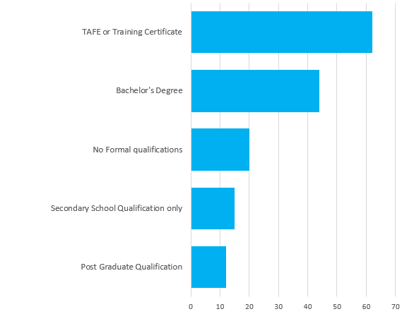

* In addition to formal qualifications, it was noted by businesses that it was important to have staff who are able to interact with others and communicate effectively, with skills such as:
* conflict management;
* human relations;
* negotiation/presentations;
* common sense;
* team building;
* sense of humour and empathy.

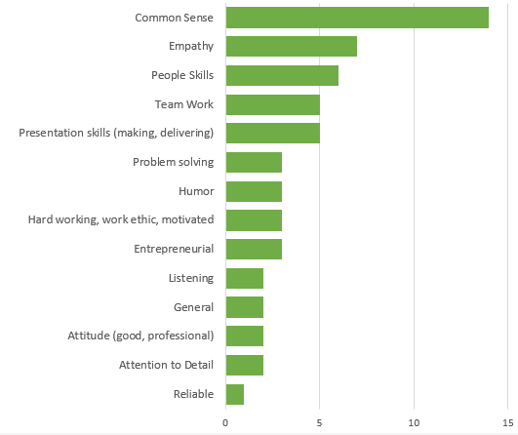

#### Services and infrastructure

* Improved telecommunications was by far the most in demand with 150 companies reporting that this was important to their businesses.
* A reduction in red tape also rated high with around 35% of respondents identifying it as a priority action.
* Roads, public transport and networking forums also rated high.

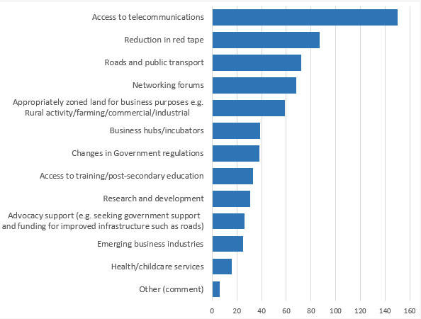

## Resident survey

To better understand the goals, skills and future priorities of our local workforce, a second survey was prepared, with 171 responses.

### Key findings:

* Most respondents were residents of Kyneton and Gisborne and are full-time employees;
* Almost 70% of the respondents work outside the shire;
* In terms of occupations and qualifications, the results correspond with the business survey with professionals and managers with bachelor degrees highly represented;
* 64% of respondents reported they are not working in their preferred location, and this is predominately due to the lack of available local jobs and lower salaries:
  + Professionals and managers with tertiary degrees are the most likely to not be working at their preferred location.



* As with business respondents, telecommunications was by far the most required as well as public transport.



#### Youth

Around 60% of survey respondents have school-aged children, mostly attending primary school. The survey captured parents’ desire to have local job opportunities for their children, particularly part-time or casual jobs for students while studying.

A consultation session with local youth representatives highlighted the following key themes:

• Important for students to gain work experience and ongoing support, in particular mentorship.

• Apprenticeships and traineeships are not available for all industries;

• There are opportunities for part-time jobs in the hospitality and retail, however, there are not as many full time positions.

• Limited opportunities in the health, art and recreation sectors.

• Greater public transport opportunities to support further study.

• Improved technology and Wi-Fi connection to support online study.

• Encourage and support young people wanting to start a business and create their own jobs.

## Agricultural Case Study and Land Suitability Analysis

This case study was undertaken to illustrate how the agricultural sector could generate sustainable local jobs and bolster the regional economy.

Macedon Ranges Shire has an advantage when it comes to climate change as future projections show that our shire may benefit from warmer and drier conditions in the future. This could result in local productivity gains and a strong regional competitive advantage over time.

### Key findings

• Agriculture has been identified as a key competitive strength with one of the highest multipliers and spill-over effects for the rest of the economy (e.g. manufacturing, professional, scientific & technical, construction, wholesale and trade sectors).

* For every 100 jobs created in agricultural, 70 more are being created in the rest of the economy.

• Five food varieties (referred to as “commodities”) were analysed and should grow well here in the future:

* Horticulture (vegetables/brassicas);
* Pastures and cropping;
* Stone fruits (e.g. cherries & olives);
* Grapes for wine production.

Note: other varieties could also grow well but further analysis would need to be undertaken.

## Conclusion

This research will form the basis of the preparation of the Macedon Ranges Economic Development Strategy 2019-2029.

The current Macedon Ranges Economic Development (2009-2019) identified five strategic priorities: Marketing and Promotion; Business Attraction and Retention; Education and Training; Promote and Support Local Enterprise and Entrepreneurship; and Infrastructure.

Actions identified to address these priorities have effectively been implemented and are completed or remain as ongoing programs within the Economic Development and Tourism Department.

The Jobs for the Future research identified that a considerable proportion of people who are leaving the Shire for employment, would prefer to work locally.

It also found that the growth of job opportunities in the Macedon Ranges would be in the professional sector, technicians and trades, community and personal service workers.

The following key themes will be investigated further through the development of the new Macedon Ranges Economic Development Strategy (2019-2029).

This process will involve focus group discussions with industry sectors and major employers.

From this, a draft strategy will be prepared for broader community feedback in the first half of 2019.

### Telecommunications

Key themes raised through the consultation in relation to improved access to telecommunications:

• Online education;

• Commuting population with work from home options;

• Businesses, particularly home-based e.g. farming in rural areas with limited access to Wi-Fi.

### Public transport

To support the commuting population and younger residents:

• Advocate for improved public transport services;

• Recognise that young people need better access to public transport, particularly in the east of the shire.

### Agricultural development and infrastructure

Undertake further research and advocacy to support the future growth of the agricultural industry:

• Researching alternative solutions to water infrastructure e.g. recycled and other technologies;

• Roads and transport;

• Rising land prices due to residential lifestyle development and proximity to Melbourne.

For more information, and to download the documents: <http://www.mrsc.vic.gov.au/Live-Work/Business-Economy/Strategies-Plans-Business/Economic-Development-Strategy>

Contact the Economic Development and Tourism Department on 5421 9616 or [ecodevadmin@mrsc.vic.gov.au](mailto:ecodevadmin@mrsc.vic.gov.au)