Macedon Ranges Shire – Jobs for the Future Blueprint – Technical Report – Land Suitability Analysis
Ms Magdalena Borges
Ms Madeleine Johnson
A/Professor Victor Sposito
A/Professor Robert Faggian

Final Report – Centre for Regional and Rural Futures (CeRRF), Deakin University
Project xxxx

DISCLAIMER
Deakin University has taken reasonable measures to ensure this information is correct at time of publication, but gives no guarantee or warranty that the content is up-to-date, complete or accurate and accepts no responsibility for the accuracy or completeness of the material. To the extent permitted by law Deakin excludes liability for any and all loss caused by use of or reliance on this information.

© Deakin University 2018

Location:
Deakin Burwood Campus
221 Burwood Hwy,
Burwood, 3125, Vic

For more information about CeRRF, Deakin University visit the website www.deakin.edu.au

Macedon Ranges Jobs for the Future Blueprint – Technical Report - Land Suitability Analysis
Final Report

CONTENTS

1. CONTENTS iii
2. FIGURES iv
3. TABLES v
5. INTRODUCTION 1
5.1. Project Aims 1
6. LAND SUITABILITY ANALYSIS METHODOLOGICAL APPROACH 3
6.1.1. Suitability Analysis 3
6.1.2. Suitability Framework 4
6.2. Data Inputs 4
6.2.1. Observed Climate 4
6.2.2. Future Climate 4
6.2.3. Landscape 5
6.2.4. Soils 5
6.3. Model Caveats 5
7. BRASSICA 7
8. GRAPE 10
9. RYEGRASS 15
10. STONE FRUIT 18
11. WHEAT 23
12. IMPACTS AND OPPORTUNITIES 26
12.1. Expansion of production 26
12.2. The value of knowledge 26
12.3. Seasonal changes 26
12.3.1. Change in sowing or planting time 26
12.3.2. Transition from cool climate grapes 26
12.4. Water 27
12.5. Infrastructure 27
13. REFERENCES 28

FIGURES
Figure 5.1. Project Structure 2
Figure 6.1. Methodological Core based on Biophysical LSA Modelling 3
Figure 7.1. Brassica land suitability area by percentage amount in the Macedon Ranges Shire – Historical, 2030, 200 8
Figure 7.2.Brassica land suitability in the Macedon Ranges Shire – Historical (1961 – 1990) (left panel), 2030 (RCP8.5) (centre panel), 2050 (RCP8.5) (right panel) 9
Figure 8.1. Cool Climate Grape land suitability area by percentage amount in the Macedon Ranges Shire – Historical, 2030, 200 11
Figure 8.2. Warm Climate Grape land suitability area by percentage amount in the Macedon Ranges Shire – Historical, 2030, 20 12
Figure 8.3.Cool climate grape land suitability in the Macedon Ranges Shire – Historical (1961 – 1990) (left panel), 2030 (RCP8.5) (centre panel), 2050 (RCP8.5) (right panel) 13
Figure 8.4.Warm climate grape land suitability in the Macedon Ranges Shire – Historical (1961 – 1990) (left panel), 2030 (RCP8.5) (centre panel), 2050 (RCP8.5) (right panel) 14
Figure 9.1. Ryegrass land suitability area by percentage amount in the Macedon Ranges Shire – Historical, 2030, 2050 16
Figure 9.2.Ryegrass land suitability in Macedon Ranges Shire – Historical (1961 – 1990) (left panel), 2030 (RCP8.5) (centre panel), 2050 (RCP8.5) (right panel) 17
Figure 10.1. Early season stone fruit land suitability area by percentage amount in the Macedon Ranges Shire – Historical, 2030, 200 19
Figure 10.2. Late season stone fruit land suitability area by percentage amount in the Macedon Ranges Shire – Historical, 2030, 200 20
Figure 10.3.Early Season Stone Fruit land suitability in the Macedon Ranges Shire – Historical (1961 – 1990) (left panel), 2030 (RCP8.5) (centre panel), 2050 (RCP8.5) (right panel) 21
Figure 10.4.Late Season Stone Fruit land suitability in the Macedon Ranges Shire – Historical (1961 – 1990) (left panel), 2030 (RCP8.5) (centre panel), 2050 (RCP8.5) (right panel) 22
Figure 12.1Wheat land suitability area by percentage amount in the Macedon Ranges Shire – Historical, 2030, 200 24
Figure 12.2.Wheat land suitability in the Macedon Ranges Shire – Historical (1961 – 1990) (left panel), 2030 (RCP8.5) (centre panel), 2050 (RCP8.5) (right panel) 25

TABLES
Table 7.1. Brassica land suitability by area and percentage in the Macedon Ranges Shire – Historical, 2030, 2050 8
Table 8.1. Cool Climate Grape land suitability by area and percentage in the Macedon Ranges Shire – Historical, 2030, 2050 11
Table 8.2. Warm Climate Grape land suitability by area and percentage in the Macedon Ranges Shire – Historical, 2030, 2050 12
Table 9.1 Ryegrass land suitability by area and percentage in the Macedon Ranges Shire – Historical, 2030, 2050 16
Table 10.1. Early Season Stone Fruit land suitability by area and percentage in the Macedon Ranges Shire – Historical, 2030, 2050 19
Table 10.2. Late Season Stone Fruit land suitability by area and percentage in the Macedon Ranges Shire – Historical, 2030, 2050 20
Table 12.1. Wheat land suitability by area and percentage in the Macedon Ranges Shire – Historical, 2030, 2050 24

INTRODUCTION
The Jobs for the Future Blueprint project aims to assist the Macedon Ranges Shire in the planning process of a sustainable and prosperous community, by analysing the potential of the region to create jobs.
This report is an accompaniment to the Macedon Ranges Shire Jobs for the Future Blueprint - Technical Report – Economic Analysis. That report contains a detailed economic analysis of the Shire’s potential for job creation and economic growth. It includes an analysis of the Shire’s agricultural capabilities in particular for economic growth and development and job creation.
The Technical Report – Economic Analysis, details three methodologies that were applied to forecast total employment, by industry and by location for the next twenty years. Additionally, the implications of such growth in the educational sector were assessed, as well as the infrastructure and other services required to support it. The background to two surveys that were conducted (to businesses and residents) and the resources including public data and information provided from REMPLAN that was utilised in the study is also included.
To complement the agricultural case study analysis a Land Suitability Analysis was also undertaken for 5 key commodities (Vegetables, Fruit, Viticulture, Pasture (as a proxy for livestock) and Cropping that are either already produced in the Shire, or of a high value to be explored for potential future production.
This Technical Report details the methodology used in the analysis and also discusses the implications and opportunities for agricultural production in the Shire out to 2050.

Project Aims
The project aims to assist the Macedon Ranges Shire in the planning process of a sustainable and prosperous community, by analysing the potential of the Shire to create jobs in the next 20 years.
Such analysis will be guided by the following principles:
- Sustainable and even development
- Resilient and diversified economies
- Decentralisation (divert people from Metropolitan Melbourne to the Shire)
- Incorporation of infrastructure and services needed to support growth
- Incorporation of innovations
- Climate change adaptation
- GHG (Greenhouse gases) reduction
The project is organised as shown in Figure 5.1, with this report containing a detailed summary of 5. Potential of agriculture to generate jobs – Land Suitability Analysis.
1. Introduction
2. Employment
Forecast
5. Potential of agriculture to generate jobs
Industry Survey
Analysis
Input - Output & Elasticity Analysis
Trend
Extrapolation
3. Implications for the educational sector
4. Infrastructure and services needed to support growth
Specialisation & Competitive Advantages Analysis
Land Suitability
Analysis
Gross Margin Analysis
Employment
Analysis
6. Comparison
7. Conclusion

Figure 5.1. Project Structure

LAND SUITABILITY ANALYSIS METHODOLOGICAL APPROACH
In order to understand how projected climatic changes impact on agricultural production, we have followed the approach shown in Figure 6.1. In short, we use a Multi Criteria Analysis (MCA) applied with an Analytical Hierarchy Process (AHP) in a Geographic Information Systems (GIS), to spatially represent the biophysically suitability of land for a particular commodity. The approach has been published (Sposito et al 2013) and applied extensively across Victoria and in other parts of the world. As such, the approach will not be covered in any detail here. But, an important point to note is that the underpinning AHP and land suitability models allows for experts’ participation in the decision making process. Compared to empirical models, an expert systems model such as this one explicitly incorporates the ‘subjective’ knowledge of experts who have understanding of the system of concern. This is an essential step in regional and local suitability analysis because often regional empirical data is lacking or poor in quality and therefore expert based knowledge can fill the gaps. The key to using expert knowledge as a data input is to ensure that a consensus position is achieved from all contributors on the weighting of each criteria.
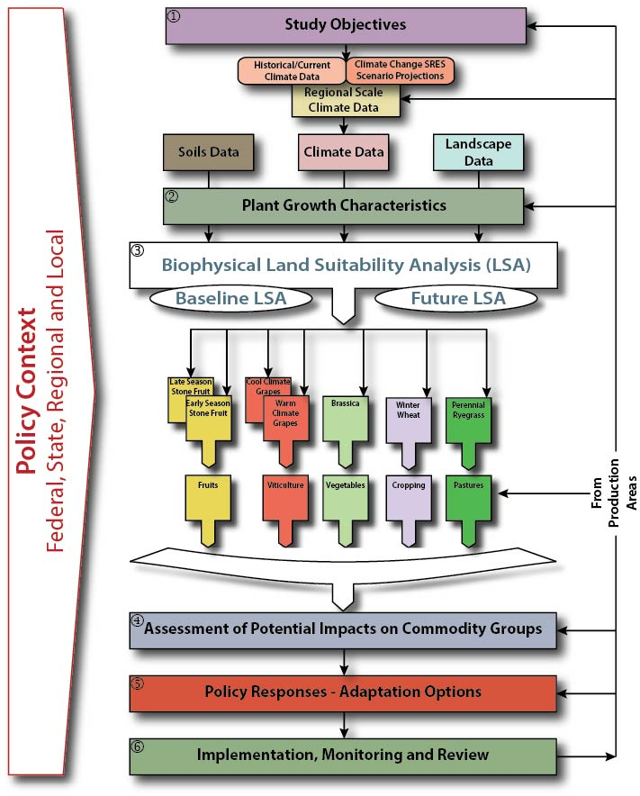
Figure 6.1. Methodological Core based on Biophysical LSA Modelling

Suitability Analysis
The AHP approach is used to assess Biophysical Land Suitability Analysis (LSA) for the agricultural commodities of interest, which is focused at the regional level. Biophysical LSA is defined as the process of determining the fitness, or the appropriateness, of a given area of land for a specified use (FAO, 1976), see also (McHarg, 1969; Hopkins, 1977). Biophysical LSA can provide a rational basis for assessing the most favourable utilisation of land resources and therefore inform land use planning (FAO, 1993). It examines the degree of land suitability for the growth (cultivation or cropping) of the agricultural commodity of interest. It has thus gained wide acceptance and adoption across a range of users including land managers, agriculturalists and planners. Modifications in agricultural land suitability caused by climate change can be assessed by comparing future suitability maps (using climate change projections) with current suitability maps (using historical/present climatic conditions). This information, alongside other points of data, will indicate land that is agriculturally valuable and which could be set aside for agricultural development. Overall this can provide an assessment of the potential climate change impacts on agricultural systems, be utilised as a decision support tool and facilitate discussions of the policy options to respond to the likely impacts.

Suitability Framework
The United Nations Food and Agricultural Organisation (FAO) have an established framework structure for the assessment of suitability for any type of land use and cover (FAO, 1976). This structure is hierarchical in design and comprises of Orders, Classes, Subclasses and Units. Suitability Orders indicate if a unit of land is Suitable (S) or Not Suitable (NS). Suitability Classes are used to reflect degrees of suitability, with three base classes defined; High, Moderate and Low Suitability. Furthermore, the Not Suitable order can be defined into two classes; Currently Not Suitable and Permanently Not Suitable. If necessary, in a given analysis, the Classes can be divided into Subclasses, which reflect types of limitation in a Class. Further to this Subclasses can be divided into Units, which are used to show production characteristics or other requirements. This framework has been modified slightly for use in the Shire. The two principle suitability orders, S and NS, were maintained but NS was further defined into Permanently Not Suitable (PNS) and Temporarily Not Suitable (TNS). Furthermore, four suitability classes were utilised; High, Moderate, Low and Very Low.

Data Inputs

Observed Climate
Past and current climate data has been obtained through the SILO Project (Jeffrey et al., 2001), which is hosted by The Science Delivery Division of the Queensland Department of Science, Information Technology, Innovation and the Arts (DSITIA), and the WorldClim Global Climate Data online database. SILO is based on Bureau of Meteorology (BoM) climate data and includes multiple datasets of variables such as temperature and rainfall. The data is Victoria-wide and is presented at a resolution of 5 km2 (grid). The WorldClim database is an online spatial dataset with a spatial resolution of 1 km². The layers are generated using interpolation of available monthly readings from weather stations on a 20 arc-second resolution grid (comparable to 1 km² resolution spatially). The dataset includes variables of rainfall, temperature and additional bioclimatic variables for the years 1950 – 2000.
Commonly used in climate studies is the ‘climate normal’, which is used as a reference period for comparative purposes between current, historical and future climates. Generally, they are calculated over a standard period of thirty years, which is long enough to include year to year variations but not that long to allow it to be influenced by long term climate trends. The World Meteorological Organisation (WMO) uses the period of 1961 to 1990, which is also used in Australian meteorological references. For use in this project a climate normal period will be used as a baseline comparison against future climate projections and simulated suitability analyses. The climate normal, hereafter, will be referred to as the ‘historical’ or ‘baseline’ climate.

Future Climate
Future climate projections were simulated through the use of the CSIRO ACCESS 1.0 Global Climate Change Model (GCM). This was run through two emissions scenarios or Representative Concentration Pathways (RCP), a low emissions renewable future scenario (RCP 4.5) and a business as usual high emissions pathway (RCP 8.5). The atmospheric content of the GCM model has been used to generate monthly based data.

Landscape
A Victoria wide Digital Elevation Model (DEM) provided the basis for landscape analysis. This is in a raster grid format, with a grid cell resolution of 100m². This data set represents the ground surface topography or terrain of Victoria. The dataset allowed the calculation of critical geographic features such as slope, altitude and aspect. The DEM has been sourced from NASA’s Shuttle Radar Topography Mission (SRTM) landscape dataset (NASA and USGS, 2014), which is supplied at 1 arc second (equivalent to a 30 metre resolution). This is hosted in conjunction with the United States Geological Survey (USGS).

Soils
Soil type (Isbell and CSIRO., 2002) is one of the most important factors that influences land utilisation. It provides the physical, chemical and biological activity basis required for plant growth. Principal information for soils data for this study has been sourced from the Soil and Landscape Grid of Australia, produced by the CSIRO (CSIRO and TERN, 2015). These soils datasets are presented in a raster grid formation at a typical resolution of 30m². Further information for soils data and attributes have been sourced from the Soils and Landform Mapping, undertaken by the Victorian State Government found on the Victorian Resources Online (VRO) web-based platform (Victorian State Government, 2015b) or the Victorian Data Portal (Victorian State Government, 2015a). Soils attributes, as used in land-use suitability modelling, can be categorised into two broad groups; physical attributes and chemical attributes. Physical attributes relate to the actual physical properties of the soil and include measures such as texture or soil horizon depth. Measurements are usually done in the field. Chemical attributes relate to the chemical composition of the soil and can include soil nutrient composition or soil pH.)

Model Caveats
The LSA models are validated using regional expertise and input by local growers and experts. However, it is important to be aware of a number of caveats when interpreting the results of the models:
1. The methodology has been formulated for application at regional and local levels. In particular, LSA maps are developed and presented at a regional level with a spatial resolution of 5 square km, which is the resolution of the downscaled climate change projections. Therefore, LSA maps should not be used to infer (current and future) conditions at a site level (e.g. at farm level).
2. LSA maps depicting future conditions substantially depend on the input climate change projection data, which are inherently uncertain. A multiplicity of futures is possible depending on major decisions over time and how the climate system will respond to them. Therefore, future LSA maps depict a possible future and, by no means, the only future.
3. The modelling approach does not account for some important components of crop production; for instance, the effect that changing climatic conditions may have on bees and pollination, or on crop disease status.
4. With the projected regional increase in temperature and concomitant decline in rainfall, extreme weather events, (including fire risk) are likely to increase across the Shire. This is not considered in the present study and will require complementary research and (possibly) the preparation of overlay maps showing areas of greater risks.
5. Each commodity’s biophysical requirements for climate, soil and landscape - were identified by a review of the scientific literature and their value ranges were validated using expert opinion and regional expertise. It is nonetheless possible for some subjective information, via the expert opinion phase of the exercise, to influence the model design or the weighting of individual criteria within the models.
6. The study did not examine different varieties within a particular agricultural commodity. Considerable variation can occur between varieties within a species with respect to their biophysical requirements.
7. It is difficult to account for the contribution that a grower’s skill level can make to the suitability of a specific commodity at a particular geographical location. It is hence entirely possible for a particular grower to achieve good yields at a location that has been modelled as having a low biophysical suitability and, conversely for a grower to achieve poor yields at a location that is ranked with a high biophysical suitability. It should also be noted that the models do not take into account other factors that may impact on suitability and yield, such as extreme climate events, pests and diseases, or socio-economic considerations.
8. The report has looked at a selection of agricultural commodities across the Macedon Ranges Shire. The reader should therefore be aware that the designation of an area in the region as less suitable or less versatile in future climates only applies to the particular commodities modelled in this report. The areas looked at in this report may become more suitable or versatile for other crops. Additional modelling will be required to examine other agricultural commodities in order to have a more comprehensive understanding of the agricultural potential of the Shire, now and in the future.

BRASSICA
The brassica biophysical LSA model determines the suitability of the region to produce a generic vegetable brassica species (Brassica oleracea) that is representative of several crops including broccoli, cauliflower, cabbage, Chinese cabbage and Brussels sprouts, among others (but not canola, which is Brassica napus). By necessity, the model assumes that irrigation is available in order to determine suitability across the entire region.
The model output relative to historical climate (Figure 7.1, left panel) indicates that the majority of the Macedon Ranges Shire is currently suitable for brassica production and generally ranked 80-90%. Some small areas are less suitable at 70%, due to a combination of soil and climatic conditions.
Looking to likely changes in suitability as we move into the future, it appears that the Shire will become more suitable for brassica production as the climate changes (Figure 7.1, centre and right panels). In both future scenarios, 2030 and 2050, the suitability of the region for brassica production increases, although stays relatively stable between 2030 and 2050, with the largest suitability group becoming 90%. The percentage area and total hectares of the Shire that falls within each suitability rating (for example, 80%) at each time point is listed in Table 7.1, which gives a good indication of degree of change over time.

Table 7.1. Brassica land suitability by area and percentage in the Macedon Ranges Shire – Historical, 2030, 2050
Brassica
 |  | Not Suitable | 0 - 40% | 50% | 60% | 70% | 80% | 90% | 100%
 |  | Hectares (ha)
Historical | 1961 - 1990 | 3,412 | - | - | 582 | 36,423 | 104,230 | 32,796 | -
RCP8.5 | 2030 | 3,412 | - | - | - | 13,860 | 91,544 | 67,626 | 1,001
 | 2050 | 3,412 | - | - | - | 17,137 | 90,294 | 66,406 | 194
 |  | Percentage (%)
Historical | 1961 - 1990 | 1.9% | - | - | 0.3% | 20.5% | 58.7% | 18.5% | -
RCP8.5 | 2030 | 1.9% | - | - | - | 7.8% | 51.6% | 38.1% | 0.6%
 | 2050 | 1.9% | - | - | - | 9.7% | 50.9% | 37.4% | 0.1%

Figure 7.1. Brassica land suitability area by percentage amount in the Macedon Ranges Shire – Historical, 2030, 200
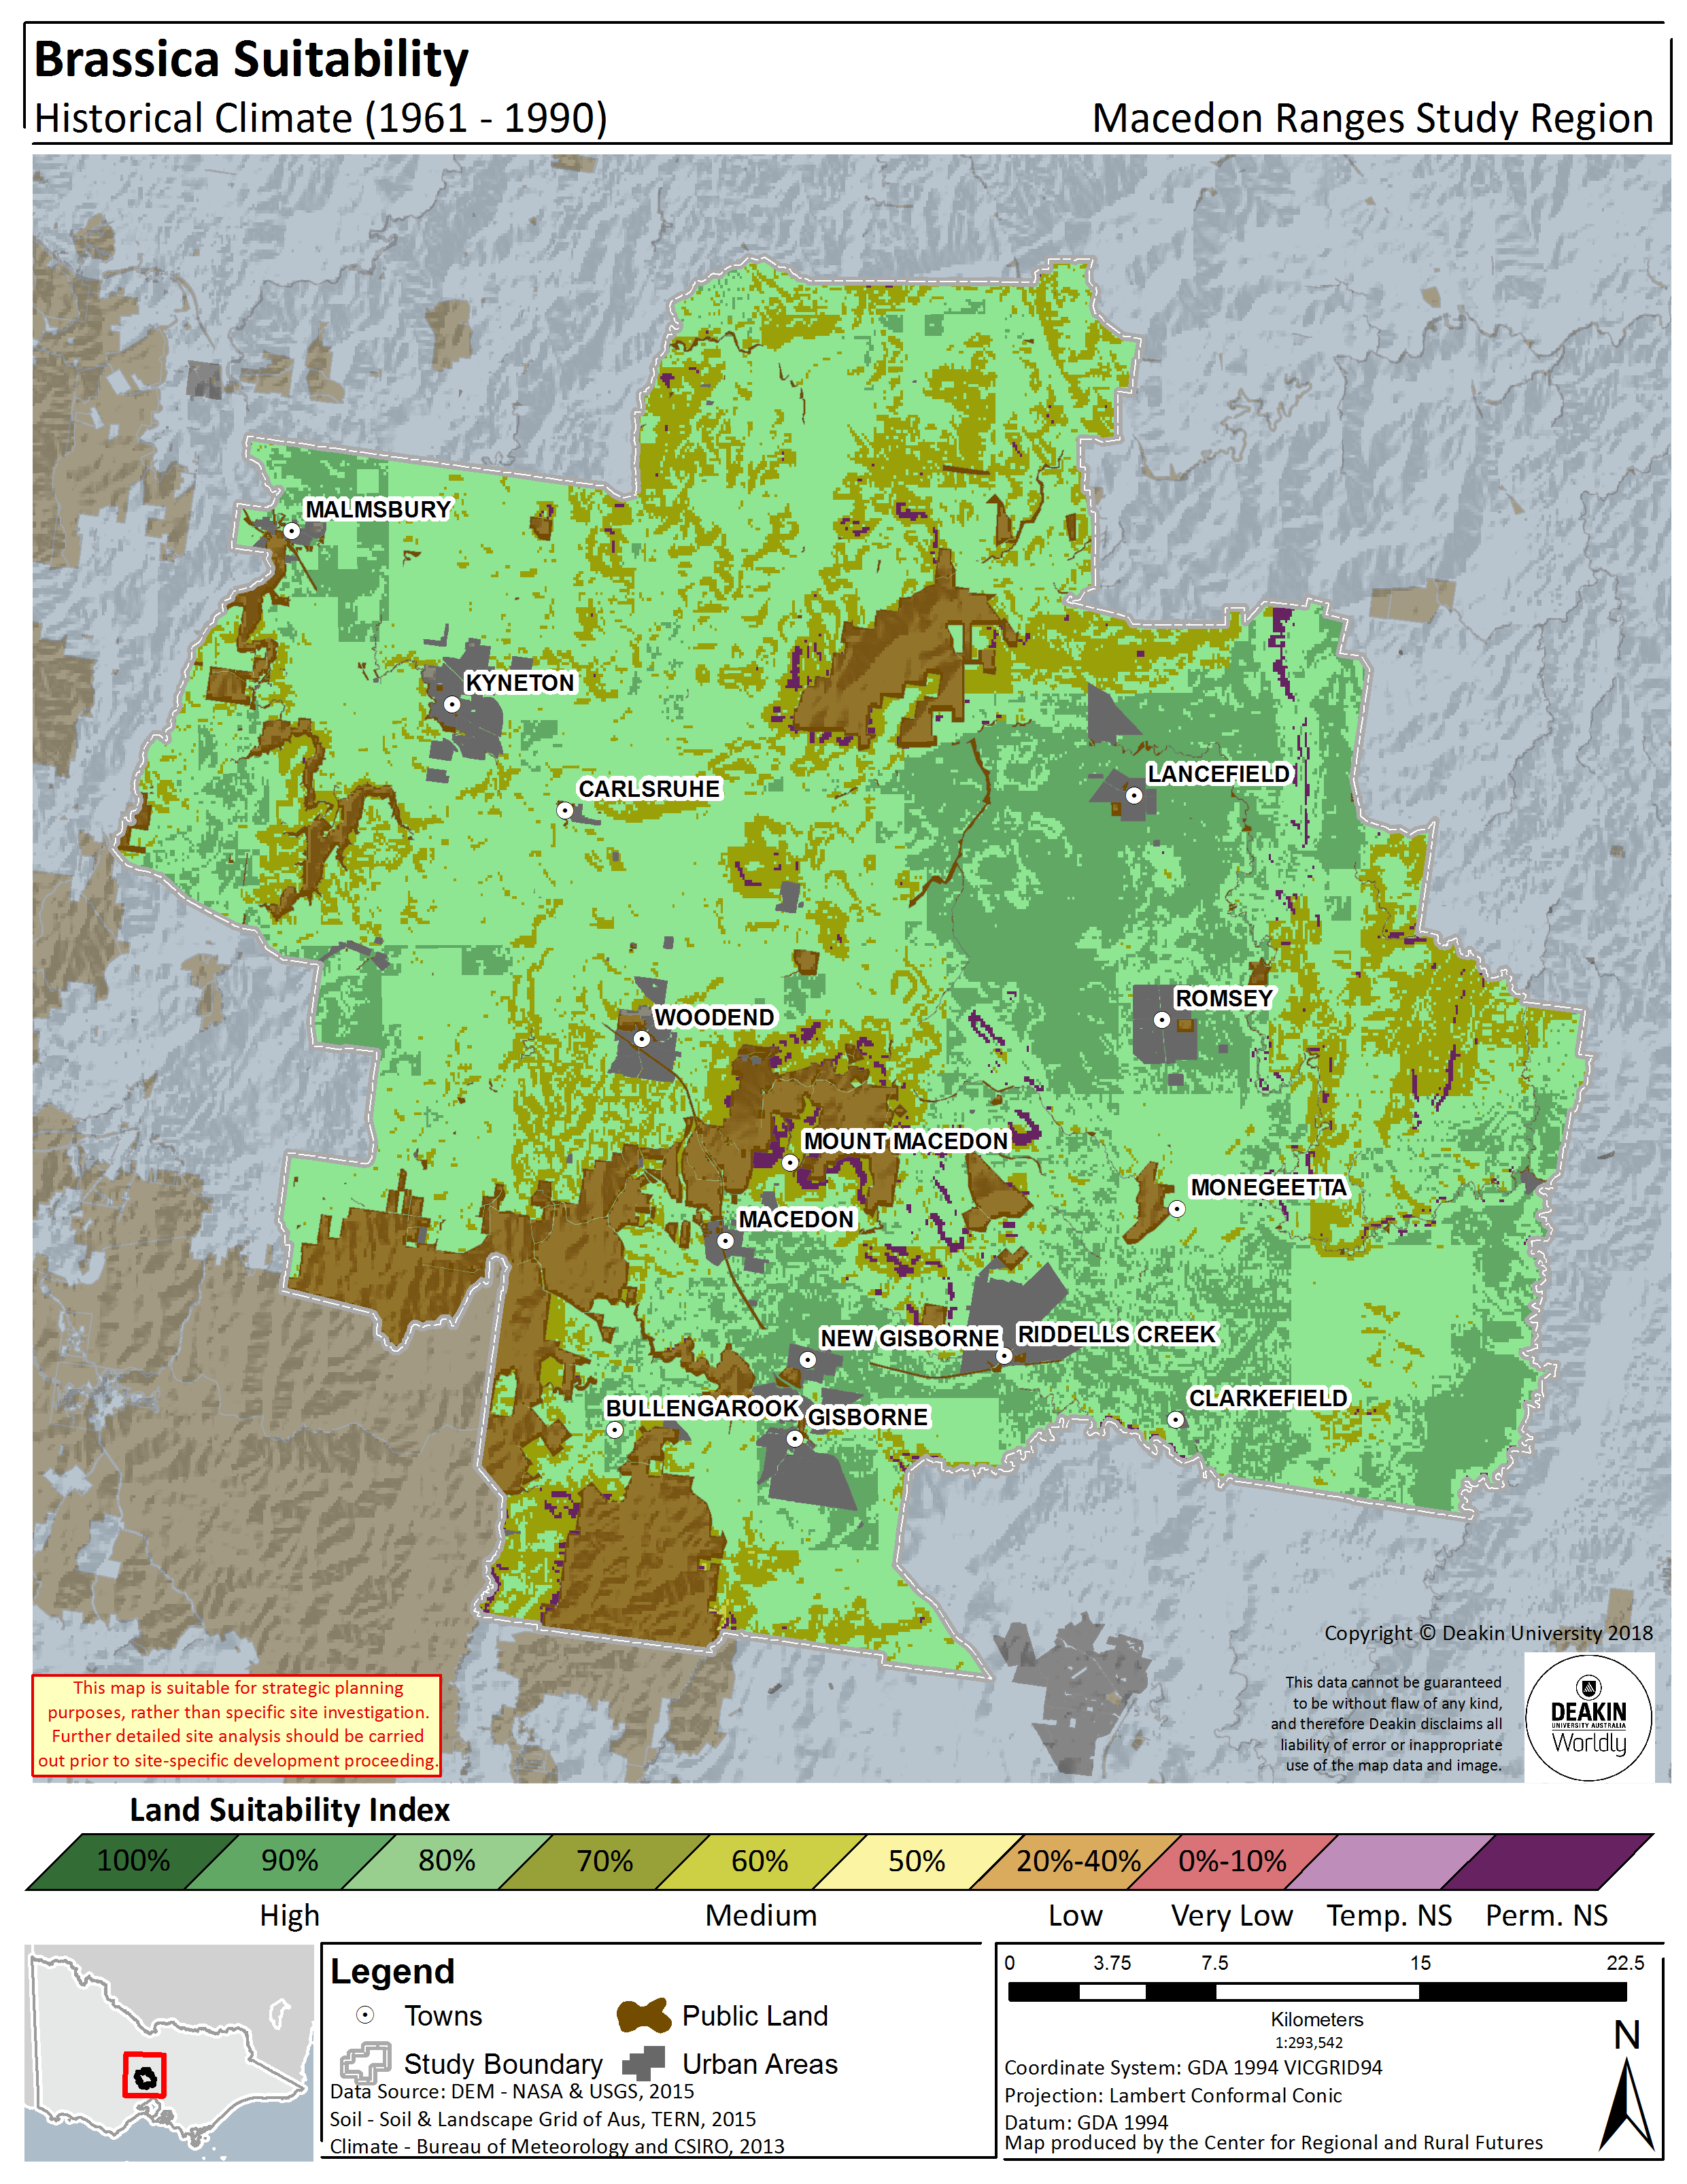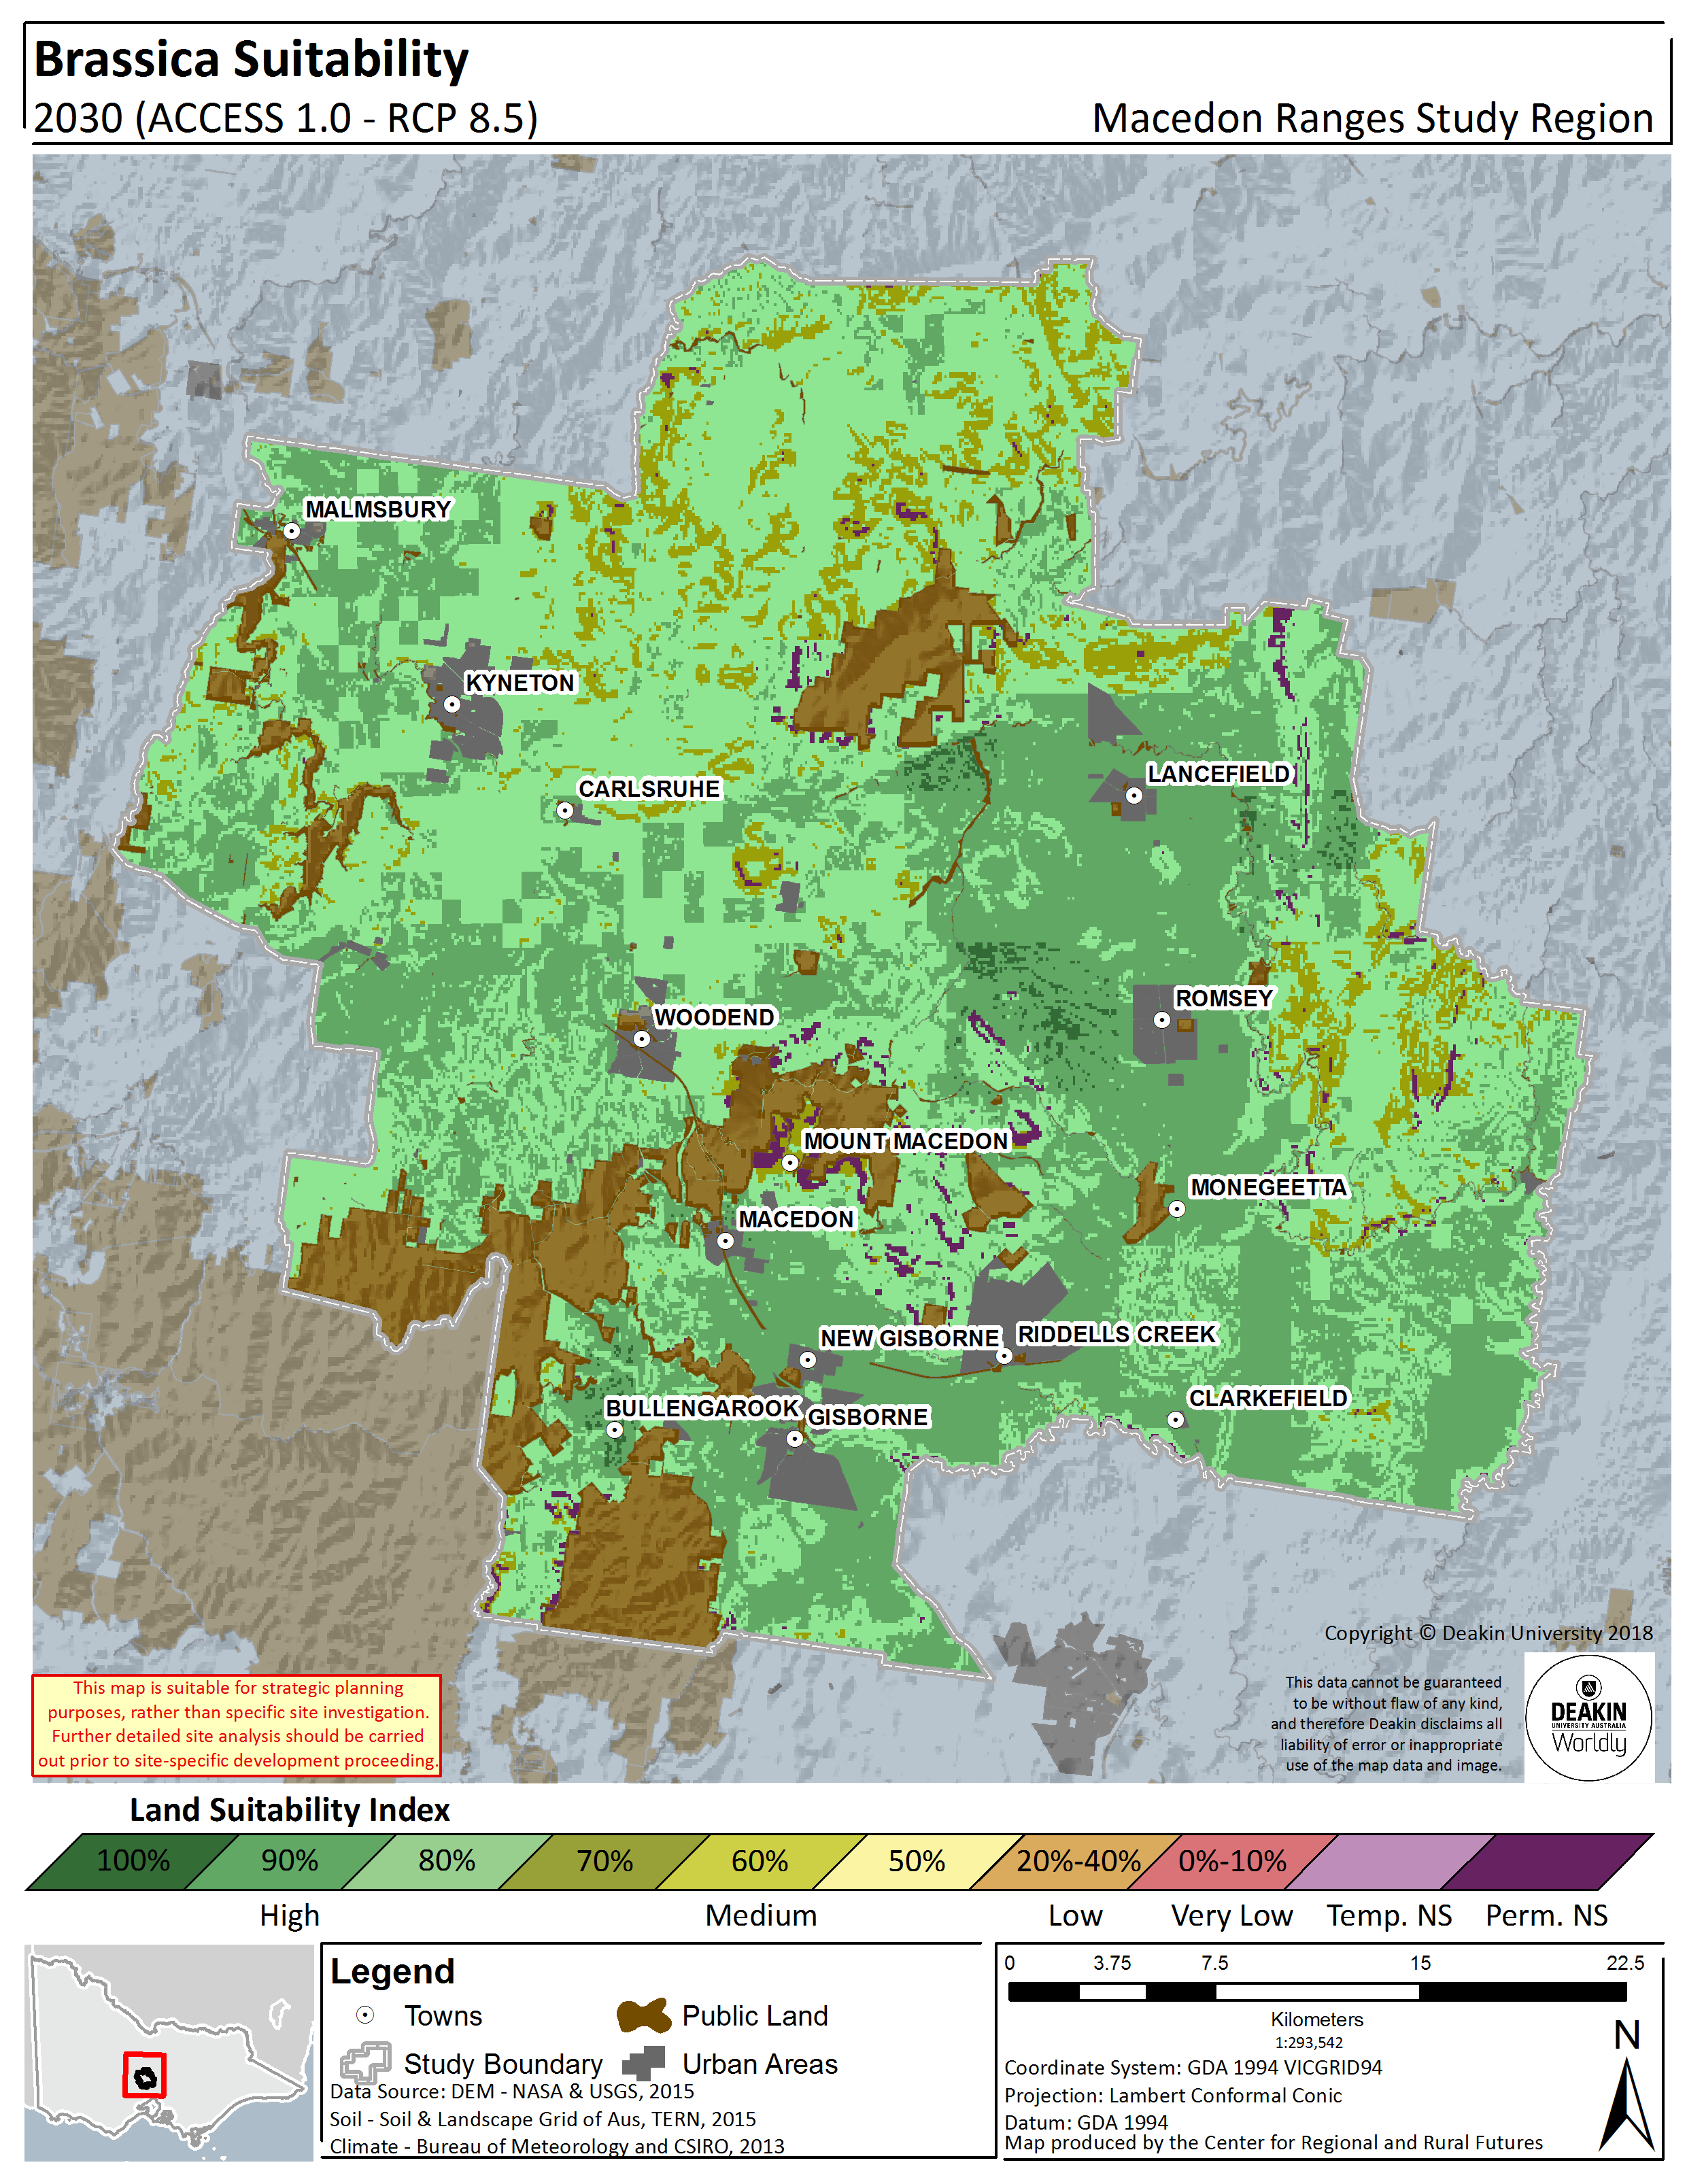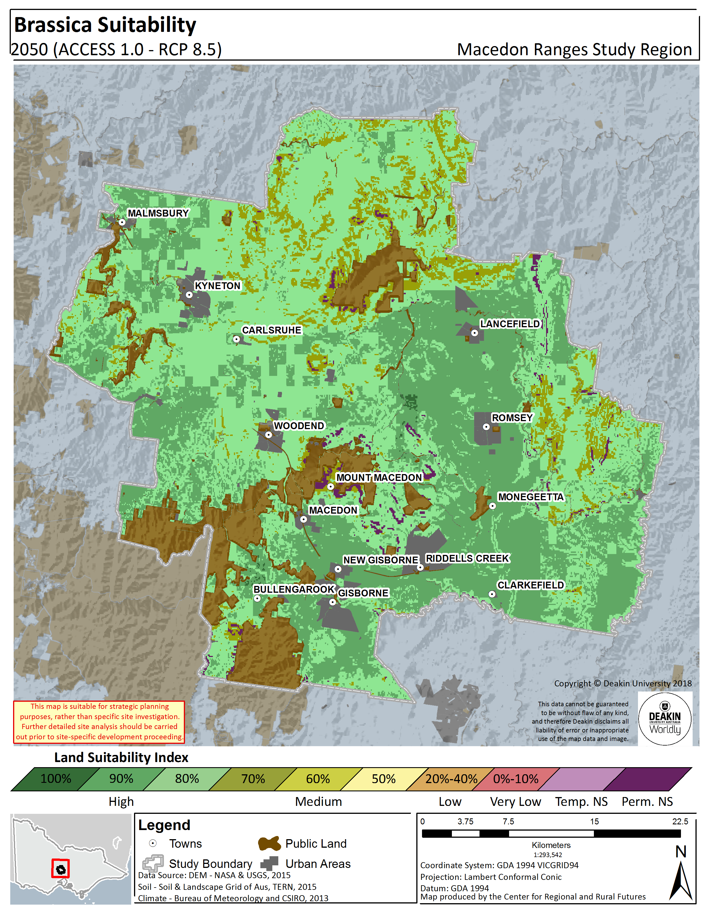
Figure 7.2.Brassica land suitability in the Macedon Ranges Shire – Historical (1961 – 1990) (left panel), 2030 (RCP8.5) (centre panel), 2050 (RCP8.5) (right panel)

GRAPE
Given the important of viticulture in the region, and the high value of the commodity, two generic varieties of grapes were modelled, a generic cool climate grape variety (currently largely grown across the region) and a generic warm climate variety. By necessity, both cool and warm climate models assume that access to water is available (such as irrigation, also in the form of dams, bores etc.), regardless of current access and water authority structure, in order to determine suitability across the entire region. The models also consider heat degree days.
The cool climate model output relative to historical climate indicates that the suitability of geographical areas for cool climate grapes corresponds closely with temperature. The majority of the Shire, is suitable for cool climate grapes with rankings of 80%. Scattered areas to the east of the Shire, are less suitable at 70%. Conversely, warm climate varieties are currently less suitable, with larger scattered areas of moderate suitability, d mainly by the lower temperatures in the region.
The models were validated with growers in the region, who specified the current cool climate suitability of the region, suitable for growing chardonnay and pinot noir in particular, driven largely by heat degree days (and climate more broadly) and elevation.
Looking to likely changes in suitability as we move into the future, the modelling indicates that the Shire will become far less suitable for cool climate grapes over time, a reduction from nearly 75% of the area at High suitability (80%) to less than 2% of the area by 2030. However, warm climate grapes remain stable into the future, maintaining around 68% of the area at a High suitability (80%) into 2030 and 2050, with stable scattered areas of moderate suitability governed largely by landscape and topographical attributes.
Figures Figure 8.3 and Figure 8.4 show the progression through time for cool climate and warm climate grapes respectively. The percentage area and total hectares of the Shire that falls within each suitability rating (for example, 80%) at each time point for cool and warm climate grapes respectively is listed in Table 8.1and Table 8.2, which gives a good indication of degree of change over time.
It is clear from the modelling that a thriving viticulture industry is possible in the future, however a transition from cooler climate varieties to warm climate varieties could be prudent.
Table 8.1. Cool Climate Grape land suitability by area and percentage in the Macedon Ranges Shire – Historical, 2030, 2050
Grape - Cool Climate
 |  | Not Suitable | 0 - 40% | 50% | 60% | 70% | 80% | 90% | 100%
 |  | Hectares (ha)
Historical | 1961 - 1990 | - | - | - | 1,117 | 15,157 | 132,765 | 26,415 | -
RCP8.5 | 2030 | - | - | 529 | 22,891 | 143,032 | 3,358 | 5,189 | -
 | 2050 | - | 15 | 9,680 | 75,523 | 89,780 | 1 | - | -
 |  | Percentage (%)
Historical | 1961 - 1990 | - | - | - | 0.6% | 8.5% | 74.8% | - | -
RCP8.5 | 2030 | - | - | 0.3% | 12.9% | 80.6% | 1.9% | - | -
 | 2050 | - | 0.01% | 5.5% | 42.6% | 50.6% | 0.0% | - | -

Figure 8.1. Cool Climate Grape land suitability area by percentage amount in the Macedon Ranges Shire – Historical, 2030, 200

Table 8.2. Warm Climate Grape land suitability by area and percentage in the Macedon Ranges Shire – Historical, 2030, 2050
Grape - Warm Climate
 |  | Not Suitable | 0 - 40% | 50% | 60% | 70% | 80% | 90% | 100%
 |  | Hectares (ha)
Historical | 1961 - 1990 | - | - | 981 | 17,941 | 35,495 | 120,562 | - | -
RCP8.5 | 2030 | - | - | 716 | 18,111 | 36,628 | 119,524 | - | -
 | 2050 | - | - | 915 | 18,381 | 36,283 | 119,400 | - | -
 |  | Percentage (%)
Historical | 1961 - 1990 | - | - | 0.6% | 10.1% | 20.0% | 67.9% | - | -
RCP8.5 | 2030 | - | - | 0.4% | 10.2% | 20.6% | 67.4% | - | -
 | 2050 | - | - | 0.5% | 10.4% | 20.4% | 67.3% | - | -

Figure 8.2. Warm Climate Grape land suitability area by percentage amount in the Macedon Ranges Shire – Historical, 2030, 20

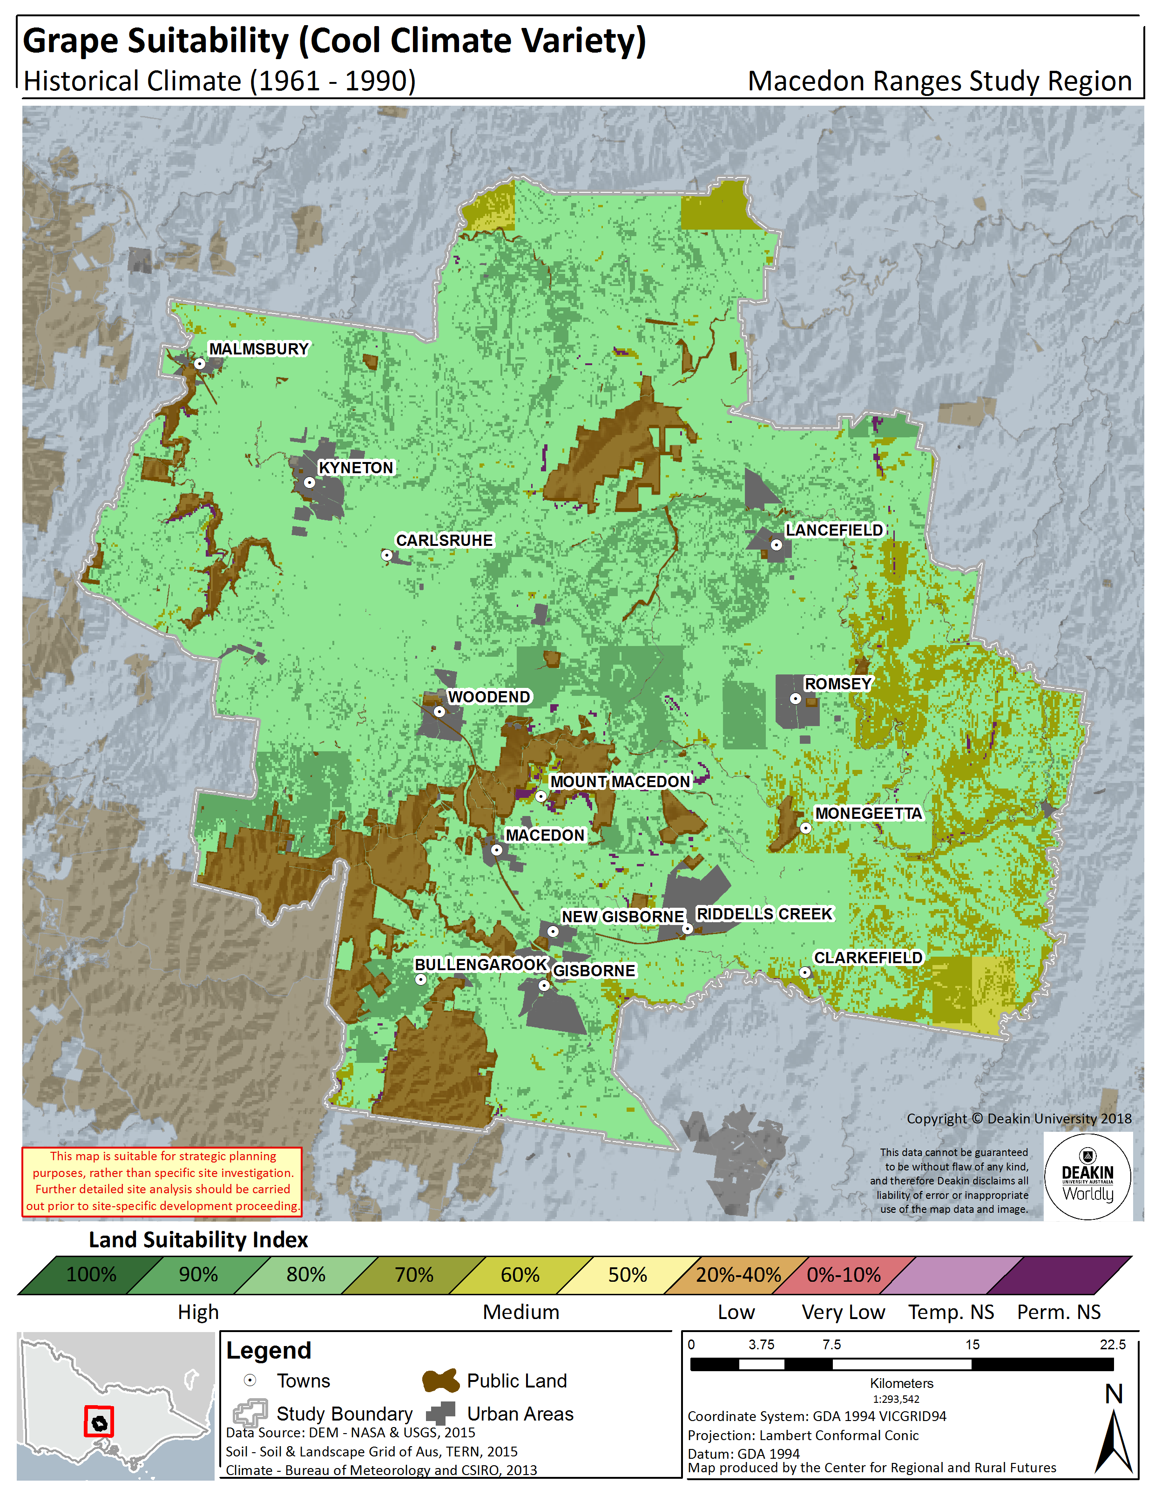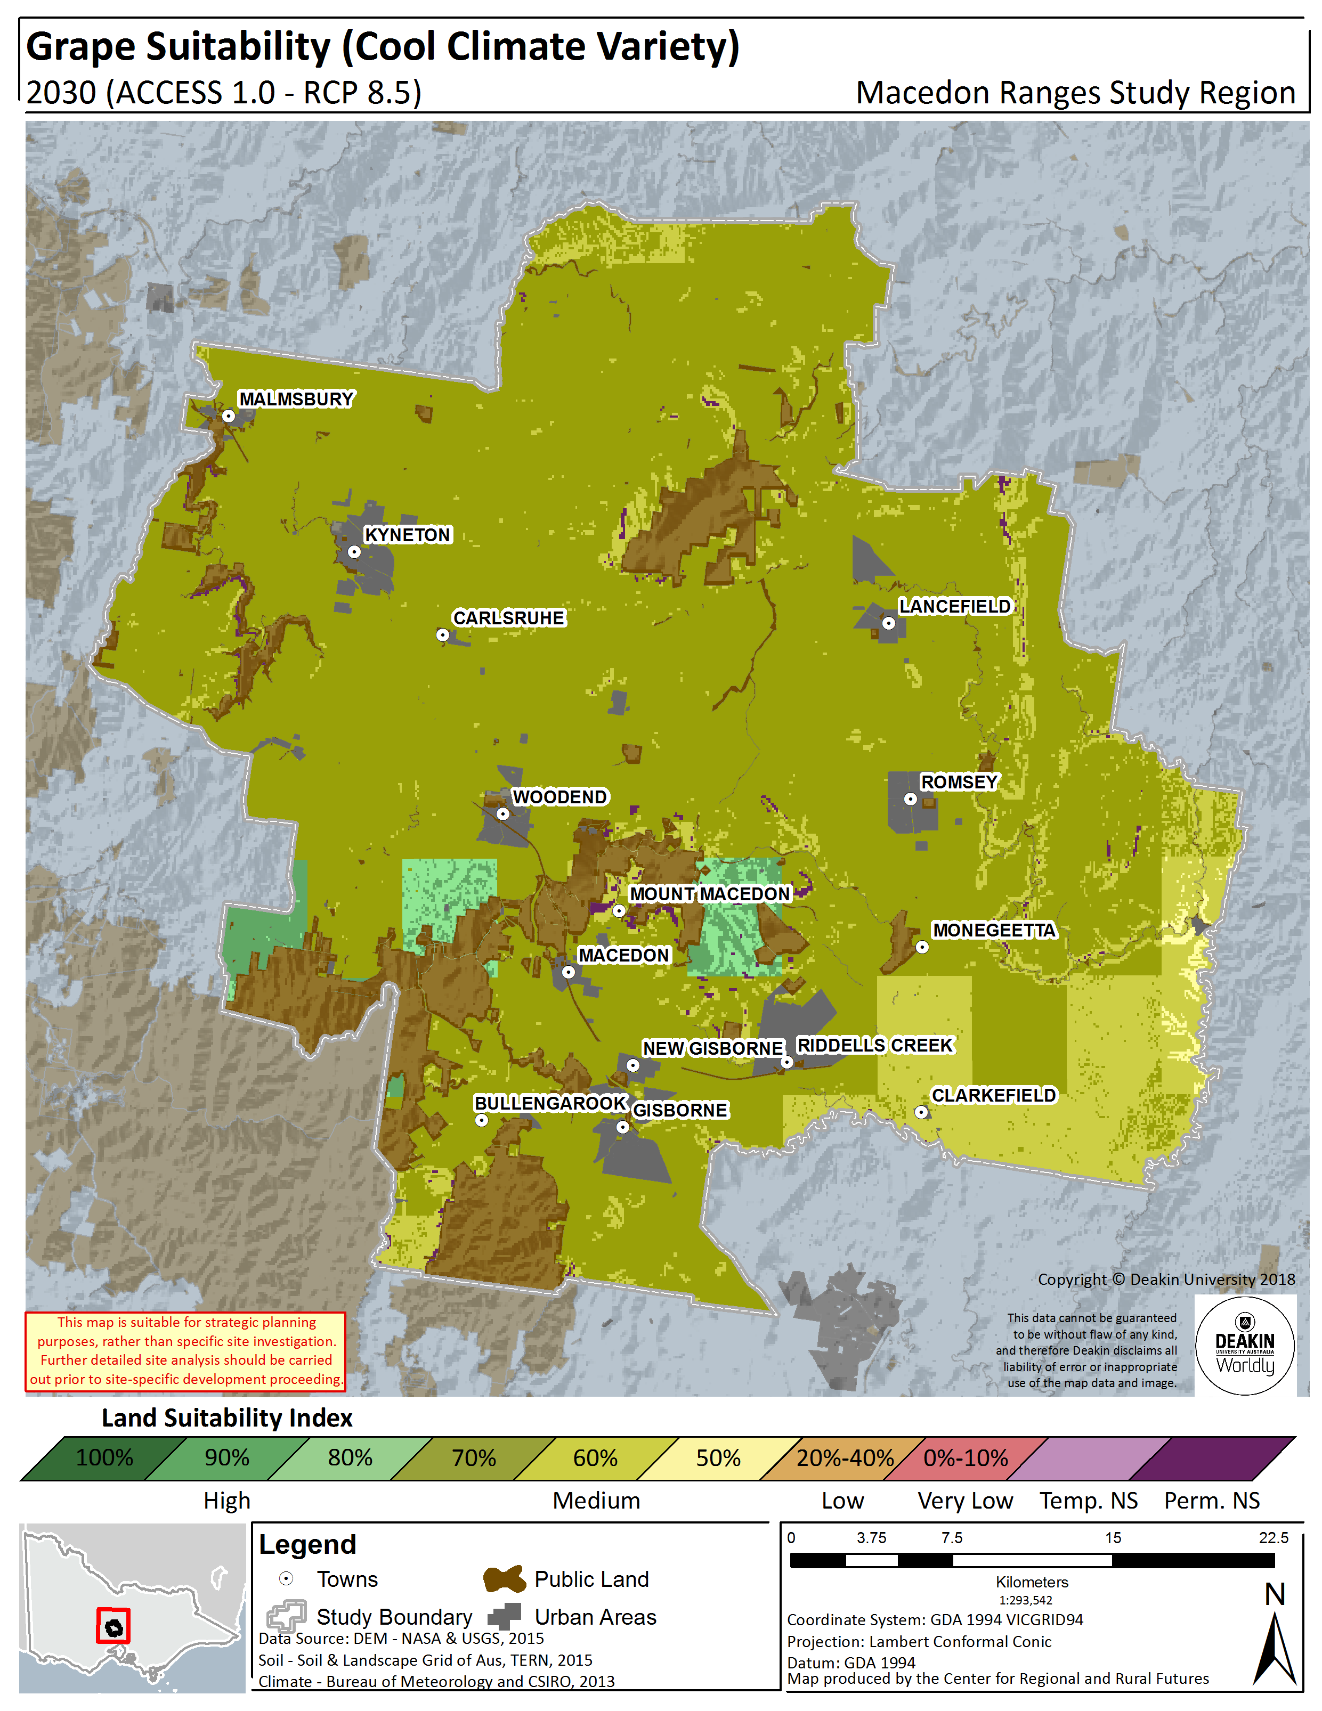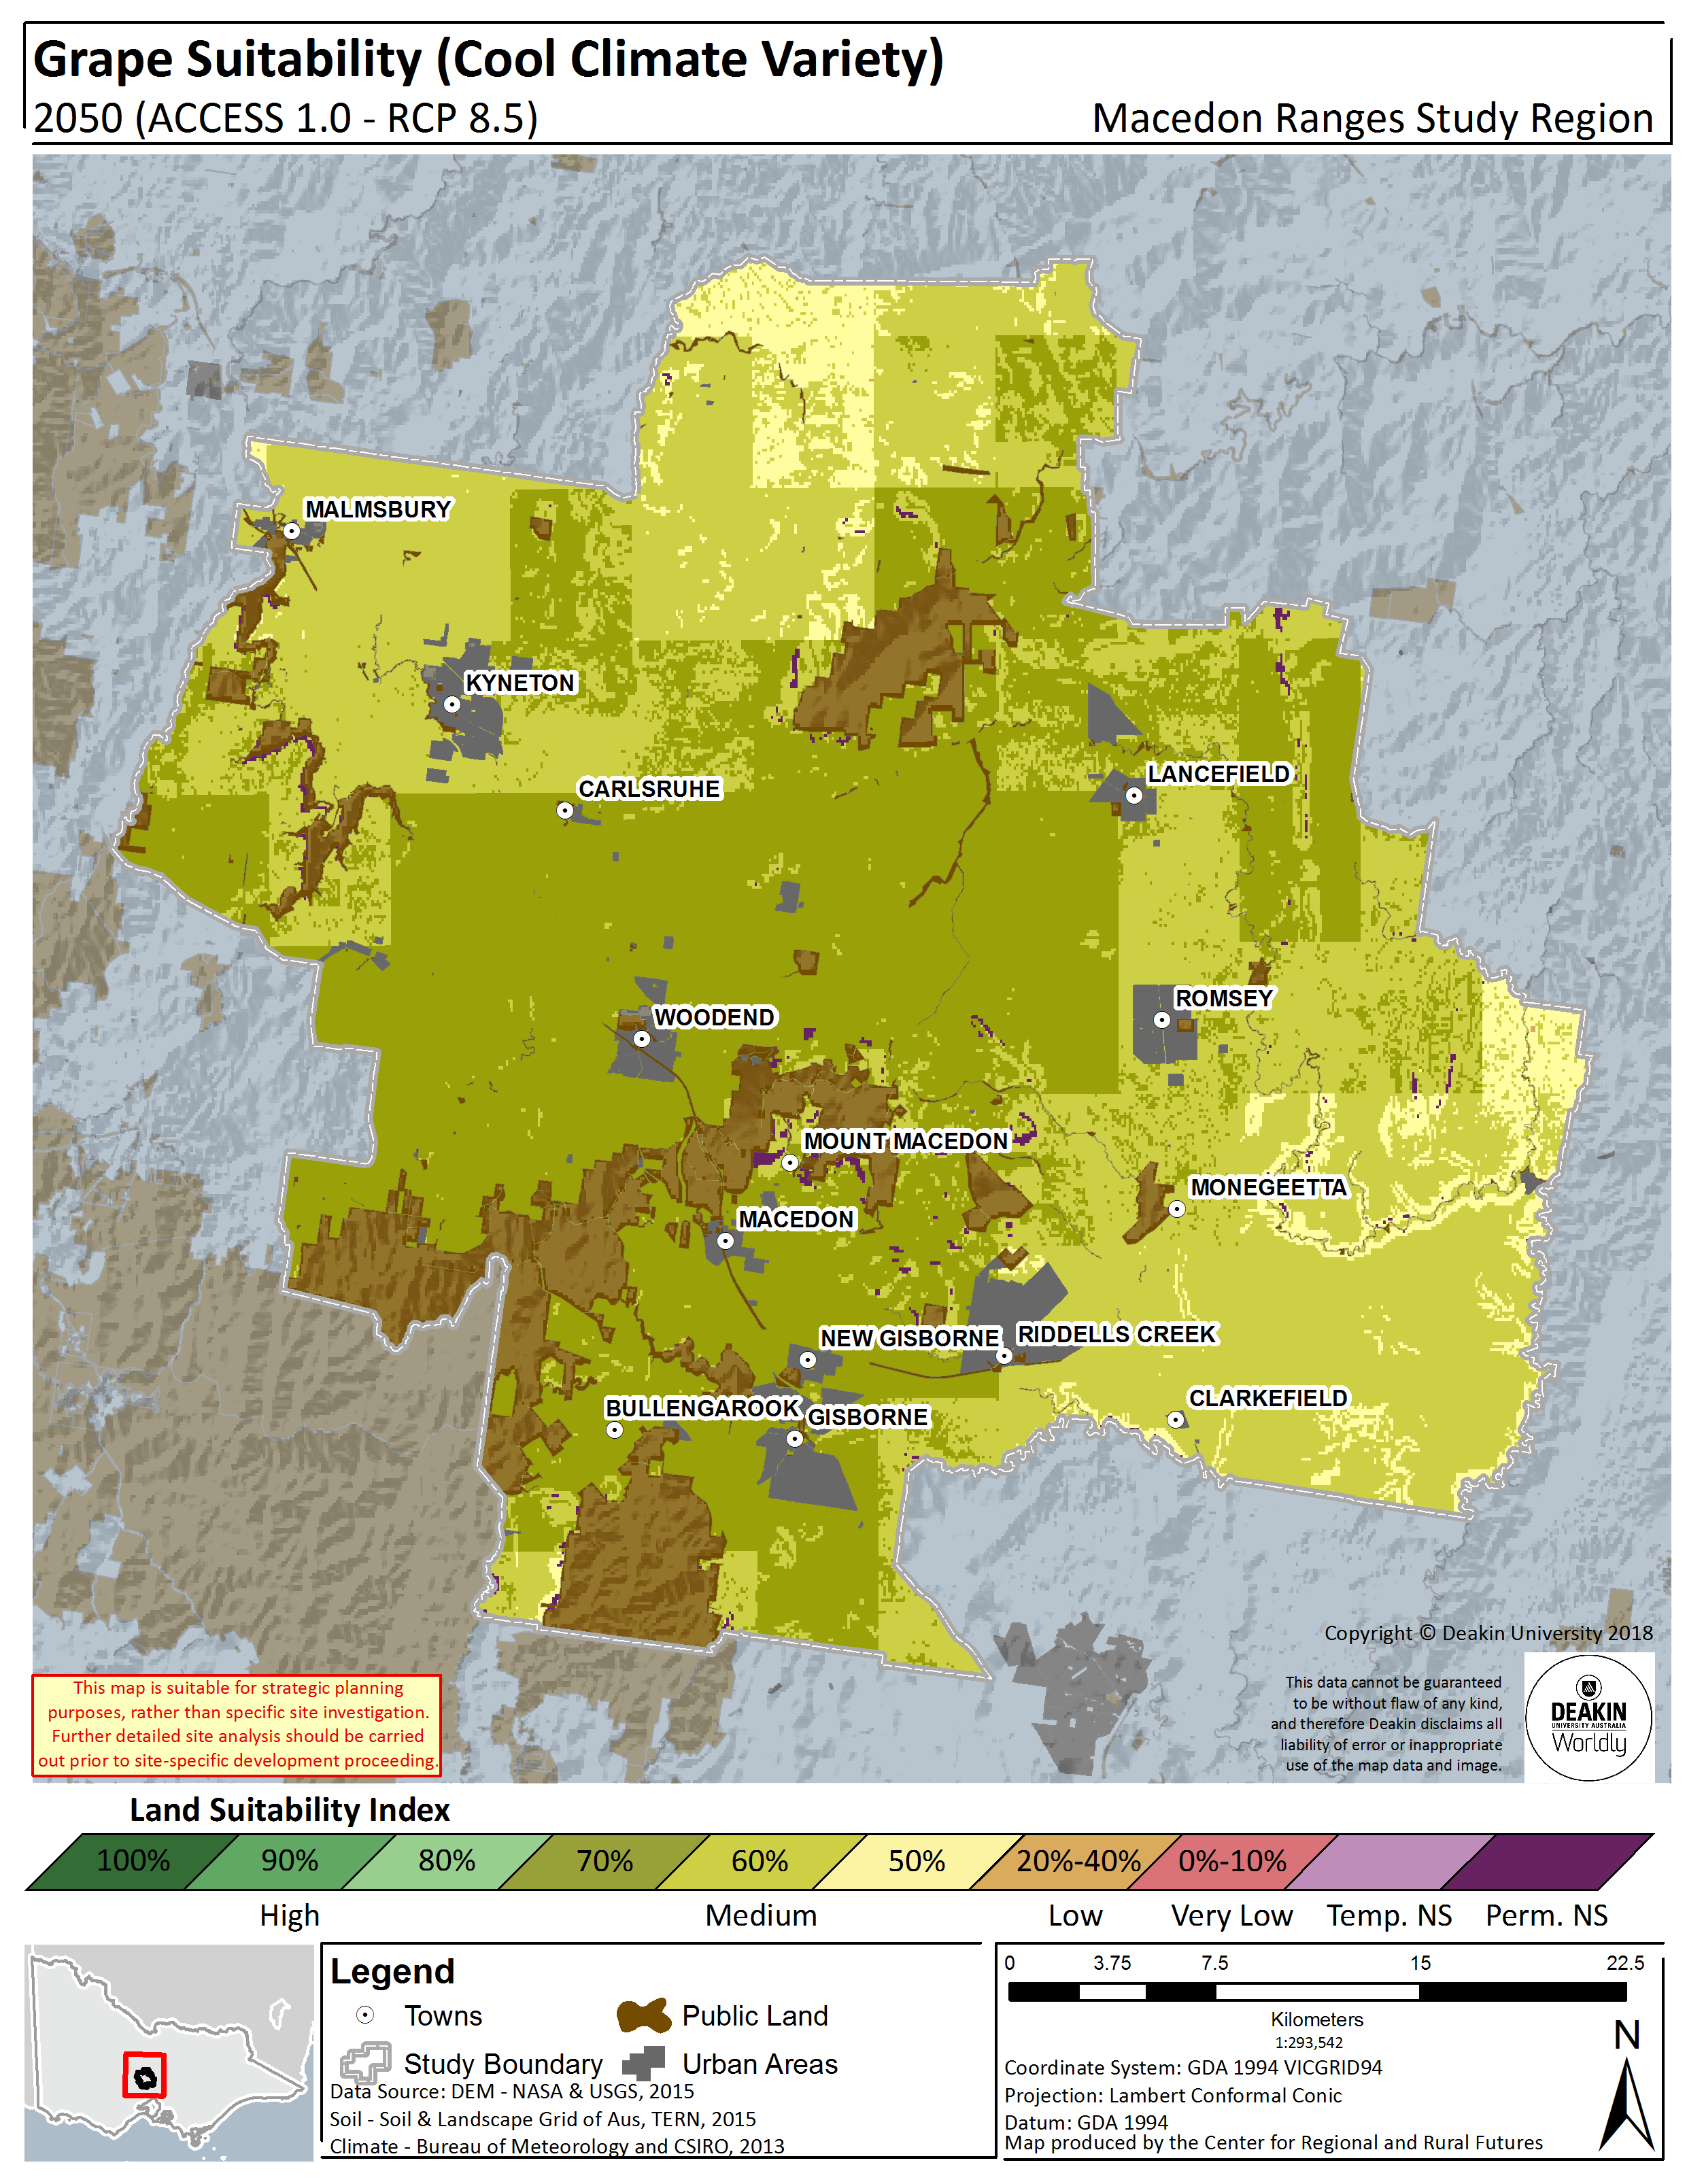

Figure 8.3.Cool climate grape land suitability in the Macedon Ranges Shire – Historical (1961 – 1990) (left panel), 2030 (RCP8.5) (centre panel), 2050 (RCP8.5) (right panel)

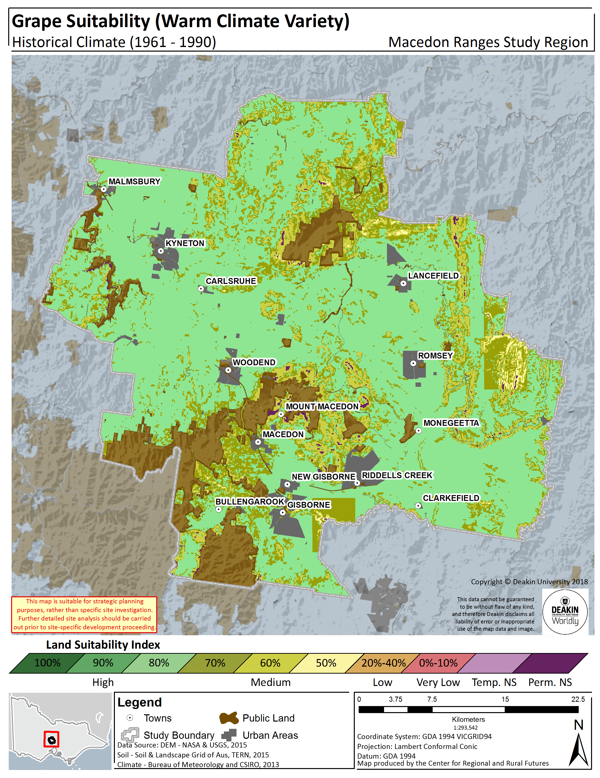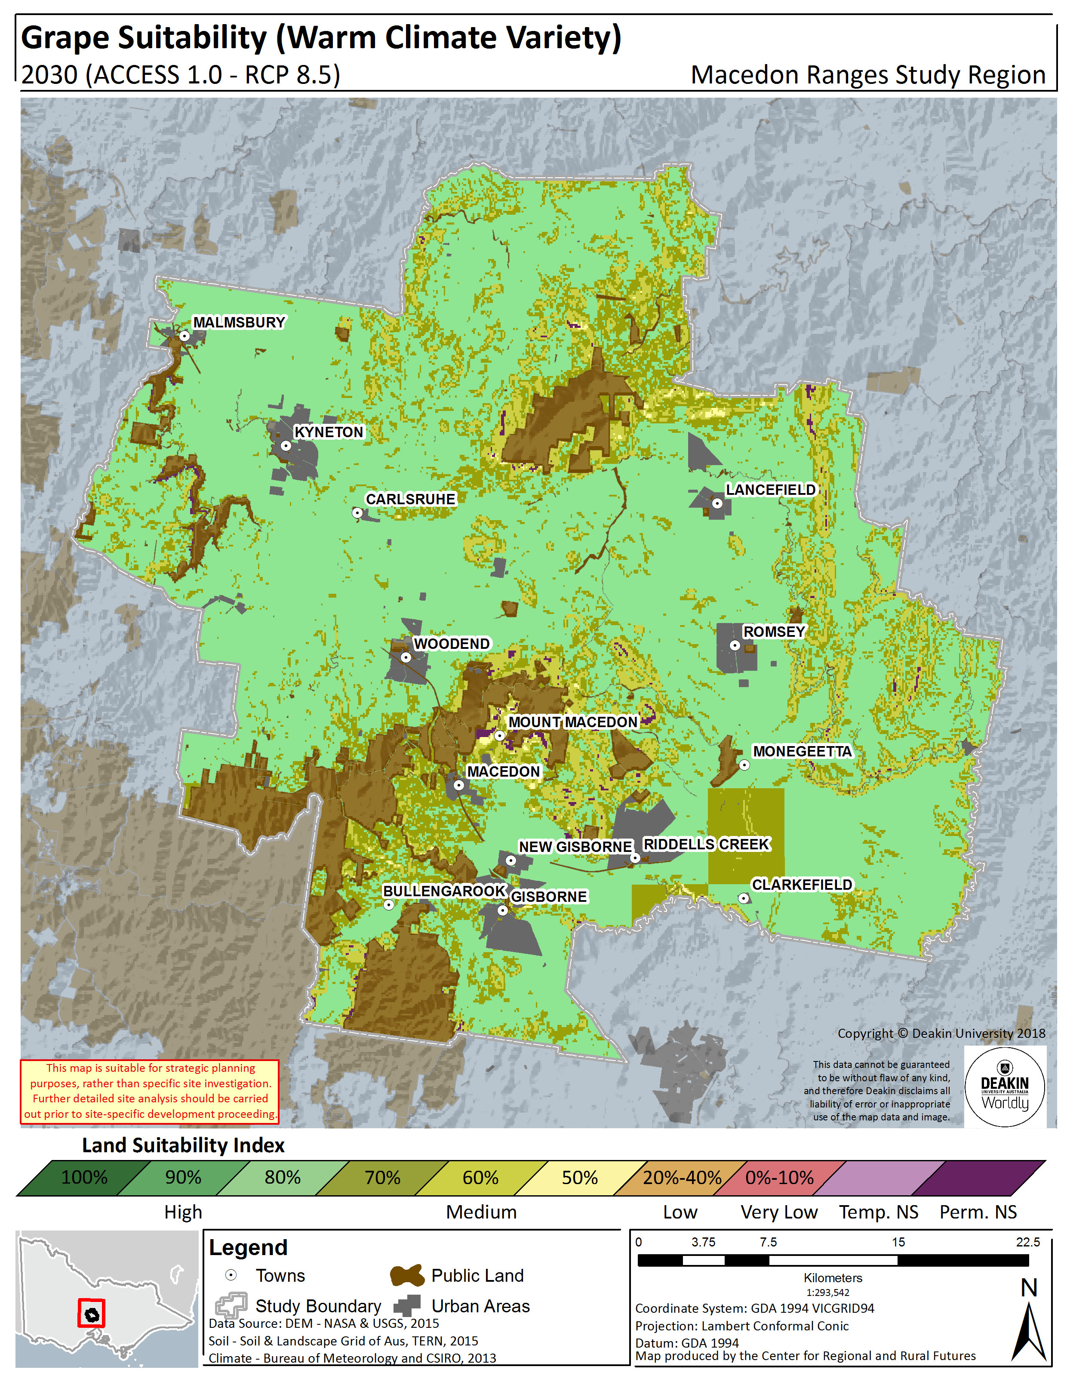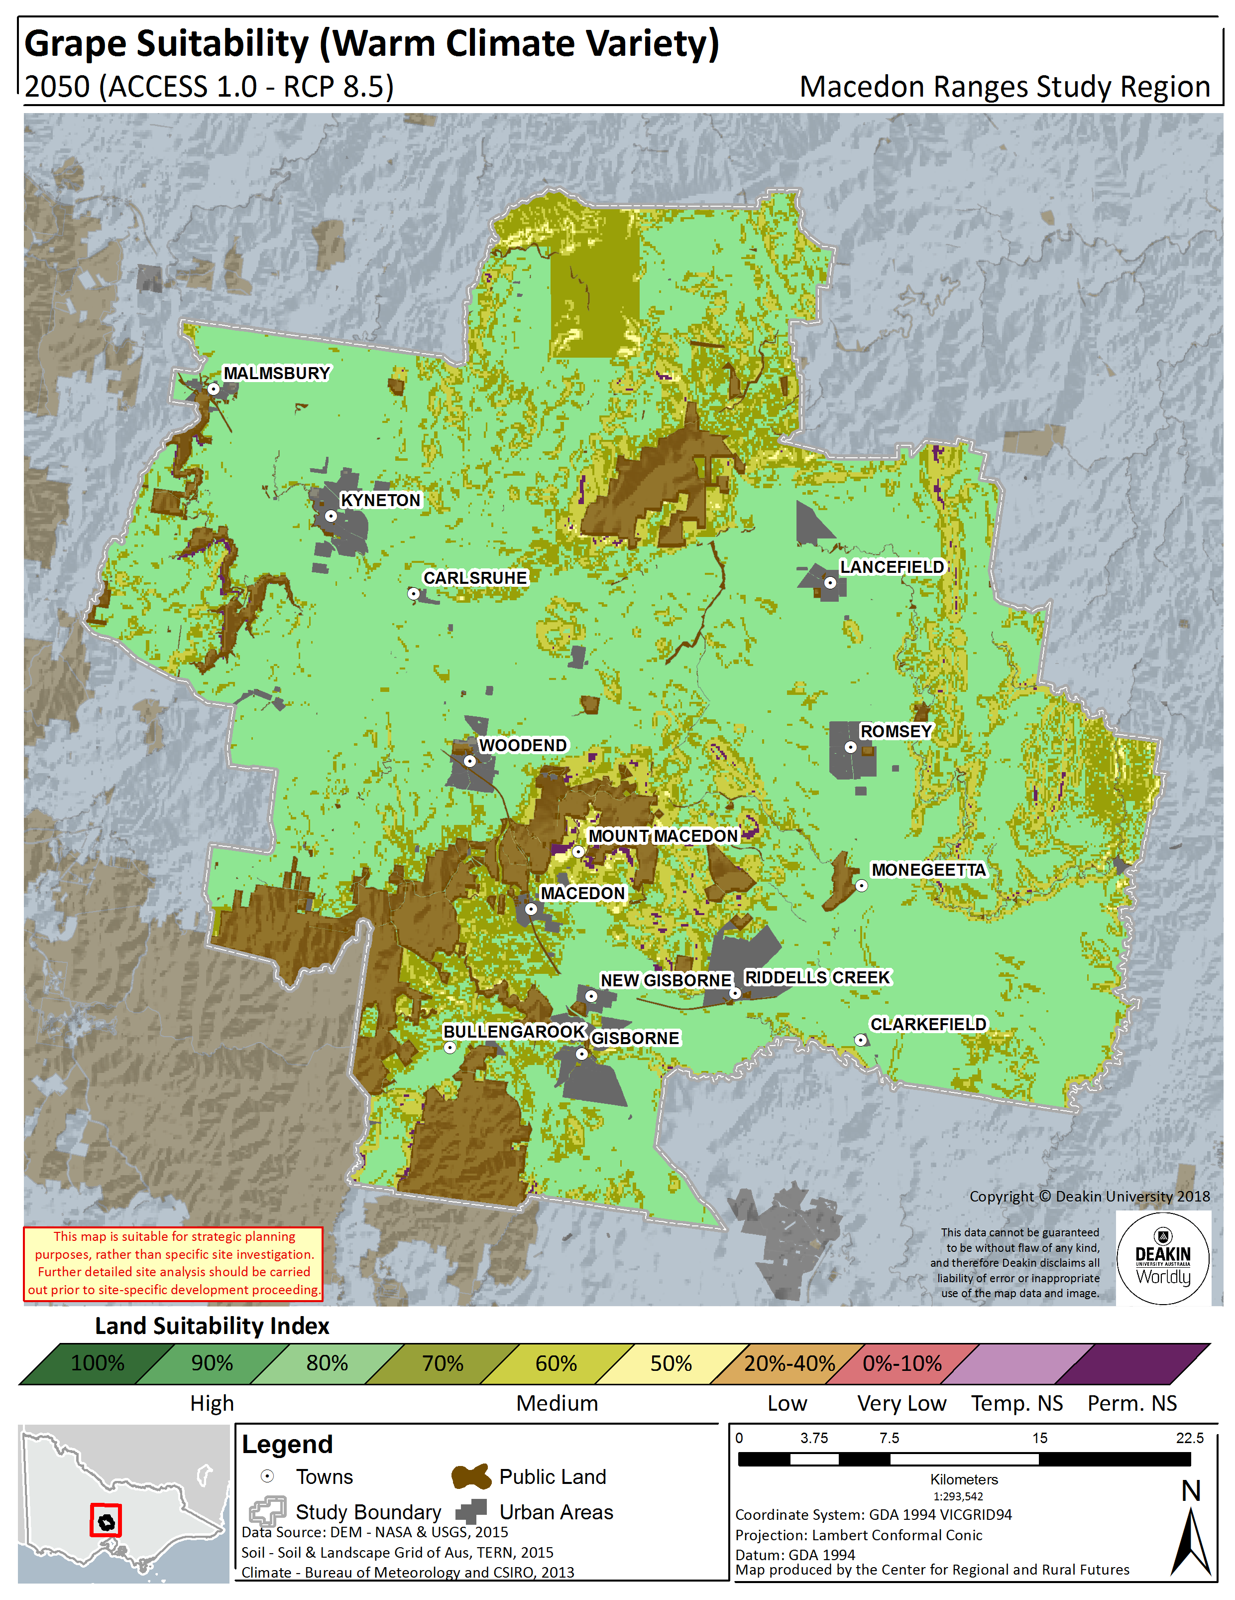
Figure 8.4.Warm climate grape land suitability in the Macedon Ranges Shire – Historical (1961 – 1990) (left panel), 2030 (RCP8.5) (centre panel), 2050 (RCP8.5) (right panel)

RYEGRASS
The ryegrass biophysical LSA model determines the suitability of the region to produce a generic ryegrass pasture.
The model output relative to historical climate (see Figure 9.2, left panel) indicates that the majority of the Shire is currently suitable for ryegrass production and generally ranked between 80 and 100% suitable. Notably, the south eastern area of the region from Riddells Creek to Clarkefield however, are significantly lower at 50% due to low rainfalls.
The region will maintain its suitability for ryegrass production into the future, with overall very high suitability (90-100%) remaining relatively stable (see Figure 9.2). In fact, overall high suitability (including 80%) improves in 2030, with slightly higher summer rainfalls over the south-east of the region improving from Riddells Creek to the boundary of the region. In 2050 this slightly decreases again, due to lower rainfalls, however it is still overall, a higher suitability than the historical scenario.
The percentage area and total hectares of the Shire that fall within each suitability rating (for example, 80%) at each time point is listed in Figure 9.1 and Table 9.1, indicating the degree of change.

Table 9.1 Ryegrass land suitability by area and percentage in the Macedon Ranges Shire – Historical, 2030, 2050
Ryegrass
 |  | Not Suitable | 0 - 40% | 50% | 60% | 70% | 80% | 90% | 100%
 |  | Hectares (ha)
Historical | 1961 - 1990 | 670 | 185 | 13,649 | 18,373 | 13,186 | 37,780 | 66,010 | 27,590
RCP8.5 | 2030 | 1,126 | - | 30 | 5,361 | 15,743 | 49,392 | 103,180 | 2,611
 | 2050 | 1,126 | - | 285 | 8,113 | 20,858 | 45,882 | 101,179 | -
 |  | Percentage (%)
Historical | 1961 - 1990 | 0.4% | 0.1% | 7.7% | 10.4% | 7.4% | 21.3% | 37.2% | 15.5%
RCP8.5 | 2030 | 0.6% | - | 0.0% | 3.0% | 8.9% | 27.8% | 58.1% | 1.5%
 | 2050 | 0.6% | - | 0.2% | 4.6% | 11.8% | 25.9% | 57.0% | -

Figure 9.1. Ryegrass land suitability area by percentage amount in the Macedon Ranges Shire – Historical, 2030, 2050

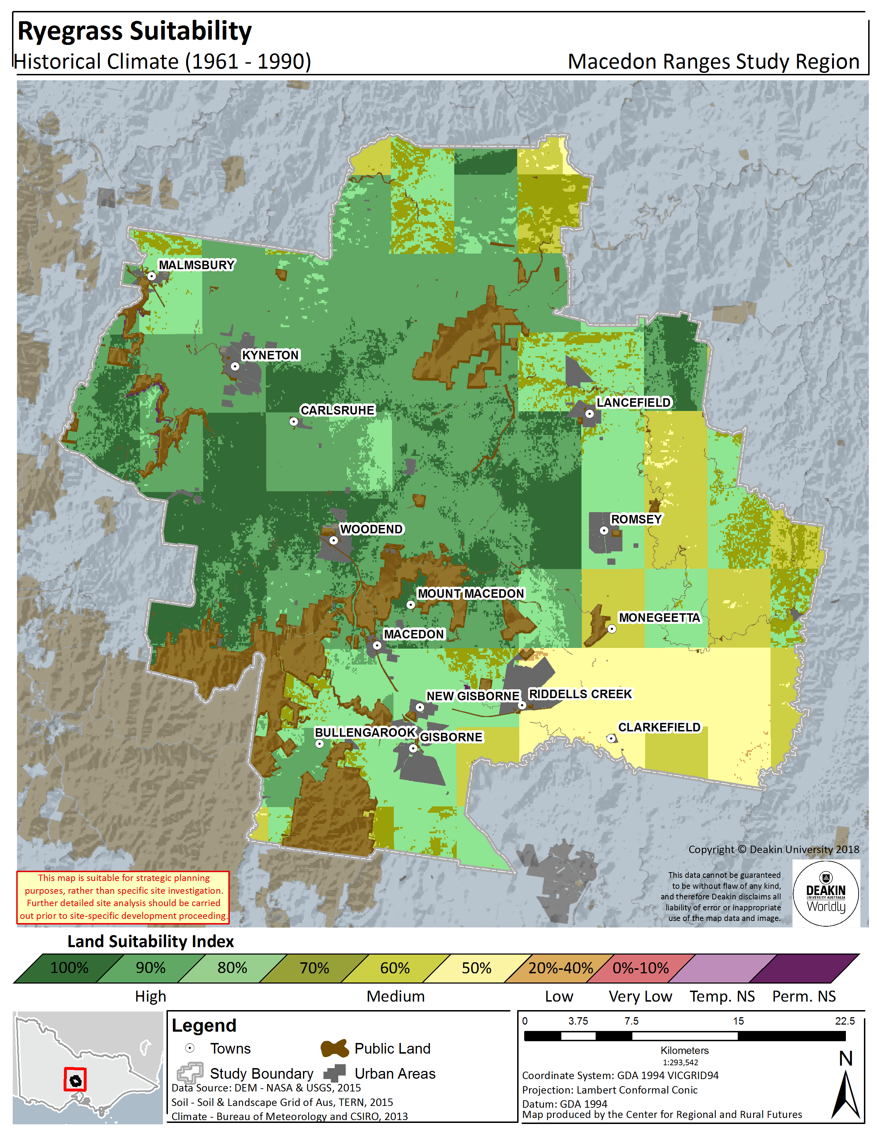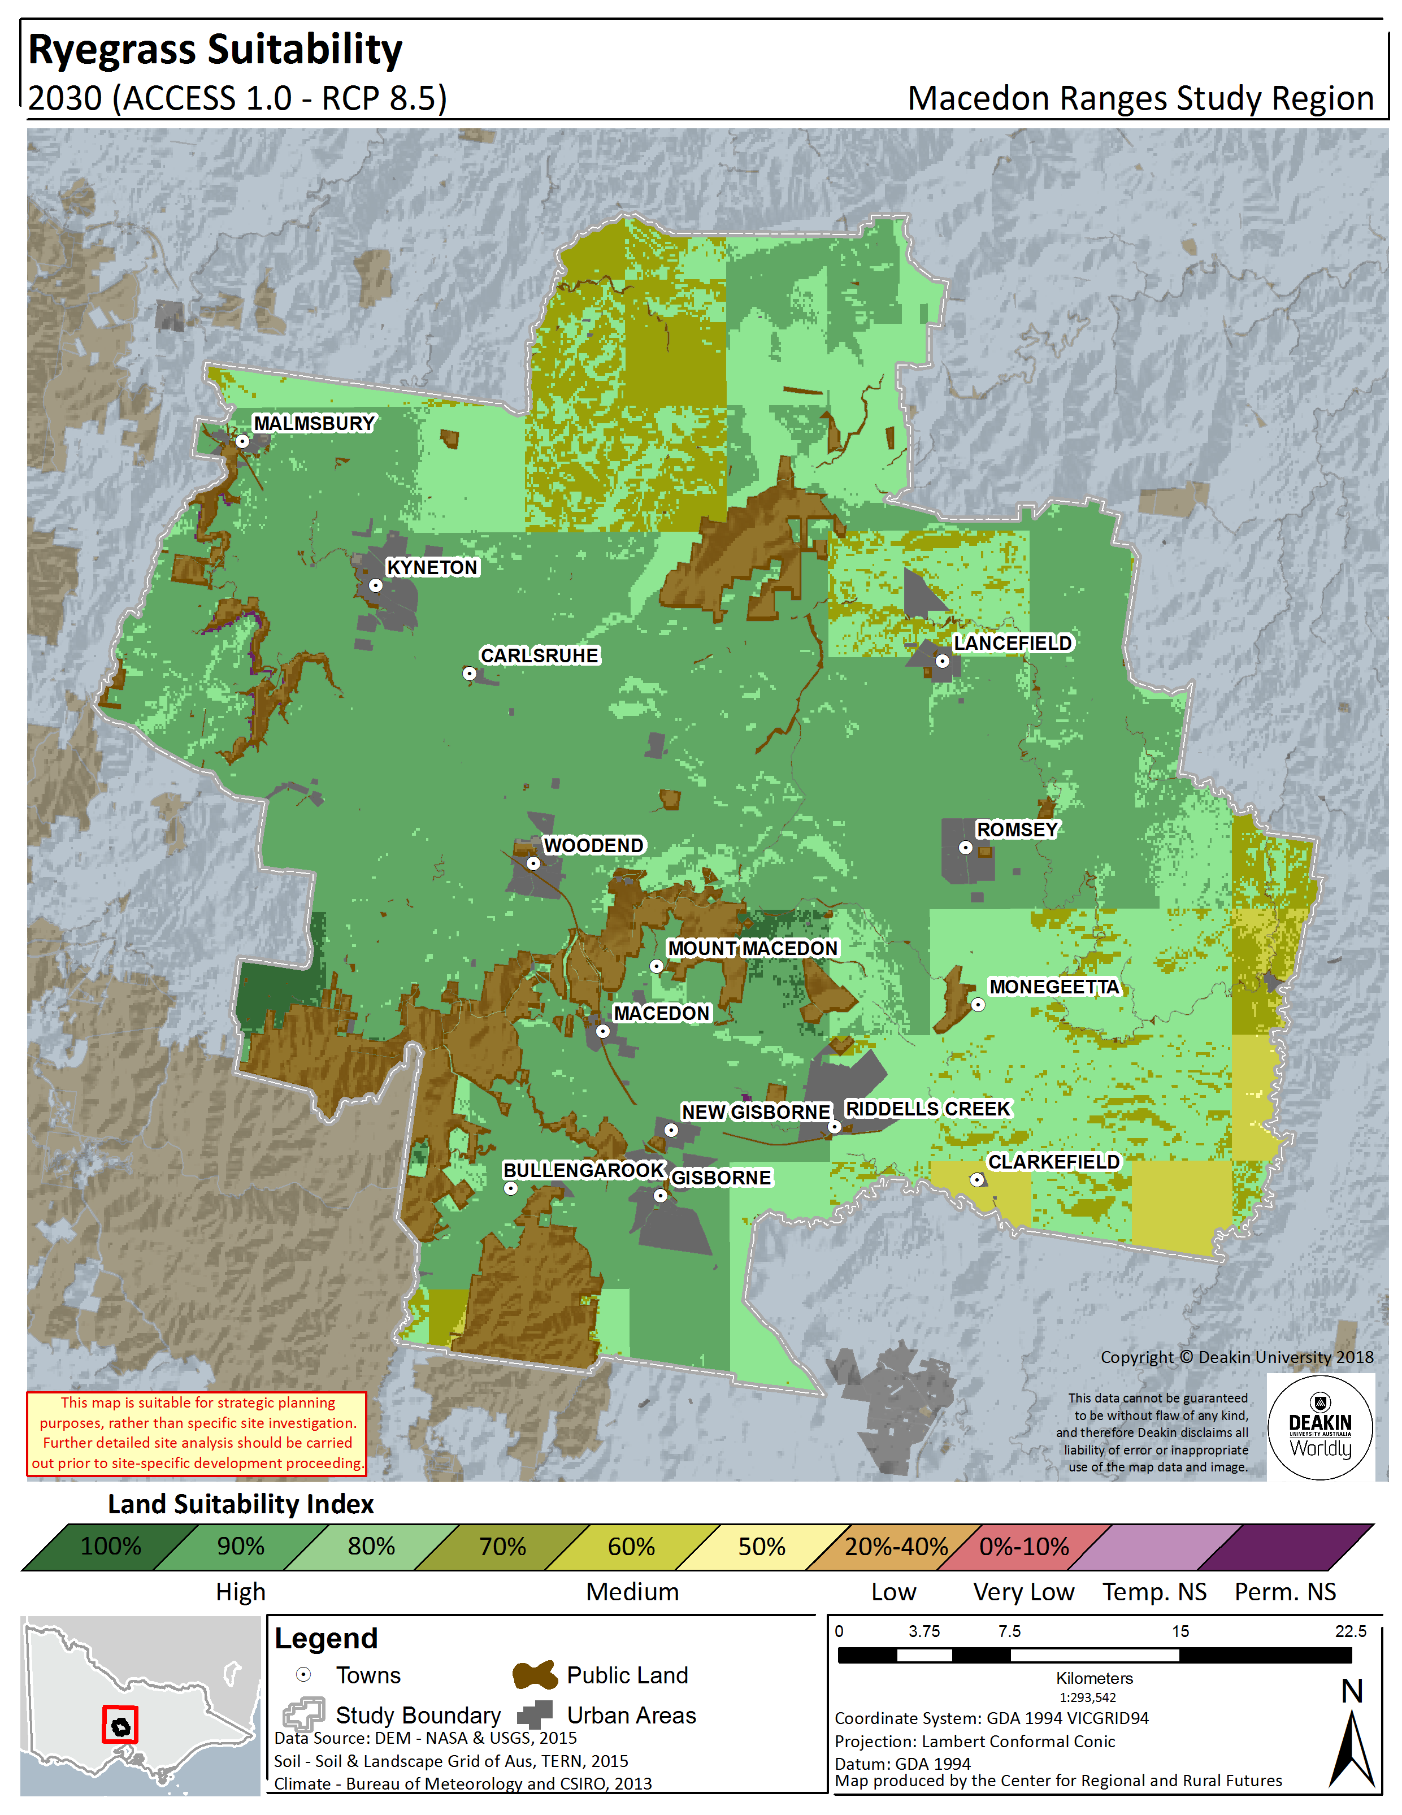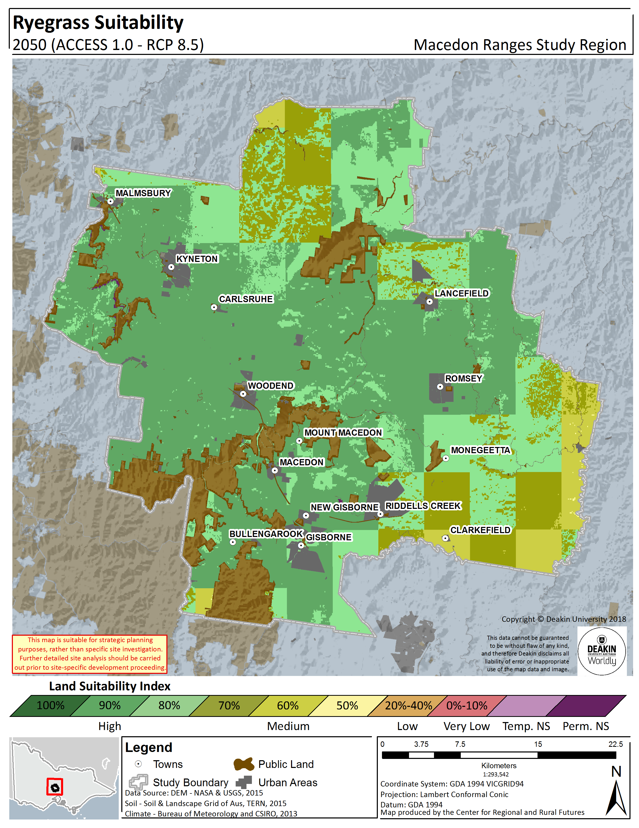
Figure 9.2.Ryegrass land suitability in Macedon Ranges Shire – Historical (1961 – 1990) (left panel), 2030 (RCP8.5) (centre panel), 2050 (RCP8.5) (right panel)

STONE FRUIT
Two generic varieties of early and late season stone fruit were modelled to account for the large range of varieties and cultivars available and their particular and complex flowering, maturing and harvesting seasons. They are broadly grouped in this report as Early Season Stone Fruit or Late Season Stone Fruit, with each variety having their own particular phenological stages; in general, however, early stone fruit will flower from September to October and have fruit growth from November to January. Late season stone fruit flower between September and November with fruit growth occurring between December and March.
The two models presented here represent generic varieties, however the Early Season Stone Fruit model has been validated with a Cherry producer with expert knowledge local to the Macedon Ranges region.
The model output relative to historical climate indicates that the suitability of both early and late season stone fruit is high (largely 80%). With the early season variety showing moderate suitability in the southern area around Riddells Creek only.
According to growers in the Shire, the impacts of a changing climate are already being felt. They reported that earlier harvesting, was becoming the norm, sometime of up to a month earlier. They also reported traditional differences in the harvesting time at locations of different elevations and local microclimates reducing and beginning to occur concurrently. Clearly this poses challenges in terms of logistics and labour, and has implications for fruit quality and size. Growers in the region have also noticed the region is noticeably direr in the last 15 years.
Looking to likely changes in suitability as we move into the future, the modelling indicates that the Shire will maintain suitability into the future at both 2030 and 2050 for both early and late season varieties. In fact a relatively stable, high suitability (80%) is seen as the dominant suitability class for both varieties. The percentage area and total hectares of the Shire that falls within each suitability rating (for example, 80%) at each time point is listed in Figure 10.1 and Figure 10.2, which gives a good indication of degree of change over time for early season and late season varieties respectively.
The even spread of high suitability for both varieties indicates the region can support a diverse stone fruit industry in the future providing it has sufficient access to water (irrigation), as has been assumed in these models.

Table 10.1. Early Season Stone Fruit land suitability by area and percentage in the Macedon Ranges Shire – Historical, 2030, 2050
Stone Fruit - Early Variety
 |  | Not Suitable | 0 - 40% | 50% | 60% | 70% | 80% | 90% | 100%
 |  | Hectares (ha)
Historical | 1961 - 1990 | 8,539 | - | - | 3 | 22,848 | 146,053 | - | -
RCP8.5 | 2030 | 10,357 | - | - | - | 987 | 166,099 | - | -
 | 2050 | 10,357 | - | - | - | 633 | 166,154 | 299 | -
 |  | Percentage (%)
Historical | 1961 - 1990 | 4.8% | - | - | - | 12.9% | 82.3% | - | -
RCP8.5 | 2030 | 5.8% | - | - | - | 0.6% | 93.6% | - | -
 | 2050 | 5.8% | - | - | - | 0.4% | 93.6% | 0.2% | -

Figure 10.1. Early season stone fruit land suitability area by percentage amount in the Macedon Ranges Shire – Historical, 2030, 200
Table 10.2. Late Season Stone Fruit land suitability by area and percentage in the Macedon Ranges Shire – Historical, 2030, 2050
Stone Fruit - Late Variety
 |  | Not Suitable | 0 - 40% | 50% | 60% | 70% | 80% | 90% | 100%
 |  | Hectares (ha)
Historical | 1961 - 1990 | 8,539 | - | - | - | 1,054 | 165,419 | 2,431 | -
RCP8.5 | 2030 | 10,357 | - | - | - | 1,735 | 165,351 | - | -
 | 2050 | 10,357 | - | - | - | 151 | 166,935 | - | -
 |  | Percentage (%)
Historical | 1961 - 1990 | 4.8% | - | - | - | 0.6% | 93.2% | 1.4% | -
RCP8.5 | 2030 | 5.8% | - | - | - | 1.0% | 93.2% | - | -
 | 2050 | 5.8% | - | - | - | 0.1% | 94.1% | - | -

Figure 10.2. Late season stone fruit land suitability area by percentage amount in the Macedon Ranges Shire – Historical, 2030, 200

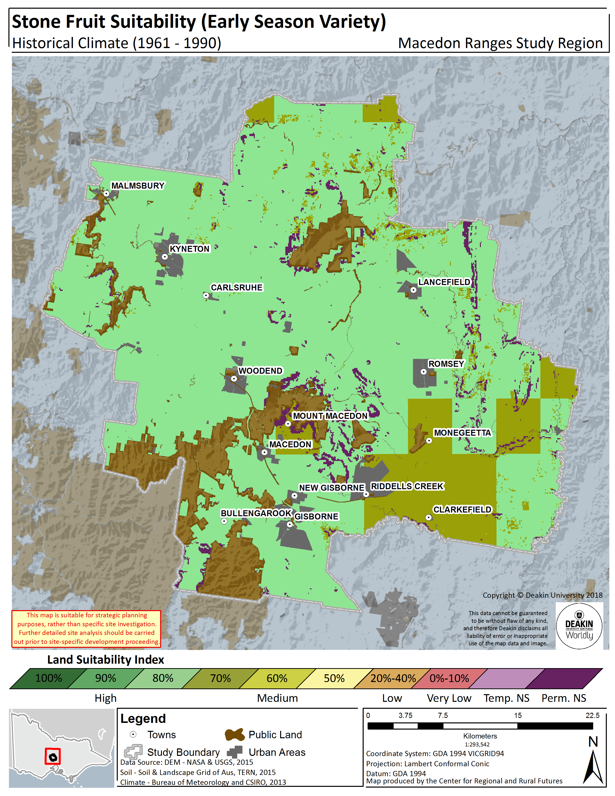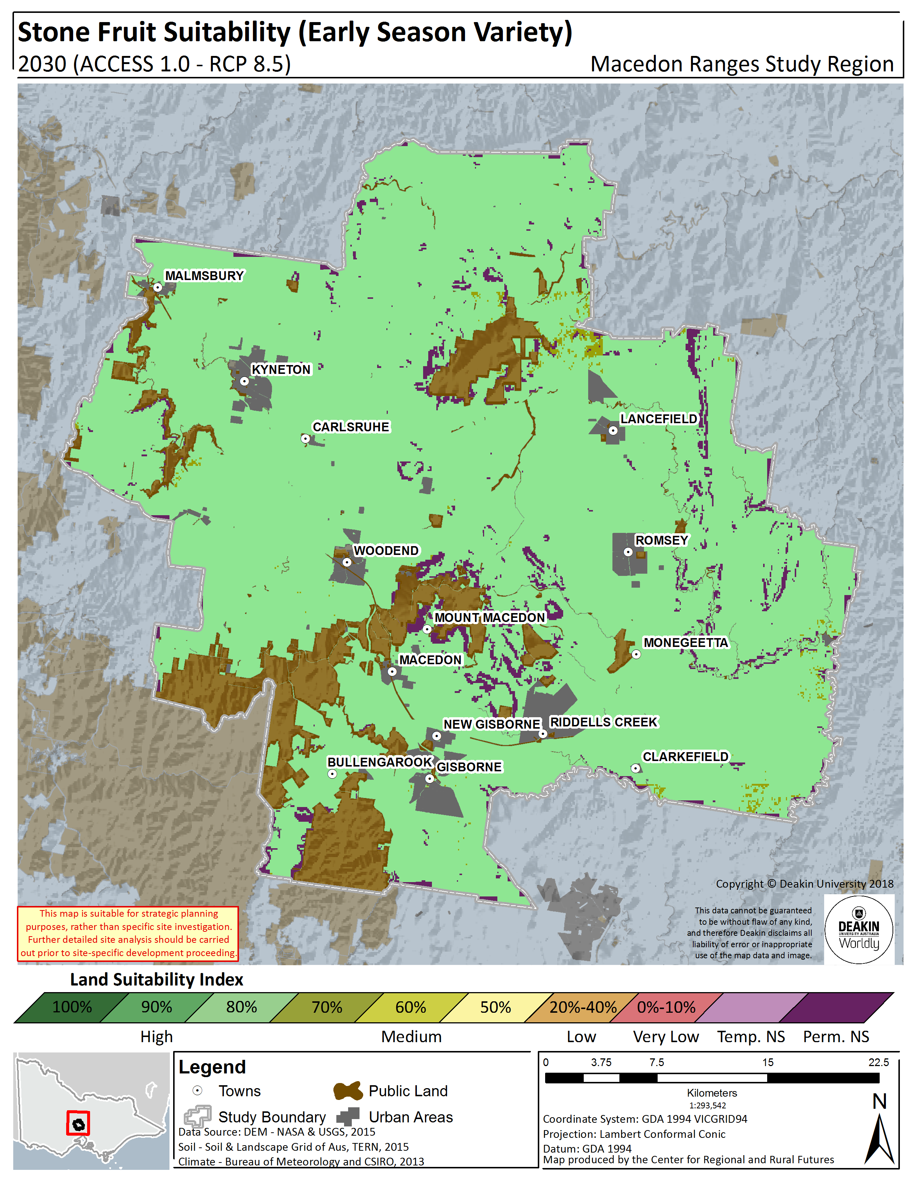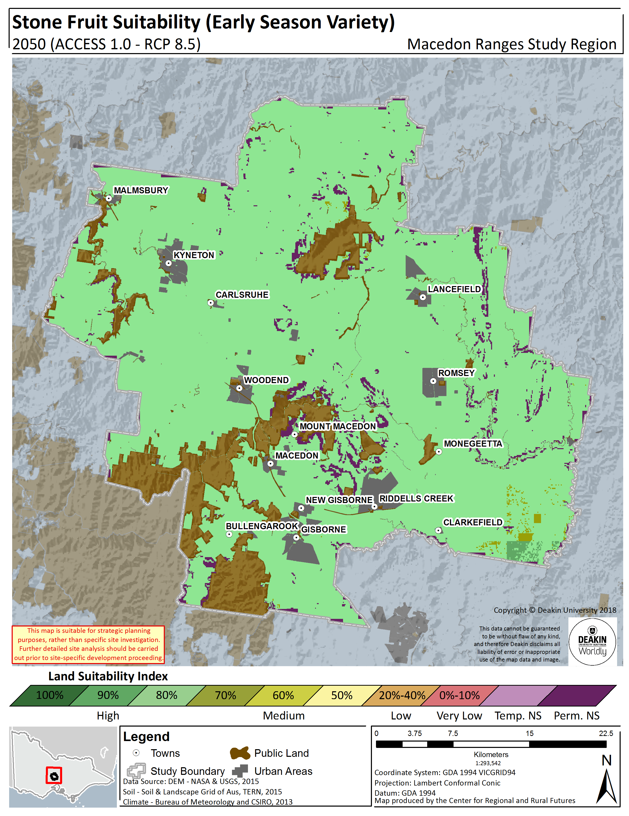
Figure 10.3.Early Season Stone Fruit land suitability in the Macedon Ranges Shire – Historical (1961 – 1990) (left panel), 2030 (RCP8.5) (centre panel), 2050 (RCP8.5) (right panel)
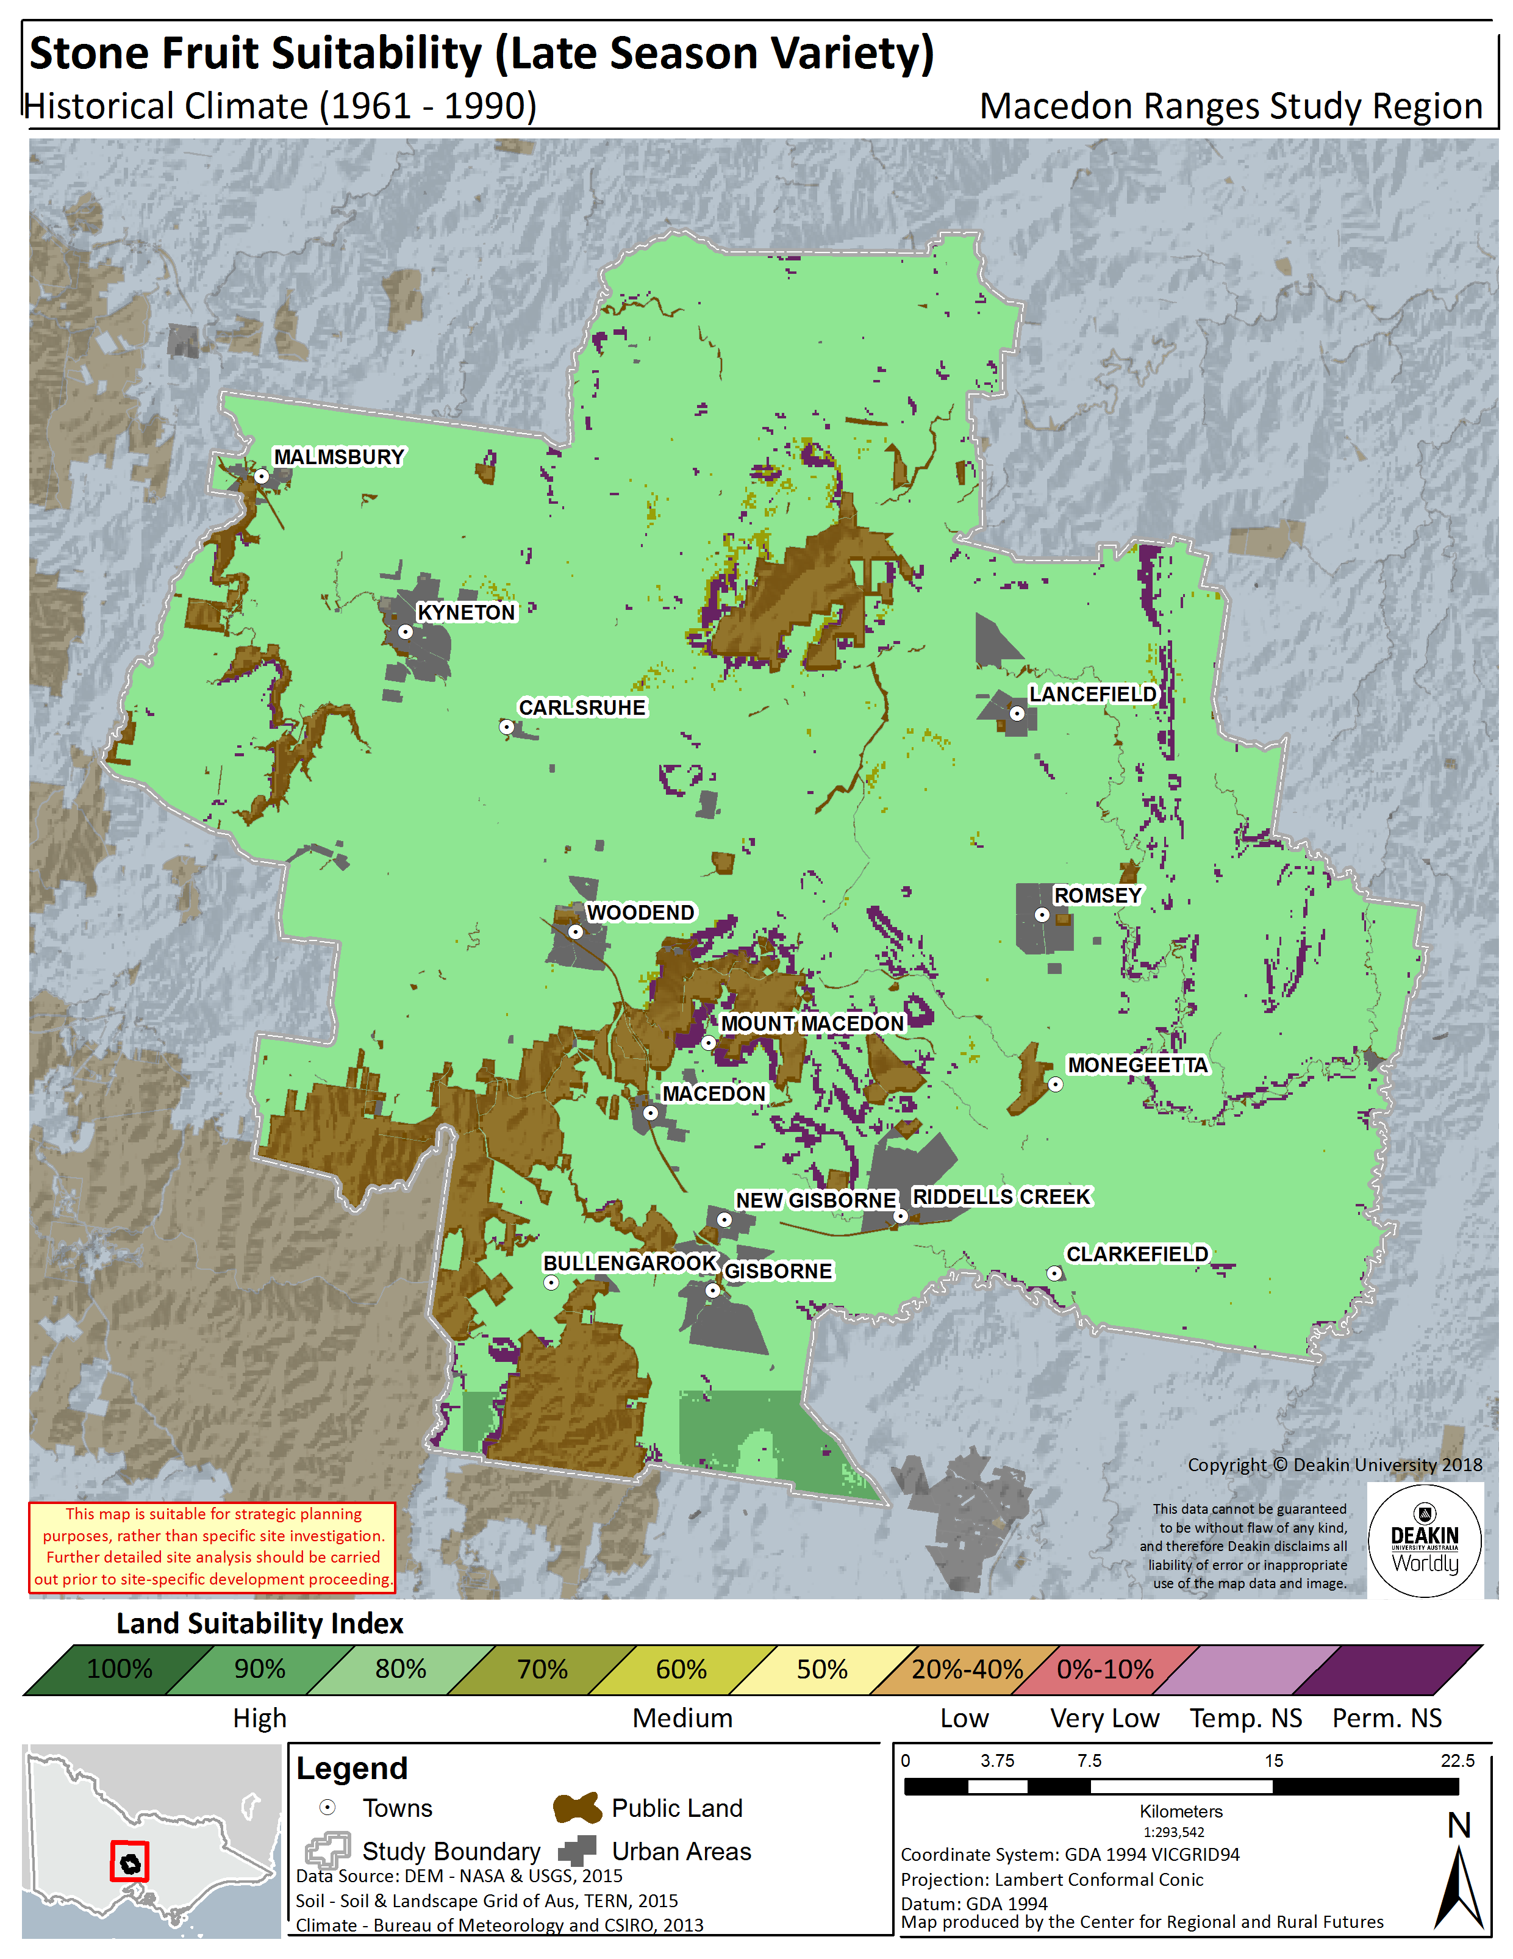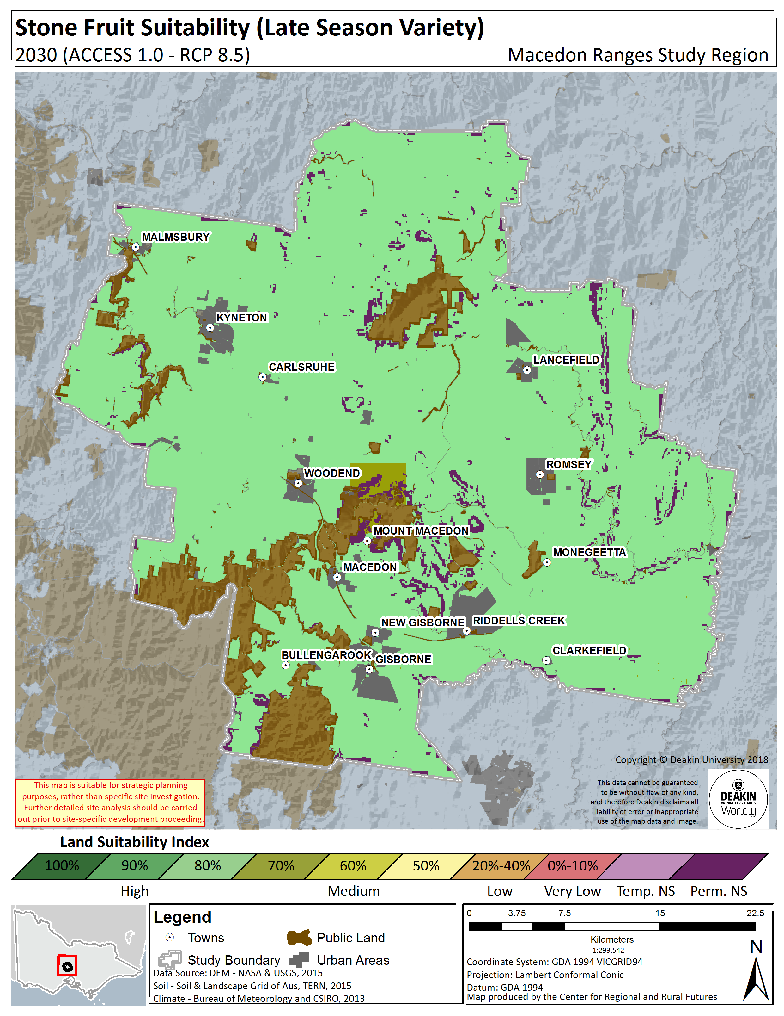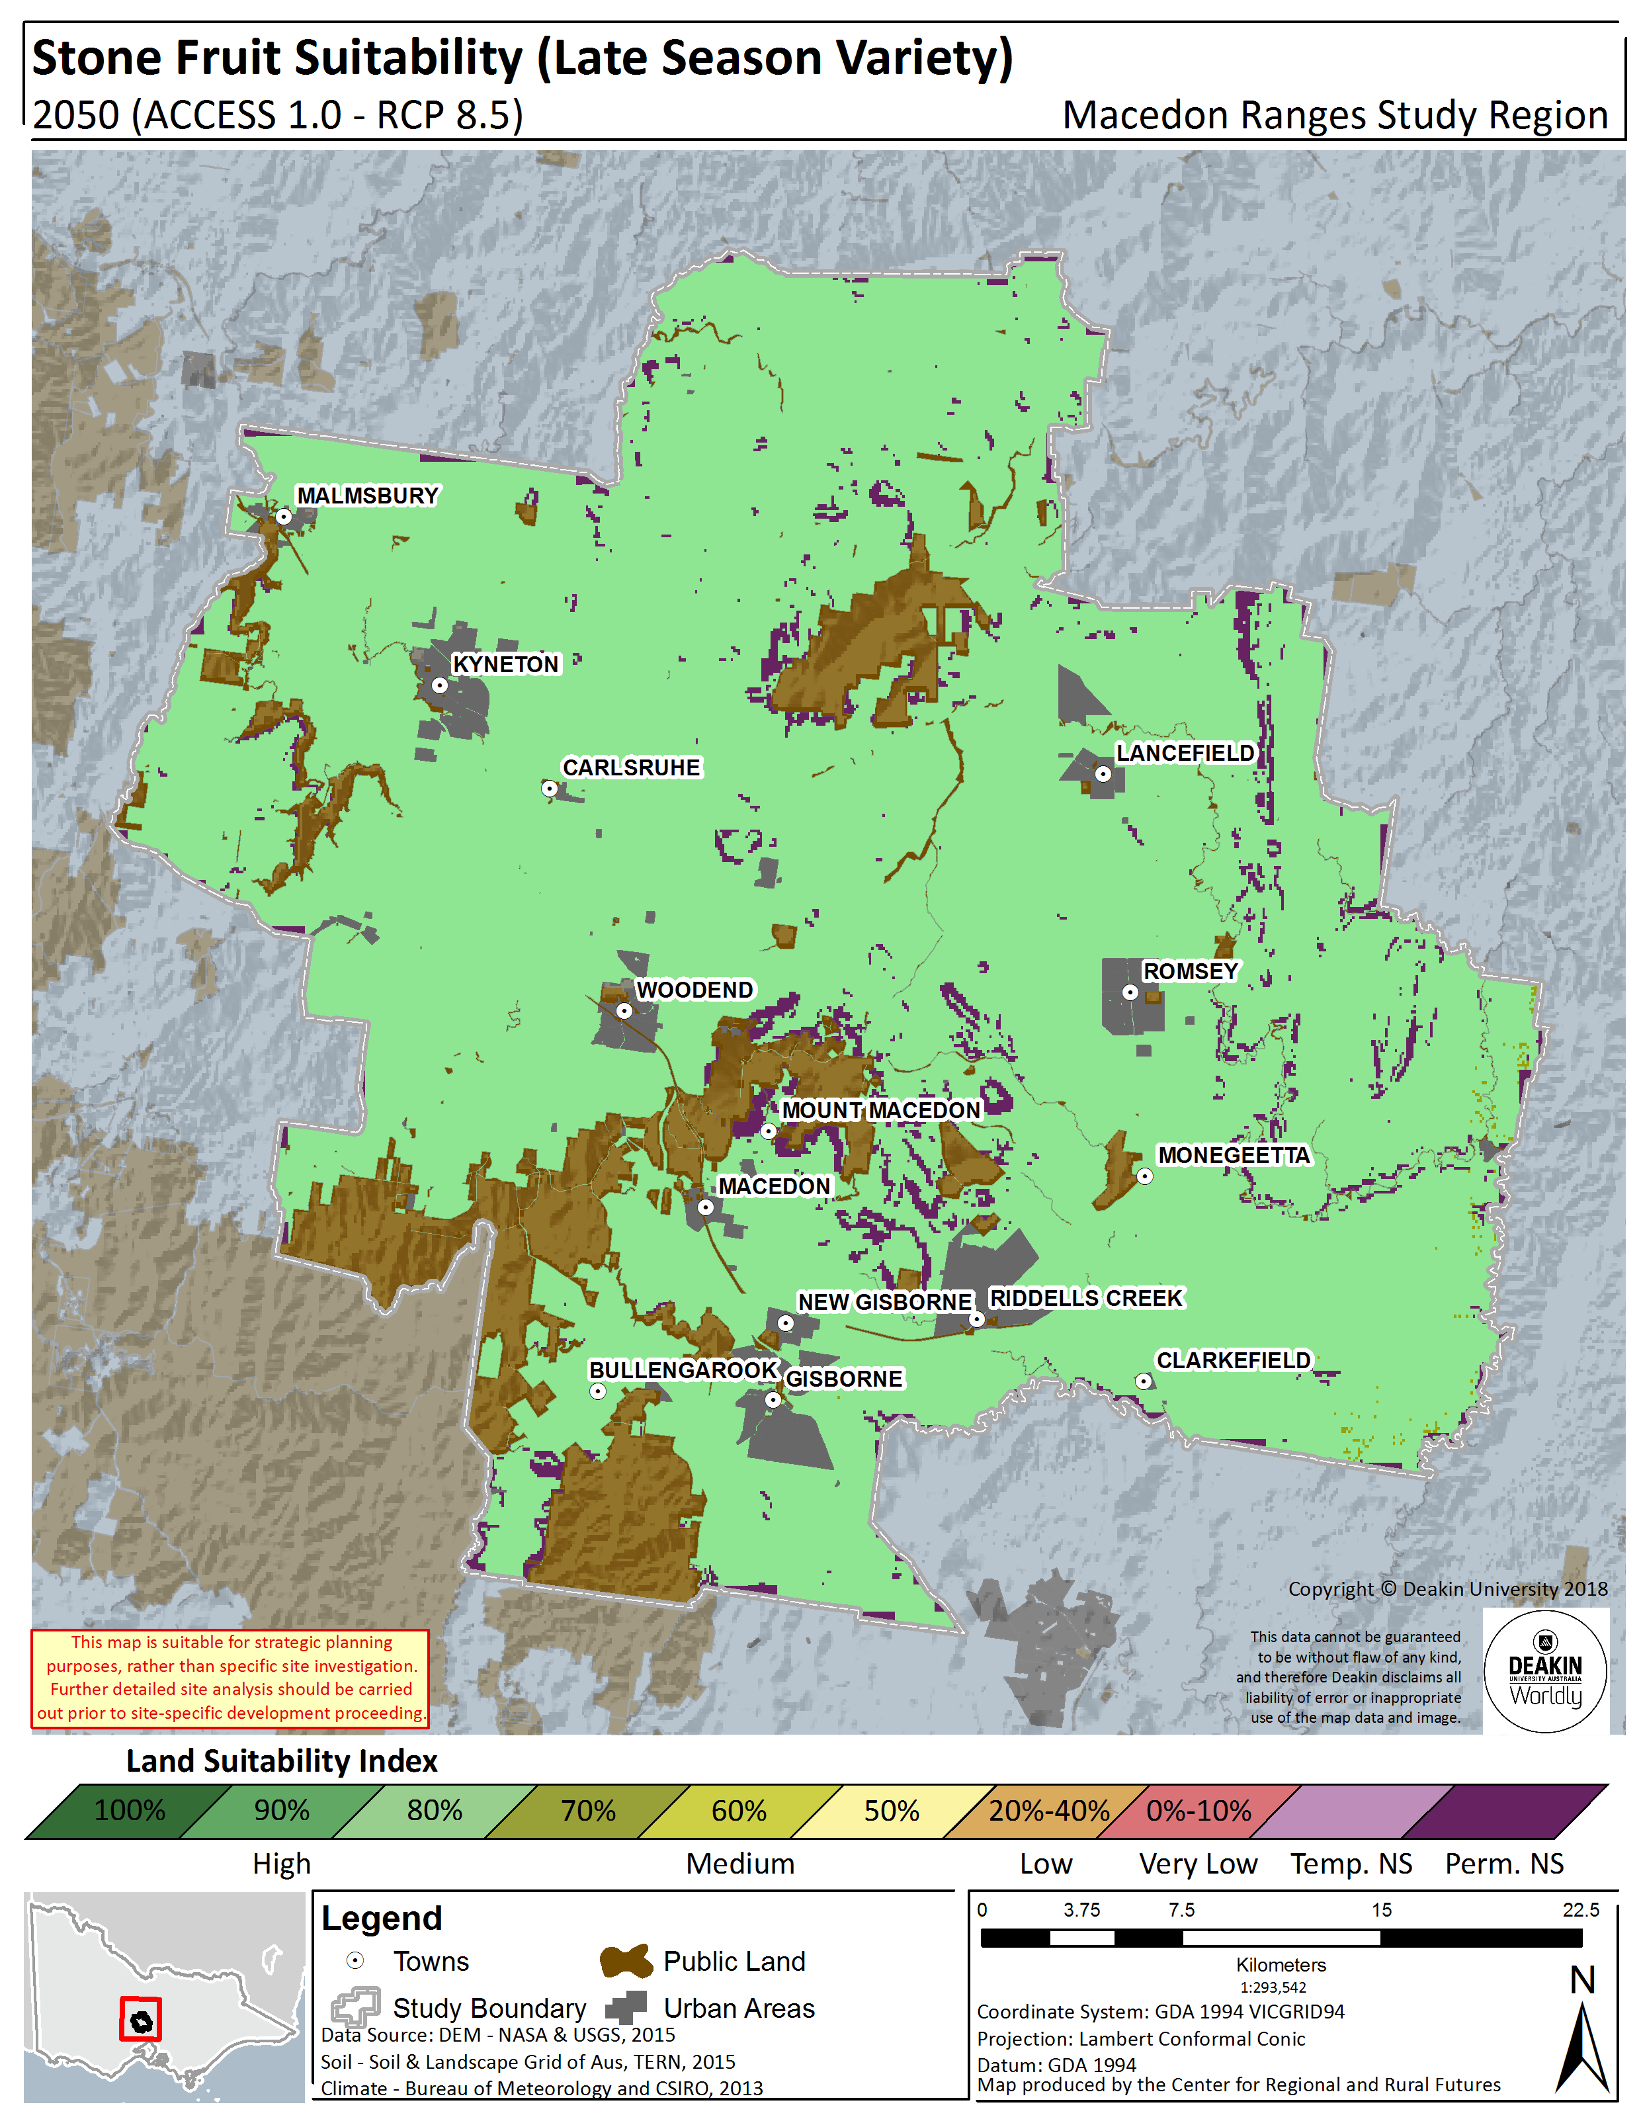
Figure 10.4.Late Season Stone Fruit land suitability in the Macedon Ranges Shire – Historical (1961 – 1990) (left panel), 2030 (RCP8.5) (centre panel), 2050 (RCP8.5) (right panel)

WHEAT
The wheat biophysical LSA model determines the suitability of the region to produce a generic winter feed wheat variety, with sowing period of May and harvest period of late November, early December onwards.
The model output relative to historical climate indicates that the majority of the Shire is currently highly suitable for wheat production and generally ranked 80% or above. Central areas around Carlsruhe to Woodend, in particular display very high suitability (100%).
In the historical climate map, areas of Permanently NS are limited in distribution, with only small areas around Mt Macedon and to the east of Lancefield and Romsey. This is associated mainly with pH levels landscape (slope) factors.
Looking to likely changes in suitability as we move into the future, the high suitability of wheat is maintained towards 2030 and 2050, with some previously 80% suitability areas around Clarkefield, becoming more highly suitable (90%). Between 2030 and 2050 the high suitability is maintained at around 60% of the area at 90% suitability and 25% of the area at 100% suitability.
The percentage area and total hectares of the Shire that falls within each suitability rating (for example, 80%) at each time point is listed in Figure 12.1, which gives a good indication of degree of change over time.

Table 12.1. Wheat land suitability by area and percentage in the Macedon Ranges Shire – Historical, 2030, 2050
Wheat
 |  | Not Suitable | 0 - 40% | 50% | 60% | 70% | 80% | 90% | 100%
 |  | Hectares (ha)
Historical | 1961 - 1990 | 8560 | - | - | - | 208 | 15,320 | 106,728 | 46,627
RCP8.5 | 2030 | 8560 | - | - | - | 520 | 6,052 | 116,632 | 45,679
 | 2050 | 8560 | - | - | - | 744 | 13,413 | 109,360 | 45,366
 |  | Percentage (%)
Historical | 1961 - 1990 | 4.8% | - | - | - | 0.1% | 8.6% | 60.1% | 26.3%
RCP8.5 | 2030 | 4.8% | - | - | - | 0.3% | 3.4% | 65.7% | 25.7%
 | 2050 | 4.8% | - | - | - | 0.4% | 7.6% | 61.6% | 25.6%

Figure 12.1Wheat land suitability area by percentage amount in the Macedon Ranges Shire – Historical, 2030, 200
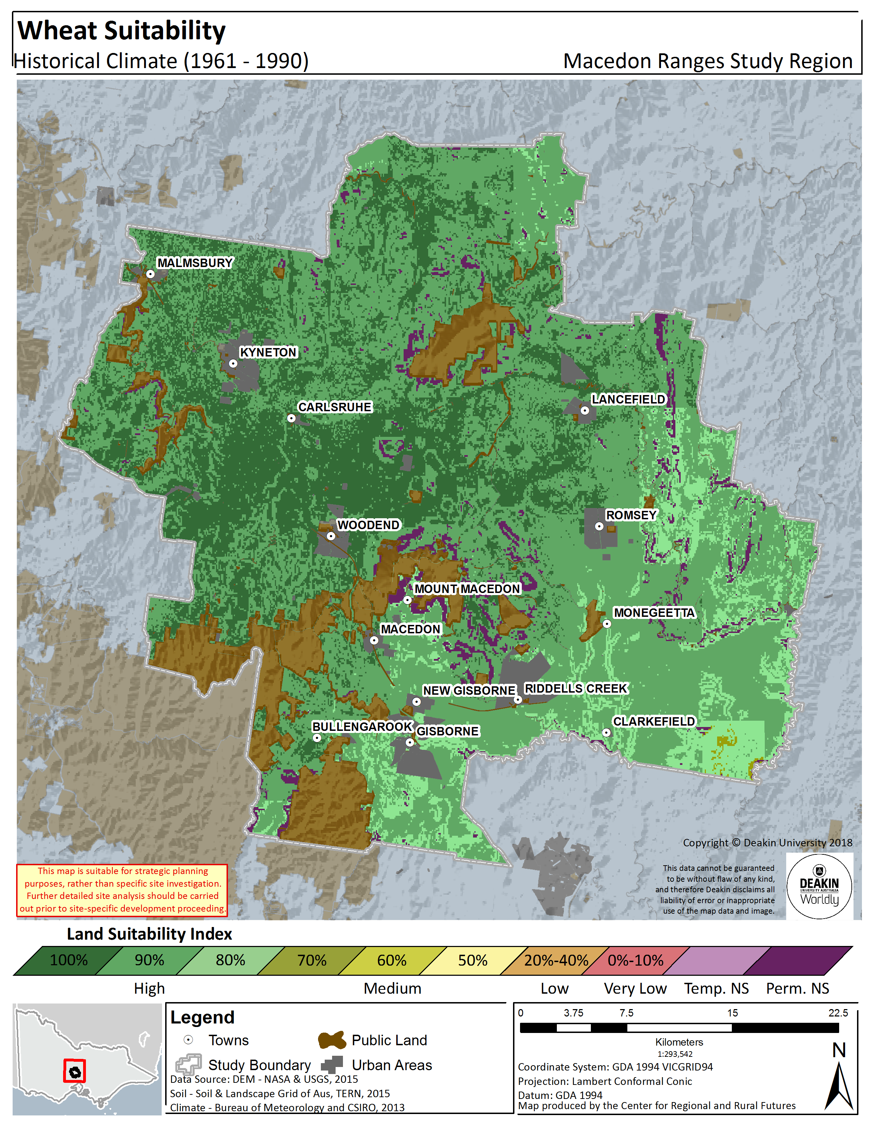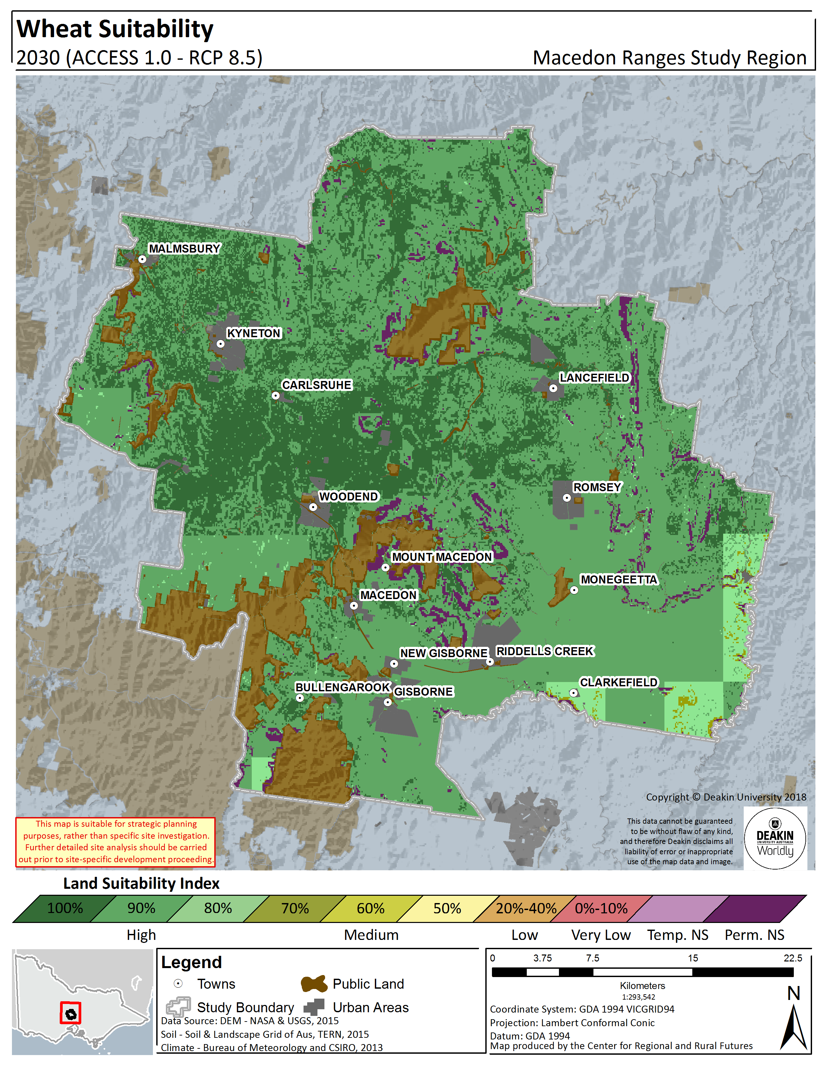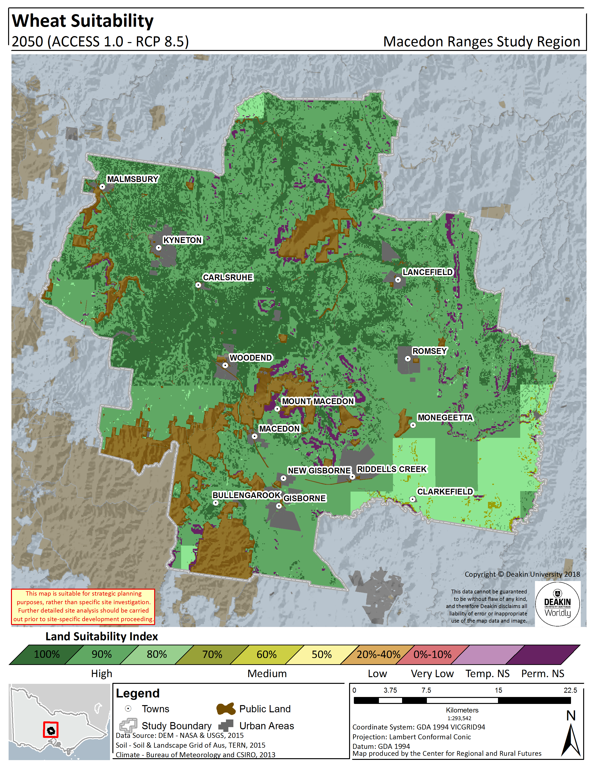
Figure 12.2.Wheat land suitability in the Macedon Ranges Shire – Historical (1961 – 1990) (left panel), 2030 (RCP8.5) (centre panel), 2050 (RCP8.5) (right panel)

IMPACTS AND OPPORTUNITIES
There are significant and wide reaching impacts that the agricultural industry will see in the future, driven largely by climatic factors. However there are also important opportunities that can be capitalised upon to adapt to projected changes and take advantage of the benefits these can have.
The impacts and opportunities can be both commodity specific, but also relevant to the agricultural industry in general.

Expansion of production
As outlined, climate change will make the Shire more suitable for multiple agricultural commodity production. So, it can be expected that over time, farmers will begin experimenting more with different varieties as an integral component of their farming systems and rotations. The potential for expansion is greater when viewed in a State or National context, where some areas that depend on specific and single commodity production will experience declines in suitability. Regional organisations can assist by:
- facilitating access to basic information about different varieties, where they can be grown (including the maps presented in this report) and production opportunities;
- ensuring that the farming landscape (including lot sizes) in highly favourable areas is preserved and not allowed to fragment; and
- prioritising the strategic use of land to avoid or manage the potential environmental impacts of the expansion, such as introducing buffer zones between highly productive pasture areas and rural living zones to reduce the likelihood of conflict between livestock farmers and tree-changers

The value of knowledge
The primary impact across the region is the declining value of farmer’s historical climate knowledge and uncertainty about future climate, both of which increase the complexity of farm decisions. Regional organisations can assist by a) facilitating access to basic information about climate change (including this report) and its impact on agricultural production and b) partnering with agribusiness groups to organise and run field days or workshops that provide farmers with the opportunity to learn from each other.

Seasonal changes

Change in sowing or planting time
The changing climate has already impacted on sowing or planting times, with these continuing to shift as climate changes. Understanding these shifts will require a combination of information sharing and new research. Critical to making decisions about sowing time is the ability to match sowing or planting time and variety.

Transition from cool climate grapes
The modelling suggests that the Shire’s suitability for cool climate gapes will decrease substantially over time, while also experiencing a stabilisation for warm climate varieties. There is a clear association between average mean temperature and the styles of wine produced in a region (Gladstones, 1992). Mean temperature is a key influence on the heat degree day summation, which is a method used for classifying the climate of a wine growing region. Wine regions are categorised according to total degree days over a seven month growing period. At present, most of the Shire is classified as Region I according to the heat degree day summation. By 2050, the Shire will be a mixture of predominantly Regions II, III and IV (note that this data is not shown but did form a critical input for the suitability modelling). As such, it can be expected that viticulturists will need to transition to new varieties over time. During the transition phase, viticulturists will need to implement strategies that offset some of the effects of warmer and drier conditions on cool climate grape varieties. In particular, it is important to note that the production of high quality wine grapes is difficult from water-stressed vines; careful irrigation management will be a critical adaptation measure.

Regional organisations can assist by:
- facilitating intra‐region field days and workshops to provide farmers with the opportunity to learn from their colleagues in different climatic zones;
- working with agribusiness groups to commission research (field trials) that identifies new suitable varieties and their optimum sowing times;
- prioritising the strategic use of land to protect those areas where warm climate grapes can be maintained and those areas where a transition to productive warm climate grape production can feasibly occur; and
- commissioning new research to assess the suitability of warm climate grapes and finer varietal suitability differences across the region.

Water
As temperatures increase and rainfall decreases, maintaining reliable access to fit-for-purpose water will become a key factor for the viticulture industry in the region. More farmers may find it necessary to apply (additional) irrigation to start their crop, where previously they might have relied on rainfall. If this is not a practice they are accustomed to, it will be necessary to ensure that the water they use is appropriate (in terms of quality) given the soil type that will be receiving it (to avoid sodicity and other problems). As a result, it may also be necessary to develop a better understanding of the available water resources (including groundwater and alternative water sources like recycled and reclaimed water) in the region and how to make it available to farmers. Regional organisations can assist by partnering with water authorities and Catchment Management Authorities to commission research that identifies the current state of water resources in the region and their likely future state under various climate change and agricultural development scenarios. Some farmers interviewed during this study have already flagged the need for additional irrigation infrastructure, partly due to the disparity across the region in terms of access to recycled water.
Additionally, it is worth mentioning that apart from the ´traditional´ concept of infrastructure, in recent years the notion of ´Blue-Green´ Infrastructure (BGI) has become increasingly important. It is an environmental planning strategy that embraces vegetation (open green spaces) as well as hydrological features (water bodies) in designed landscape components (Ghofrani, Sposito and Faggian, 2017). These components are strategically designed to provide many functions such as flood control, water storage for irrigation and industry use, biodiversity corridors, removal pollutants from water, among many others. Therefore, although it was not analysed in this project, considering these type of infrastructure would be relevant in the future to build resilient communities against climate change and to enhance and protect the environment.

Infrastructure
The opportunities for agriculture across the region, expansion of the area devoted to primary production and the possible shift towards more diverse varieties, the introduction of infrastructure that facilitates local processing and value-adding could be considered. Providing such whole-of-chain opportunities within the agricultural systems can also ensure that opportunities for local job creation are maximised and that the associated downstream economic activities remain local.
The information contained in this report on likely future extent and yields can support further economic and infrastructure analyses of the agricultural sector in the region. Regional organisations could assist by commissioning the development of detailed strategic agricultural development plans for the region and partnering with State and Federal agencies to implement them.

REFERENCES
Callaghan, T. V., Björn, L. O., Chernov, Y., Chapin, T., Christensen, T. R., Huntley, B., Ims, R. A., Johansson, M., Jolly, D. & Jonasson, S. 2004. Responses to projected changes in climate and UV‐B at the species level.AMBIO: A Journal of the Human Environment, 33, 418‐435.
CSIRO & BOM 2007. Climate Change in Australia: Technical Report 2007. In: PEARCE, K., HOLPER, P. N., HOPKINS, M., BOUMA, W. J., WHETTON, P. H., HENNESSY, K. J. & POWER, S. B. (eds.). Australia: CSIRO Marine and Atmospheric Research; Bureau of Meteorology.
CSIRO & BOM 2015. Climate Change in Australia Information for Australia’s Natural Resource Management Regions: Technical Report. In: WHETTON, P. H., EKSTRÖM, M., GERBING, C., GROSE, M., BHEND, J., WEBB, L. & RISBEY, J. (eds.). Australia:
CSIRO; Bureau of Meteorology. CSIRO & TERN. 2015. Soil and Landscape Grid of Australia [Online]. Australia: CSIRO. Available: http://www.clw.csiro.au/aclep/soilandlandscapegrid/index.html 2015].
Faggian, R., Johnson, M., Sposito, V. & Romeijn, H. 2016. Climate Smart Agricultural Development in the Goulburn Broken Region: Technical Reports. Centre for Regional and Rural Futures, Deakin University, Burwood.
Faggian, R., Sposito, V. & Romeijn, H. 2016. Future Landscapes: Regional Agricultural and Biodiversity Climate Adaptation and Opportunities Plan . Centre for Regional and Rural Futures, Deakin University, Burwood.
FAO 1976. A Framework for Land Evaluation, Rome, Italy, Food and Agriculture Organisation of the United Nations.
FAO 1993. Guidelines for Land‐Use Planning, Rome, Italy, Food and Agriculture Organisation of the United Nations.
H, L. D. 1977. Methods for Generating Land Suitability Maps: A Comparative Evaluation. Journal of the American Institute of Planners, 43, 386‐400.
Hossain, H., SPOSITO, V. & EVANS, C. 2006. Sustainable land resource assessment in regional and urban systems. Applied GIS, 2, 24.1-24.21.
IPCC 2007. Climate Change 2007: The Physical Science Basis. Contribution of Working Group I to the Fourth Assessment Report (AR4) of the Intergovernmental Panel on Climate Change. In: SOLOMON, S., QIN, D., MANNING, M., CHEN, Z., MARQUIS, M., AVERYT, K. B., TIGNOR, M. & MILLER, H. L. (eds.). Cambridge, United Kingdom and New York, NY, USA: Cambridge University Press.
IPCC 2013. Climate Change 2013: The Physical Science Basis. Contribution of Working Group I to the Fifth Assessment Report (AR5) of the Intergovernmental Panel on Climate Change. In: STOCKER, T. F., QIN, D., PLATTNER, G.‐K., TIGNOR, M., ALLEN, S. K., BOSCHUNG, J., NAUELS, A., XIA, Y., BEX, V. & MIDGLEY, P. M. (eds.). Cambridge, United Kingdom and New York, NY, USA: Cambridge University Press.
Isbell, R. F. & CSIRO. 2002. The Australian Soil Classification, Collingwood, Victoria, Australia, CSIRO.
Jeffrey, S. J., Carter, J. O., Moodie, K. B. & Beswick, A. R. 2001. Using spatial interpolation to construct a comprehensive archive of Australian climate data. Environmental Modelling & Software, 16, 309‐330.
McHarg, I. L. 1969. Design with nature, Garden City, N.Y., Published for the American Museum of Natural History [by] the Natural History Press.
NASA & USGS 2014. Shuttle Radar Topography Mission (SRTM) 1 Arc‐Second Global. USA: NASA, USGS.
Reid, W. V., Mooney, H. A., Cropper, A., Capistrano, D., Carpenter, S. R., Chopra, K., Dasgupta, P., Dietz, T., Duraiappah, A. K., Hassan, R., Kasperson, R., Leemans, R., May, R. M., McMichael, T., Pingali, P., Samper, C., Scholes, R., Watson, R. T., Zakri, A. H., Shidong, Z., Ash, N. J., Bennett, E., Kumar, P., Lee, M. J., Raudsepp‐Hearne, C., Simons, H., Thonell, J. & Zurek, M. B. 2005. Millennium Ecosystem Assessment: Ecosystems and human well‐being. In: JOSÉ SARUKHÁN & WHYTE, A. (eds.). Washington DC, USA: Island Press.
Steffen, W. 2009. Climate change science: faster change and more serious risks, Commonwealth of Australia.
Steffen, W., Sanderson, R. A., Tyson, P. D., Jäger, J., Matson, P. A., Moore III, B., Oldfield, F., Richardson, K., Schellnhuber, H. J. & Turner, B. L. 2006. Global change and the earth system: a planet under pressure, Springer Science & Business Media.
Victorian State Government. 2015a. Victoiran Government Data Portal [Online]. Victoria: Victorian State Government. Available: https://www.data.vic.gov.au/ 2015].
Victorian State Government. 2015b. Victorian Resources Online [Online]. Victoria: Victorian State Government. Available: http://vro.agriculture.vic.gov.au/dpi/vro/vrosite.nsf/pages/vrohome 2015].

