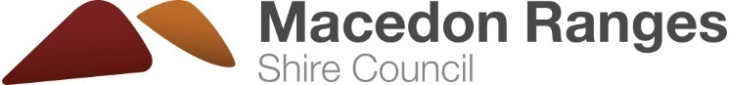
Answer sheet: Oops! That’s the wrong bin
Putting the wrong item in the wrong bin is called contamination.
Did you know this can result in whole truckloads of recycling ending up in landfill? By sorting our waste in to the right bins, together we can recycle more and waste less!
Some of these items have been put in the wrong bin.
Activity: Can you cross out the items that have been sorted incorrectly?

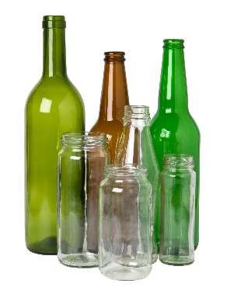
Let’s start with the glass-only bin. Which items do not belong in here?
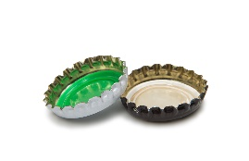
Example:
✘

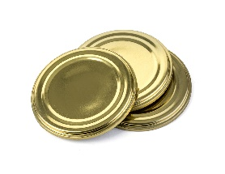
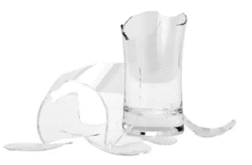
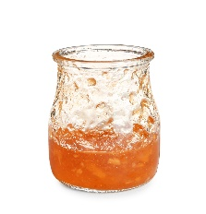
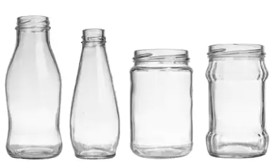
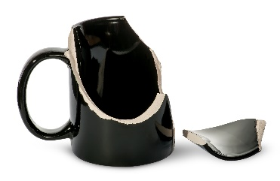
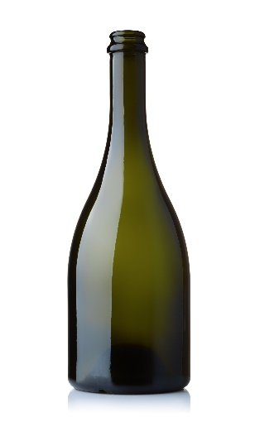
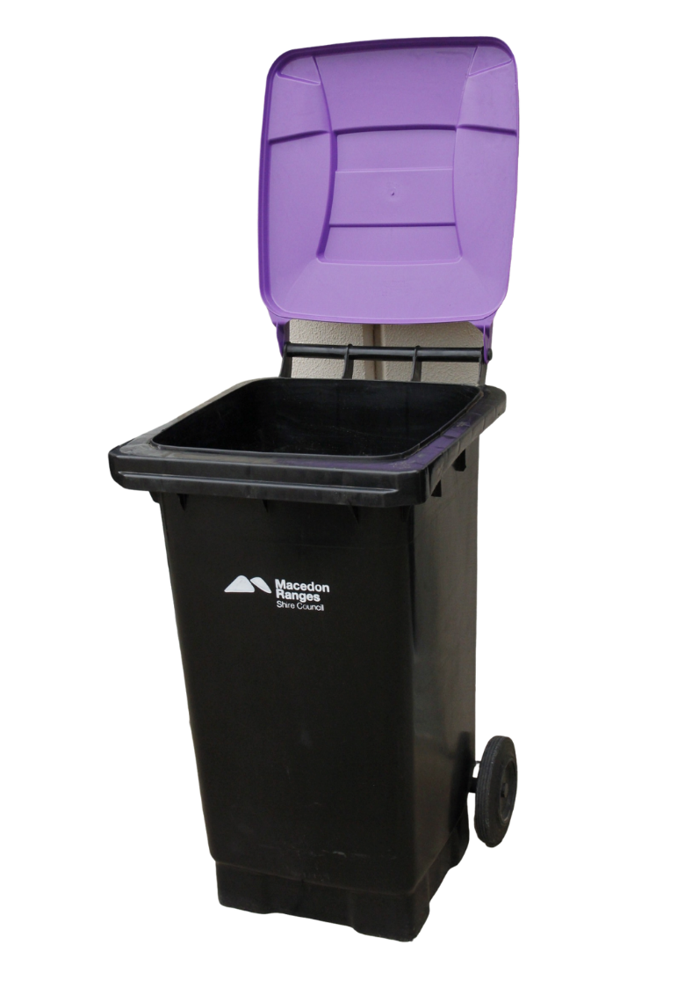
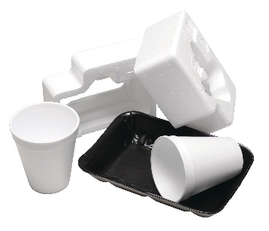
Which items do not belong in your recycling bin?
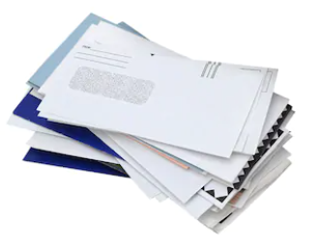
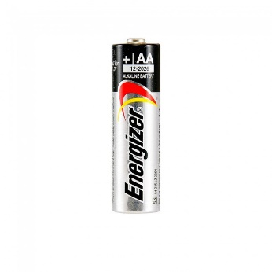
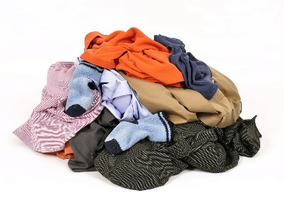
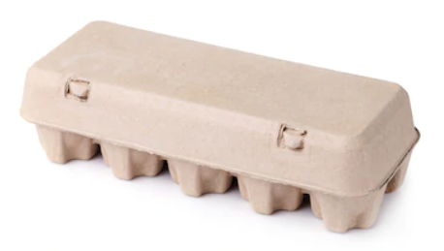
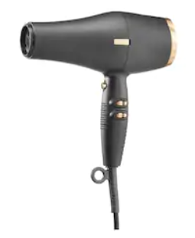
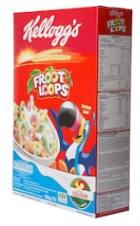
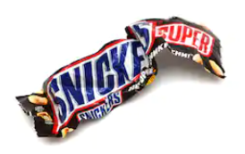
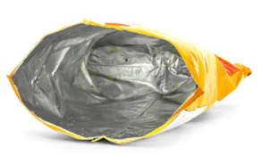
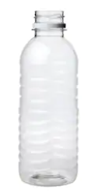
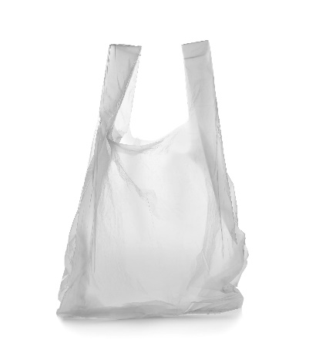
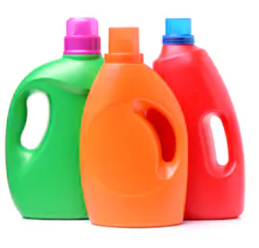
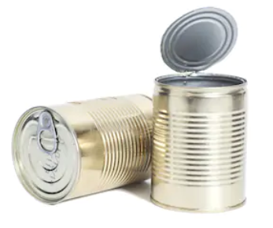
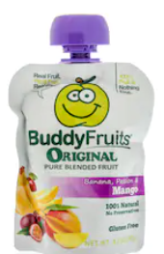
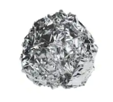
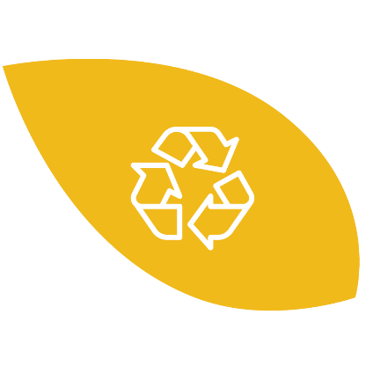
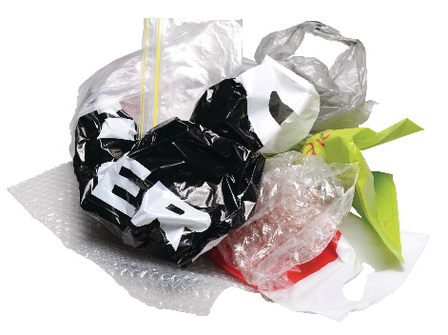
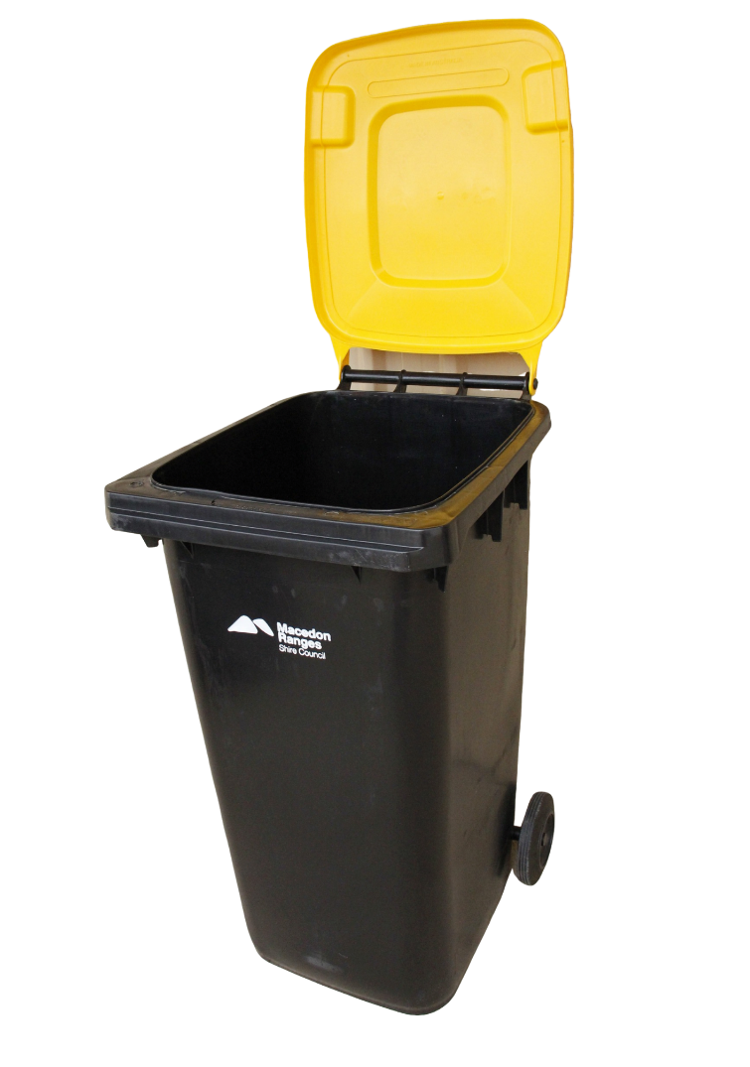
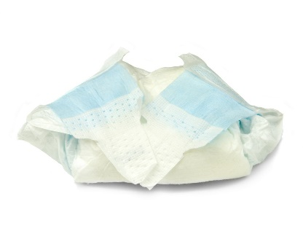
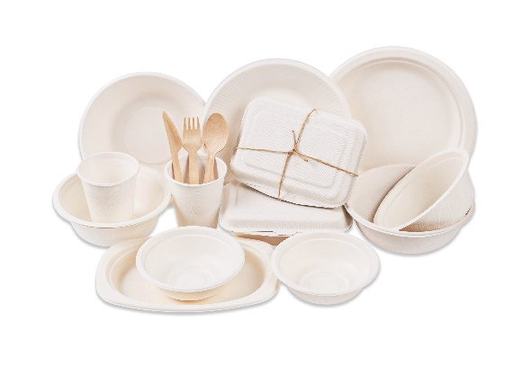
Which items do not belong in your FOGO (Food Organics Garden Organics) bin? Handy hint: If it used to live or grow, then it’s FOGO!
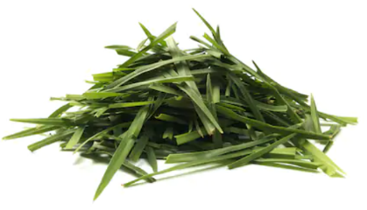
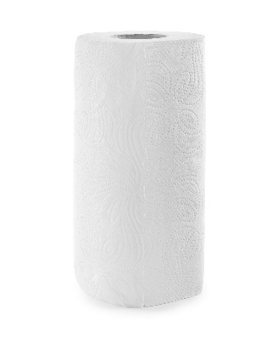
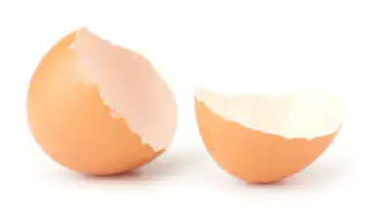
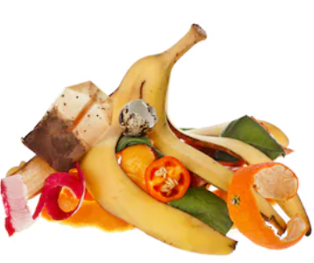
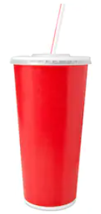
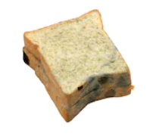
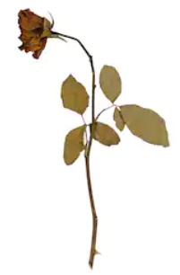
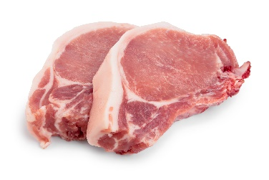
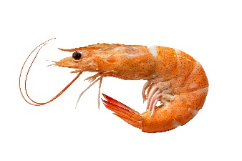
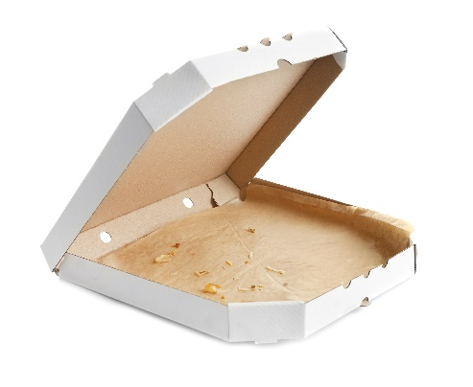
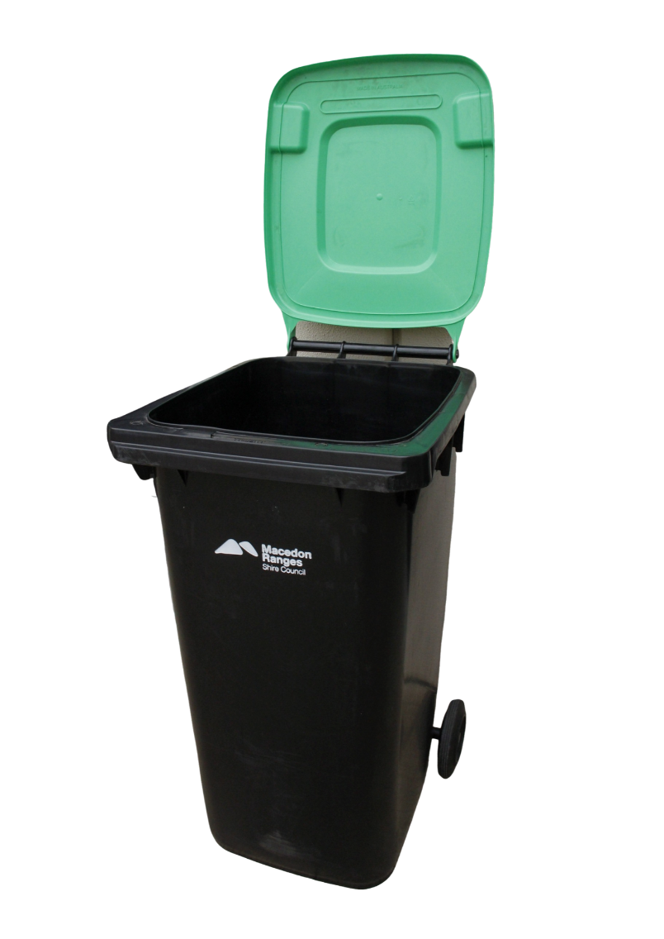
Which items do not belong in your general waste bin?
Remember: Using your general waste bin should be a last resort. Check first if an item can be recycled or composted.
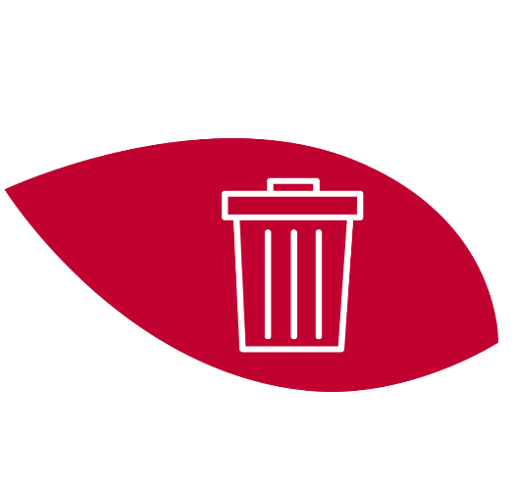
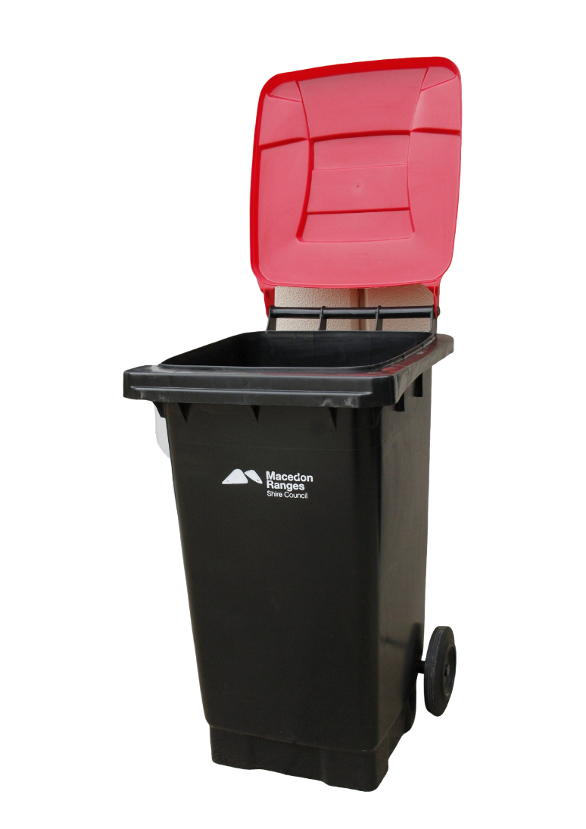
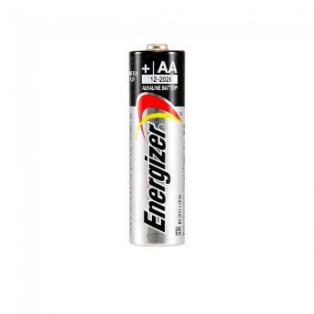
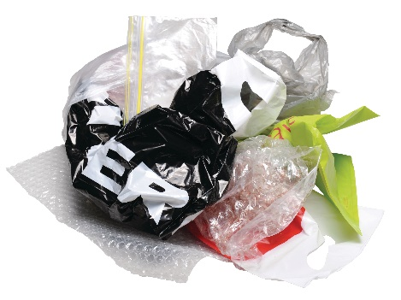

Extra notes:

Glass-only bin
- Glass jars and bottles only. Broken bottles and jars are okay.
- No lids, metal lids can go in recycling bin.
- Empty all food from jars and bottles before placing in bin.
- No ceramics, drinking glassware or non-recyclable glass eg. Pyrex and perfume bottles.
- Labels on jars and bottles are okay.
Recycling bin
- Accepted materials: Paper, cardboard, rigid plastics, household aluminium and steel items.
- All soft plastics including plastic bags, yoghurt pouches, chip and chocolate wrappers cannot be recycled through the kerbside service. Soft plastics can get stuck in machinery and all need to go in general waste bin or specialist recycling program.
- E-waste (Any electronic waste with a cord, battery or plug) must not go in any kerbside bin and taken to a resource recovery facility (transfer station) for recycling.
- Old clothing, shoes and textiles must not go into the recycling bin. Donate if still in good condition, if damaged place in general waste bin.
FOGO bin
- Materials that are not certified compostable such as nappies, plastic bags, food packaging must not be placed in the FOGO bin, as they will not break down in the composting process.

General waste bin
- Only materials that cannot be recycled or composted should be placed in this bin.
- E-waste (Any electronic waste with a cord, battery or plug) must not go in any kerbside bin and taken to a resource recovery facility for recycling.
- Soft plastics are accepted but if you want to reduce your waste and recycle more, you can take your soft plastics to a resource recovery facility.

For more information on waste and recycling in Macedon Ranges Shire, visit our website mrsc.vic.gov.au/bins or contact our customer service team on 5422 0333.

