Answer sheet: Waste warrior word search
Can you find all of the words in the list? Circle each letter of the words you find, the leftover letters will leave you with the secret sentence.
Hint: Words can be found horizontal, vertical, diagonal, forwards and backwards.

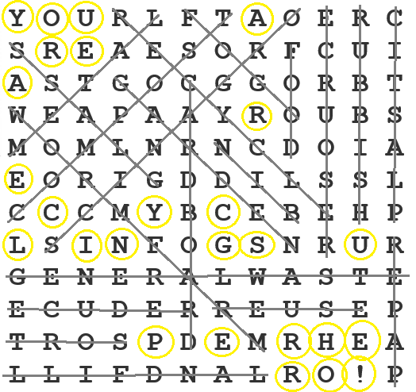
Y O U R L F T A O E R C
S R E A E S O R F C U I
A S T G O C G G O R B T
W E A P A A Y R O U B S
M O M L N R N C D O I A
E O R I G D D I L S S L
C C C M Y B C E B E H P
L S I N F O G S N R U R
G E N E R A L W A S T E
E C U D E R R E U S E P
T R O S P D E M R H E A
L L I F D N A L R O ! P

BIN  CARDBOARD  COMPOST  FOGO  FOOD  GARDEN  GENERAL WASTE  GLASS  LANDFILL  METAL | ORGANICS  PAPER  PLASTIC  RECYCLE  REDUCE  RESOURCE  REUSE  RUBBISH  SORT  WORM FARM

Secret sentence:
Hint: There are 26 letters and characters left over
YOU ARE A RECYCLING SUPERHERO!

