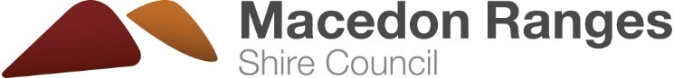
Answer sheet: Fill in the blank

Fill in the blank with a word from the word bank below.
purple  general waste  recycled  red | sorting  planet  FOGO  yellow

1. By sorting our waste in to the right bins we can ensure everything gets recycled correctly.
2. Items made from paper, cardboard, metal and rigid plastics all go in to the recycling bin with the yellow lid.
3. All organic materials such as food scraps and garden waste go into the FOGO (Food Organics Garden Organics) bin with the lime green lid.
4. Glass needs to be sorted separate to other items to get recycled. We can put glass in the bin with the purple lid.
5. When an item gets recycled it gets turned into something new! For example a cardboard box into a cereal box or vegetable peelings into compost.

6. Any item that can't be recycled or composted goes in the general waste bin with the red or dark green lid.

7. Everything that goes in the general waste bin ends up in landfill, a big hole in the ground!

8. We can help the planet by recycling more and throwing away less rubbish.

For more information on waste and recycling in Macedon Ranges Shire, visit our website mrsc.vic.gov.au/bins or contact our customer service team on 5422 0333.

