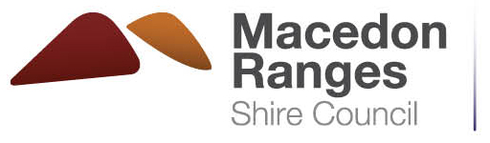 | Upon payment this form constitutes a Tax Invoice.
ABN 42 686 389 537 – PO BOX 151, KYNETON VIC 3444
T 03 5422 0333 – F 03 5422 3623 – mrsc@mrsc.vic.gov.au – www.mrsc.vic.gov.au
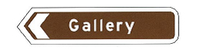
Tourist Signing Application Fee $104
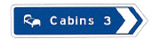
This fee applies for a Tourist Accommodation signing application or Tourist Attraction signing application. Example:

All applications lodged incur an administrative fee for processing. No action will be taken until payment is processed and the application is received complete with all supporting documentation.
Contact name:
Business name:
Address:
Email: |  | Phone: |  | Mobile:
Signature
Your name:
Signature: |  | Date:
Privacy
The collection and handling of personal and health information is in accordance with Council’s Privacy Policy which is displayed on Council’s website, mrsc.vic.gov.au/privacy and available for inspection at or collection from Council’s customer service centres.

Office Use Only (account number 10-7630-8587-40228)
 | Receipt no: |  | Date:
 | Received by: |  | Paid: | $
Payment options
- In person: present this form and payment (cash, cheque/money order, EFTPOS or credit card) at one of our Service Centres.
- By Post: Mail this form and payment to PO BOX 151, KYNETON VIC 3444.
Credit card payment authorisation
 | Mastercard |  |  |  |  | Visa
 | I authorise you to charge the following amount to my credit card: $
Name on card:
Credit card number:
Expiry date (xx/xx): |  | Signature:

