Roadside and Footpath Trading - New Permit Application

Proprietor’s Details
Name:
Postal Address:
Phone: | Email:
Business Details:
Trading Name:
Property Address:
Contact Person:
Phone: | Email:
Days/hours of operation:
I wish to apply for a new Roadside and Footpath Trading Permit for *Up to and incl. 12 month permit duration or *Over 12 months permit duration - maximum to 24 months to include the following items:

Calculate fee to be paid based on the period you have chosen for your business** | *Up to and incl. 12 month permit duration | *Over 12 months permit duration - maximum 24 months | **Fee based on option period chosen
Moveable advertising signs - max. of 2 items permitted | $49.00 | $86.00
Moveable flags | $49.00 | $86.00
Outdoor Dining tables and seats - up to 4 | $185.00 | $324.00
Outdoor Dining tables and seats - between 5-8 | $276.00 | $483.00
Outdoor Dining tables and seats - 9 or more | $384.00 | $672.00
Display tables, shelves, racks etc - Up to 4 | $98.00 | $172.00
Display tables, shelves, racks etc - between 5-8 | $147.00 | $257.00
Display tables, shelves, racks etc - 9 or more | $197.00 | $345.00
Ancillary Furniture (Umbrella, heaters, barrier screens, plants) | $63.00 | $110.00
Real Estate Signs – Annual price per franchise | $226.00 | $395.00
TOTAL PAYMENT DUE
If you wish to be contacted about other alternative items not listed above, please tick here ☐
What days of the week and hours you are applying to place furniture items out:
If applying for Outdoor Dining, do you plan to serve alcohol at these tables? |  | YES | NO
If applying for Outdoor Dining, do you plan to allow BYO alcohol at these tables? |  | YES | NO
If you answered yes to above, do you currently have a liquor licence? |  | YES | NO
What type of liquor licence do you have or will you be applying for?
Payment options
By Mail: cheque or money order – payable to Macedon Ranges Shire Council, or complete Credit Card payment authorisation below. Mail this form and payment to PO BOX 151 KYNETON VIC 3444.
Credit Card Payment Authorisation |  |  |  |  |  |  | Mastercard |  |  |  |  |  |  |  | Visa
I authorise you to charge the following amount to my credit card: |  |  |  |  |  |  |  |  |  |  |  |  |  |  | $
Name on Card
Credit Card Number
Expiry Date (xx/xx): |  |  |  |  |  | Signature:
Footpath Trading Plan
A footpath trading plan forms part of your use of the public space agreement which MUST be completed and attached to your application.
It must include a detailed plan/sketch of the area indicating the measurements of the Pedestrian Zone, Trading Zone and Kerb Zone. An example has been provided below should you need it.
Kerb Zone and Pedestrian Zone are fixed areas as indicated in the example below and cannot be changed.
The type and dimensions of furniture, goods or other items must be included. Include all items you are applying for on this form and ensure that all items you have indicated are included on your sketch. Please ensure you clearly indicate the entire proposed Trading Zone by marking a boundary line on your plan.
Application Checklist – please tick all that apply:
I have attached a copy of a current Public Liability Insurance Certificate of Currency for a minimum of $10 million cover for the items and activities proposed on Council land together with details of the exclusions under the policy.
I have attached a copy of existing Liquor Licence (if applicable).
I have attached written consent of relevant neighbouring premises (if applicable).
I have attached a Footpath Trading Plan that fully complies with the Roadside and Footpath Trading Policy.

Privacy Statement
Macedon Ranges Shire Council is committed to protecting your privacy. The personal information you provide on this form is being collected for the primary purpose of assessing your permit application. Where required, your name, address, contact details and any other personal information contained in copies of documents submitted in support of your application, will be provided to Macedon Ranges Shire Council staff to enable them to process your application. Your personal information will not be disclosed to any external party without your consent, unless required or authorised by law. If you wish to gain access to, or alter any personal information you have supplied on this application, please contact us on (03) 5422 0333 or via email to mrsc@mrsc.vic.gov.au You can access Council’s Privacy Policy at mrsc.vic.gov.au

Declaration
I have read and understand Council's Roadside and Footpath Trading Policy and agree to comply with this policy and to fully abide by all conditions of my permit. I understand the issue of this permit is at the discretion of Council and that at any time Council may cancel or amend my permit in accordance with Part 2 of the Community Local Law 2023**.
Name:______________________________  Signature:___________________________ | Date:________
A Local Laws Officer will be in contact regarding the assessment of your application. We are endeavouring to process applications as expediently as possible. However, more complex applications may take longer to assess and approve.
Example Footpath Trading Plan
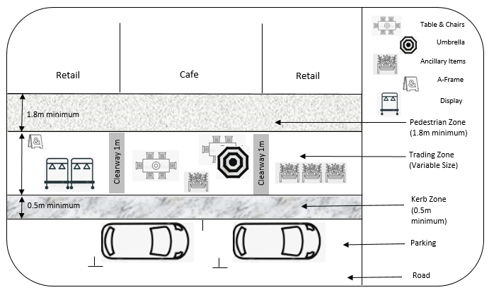
Tables & Seats

