ABN 42 686 389 537 – PO BOX 151, KYNETON VIC 3444
T 03 5422 0333 – F 03 5422 3623 – mrsc@mrsc.vic.gov.au – www.mrsc.vic.gov.au
Roadside and Footpath Trading
Application to Temporarily Amend Current Permit due to COVID-19

Please quote your current permit number  Proprietor’s Details |  | STREET / ___ _________
Name:
Postal Address:
Phone: | Email:
Business Details:
Trading Name:
Property Address:
Phone: | Email:
Days/hours of operation:
Contact Person:
Phone: | Email:

I wish to apply to amend my current Roadside and Footpath Trading Permit to include all the following items. Please include items already on your permit:
 | QTY | TOTAL FEE
- Total moveable / non-fixed advertising signs - maximum 2 |  | $0
- Total moveable / non-fixed flags |  | $0
- Total outdoor dining tables and seats sets |  | $0
- Total display tables, shelves, racks etc |  | $0
- Total ancillary furniture (umbrellas, heaters, barrier screens, plants) |  | $0
If you wish to be contacted about other alternative items not listed above, please tick here ☐
What days of the week and hours you are applying to place furniture items out:
If applying for Outdoor Dining, do you plan to serve alcohol at these tables? |  | YES | NO
If applying for Outdoor Dining, do you plan to allow BYO alcohol at these tables? |  | YES | NO
If you answered yes to above, do you currently have a liquor licence? |  | YES | NO
What type of liquor licence do you have or will you be applying for?
Are you applying to place items in front of neighbouring premises? |  | *YES | NO
*If yes, you must supply written consent from the owner/occupier of the neighbouring premises with your application and ensure your Public Liability Insurance covers this area. Please use the template provided. Officers will verify their consent as part of the approval process.
Footpath Trading Plan
A footpath trading plan forms part of your use of the public space agreement and MUST be completed with your amendment application.
It must include a detailed plan/sketch of the area indicating the measurements of the Pedestrian Zone, Trading Zone and Kerb Zone. A template has been provided with this application form which you may use to prepare your plan, should you need it.
Kerb Zone and Pedestrian Zone are fixed areas as indicated in the example below and cannot be changed.
The type and dimensions of furniture, goods or other items must be included. Include all items on your current permit, as well as the additional items you are applying for on this form and ensure that all additional items you have indicated above are included on your sketch. Please ensure you clearly indicate the entire proposed Trading Zone by marking a boundary line on your plan.
Example Footpath Trading Plan
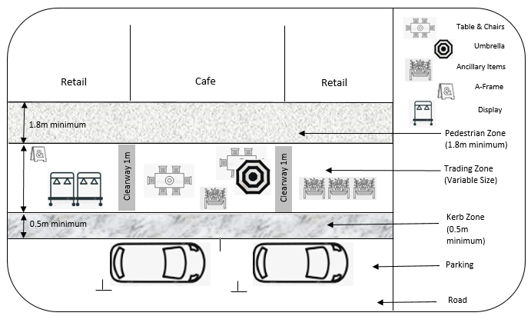
Tables & Seats
Application Checklist – please tick all that apply:
I have attached a copy of a current Public Liability Insurance Certificate of Currency for a minimum of $10 million cover for the items and activities proposed on Council land together with details of the exclusions under the policy.
I have attached a copy of existing Liquor Licence (if applicable).
I have attached written consent of relevant neighbouring premises (if applicable).
I have attached a Footpath Trading Plan fully complies with the Roadside and Footpath Trading Policy.
I am applying for temporary items for COVID 19 trading outside of the Roadside and Footpath Trading Policy*.
*A Local Laws Officer will be in contact regarding the assessment of your application. We are endeavouring to process applications as expediently as possible. However, more complex applications may take longer to assess and approve.

Privacy Statement
Macedon Ranges Shire Council is committed to protecting your privacy. The personal information you provide on this form is being collected for the primary purpose of assessing your permit application. Where required, your name, address, contact details and any other personal information contained in copies of documents submitted in support of your application, will be provided to Macedon Ranges Shire Council staff to enable them to process your application. Your personal information will not be disclosed to any external party without your consent, unless required or authorised by law. If you wish to gain access to, or alter any personal information you have supplied on this application, please contact us on (03) 5422 0333 or via email to mrsc@mrsc.vic.gov.au You can access Council’s Privacy Policy at mrsc.vic.gov.au
Declaration
I have read and understand Council's Roadside and Footpath Trading Policy and agree to comply with this policy (except for COVID-19 allowances set out in my permit) and to fully abide by all conditions of my permit. I understand the issue of this permit is at the discretion of Council and that at any time Council may cancel or amend my permit in accordance with Clause 54 of the Local Law**. I understand that any allowances or conditions granted in relation to COVID-19 restrictions are temporary and will be voided on 1 July 2021 or sooner at the discretion of Council.
Name:______________________________  Signature:___________________________ | Date:________

**General Purposes and Amenity Local Law No. 10 of 2013

