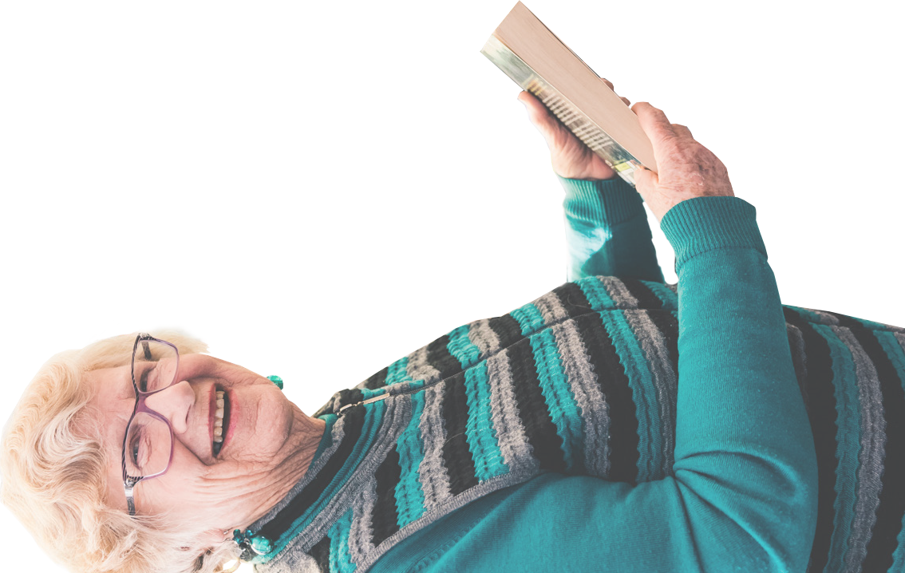
POSITIVE AGEING PLAN
2020-2025
Macedon
Ranges
Shire Council
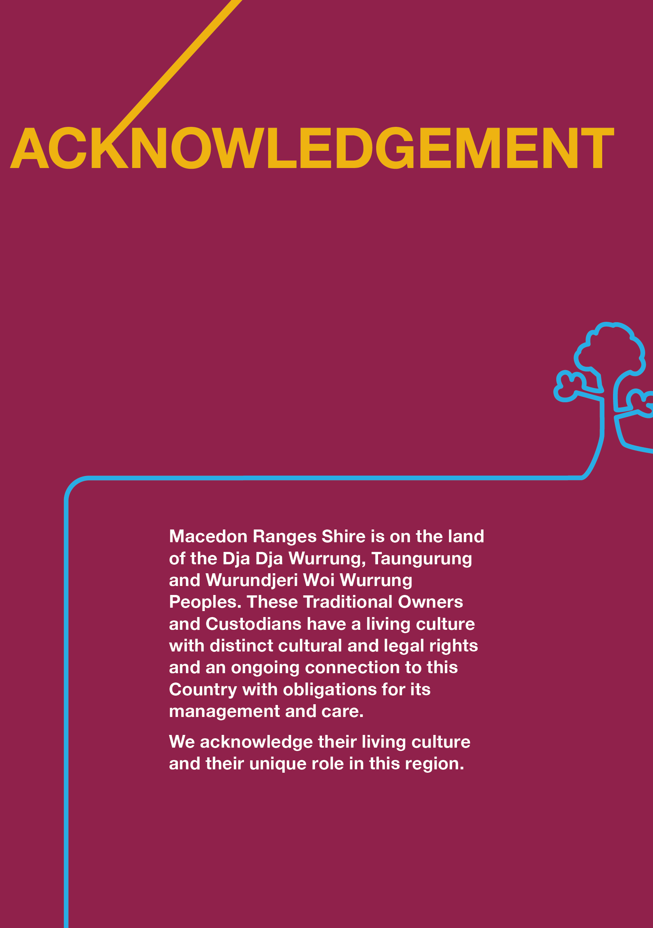

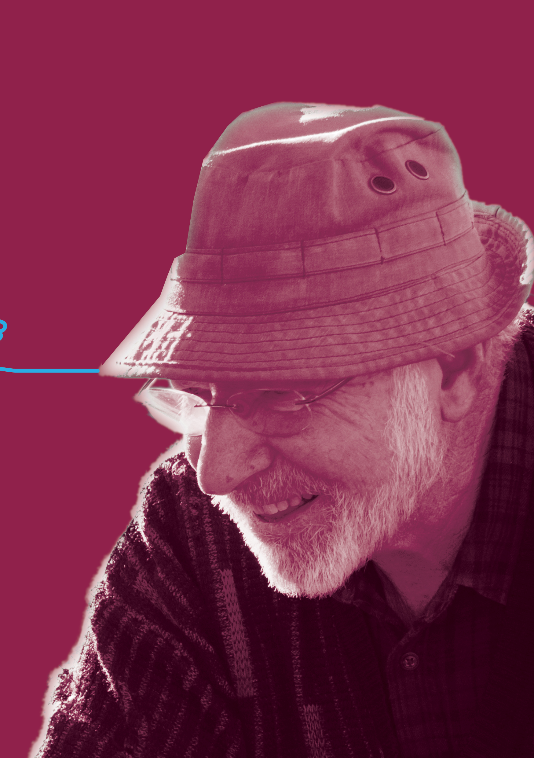
3

Thank you to all who have contributed to the community consultation and the development of this plan. We’d like to acknowledge our valued community members, volunteers and staff, local community groups and organisations, whose input has informed the creation of PARTICIPATE.
A summary of this report has been created and can be accessed via our website mrsc.vic.gov.au/PARTICIPATE
Contents

Acknowledgements ……………………………..……………………………………………...…2
The story of PARTICIPATE………………………………………………...…………………..…6
PARTICIPATE – A Foreword from the Mayor…………………………………………......……8
PARTICPATE – What we did …………………………………………..……………………......9
PARTICIPATE – Why we did…………………………………………………….…………...…10
PARTICIPATE – Situation ………………………………………………………………………14
Older people in the Macedon Ranges………………………………….…………..…..15
The current situation ……………………………………………………….….…………16
Diversity in the older population ……………………………………………………..…16
Older people and local government ………………………………………….………...17
Victorian Government ……………………………………………………………..…….17
Australian Government ……………………………………………………………….…18
PARTICIPATE – The How……………………………………………………..........................19
PARTICIPATE – We Found ………………….…………………………………………………21
The Priority Action Areas………………………………………………………….....................30
The Action Plan ……………………………………………………………...…………………...34
PARTICIATE – How we will implement………………………………………………………...53
PARTICIPATE – How we will evaluate……………………………………….………………..53
Appendix 1 – Age-friendly Victoria Declaration ……………………………………………….56
Appendix 2 – Survey Questions and findings …………………………………………….…..57
Appendix 3 – We Found: Additional supporting data from consultation………….………...58
Appendix 4 – Qualitative locations and audience reached…………………..………………64
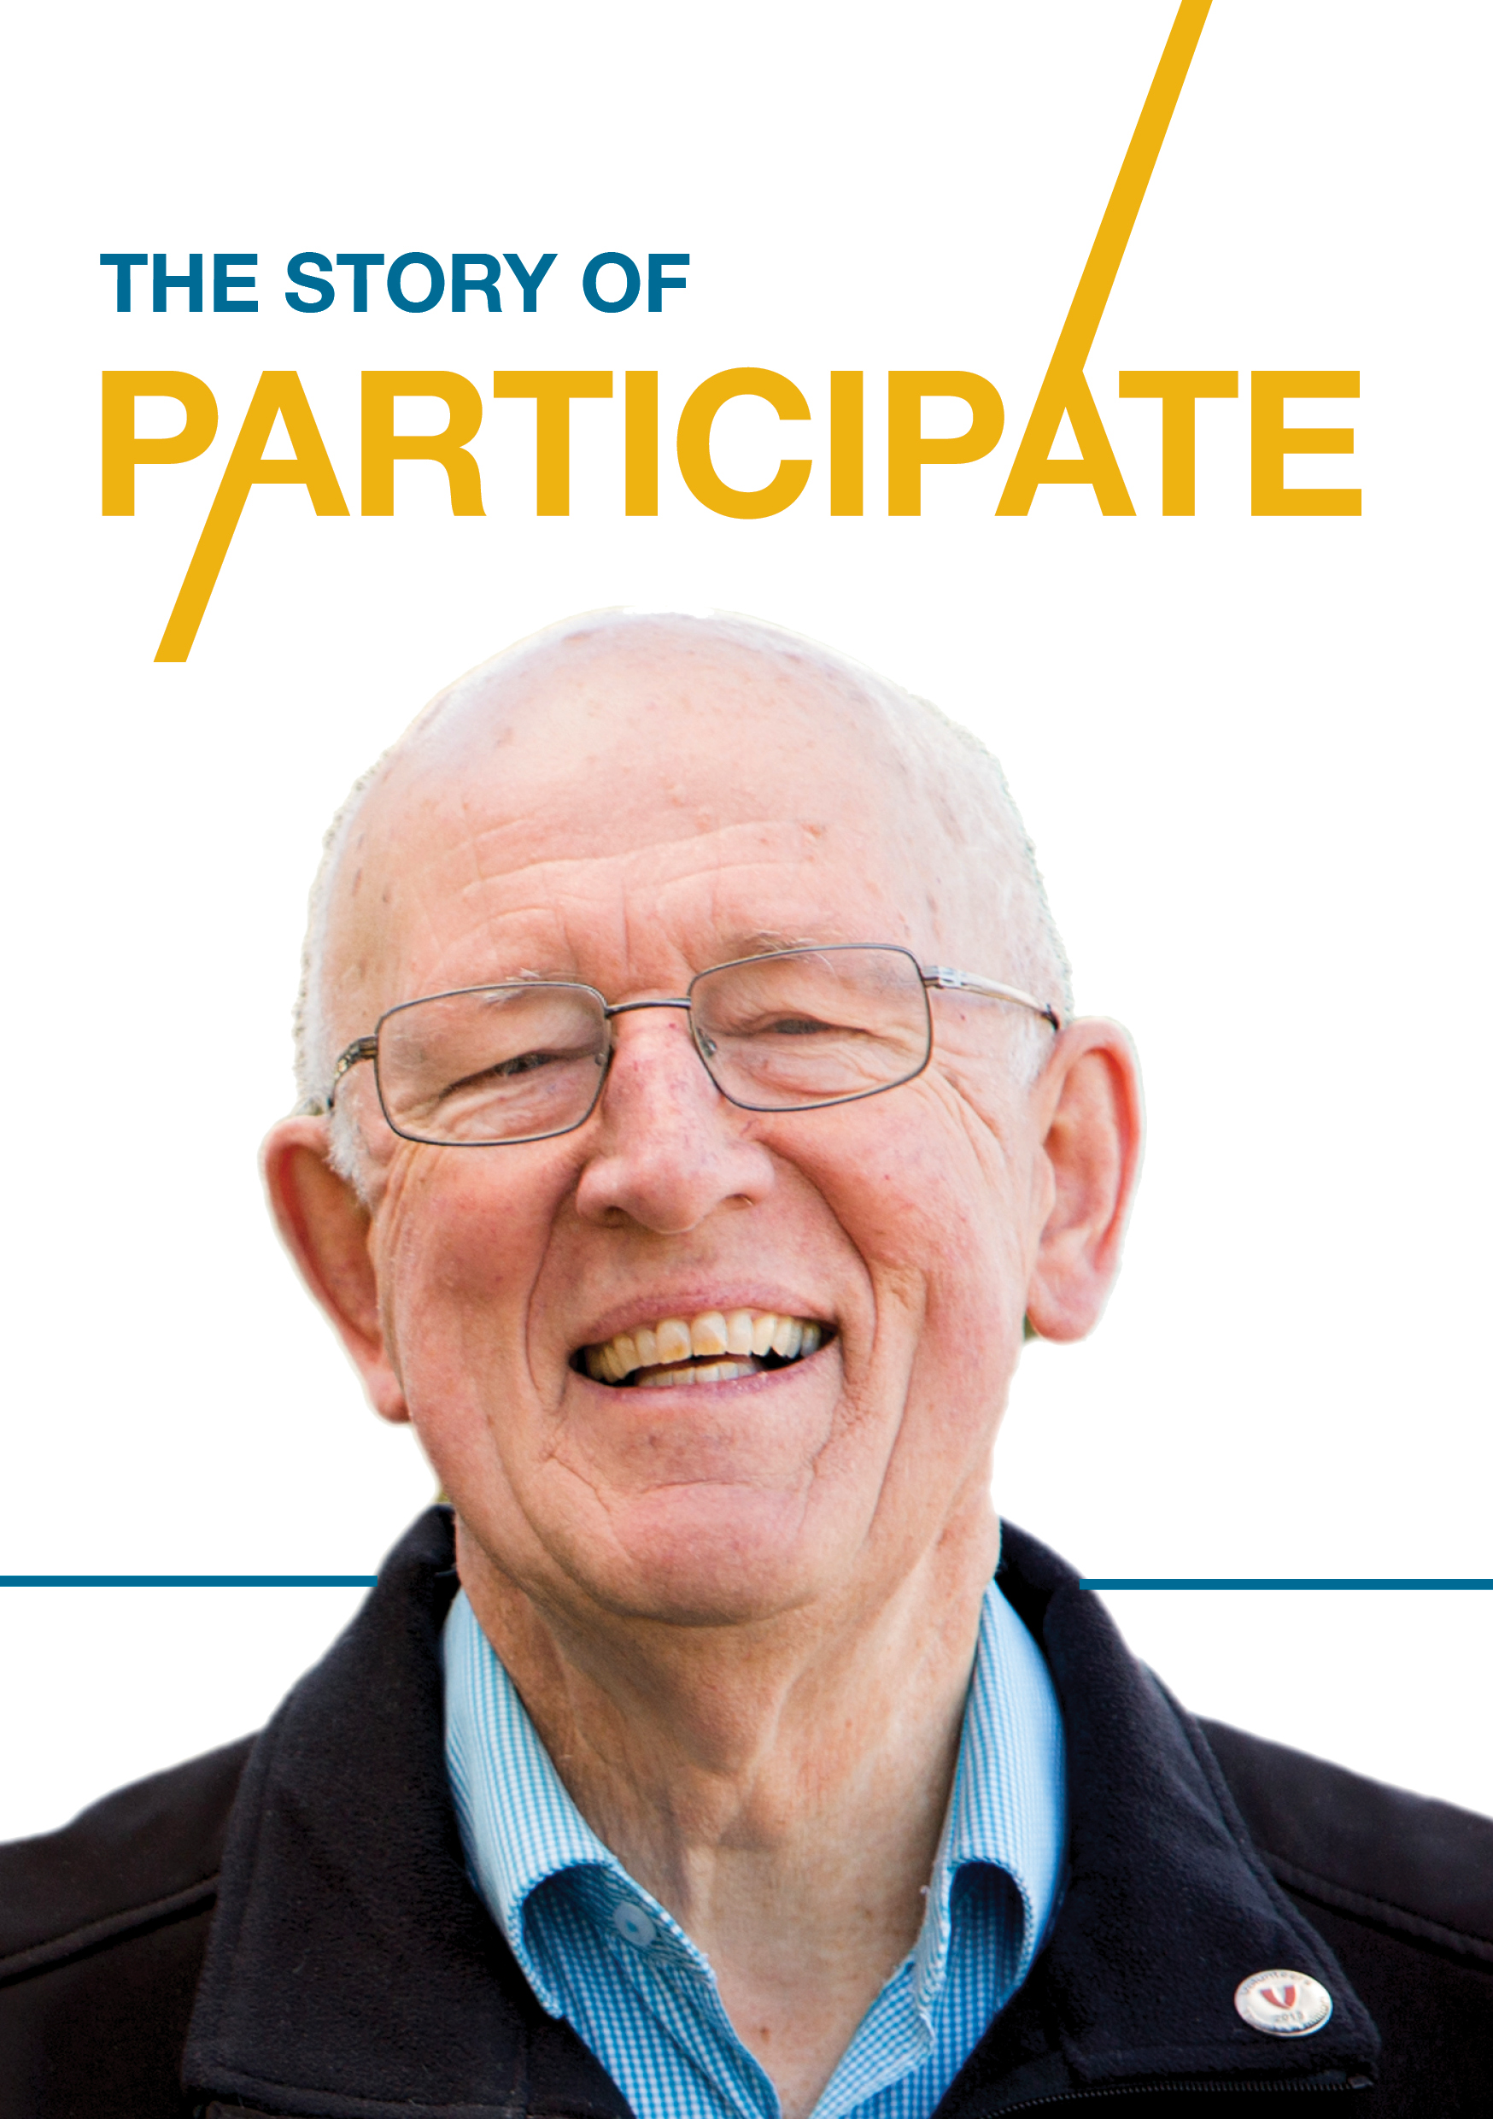
6
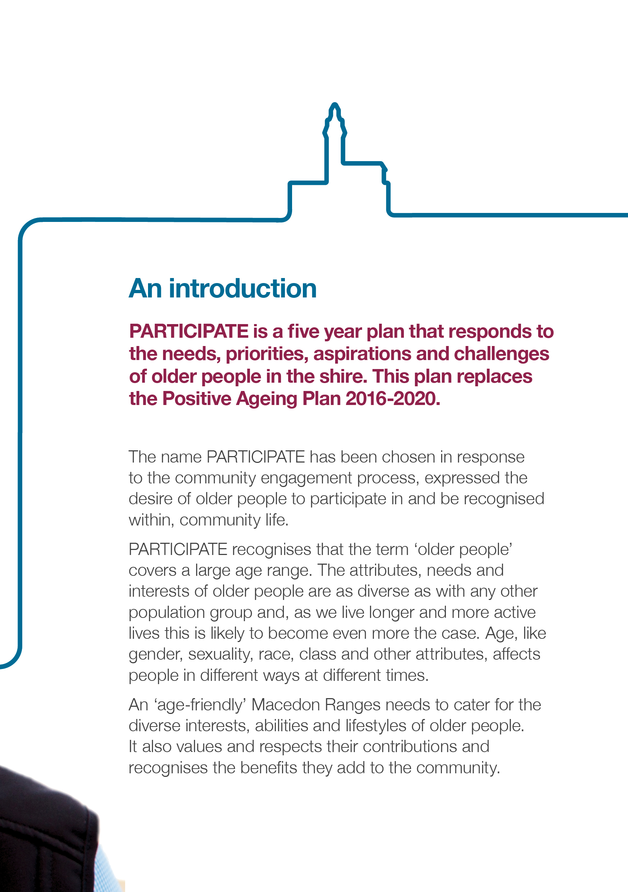
7
PARTICIPATE – A foreword from the Mayor
The concept of ageing is changing. Demographics show that the proportion of our population over 65 years of age is increasing, and older people today have different expectations, needs, interests and lifestyles to previous generations.
Older people come from diverse social and cultural backgrounds and their health and support needs vary greatly. People are generally living longer and enjoying better health, allowing them to work longer and actively participate in and contribute to their community.
The forecast increase in the number of older residents in the shire is likely to result in an increased demand for services and support.
Improvements to local infrastructure such as community and cultural facilities, footpaths, trails and public / open spaces that accommodate the needs of people of all ages and abilities will also need to be an important planning consideration.
PARTICIPATE is Macedon Ranges Shire Council’s Positive Ageing Plan 2020–2025. The plan will guide our activities as we cultivate an age-friendly community where older people feel valued, safe and connected. This plan replaces the Positive Ageing Plan 2016-2020.
PARTICIPATE was developed through community consultation and engagement with older residents and service providers. A range of priority action areas were identified to respond to needs for now and into the future.
The priority action areas are as follows:
- Older people stay socially connected and active
- Older people live well in the community
- Older people’s needs are recognised in infrastructure, housing and the built environment
- Older people are respected and valued by the community.
In implementing PARTICIPATE, Macedon Ranges Shire Council will take actions that are consistent with its role as a provider of services, an advocate, a facilitator and planner, to improve the lives of older members of our community.

Cr Janet Pearce
Mayor

PARTICIPATE - what we did
Council is committed to meaningful consultation with all members of the community and recognises a strong community plan should reflect the community’s needs, concerns, priorities and aspirations. We sought the views of a range of stakeholders, primarily older people, but also community groups, service providers and other community members in the shire.
The consultation entailed a range of innovative engagement activities, including place-based community pop-ups at key events and activities in the shire, meetings with targeted stakeholders and community groups, and a survey available online via Council’s website and in hard copy.
These activities attempted to capture people’s views on four main questions:
- What three things are the most important to improve in the Macedon Ranges to ensure older people can live a safe, healthy, connected and happy life?
- What challenges do you think older people have living in Macedon Ranges?
- What are your ideas for making Macedon Ranges an age-friendly shire?
- What do you like about being an older person in the Macedon Ranges?

We also looked at the issues that we know will shape the funding and supply of services for older people. The aged care sector is undergoing significant reform as the Australian Government plans for an ageing population. There are many changes that Council and others will need to consider in the period 2020-2025.

PARTICIPATE - why we did it
Setting out Council’s commitment to an age-friendly Macedon Ranges
The previous Council Plan (2013-2017) identified working towards membership of the World Health Organisation Global Network of Age-friendly Communities (the Network) as a Year 1 Action, and this was achieved in 2015. Network communities are of different sizes and located all over the world. Their efforts to become more age-friendly take place within diverse cultural and socio-economic contexts.
As a member of the Network, Council shares the desire and commitment to promote healthy and active ageing and a good quality of life for their older residents. Appropriate consultation and engagement with older residents is considered an integral element of all age-friendly communities. At the time of this plan being developed Council is still an active member of the Network.
In 2017, Council reaffirmed its commitment to an age-friendly Macedon Ranges, becoming a signatory to the Age-friendly Victoria Declaration, an initiative of the Victorian Government and Municipal Association of Victoria (Appendix 2).
The actions identified in Participate require Council departments to work together and as such are linked to several Macedon Ranges Shire Council plans and strategies including:
- Macedon Ranges Shire Council Plan 2017–2027 (the Council Plan)
- Municipal Health and Wellbeing Plan (in the Council Plan)
- Disability Action Plan (in the Council Plan)
- Arts and Culture Strategy 2018-2028
- Municipal Emergency Management Plan
- Sport and Active Recreation Strategy 2018-2028
- Elevate Youth Strategy 2018-2028
- Walking and Cycling Strategy 2014 (-2024)
- Shire-wide Footpath Plan
- Asset Management Plan – Footpaths
- Asset Management Plan – Open Spaces
- Climate Change Action Plan 2017
Our work in the development of this plan has been guided by the vision, themes and priority areas outlined in the current Council Plan (2017-2027).
A 2019-2020 action under the priority area of Promote Health and Wellbeing is to ‘develop a Positive Ageing Plan to prioritise need, attract funding and guide allocation of resources to services and programs’. Participate delivers this action.

Council Plan Priority Area | Ageing context
Promote health and wellbeing | - We are living longer and more active lives and have differing expectations but generally, older people seek purposeful, meaningful participation and the opportunity to contribute to their community.  - Ageism and ageist stereotypes reduce older people’s opportunities to participate, contributing to mental and physical health issues and increased risk of elder abuse.  - Rates of elder abuse are difficult to estimate due to under-reporting, however it is estimated that in Australia, between 2-6 per cent of people aged over 65 year’s experience elder abuse, financial abuse being the most common form of abuse.  - As we age, we are increasingly vulnerable to physical and mental health conditions affecting our capacity to function independently. In 2016, 12.2 per cent of Macedon Ranges residents aged 65 years and older needed assistance with daily activities due to severe or profound disability (compared to 4.1 per cent across all Macedon Ranges residents).  - There were approximately 759 people with dementia in 2017 in the shire. By 2050 this is expected to increase to approximately 5,787 people. This is the fifth highest projected growth rate of all Victoria’s 79 Local Government Areas.  - Older people often experience significant losses and risks, including loss of work-related identity, death of a partner, siblings and friends, reduced contact with family and friends, reduced/limited income, reduced physical function and fewer opportunities for social contact.
Promote the natural environment | - Older people often have a good understanding of and strong commitment to the natural environment. They are well placed and want to contribute to preservation of the natural environment for future generations.  - Older people are particularly vulnerable to environmental impacts such as extreme weather events due to climate change. For example, during the 2009 heatwave in Victoria (Black Saturday bushfires), in those aged 75 years and over there were 248 excess deaths, representing a 64 per cent increase over the preceding five years. In those aged 65-74 years there were 46 excess deaths, representing a 46 percent increase (compared with the average over the proceeding five years). Mortality during heatwaves can be difficult to measure, as deaths tend to occur from exacerbations of chronic medical conditions as well as direct heat related illness, particularly in the frail and elderly.  - For people to remain at home and living within their community as their needs change, the environment in which we live needs to be conducive to older people’s needs. Open space planning needs to consider older people’s needs such as cleanliness and feeling safe, accessibility including safe bike tracks, footpaths and pedestrian crossings, adequate toilets and seating.
Improve the built environment | - Older people represent 16.5 per cent of our community, increasing to 19.7 per cent by 2026. They face specific challenges in the built environment in terms of distances to walk, risks at road crossings, steps, uneven surfaces and unclear signage.  - An increasing commitment to universal design and consulting with older people is required to ensure that these factors are not barriers to their active participation in their community.  - The need for diverse housing options is essential to the safety and wellbeing of older people. This includes consideration of access, affordability, design, ability to modify and maintain, access to services as well as connections to community and family.
Enhance the social and economic environment | - In 2016, Macedon Ranges had a higher than state average employment participation rate for residents aged over 65 (employed part time or full time) comprising 5.9 per cent of the population, compared to the Victorian average of 4.2 per cent.  - Older people contribute economically as workers, business owners, consumers, carers and volunteers but face increasing barriers to participation in the community and in maintaining their personal networks, particularly if they don’t drive and/or have limited mobility.  - In 2014, 34.6 per cent of Australians aged 65-74 years, 25.5 per cent of those aged 75 – 84 years and 18.9 per cent of those aged 85 and over had volunteered in the last 12 months  - In 2016, 26 per cent of the Macedon Ranges population aged 15+ reported doing some form of voluntary work (a slightly higher proportion than for regional Victoria at 24.3 percent). Many of these volunteers are older residents.  - In 2018, almost all older Australians (living in households) had participated in social activities at home (97.4 per cent) or outside their home (94.4 per cent) in the previous 3 months.  - Low income and limited assets increase some older people’s vulnerability to isolation, poor nutrition and unsafe environments.  - In the era of technology and the focus on delivery of information and services online, older people who cannot or choose not to access the technology and/or do not have access to support are often significantly disadvantaged.
Deliver strong and reliable government | - Participate has been developed after consultation with a wide range of older people and those who support them. The issues, priorities and values expressed by older people have been taken into account in developing Participate.  - Council’s Community Consultation Framework was used to complete the consultation for the development of this plan adhering to best practice guidelines.  - PARTICIPATE will inform Council in relation to the implications of decisions and resource allocation for older people.  - PARTICIPATE will be supported by the development of annual action plans that will report to Executive on a quarterly basis and to Council annually. Where additional resources are required these will be sourced through grants and/or the annual budget process.
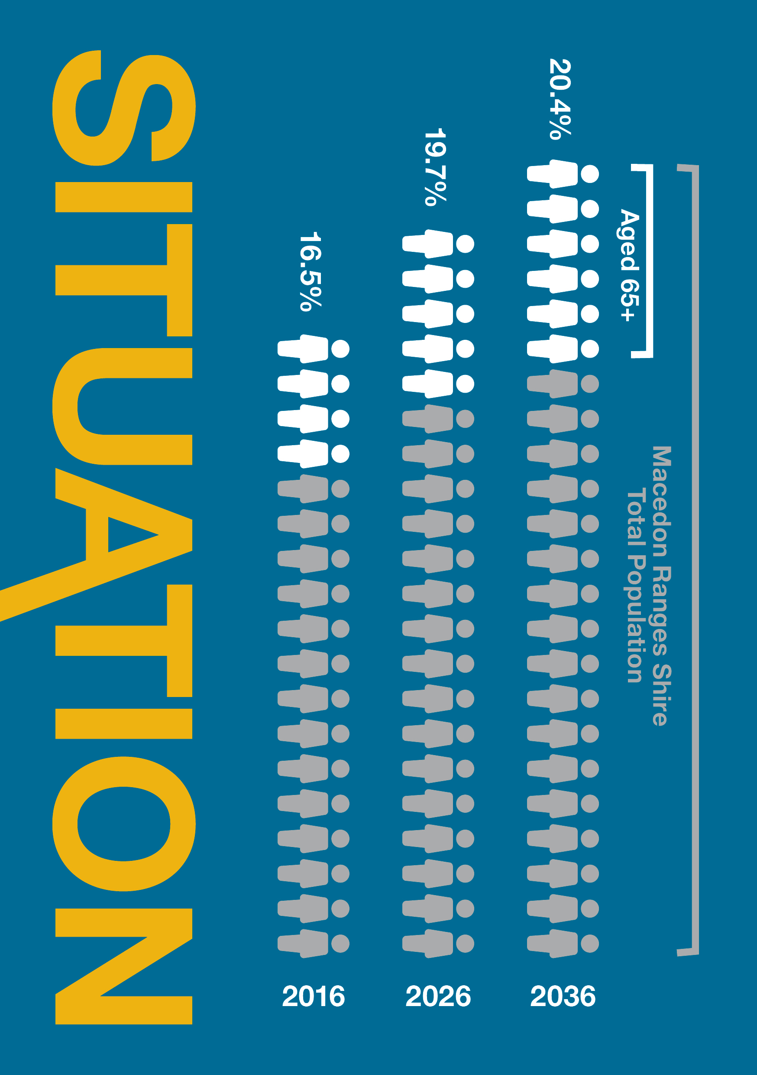

14
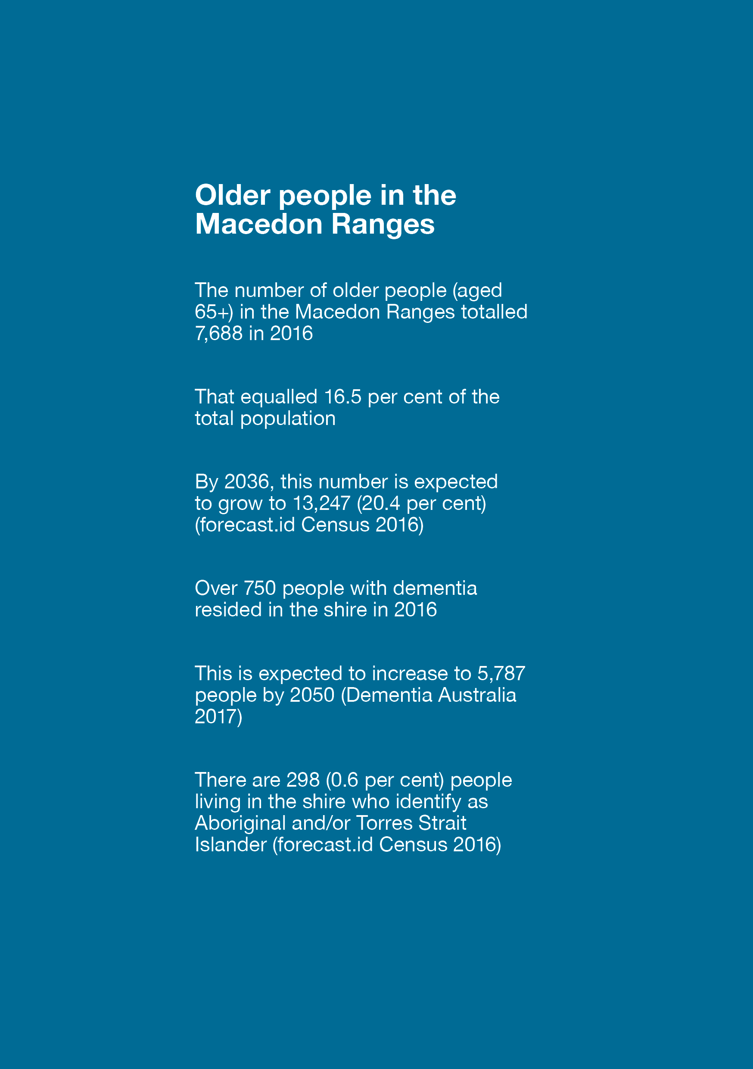
15

The current situation
Older people in the Macedon Ranges
The shire’s total population was approximately 46,000 people at the time of the 2016 census and is projected to grow to just over 64,000 people by 2036. A large proportion of all growth (45 per cent) is projected to occur in the Gisborne district. The Riddells Creek, Kyneton and Romsey districts are also projected to experience strong population growth.
The shire’s older population is also increasing rapidly. To illustrate, the number of people aged 65+ is projected to grow at 2.8 per cent per annum to 2036, resulting in an additional 5,559 people aged 65+ across the shire. Population growth in the 65+ age group will be greatest in the Gisborne district, followed by Kyneton and Woodend. Proportional growth in areas such as Riddells Creek will be significant.

Diversity in the older population
The Australian government funds aged care services for non-Indigenous people aged 65 years and older, and for Aboriginal and Torres Strait Islander (ATSI) people aged 50 years and older. The lower age range reflects the disparity in health status between ATSI people and the non-Indigenous population which is influenced by socio-economic disadvantage and geographical, environmental and social factors.
In the 2016 Census, 298 people living in Macedon Ranges Shire or 0.6 per cent of the population identified as Aboriginal and/or Torres Strait Islander. This is less than the regional Victorian percentage of 1.6 per cent. Their median age was 25 years, slightly higher than the Victorian median of 23 years.
In 2016, 79.8 per cent of Macedon Ranges’ residents were born in Australia and English was the only language spoken at home in 89 per cent of households. The most common countries of birth were England (4.2 per cent), New Zealand (1.3 per cent), Germany (0.6 per cent), Scotland (0.6 per cent) and (Italy 0.5 per cent)
The Australian Institute of Health and Welfare states that ‘there is currently no way to identify LGBTI older Australians accessing aged care services. Recently, the specific concerns of the older LGBTI community have been highlighted at the national level in the form of The National Lesbian, Gay, Bisexual, Transgender and Intersex (LGBTI) Ageing and Aged Care Strategy. This strategy addresses the need for change in aged care services, to promote equitable access to high-quality aged care for all people who identify as LGBTI’.

Older people and local government
PARTICIPATE follows in the footsteps of the previous Positive Ageing Plan 2016-2020, which like the current plan, was informed by extensive community consultation.
Macedon Ranges Shire Council has been a leader in the promotion and implementation of age-friendly principles. Initiatives include:
- Five years membership of the World Health Organisation Global Network of Age-friendly Communities and signing the Age-friendly Victoria Declaration in 2017
- Leadership of Loddon Mallee Move It project which aims to encourage older Australians, particularly those who are least active, to increase physical activity.
- Development of an Age-friendly Checklist and Welcome Pack to enable community groups to become more welcome and inclusive, and the Age-friendly Community Group Directory
- The Macedon Ranges Over 55s Connect Facebook page, which aims to inform older people about services, activities and topics of interest.
All of the above have been developed and implemented in collaboration with older residents.
Council is funded by the Australian Government to deliver the Commonwealth Home Support Program (CHSP), which enables older residents to continue to live safely and independently in their own homes. We also support local seniors groups and offer grants to assist clubs and groups to engage older residents through the Community Funding Scheme.
The Macedon Ranges Elder Rights Network was established during 2018 with funding from the Victorian Government. The long-term goal of the network is to prevent elder abuse, but to date, activities have focussed on raising awareness of elder abuse and its impact on older people, and the services and support available for older people who are experiencing abuse.
Council is also supported by the Victorian Government to offer activities during the annual Victorian Seniors Festival in October. This includes the popular Greylight Dance, run in partnership with Victoria Police.

Municipal health and wellbeing
Local government plays an important role in planning for optimal health and wellbeing of its residents. This ongoing work permeates many of the functions of Council, with our Council Plan broadly reflecting social determinants of health.
During the drafting of this plan, the COVID-19 pandemic was declared. This disease is having a profound impact on older Victorian’s, and council continues to work with other levels of government to respond and seek to protect communities.

Council remains committed to supporting our vulnerable community members during the current and any future pandemics.

Victorian Government
In 2016, the management of aged care began transitioning from the Victorian Government to the Australian Government. Through this transition phase to the present, the Victorian Government’s ageing agenda has focused on:
- Responding to the changing demographic profile of Victoria
- Supporting older Victorians’ ability to age well across three main areas: optimising health and wellbeing at all life stages, addressing disadvantage and improving social participation
- Improving access and quality of service responses for our diverse older population.
In April 2016, the Victorian Government signed an Age-friendly Declaration with the Municipal Association of Victoria (MAV). The Declaration is a commitment to planning for and establishing age-friendly communities across Victoria.
The Department of Health and Human Services (DHHS), through MAV, has supported Macedon Ranges and other local government areas with:
- Age-friendly initiatives, such as the Macedon Ranges Over 55s Connect project
- The establishment of the Macedon Ranges Elder Rights Network
- Annual Seniors Festival activities.

Australian Government
The Australian Government has responsibility for the coordination and management of aged care services across Australia and the implementation and monitoring of National Aged Care Quality Standards.
My Aged Care is now the starting point to access all government-funded aged care including the Commonwealth Home Support Programme, Home Care Packages and Residential Care. The Australian Government’s aim is a nationally consistent system to be implemented beyond 2022, resulting in major changes to the funding and delivery of aged care services nationwide.
In 2018, the Australian Government initiated the Royal Commission into Aged Care Quality and Safety, to “establish the full extent of problems with Australia’s aged care system and how to best meet the challenges and opportunities of delivering aged care”. The interim report, delivered in October 2019, flagged the need for significant reform. The final report was not available at the time of developing Participate but is expected to recommend major “systemic and transformational” change.
Council will monitor and respond to these changes to ensure our older residents are appropriately informed and will continue to have a role in promoting the health and wellbeing of all residents, including older people, in accordance with the priorities identified in the Council Plan.
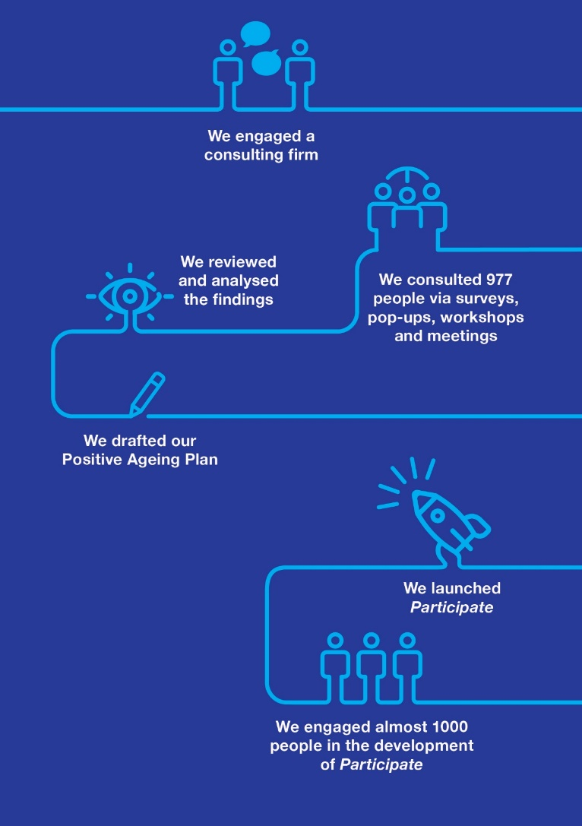
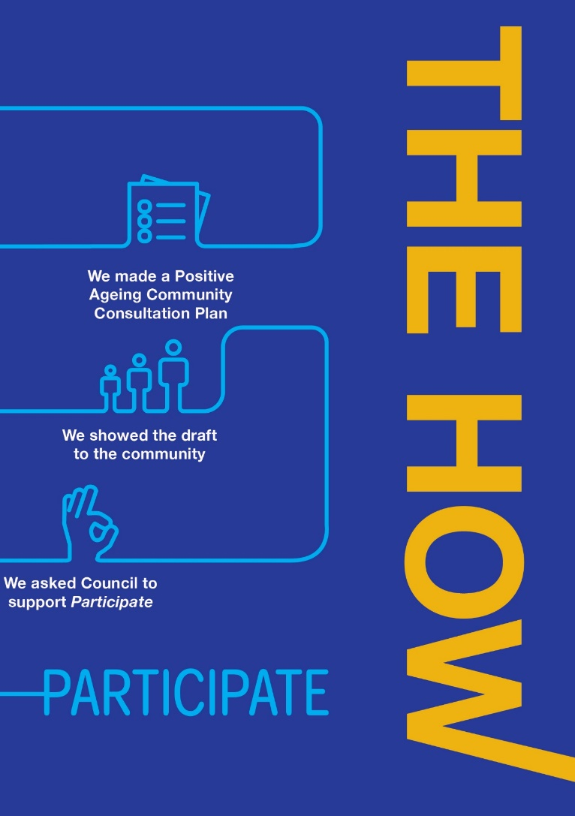
19

PARTICIPATE - how we did it
Council engaged consultation experts to plan an extensive community engagement program using Council’s engagement framework. The framework aligns with the International Association for Public Participation (IAP2) methodology and ensures a strategic approach to identifying and reaching key stakeholders, selecting engagement methods and tools, and identifying the information needed from people to inform planning.
Consultation for Participate engaged nearly 1,000 people with responses from across the shire. To do so we:
- Engaged face-to-face with 283 participants through meetings, workshops and drop-in sessions with service providers, health service providers, at community events and with seniors groups across the municipality
- Had 305 engagements with residents via social media
- Engaged 70 participants through five place-based community pop-ups at key locations. These enabled us to meet a diverse range of community members in busy locations during their normal day to day activities or whilst they were attending special community events, and
- Received 310 responses to the online and hard copy survey about how to create an age-friendly community.

With an aim of reaching 10 per cent (890) of the older population in the shire, a focus of the consultation was to ensure we used appropriate engagement strategies and consultation methods that are accessible to older people.
Here is a breakdown of the consultation activities process that led to PARTICIPATE, how we went about it and what was found.
Positive Ageing Plan specific engagement activities | Participants
Positive Ageing Plan surveys (hard copy and online) | 310
Positive Ageing Plan workshops, meetings and drop-in session participants | 283
Positive Ageing Plan social media engagements (Twitter/Facebook) | 305
Pop-Up engagement dotmocracy participants | 44
Pop-up engagement chat board participants (approx.) | 35
Total participation | 977

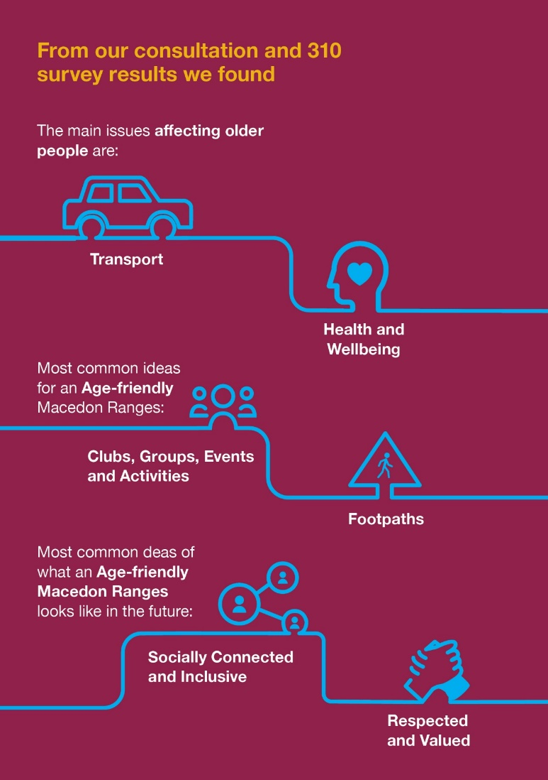
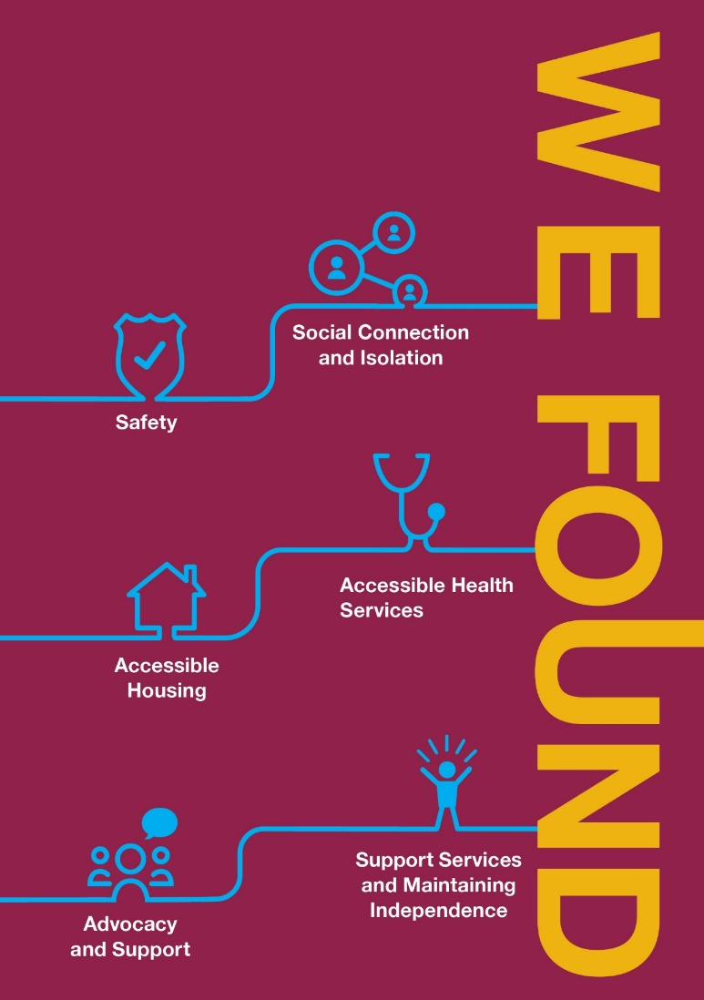
21

PARTICIPATE - what we found
Most people we heard from were aged between 70-84 years (40.6 per cent) followed by 60-69 years (21.6 per cent). Almost 15 per cent of respondents are over 85 years. More women than men participated in our consultation.
Just over a quarter (28 per cent) indicated that they currently use Commonwealth Home Support Program services delivered by Council. In the 2016 census, 12 per cent of Macedon Ranges residents aged 65 years and older needed assistance with daily activities due to severe or profound disability. Although the data are not directly comparable, the proportion of consultation participants using Council services is therefore likely higher than would be expected across the broader population of older Macedon Ranges residents.
There were four areas of focus about which we gathered data and information, including older people’s priorities, aspirations and challenges, and what they liked about growing older in the Macedon Ranges.

Open-ended survey questions
Responses to the four open-ended survey questions were analysed, sorted and categorised using some prescribed themes as well as themes and sub-themes that emerged in the consultation process. See Appendix 3 for an explanation of how comments were analysed and themed into priority action areas. The key findings relating to each question are described below.
Graph 1. What challenges, if any, do you think older people have living in Macedon Ranges?
Graph 2. What are your ideas for making Macedon Ranges an age-friendly shire?

Graph 3. What do you like about ageing in the Macedon Ranges?

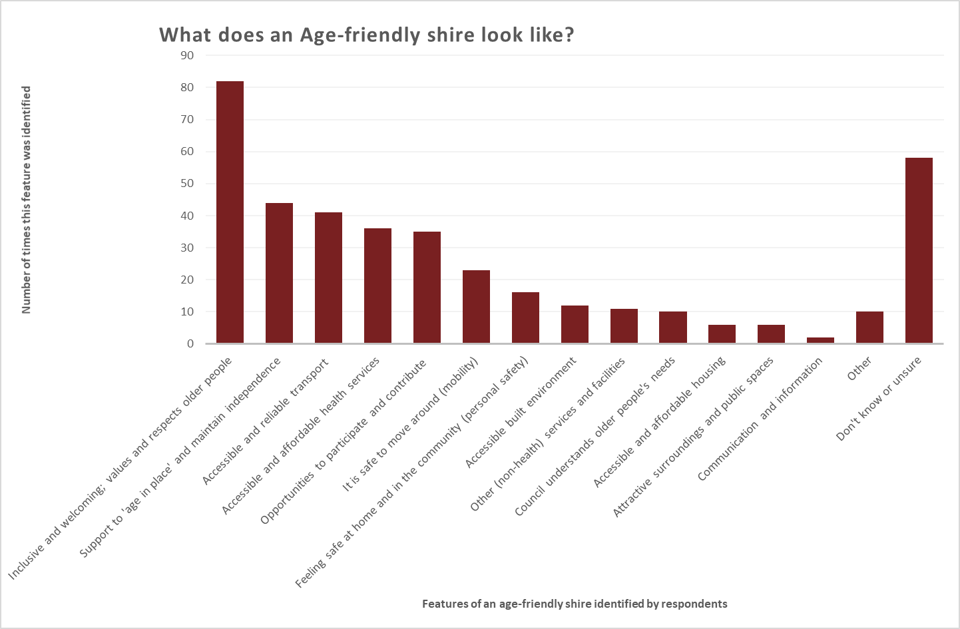
Graph 4. Thinking about Macedon Ranges in the future, describe what an age-friendly shire looks or feels like and/or what it means to you.

PARTICIPATE, what we found cont’d…
Older people want to stay connected and active by accessing transport options and by being able to move around safely and easily.
Moving around safely and easily was considered the biggest challenge for older residents. They told us that the lack of local transport options in the shire compromised their ability to be active and connected, and to access the services and facilities they needed. This was particularly concerning for people who had lost or will lose the ability to drive.
The topics of transport and safety combined generated the largest number of ideas for making the shire more age-friendly. These included better, more or more frequent buses; affordable transport options; more disabled parking spaces close to shops and services; footpath improvements including better connectivity; lowering speed limits; safer road crossings and longer crossing times.
‘A bus that is suitable for older people to access’
‘Footpaths for safe walking and wheelchairs’
‘More traffic lights, making it safe to cross roads’
‘Travelling to activities can be difficult if no car / license to drive’
While safety was a concern for a substantial number of older people, a considerable number of comments also indicated that it was something people liked about ageing in the shire.
Older people want better access to health and support services
A considerable number of older people expressed concern that health facilities were not close enough to get to easily, and that travel to hospital or specialist medical services was difficult. Many people also wanted more transport options to access these services.
‘Medical services (hospitals) further away’
‘Limited professional/specialist medical services’
However, a comparable number of older people identified access to physical and mental health services as something they liked about living in the Macedon Ranges.
Many older people also expressed concern about the difficulty in maintaining their own homes and the challenges of accessing home-support services in general but in particular, services that assisted with home maintenance.
‘Maintaining large homes and gardens with limited home care services’
Suggestions included increasing in-home support services including firewood deliveries, a housemate, meals on wheels, cleaning services, home care packages, help with shopping, gardening and mowing services would assist in addressing these challenges. However, a moderate number of people also indicated that the support services available were something they liked about ageing in the Macedon Ranges.
‘People can age in place and have choices’

Older people want to be connected and stay active by participating in clubs, groups and activities.
An age-friendly shire was seen as offering a range of suitable, accessible and affordable social events and activities for older people to stay connected, active and mobile. There was a considerable number of comments indicating that Macedon Ranges’ clubs and groups were something they liked about ageing here, and in particular that they like ageing in the Macedon Ranges because of its community feel.
‘Sense of community – there is still a village willingness to help others... at this stage’.
‘The community spirit and fellowship of the long term residents’.
However we heard that many older people were worried about becoming isolated or lonely, with a moderate number indicating that accessing ‘clubs and groups’ was a challenge for them. ‘Clubs and groups’ were also identified by a considerable number or people as an idea for making Macedon Ranges a more age-friendly shire. It is not clear whether this was because of a perceived lack of clubs and groups, because clubs and groups were difficult to access or both.
‘Continue to provide access to social and volunteer activities’
‘Let's have more community activities across ALL ages’
‘Opportunities for older people to engage in community spaces/groups/outings’
Specific suggestions included gardening, craft, social activities, swimming, dances, Men’s Shed, volunteering opportunities, singalongs, community meals, local movie showings, entertainment, an all ages sports day, senior citizens’ centre, community gardens, activities with childcare centres, informal coffee mornings or book groups, grandparents network and inclusive events. Several of these activities are already offered within the shire so it may be that people just don’t know about them, or that they have difficulty accessing them.
Access to housing and improvements to the built environment are a concern for older people.
Although not mentioned as frequently as other issues, access to affordable and appropriate housing and improvements to the built environment, (mainly seating, toilets and shops), were a concern for older people.
People also commented that they would like to see a wider variety of shops in the shire and more places that offer delivery.
‘Housing costs – limited affordable "downsized" housing’
‘Well maintained accessible (public) toilets’
‘Accessible shops with disabled-friendly doorways’
Other concerns for older people are being respected and tackling ageism.
People expressed concern about attitudes towards older people and not being taken seriously because of their age. Several older people wanted to be recognised and respected and given more of a voice in their communities.
It was considered important by several people that an age-friendly shire ensured older people felt included, valued and respected.
‘Valuing older people and prioritising needs’
‘The aged residents are treated with respect and courtesy’
‘There is evidence of a culture of respect for the elderly, and all planning decisions have considered the needs of the elderly in the community’

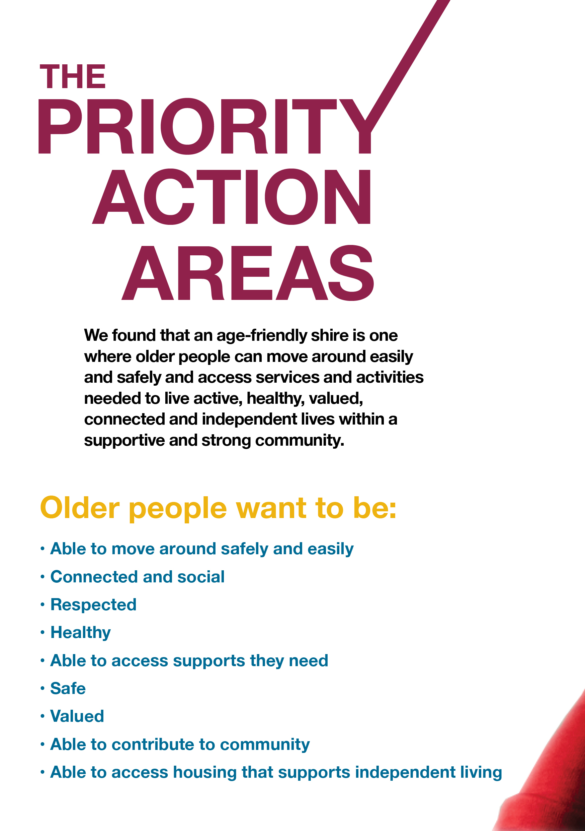

30
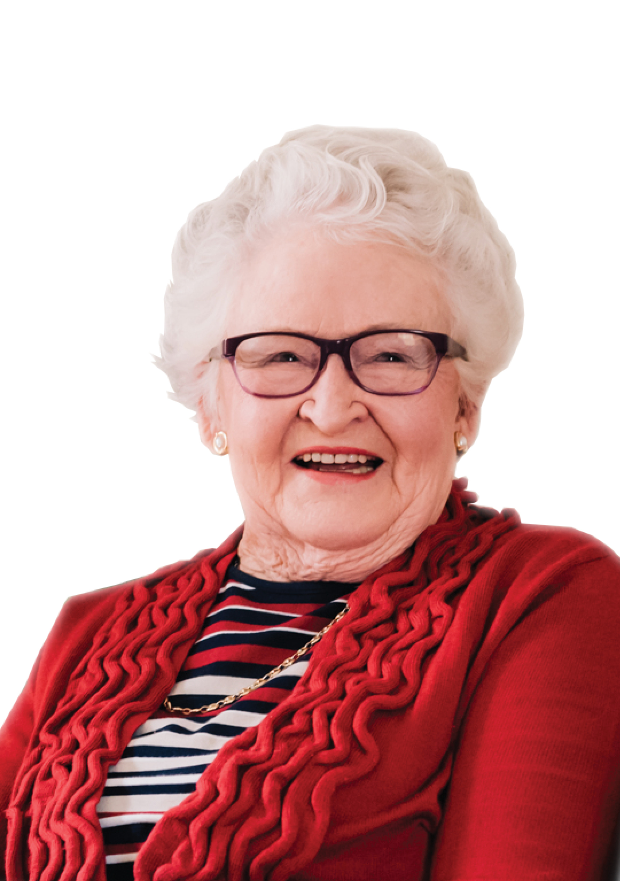

31
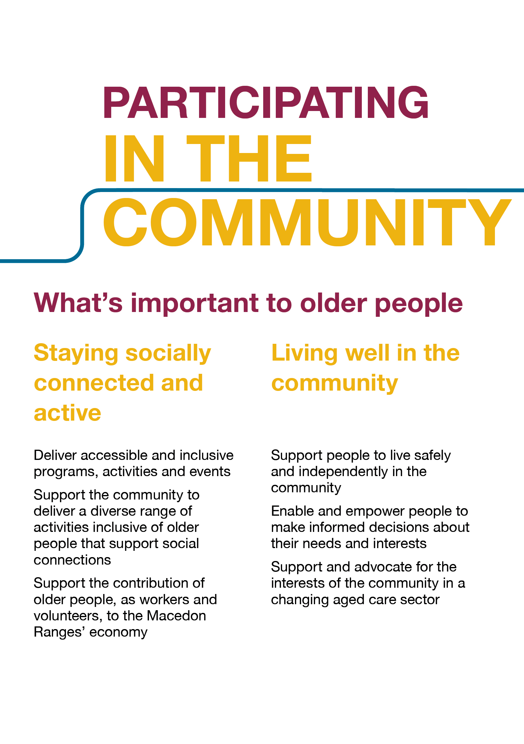
32
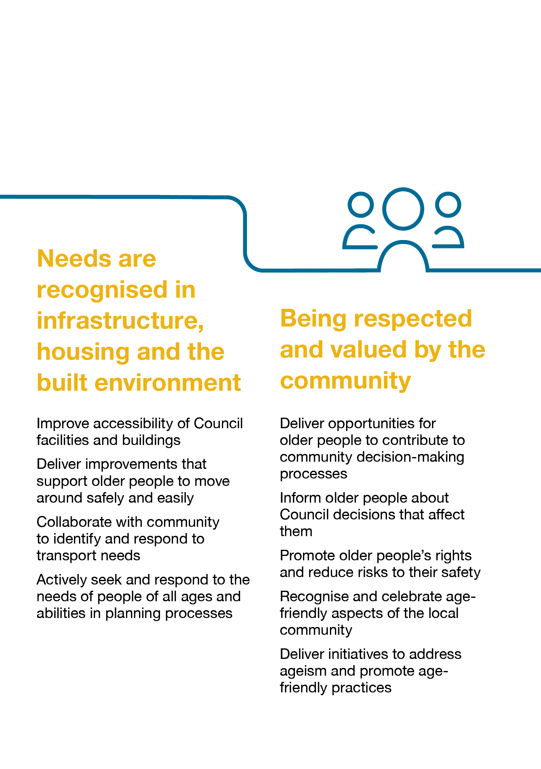
33
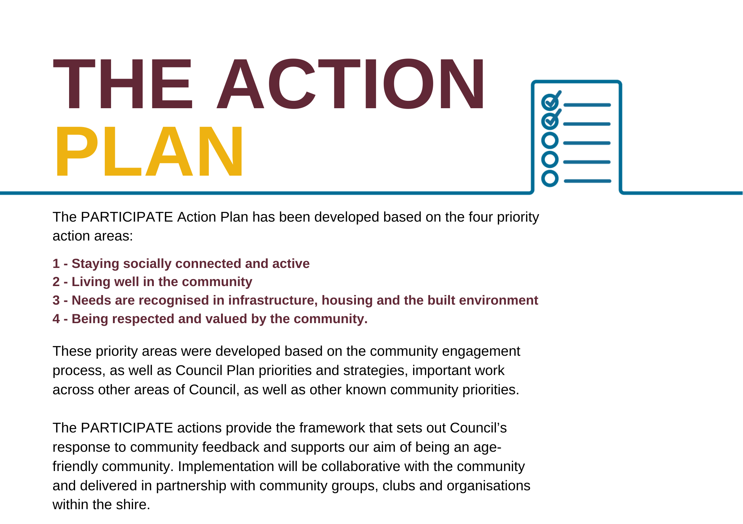
34
Action Plan
Priority Action Area 1 – Staying socially connected and active
I feel included and am able to participate in the community, events and activities that I choose
STRATEGY 1.1: Deliver accessible and inclusive programs, activities and events

 |  |  | ACTIONS | RESPONSIBILITY & RELATED STRATEGY/PLAN |  | RESOURCES | TIMELINE |  |  | INDICATORS AND MEASURES
1.1.1 |  |  | Coordinate and promote accessible and inclusive programs, activities and events | Planning and Environment  MRSC Arts & Culture Strategy 2018-2028 |  | Within existing resources | 2020-25 |  |  | Community Satisfaction Survey score for Community and Cultural Activities Performance shows an improvement annually for people aged 65 years and over
1.1.2 |  |  | Work in partnership to explore opportunities to improve access (or increase transport options) to local programs, activities and events e.g. trialling of volunteer transport support service for some events | Assets and Operations  MRSC Sport and Active Recreation Strategy 2018-2028  Planning and Environment  MRSC Arts & Culture Strategy 2018-2028  Romsey and Lancefield Neighbourhood House |  | Within existing resources | 2020-25 |  |  | Funding sourced for a new transport program to be trialled  Community Satisfaction Survey score for Community and Cultural Activities Performance shows an improvement annually for people aged 65 years and over
STRATEGY 1.2: Support the community to deliver a diverse range of activities inclusive of older people that support social connections
 | ACTIONS |  |  | RESPONSIBILITY & RELATED STRATEGY/PLAN |  | RESOURCES |  |  | TIMELINE |  |  | INDICATORS AND MEASURES
1.2.1 | Support local groups and organisations to increase opportunities for social connections and participation |  |  | Assets and Operations  MRSC Sport and Active Recreation Strategy 2018-2028  Planning and Environment  MRSC Arts & Culture Strategy 2018-2028 |  | Within existing resources |  |  | 2020-25 |  |  | Number of programs, activities and events delivered (specifically for older people) and annual increase in participation rates
1.2.2 | Direct Council community grant funding to initiatives that emphasise inclusiveness |  |  | Planning and Environment  Community Funding Scheme |  | Within existing resources |  |  | 2020-25 |  |  | Number of Community Funding Scheme grant applications funded that support increased opportunities for older people to participate
1.2.3 | Support and encourage greater diversity in community organisations/groups catering for older people to be inclusive of people regardless of their ability, cultural background, gender, sexual orientation and to deliver new initiatives as appropriate to support this |  |  | Corporate and Community |  | Within existing resources |  |  | 2020-25 |  |  | Delivery of annual community education sessions and production of a resource to support and encourage diversity  Number of participants from community groups in sessions
1.2.4 | Promote and share outcomes of (age-friendly) local projects and support them to be sustainable |  |  | Corporate and Community |  | Within existing resources |  |  | 2020-22 |  |  | Loddon Mallee Move It project evaluation completed and results disseminated with partners and community
STRATEGY 1.3: Support the contribution of older people to Macedon Ranges’ economy as workers and volunteers
 |  | ACTIONS |  | RESPONSIBILITY & RELATED STRATEGY/PLAN | RESOURCES |  |  | TIMELINE |  |  | INDICATORS AND MEASURES
1.3.1 |  | Facilitate diverse and meaningful volunteer and work opportunities for older people (within and outside Council) |  | CEO  Volunteer Central Victoria | Within existing resources |  |  | 2020-21 |  |  | Increase in number of older people volunteering  Increase in the diversity of roles older people are undertaking
1.3.2 |  | Collaborate with Volunteer Central Victoria and across Council to coordinate, support, engage and recognise volunteers |  | CEO  Volunteer Central Victoria | Within existing resources |  |  | 2020-21 |  |  | Annual celebration held for volunteers
1.3.3 |  | Improve access to volunteer and work opportunities for older people |  | CEO | Within existing resources |  |  | 2021-25 |  |  | Number of staff and volunteers aged 65+ maintained and/or increased annually

Priority Action Area 2: Living well in the community
I am confident that there are services, supports and programs available that meet my needs
STRATEGY 2.1: Support people to live safely and independently in the community
 | ACTIONS | RESPONSIBILITY & RELATED STRATEGY/PLAN | RESOURCES | TIMELINE | INDICATORS AND MEASURES
2.1.1 | Continue to support and encourage older people to live independently and enable them to participate and contribute to their community | Corporate and Community | Australian Government and Council funding to July 2022  Fees apply | To July 2022 | 90% of clients report satisfaction with the Macedon Ranges Commonwealth Home Support Programme Services
2.1.2 | Provide information to the community about local services and supports, evolving aged care sector reform including the outcomes of the Royal Commission into Aged Care | Corporate and Community | Within existing resources | 2020-25 | Relevant information about services and support including aged care reforms is communicated promptly with the community via local and social media and relevant publications.
2.1.3 | Identify organisational and service implications of the changing landscape of aged care reform | Corporate and Community | Within existing resources | 2020-25 | Correspondence submitted to Victorian and/or Australian Governments as required
2.1.4 | Raise awareness of mental health issues, and educate the community to enable them to support older people who are experiencing mental health problems | Corporate and Community | Within existing resources and some additional resources to be sourced  Some cost recovery | 2020-25 | Three Older Person Mental Health First Aid Courses delivered annually
2.1.5 | Support the community to be well informed about how to keep safe during emergencies | Planning and Environment | Within existing and additional resources | 2020-25 | Deliver at least 8 community education sessions per year on emergency planning and readiness  Community Satisfaction Survey score for Emergency and disaster management Performance shows an improvement annually for people aged 65 years and over
2.1.6 | In partnership with local public and community health agencies, support networks and community groups, raise awareness about dementia and support people living with dementia and their carers | Corporate and Community  Health agencies and networks, community groups / organisations | Within existing resources | 2020-25 | Local dementia initiatives are promoted and supported as appropriate
2.1.7 | Work in partnership with local public and community health agencies, networks and community groups to investigate new ways to support community members to access and use technology (including phones, tablet, internet) | Corporate and Community  Macedon Ranges health agencies and networks, community groups / organisations  Goldfields Library | Within existing and additional resources | 2020-22 | New project identified and delivered  Number of people supported to use IT for social connection with family and friends
2.1.8 | Identify gaps in services for older people and advocate for local needs in relation to diversity and disadvantage | Corporate and Community | Within existing resources | 2020-25 | Community Satisfaction Survey score for Elderly Support Services Performance shows an improvement annually for people aged 65 years and over  Community Satisfaction Survey score for Lobbying on behalf of the community Performance shows an improvement annually for people aged 65 years and over
2.1.9 | Investigate reported gaps in health and medical services and advocate to increase availability where need is evidenced. | Corporate and Community | Seek resourcing options | 2021-25 | Community Satisfaction Survey score for Lobbying on behalf of the community Performance shows an improvement annually for people aged 65 years and over
2.1.10 | Support the establishment and/or expansion of health and medical service businesses based on gaps identified | Planning and Environment | Seek resourcing options | 2021-25 | Number/breadth of health and medical services/ supports increased
2.1.11 | Develop principles to guide Council’s response to developer applications for residential aged care facilities | Planning and Environment | Seek resourcing options | 2020-25 | Number of appropriate development submissions received
2.1.12 | Continue to invest in older people by actively sourcing appropriate funding opportunities in partnership with the community | Corporate and Community | Within existing resources | 2020-25 | Funding opportunities that meet local needs and appropriate partners are identified and applications submitted
2.1.13 | Collaborate with the community to increase the number of programs and activities available to older people | Corporate and Community | Within existing resources | 2021-25 | New programs and/or activities are supported as appropriate  - in response to an identified community need, and  - to become sustainable and independent in the long term

STRATEGY 2.2: Enable and empower people to make informed decisions about their needs and interests
 | ACTIONS | RESPONSIBILITY & RELATED STRATEGY/PLAN | RESOURCES | TIMELINE | INDICATORS AND MEASURES
2.2.1 | Educate the community about services and supports that assist them to advocate for their rights | Corporate and Community  Older Persons Advocacy Network  Elder Rights Advocacy  Seniors Rights Victoria | Existing | 2020-25 | At least 75 per cent of participants in awareness and/or education sessions indicate increased understanding of where they can obtain support
2.2.2 | Disseminate information that enables older residents to improve environmental sustainability in their homes and reduce utilities costs | Planning and Environment  Climate Change Action Plan | Part within existing resourced projects  Seek resourcing for more targeted information | 2020-25 | Older residents across the Macedon Ranges receive information that informs them of ways to safely reduce home energy use and environmental costs  Uptake of energy-saving initiatives by older residents
Links to 2.1.1 & 2.1.3

STRATEGY 2.3: Support and advocate for the interests of the community in a changing aged care sector
 | ACTIONS | RESPONSIBILITY & RELATED STRATEGY/PLAN | RESOURCES | TIMELINE | INDICATORS AND MEASURES
2.3.1 | Maintain an active watch on aged care reform changes impacting the shire | Corporate and Community | Within existing resources | 2020-22 | Participate in forums and meetings related to reforms.  Respond to relevant inquiries, using regional or local approaches.
2.3.2 | Continue to advocate to Australian and Victorian Governments for fair and equitable access to service and support needs of the community | Corporate and Community | Within existing resources | 2020-22 | Community Satisfaction Survey score for Elderly Support Services Performance shows an improvement annually for people aged 65 years and over  Community Satisfaction Survey score for Lobbying on behalf of the community Performance shows an improvement annually for people aged 65 years and over
2.3.3 | Develop and implement a plan for Council’s future role in supporting older residents to live safely and independently | Corporate and Community | Within existing resources | 2021-23 | A plan has been developed that identifies how older people will be supported in the context of:  - Ongoing aged care reforms  - The Australian Government’s response to the Royal Commission into Aged Care Quality and Safety, and  - Local needs and gaps in services and support  - Council priorities and responsibilities

Priority Action Area 3: Needs are recognised in infrastructure, housing and the built environment
I feel I can participate in and move around my community safely and easily
STRATEGY 3.1: Improve accessibility of Council facilities and buildings
 | ACTIONS | RESPONSIBILITY & RELATED STRATEGY/PLAN | RESOURCES | TIMELINE | INDICATORS AND MEASURES
3.1.1 | Plan for inclusion of people of all ages and abilities in design and development of the new Macedon Ranges Regional Sports Precinct | Assets and Operations | Within existing resources | 2020-21 | Macedon Ranges Regional Sports Precinct is an inclusive development and is accessible for people of all ages and abilities
3.1.2 | Review assets by auditing compliance with accessibility requirements (including age and dementia friendliness) and seek to address gaps identified in audit | Assets and Operations | Some within existing resources  Additional resources may be sought for specific items | 2020-25 | Number of assets audited annually  Number of upgrade works addressing accessibility completed annually
3.1.3 | Use accessible design standards for new/upgraded signage in Council owned and managed facilities and at Council sponsored events | CEO  Assets and Operations  Council Branding Guidelines | Within existing resources or as part of relevant project funding | 2020-25 | Council staff demonstrate improved understanding and emphasis on accessible design for signage  New/upgraded signage at Council-owned and managed facilities and at Council-sponsored events complies with the relevant standards

STRATEGY 3.2: Deliver improvements that support older people to move around safely and easily
 | ACTIONS | RESPONSIBILITY & RELATED STRATEGY/PLAN | RESOURCES | TIMELINE | INDICATORS AND MEASURES
3.2.1 | Improve accessible parking in key locations | Assets and Operations | Within existing resources | 2020-25 | Community Satisfaction Survey score for Parking Facilities Performance shows an improvement annually for people aged 65 years and over
3.2.2 | Deliver improvements to footpaths, including footpath connectivity, to meet local needs | Assets and Operations  Shire-wide Footpath Plan | Existing annual funding allocation  Additional resources may be sought for specific identified projects/issues | 2020-25 | Community Satisfaction Survey score for Condition of Local Streets and Footpaths Performance shows an improvement annually for people aged 65 years and over
3.2.3 | Include in improvements to parks and public spaces accessibility considerations for older people, including exploring age and dementia-friendly modifications to these spaces such as reducing trip hazards, improving wayfinding cues | Assets and Operations  MRSC Open Space Strategy  Walking and Cycling Strategy  Shire-wide Footpath Plan | Additional resources may be required | 2020-25 | Number of works completed annually to parks and public spaces that focus on accessibility  Activation of Healthy Heart of Victoria outdoor exercise equipment completed
Links to 1.1.2

STRATEGY 3.3: Collaborate with community to identify and respond to transport needs
 | ACTIONS | RESPONSIBILITY & RELATED STRATEGY/PLAN | RESOURCES | TIMELINE | INDICATORS AND MEASURES
3.3.1 | Advocate to the Victorian Government for improved public transport within the region | Corporate and Community | Within current resources | 2020-25 | Community Satisfaction Survey score for Lobbying on Behalf of the Community Performance shows an improvement annually for people aged 65 years and over
3.3.2 | Advocate for Victorian Government funding for a feasibility study to expand bus services and on-demand transport within and between Macedon Rages townships.  (On-demand transport includes taxis, ride-sharing, car-sharing, volunteer transport) | Corporate and Community | Within current resources | 2020-22 | Funding for a feasibility study is obtained

STRATEGY 3.4: Actively seek and respond to the needs of people of all ages and abilities in planning processes
 | ACTIONS | RESPONSIBILITY & RELATED STRATEGY/PLAN | RESOURCES | TIMELINE | INDICATORS AND MEASURES
3.4.1 | Ensure structure plans consider diverse housing options to reflect demographic change, including smaller dwellings for older people in well serviced locations | Planning and Environment  Gisborne Structure Plan  Kyneton Town Centre Urban Design Framework project | Within existing resources | 2020-25 | Gisborne Structure Plan and Kyneton Urban Design Project provide for diverse housing options
3.4.2 | Ensure that planning for all aspects of the built environment addresses accessibility issues for people of all abilities and includes seating and public toilets | Planning and Environment  Gisborne Urban Design Framework  Kyneton Urban Design Framework | Within existing resources | 2020-25 | MRSC planning for the built environment incorporates seating, public toilets and other features important for older people
3.4.3 | Review Council’s Developer Contribution Plan to include footpath connectivity, transport and access to community facilities | Planning and Environment  Developer Contribution Plan | Within existing resources | 2020-21 | Review completed and reported in annual work plan
3.4.4 | Seek input from older people into the regular consultative process for the 10 Year Asset Plan | Planning and Environment  Council’s annual budget process  MRSC Community Consultation Framework | Seek resources | 2020-25 | Consultation data collects age related data and responses received from the over 65 year population.

Priority Action Area 4: Being respected and valued by the community
My right to live a safe, dignified life and make my own decisions is respected and my contributions and input are valued
STRATEGY 4.1: Deliver opportunities for older people to contribute to community decision-making processes
 | ACTIONS | RESPONSIBILITY & RELATED STRATEGY/PLAN | RESOURCES | TIMELINE | INDICATORS AND MEASURES
4.1.1 | Inform, enable and encourage older residents to ‘Have Your Say’ on Council-related activities | CEO  Corporate and Community  MRSC Community Consultation Framework | Within existing resources | 2020-25 | Community Satisfaction Survey score for Community Consultation and Engagement Performance shows an improvement annually for people aged 65 years and over  Increased subscribers to Macedon Ranges Over 55s Connect newsletter and Facebook
4.1.2 | Ensure that Council policy and plans for communication, consultation and advocacy include processes that address the needs of older people | CEO  Corporate and Community  MRSC Community Consultation Framework | Within existing resources | 2020-25 | Community Satisfaction Survey score for Community Consultation and Engagement Performance shows an improvement annually for people aged 65 years and over  Increased subscribers to Macedon Ranges Over 55s Connect newsletter and Facebook

STRATEGY 4.2: Inform older people about Council decisions that affect them
 | ACTIONS | RESPONSIBILITY & RELATED STRATEGY/PLAN | RESOURCES | TIMELINE | INDICATORS AND MEASURES
4.2.1. | Communicate and share information in a range of ways/methods to cater to the diverse needs of the community e.g. newsletters, information and education sessions | CEO | Within existing resources | 2020-25 | Community Satisfaction Survey score for Informing the Community Performance shows an improvement annually for people aged 65 years and over

STRATEGY 4.3: Promote older people’s rights and reduce risks to their safety
 | ACTIONS | RESPONSIBILITY & RELATED STRATEGY/PLAN |  | RESOURCES | TIMELINE | INDICATORS AND MEASURES
4.3.1 | Reduce elder abuse by raising awareness of older people’s rights and how risks of abuse can be addressed | Corporate and Community |  | Within available resources | 2020-22 | At least 75% of responses to feedback after community education activities (not just those focusing on elder abuse) indicate they are more aware of their rights after participating
4.3.2 | Promote personal safeguards against fraud/scams | Corporate and Community |  | Within available resources | 2020-22 | Community Satisfaction Survey score for Informing the Community Performance shows an improvement annually for people aged 65 years and over
STRATEGY 4.4: Recognise and celebrate age friendly aspects of the local community
 | ACTIONS | RESPONSIBILITY & RELATED STRATEGY/PLAN | RESOURCES | TIMELINE | INDICATORS AND MEASURES
4.4.1 | Explore initiatives to recognise local businesses, groups, organisations and services that celebrate ageing and/or adopted positive ageing practices and strategies to support older people | Corporate and Community  Municipal Association of Victoria  Victorian Government | Within available resources | 2021-22 | Seek and support at least one nomination each year from the community for the Victorian Government Age-Friendly Victoria Award (which recognises an organisation for creating age-friendly communities, promoting active ageing and improving quality of life and inclusion for older people).  Seek to include recognition of positive ageing practices in councils business awards and events and Festivals Grants process

STRATEGY 4.5: Deliver initiatives to address ageism and promote age-friendly practices
 | ACTIONS | RESPONSIBILITY & RELATED STRATEGY/PLAN | RESOURCES | TIMELINE | INDICATORS AND MEASURES
4.5.1 | Council continues to lead in promoting and demonstrating age-friendly practice in Macedon Ranges. | Corporate and Community | Within existing resources | 2020-25 | Annual work plan for Positive Ageing Plan completed and actions completed  Council approves and endorses commitment to drafting new plan beyond 2025
4.5.2 | Deliver on annual requirements of membership to the World Health Organisation’s Global Network of Age Friendly Communities Network and the Age Friendly Victoria Declaration | Corporate and Community | Within existing resources | 2020-25 | Council supports the maintenance of Macedon Ranges Shire’s membership of the  Global Network  Council renews its endorsement of the Age-friendly Victoria Declaration  Submission of two Age-friendly Practice case studies per annum to WHO GNAFC
4.5.3 | Support and promote age-friendly community initiatives, to address inclusion and promote respect of older people | Corporate and Community | Within existing resources | 2020-25 | Seek and support at least one nomination each year from the community for the Victorian Government Age-Friendly Victoria Award (which recognises an organisation for creating age-friendly communities, promoting active ageing and improving quality of life and inclusion for older people).
4.5.4 | Investigate the feasibility of delivering a new education and awareness raising program for Council to counteract ageism, such as the EveryAGE Counts campaign | Corporate and Community | Seek resources | 2021-22 | Council supports the EveryAGE counts campaign  35 per cent of Council staff complete the EveryAGE counts ‘Am I Ageist’? quiz
4.5.5 | Consider and implement a process whereby policies and plans are reviewed with an age-friendly lens | Corporate and Community | Seek resources | 2021-22 | A process is developed that enables assessment of Council policies and plans  The process is implemented and reviewed
4.5.6 | Ensure that the contributions of older people to the community are appropriately recognised | Corporate and Community  Volunteer Central Victoria | Within existing resources | 2020-25 | Older people and relevant Council departments have been consulted and an options for recognition identified – 2020-2021  The preferred option is implemented 2021-2025
4.5.7 | Ensure that the diversity of older people is accurately portrayed and reflected in Council publications and materials | CEO | Within existing resources | 2020-25 | Build on photo library of council and use local images and images of people in publications (where possible)  A review of Council publications and materials indicates older people are represented at their portrayal does not depict stereotypes about older people and ageing.

PARTICIPATE - how we will implement
Council’s Community Support unit will be responsible for leading the implementation of Participate and reporting to Council annually.
A collaborative approach is required and in several instances responsibilities of some actions may extend across other areas of Council and partner agencies. This includes a range of service providers, agencies of the Victorian and Australian government and local community groups, clubs and organisations. Emphasis has also been placed on building capacity in the community to support programs that encourage community-led initiatives.
We acknowledge the importance of having older people involved in the planning and design of new activities and aim to facilitate this where appropriate to encourage greater PARTICIPATION.
An annual work plan will be developed by the Healthy Ageing Engagement team that incorporates Participate actions. This work plan will inform reporting to key stakeholders and review of strategies as appropriate in the light of changing priorities at all levels of government, emerging issues and opportunities such as new funding streams.
It is acknowledged that the success of the plan relies on Council, identified stakeholders and the community working together.

PARTICIPATE - how we will evaluate
- Against the measures and/or indicators specified in the Action Plan
- Inclusion and measurement in service planning
- Reporting progress against selected activities as part of the quarterly reporting process
- Annual review and briefing to Council

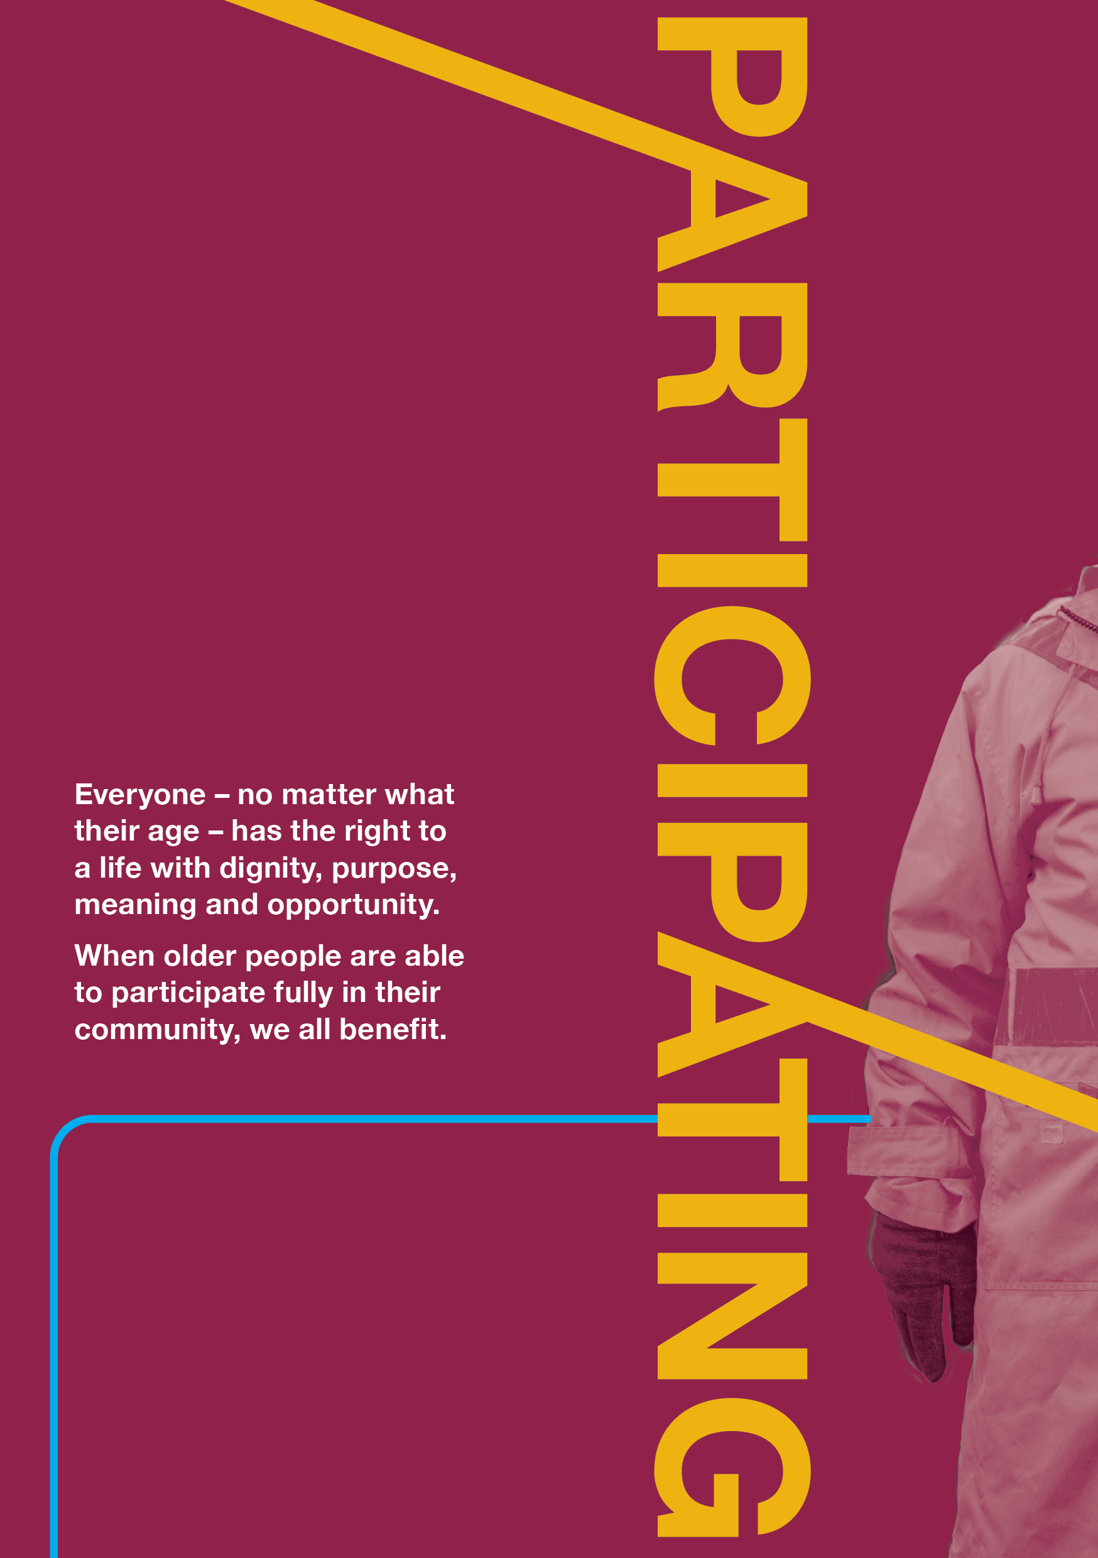
54
55

Appendix 1: Age-friendly Victoria declaration
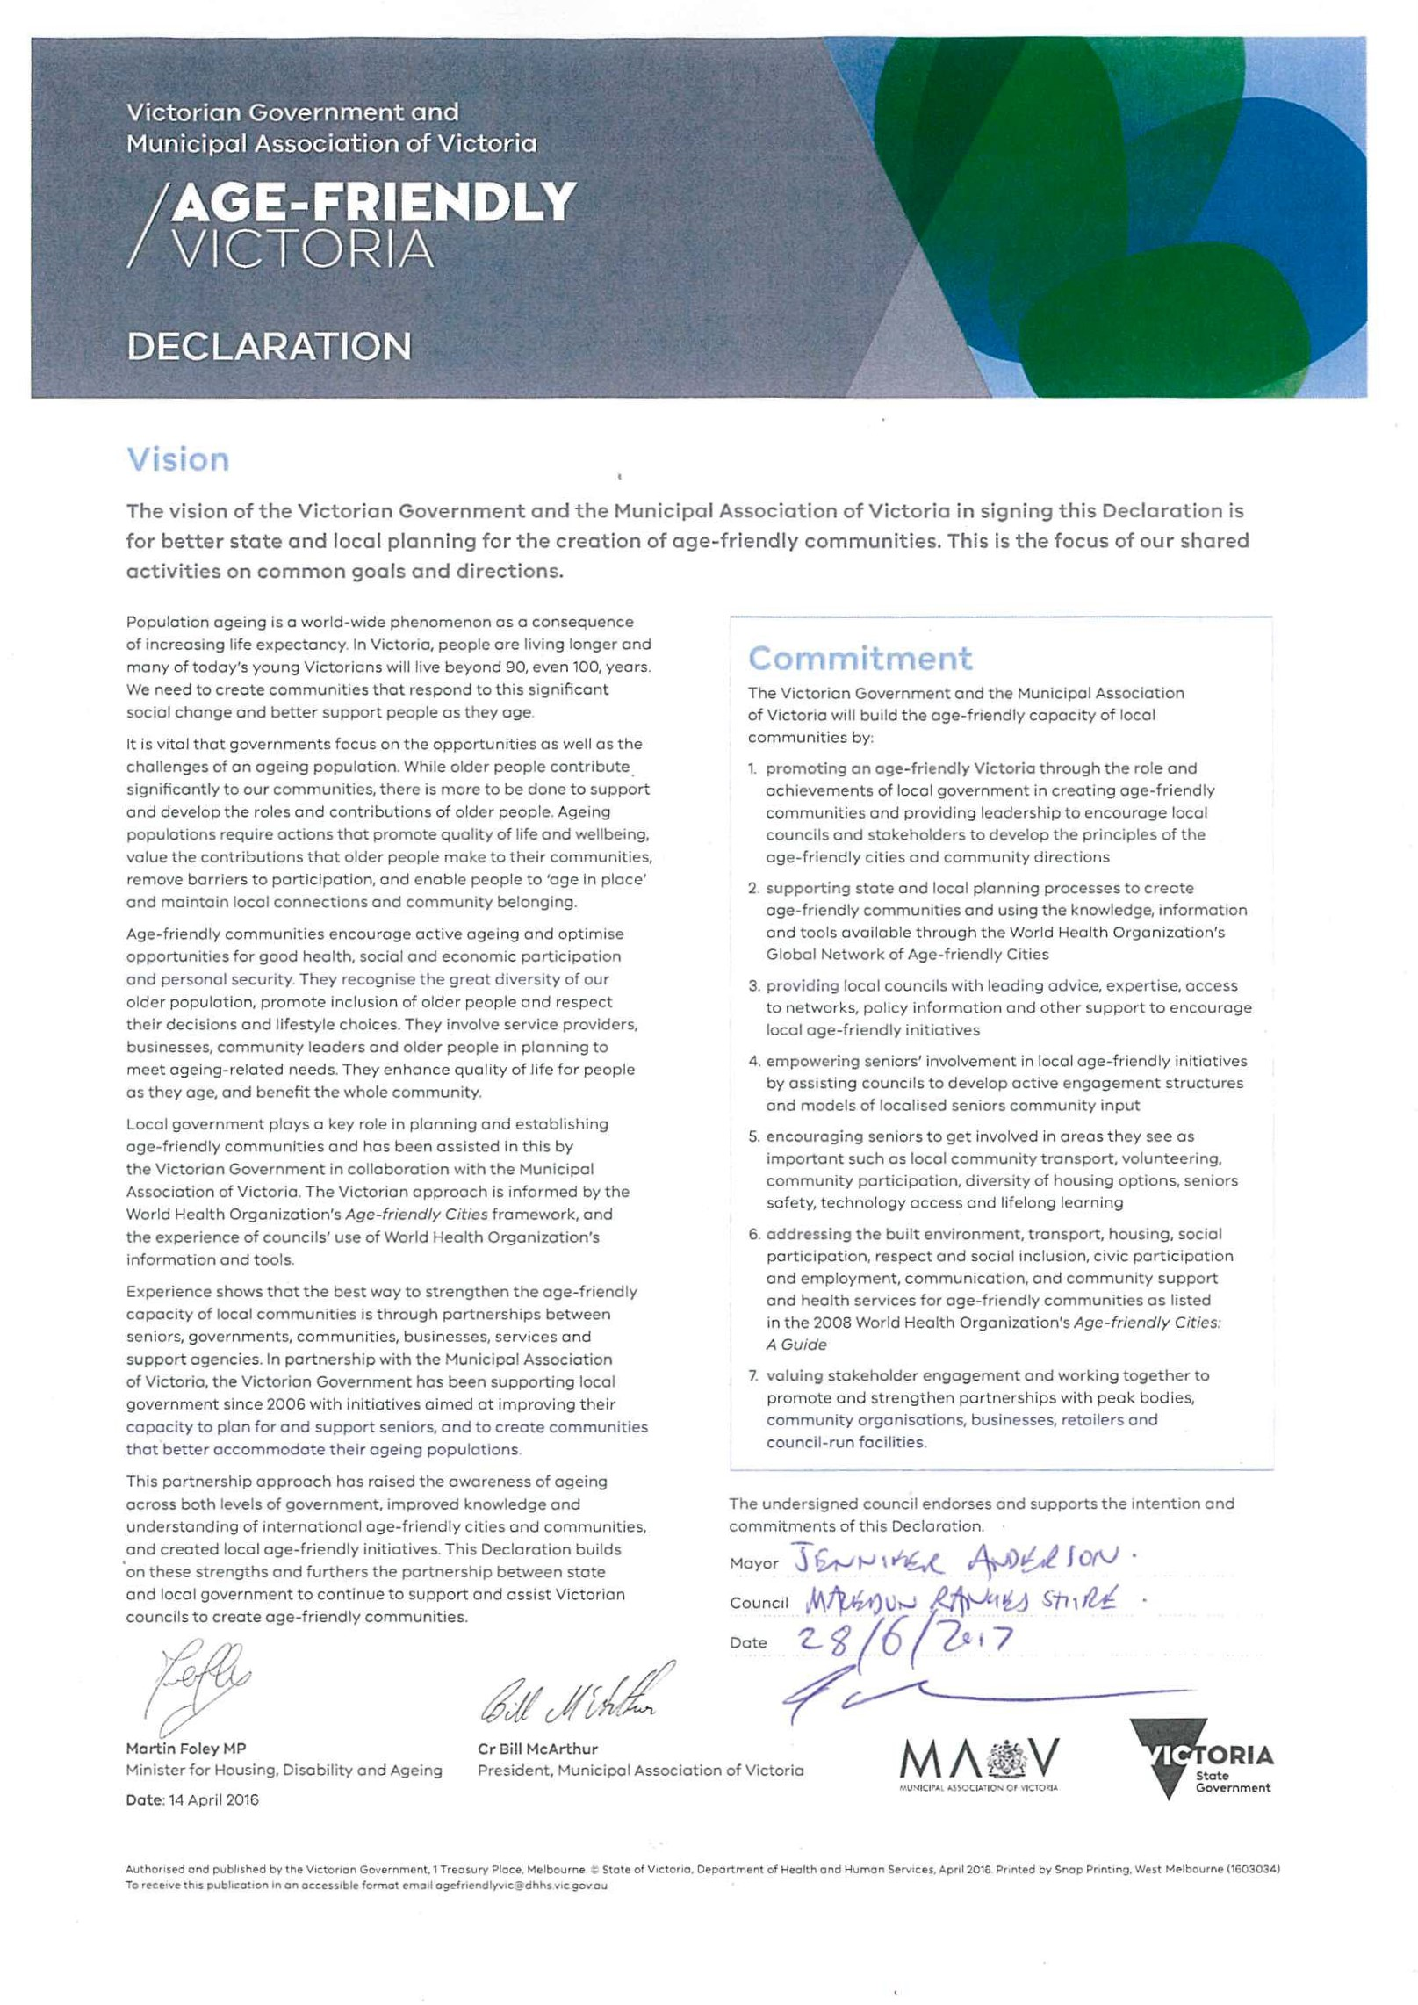

Appendix 2: Survey questions and findings
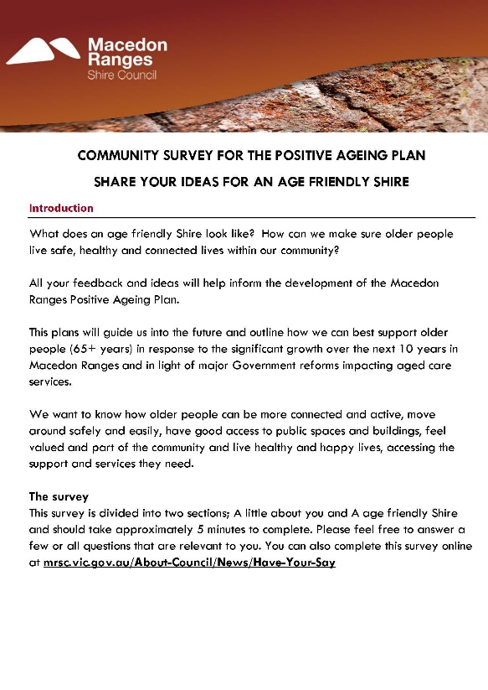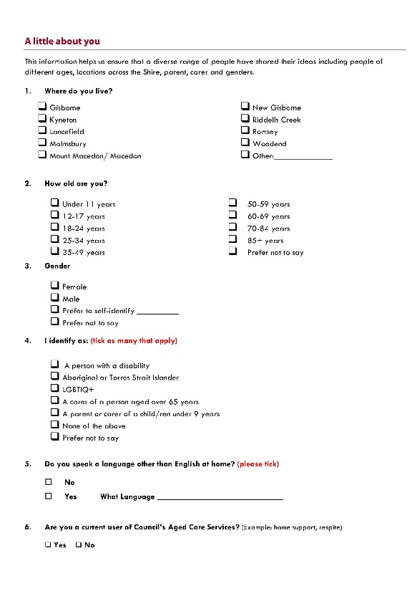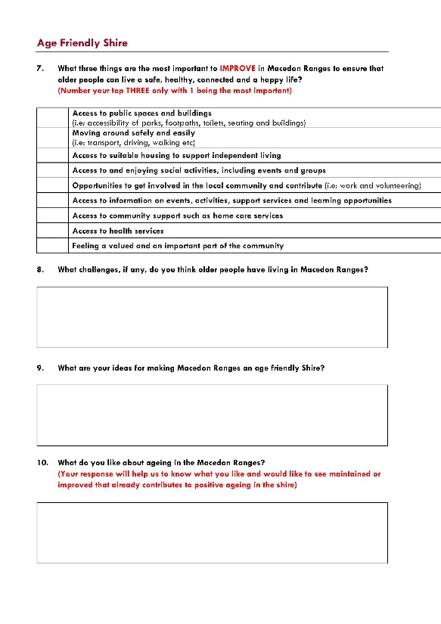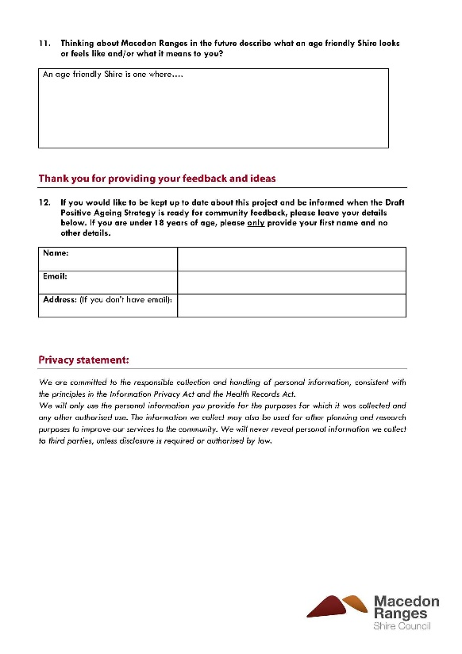

Appendix 3: We Found – additional supporting data from consultations
Approach to data analysis for open-ended survey questions
As the consultation generated large volumes of personalised feedback via the online and hard copy surveys open ended questions, the responses were analysed, carefully sorted, and categorised using some prescribed themes as well as emergent themes and sub-themes. Over 4,200 individual comments were received via the eight open-ended questions in both surveys.
The feedback was collated and manually reviewed for recurring and common themes, which were then identified as sub-themes. Following the identification of sub-themes, each statement within the feedback was coded to generate frequency counts that reflected the relative centrality of the topic. Where a statement did not appear to neatly fit within a theme or sub-theme, it was classified as “Other”.
To understand the number of comments received under each open-ended question the following terms were used to describe the number of comments received in each theme and sub-theme.
Term | Number of comments
Very large amount/number of comments | = 150+
Large amount | = 100–149
Sizeable amount | = 75–99
Substantial amount | = 50–74
Considerable amount | = 25–49
Moderate amount | = 15–24
Several comments | = 8–14
Small number | = 4–7
Few | = 3
Couple | = 2

The findings
Challenges for older people
The most frequently identified challenges facing older people in the shire were accessing transport, the ease of getting around generally and accessing health services. In addition, the issue of footpath quality and continuity was frequently raised, making ease of movement the most identified issue for respondents.
Other topics with a considerable number of comments included public transport (predominantly the need for more, and more accessible public transport), the importance of opportunities for older people to make social connections in order to reduce social isolation, and support services availability to assist people to maintain independence.

Ideas for making an age-friendly shire
Ideas for an age-friendly shire most commonly discussed the availability and accessibility of activities and events. The social connections and inclusion that this was considered to facilitate were viewed as essential to create an age-friendly shire. Good transport was again considered an important facilitator of positive outcomes.
Increased housing and health provision were also considered important aspects of making an age-friendly shire.
Again, footpaths were identified as an aspect of infrastructure in need of improvement. This was viewed as enabling shire residents to move about more freely and safely.

What is liked about ageing in the Macedon Ranges?
The most liked aspects of ageing in Macedon Ranges was the community feeling created by being surrounded by friendly and supportive people. In addition, living in a lightly populated place and being able to access good health services were liked by many. People valued the positive community feel of where they live and the unhurried pace of life, typical of smaller towns. A number of respondents also appraised the attractiveness of the area or the quality of the natural environment.
A substantial number of respondents stated they did not know what they liked about ageing there.

What an age-friendly shire looks like
Respondents’ aspirations for an age-friendly shire discussed feeling included, welcome, and valued, and the ability to access support services into old age so that independence can be maintained. For many, this meant a strong sense of community with informal supports in place.
In addition, the ability to participate socially, including ease of movement to and from activities, were important for people. Other fundamental aspects of an age-friendly shire were individuals feeling safe and having access to quality health care.

Things that are most important to improve in Macedon Ranges to ensure older people can live a safe, healthy, connected and happy lives
Survey respondents were asked to select from a list of nine predetermined items the three things that were most important to improve to ensure older people lived safe, healthy, connected and happy lives.
Of the 292 respondents who answered this question, moving around safely and easily was the most important with a weighted average of 7.82, followed access to public spaces and buildings (weighted average 7.75), access to suitable housing to support independent living (weighted average 7.57) and access to health services weighted average 7.56).
What three things are most important to IMPROVE in the Macedon Ranges to ensure older people can live a safe, healthy, connected and happy life?

Appendix 4. Qualitative consultation locations and audience reached
GROUP | TOWN | TYPE
Romsey/Lancefield Feed It forward | Romsey | Community Lunch
Woodend Community Lunch | Woodend | Community Lunch
Residents - no specific group | Kyneton | Community lunch
Residents - no specific group | Gisborne | Info table + surveys
Kyneton University of the third Age (U3A) | Kyneton | Interactive Workshop
Men’s Shed/ Senior Citizens Group | Riddells Creek | Interactive workshop
Council staff - Healthy Hearts Victoria, Aquatic and Leisure, Arts and Culture, Immunisation, Infrastructure (playgrounds/maintenance/outdoor space), Maternal Child Health, Early Years Staff, Community Support Unit, Customer Support unit, Youth services |  | Interactive workshop
Men’s sheds/ Senior Citizens Group / U3A (2) | Kyneton | Interactive workshop
Men’s sheds/ Senior Citizens Group / U3A (1) | Gisborne | Interactive workshop
Invited U3A, Seniors, Men’s Sheds + targeted other local community groups | Woodend | Interactive workshop
Invited U3A, Seniors, Men’s Sheds + targeted other local community groups | Lancefield | Interactive workshop
Invited U3A, Seniors, Men’s Sheds + targeted other local community groups | Romsey | Interactive workshop
Macedon Ranges Community Care Partnership group | Gisborne | Meeting
Cobaw Community Health, Macedon Ranges Health, Kyneton District Health, Aged Care providers etc. (Doctors surgeries/specialist – Occupational Therapist/Speech pathologist) |  | Phone consults and surveys
Kyneton Agricultural Show | Kyneton | Pop up 1
Residents - no specific group | Woodend | Pop-Up 2
Residents - no specific group | Kyneton | Pop-Up 3
Residents - no specific group | Woodend | Pop-Up 4
Residents - no specific group | Gisborne | Pop-Up 5

Qualitative findings
Community Groups
Six interactive sessions were held with community members and representatives from local groups to facilitate targeted discussions about positive ageing in Macedon Ranges. In total fifty-four people attended these sessions and included residents and representatives from:
- Kyneton U3A
- Kyneton Senior Citizens Group
- Macedon Ranges Health
- Gisborne Church of Christ
- Riddell & District Senior Citizens Club
- Intereach
- Lancefield Men’s Shed
In addition, a separate meeting was also held with representatives from the Macedon Ranges Community Care Partnership Group that was attended by seven people with representatives from:
- Kyneton District Health (newly named Kyneton Health - Central Highlands Rural Health)
- Macedon Ranges Health (supported by Benetas)
- Cobaw Community Health
- Macedon Ranges Shire Council
- Department of Health and Human Services
Council staff also attended a range of groups and community lunches to talk about the project and distribute information and hard copy surveys. Over 275 surveys were distributed to attendees.
Below is a summary of the feedback received at these sessions. Not all sessions provided opportunities for instant feedback, with many participants taking home a hard copy survey to be returned via a reply-paid envelope.
Interactive sessions
At the interactive session, people were asked ‘What challenges do older people have living in Macedon Ranges.’
The highest number of responses to this question involved people’s health and wellbeing (19 comments), in particular being able to access various health services. The second highest number of responses involved transport (13 comments) including the lack of public transport and transport options to help older people stay mobile, connected and less isolated.
Comments relating to infrastructure were raised 11 times and included concerns about lack of footpaths and parking. Unsafe footpaths was also raised several times under the theme of safety. Other topics under safety included fear associated with bushfires, increased traffic and cars speeding and lack of street lighting.
Isolation of older people across Macedon Ranges was also raised as an important challenge (mentioned in 9 comments) as well as poor internet access.

The table below shows the number of comments made under each theme:
Theme | No of comments
Health and wellbeing (including access to services) | 19 comments
Transport | 13 comments
Infrastructure | 11 comments
Safety | 10 comments
Social connection and isolation | 9 comments
Communication | 7 comments
Advocacy and support | 1 comment
Other | 3 comments
Participants in these sessions were also asked: What are your ideas for making Macedon Ranges an age-friendly shire?
A range of ideas was provided across all the key themes. There were 13 ideas under health and wellbeing, which mainly involved increased services for older people in Macedon Ranges like:
- Services to help people remain independent:
  - outreach services to smaller towns and rural areas
  - delivered meals
  - assistance with getting groceries and shopping
  - assistance with maintaining properties in the lead up to bushfire season
- Places for older people to connect like a drop-in centre and recreational activities
- Support services including for mental health and for those who have lost a partner
There were eight ideas involving Council supporting already existing seniors’ groups to help them grow and be successful and eight ideas relating to communications, seven of which were about Council increasing and improving communications with older people and information available.
Other ideas included undertaking a footpath audit and improving unsafe footpaths, more community bus services, celebrating and promoting Neighbours Day to get neighbours to look out for each other and more intergenerational activities and opportunities.

The table below shows the number of comments made under each theme:
Theme | No of comments
Health and wellbeing (including access to services) | 13 comments
Advocacy and support | 8 comment
Communication | 8 comments
Social connection and isolation | 6 comments
Transport | 5 comments
Infrastructure | 4 comments
Safety | 2 comments
Five of the six groups participated in an activity where they were asked to prioritise which of these ideas or focus areas was most important. They were asked to pick their top three priorities. The top-rated priority areas were:
- addressing isolation
- better access to medical services in particular mental health services
- better roads and footpaths
- improved information and communications
- more and extended bus services
At the interactive sessions 23 participants provided input into a dotmocracy activity which asked: ‘what three things are the most important to improve in Macedon Ranges to ensure older people can live safe, healthy, connected and happy lives?’. People were given three dots to place on the dotmocracy board.
Feedback was fairly even across the dotmocracy board, but the three top responses were:
- feeling valued and an important part of the community (13 dots)
- access to health services (9 dots)
- moving around safety (9 dots)
- opportunities to get involved (9 dots)

DOTMOCRACY
What three things are the most important to improve in Macedon Ranges to ensure older people can live safe, healthy, connected and happy lives?
Access to Public Spaces | Moving around safely | Access to suitable housing | Access to and enjoying social activities | Opportunities to get involved | Access to information on events, activities | Access to community support | Access to health services | Feeling values and an important part of community
4 | 9 | 7 | 7 | 9 | 4 | 7 | 9 | 13

The final activity in these sessions involved discussing the Australian Government’s aged care reforms and how these may impact Council and the delivery of in-home aged care services.
After discussing the reforms, participants were asked: ‘given what we have just spoken about, if other providers are available, how important is it that Council provides home care services? (Including personal care, domestic assistance - assistance with household tasks, shopping, support in accessing the community and respite)’.
Participants were asked to tick their preferred option. 22 people participated in this activity.
Very important | Important | Neutral | Low importance | Not important
6 | 5 | 2 | 5 | 4
*Please note: the above figures are from five of the six interactive sessions facilitated by consultants. Comments from the Lancefield Men’s Shed session hosted by Council staff indicated that most participants (out of 19) felt it was important for Council to continue to deliver home care services. 54 attendees at the Riddells Creek Senior Citizens Group, which was also attended by Council staff, indicated they thought it was very important that Council continue to provide home care services.
Feedback on this topic from the sessions was mixed.
Some people felt it was important for Council to still provide in-home aged care services because:
- they were concerned with the quality of services from other providers
- they didn’t want to have to ring around different companies to get services
- they preferred a trusted service provider that could make accessing services easy
Others felt it was not as important for Council to deliver the services but to play a supporting or ‘watch dog’ role on behalf of the community including:
- helping people to find the right care
- monitoring service providers to make sure they are good operators
- dealing with concerns and complaints about local service providers
Given the complexity of the topic, and lack of time in the sessions, this could be seen as a good starting conversation with the community about the potential impacts of the Australian Government reforms.
Community Care Partnership Group meeting
A meeting was held with seven representatives from the Community Care Partnerships Group.
The key challenges that they identified for older people in the area included:
- social support and transition packages – not enough funding in the packages
- long wait list for home care packages
- social isolation especially for LGBTIQ older people
- physical isolation and issues around bush fires and climate change (heat)
- lack of transport options including taxi’s / lack of accessible transport
- financial stress for many older people including paying rates and bills
- footpaths – lack of them and many are unsafe
- shortage of qualified staff in the area such as Occupational Therapists, physiotherapists, speech pathologists
- poor internet access
This group felt the priorities that should be focussed on to make Macedon Ranges more age-friendly included:
- improved communications and information for older people – e.g.: joint effort by agencies to cross promote and inform about services and campaigns
- increased transport options for older people
- a focus on social and affordable housing – e.g.: social and affordable housing strategy
- improved internet access
In relation to the Australian Government’s aged care reforms, this group indicated that it was important to continue the conversation with the community but to be clear about what the community could influence in relation to Council’s decision making on the future of these services.
Council staff workshop
A workshop was held with key staff on Thursday 12 December 2019. Twenty staff from across a range of Council departments attended the workshop to provide input and feedback to inform both the Early Years Plan and the Positive Ageing Plan.
Below is a summary of the feedback provided at these session’s.
Staff were asked ‘what challenges do you think older people have living in Macedon Ranges?’
The highest number of responses to this question involved social isolation, being able to meet and connect with people of all ages and having events and activities to keep people active and connected.
There were seven comments about access to services for older people and six comments about local infrastructure needing improvement and being inaccessible, in particular housing and footpaths.
There were also six comments about the challenges around communications and older people accessing information, especially when it is online. This was followed by five comments about the lack of transport options for older people across the shire.
The below table shows the number of comments made under each theme:
Theme | No of comments
Social connection and participation | 13 comments
Health and wellbeing (including access to services) | 7 comments
Infrastructure | 6 comments
Communications | 6 comments
Transport | 5 comments
Safety | 4 comments
Other | 2 comments
Participants in this meeting were also asked: ‘What are your ideas for making Macedon Ranges an age-friendly shire?
A range of ideas was provided across most themes. Some of these ideas are listed below:
- Establish a volunteer dog walking program to enable people to continue to keep their dogs and exercise them when mobility becomes an issue
- Activities that link generations like inter-generational playgroups and school visits and all age outdoor spaces
- Increase funding for footpath improvements and improvements to the built environment
- Capitalise on the strong local culture of volunteering for transport solutions and to connect people
- Age-friendly Council awards for local businesses and services
- Better outcomes from developer contributions for more age-friendly housing

The table below shows the number of comments made under each theme:
Theme | No of comments
Social connection and participation | 4 comments
Advocacy and support | 4 comment
Infrastructure | 4 comments
Transport | 1 comment
Health and wellbeing (including access to services) | 1 comment
Safety | 0 comments
Communication | 0 comments
Participants were also asked to ‘describe what an age-friendly shire looks like’.
Responses included a place where there was more diverse, affordable and accessible housing, better transport options and where people were connected to the community and each other.

Age-friendly shire pop-up results
There were a range of ways the community could provide their feedback and ideas during the five place-based pop-up events. They could provide their feedback via a dotmocracy board, chat board, Big Ideas drawing sheet as well as via the hard copy survey.
Below are the results of the chat board responses and dotmocracy activity. The age-friendly surveys collected at the pop-up events have been analysed alongside the online surveys, which can be found on section 6.1.
Participation at the five place-based pop-up events were higher at the large-scale community events such as the Kyneton Show and Gisborne Carols by Candlelight. The other three smaller pop-up events were a great opportunity to engage with and inform the community, especially older people who were out shopping, of their opportunity to share their feedback and ideas with many taking a hard copy survey to post back.

Age-friendly chat board responses
A total of 35 comments were written on the chat board in response to the question ‘What are your ideas for making Macedon Ranges age-friendly?’
There was a diverse range of comments including the need for more and improved footpaths (improve footpaths, more footpaths rather than walking on roads) which came up at most pop-up events, the need for more transport (a GisBus in every town, community transport, transport for out of towners, more community transport to shopping centres), support for older residents (grass cutting, property maintenance, home care) as well as comments about dogs off lead/dog parks and the need for more LGBTI events and social activities.

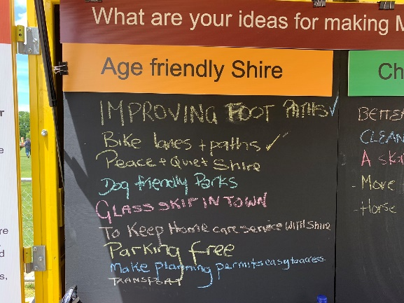

COMMENTS
Improving footpaths | Suggestion boxes
Bike lanes and paths | Footpaths
Peace and quiet shire | Improve waiting times for Aged Support
Dog friendly parks | Help with grass cutting
Glass skip in town | Transport
To keep home care services with shire | Transport for out of towners
Parking free | Help to maintain properties
Make planning permits easy to access | Ad hoc in-home services to access when needed
Transport | Enforcement of dogs off-lead (impacting safety) e.g. by the river
More affordable housing | Community transport
Lights at High Street (Coles) | More footpaths-safer for older people rather than walking on roads
Signage and crossing outside Woodend Coles | More disability parking spaces
A GisBus in every town | 40km speed limits in built up areas
Better maintained public toilets | More bus/community transport to shopping centres (well publicised)
Footpaths | More LGBTI social events
IGA/shops for New Gisborne | 50 metre New Gisborne pool
Better community/helping | Better bike path connecting to train stations for local residents and day trippers from the city
More LGBTI friendly
Age-friendly dotmocracy results
Forty-four people participated in the age-friendly shire dotmocracy activity. Participants were asked what the most important things were to improve to ensure older people can live safe, healthy, connected and happy lives.
Four themes received the same number of responses from people over 18 years. Access, to public spaces, moving around easily, opportunities to get involved and access to community support. Access to health services and feeling valued and important also received a moderate number of votes.
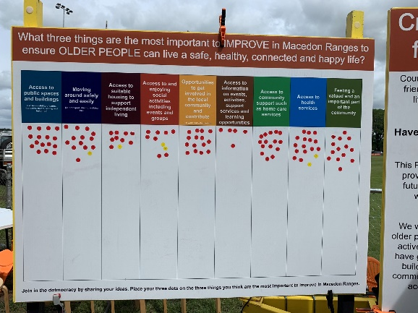

Pop up session findings
 | Access to Public spaces |  | Moving around safely |  | Access to suitable housing |  | Access to and enjoying social activities |  | Opportunities to get involved |  | Access to information on events, activities |  | Access to community support |  | Access to health services |  | Feeling valued and important
 | Under 18 | Over 18 | Under 18 | Over 18 | Under 18 | Over 18 | Under 18 | Over 18 | Under 18 | Over 18 | Under 18 | Over 18 | Under 18 | Over 18 | Under 18 | Over 18 | Under 18 | Over 18
Pop-Up 1-Kyneton Show | 0 | 17 | 1 | 15 | 1 | 11 | 2 | 8 | 0 | 15 | 0 | 4 | 0 | 15 | 2 | 16 | 0 | 14
Pop-Up 2-Woodend Coles | 0 | 0 | 0 | 1 | 0 | 1 | 0 | 1 | 0 | 1 | 0 | 0 | 0 | 1 | 0 | 0 | 0 | 1
Pop-Up 3-Kyneton Woolworths | 0 | 0 | 0 | 1 | 0 | 0 | 0 | 0 | 0 | 0 | 0 | 1 | 0 | 1 | 0 | 0 | 0 | 0
Pop-Up 4-Woodend Children's Park | 0 | 0 | 0 | 0 | 0 | 0 | 0 | 0 | 0 | 0 | 0 | 0 | 0 | 0 | 0 | 0 | 0 | 0
Pop-Up 5-Gisborne Carols | 0 | 0 | 0 | 0 | 0 | 0 | 0 | 1 | 0 | 1 | 0 | 1 | 0 | 0 | 0 | 0 | 0 | 0
Sub total | 0 | 17 | 1 | 17 | 1 | 12 | 2 | 10 | 0 | 17 | 0 | 6 | 0 | 17 | 2 | 16 | 0 | 15
TOTALS | 17 |  | 18 |  | 13 |  | 12 |  | 17 |  | 6 |  | 17 |  | 18 |  | 15

Consultation challenges and our approach
Although the overall response to the consultation activities was high, we did experience some key challenges and constraints when planning and delivering the engagement program. The table below outlines these engagement constraints or challenges, and the mitigation strategies used to minimise negative impacts.
Engagement challenges/constraints | Mitigation
Large area to cover - Macedon Ranges Shire is a geographically large area, covering approximately 1,747 km², with a population of 49,388 (2018 estimated resident population-ABS) across nine major towns and a total of 46 towns and villages. | A detailed schedule of engagement activities was developed to ensure careful selection of as many towns and villages as possible to be included.
Engaging beyond the physical area – reaching residents who commute outside of Macedon Ranges Shire each day. | Developed and promoted the online survey.
Planning for adverse weather for the place-based pop up consultation events. | The engagement program had some flexibility built in in case consultation events had to be re-scheduled.
Obtaining the views of ‘hard to reach’ residents including people with a disability or from low-socioeconomic backgrounds, people from Culturally and Linguistically Diverse (CALD) backgrounds, people who are socially isolated | Use of pop-ups to engage participants during normal daily activities e.g. shopping
The feedback was collated and manually reviewed for recurring and common themes, which were then identified as sub-themes. Following the identification of sub-themes, each statement within the feedback was coded to generate frequency counts that reflected the relative centrality of the topic. Where a statement did not appear to neatly fit within a theme or sub-theme, it was classified as “Other”.
Additional considerations
We ran some of the Participate consultation activities alongside consultation for the development of Council’s new early years plan. A voting pod, as part of place-based pop-ups, was the only tool where a general question was asked that related to both Early Years and Positive Ageing. 226 people participated in this activity, with most being under 18 years. A substantial majority of those who participated think that Macedon Ranges is either ‘Good’ or ‘Great’ at being child and age-friendly.

Macedon Ranges Shire Council PO Box 151, Kyneton VIC 3444
Call (03) 5422 0333
Email mrsc@mrsc.vic.gov.au
Follow us on facebook.com/Over55sConnect mrsc.vic.gov.au
Read the Positive Ageing Plan 2020-2025: PARTICIPATE on our website mrsc.vic.gov.au/PARTICIPATE

World Health Organisation, WHO Global Network for Age-friendly Cities and Communities
Australian Bureau of Statistics, Census of Population and Housing 2016
Dementia Australia, Dementia statistics for Victoria
Department of Health and Human Services, January 2009 Heatwave in Victoria: an Assessment of Health Impacts
Ibid
World Health Organisation Age-friendly Cities Guide
Australian Bureau of Statistics, profile id Population and age structure
World Health Organisation Age-friendly Cities Guide
Australian Bureau of Statistics, Resident workers key statistics – all industry sectors
Australian Bureau of Statistics, General Social Survey: Summary Results, Australia, 2014
Australian Bureau of Statistics, profile id Macedon Ranges Shire Volunteer work
Australian Bureau of Statistics, Disability, Ageing and Carers, Australia: Summary of Findings, 2018
Australian Bureau of Statistics, profile id – Population and age structure
National Aboriginal and Torres Strait Islander Health Plan 2013-2023
Australian Bureau of Statistics, 2016 Census Quick Stats: Macedon Ranges (S)
ibid
Australian Bureau of Statistics, 2016 Census Quick Stats: Macedon Ranges (S)
Australian Institute of Health and Welfare - Older Australia at a glance report
Victorian Government – Ageing and Aged Care April 2020
Royal Commission into Aged Care Quality and Safety – Interim Report royalcommission.gov.au/publications/Pages/interim-report.aspx
ibid
International Association for Public Participation

