Developing a Project Plan
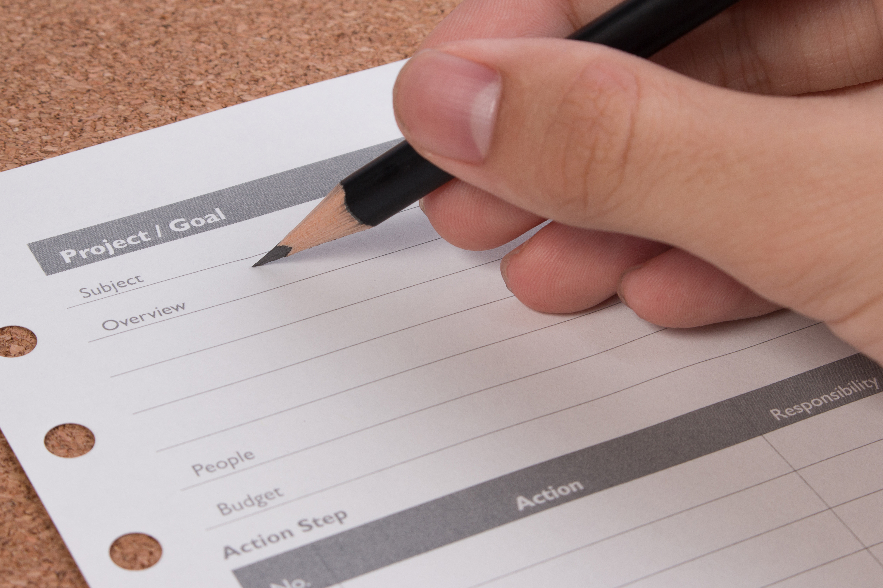
Tips for developing a clear plan
You can strengthen your grant proposal by:
- Communicating clearly in a way funders understand.
- Showing how you will utilise the funds
- Making it easier to meet any reporting requirements during the project.
- Making it easier to acquit the grant once the project is complete.
Some funders will provide templates to use. It is recommended that you use these. If however, you wish to use your own format, make sure you incorporate all details set out in the funder’s templates.
Getting started
- Your project plan should provide the answers to the following questions:
What, Why, Who, How, When, Where and How much?
- Your project should have a clear goal that should closely align with the goals of the funder.
- The activities you undertake in your project should lead to outcomes that help you meet that goal.
- Project outcomes should be clear and provide measurable benefits.

For example:
Your goal might be
- to provide safe ways for groups to gather and reconnect outdoors post COVID in Gardiner Reserve
The outcomes might be
- improved facilities
- more people visiting Gardiner Reserve
- more outdoor community events
Your activities might be
- building undercover BBQs
- installing benches
- purchasing outdoor event equipment
- organising a launch event
- promoting new facilities for community events to local groups

SMART Goal Setting
Setting SMART Goals is a great way to make grant reporting and acquittal easier, whilst helping you to keep your project on track:

- Specific – clear and to the point (answers the who and what)
- Measurable – you will be able to see evidence that your goal was successful
- Achievable – you will be able to deliver the project
- Relevant – the goal should be relevant to what you actually want your project to do
- Time Bound – you should be able to set timeframes for the goal being achieved

Evaluation
If you have used the SMART approach when designing your project, it makes it easier to meet reporting requirements during the project and when it comes time to acquit your grant you will know exactly what to measure to test your success.

Going back to our example:
You could measure outputs by the number of additional BBQs, benches, number of people at a launch event etc.
Other measureable outcomes could include:
- Improved facilities (use of photographs to show comparison of facilities before and after)
- More outdoor community events (number of community events held in reserve before and after)

For more information email grants@mrsc.vic.gov.au

