Amess Road Precinct Structure Plan
Frequently asked questions
What is a Precinct Structure Plan (PSP)?
A Precinct Structure Plan (PSP) provides a ‘blueprint’ for development and infrastructure investment that will occur over many years. A PSP lays out the important features of the precinct for local communities such as roads, parks, key transport connections and areas for housing. A PSP is informed by existing plans and strategies, such as the Macedon Ranges Settlement Strategy and the Riddells Creek Structure Plan.
Why is the Amess Road PSP being prepared?
The Urban Growth Zone requires preparation of a Precinct Structure Plan to guide development. The future development of the Amess Road precinct will be guided by a Precinct Structure Plan.
What has led to this point?
The 2011 Settlement Strategy and 2013 Riddells Creek Structure Plan support Riddells Creek growing into a district or large district town by 2036. The 2013 Riddells Creek Structure has designated the Amess Road precinct as a priority residential development area. Following this, the Minister for Planning approved Amendment C100 and the land north of Amess Road was rezoned to Urban Growth Zone.
What has not been decided?
Council have not made any decisions regarding the Amess Road PSP project or the draft urban framework plan. The purpose of the September consultation was to understand the views of the community to inform Council before Council makes any decisions.

How can I have a say in what the PSP looks like?
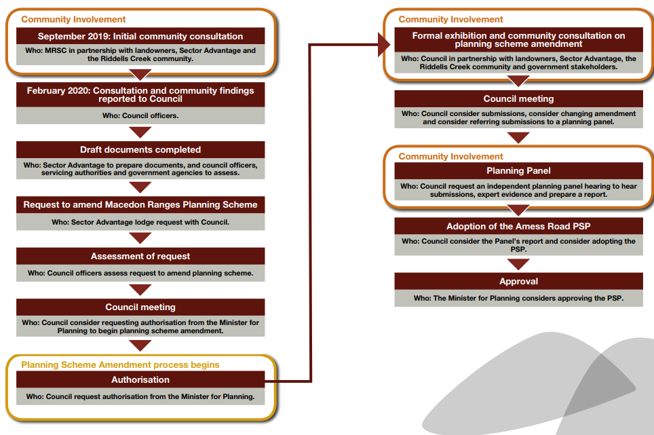
Community involvement and next steps in the project is shown on the process map below:
Neighbourhood Character and lot sizes
Neighbourhood/town character is an important consideration in the design of housing. One outcome of a PSP is to provide housing in response to the identified needs of the community. A PSP must be designed to deliver housing which provides diversity, provides for an appropriate overall population and housing design which achieves an appropriate township character outcome. These needs are considered and balanced through preparation of the PSP. This is in response to the Riddells Creek Structure Plan principles and directions at page 11, including:
- Protect the urban and rural character and amenity of the residential areas
- Consolidate residential growth and development
- Allow for a range of lot sizes, housing types and lifestyle opportunities to meet the needs of the community
- Provide for a range of residential development opportunities within the ‘Priority Residential Development Precinct’ that increases housing diversity and provides greater housing choice.
ABS census data from 2016 shows Riddells Creek contained 1,172 private dwellings, of which 95% were separate houses and over 92% of dwellings contain 3 Bedrooms or more. The Structure Plan notes the lack of housing diversity has led to concerns that future generations will not be able to afford to settle in the Township or that there will be limited accommodation options for people wanting to downsize. Lot sizes have not been decided on, but it is recognised that existing policy promotes housing diversity, which requires a range of lot sizes. Diversity includes larger lots for families with children, medium sized lots and also includes smaller lots for singles or couples either looking to enter the housing market or looking to downsize from a larger property. A diversity of lot sizes is Important because it supports a range of people with different housing needs at different stages of their life.
The Riddells Creek Structure Plan includes a footnote at p. 62 providing an approximate lot size range of 800-1200 sqm to allow for neighbourhood character. Average lot size is calculated by dividing net developable area by the number of lots. It is noted that the Riddells Creek Structure Plan does not specify lot size based on the need for housing diversity or the overall population and further work is needed to determine the appropriate range of lot sizes to provide housing diversity and an appropriate character outcome.
Community infrastructure
Open space, recreational and community infrastructure and service requirements will be determined by the community needs assessment technical report which reviews population and demographic projections. This report will be used to help determine matters such as the location, timing of delivery and investment in new and existing facilities to meet the anticipated needs of the community.
Traffic and transport
Preparation of a PSP includes preparing a traffic and transport technical report which considers walking, cycling, cars, traffic and public transport. This work will identify transport infrastructure capacity, propose upgrades where needed and inform the design of the precinct and surrounds. It is acknowledged that existing roads such as Amess Road and the intersection with Amess Road and Gisborne-Kilmore Road, will likely require upgrading. It's anticipated that Amess Road will be widened, include footpaths and/or shared path and additional tree planting, however design is not finalised at this stage. It’s also anticipated that VicRoads will reduce the speed limit on Gisborne-Kilmore Road. This work will improve the safety for pedestrians and other road users, as well as increase the capacity of the roads for vehicles.
Natural environment
A PSP involves qualified professionals producing technical reports assessing various environmental aspects including flora and fauna, a storm water management strategy, geomorphology and vegetation values assessment, an ecology and biodiversity assessment, arborist report and Growling Grass Frog survey. This information informs the Precinct Structure Plan (PSP). The PSP can incorporate environmental requirements regarding such things as retention of vegetation via a Native Vegetation Precinct Plan, design of waterways, and environmentally sensitive design in development.
The draft urban framework plan shows Sandy Creek and Wurundjeri Creek located in public reserves. Constructed drainage reserves and natural waterway reserves can serve a drainage function as well as multiple other functions, where appropriate. Some drainage reserves can include walking and cycling pathways, areas for conservation of native vegetation and act as wildlife corridors. The design of the constructed drainage reserves and natural waterway reserves in the precinct are intended to be multifunctional, provide a benefit to residents, flora and fauna, and are subject to Melbourne Water approval. A PSP can require the creeks be restored and revegetated, and serve as open space corridors providing public access, movement for wildlife and best practice land management.
Car Parking
The issue of car parking in the town centre and at the train station is noted. Council will continue to advocate to the Department of Transport to progress upgrades to station car parking.
Infrastructure requirements
Preparation of a Precinct Structure Plan (PSP) involves preparation of various technical reports which review the current capacity of infrastructure and determine what new or upgraded infrastructure is needed to support an increase in population. These reports are currently being prepared. The timing of delivery of infrastructure is dependent on when it is required. A PSP can require the delivery of infrastructure by specifying the time at which it is required.
Open space planning
Precinct Structure Planning (PSP) Guidelines and Clause 56.05 of the Macedon Ranges Planning Scheme provide guidance around the design of open space. They require new subdivisions provide local parks within 400m safe walking distance of at least 95% of all dwellings; active open space within one kilometre of 95% of all dwellings; linear parks and trails along waterways, vegetation corridors and road reserves within 1 kilometre of 95 percent of all dwellings. The PSP will be designed to incorporate these requirements.
Path connections
Council have a Shire wide footpath plan which sets the priorities for construction of paths for future years and is updated on an ongoing basis. The aim is to improve walking access to schools, business districts, community and recreational facilities, transport connections and general access improvements for residents. One challenge for delivery of footpaths in existing areas is funding. New development provides the opportunity to leverage development contributions which can be used to pay for improving existing infrastructure (such as road and path upgrades) and providing new infrastructure (such as new paths). However, it is beyond the scope of the PSP to address provision of footpaths throughout the whole of town.
The Macedon Ranges Shared Trails Feasibility Studies have examined shared path connections between towns in the Shire. Shared path connection between Riddells Creek and Gisborne are planned but subject to funding. The PSP can seek connection of a new shared path along Amess Road with the existing shared path along Main Road.
Timing of development
A Precinct Structure Plan is a planning tool used to guide and coordinate development of a large area called a ‘precinct’. Development of land can only occur after the PSP is approved, and is subject to a planning permit being lodged with and approved by Council. There is currently no proposal to subdivide land and no timeframe for development of the precinct to start or finish. Development of the precinct is expected to occur in stages over time and it is possible that development may not be complete until after 2036.
Services
Preparation of a PSP includes consultation with servicing authorities to ensure all necessary services can be delivered and designed appropriately and ensure that all lots can be serviced. The necessary services and infrastructure are considered and planned for as a part of the PSP process. The PSP will detail information about servicing and infrastructure requirements, locations and timing of delivery.
Bushfire
The Macedon Ranges Planning Scheme Clause 13.02-1S requires the protection of human life is given priority over all other policy considerations. Council is working with the Country Fire Authority during preparation of the PSP in order to understand their views and satisfy their requirements. See Submission number 237 to read the Submission from the CFA. It’s also important to note that the bushfire risk to human life was considered at the time the Riddells Creek Structure Plan was prepared and implemented, and was considered when the decision was made to designate the land as priority residential development precinct. These decisions were made in consultation with the Country Fire Authority. The Country Fire Authority did not object to the priority residential development designation, nor implementation with the Urban Growth Zone via planning scheme amendment C100.
Energy efficiency
Energy efficiency and electricity consumption of dwellings can be determined by a range of measures, including solar. Other measures include building materials and thermal mass, dwelling orientation, design and layout, daylight and shading, landscaping, ventilation, window placement, type and glazing options. Further details on this are included in the Macedon Ranges Shire Council Environmentally Sustainable Design Factsheet via the Council website. All new houses must comply with the energy efficiency requirements of the Building Code of Australia (BCA) Volume Two. This design and compliance is determined at the building permit stage which is typically the final stage of the approvals process. Typical houses in a residential subdivision don’t require a planning permit in addition to the building permit. This means that the influence of Council is generally restricted to setting up the pre-conditions for a resource efficient dwelling to be built on the land at the time of subdivision.
Retail needs
Preparation of the PSP includes a retail needs assessment technical report. This report analyses whether additional retail is needed. It is anticipated that the precinct will generate additional retail demand and it’s noted that there is no land proposed to be used for retail in the precinct. It Is further noted that there is planning permission for a supermarket in the town centre.
Infrastructure funding and the Development Contributions Plan (DCP)
In response to who pays for or delivers infrastructure, technical reports will inform the preparation of a Development Contributions Plan (DCP) to be implemented via a planning scheme amendment. The DCP is the mechanism which funds the infrastructure necessary to support a growing population. This includes funding upgrades to existing infrastructure as well as funding new infrastructure. The DCP will set out information such as the items requiring funding from development contributions, the cost of the item, the priority of delivery of the item, and the location and design of the item. Once listed in the DCP Council has a legal responsibility to deliver these items. All land owners covered by the DCP which develop their land in a way which increases demand on infrastructure, are obliged to pay development contributions - this will be detailed in the DCP. The DCP is yet to be prepared, but sits beside and is critical to the implementation of the Precinct Structure Plan (PSP).
Examples of projects that can be included in a DCP:
- Land and construction costs for road and drainage upgrades
- Landscaping and streetscaping works
- Parks, community centres, neighbourhood houses and libraries
- Sporting facilities
- Youth facilities
- Community health centres
- Bike and walking paths
- Public lighting and toilet blocks.
Future population and the Settlement Strategy
The 2011 Settlement Strategy includes a year 2036 population recommendation for Riddells Creek, however the Macedon Ranges Planning Scheme instead designates Riddells Creek as growing to a district town or large district town with a population range. The town designation represents the role and function of the town. The population range is not an absolute maximum population figure or population cap. This understanding was shared between Council and the Planning Panel for Amendment C100 which implemented the Riddells Creek Structure Plan.
Flooding
Preparation of a PSP includes preparation of a storm water management strategy technical report. This report will assess any flooding issues in both a pre-development and post-development setting. This report determines how waterways will operate and what constructed drainage assets and drainage reserves are required to manage storm water. The report, the design of drainage assets and reserves, and design of future development is subject to agreement from Melbourne Water to ensure storm water is appropriately managed and risk of flooding mitigated.
Cultural Heritage
Preparation of a PSP involves preparing a pre-contact and post-contact heritage study to determine the cultural heritage values of the precinct. In addition to this, a Cultural Heritage Management Plan (CHMP) is required prior to the issue of a planning permit for subdivision. A CHMP will be prepared in association with the Wurundjeri Aboriginal Corporation and Aboriginal Victoria, and include detailed historical and archaeological investigation of aboriginal cultural heritage values on the site.

Ambulance, police, fire, education and train services
These services are provided and planned by state government agencies and are beyond the control of Council. The PSP project will involve consultation between Council and the Country Fire Authority, Ambulance Victoria, Victoria Police, the Department of Education and Training and Department of Transport as the agencies responsible for these services.
Further assistance
For further information about the Amess Road PSP project, please contact the Macedon Ranges Shire Council Strategic Planning department on (03) 5422 0333.

