Amess Road Precinct Structure Plan Community Information Drop-in Session
Thursday 19 September 5:00pm-8:00pm
Sticky Notes Community comments

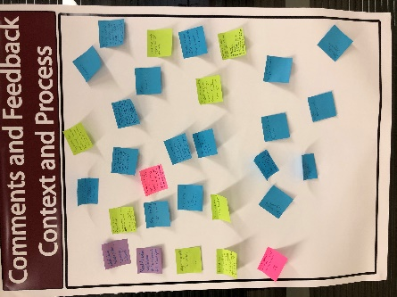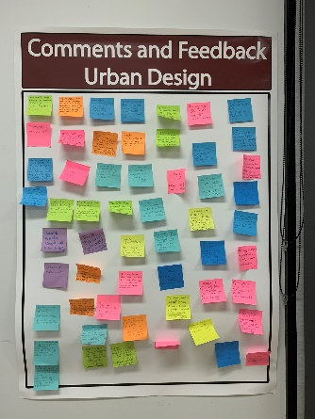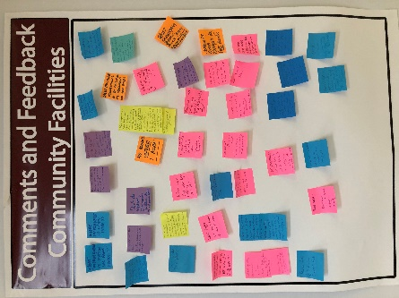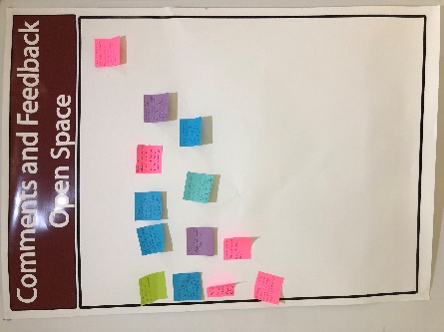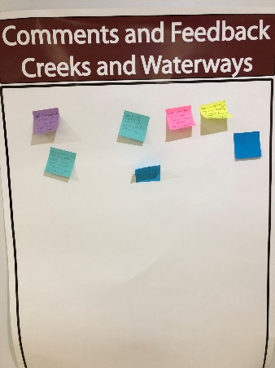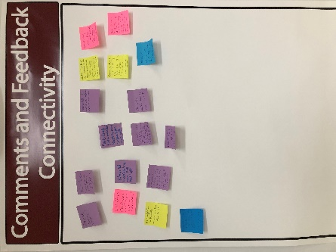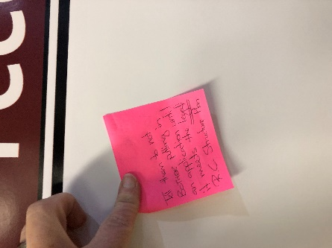
Context and Process
Ambulance
The PSP is being created to offset the region being zoned urban growth. The zoning needs to be addressed
Any plans for new roads, health + medical facilities, age care, ambulance, increased police and fire services?
Minimum block size is too small – more what you would expect in inner Melbourne, not a rural town
When will the infrastructure be done, years after development like the rest of Riddells and Gisbone
Block sizes not negotiable – keep the rural living style to the town
Contribution to town facilities
What about infrastructure?
So many more people – KEEP RIDDELL RURAL
What about schools, water, sewage, internet?
Need to make subdivision fit into community feel – not a ghetto
Keep Riddells Creek RURAL
That is a lot of growth on small, cheap property. I hope we have police to “help” our own lower socio-economic friends
Train expansion
Block size totally inappropriate for this area
Why are graphics not clear? The graphics of the development are not clear enough
Crime rate will go up – no police available
Already have water pressure problems after previous northern development. How is this being addressed?
Already no enough parking for commuters at the station
Will town centre and railway have more parking? Other infrastructure seems ignored
Council in bed with developers – more houses = more rates
Doesn’t meet the structure plan at all – at the very minimum increase the block sizes to 800sq
What about infrastructure?
Extreme concern block sizes
Water, traffic, roads, infrastructure, sewage, power, gas, effect on rural town
City blocks on country land inappropriate
Fire Brigade upgrade
Bringing the suburbs to the shire – over development – all about money
Fire risk
More schools and other educational facilities
Exit strategies for fore evacuation
Size blocks totally out of character with town appeal
Traffic management
Police upgrade

Urban Design
% of homes under 400sqm 68%. % of homes under 600sqm 90%
Density way too high! Out of character
25 acre blocks across the road in Amess, 5-25 acre blocks across the road in Main, 476sqm + 596sqm blocks on your plan – not fitting in
1290 houses – how much in $ are you contributing to the 1,000 extra carparks at the station and $ to upgrade the sewage system to cope?
These lots are the size of inner city semi-detached units without land
The actual land used to build dwellings is ONLY 68ha NOT 99.9 (as listed)
The proposed development is over-bearing, out of scale and out of character in terms of its size (block sizes) compared with existing development in the vicinity
Unacceptable high density/ over development of the site. Loss of the open feel of the town. Destroy town character
Country life not city life!!!
Willows Bank in Gisbone 680sqm size 711 lits to 615 including a new primary school to cope – no school on your plan
How wide are the roads? This size block will have cars parked on both sides of the road. Each house will have 2 cars and as kids grow up another one each for a few years – can fire truck drive between cars parked ion both sides?
Who is accountable for the traffic management through Riddells Creek?
Who is responsible for moving people in bushfires?
What about the farming land next to the development – will they have to cease as they currently operate machinery at night?
The zoning the developers are trying to get through is Neighbourhood – it should be General at the very least
Get the sequence right – build the infrastructure first
How are you going to accommodate the increase in demand for station parking, which is already fill by 8am?
Is there a limit? Ambit claim of number of houses
Qty if tiny lots is out of character for the town
Need to provide a variety of lot sizes for a variety of people in our community – support for infill development first for smaller blocks (older people / first home buyers)
Fails the Riddells Creek Structure Plan over and over again
Size and quantity of small blocks is turning a beautiful town into a ghetto which will crate more crime
P3 Structure Plan “features of the residential area is the GENEROUS size of allotments with dwellings WELL SET BACK from the road
P30 Structure Plan “priority Residential Development must be of a form and scale compatible with the existing residential character of adjoining and nearby areas – OBVIOUSLY NOT
At a minimum C100 expectations – why talk to us about a proposal that does not even meet that?
I would like Riddell to remain RURAL – why the need of encouraging development if this scale? Is bottom line money?
I find the proposal very divisive. Riddells Creek currently has a lovely community feel and this plan does nothing but divide the town
Need to make plan comply with RC structure plan
This is high density ghetto dropped into a rural community
Greedy developers – make block size minimum ¼ acre (1,000m2) Keep Riddell Rural
Amendment C100 allows 800 allotments there should be no more than that. 800 is max 1290 lots exceeds the max
35 years a resident, came for the country lifestyle, so my children could experience birds, kangaroos etc. I want that lifestyle for my 4 year old grandson
Manage/ improve infrastructure before new subdivision
I think Gyro Court has good density, appropriate to the environment an this development should aim to copy that
Gyro Cl is a high fire risk. This area isn’t? Has the fire risk been removed?
Elevated lots are visible from the southern plain AGAINST Council policy
No smaller than ¼ acre blocks. Infrastructure must be in place first!! – school, medical, water, transport, roads
Size of blocks – have not considered room for space as per required in bushfire prone areas
The lot sizes are like those in a Melbourne development or in Sunbury and inappropriate in a rural town that is fast losing its appeal as a rural town
Utilisation of existing facilities
Are these Metricon Houses? How many will be zero carbon?
If the developer has been aware of the C100 structure plan, 1290 lots would not have been proposed. Surely developers needs to acquaint themselves with rules and regulations
To many tiny lots. A few ok. Most minimum should be 850 – 1000 sqm
What happens in the event of a bushfire? How will we evacuate an extra 2000 people?
Too many houses in the space – large population increase without infrastructure
What about flora and wildlife?
Fire risk narrow roads - small blocks – suburbs in the country
Size of blocks too small for rural town
Yay my property is worth more LOL!
Are the trees going to sty along main road Dromkeen. The rural scene will disappear. Over crowding will cause major traffic issues and crime!! Will loose our identity and become suburbia NOT TOO MANY HOUSES
Too many small blocks on outer edge of development. Entire subdivision should be limited by 1200 – 2000m2 blocks minimum
Traffic lights @ Gyro Cl would be dangerous for large vehicles coming down the hill (buses, trucks). Main Rd/ Amess/ Racecourse intersection will be very busy and dangerous
Lot sizes are too small – too many lots for Riddells Creek
Why not put this in Clarkefield? They are screaming out for development – development land sold already
Why was any development proposed not out on Daffodil farm which is next to railway station which is common sense
Wider roads, bigger set backs from the road, larger lot sizes, retain trees, more garden / open space
Would feel like suburbia. We don’t need antoerh Diggers or Goonawarra

Community Facilities
Before separating or developing a new sports precinct Council/ developers contribution should be used for upgrade improvements and further development of current recreation precinct - need netball courts 2 x ovals (current oval needs lights and to be stripped up and rebuilt)
What improvement to station car parks, school??
What improvement to Main Rd??
The train station is already over capacity. The trains are already over capacity. How will this be managed?
Riddells Creek is a quiet town. This development will create more traffic not enough parking in the train station
Where are the basics? Ambulance station? Hospital? Manned Police station? Council services? Manned fire service? Parking in the town?
Infrastructure connections to be paid for by developers not rate payers
Any walking tracks or cycle tracks? Wider roads? Safety for wildlife
RC does not have the facilities (education, medical, shops) to accommodate a doubling in population. The development needs a school, medical centre, + bus to the station
Where will all the kids go to school?
Don’t do separate community facilities, use or expand existing ones
No blocks under 1 acre
Roads – what’s the plan?
Bushfire evacuation – how will this be safely managed
Small blocks are good for developer but what about children with no backyeards to play or exercise
What is the fire plan?
Parking, footpaths – maintenance of current infrastructure all needed desperately in Riddells Creek before new pressures put on the deteriorating infrastructure
Where are the walking cycling tracks?
How will the school and preschool cope? Where will our kids go? Secondary school??
Trains an station car park are already full!!
Tress boarding between private areas surrounding the whole areas
Will we get a library or health/ elderly care services (believe Council is cutting)
Streets wide enough for fire exists
Will there be another school? Or secondary college? – too many have families lots more kids
Most households in Riddells Creek are 1000 to 2000sm not 500sm – bushire risk
Water supply – we can’t supply the town now
Splitting facilities in the town – infrastructure not here – schools, medical, roads
Schools – primary – not big to take in all these potential new families
Shops – no parking now Train station overcrowded, no parking
Have to bus or train out of town for secondary school – need secondary school
Min 3 acre blocks
1000m lots, street width – cif parking on both sides of street fire trucks can’t get down
Currently insufficient car parks at train station – doubling population need new car parks
Primary school at capacity for out of hours (before/ after school) care. We are on wait list. Will need significant expansion
Will need bigger supermarket, more parking in shopping precinct or better yet new retials precinct in development area
Will ambulances or fire trucks fit in streets – only one way out onto 2 way street
I have very serious concerns re social welfare issues: education, medical, transport, isolation, - need to be in place before housing and people otherwise we’re courting a social disaster and will need more services
School growth secondary + primary where? Braemar too expensive, Gibson High to full, Salesian full – Riddells Creek Primary how will this be supported with growth?
Childcare – no hospital for 60kms!
Local GP is often fully booked. Need more services and retail to cater for double population
Smallest blocks should be closest to town!
Road safety? – Dromkeen Hill + trucks = danger already
Trains full at 7.46am Carpark full

Creeks Waterways and Open Space
Get independent studies done on threatened species on this land
Look at creek restoration in Riddells Creek put the right EVC plants in
Can there be some wildlife corridors please – or will we just shoot them
Does it take a housing development to restore a creek? Intensive housing doesn’t affect creeks and wildlife
Restore dry creek
Developing of creek is never going to match up with nature
The existing creek has lots of woody weeds. Soil does not need to be disturbed when they are removed
What consideration has been given to the wildlife? Once again over development pushing wildlife out
Id like to see a green belt between the town and the development
It seems Sector Advantage should be working in Truganina not regional Vic
If Sector Advantage thinks this is a suitable subdivision – they are the wrong developer
Doesn’t this design decrease open space? Will put pressure on roads, schools, trains + services
We have a lot of significant Indigenous flora around Riddells Creek which need to be protected. Wildlife corridor required for th native animals (60m does not cut it)
Why is Dromkeen included as part of the green region? They haven’t sold
Really! Relocated dead old trees???
There are no wildlife corridors in this plan to funnel kangaroos etc through to open paddocks
Once again poor kangaroos and wildlife lose because a developer’s greed for money
Wildlife, sustainable housing, Environment reflect climate change
Kangaroos in Amess Rd and other wildlife? What will happen to them?
Sunbury is having trouble with vandalism around the Vic Uni site – how will you stop this happening in Dromkeen?

Connectivity
Parking station? Shops?
Footpaths? Cannot even get them in current estates
Excessive traffic down Amess to access Melbourne airport or train station - Traffic flow from new estate onto over used roads – traffic lights onto a hill?? – Two way road – Infrastructure first
No/ poor NBN presently – poor road + footpaths – no bike tracks
Roads will need a lot of work – from Main Rd to Amess Rd already dangerous and entrance from Main Rd would be extremely dangerous also
Agree walking / bike tracks – big tick – but what will they join up to? – nothing – infrastructure first
Roads already poorly maintained – Need to fix roads in town before more traffic
Kilmore Road incredibly busy now – will needs lights
Like Point Cook – how will they get in and out?
Develop south of railway on town centre doorstep
Bike paths before houses
What guarantees will we have that the connectivity i.e walking, bike paths will be in the plan? The Supermarket plan was approved even thought the RCSP had bike paths in it
Kids travelling out of town for schooling as primary school wont cope - disconnect
Not enough footpaths in Riddell now. How will people get from new subdivision? Current properties don’t have path networks
No foot or bike paths in Riddells Creek – fix this first then build
Upgrade internet connection – twice the people = worse signal speed
Footpaths on Amess Road – can’t cross new dry creek

General comments and feedback
What OI want is for Council to say to the developer that it does not meet the RC Structure Plan – tell them to not bother putting in an application until it meets the legal RC structure plan

Questions/ comments made at the community information drop-in sessionduring presentations

Process

- C100 said the area would only have 700-800 houses. Why have the goal posts changed to 1290 lots?

- Why did we go through this process for C100 and the developer was given no goal posts to amend their plans?

- What is the purpose of having a Riddells Creek Structure Plan when the developers don’t have to meet any of the restrictions in the plan?

- How have we been presented with this document? Shouldn’t Council have told the developer the plan doesn’t comply and that they need to go back to the drawing board?

- Will Council be guided by C100 when assessing the application?

- Can you explain how the developer is proposing 1290 lots when C100 says only 700-800? Why wasn’t the developer informed that they were going beyond the requirements of C100?

Urban design

- What can the development get blown out to? I’m worried about the number of houses increasing with this development. It gets blown out everywhere else.

- Why does the plan include such small block sizes? Don’t let the developer be so greedy.

- What is urban growth? Block sizes are too small.

- What is C100 and how does this relate to block sizes?

- Does the developer want to change this area to a Neighbourhood Zone?

- The development needs a diversity of block sizes.

Infrastructure, facilities and services

- Where will the water come from for all the new houses?

- Before any development we need new infrastructure. There is nothing in the plan that speaks to existing residents. This development is not suitable for a rural environment.

- How will the development accommodate and support increased population? What about
  - current parking at the station – there is no parking now
  - schools – our schools don’t have room to support an extra 300 kids
  - medical facilities

- Council struggles to provide basic services for the town now – how is Council going to do this when the population increases? What is Council going to do with the town first before supporting more development?

- Council needs to include strict ESD principles into the development (all new developments) including solar panels, recycled water, water usage, footpaths/ bike paths to increase sustainable transport.

- Our schools can’t cope with the increased population. We don’t have enough high schools.

- The town needs sewage upgrades and water supply sorted out before a new development goes in.

- We struggle to get a footpath/ footpath upgraded now. How is Council going to deal with this when the population increases? And who is going to pay for this? It needs to be the developer. The developer needs to pay for new infrastructure outside of the precinct – like footpaths to support all of those new people walking to the train station.

Creeks waterways and open space

- What will happen to the wildlife like kangaroos? The wildlife has been ignored in this plan.

- The area needs an independent environmental study to look at impact on important animal and plant species.

- What is Council doing to prevent deliberate clearing of native vegetation? Council needs to ensure there are interim controls in place to stop people clearing protected species.

Safety

- What about fire safety? The 2009 Royal Commission recommended that this area has access and defendable space. This development presents a big safety risk in relation to evacuation and emergency service vehicles.

- How do we get emergency service vehicles into this area when the roads are so small and there will be parking on both sides of the road?

- This site is a fire trap – there are no exits. Council needs to consult the CFA in their assessment. The little railway bridge out of town is a major safety issue and wont cope with many more people trying to quickly leave the area.

- The development needs to go beyond the minimum standards re access.

- I’m concerned about crime and the new development being like a ghetto, isolated with its own hub and sports facilities.

