**Zion Baptist Chapel (Former) Statement of Significance, May 2021**

|  |  |
| --- | --- |
| **Heritage place:** Zion Baptist Chapel (former), 2\TP856403 Colwells Road, Woodend | **PS ref no.:** HO342 |

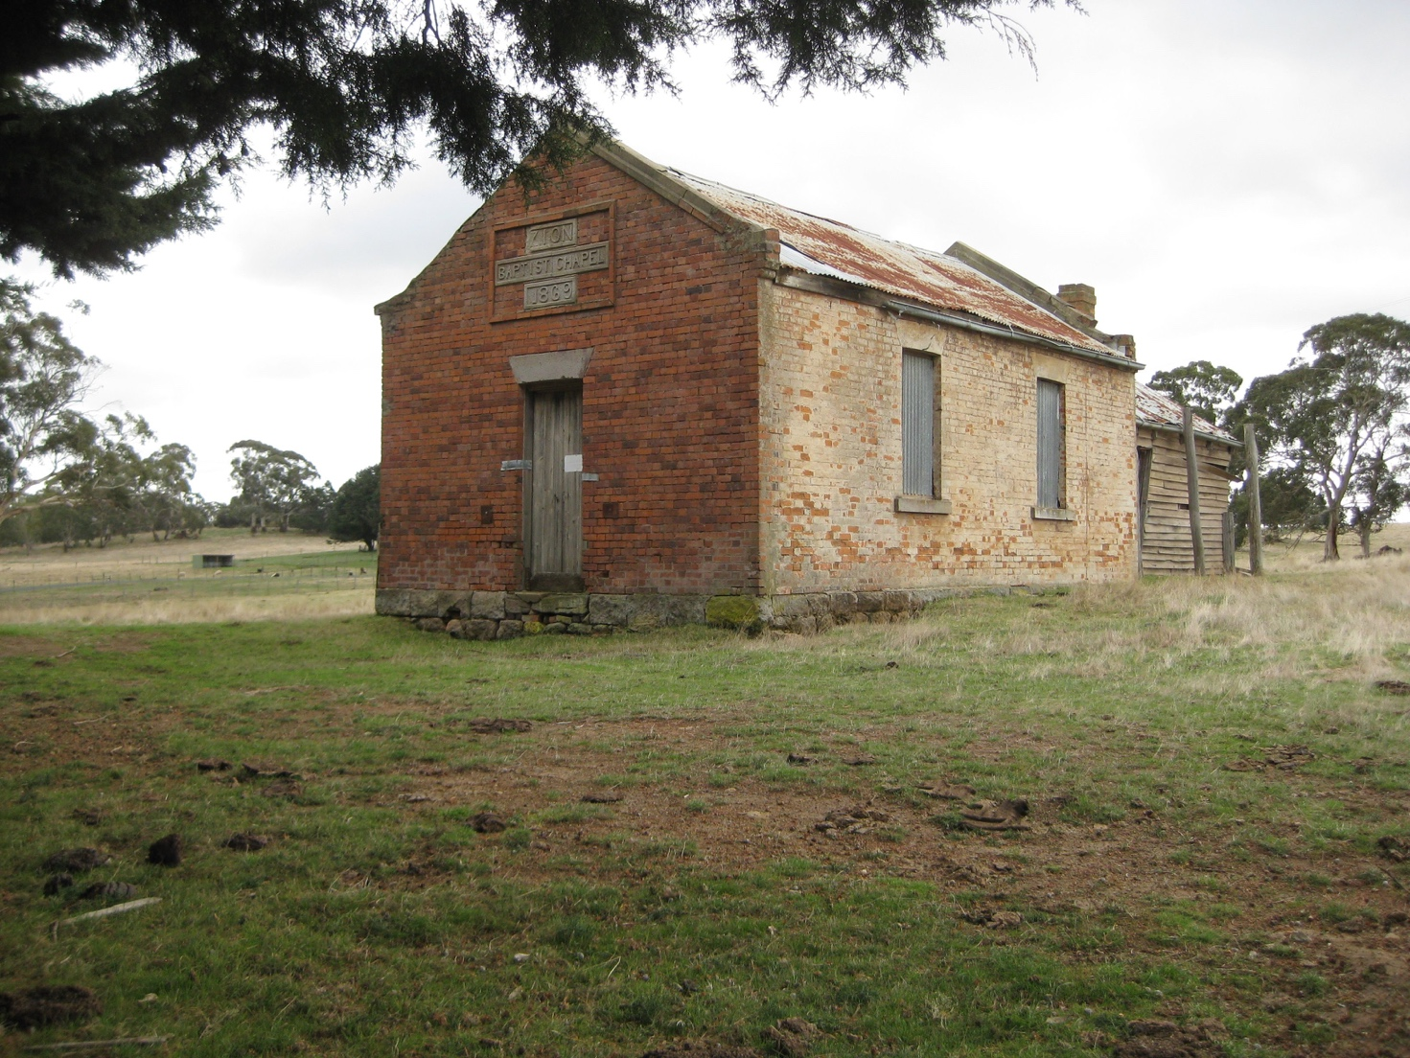

Figure 1. Zion Baptist Chapel, Colwells Road, Woodend (GJM Heritage/Frontier Heritage, May 2018)

***What is significant?***

The Zion Baptist Chapel, Colwells Road, Woodend, a chapel built in 1869 for the Strict Baptist Church.

Elements that contribute to the significance of the place include (but are not limited to):

* The chapel’s original form, materials and detailing
* The chapel’s high level of integrity to its original design.

***How is it significant?***

The Zion Baptist Chapel, Colwells Road, Woodend is of is of local historical and architectural significance to the Shire of Macedon Ranges.

***Why is it significant?***

The Zion Baptist Chapel, built in the nineteenth century, has strong associations with the early history of the Woodend district as a place of worship which offered exclusive membership to Particular Baptists - a minority and strict religious group (Criterion A).

The Zion Baptist Chapel is a fine and representative example of a small and austere nineteenth century rural chapel. It displays typical features of a simple place of worship from this period in Woodend and across Victoria more broadly, including a gabled hall-like form and an unadorned exterior (Criterion D).

*Summary*

The Zion Baptist Chapel, Woodend, built in 1869, is one of a small number of remaining places of worship associated with this exclusive religion.Situated in a remote location near Newham, the Zion Baptist Chapel, Woodend is a small, simple hall-like place of worship, severely austere in character.

**Image**



Figure 2. The north and east elevations of the Zion Baptist Chapel; no date to photo (Smith, 1994).

**Aerial**

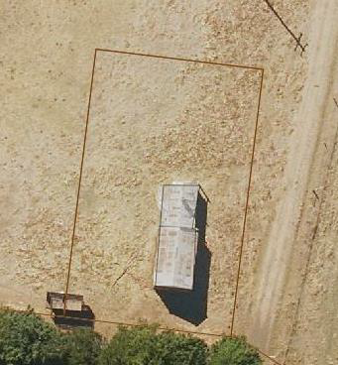

Figure 3. Aerial photo of 2\TP856403 Colwells Road, Woodend (Source: Macedon Ranges Shire Council, aerial dated March 2018).

**Primary source:**

*Macedon Ranges Shire Heritage Study: Woodend, Lancefield, Macedon & Mount Macedon Stage 2 Final Report Volumes 1 and 2* (GJM Heritage and Frontier Heritage, April 2019)