**Woodend Racecourse (Former) Statement of Significance, May 2021**

|  |  |
| --- | --- |
| **Heritage place:** Woodend Racecourse (former), 1-29 Forest Street and 11 (part) Davy Street, Woodend | **PS ref no.:** HO344 |

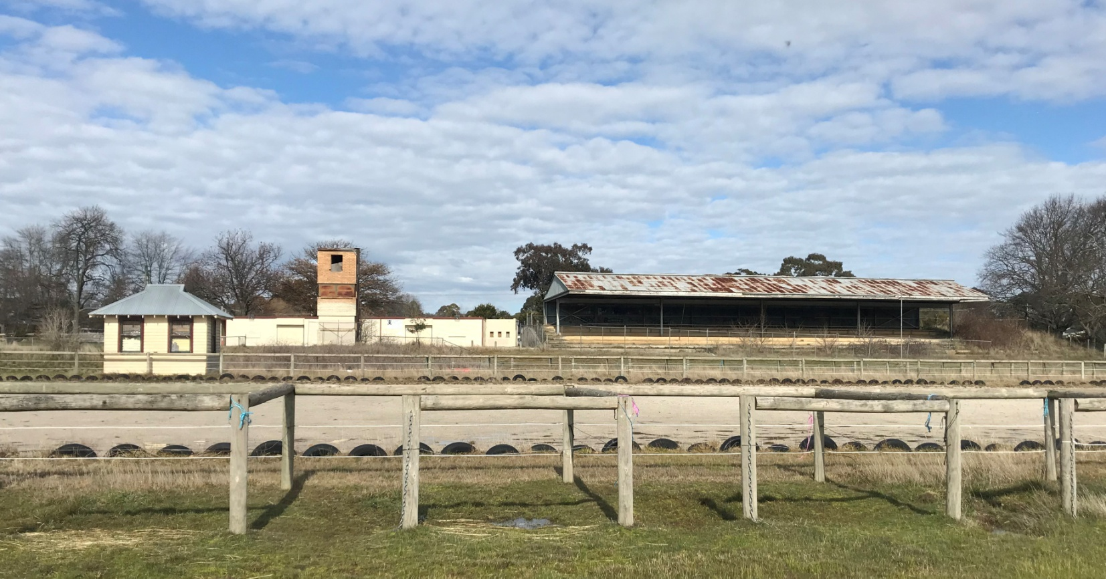

Figure 1. 1-29 Forest Street and 11 (part) Davy Street, Woodend (GJM Heritage, August 2018)

***What is significant?***

The Woodend Racecourse, 1-29 Forest Street and 11 (part) Davy Street, Woodend.

Elements that contribute to the significance of the place include (but are not limited to):

* The original form, materials and detailing of the grandstand, photo finish tower, race caller’s tower, vet’s room and single room timber structure
* The high level of integrity to the original design of the grandstand, photo finish tower, race caller’s tower, vet’s room and single room timber structure

*Description*

The structures that remain on the site which relate to the former racecourse activities are located in the south east corner of the site, generally in the area where the track has been removed. The largest of the structures is the grandstand. It is a steel and timber framed structure with a rough bluestone block retaining wall on the southern side. Above the bluestone retaining wall is a steel and timber framed, corrugated galvanised iron clad rear wall of the grandstand. The stepped tiers within the grandstand are edged with concrete either side of the single row of steel columns with beam over running east west. There are no walls at the east and west ends of the grandstand and the northern side, which faced the track is open.

To the east of the grandstand is a small, square plan form, double height structure which is believed to have been the photo finish tower. The structure is of cream brick with a simple opening at each level across the northern (track) side which wraps around the east and west sides. The roof is a single pitch of minimal slope, clad with corrugated sheet metal and falls to the north.

Further east, on the outside of the south-east edge of the former track alignment is another tower structure. It is also steel and timber framed, consisting of a pole supporting a platform with balustrade and roof over of approximately 2 metres by 1.5 metres. It is assumed this tower was occupied by the race callers.

In the south east corner of the site, fronting Forest Street is a cream brick building which is stylistically and materially contemporary with the photo finish tower. The single-storey structure has a low pitch corrugated sheet metal clad roof. The precise function of the building is not known however it is clearly horse related with a stall on one side with timber stable doors cut across the north west corner and an office room adjacent. It may have been the racecourse vet location.

North east of the grandstand is a small rectangular plan form, timber framed, Dutch gable roofed building. It is a one room structure with a pair of double hung sash windows on one long wall, another central window, a short wall and a door central in the opposite wall.

* Remnant outline of the race track
* Relationship of the built structures to the remnant race track
* Remnant mature trees associated with the grandstand.

*Description*

A row of mature trees between the Forest Street entrance gate and the grandstand are likely to date from the racecourse period.

***How is it significant?***

The Woodend Racecourse is of local historical and architectural significance to the Shire of Macedon Ranges.

***Why is it significant?***

The Woodend Racecourse operated at this site for almost 100 years and demonstrates the importance of this form of sport as a recreational activity within the rural community of Woodend and the broader Macedon Ranges Shire community for a long period (Criterion A).

Five remaining built structures at the Woodend Racecourse relate to the place’s use as a racecourse and demonstrate principal characteristics of typical racecourse structures. These include the grandstand with remnant mature trees, photo finish tower, race caller’s tower, vet’s room and a single room timber structure (Criterion D).

*Summary*

The Former Woodend Racecourse, Woodend operated at this site for almost 100 years and demonstrates the importance of this form of sport as a recreational activity to the rural communities in the Macedon Ranges Shire for a long period of time. The Woodend Racecourse has remnants of the outline of the track and retains some twentieth century fabric and remnant mature trees to clearly demonstrate its purpose.

**Image**



Figure 2. Row of mature trees (GJM Heritage/Frontier Heritage, July 2018)

**Aerial**



Figure 3. Aerial photo of 1-29 Forest Street and 11 (part) Davy Street, Woodend (Source: Macedon Ranges Shire Council, aerial dated March 2018).

**Primary source:**

*Macedon Ranges Shire Heritage Study: Woodend, Lancefield, Macedon & Mount Macedon Stage 2 Final Report Volumes 1 and 2* (GJM Heritage and Frontier Heritage, April 2019)