Woodend Masonic Lodge No. 403 Statement of Significance, May 2021
Heritage place: Woodend Masonic Lodge No. 403, 35 (part) Forest Street, Woodend | PS ref no.: HO345

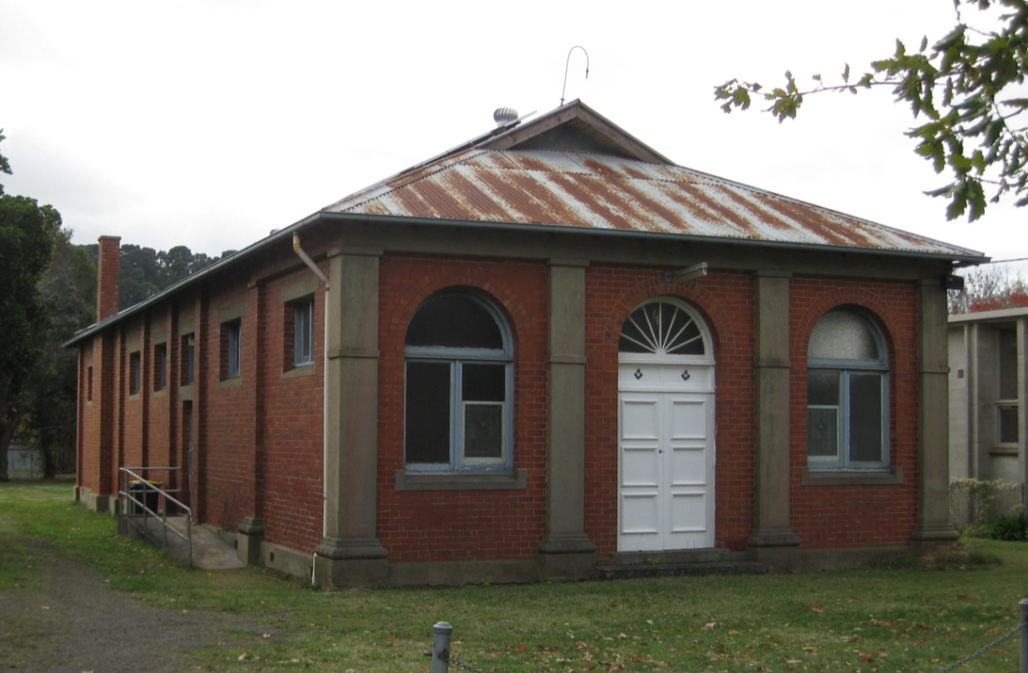
Figure 1. 35 (part) Forest Street, Woodend (GJM Heritage/Frontier Heritage, May 2018)
What is significant?
The Woodend Masonic Lodge, 35 (part) Forest Street, Woodend, a masonic hall established in 1926.
Elements that contribute to the significance of the place include (but are not limited to):
- The building’s original form, materials and detailing
- The building’s high level of integrity to its original design.
The recent small addition to the east of the building is not significant.
How is it significant?
The Woodend Masonic Lodge is of local historical and architectural significance to the Shire of Macedon Ranges.
Why is it significant?
The Woodend Masonic Lodge is of historical significance for its demonstration of the importance of freemasonry in the life of country towns, particularly after World War I. It has strong associations with the local Woodend community as a place for meeting and learning (Criterion A).
The Woodend Masonic Lodge is a fine and representative example of a country masonic hall within a rural township. It displays typical characteristics of a masonic hall from this period in Woodend and across Victoria more broadly, including a gabled hall-like form, an unadorned red brick exterior, and the incorporation of simple classical detailing and masonic symbols (Criterion D).
Summary
The Woodend Masonic Lodge, Woodend is of note as a highly intact and representative example of this building type in the Shire of Macedon Ranges. It displays typical characteristics of a masonic hall from this period in the municipality and across Victoria more broadly.
Aerial
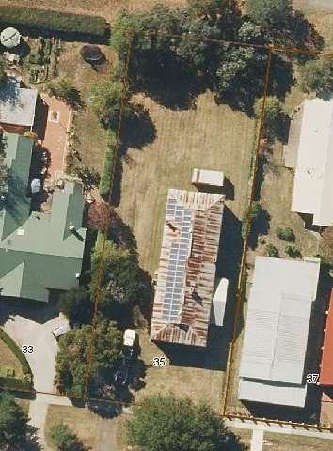
Figure 2. Aerial photo of 35 (part) Forest Street, Woodend (Source: Macedon Ranges Shire Council, aerial dated March 2018).
Primary source:
Macedon Ranges Shire Heritage Study: Woodend, Lancefield, Macedon & Mount Macedon Stage 2 Final Report Volumes 1 and 2 (GJM Heritage and Frontier Heritage, April 2019)

