Woodend Catholic Primary School (Former) Statement of Significance, May 2021
Heritage place: Woodend Catholic Primary School (former), 16 Brooke Street, Woodend | PS ref no.: HO338

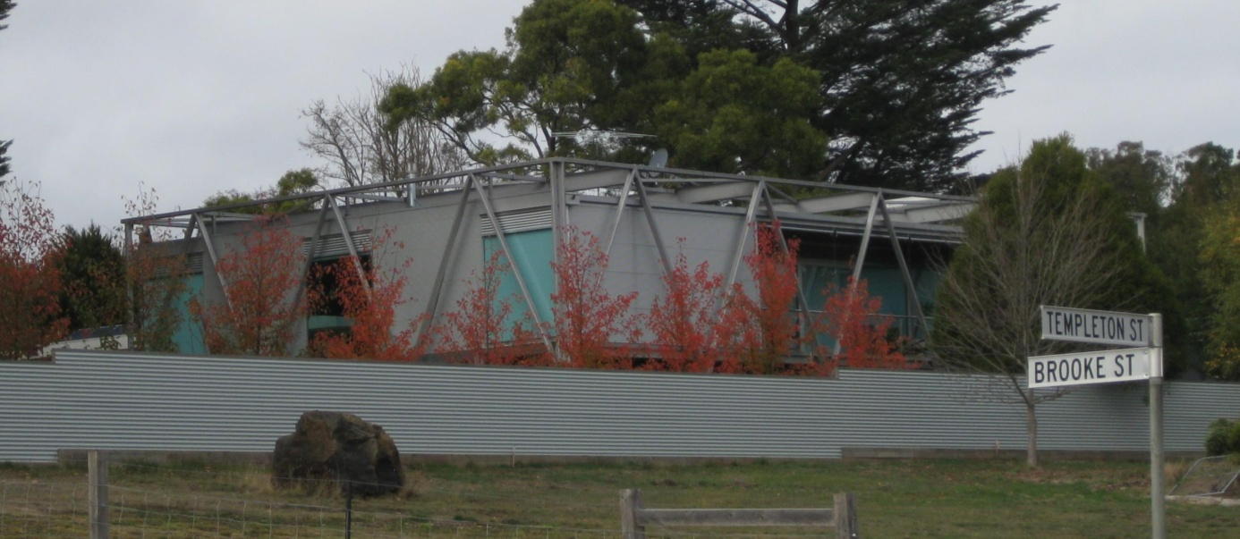
Figure 1. 16 Brooke Street, Woodend (GJM Heritage/Frontier Heritage, May 2018)
What is significant?
The Former Woodend Catholic Primary School, 16 Brooke Street, Woodend, a school building constructed in 1973.
Elements that contribute to the significance of the place include (but are not limited to):
- The building’s original form and detailing
- The building’s high level of integrity to its original design
Later alterations, including changes to windows and external cladding, and the recent outbuilding are not significant.
How is it significant?
The Former Woodend Catholic Primary School is of local historical and architectural significance to the Shire of Macedon Ranges.
Why is it significant?
The Former Woodend Catholic Primary School has strong associations with the Catholic Church and the role it played in Catholic education in Woodend (Criterion A).
The Former Woodend Catholic Primary School is a fine example of a 1970s structure which demonstrates both modular construction and structural expression. It is an uncommon example of this type of modular construction in Woodend and across the Shire more broadly (Criterion B).
Summary
The Former Woodend Catholic Primary School, Woodend is of note as a fine and intact example of an innovative 1970s structure. There are no identified comparators in the Shire of Macedon Ranges.

Aerial
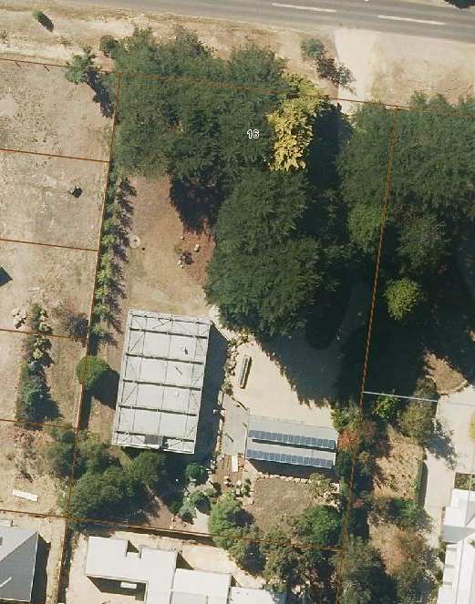
Figure 2. Aerial photo of 16 Brooke Street, Woodend (Source: Macedon Ranges Shire Council, aerial dated March 2018).
Primary source:
Macedon Ranges Shire Heritage Study: Woodend, Lancefield, Macedon & Mount Macedon Stage 2 Final Report Volumes 1 and 2 (GJM Heritage and Frontier Heritage, April 2019)

