**The Grange Farm Complex Statement of Significance, May 2021**

|  |  |
| --- | --- |
| **Heritage place:** The Grange Farm Complex, 153 (part) Collivers Road, Lancefield | **PS ref no.:** HO319 |

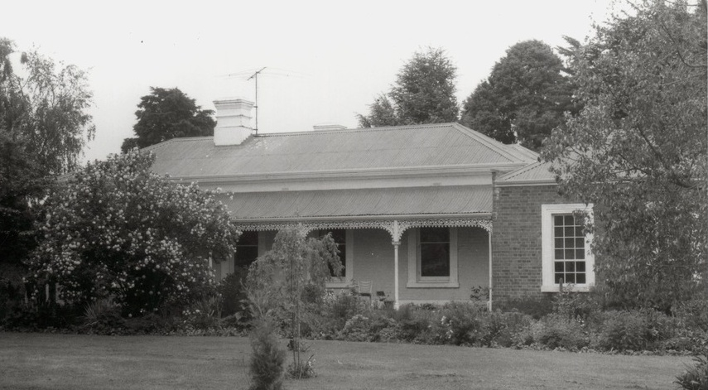

Figure 1. 153 (part) Collivers Road, Lancefield (photo dated 1989, Source: SLV, Image H2013.6/235).

***What is significant?***

The Grange Farm Complex, 153 (part) Collivers Road, Lancefield, a farming property established in the nineteenth century.

Elements that contribute to the significance of the place include (but are not limited to):

* The farmhouse’s original form, materials and detailing
* The farmhouse’s high level of integrity to its original design
* Early timber outbuildings

*Description*

Located south of the house and garden are the outbuildings, which are thought to have some earlier timber farm structures.

* Gardens, including mature trees and plantings.

*Description*

The house is surrounded by mature trees and a box hedge lining the path from the gravel drive to the front verandah. The plantings include holly, Cedrus deodara, oaks, many cordylines and a walnut tree. Much of the house garden is from the early to mid-twentieth century with blue spruce, golden pencil cypress, variegated Pittosporum sp. and a mature Italian cypress, cut leaf birch, a large Doryanthes sp. and variegated flax.

More recently constructed outbuildings are not significant.

***How is it significant?***

The Grange Farm Complex is of local historical and architectural significance to the Shire of Macedon Ranges.

***Why is it significant?***

The Grange Farm Complex demonstrates the early establishment and subsequent development of farming properties in the rich agricultural district of Lancefield (Criterion A).

The Grange Farm Complex is a fine, intact and representative example of a nineteenth century farming property. It displays typical features of a farm complex in Lancefield and across Victoria more broadly, including a substantial farmhouse, outbuildings and mature plantings (Criterion D).

*Summary*

The Grange Farm Complex, Lancefield is of note as a representative and intact example of a nineteenth farming property in the Shire of Macedon Ranges. The district gained a reputation as a rich agricultural area and properties such as this clearly illustrate this development. It displays a range of characteristics typical of this place type including a single-storey dwelling, a range of associated outbuildings, mature vegetation and a sizable allotment of farming land.

**Image**



Figure 2. A 1989 photo purported to be of outbuildings at ‘The Grange’, Lancefield. This photo is annotated ‘Looking over collapsing wooden fence and long grass towards back of shop (probably referring to ‘Mustey's butcher shop’) showing dilapidated roof and weatherboard walls’ (SLV, Image H2013.6/240).

**Aerial**

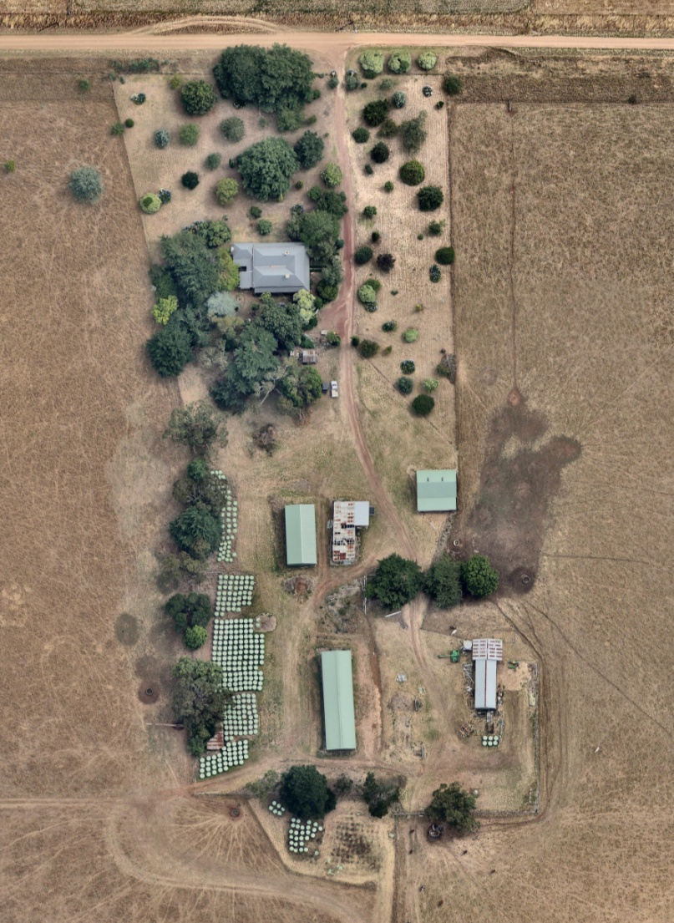

Figure 3. Aerial photo of 153 (part) Collivers Road, Lancefield (Source: Nearmap, aerial dated Jan 2018).

**Primary source:**

*Macedon Ranges Shire Heritage Study: Woodend, Lancefield, Macedon & Mount Macedon Stage 2 Final Report Volumes 1 and 2* (GJM Heritage and Frontier Heritage, April 2019)