St Andrews Presbyterian Church (Former) Statement of Significance, May 2021
Heritage place: St Andrews Presbyterian Church (former), 37 (part) Forest Street, Woodend | PS ref no.: HO346

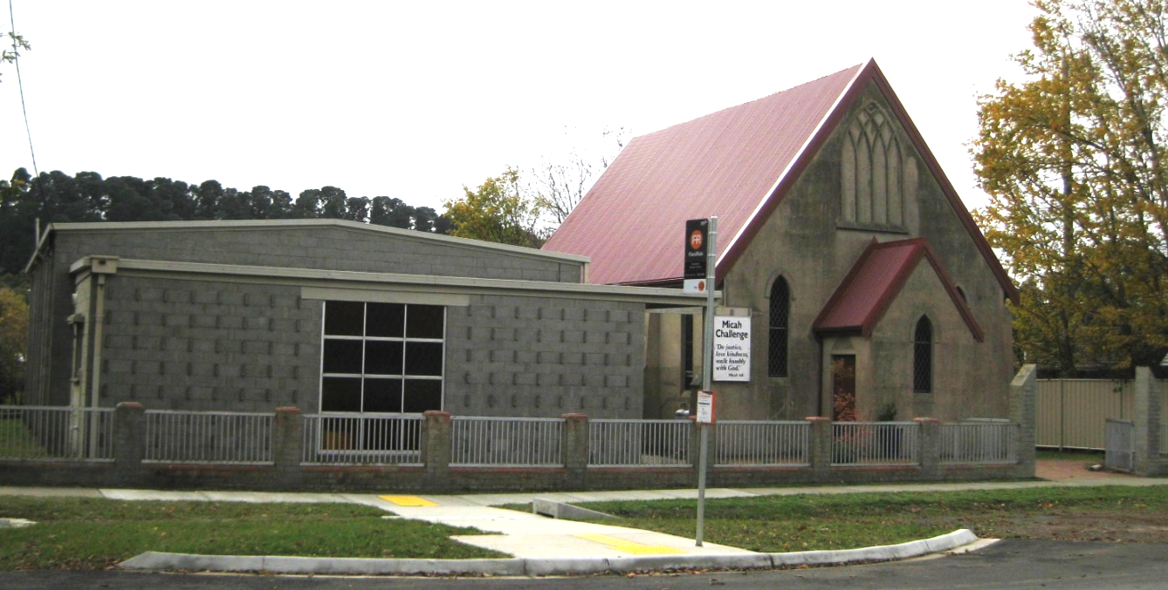
Figure 1. 37 (part) Forest Street, Woodend (GJM Heritage/Frontier Heritage, April 2018)
What is significant?
The Former St Andrews Presbyterian Church, 37 (part) Forest Street, Woodend, a church built in 1910.
Elements that contribute to the significance of the place include (but are not limited to):
- The church’s original form, materials and detailing
- The church’s high level of integrity to its original design.
The adjacent hall (1963) and entrance gateway are not significant.
How is it significant?
The Former St Andrews Presbyterian Church is of is of local historical, architectural and technical significance to the Shire of Macedon Ranges.
Why is it significant?
The Former St Andrews Presbyterian Church, Woodend is of historical significance as a substantially intact early twentieth century church which has strong associations with the local Woodend community. Its early and continuing use illustrates the importance of worship in the region (Criterion A).
The Former St Andrews Presbyterian Church, Woodend is a fine and representative example of a church within a rural township. The building displays typical characteristics of this church type in Woodend and across Victoria more broadly, including the adoption of the Gothic Revival style evidenced by pointed arch-headed windows, wall buttresses and steeply pitched roofs (Criterion D).
The Former St Andrews Presbyterian Church, Woodend is of technical significance as an early use of concrete block construction in Woodend and across Victoria more broadly (Criterion F).

Summary
The Former St Andrews Presbyterian Church, Woodend, constructed in 1910, is of note as a fine and representative example of a church within a rural township in the Macedon Ranges Shire. The Former St Andrews Presbyterian Church, Woodend is highly intact and it is of particular note for its early use of concrete block construction.
Aerial
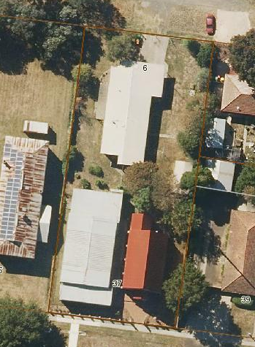
Figure 2. Aerial photo of 37 (part) Forest Street, Woodend (Source: Macedon Ranges Shire Council, aerial dated March 2018).
Primary source:
Macedon Ranges Shire Heritage Study: Woodend, Lancefield, Macedon & Mount Macedon Stage 2 Final Report Volumes 1 and 2 (GJM Heritage and Frontier Heritage, April 2019)

