St Ambrose Catholic Church Complex Statement of Significance, May 2021
Heritage place: St Ambrose Catholic Church Complex, 16 and 18 (part) Templeton Street, Woodend | PS ref no.: HO349

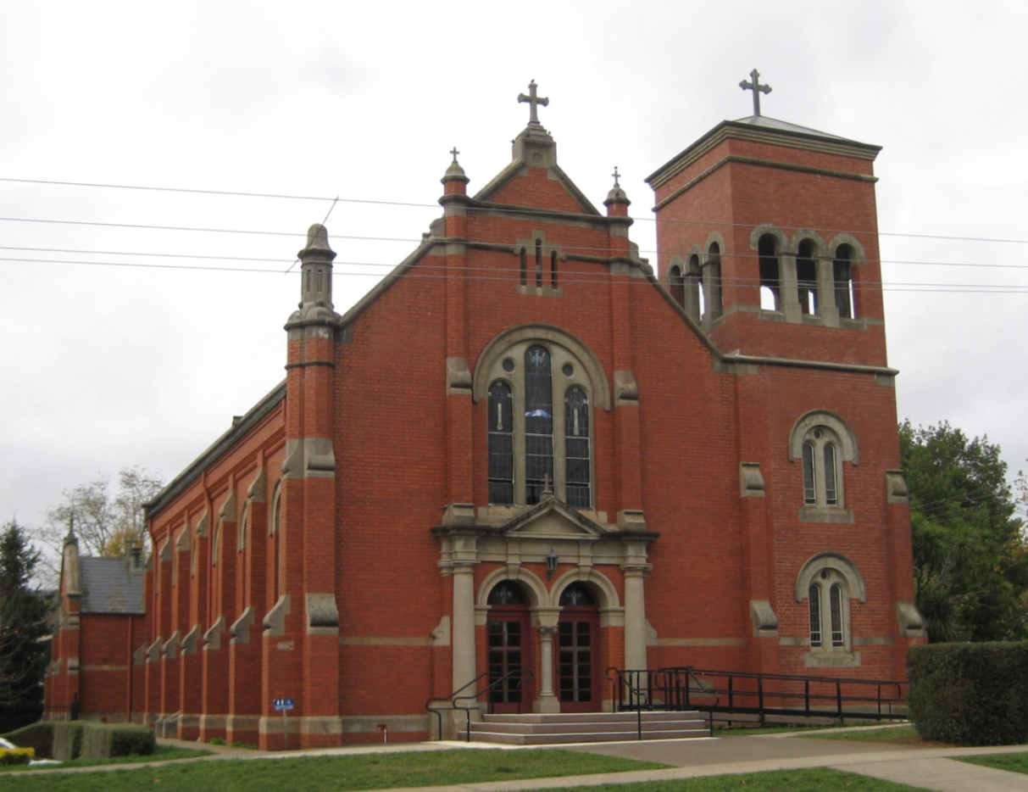
Figure 1. Church at 16 Templeton Street, Woodend (GJM Heritage/Frontier Heritage, May 2018)
What is significant?
The St Ambrose Catholic Church Complex, 16 and 18 (part) Templeton Street, Woodend, comprising a church (1916 & tower 1966), parish hall (1928) and presbytery (1889, remodelled 1952).
Elements that contribute to the significance of the place include (but are not limited to):
- The original form, materials and detailing of the church (including later tower) and the parish hall
- The form, materials and detailing of the remodelled presbytery
- The high level of integrity of the church and parish hall to their original design
- The high level of integrity of the presbytery to its remodelled 1952 form.
School buildings on the site, recent additions to the parish hall, and the 1889 presbytery fence and gate posts are not significant.
How is it significant?
The St Ambrose Catholic Church Complex is of is of local historical and architectural significance to the Shire of Macedon Ranges.

Why is it significant?
The St Ambrose Catholic Church Complex is of historical significance as a highly intact group of religious buildings, including a church, parish hall and presbytery, which together have strong associations with the local Woodend community. The complex is illustrative of a large parish in a rural town and Its continuing use illustrates the importance of worship in the region (Criterion A).
The St Ambrose Catholic Church Complex is a fine, intact and representative example of a church complex within a rural township. It contains buildings which display typical characteristics of a range of styles, including Federation Romanesque and Interwar Gothic (Criterion D).
Summary
The St Ambrose Catholic Church Complex, Woodend is of note as a fine, representative and highly intact group of religious buildings within a rural township in the Shire of Macedon Ranges. These buildings display a range of characteristics that have associations with a range of periods and architectural styles, including Federation Romanesque and Interwar Gothic, and remain highly intact to demonstrate these associations.
Aerial
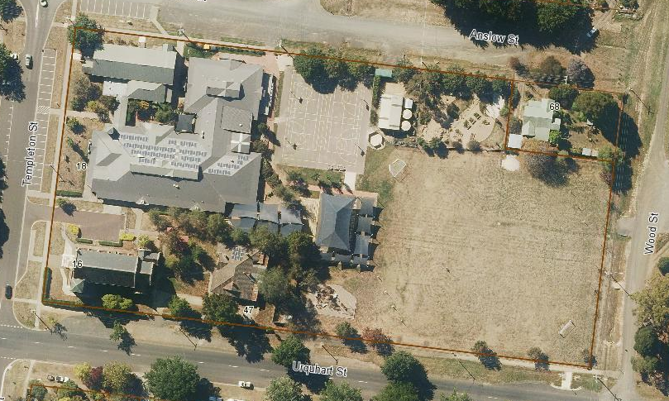
Figure 2. Aerial photo of 16 and 18 (part) Templeton Street, Woodend (Source: Macedon Ranges Shire Council, aerial dated March 2018).
Primary source:
Macedon Ranges Shire Heritage Study: Woodend, Lancefield, Macedon & Mount Macedon Stage 2 Final Report Volumes 1 and 2 (GJM Heritage and Frontier Heritage, April 2019)

