Springfield State School No. 1963 (Former) Statement of Significance, May 2021
Heritage place: Springfield State School No. 1963 (former), 3 Clarkes Lane, Woodend North | PS ref no.: HO350

Figure 1. 3 Clarkes Lane, Woodend North (GJM Heritage/Frontier Heritage, May 2018)
What is significant?
The Former Springfield State School No 1963, 3 Clarkes Lane, Woodend North, a school built in 1877.
Elements that contribute to the significance of the place include (but are not limited to):
- The school building’s original form, materials and detailing
- The school building’s high level of integrity to its original design.
Substantial later additions and outbuildings to the east of the original school building are not significant.
How is it significant?
The Former Springfield State School No 1963 is of is of local historical and architectural significance to the Shire of Macedon Ranges.
Why is it significant?
The Former Springfield State School No 1963 is of historical significance as a demonstration of the increasing importance of education in the life of country towns in the 1870s. It has strong associations with the local former Springfield community as a place of education (Criterion A).
The Former Springfield State School No 1963 is an intact and representative example of a small nineteenth century school within a rural township. It displays typical characteristics of a small school from the 1870s in the Woodend area and across Victoria more broadly, including a two-roomed, T-shaped gabled form with porch and an unadorned exterior (Criterion D).
Summary
The Former Springfield State School No 1963, Woodend North is of note as an intact and representative example of a small school building in the Shire of Macedon Ranges. It displays typical characteristics of a small school from the 1870s in rural Victoria.
Aerial
(Note that this has been corrected to account for distortion between the cadastral boundaries and the aerial).
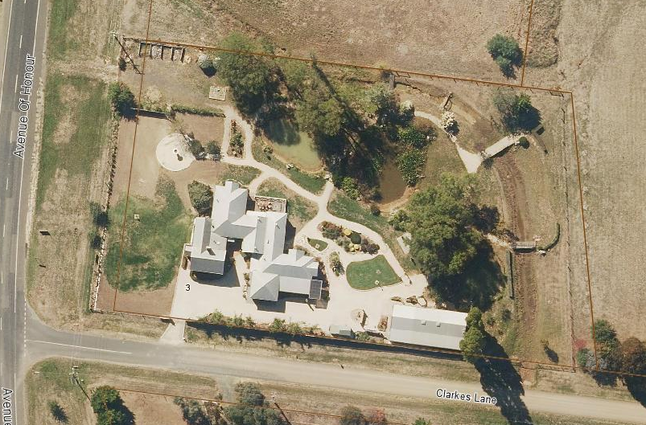
Figure 2. Aerial photo of 3 Clarkes Lane, Woodend North (Source: Macedon Ranges Shire Council, aerial dated March 2018).
Primary source:
Macedon Ranges Shire Heritage Study: Woodend, Lancefield, Macedon & Mount Macedon Stage 2 Final Report Volumes 1 and 2 (GJM Heritage and Frontier Heritage, April 2019)

