**Sefton Statement of Significance, May 2021**

|  |  |
| --- | --- |
| **Heritage place:** Sefton, 864 Mount Macedon Road, Mount Macedon | **PS ref no.:** HO334 |

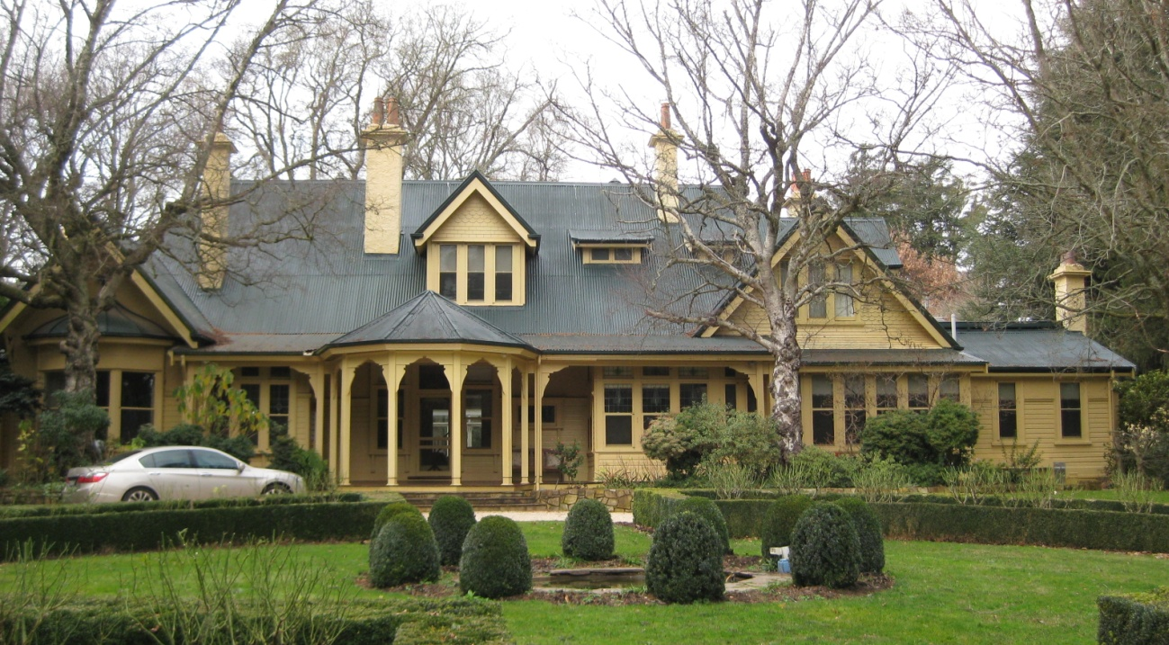

Figure 1. 864 Mount Macedon Road, Mount Macedon (GJM Heritage/Frontier Heritage, June 2018)

***What is significant?***

Sefton, 864 Mount Macedon Road, Mount Macedon, a hill station including a substantial Federation house within an established garden setting.

Elements that contribute to the significance of the place include (but are not limited to):

* The external form, materials and detailing of the house
* The house’s high level of integrity to its original design
* Early outbuildings and main entrance gates

*Description*

Access to the property is through substantial timber gates fronting Mount Macedon Road, along a gravel drive to the main house.

Further south of the main house there are several sheds and storage facilities.

* Gardens, including mature plantings such as the hedges, garden beds, structures, water features and rockeries.

*Description*

The property has an extensive landscaped garden. The large house is the elevated centerpiece, set on axis, of a large mature garden. The approach path follows the garden axis while on one side, extensive lawn slopes away to the north. There are a number of mature trees throughout the site and a formal well maintained circular hedged garden bed in front of the house. There is a tennis court to the east. The property is partly bounded on the southern and western sides by a mature hedge, with the name ‘SEFTON’ trimmed out of it.

Recent alterations, additions and outbuildings, including the conference centre building, manager’s and Sefton cottages, are not significant.

***How is it significant?***

Sefton is of local historical, architectural and aesthetic significance to the Shire of Macedon Ranges.

***Why is it significant?***

Sefton has strong associations with the establishment of hill stations at Mount Macedon by prominent and wealthy Victorians from the 1870s. The place clearly illustrates the initial establishment, and the subsequent development, of the mountain as a summer retreat comprising large garden estates with substantial houses set in extensive grounds (Criterion A).

Sefton is a representative example of a hill station established at the mountain location from the 1870s. It displays typical features of this place type, including extensive grounds, a large, prominent house, outbuildings and a variety of separate gardens, garden features and structures. The house is a fine and highly intact example of a Federation house which strongly reflects the architectural style popular in the first decade of the twentieth century. The asymmetrical composition, with complex roof forms and multiple gables, and architectural elements and materials, including tall chimneys and timber verandah detailing, are typical of the style (Criterion D).

Sefton is a highly developed picturesque hill station. Extensive grounds, containing a prominently-sited house, expansive lawns, mature plantings, garden beds, hedges, structures, water features, rockeries, paths and a tennis court present a picturesque composition. The house itself is a carefully designed and well-resolved example of a Federation house. The asymmetrical massing, with picturesque roofline, tall chimneys, dormers and gables, bay windows and projecting polygonal front porch present a picturesque composition of this architectural style (Criterion E).

Sefton has close associations with prominent Victorian businessman and politician, William L Baillieu, as the owner and occupant of the property from 1908, and the well-known Baillieu family who owned Sefton until the 1980s. Sefton has close associations with well-known Melbourne architects Sydney Smith and Ogg who were responsible for the design of the house in 1908 (Criterion H).

*Summary*

Sefton, Mount Macedon is of note as a fine and representative example of a Mount Macedon hill station. Sefton retains its extensive grounds, grand Federation residence, outbuildings and a number of developed garden areas within the property boundaries. Despite modifications to both the buildings and garden, the place has clear associations with the important hill station class of place.

**Image**



Figure 2. Outbuildings to the south of the house (GJM Heritage/Frontier Heritage, June 2018)

**Aerial**



Figure 3. Aerial photo of 864 Mount Macedon Road, Mount Macedon (Source: Macedon Ranges Shire Council, aerial dated March 2018).

**Primary source:**

*Macedon Ranges Shire Heritage Study: Woodend, Lancefield, Macedon & Mount Macedon Stage 2 Final Report Volumes 1 and 2* (GJM Heritage and Frontier Heritage, April 2019)