**Pindari Statement of Significance, May 2021**

|  |  |
| --- | --- |
| **Heritage place:** Pindari, 2-8 Dickens Street, Woodend | **PS ref no.:** HO343 |

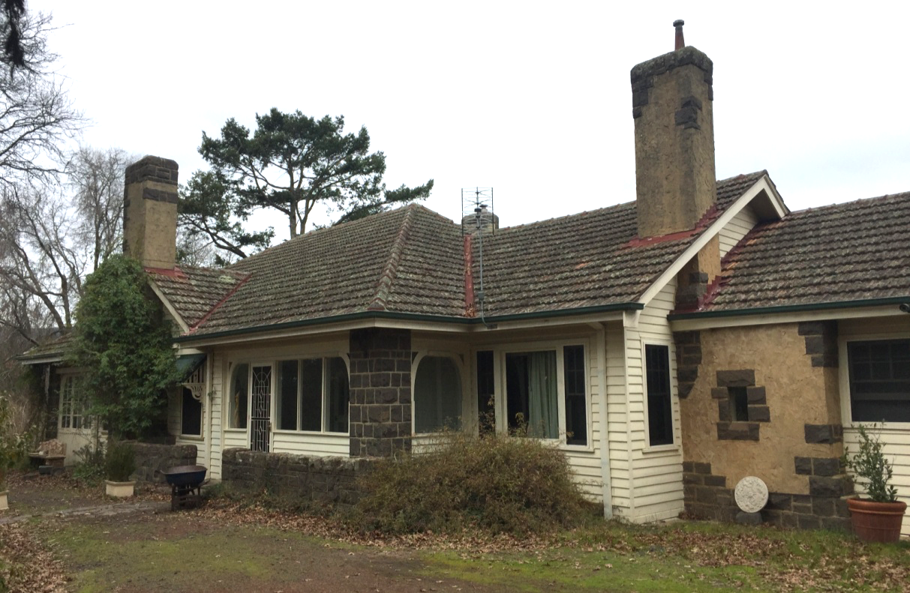

Figure 1. 2-8 Dickens Street, Woodend (GJM Heritage/Frontier Heritage, June 2018)

***What is significant?***

Pindari, 2-8 Dickens Street, Woodend, a house built in 1931-32 and designed by architects Oakley and Parkes.

Elements that contribute to the significance of the place include (but are not limited to):

* The house’s original form, materials and detailing
* The house’s high level of integrity to its original design
* 1930s gate and fence along the northern boundary
* Garden, mature trees and plantings.

*Description*

The property has a mature garden including large trees such as pin oaks, deodar cedars, *Cryptomeria sp., Rhododendron sp.*, and garden beds of azaleas and camellias which is accessed via the northern boundary which is partially obscured by hedging.

The rear of the property, the southern boundary is defined by a substantial hedgeline.

The garage and other outbuildings, and later additions to the rear (south) and west side, and the enclosure of the front (north) porch and east verandahs, are not significant.

***How is it significant?***

Pindari is of local historical, architectural and aesthetic significance to the Shire of Macedon Ranges.

***Why is it significant?***

Pindari is illustrative of residential development which occurred in rural townships in the inter-war years of the twentieth century (Criterion A).

Pindari is a fine, intact and representative example of an Inter-war house. It displays typical features of a house of the 1930s in Woodend and across Victoria more broadly, including informal massing with asymmetrical elevations, tiled hipped roof forms and multi-paned windows (Criterion D).

Pindari is a well-considered and carefully detailed house set in a mature garden. The timber house, with rubble stone and roughcast chimneys, chunky bluestone porch piers and balustrade and thick timber brackets, together with the garden, presents a highly picturesque composition from the Inter-war period (Criterion E).

*Summary*

Pindari, Woodend is of note as a well-considered and carefully detailed representative example of a substantial Inter-war house set in a mature garden built in a rural township.

**Image**



Figure 2. North elevation (GJM Heritage/Frontier Heritage, June 2018)

**Aerial**



Figure 3. Aerial photo of 2-8 Dickens Street, Woodend (Source: Macedon Ranges Shire Council, aerial dated March 2018).

**Primary source:**

*Macedon Ranges Shire Heritage Study: Woodend, Lancefield, Macedon & Mount Macedon Stage 2 Final Report Volumes 1 and 2* (GJM Heritage and Frontier Heritage, April 2019)