**Penola Statement of Significance, May 2021**

|  |  |
| --- | --- |
| **Heritage place:** Penola, 222 (part) Alton Road, Mount Macedon | **PS ref no.:** HO327 |

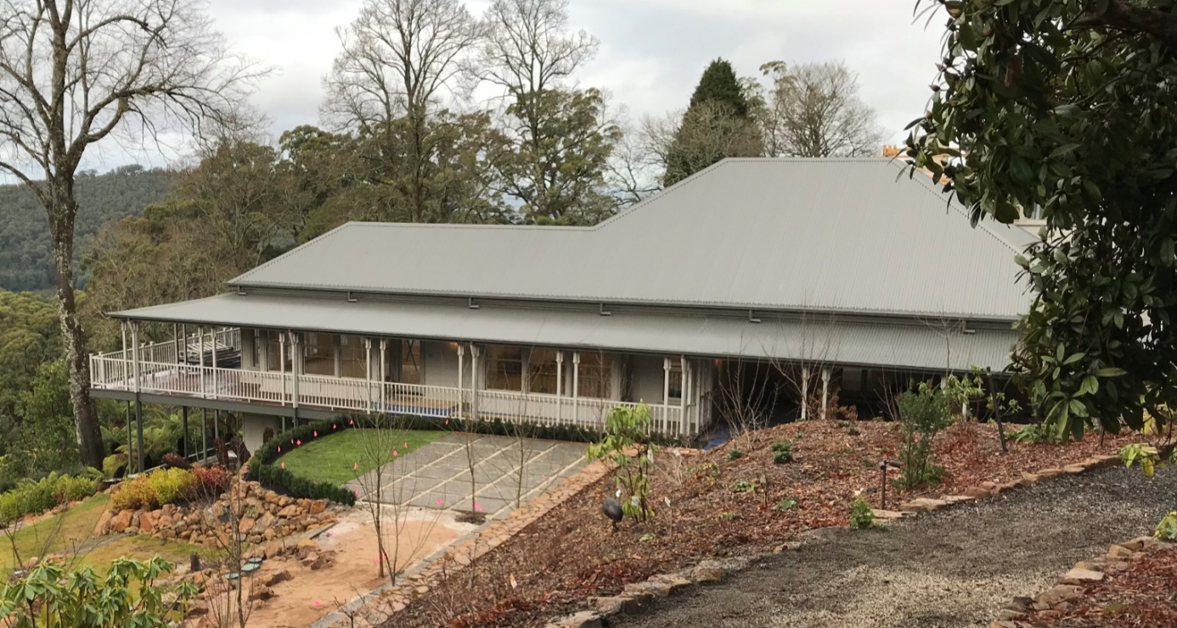

Figure 1. 222 (part) Alton Road, Mount Macedon (GJM Heritage/Frontier Heritage, June 2018)

***What is significant?***

Penola, 222 (part) Alton Road, Mount Macedon, a hill station comprising a pre-fabricated house erected on the property in 1881 and associated gardens.

Elements that contribute to the significance of the place include (but are not limited to):

* The external form of the house
* The house’s high level of integrity to its original design
* Gardens, including mature plantings, structures, stone walls and paving, water features and remnant tennis court.

*Description*

Much of the planting below the house is original, including the laurel and holly hedging, mature tree specimens (large Douglas fir), serpentine paths, flax, yew, camellias, weeping holly, cordylines, most garden beds (except those in front of the house) and maples.

A grass tennis court lies below the house and appears to date from the Brookes time.

Recent alterations and additions are not significant.

***How is it significant?***

Penola is of local historical, architectural and aesthetic significance to the Shire of Macedon Ranges.

***Why is it significant?***

Penola has strong associations with the establishment of hill stations at Mount Macedon by prominent and wealthy Victorians from the 1870s. The place clearly illustrates the initial establishment, and the subsequent development, of the mountain as a summer retreat comprising large garden estates with substantial houses set in extensive grounds (Criterion A).

Penola is a representative example of a hill station established at the mountain location from the 1870s. It displays typical features of this place type, including extensive grounds, and a large, prominent house surrounded by mature plantings (Criterion D).

Penola is a highly developed picturesque hill station. The prominently-sited house surrounded by extensive grounds, presents a picturesque composition (Criterion E).

*Summary*

Penola, Mount Macedon is of note as a fine and representative example of a Mount Macedon hill station. Penola retains its extensive grounds, house and mature plantings within the property boundaries. Despite modifications to both the house and garden, the place has clear associations with the important hill station class of place.

**Image**



Figure 2. Penola prior to recent works. No date to photo; but is pre-1996 when the tower was built (Boyd & Boyd, 2009:90).

**Aerial**

(Note that this has been corrected to account for distortion between the cadastral boundaries and the aerial)

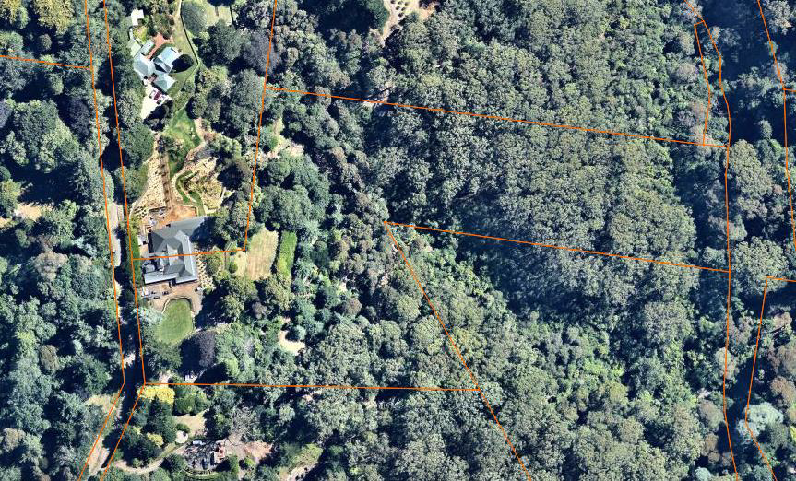

Figure 3. Aerial photo of 222 Alton Road, Mount Macedon (Source: Nearmap, aerial dated Jan 2018).

**Primary source:**

*Macedon Ranges Shire Heritage Study: Woodend, Lancefield, Macedon & Mount Macedon Stage 2 Final Report Volumes 1 and 2* (GJM Heritage and Frontier Heritage, April 2019)