Newland Farm Complex Statement of Significance, May 2021
Heritage place: Newland Farm Complex, 46 Millers Lane, Lancefield | PS ref no.: HO324

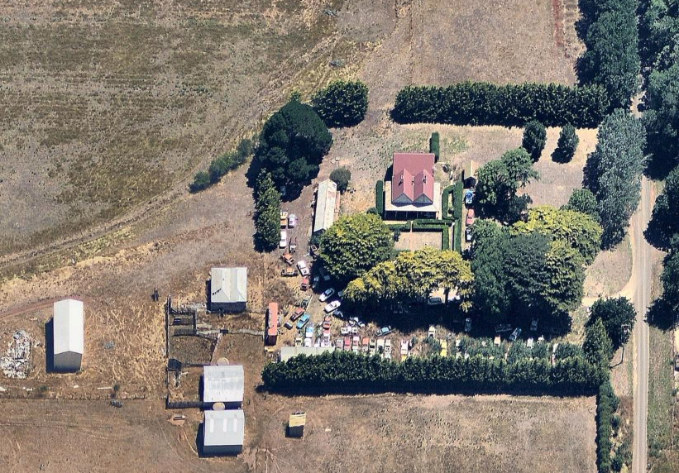
Figure 1. 46 Millers Lane, Lancefield (Aerial photo dated Jan 2017. Source: Nearmap)
What is significant?
Newland Farm Complex, 46 Millers Lane, Lancefield, a farming property established in the mid-nineteenth century.
Elements that contribute to the significance of the place include (but are not limited to):
- The farmhouse’s original form, materials and detailing
- The farmhouse’s high level of integrity to its original design
- The early stone structure and outbuildings
Description
There are several outbuildings on the site, which may include an early stone structure. To the east of the house is a small gable roofed structure which is thought to be a freestanding garage. To the west of the house is a long gable roofed single-storey building and a further gable roofed shed like structure is in the south west corner of the site.
- Gardens, including mature trees and plantings.
Description
The relatively flat site is bound to the north, south and west with fencing partially lined by hedging.
The property has several mature trees, principally to the south of the house, which include exotics such as Monterey cypress lining the drive and oaks at the Millers Lane entrance. What may be a walnut tree stands nearby, with possibly an osage orange and a deodar cedar. Close to the house, on the north, south and east sides are a series of formal trimmed privet hedge lines defining the house yard area.
More recently constructed outbuildings are not significant.
How is it significant?
Newland Farm Complex is of local historical and architectural significance to the Shire of Macedon Ranges.
Why is it significant?
Newland Farm Complex demonstrates the early establishment and subsequent development of farming properties in the rich agricultural district of Lancefield (Criterion A).
Newland Farm Complex is a fine, intact and representative example of a nineteenth century farming property. It displays typical features of a farm complex in Lancefield and across Victoria more broadly, including a substantial farmhouse, outbuildings and mature plantings (Criterion D).
Summary
The Newland Farm Complex, Lancefield is of note as a representative and intact example of a nineteenth century farming property in the Shire of Macedon Ranges. The district gained a reputation as a rich agricultural area and properties such as this clearly illustrate this development. It displays a range of typical characteristics of this place type including a single-storey dwelling, a range of associated outbuildings, mature vegetation and a sizable allotment of farming land.
Aerial
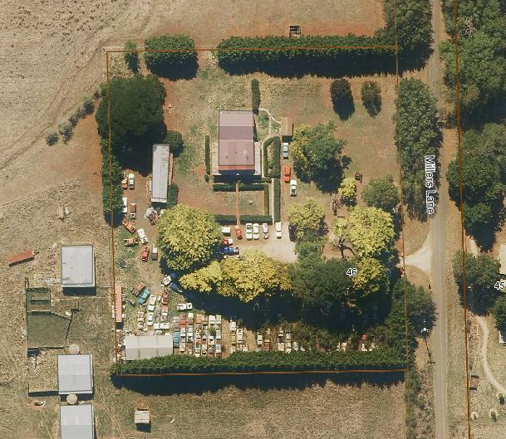
Figure 2. Aerial photo of 46 Millers Lane, Lancefield (Source: Macedon Ranges Shire Council, aerial dated March 2018).
Primary source:
Macedon Ranges Shire Heritage Study: Woodend, Lancefield, Macedon & Mount Macedon Stage 2 Final Report Volumes 1 and 2 (GJM Heritage and Frontier Heritage, April 2019)

