**Mount Macedon Presbyterian Church (Former) Statement of Significance, May 2021**

|  |  |
| --- | --- |
| **Heritage place:** Mount Macedon Presbyterian Church (former), 682 Mount Macedon Road, Mount Macedon | **PS ref no.:** HO333 |

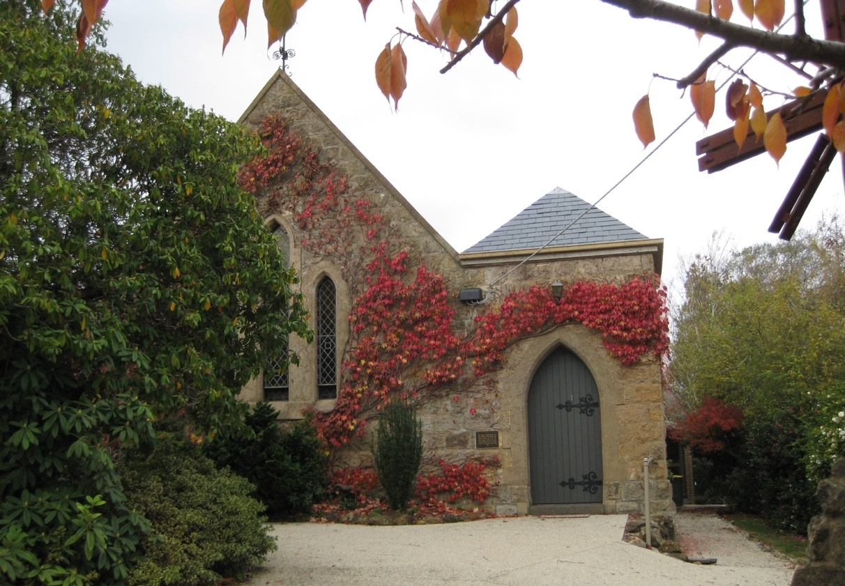

Figure 1. Mount Macedon Presbyterian Church (GJM Heritage/Frontier Heritage, May 2018)

***What is significant?***

The Former Mount Macedon Presbyterian Church, 682 Mount Macedon Road, Mount Macedon, a Gothic Revival style church originally built in 1874 and reconstructed following the Ash Wednesday fires.

Elements that contribute to the significance of the place include (but are not limited to):

* The church’s original form, materials and detailing and 1983-84 replacement fabric
* The church’s high level of integrity to its original design
* Rubble stone cairn and cross marking the Ash Wednesday 1983 fires.

The modern brick hall and amenities area at the rear of the Church are not significant.

***How is it significant?***

The Former Mount Macedon Presbyterian Church is of local historical and architectural significance to the Shire of Macedon Ranges.

***Why is it significant?***

The Former Mount Macedon Presbyterian Churchis of historical significance as a church originally constructed in the 1870s which has strong associations with the local Mount Macedon community. Its early and continuing use as a church, and its reconstruction after significant fire damage in the Ash Wednesday fires, illustrates the enduring value of worship in the district (Criterion A).

The Former Mount Macedon Presbyterian Church is a fine and representative example of a small 1870s church within a rural township. The building displays typical characteristics of a nineteenth century church in Macedon and across Victoria more broadly, including the adoption of the Gothic Revival style with pointed arch-headed windows and steeply pitched roofs (Criterion D).

*Summary*

The Former Mount Macedon Presbyterian Church, Mount Macedon constructed in 1874 and rebuilt in 1983-84, is of note as a fine representative example of an 1870s church within a rural township in the Macedon Ranges Shire. Despite the extensive damage to the building in the Ash Wednesday fires in 1983, it has been reconstructed using original materials. The building therefore retains a high degree of integrity to its original construction and clearly demonstrates its ongoing use as a church.

**Image**



Figure 2. Cairn commemorating reconstruction and reopening of Church in 1984 (GJM Heritage/Frontier Heritage, June 2018)

**Aerial**



Figure 3. Aerial photo of 682 Mount Macedon Road, Mount Macedon (Source: Macedon Ranges Shire Council, aerial dated March 2018).

**Primary source:**

*Macedon Ranges Shire Heritage Study: Woodend, Lancefield, Macedon & Mount Macedon Stage 2 Final Report Volumes 1 and 2* (GJM Heritage and Frontier Heritage, April 2019)