**Manchester Unity Convalescent Home (Former) Statement of Significance, May 2021**

|  |  |
| --- | --- |
| **Heritage place:** Manchester Unity Convalescence Home (former), 8 Carlisle Street, Woodend | **PS ref no.:** HO340 |

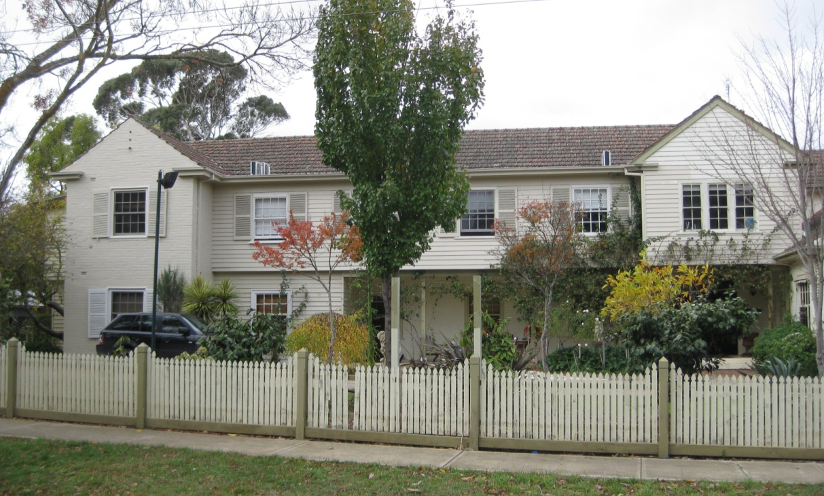

Figure 1. 8 Carlisle Street, Woodend (GJM Heritage/Frontier Heritage, June 2018)

***What is significant?***

The Manchester Unity Convalescence Home (Former), 8 Carlisle Street, Woodend, a rest home established in 1941.

Elements that contribute to the significance of the place include (but are not limited to):

* The original form, materials and detailing of the main building, staff cottage and garages
* The high level of integrity of the main building, staff cottage and garages to their original design
* The original form, materials, detailing and high level of integrity of the interior of the main building to its original design. This includes the main entrance foyer, stair, ground and first floor corridors and formal lounge/dining room with timber truss ceiling in the main building.

*Description*

The principal internal spaces which remain intact to the original form include the entrance hall, staircase, first floor landing, the corridors at both levels on the northern side of the entrance hall and landing, and the lounge and dining room on the southern side of the entrance. The entrance hall is a generous open space with a finely detailed semi-circular staircase sweeping around the reception counter up to the balconied first floor landing. The corridors that run north of the entrance hall and landing at both levels retain the original form and materials including feature doors to the rooms on both sides and the original numbering and signage.

South of the entrance hall is the large open lounge and connected dining room, each with a bay window at the east and west ends. The elaborately detailed rooms include timber panelling, a raked timber lined ceiling with exposed decorative timber trusses and a large open fireplace.

* Gardens, including mature trees and plantings, and ornamental lake.

*Description*

At the rear of the site is a mature garden with lawned areas, *Arbutus unedo* specimens, clipped hedges, bushes, ornamental lake and a tennis court.

Additions made to the main building from the 1990s and a later conference building to the south-east, and the infilling of the western verandah of the main building, are not significant.

***How is it significant?***

The Manchester Unity Convalescence Home (Former), 8 Carlisle Street, Woodend is of local historical and architectural significance to the Shire of Macedon Ranges.

***Why is it significant?***

The former Manchester Unity Convalescent Home, 8 Carlisle Street, Woodend demonstrates the recognition of the benefits of a healthy climate afforded by rural locations such as Woodend for the assistance of recuperation, particularly during the 1940s (Criterion A).

The former Manchester Unity Convalescent Home, 8 Carlisle Street, Woodend is a rare surviving example of a recuperative rest home within the Macedon Ranges Shire. Rest homes were typically established by friendly societies and churches at country and seaside locations and the former Manchester Unity Convalescent Home, Woodend remains to demonstrate this once common building type (Criterion B).

The former Manchester Unity Convalescent Home, 8 Carlisle Street, Woodend has close associations with Melbourne architect Marcus Barlow, who designed a number of buildings for Manchester Unity, including the innovative and prominent Manchester Unity building, Swanston Street, Melbourne. This place demonstrates Barlow’s connection with this friendly society (Criterion H).

*Summary*

The former Manchester Unity Convalescent Home, Woodend is of note as a rare surviving example of a country rest home within the Macedon Ranges Shire. Designed and constructed in an Interwar Georgian Revival style by Melbourne architect Marcus Barlow, the original purpose of the building is reflected in its present use and presentation.

**Image**



Figure 2. Stairwell in entrance foyer (GJM Heritage/Frontier Heritage, March 2019)

**Aerial**



Figure 3. Aerial photo of 8 Carlisle Street, Woodend (Source: Macedon Ranges Shire Council, aerial dated March 2018).

**Primary source:**

*Macedon Ranges Shire Heritage Study: Woodend, Lancefield, Macedon & Mount Macedon Stage 2 Final Report Volumes 1 and 2* (GJM Heritage and Frontier Heritage, April 2019)