**Macedon Cemetery Statement of Significance, May 2021**

|  |  |
| --- | --- |
| **Heritage place:** Macedon Cemetery, 54 Bent Street, Macedon | **PS ref no.:** HO325 |

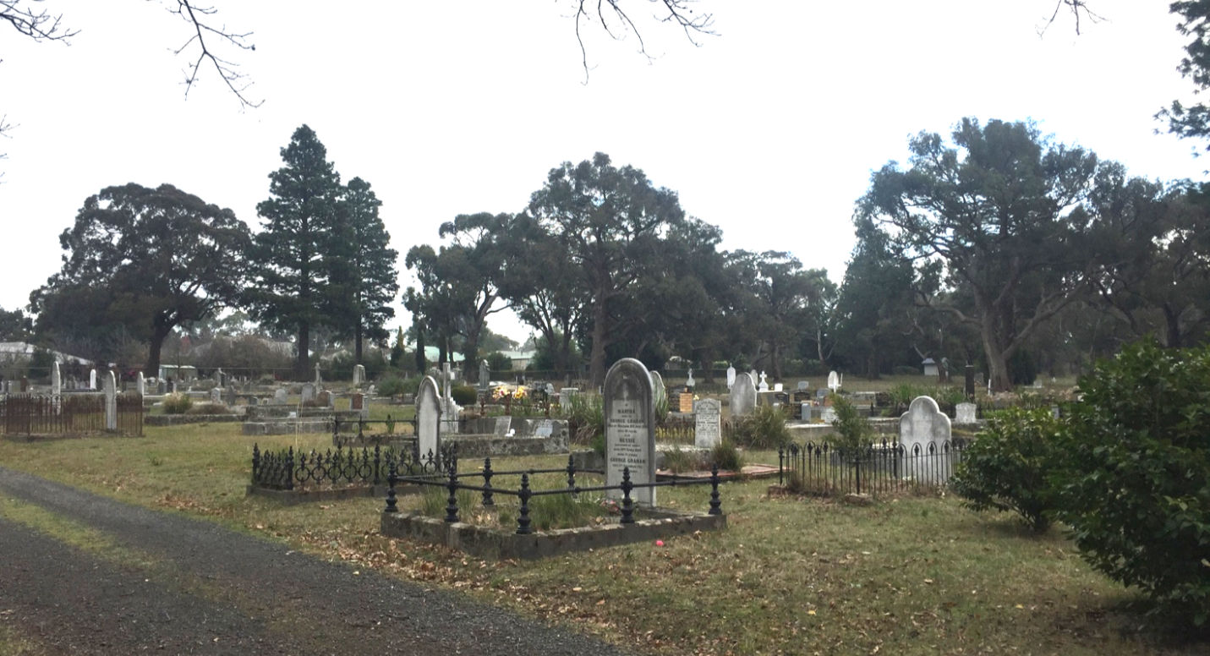

Figure 1. Macedon Cemetery (GJM Heritage/Frontier Heritage, June 2018)

***What is significant?***

Macedon Cemetery, 54 Bent Street, Macedon, a cemetery established in the mid-nineteenth century.

Elements that contribute to the significance of the place include (but are not limited to):

* The cemetery’s original layout (including the network of paths and plantings and entrance gates), early graves and memorials along with those from the later nineteenth and twentieth centuries

*Description*

The street boundaries are defined by a metal post and mesh fence with rendered brick stepped pillars and decorative iron gates providing the access to the site from Bent Street.

Mature trees are scattered throughout the cemetery including groups of pines of various species, oaks and gums. Along the west boundary of the site there are a number of mature Monterey pines.

* The cemetery’s high level of integrity to its original design.

Modern structures such as the rotunda and maintenance shed and facilities, and the boundary fence are not significant.

***How is it significant?***

Macedon Cemetery is of local historical, cultural and aesthetic significance to the Shire of Macedon Ranges.

***Why is it significant?***

Macedon Cemetery is of historical significance as a substantially intact mid-nineteenth century cemetery which has strong associations with both the early and continuing history of Macedon and Mt Macedon. The graves and memorials provide important information about the local community and about prominent Victorians, including Lord Richard G Casey and Lady Ethel Casey, artist Ellis Rowan and Melbourne *Age* newspaper owner, Oswald J Syme and family (Criterion A).

Macedon Cemetery is a fine and representative example of a mid-nineteenth century cemetery within a rural township, with later graves demonstrating the continued use of the place through the late nineteenth and twentieth centuries. It displays typical features of a cemetery from this period in Macedon and across Victoria more broadly, including formal denominational division and layout of paths and graves, distinctive memorials and railings and mature plantings (Criterion D).

Macedon Cemetery contains a collection of distinctive memorials, decorative graves and railings and mature plantings which together present a picturesque rural setting at the base of Mount Macedon (Criterion E).

*Summary*

The Macedon Cemetery, Macedon is of note as a fine and intact example of a local cemetery originally established in the mid-nineteenth century. It contains collection of distinctive memorials, decorative graves and railings and mature plantings*.*

**Image**



Figure 2. Main Entrance gates, Bent Street (GJM Heritage/Frontier Heritage, June 2018)

**Aerial**



Figure 3. Aerial photo of 54 Bent Street, Macedon (Source: Macedon Ranges Shire Council, aerial dated March 2018).

**Primary source:**

*Macedon Ranges Shire Heritage Study: Woodend, Lancefield, Macedon & Mount Macedon Stage 2 Final Report Volumes 1 and 2* (GJM Heritage and Frontier Heritage, April 2019)