**Lancefield Railway Station (Former) & Railway Line Remnants Statement of Significance, May 2021**

|  |  |
| --- | --- |
| **Heritage place:** Lancefield Railway Station (former) & Railway Line Remnants, 36 (part), 42 & 68A (part) Main Road, Lancefield | **PS ref no.:** HO322 |

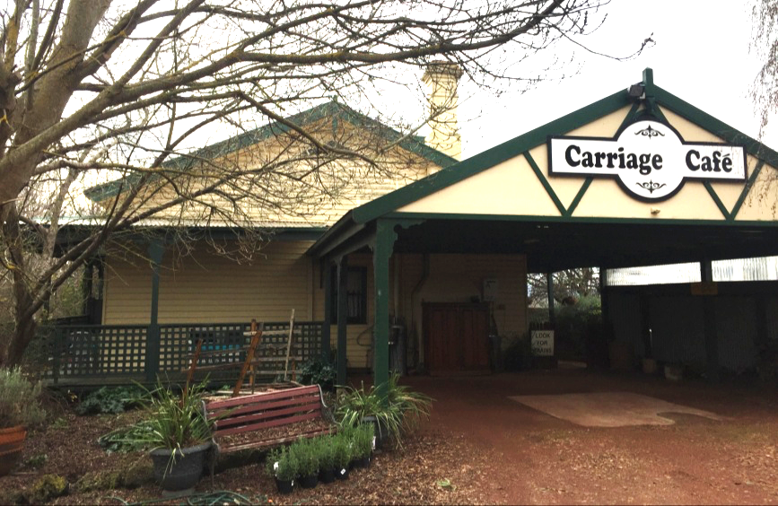

Figure 1. Former Lancefield Railway Station, 42 Main Road, Lancefield (GJM Heritage/Frontier Heritage, June 2018)



Figure 2. Former timber bridge, 68A (part) Main Road, Lancefield (GJM Heritage/Frontier Heritage, July 2018)

***What is significant?***

The Former Lancefield Railway Station and Railway Line Remnants, 36 (part), 42 and 68A (part) Main Road, Lancefield, a railway station built in 1881 and associated remnant railway line from 1881.

Elements that contribute to the significance of the place include (but are not limited to):

* The railway station’s original form, materials and detailing
* The railway station’s high level of integrity to its original design
* Remnants of railway line infrastructure.

Additions to the north, west and south of the railway station building, and a building located to the south-west, are not significant.

***How is it significant?***

The Former Lancefield Railway Station and Railway Line Remnants are of historical and architectural significance to the Shire of Macedon Ranges.

***Why is it significant?***

The Former Lancefield Railway Station and Railway Line Remnants are illustrative of the network of railway lines developed in the late nineteenth century to service rural townships. It reflects the importance of the local railway network to rural communities in the late nineteenth and early twentieth century and the final closure of the line in the 1950s demonstrates the decline of the smaller rural lines in the late twentieth century (Criterion A).

The Former Lancefield Railway Station, 42 Main Road, Lancefield is an intact and representative example of a railway station in a rural township. It displays typical characteristics of a small late nineteenth century regional railway station, including a simple rectangular plan with gable roof form and verandah, and the typical use of timber for framing, cladding, window frames and doors (Criterion D).

*Summary*

The Former Lancefield Railway Station, Lancefield together with railway line, bridge and underpass remnants, is of note as a representative and intact example of a railway station, with associated infrastructure, within a rural township in the Shire of Macedon Ranges. The Former Lancefield Railway Station was constructed on a rural branch line in the Shire of Macedon Ranges and, as the only remaining station, demonstrates the development of the local railway network within the Shire. Remnant sections of associated railway infrastructure augment an understanding of the station.

**Aerial**

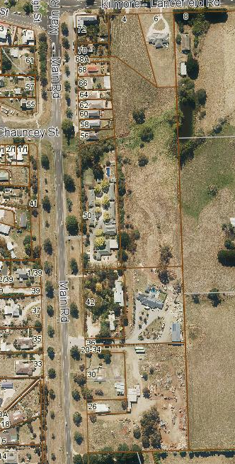  
Figure 3. Aerial photo of 36 (part), 42 & 68A (part) Main Road, Lancefield (Source: Macedon Ranges Shire Council, aerial dated March 2018).

Remnant of formed concrete bases for railtrack adjacent to former Station building

Remnant of underpass

Remnant timber trestle bridge

**Primary source:**

*Macedon Ranges Shire Heritage Study: Woodend, Lancefield, Macedon & Mount Macedon Stage 2 Final Report Volumes 1 and 2* (GJM Heritage and Frontier Heritage, April 2019)