**Lancefield Presbyterian Manse (Former) Statement of Significance, May 2021**

|  |  |
| --- | --- |
| **Heritage place:** Lancefield Presbyterian Manse (former), 3416 Melbourne Lancefield Road, Lancefield | **PS ref no.:** HO323 |

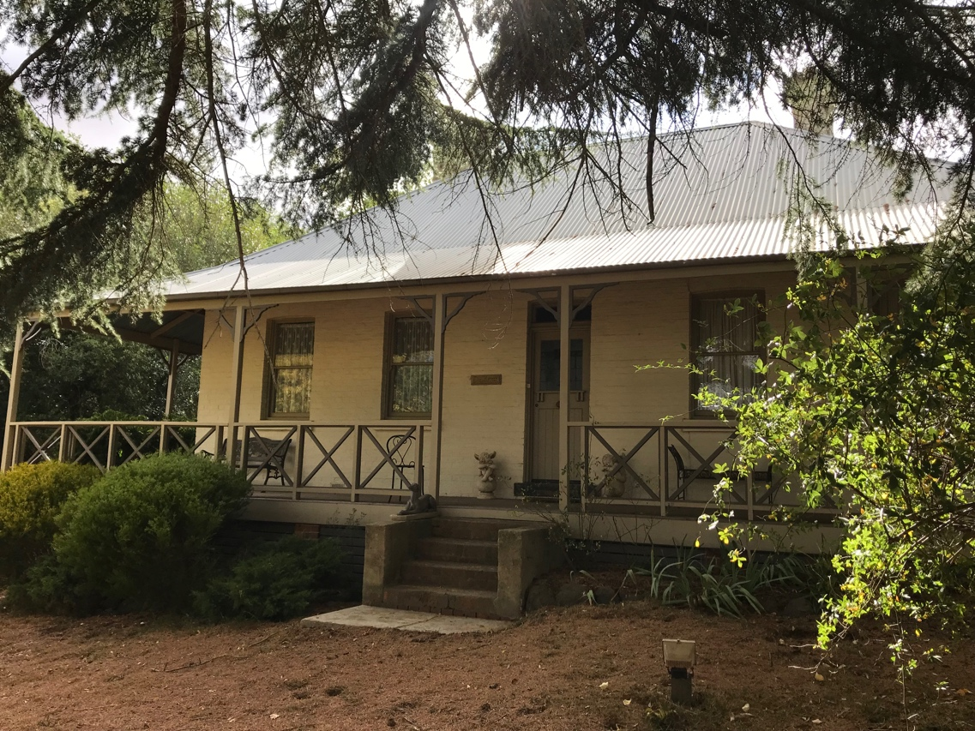

Figure 1. 3416 Melbourne Lancefield Road, Lancefield (GJM Heritage/Frontier Heritage, March 2019)

***What is significant?***

The Former Lancefield Presbyterian Manse, 3416 Melbourne Lancefield Road, Lancefield, a church residence built in 1862.

Elements that contribute to the significance of the place include (but are not limited to):

* The house’s original form, materials and detailing
* The house’s high level of integrity to its original form and design
* Mature trees and plantings, including the cedars, Hawthorn hedge, Elm and Fir.

*Description*

The house is surrounded by a landscaped setting which includes a number of mature trees (cedar, fir and elm) to the north and west (front) of the house. The site boundaries to the north and south is bordered by hawthorn hedges.

Recent additions, alterations and outbuildings are not significant.

***How is it significant?***

The Former Lancefield Presbyterian Manse is of local historical and architectural significance to the Shire of Macedon Ranges.

***Why is it significant?***

The Former Lancefield Presbyterian Manse is of historical significance as an early church residence which has strong associations with the local Lancefield community. Its construction in the 1860s demonstrates the early need for places of worship in rural townships and the continuing use of the place for religious purposes for some sixty years illustrates the enduring value of worship in the district (Criterion A).

The Former Lancefield Presbyterian Manse is a fine and representative example of a small 1860s church residence in a mature landscape setting from the Victorian period. The building displays typical characteristics of a Victorian house in the Macedon Ranges Shire, including hipped roof and return verandah (Criterion D).

*Summary*

The Former Lancefield Presbyterian Manse, Lancefield, constructed in 1862, is of note as an early church residence in a mature landscape setting, within a rural township in the Macedon Ranges Shire.

**Image**



Figure 2. Photo of The Manse, believed to date to c1900 (owner’s collection, accessed March 2019)

**Aerial**



Figure 3. Aerial photo of 3416 Melbourne-Lancefield Road, Lancefield (Source: Macedon Ranges Shire Council, aerial dated March 2018).

**Primary source:**

*Macedon Ranges Shire Heritage Study: Woodend, Lancefield, Macedon & Mount Macedon Stage 2 Final Report Volumes 1 and 2* (GJM Heritage and Frontier Heritage, April 2019)