House 29-31 Margaret Street, Macedon Statement of Significance, May 2021
Heritage place: House, 29-31 Margaret Street, Macedon | PS ref no.: HO326

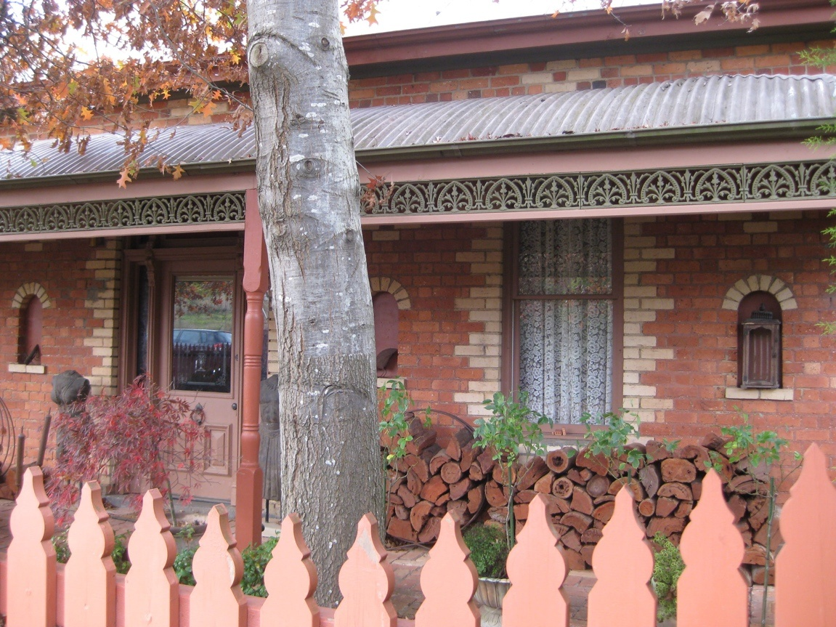
Figure 1. 29-31 Margaret Street, Macedon (GJM Heritage/Frontier Heritage, May 2018)
What is significant?
House, 29-31 Margaret Street, Macedon, built c1900-1908.
Elements that contribute to the significance of the place include (but are not limited to):
- The house’s original form, materials and detailing
- The house’s high level of integrity to its original design.
Later alterations and additions are not significant.
How is it significant?
The house at 29-31 Margaret Street, Macedon is of local historical, architectural and aesthetic significance to the Shire of Macedon Ranges.
Why is it significant?
The house at 29-31 Margaret Street, Macedon is illustrative of residential development which occurred in rural townships in the first decade of the twentieth century (Criterion A).
The house at 29-31 Margaret Street, Macedon is a fine and representative example of a small turn of the century house in a rural township. It displays typical features of a house of this period in Macedon and across Victoria more broadly, including bichromatic brickwork, simple hipped roof, double hung windows and front verandah with timber posts (Criterion D).
The house at 29-31 Margaret Street, Macedon is a well-considered and carefully detailed house. The house, with bichromatic brick walls and chimneys and unusual niches to the front façade, presents a picturesque composition from the turn of the century (Criterion E).
Summary
The house at 29-31 Margaret Street, Macedon is of note as a well-considered and carefully detailed representative example of a small turn of the century house in a rural township in the Macedon Ranges Shire. The house at 29-31 Margaret Street, Macedon retains sufficient integrity to clearly demonstrate the characteristics of this place type.
Aerial
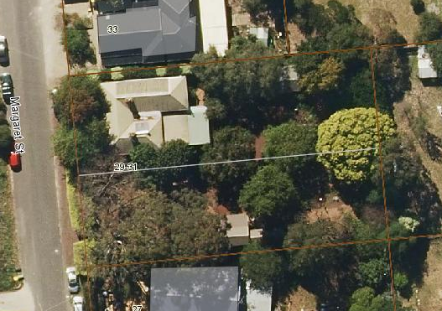
Figure 2. Aerial photo of 29-31 Margaret Street, Macedon (Source: Macedon Ranges Shire Council, aerial dated March 2018).
Primary source:
Macedon Ranges Shire Heritage Study: Woodend, Lancefield, Macedon & Mount Macedon Stage 2 Final Report Volumes 1 and 2 (GJM Heritage and Frontier Heritage, April 2019)

