**Glen Drouitt Statement of Significance, May 2021**

|  |  |
| --- | --- |
| **Heritage place:** Glen Drouitt, 51 Glen Drouitt Road, Mount Macedon | **PS ref no.:** HO331 |

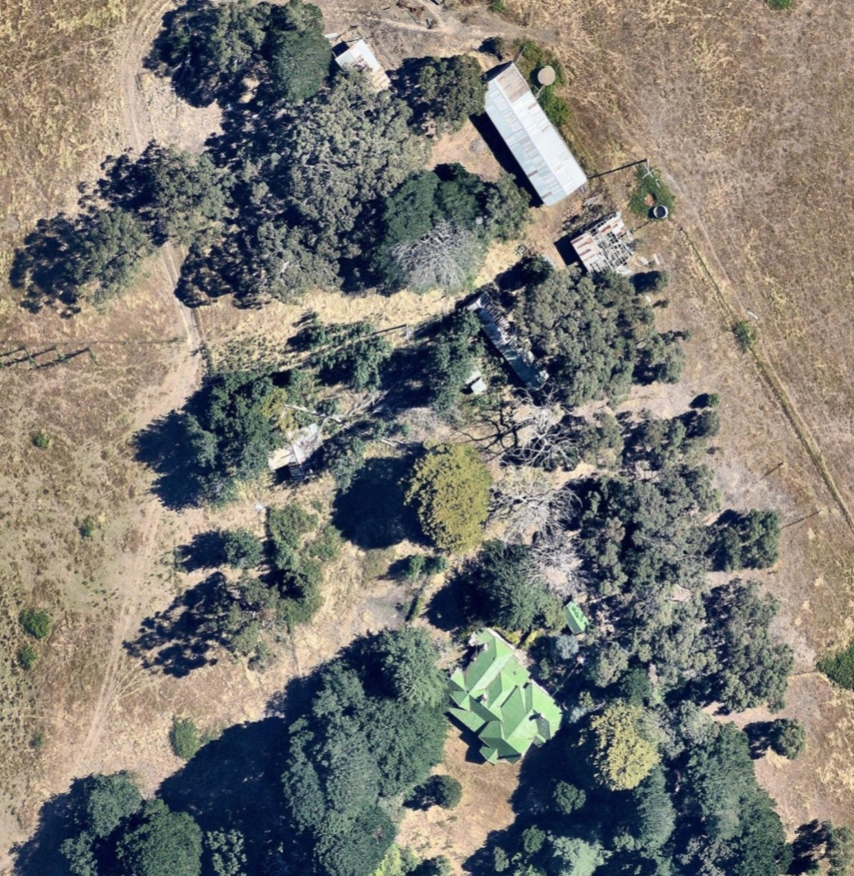

Figure 1. 51 Glen Drouitt Road, Mount Macedon (Aerial dated Jan 2018. Source: Nearmap)

***What is significant?***

Glen Drouitt, 51 Glen Drouitt Rd, Mount Macedon, a farming property established in the nineteenth century.

Elements that contribute to the significance of the place include (but are not limited to):

* The farmhouse’s original form, materials and detailing
* The farmhouse’s high level of integrity to its original design
* Early outbuildings, including a dairy, house gate and fence

*Description*

The gabled brick dairy (painted) is sunk into the ground for cool storage of dairy produce.

There are two sets of large timber gate posts (each with capping and a ball) at the house yard entrances, one with a picket remnant.

* Gardens, including mature trees and plantings.

*Description*

The house is surrounded by remnants of a mature exotic garden surrounded by hedges. The drive is lined with cedars, pines and gum. There is a lake to the south of the house.

The garden has deteriorated but there are mature trees such as a cedar, deodar cedars near the house, old Monterey pines, some Canary Island pines, bulbs and to the south of the house are hawthorns (pink, white), rowan trees, a stone and bulb-lined path leading west to a tennis court next to the ornamental lake, with its island planted with cordylines and trees surrounding. Nearer the house are a *Trachycarpus fortuneii* to the north-east.

More recently constructed outbuildings are not significant.

***How is it significant?***

Glen Drouitt is of local historical and architectural significance to the Shire of Macedon Ranges.

***Why is it significant?***

Glen Drouitt demonstrates the early establishment and subsequent development of farming properties in the rich agricultural districts of the Macedon Shire Ranges (Criterion A).

Glen Drouitt is a fine, intact and representative example of a nineteenth century farming property. It displays typical features of a farm complex in Mount Macedon and across Victoria more broadly, including a substantial farmhouse, outbuildings and mature plantings (Criterion D).

*Summary*

Glen Drouitt, Mount Macedon is of note as a representative and intact example of a farming property in the Shire of Macedon Ranges. The district gained a reputation as a rich agricultural area and properties such as this clearly illustrate this development. It displays a range of characteristics typical of this place type including a single-storey dwelling, a range of associated outbuildings, mature vegetation and a sizable allotment of farming land.

**Image**



Figure 2. The house in 1994 (TBA Planners et al., 1994:309).

**Aerial**

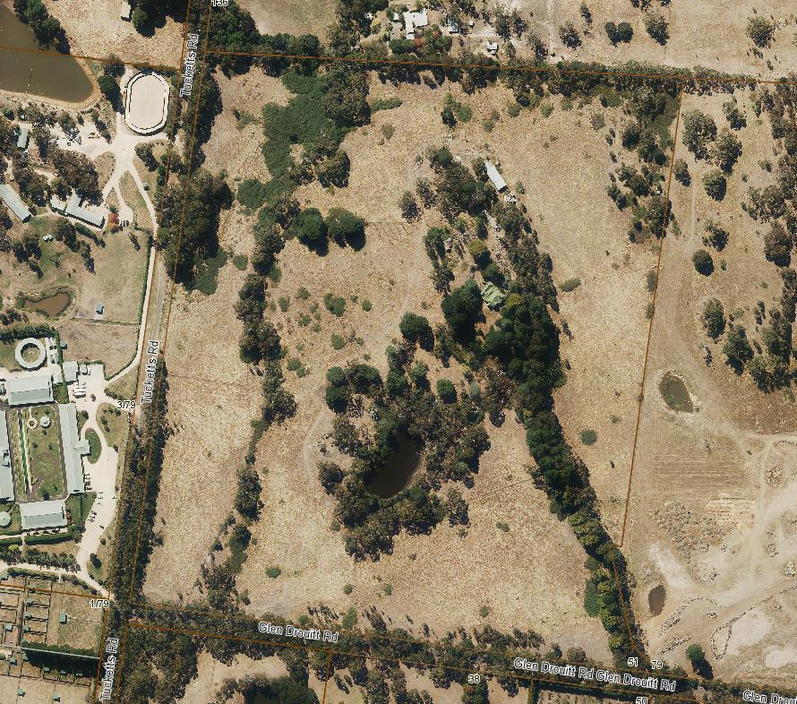

Figure 3. Aerial photo of 51 Glen Drouitt Road, Mount Macedon (Source: Macedon Ranges Shire Council, aerial dated March 2018).

**Primary source:**

*Macedon Ranges Shire Heritage Study: Woodend, Lancefield, Macedon & Mount Macedon Stage 2 Final Report Volumes 1 and 2* (GJM Heritage and Frontier Heritage, April 2019)