**Flint Hill Statement of Significance, May 2021**

|  |  |
| --- | --- |
| **Heritage place:** Flint Hill, 65 (part) Romsey Road, Woodend | **PS ref no.:** HO348 |

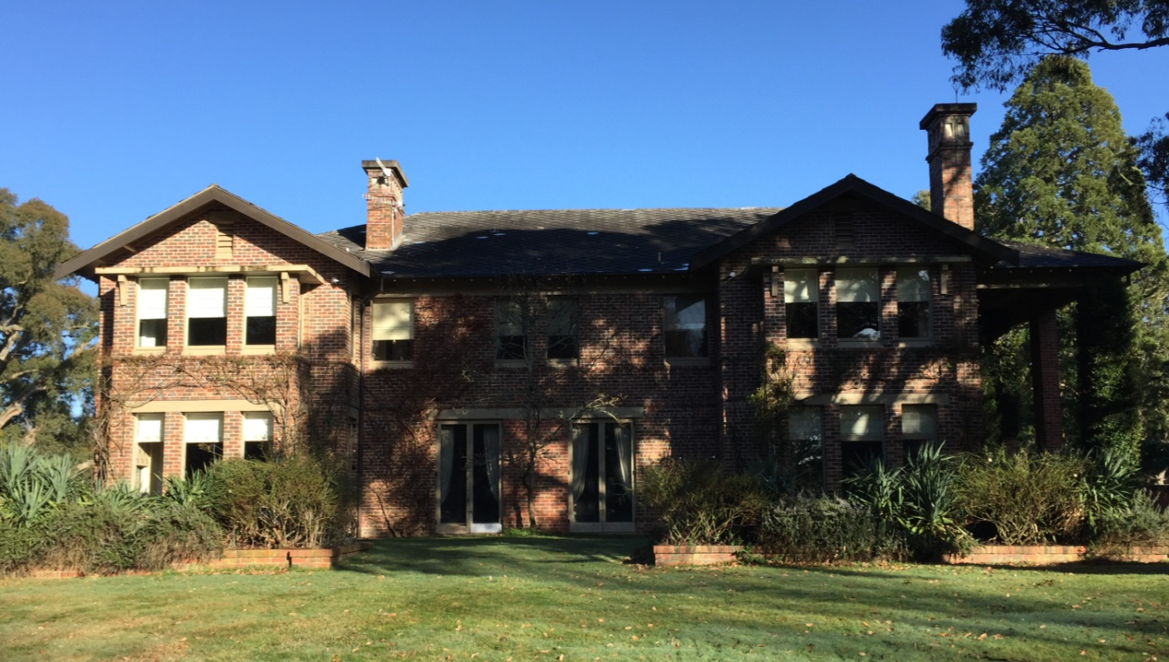

Figure 1. 65 (part) Romsey Road, Woodend (GJM Heritage/Frontier Heritage, July 2018)

***What is significant?***

Flint Hill, 65 (part) Romsey Road, Woodend, a house built in 1922-23, and associated garden.

Elements that contribute to the significance of the place include (but are not limited to):

* The form, materials and detailing of the house
* The house’s high level of integrity to its original design
* Gardens, including mature trees and plantings on the National Trust Tree Register

*Description*

The place has an extensive woodland garden with elements such as gravelled pathways, stone paving, a tennis court with practice wall, a large ornamental lake and smaller ponds, all set well off the road. The garden includes three trees which are listed on the National Trust tree register and identified with a plaque at the trunk base. They are a Lucombe Oak on the main lawn north east of the house; a Caucasian Fir south east of the house and a Bishops Pine near the rhododendrons. Other major trees include many gums, large oaks, a large peppermint to the rear and south side of the house, and three very large sequoias at the front. There are also mature rhododendrons.

Recent alterations and additions, including recently constructed outbuildings, are not significant.

***How is it significant?***

Flint Hill is of local historical, architectural and aesthetic significance to the Shire of Macedon Ranges.

***Why is it significant?***

Flint Hill is illustrative of residential development which occurred on the outskirts of rural townships in the inter-war years of the twentieth century and is associated with the establishment of summer houses in easily accessible rural townships by wealthy Melburnians (Criterion A).

Flint Hill is a large, representative example of an Inter-war house. It demonstrates the use of typical materials of the 1920s in Woodend and across Victoria more broadly, including clinker brick and cement diagonal pattern roof shingles, and elements such as dominant two-storey rectangular window bays and clinker brick chimneys, all with heavy cement cappings (Criterion D).

Flint Hill is a well-considered and carefully detailed house set in a large mature garden. The clinker brick house with simple roof form and tall chimneys, together with the garden, presents a highly picturesque composition from the Inter-war period (Criterion E).

Flint Hill has close associations with the Brookes family, in particular successful Melbourne businessman, Harold Brookes, and his wife Dorothy who was involved in many charities and was an active member of a number of established clubs. The Brookes family owned and occupied the country house from its establishment in 1922 until the mid-1950s (Criterion H).

*Summary*

Flint Hill, Woodend is of note as a well-considered and carefully detailed example of a large Inter-war house and garden established on the outskirts of a rural township in the Inter-war period.

**Image**



Figure 2. Lucombe Oak north east of house (GJM Heritage/ Frontier Heritage, July 2018)

**Aerial**



Figure 3. Aerial photo of 65 Romsey Road, Woodend (Source: Macedon Ranges Shire Council, aerial dated March 2018).

**Primary source:**

*Macedon Ranges Shire Heritage Study: Woodend, Lancefield, Macedon & Mount Macedon Stage 2 Final Report Volumes 1 and 2* (GJM Heritage and Frontier Heritage, April 2019)