**Dreamthorpe Statement of Significance, March 2021**

|  |  |
| --- | --- |
| **Heritage place:** Dreamthorpe, 455 Mount Macedon Road, Mount Macedon | **PS ref no.:** HO332 |

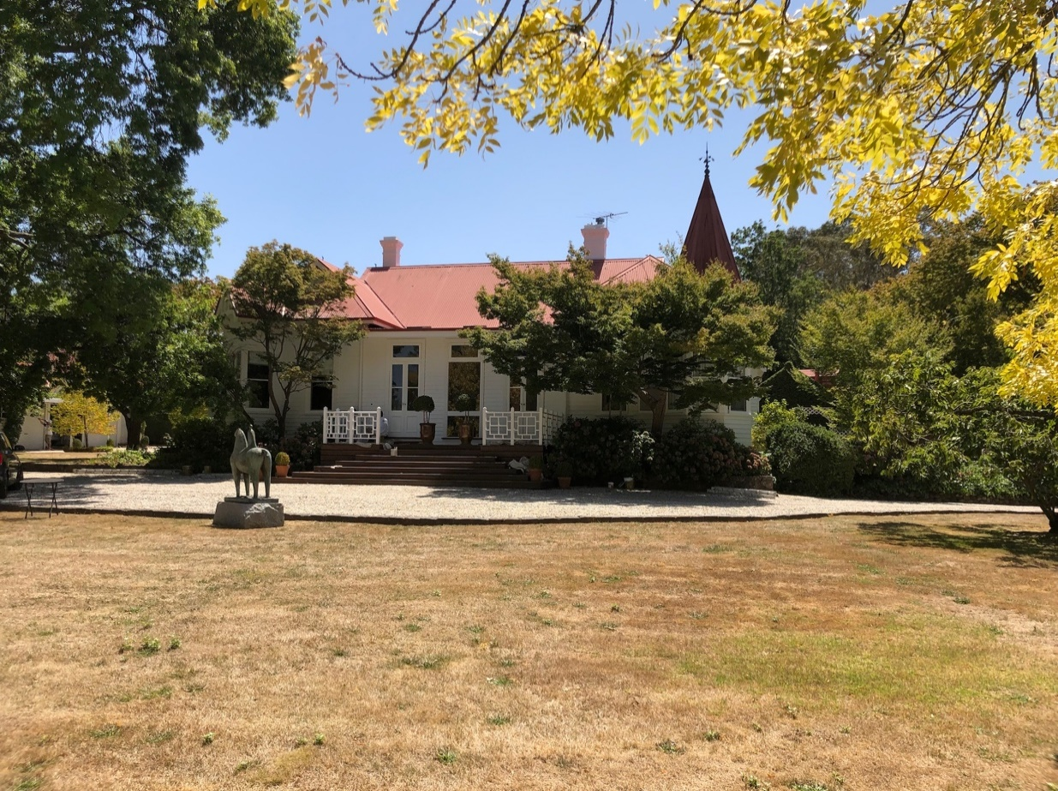

Figure 1. 455 Mount Macedon Road, Mount Macedon (GJM Heritage/Frontier Heritage, March 2019).

***What is significant?***

Dreamthorpe, 455 Mount Macedon Road, Mount Macedon, a hill station established in the 1880s and including a Victorian house modified in the Edwardian period.

Elements that contribute to the significance of the place include (but are not limited to):

* The external form, materials and detailing of the house
* The house’s high level of integrity to its Victorian and Edwardian design
* Early outbuildings

*Description*

An old gabled colonial-bonded brick structure to the north east of the house is thought to have been the earliest house on the site but this has been much changed and appears more likely to have been connected with the nursery or a former farm function. Other associated early outbuildings include a series of garden pavilions and storage structures, including a gable roof timber building currently used as a garage.

* Gardens, including mature plantings.

*Description*

There are extensive exotic trees throughout the garden and around the perimeter of the yard, along with a crab apple hedge extending along Turitable Avenue to Mount Macedon Road. Plantings also include very large *Cupressus lawsoniana*, and a *E.viminalis* specimen. Other mature tree specimens include *Cedrus deodara*, poplars, oaks, *Cupressus macrocarpa*, and pin oak. A pink hawthorn hedge lines the east boundary along with a rubble stone wall.

A large ornamental pond and stream is a feature of the garden.

Recent alterations and additions are not significant.

***How is it significant?***

Dreamthorpe is of local historical, architectural and aesthetic significance to the Shire of Macedon Ranges.

***Why is it significant?***

Dreamthorpe has strong associations with the establishment of hill stations at Mount Macedon by prominent and wealthy Victorians from the 1870s. The place clearly illustrates the initial establishment, and the subsequent development, of the mountain as a summer retreat comprising large garden estates with substantial houses set in extensive grounds (Criterion A).

Dreamthorpe is a representative example of a hill station established at the mountain location from the 1870s. It displays typical features of this place type, including extensive grounds, a large, prominent house, outbuildings and a collection of mature trees and other plantings (Criterion D).

Dreamthorpe is a highly developed picturesque hill station. Extensive grounds, containing a prominently-sited house, mature plantings and a water feature present a picturesque composition (Criterion E).

*Summary*

Dreamthorpe, Mount Macedon is of note as a fine and representative example of a Mount Macedon hill station. Dreamthorpe retains its extensive grounds, modified Victorian house and various outbuildings, and garden which includes mature trees and other plantings. Despite modifications to the house, outbuildings and garden, the place has clear associations with the important hill station class of place.

**Image**



Figure 2. Gabled weatherboard outbuilding currently used as a garage (GJM Heritage/Frontier, March 2019)

**Aerial**



Figure 3. Aerial photo of 455 Mount Macedon Road, Mount Macedon (Source: Macedon Ranges Shire Council, aerial dated March 2018).

**Primary source:**

*Macedon Ranges Shire Heritage Study: Woodend, Lancefield, Macedon & Mount Macedon Stage 2 Final Report Volumes 1 and 2* (GJM Heritage and Frontier Heritage, April 2019)