Craigielea Statement of Significance, May 2021
Heritage place: Craigielea, 109 (part) Mountains Road, Mount Macedon | PS ref no.: HO335

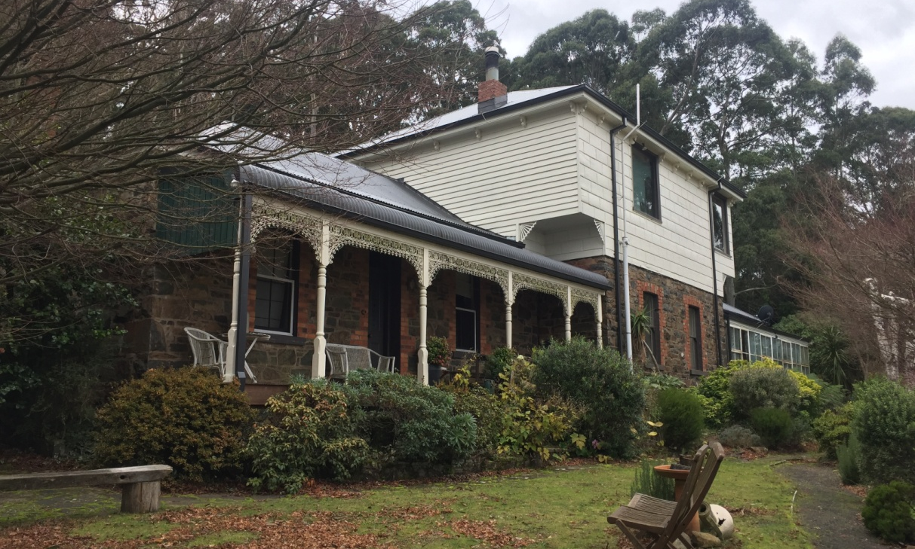
Figure 1. 109 (part) Mountains Road, Mount Macedon (GJM Heritage/Frontier Heritage, June 2018)
What is significant?
Craigielea, 109 (part) Mountains Road, Mount Macedon, a Victorian house built of freestone and brick.
Elements that contribute to the significance of the place include (but are not limited to):
- The house’s original form, materials and detailing
- The house’s high level of integrity to its Victorian design
Reconstructed and modern structures such as the 1875 cottage and Nissen Hut on the site are not significant.
How is it significant?
Craigielea is of local historical and architectural significance to the Shire of Macedon Ranges.
Why is it significant?
Craigielea, Mount Macedon is a fine and representative example of a Victorian Italianate house, with various additions, on the outskirts of a rural township. The original freestone and brick section of the house displays typical features of an Italianate house including a hipped roof, brick chimney, double hung windows and (reconstructed) front timber-framed verandah with cast iron decoration (Criterion D).
Summary
Craigielea, Mount Macedon is of note as a fine and representative example of a house built on the outskirts of a rural township in the late nineteenth century. Craigielea is a fine example of a residence constructed in freestone instead of the more prolific weatherboard or brick examples.

Aerial
Figure 2. Aerial photo of 109 (part) Mountains Road, Mount Macedon (Source: Macedon Ranges Shire Council, aerial dated March 2018).
Primary source:
Macedon Ranges Shire Heritage Study: Woodend, Lancefield, Macedon & Mount Macedon Stage 2 Final Report Volumes 1 and 2 (GJM Heritage and Frontier Heritage, April 2019)

